- Run the SQL script in SQL Server Management Studio and make sure it successfully runs.
- Next, open the project, the initial form layout should look like this:
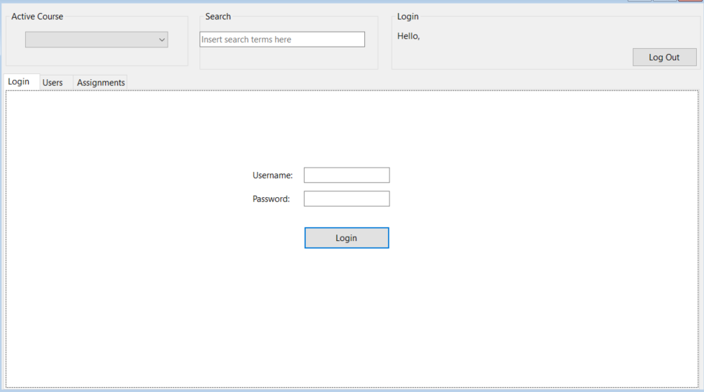
- You should run the scaffolding command to create models and a context from the database.
- Your next task will be to set up the Form Load. On load, the form should only display the Login tab and nothing else.
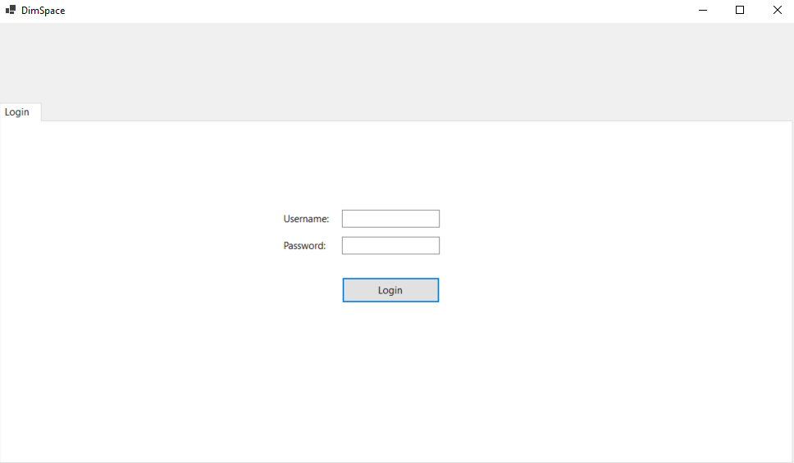
- Next, you will need to set up the Login.
Login Examples (From database, can use / check others)
Instructor: clondon | Password: clondon
Student: nlewis | Password: nlewis

  - Use a class level variable to store the user who is logging in.
  - You will need to check the username and password against the database and allow login if successful. If unsuccessful, display a message box.
  - On successful login, the Login tab should disappear and the appropriate content should appear.
  - The appropriate group boxes should be visible, and the label (lblUserName) should update with the logged in user.
  - For this lab, you can use binding sources, or set the datagridview’s data sources directly, whichever option works best for you.
  - Clicking the Log Out button should reset the Form back to its initial state.

- Next up, have the Active Course combo box set a search in the Users OR Assignments tab for the selected Course, returning the appropriate records to the data grid.
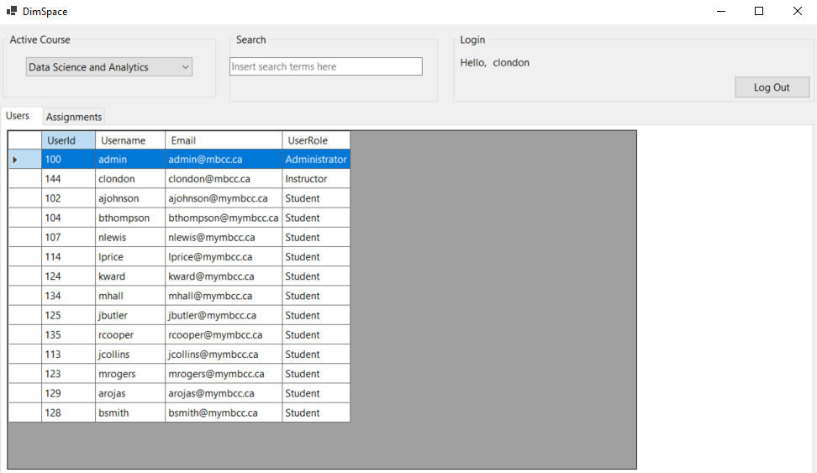
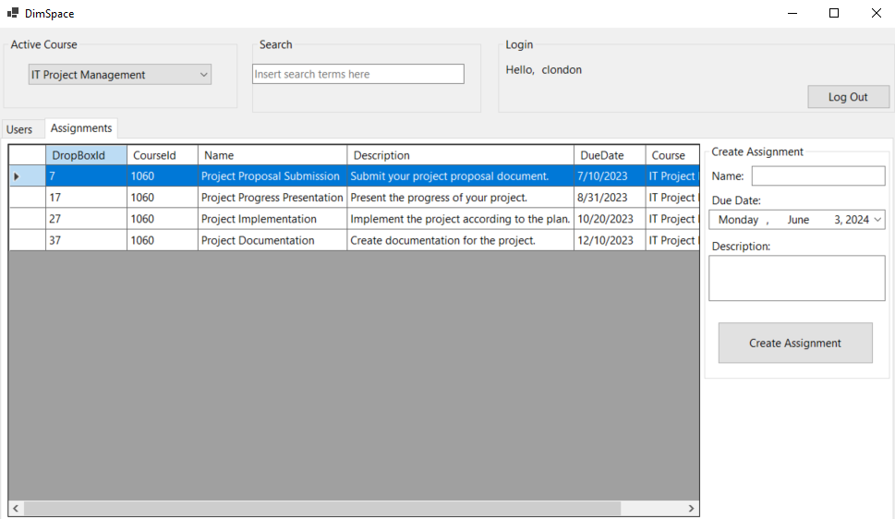
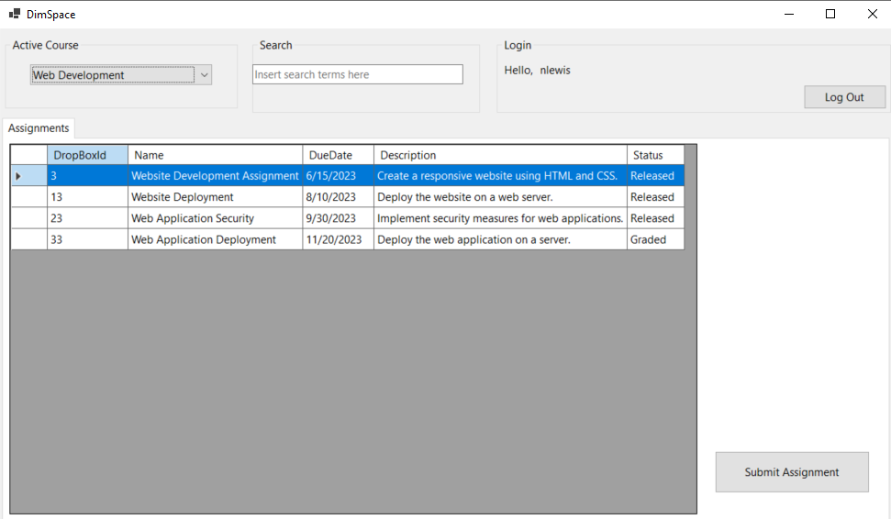
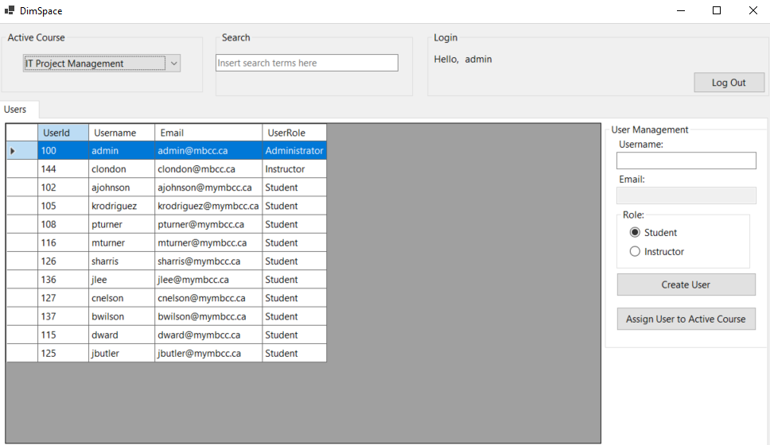
- Next you will need to write the code for Use Cases provided below.

Use Cases
User Login
- Actor: Any user
- Precondition: User must have valid credentials.
- Flow:
  - User enters username and password.
  - User clicks on the login button.
  - System validates credentials and sets user login if valid.
  - System displays relevant tabs and data based on user role.
- Notes: A student should only see their assignments (dropbox) tab whereas an instructor should see both the users and assignments tabs. An administrator should only see the users tab.
Search
- Actor: Any user
- Flow:
  - User enters search term into search bar.
  - Search updates dynamically, showing any valid results.
Users: Search username.
Assignments: Search DropBox Name and Description.

Create Assignment
- Actor: Instructor
- Precondition: User must be logged in as an Instructor.
- Flow:
  - Instructor enters assignment details.
  - Instructor clicks on the create assignment button.
  - System validates the input and creates a new assignment.
  - System assigns the assignment to students in the active course.
Submit Assignment
- Actor: Student
- Precondition: User must be logged in as a Student.
- Flow:
  - Student selects an assignment from the list.
  - Student clicks on the submit assignment button.
  - System validates and changes the status to submitted.
Create User
- Actor: Administrator
- Precondition: User must be logged in as an Administrator.
- Flow:
  - Administrator enters user details.
  - Administrator clicks on the create user button.
  - System validates input and creates a new user.
  - System assigns the user to the active course.
- Note: Have email assigned based on the format from the database.
Assign User to Course
- Actor: Administrator
- Precondition: User must be logged in as an Administrator.
- Flow:
  - Administrator selects a user from the user list. (Name will be displayed in the textbox).
  - Administrator selects a course from the Active Course dropdown.
  - Administrator clicks on the assign user button.
  - System assigns the selected user to the active course.

ER Diagram
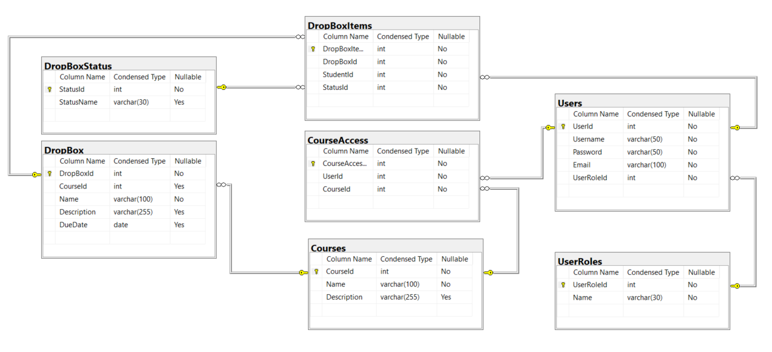
Additional Notes
- Error Handling: Proper error handling should be in place for database operations and user input validations.
- Security: Passwords DO NOT need to be hashed before storing them in the database. Implement proper access control based on user roles.
Expectations:
- Create methods for repeated code.
Submission Requirements:
- Memo: paragraphs explaining problems, time spent, also include scaffolding command used.
- Zip: zip of entire project.

