Tutorial Questions: Chapter 9

1. **For our simple robot model, describe the set of points that can be reached by the tip of the upper arm.**

The upper arm can reach the lower arm and the torso, allowing it to have much more control over the lower arm (which would be its children object). Just like the rest of the arm the upper arm has 3 degrees of freedom enabling it to move in 3 dimensions.

1. **Why is ray tracing a good strategy for rendering a scene described by a CSG tree?**

Because you can store one colour to each quadrant and just subdivide any quadrant that has multiple colours until they have one color. Because of the way this process works it would also be a very good way to store color information without taking too much processing time or memory.

1. **Show how quadtrees can be used to draw an image at different resolutions.**

the image starts off with 4 quadrants then for each quadrant that contains multiple colours that quadrant is then split into 4 quadrants and the process is repeated until there is only one colour per quadrant. This allows images from any resolutions to be stored in a file with very little processing time and memory.

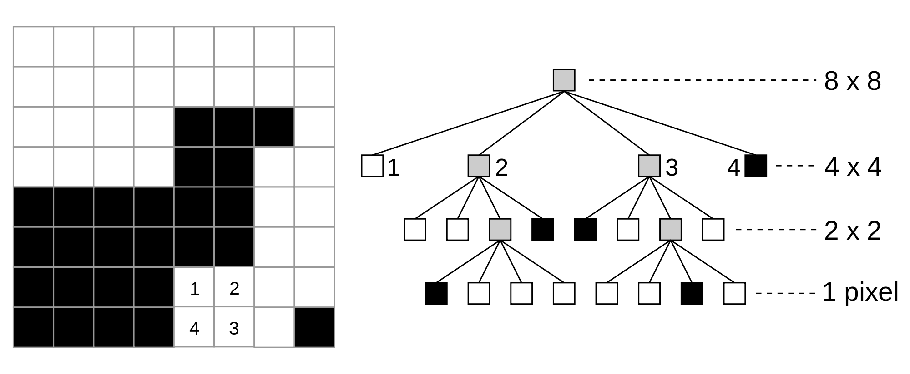

1. **Is it possible to design a scene graph structure that is independent of the traversal algorithm?**

No, execution of a program causes traversal of the scene graph, which executes graphics functions that are implemented in OpenGL.