EE4013 Lab 2

Q1: Both are using http 1.1

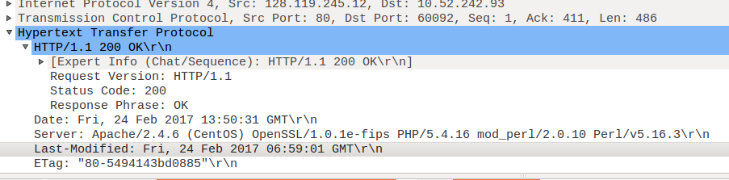

Q2: English(US)

Q3: Server: 128.119.245.12
My computer: 10.52.242.93

Q4: Status code: 200

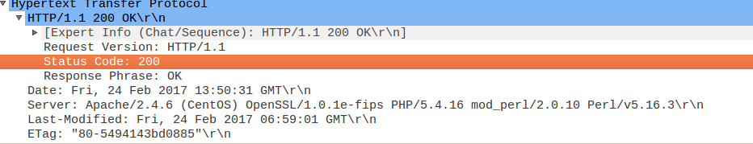

Q5: Last modified: Friday 24/Feb/2017 06:59:01 GMT

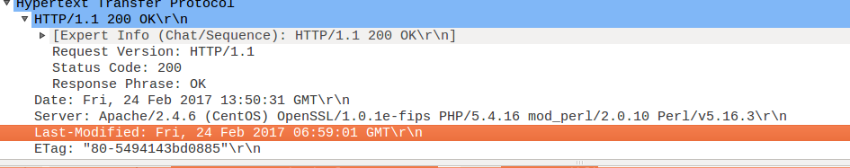

Q6: 128 bytes

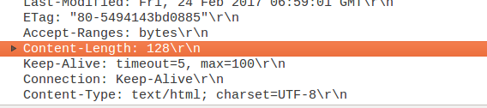

Q7: Accept-Ranges

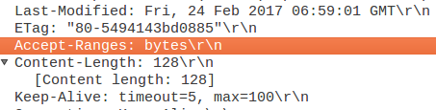

Q8: No

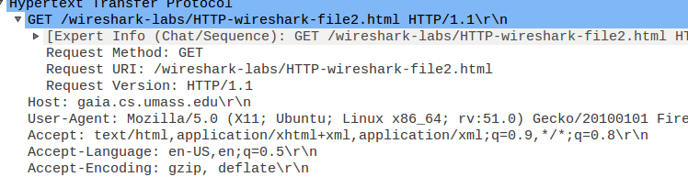

Q9: Yes. The content matches

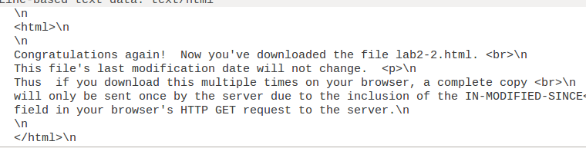

Q10: Yes, follwed by time of first link

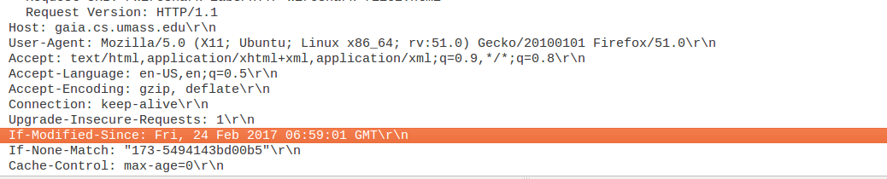

Q11: Status code: 304
Response Phrase: Not Modified

The server did not explicitly return the contents again, as the status code of 304 indicated no change.

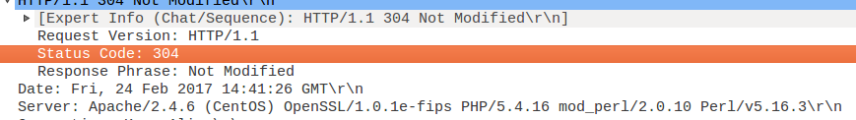

Q12: Browser sent 1 GET request

Packet Number : 25

Q13: Packet number: 31

Q14: Status Code: 200
Response Phrase: OK

Q15: 2 TCP Segments were required

Q16: 4 GET requests sent

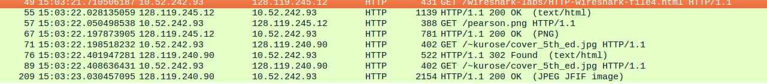
Q17: Images were downloaded serially, as an OK was received before the next GET

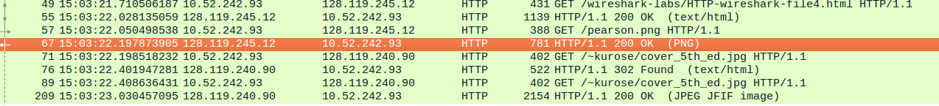

Q18: Response: 404 Not Found

(entered username and password correctly so not sure what’s wrong)

