**Part1: Write Up**

For sjbarrier, my implementation consisted of chunking the array by the size of the array divided by the number of threads. For each iteration of my loop, I multiplied the chunk size by the iteration number and sent that to the repeated blur.

For srbarrier, my implementation of the barrier was almost identical to the book. Of course, not everything from java can be a direct translation into C++. That is where I decided to use atomic_fetch_sub()to calculate my position. I also used an atomic_int and an atomic_bool for my private variables.

For srobarrier, I was surprised in how simple our optimization was. I added this_thread::yield()to my spin lock and memory_order_relaxed to my atomic load functions.

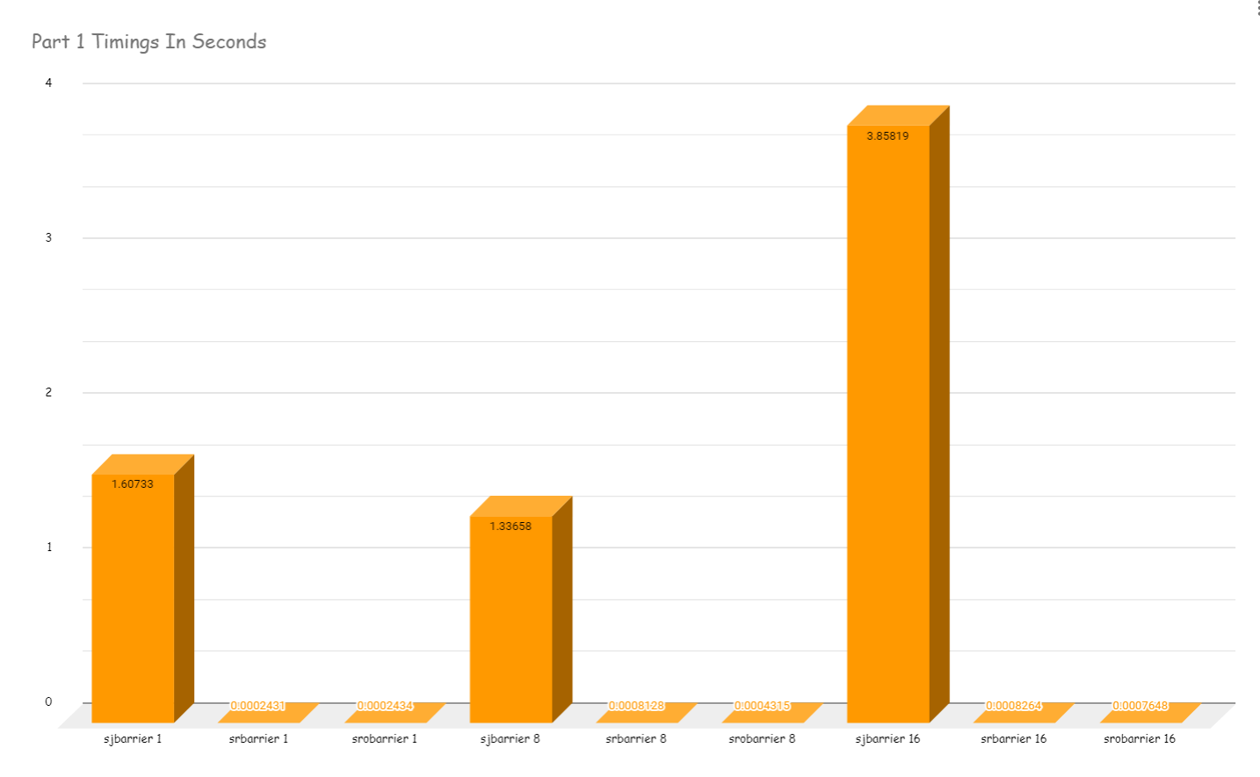

The results of these binaries were similar, even when the number of threads changed.

|  |  |  |
| --- | --- | --- |
| sjbarrier 1 | srbarrier 1 | srobarrier 1 |
| 1.60733 | 0.0002431 | 0.0002434 |

|  |  |  |
| --- | --- | --- |
| sjbarrier 8 | srbarrier 8 | srobarrier 8 |
| 1.33658 | 0.0008128 | 0.0004315 |

|  |  |  |
| --- | --- | --- |
| sjbarrier 16 | srbarrier 16 | srobarrier 16 |
| 3.85819 | 0.0008264 | 0.0007648 |

After I compared the time of each barrier implementation, it appears that the more threads we allocate, the more time it takes to synchronize.