**Part 2: Write Up**

During the execution of part2, I struggled with reproducing relaxed memory behavior. I could not get any relaxed memory behavior until I included the -O3 flag in my make file. This helped even though consistently acquiring the desired behavior was difficult. If I were trying to reproduce relaxed behavior consistently, I would buy a legitimate Linux based computer rather than trying to run a Linux image on docker. From the two images posted below, we can see that the results vary greatly.

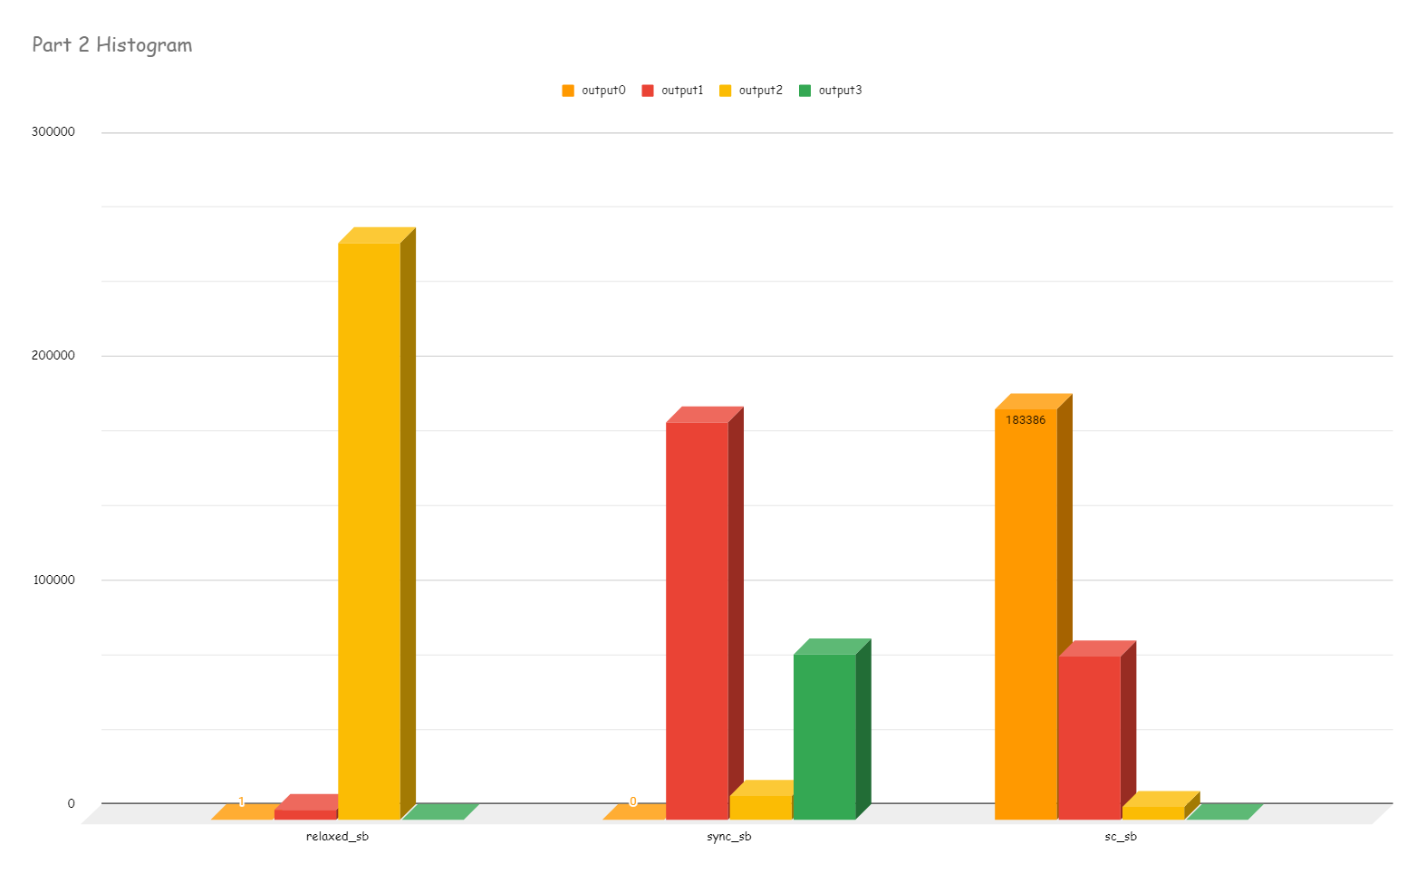

|  |  |  |
| --- | --- | --- |
| relaxed_sb | sync_sb | sc_sb |
| 1 | 0 | 183386 |
| 4437 | 177637 | 72953 |
| 257704 | 10727 | 5805 |
| 2 | 73780 | 0 |