**Part 3: Write Up**

Include a brief pdf report: include a graph of the throughput of each of the mutexes. Describe the number of mutual exclusion violations you observed for the relaxed mutex, and describe the fences you inserted to the TSO-fixed implementation.

While programming part 3, it seemed like we were almost digressing back to homework 2 when we had to create many of the primitive spin locks. It wasn’t until I realized that creating these with relaxed memory could give us a very different result. Because of the reordering of the loads and stores (as described in the May 13th lecture), it is possible that our program could become optimized in a wrong way. Because of this, the relaxed mutex implementation got 2,852,383 mutual exclusion violations. In order to stop the re-orderings of the store/load event, I used the fence macro that was defined for us. This eliminated every mutual exclusion violation by preventing any reordering.

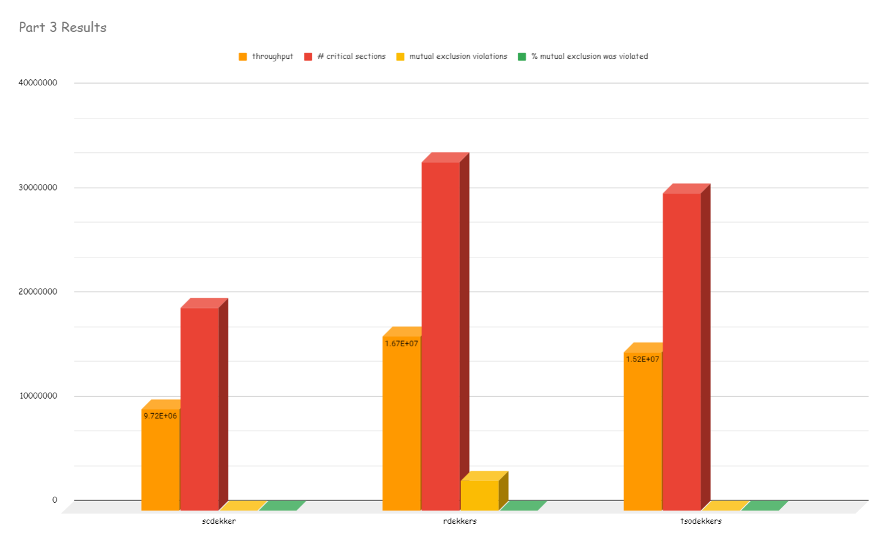

|  |  |  |
| --- | --- | --- |
| scdekker | rdekkers | tsodekkers |
| 9.72E+06 | 1.67E+07 | 1.52E+07 |
| 19431471 | 33377958 | 30371927 |
| 0 | 2852383 | 0 |
| 0 | 8.55% | 0 |