Setup Surface Pro / Dragonfly Python environment

Get access to Gitlab ED2 template repository and clone to C: drive

Check you have the N: drive mapped as \\lonfs01\dept\databases

If above is not holding, raise a ticket to IT to fix (add to AD group)

Under the N: -> NPC -> ED folders, you should see:

* the DATA folder containing raw, stripped and sample gathered output folders
* the METADATA folder containing the labelling spreadsheet CSVs
* the PYTHON folder containing a copy of the GIT LAB repository’s latest scripts
  + strip
  + 102 individual tabs
  + runall
  + concat
  + group
  + (config to centralise date, file and path variables – TBC)

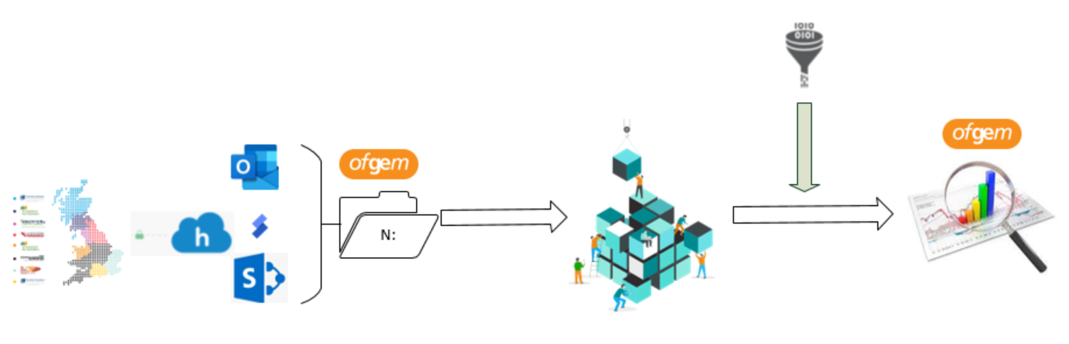

Manually extract 14 raw submissions through Outlook/Huddle/SkySync and SharePoint to the raw data folder on N:

Check these are adhering to the correct templates (**up to date as of December 2020**)

If necessary, copy the latest scripts from Git (current version 4.0) or copy from N: to C:

Output is always to local folders on C:

Run **40strip** to produce a simplified version of the files, unformatted with no blank rows (edit path for utils)

Check that the configuration settings (date_str, company_list, company_path_dict) are current

Run **run_all** to produce 102 machine-readable output files per DNO

Check output and edit Metadata and/or Python scripts to correct issues

Run **concat** to concatenate 14 DNOs into one output group (x 102)

Run **ED_group_and_deBOM** with gather (per DNO) or concat (grouped DNOs) folders to aggregate files and clean up symbols

Individual and grouped files (master, master_grouped, memo, misc and 12 other grouped outputs) are now available for further analysis or ingestion

Copy output files to SharePoint as required

See data flow below

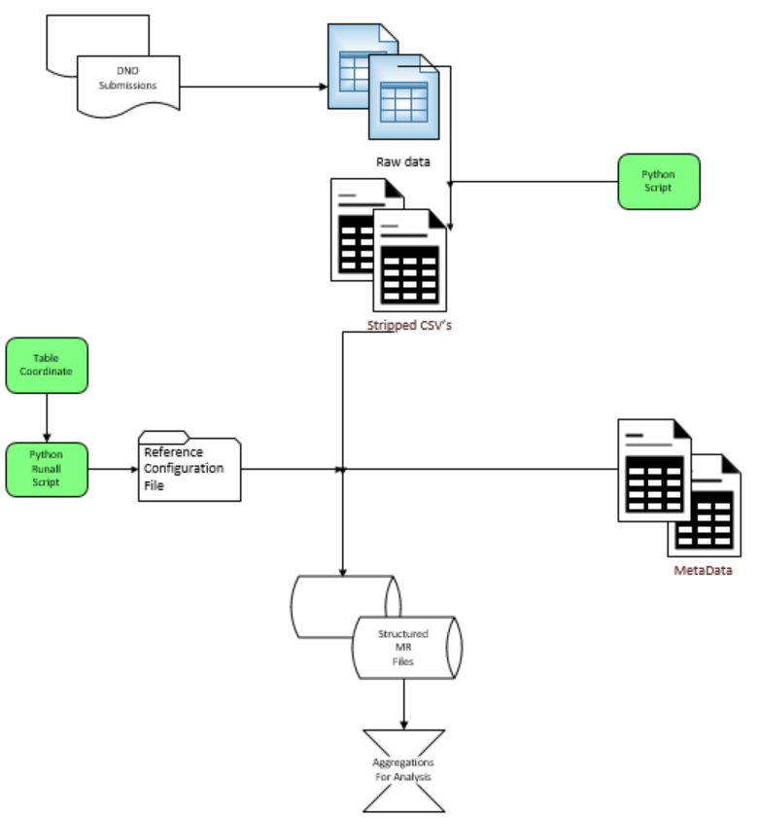

Source files: N:\NPC-DS Project\ED\data\draft_raw_xlsx

Metadata: N:\NPC-DS Project\ED\ed_bpdt_metadata

Python scripts: C:\Users\<profile name>\npc-gather-from-excel\ed2

Tab output: C:\network_price_controls\gather

Grouped output: N:\NPC-DS Project\ED\data\gather\Grouped