Meso-scale-Cantilevers-Abaqus-Automation Documentation

By Robert J Scales & Rory Rose

# Introduction

This code is primarily designed to allow one to serially run multiple ABAQUS simulations for the resonant fatigue of cantilevers, where the parameters between jobs can be altered by hand or handled via MATLAB, thus allowing for basic parametric studies to be quickly performed.

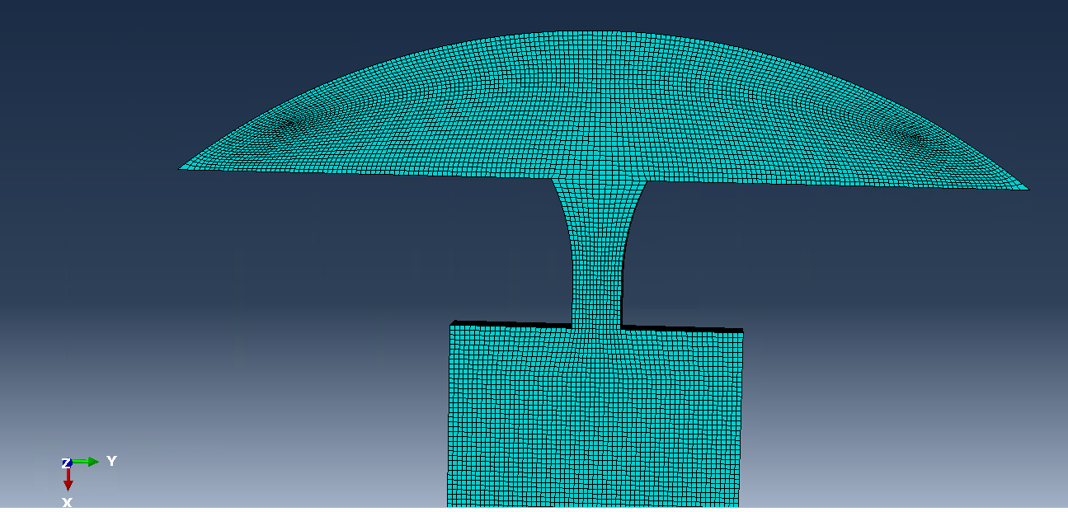The base code that is stored within the code on the GitHub uses cantilevers of the following design:

With this design of cantilever, the current available methods are the following:

1. Standard static – This is used for modelling how a concentrated force acting on the centre of the cantilever paddle will deform the cantilever; thus, giving one the stiffness value of said point for that cantilever. Produces the displacement of the node that the force is applied on for a load of 1N in a .rpt file.
2. Frequency eigenmodes – Finds the first resonant frequency of the part and creates a .rpt file with this value
3. Direct dynamic – Writes the stress components in the top surface elements of the cantilever and the position of two nodes in the free end used to measure the angle of the free end to a .rpt file given in Coordinates, stress values and displacements.
4. Calibration of standard static – This is like the *standard static* method, however now the load is applied on three points along the cantilever axis along the paddle. Thus, outputting a predicted stiffness vs loading point location plot, and allowing one to predict where their experimental loading location could be. (Currently not working as intended as loads are applied simultaneously which we can implement if this method proves to be useful)

# Structure of the code

The following flowchart describes the MATLAB flow in which the code operates, with the **other** flowchart describing how the MethodFile.py should be constructed, and how it is run within ABAQUS.

