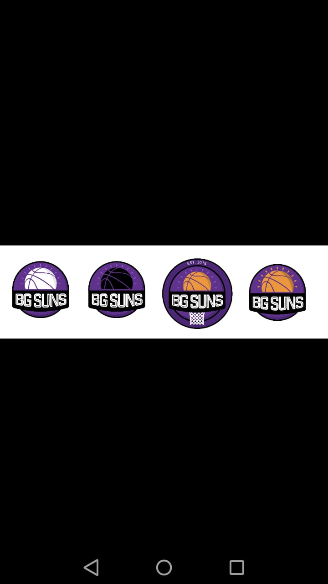

**BG Suns Club**

**Player Code of Conduct**

**By way of registration to play in the 2018/2019 basketball season, you are hereby agreeing and accepting to abide by the below code of conduct for the BG Suns Basketball Club.**

The purpose of the Player’s code of conduct is to set a standard of behavior required by each and every

Suns Basketball Club representative and to ensure all players enjoy their experience in playing basketball

for the BG Suns. This will ensure the improvement in basketball players and assist their team as a whole to improve.

All players must ensure that everyone understands and discuss in detail what it means to play as a team and abide by this code.

Every Suns Basketball player MUST at all times:

• Play for their own enjoyment (i.e. not just for coaches or parents)

• Be encouraging and supportive of all team mates (i.e. through positive, constructive encouragement

and communication.

• Be willing to listen and accept constructive criticism from their coaches to grow and develop as a player.

• Push themselves to improve by practicing hard with 100% commitment (i.e. by training with focus, effort and diligent listening skills).

• Push themselves by playing with 100% commitment to the team and as a team player (i.e. playing with focus, effort and sharing the ball around to work as a team).

• Play each game for the team’s benefit and work equally hard for yourself and for your team. (i.e. by playing unselfishly and not for their individual benefit).

• Play fair, and be a good sport. Play with composure and self-discipline and not will fully break the rules of the association. (i.e. by committing deliberate fouls).

• Control your temper.

• Accept that court time is earned through attitude and effort, and that coaches will do their best to ensure equal court time for such players.

• Respect referees and officials by accepting all calls graciously.

• Show good sportsmanship by interacting with referees, officials, opponents and opposition coaches

in a professional, good humored manner. (i.e. by offering a hand to help opponents up from the floor after a foul is given and by shaking the hands of the opposition players at the end of each game. (with eye contact)

• Treat all players as you would like to be treated.

• Respect all the facilities that the Suns Basketball uses by not damaging basketball venues and equipment (i.e. floors, balls, lights and rings)

• Respect the rights, dignity and worth of every player.

• Most importantly have fun!!! Set your own goals and achievements for the year; communicate with your coach and player liaison as much as you can.

• ENJOY!!!!

**Basketball is a recreational activity for enjoyment, teamwork and health.**

A breach of the Suns Basketball Club’s Code of Conduct agreement may result in disciplinary action by the Coach (following approval by the Suns committee).

In the matter of a serious offence by any player, coach or parent, individuals may be liable to referral of their conduct and the consequences may include:

• Omission (short-term) or suspension (medium-term) from playing for the team.

• Permanent de-registration from the Suns Basketball Club

• A fine imposed at the discretion of the Suns Basketball Club.

Ultimately, whether you are representing the Suns Basketball Club as a coach, player, parent or legal guardian, your aim should be to always conduct yourself in a way that ensures the enjoyment of every player in a safe environment.

Remember: -

**The depth of the commitment of team members to work together effectively to accomplish the goals of the team is a critical factor in team success.**

**Registration and Fees**

* All players are required to complete the Club’s registration process prior to the   
  commencement of each season.
* All players are required to pay the prescribed Membership Fees each season, by the due date.
* Membership Fees are due prior to the commencement of the new season, or as   
  notified by the Club.
* A player who fails to pay the required Membership Fees by the due date will be   
  suspended from participating with the team (including training) until such payment   
  is made.
* Any player that is injured for more than 2 months, pending medical evidence will be allowed to ‘freeze’ their monthly subs until they are fit enough to play.
* If a player has their subs ‘frozen’ they must pay the sub closest to the month before or the next month (i.e., if player is eligible to play on the 10th of the month, they will have to pay for that particular month. However, if a player can play on a day past mid-month, they will be required to start subs immediately from the following month and also be eligible for training fees as highlighted further down).

**Social Media**

* The club will record take photographs and videos of games and training sessions for club social media purposes and to aid team training sessions as well as player development initiatives. Find the BG SUNS…

**Club Board Structure**

|  |  |  |  |  |  |  |  |
| --- | --- | --- | --- | --- | --- | --- | --- |
| **Chairman** | | Peter Atkinson | | **General Manager** | | Archibald Boka | |
| **Treasurer** | Craig Harvey | | **Secretary** | Mutsa Mukuze | **Lay Member** | | James Morley |
| **Coach** | Stuart Mills | | | **Coach** | *Recruiting* | | |
| **Financial liaison** | Enrico Ponzio | | **Player Liaison** | TBC | **Captain** | | Archibald Boka |

|  |  |  |  |  |
| --- | --- | --- | --- | --- |
| **Affiliated qualified referees** | Steve Hunt | Pete Mills | **Training referee** | *Recruiting* |

|  |  |  |  |  |
| --- | --- | --- | --- | --- |
| **Table officials** | Gabriella Norman | *Recruiting* | Matt Gough | *Recruiting* |

|  |  |  |  |  |
| --- | --- | --- | --- | --- |
| **Media team** | *Recruiting* | *Recruiting* | Keith | *Recruiting* |

**Basketball England Registration instructions**

Please complete registration form on the Basketball England website

Basketball England website >> Log In >> Sign Up

<https://membership.basketballengland.co.uk/Account/SignUp>

Proceed to checkout and select Club To Pay

Club CA code: CA44328

Verify your account via the email sent to you from Basketball England

You will be lent a BG SUNS kit. Take a clear front facing picture (white background),

e.g.



Log out then back into account (link below) using registration number Basketball England email you and upload photo in the Eligibility tab

Basketball England website >> Log In >> Log In >> Eligibility

<https://membership.basketballengland.co.uk/>

Once registration complete; email club secretary completed registration form.

Once your profile has been verified by Basketball England (typically 2-3 working days), log in to your account and download your membership card accessible via the Eligibility tab. Email Membership Card to the club secretary who will ensure your credentials are readily available for checks by league fixture referees pre-game. Alternatively, please download and ensure copy (digital / paper) is available for checks pre-game.

|  |  |  |  |  |
| --- | --- | --- | --- | --- |
| **Surname:** |  | **Preferred Nickname:** |  | |
| Kit numbers NOT available | 0, 1, 2, 3, 4, 7, 8, 9, 10, 12, 23, 28, 47 | | **Preferred Kit number #:** |  |

**Preferred position (please mark with an ‘x’)**

|  |  |  |  |  |  |  |  |  |  |
| --- | --- | --- | --- | --- | --- | --- | --- | --- | --- |
| Point Guard |  | Shooting Guard | X | Small Forward |  | Power Forward |  | Centre |  |

**Further development (please mark other interests with an ‘x’)**

|  |  |  |  |  |  |  |  |  |  |
| --- | --- | --- | --- | --- | --- | --- | --- | --- | --- |
| Table officiating |  | Refereeing |  | Coaching |  | Basic First Aid |  |  |  |

**Kit SHIRT size (please mark with an ‘x’)**

|  |  |  |  |  |  |  |  |  |  |
| --- | --- | --- | --- | --- | --- | --- | --- | --- | --- |
| Small |  | Medium |  | Large |  | XL |  | 2XL |  |

**Kit SHORT size (please mark with an ‘x’)**

|  |  |  |  |  |  |  |  |  |  |
| --- | --- | --- | --- | --- | --- | --- | --- | --- | --- |
| Small |  | Medium |  | Large |  | XL |  | 2XL |  |

**Compression top size (please mark with an ‘x’)**

|  |  |  |  |  |  |  |  |  |  |
| --- | --- | --- | --- | --- | --- | --- | --- | --- | --- |
| Small |  | Medium |  | Large |  | XL |  | 2XL |  |

**Shooting shirt size** **(please mark with an ‘x’)**

|  |  |  |  |  |  |  |  |  |  |
| --- | --- | --- | --- | --- | --- | --- | --- | --- | --- |
| Small |  | Medium |  | Large |  | XL |  | 2XL |  |

**Hoody size** **(please mark with an ‘x’)**

|  |  |  |  |  |  |  |  |  |  |
| --- | --- | --- | --- | --- | --- | --- | --- | --- | --- |
| Small |  | Medium |  | Large |  | XL |  | 2XL |  |

**Track suit size** **(please mark with an ‘x’)**

|  |  |  |  |  |  |  |  |  |  |
| --- | --- | --- | --- | --- | --- | --- | --- | --- | --- |
| Small |  | Medium |  | Large |  | XL |  | 2XL |  |

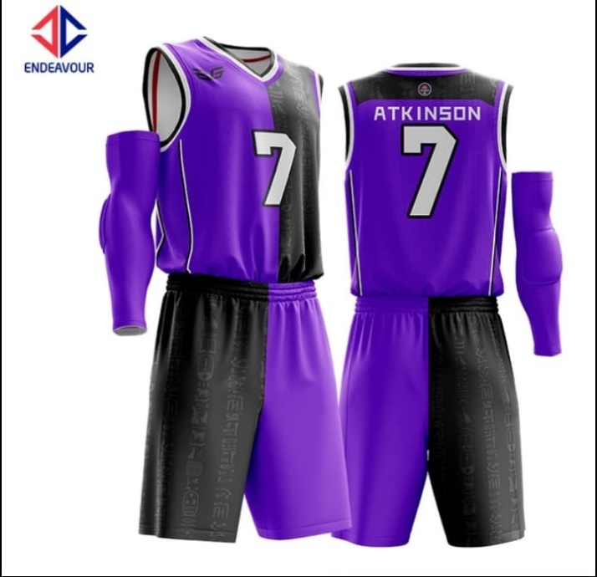

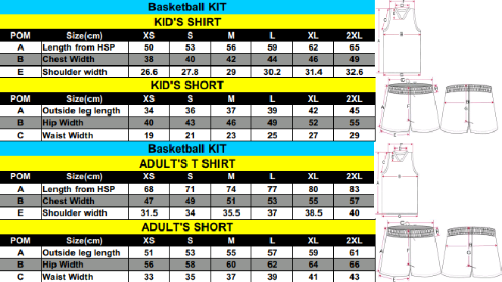

**Optional extrals**

|  |  |  |  |  |  |  |  |  |  |
| --- | --- | --- | --- | --- | --- | --- | --- | --- | --- |
| **Compression top** | | **Shooting shirt** | | **Hoody** | | **Track suit** | |  | |
| **£** | | **£** | | **£** | | **£** | | **£** | |
| **Y / N** |  | **Y / N** |  | **Y / N** |  | **Y / N** |  | **Y / N** |  |

|  |  |  |  |  |
| --- | --- | --- | --- | --- |
| **Molten Ball** | **2L Water Bottle** | **Ball bag** |  |  |
| **£** | **£** | **£** | **£** | **£** |
| #: | #: | #: | #: | #: |

**Rookie**

|  |  |  |  |  |  |
| --- | --- | --- | --- | --- | --- |
| **First name** |  | **Surname** |  | **Nationality** |  |

|  |  |  |  |
| --- | --- | --- | --- |
| **D.O.B (day.mon.year)** |  | **Address** |  |

|  |  |  |  |
| --- | --- | --- | --- |
| **Email** |  | **Mobile number** |  |

**Your mama!**

|  |  |  |  |
| --- | --- | --- | --- |
| **Emergency Contact Name** |  | **Mobile number** | **Nationality** |

**Commitment type (Purple or Black, please mark with an ‘x’)**

|  |  |
| --- | --- |
| **Training only** |  |

Regular season average: 3+ training sessions a month, eligible for cup, friendly and summer league games

 £20 / month Winter season payable from 01 September to 01 March

£20 / month Summer season payable from 01 April to 01 July

£15 / year Basketball England registration payable pre first eligible game

£5/ year DBA League registration payable pre first eligible cup / summer league game

£15 / year Player insurance payable pre first eligible cup game

|  |  |
| --- | --- |
| **Training & Games** |  |

 Regular season average: 3+ training sessions a month and 3+ game a month

£35 / month Winter season payable from 01 September to 01 March

 £35 / month Summer season payable from 01 April to 01 July

£15 / year Basketball England registration payable pre first eligible game

£5 / year League registration payable pre first game (per registered league DBA / SABA)

£15 / year Player insurance payable pre first game (per registered league DBA / SABA)

£25 / kit Payable pre first game

**Bank details** (*use name as direct debt reference*)

|  |  |  |  |  |  |  |  |
| --- | --- | --- | --- | --- | --- | --- | --- |
| **Bank Name** | HSBC | **Account Name** | BG SUNS | **Sort Code** | 40-13-07 | **Account number** | 026 577 24 |

Upon signing you are agreeing to the terms and conditions laid out above and in the player code of conduct and registration/fees section.

|  |  |  |  |
| --- | --- | --- | --- |
| **Signed** |  | **Date (day.mon.year)** |  |

Print name, date & email back to [BGSUNS@hotmail.com](mailto:BGSUNS@hotmail.com) for the attention of club secretary, Mutsa. The player liaison, has a unique set of skills, she will look for you, she will find you, you will sign the form.