First Note
This is only partila test. Your job is a big disaster. I stopped teh test because you didn’y make what I asked insid eteh docuemnt. Pheraps you must work more seriously and you must do the rea changes wrote inside the application and make all verify to applicate the changes for all application. After your change a Iwill do a complete test. When all is ok, please send me the note made, not made. DO I will do a complete test.

- Did solve or not????
You must change my guide for AI and solve the problem that TXT don’t import the images becaus eI must create the questions using TXT to read them. And add inside the dahbard that guide

- Didn’t solve the web show for some second not correct colors of buttons and logo. So there are some bugs stil regard databse and applications,
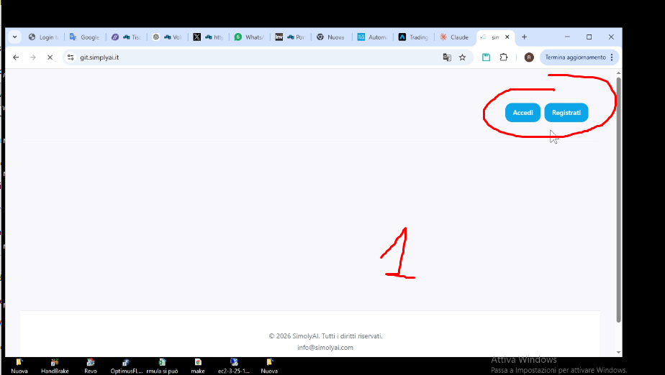
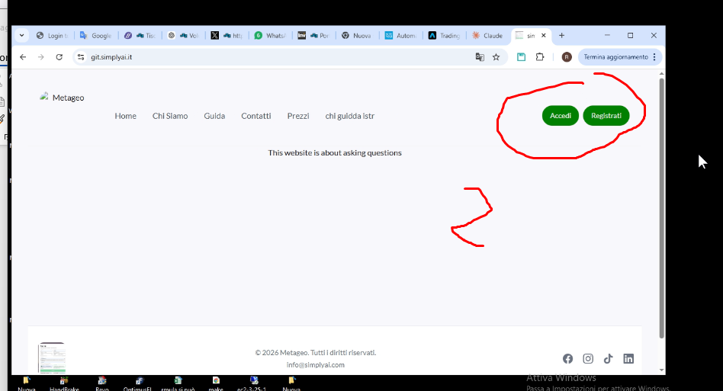

Ok but the logo is too small in web pages, but too big in dashboard
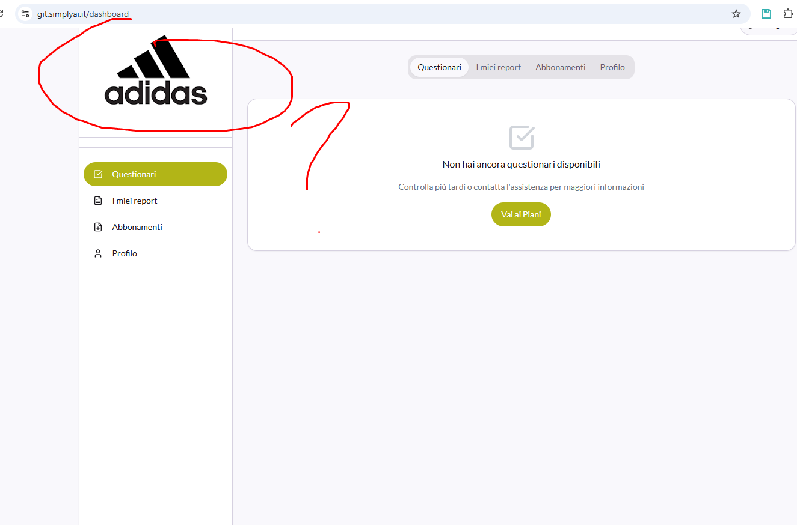
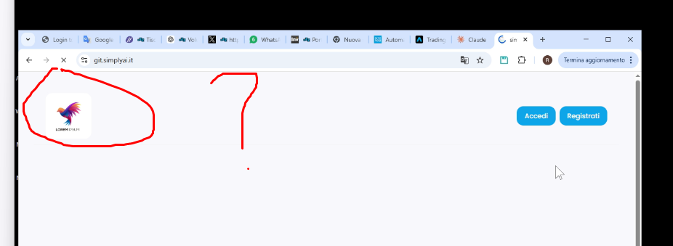

And why insidee the dsahboard don’t show the same logo of all pages and didn’t delate the text????

ok
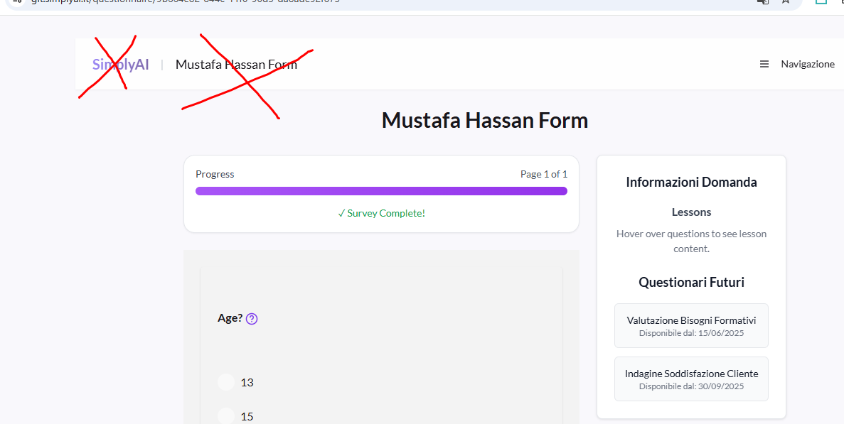

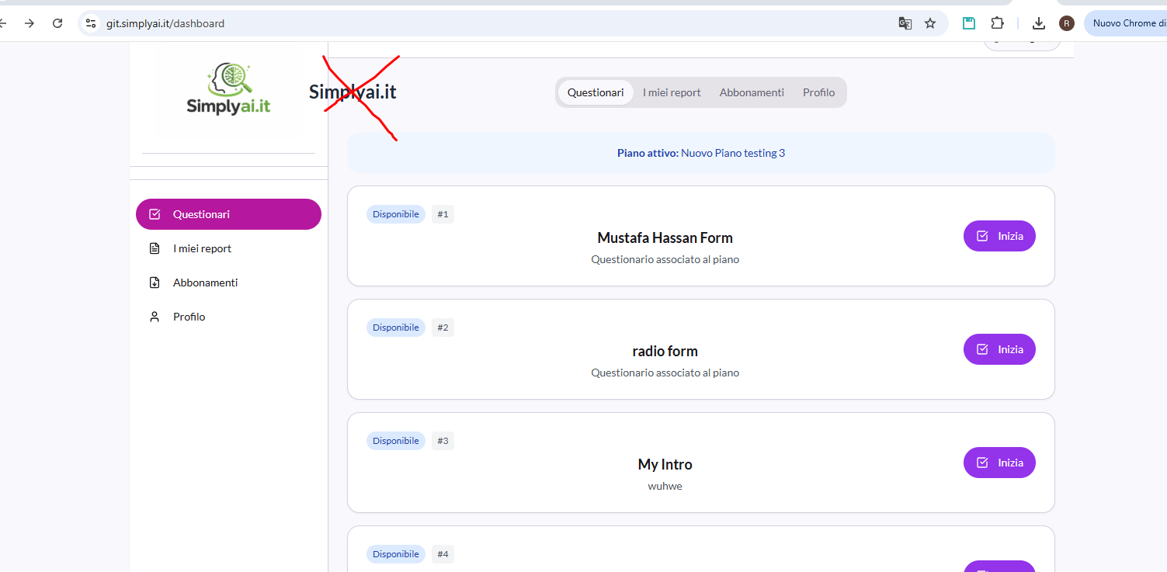

Ok And where is the the old information of contact?? 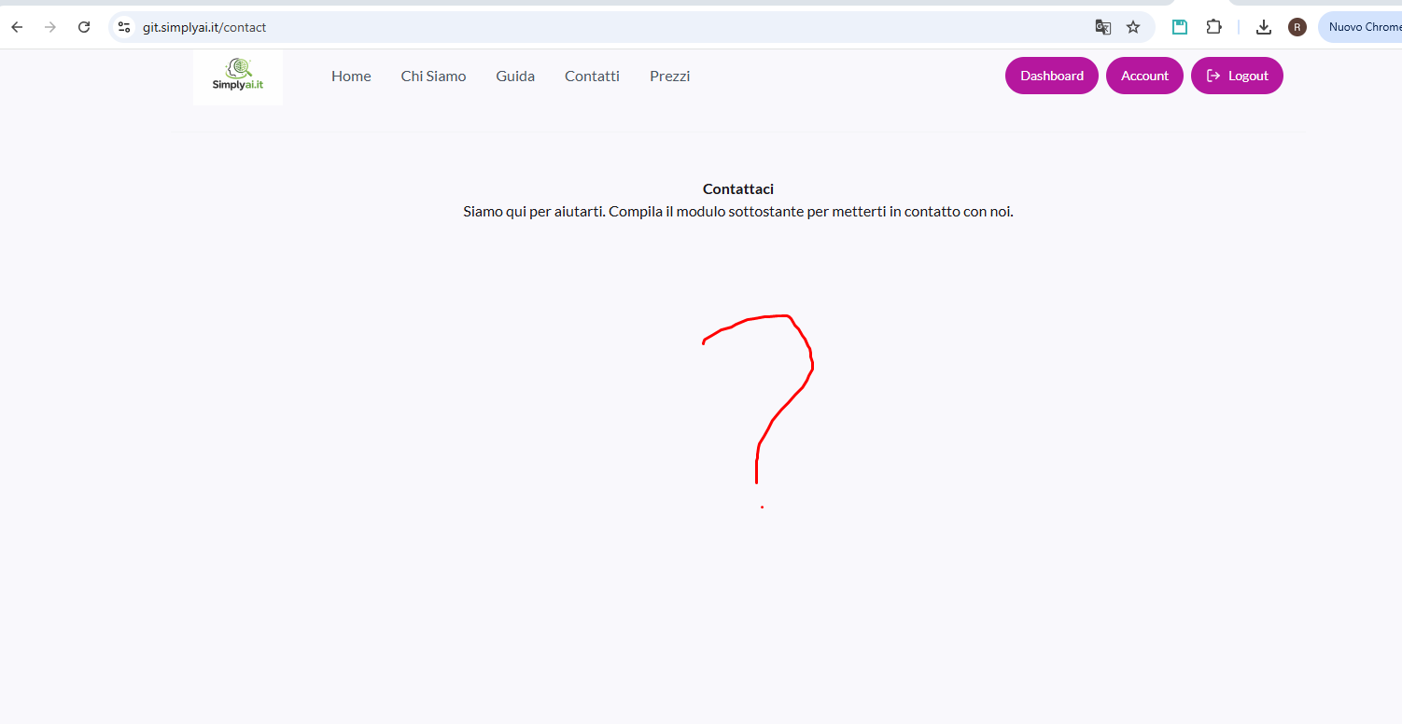 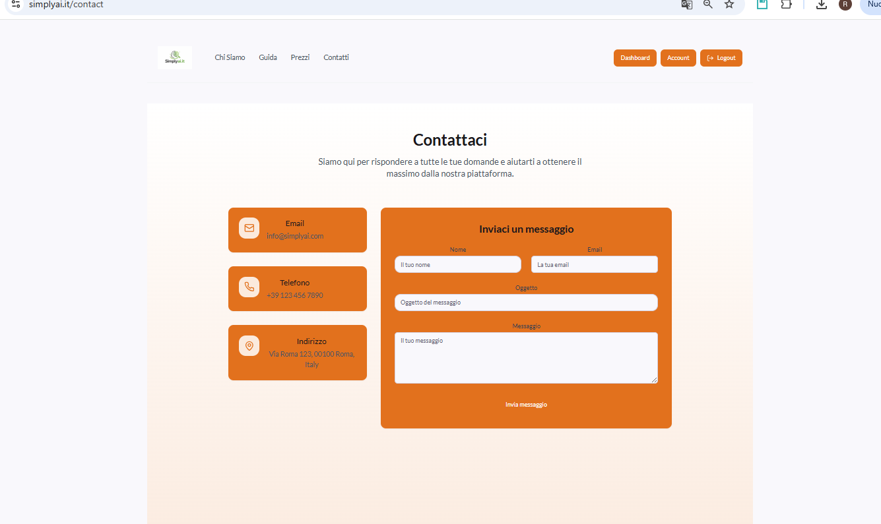

- Why the footer work only for home page. It must work for all pages. I already wrote this.

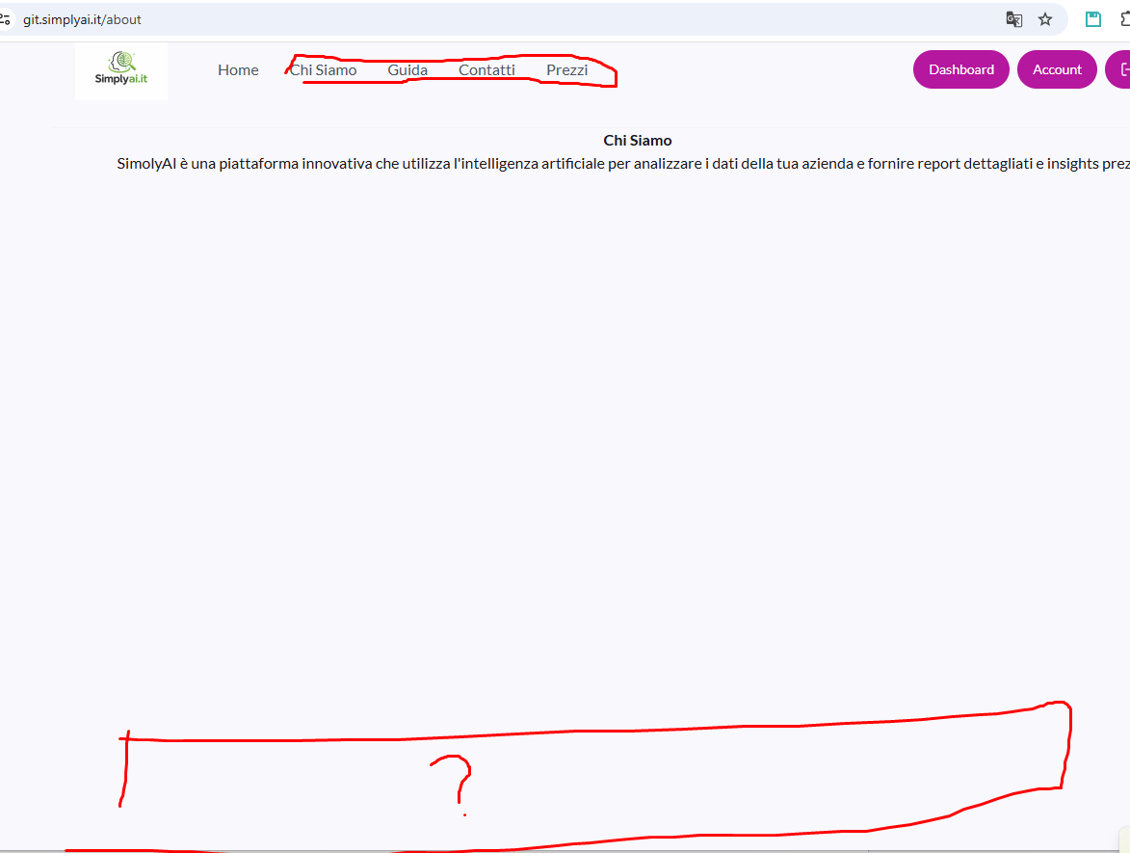
And footer of dahboard????
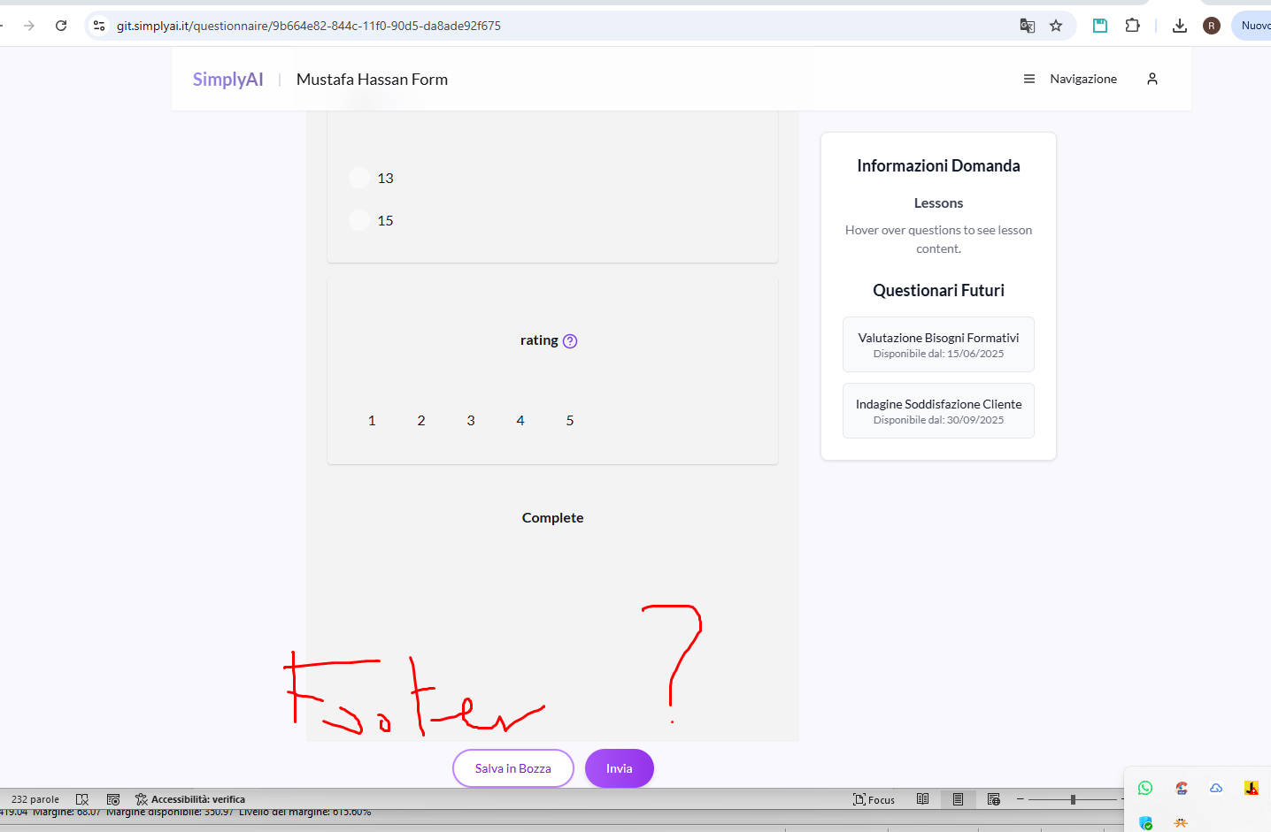

You didn’t understand what means sections and columns. Now add a text. Please see wordpress or my simplyai.it
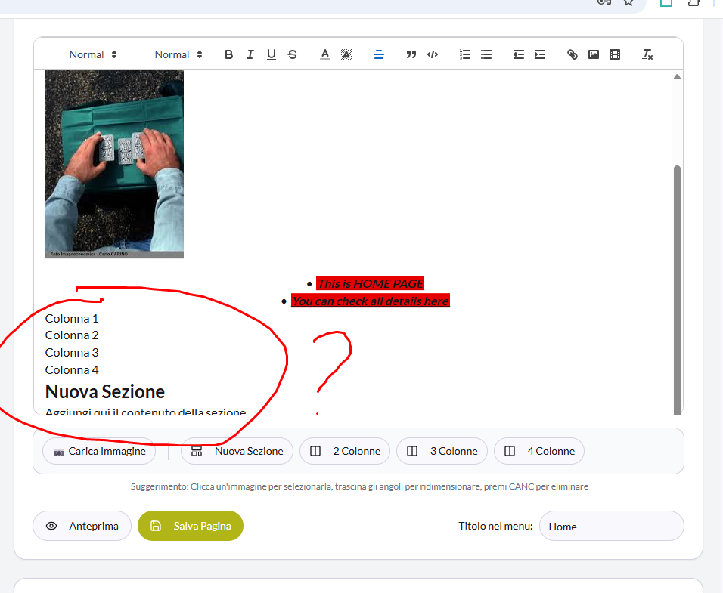
- Why the editor don’t have sections and columns how the initial editor. I explained many way this.

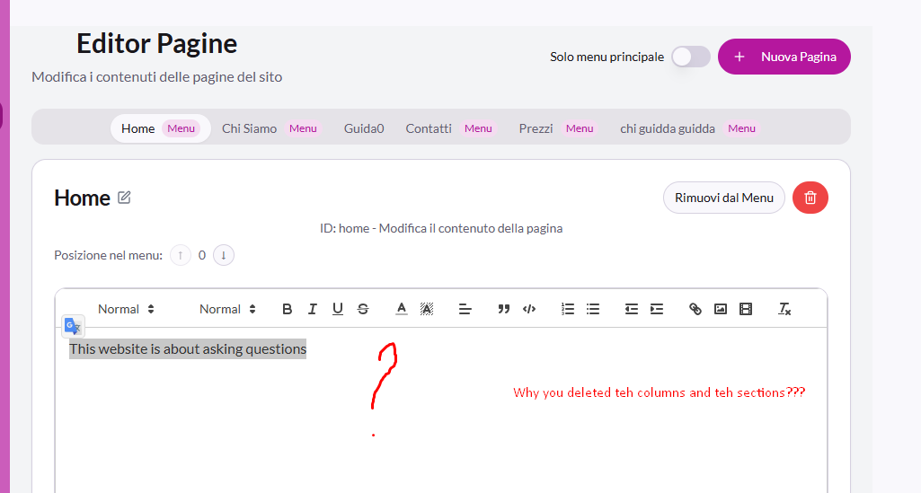

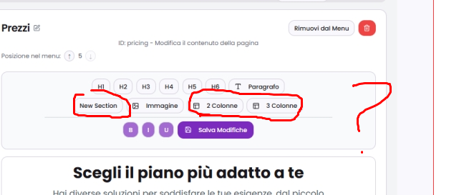

You didn’t make the editor of report page
And why you ddidn’t add the editor inside page report editor??
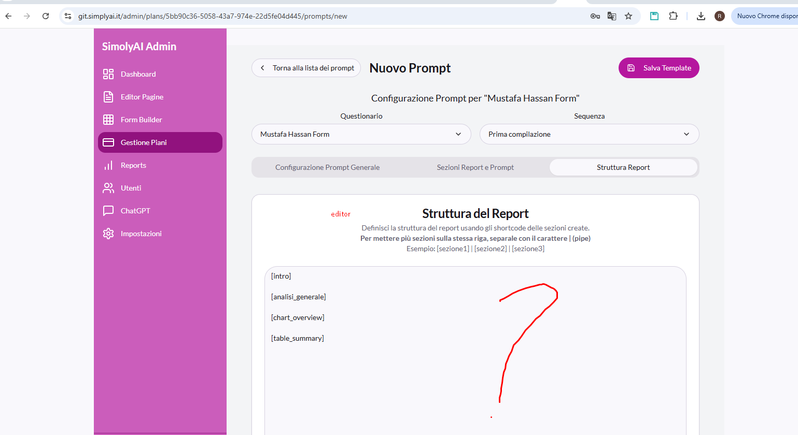

- Dont work still. The information are not correct. For example there are many user and the report show 0. And don’t show the charts.
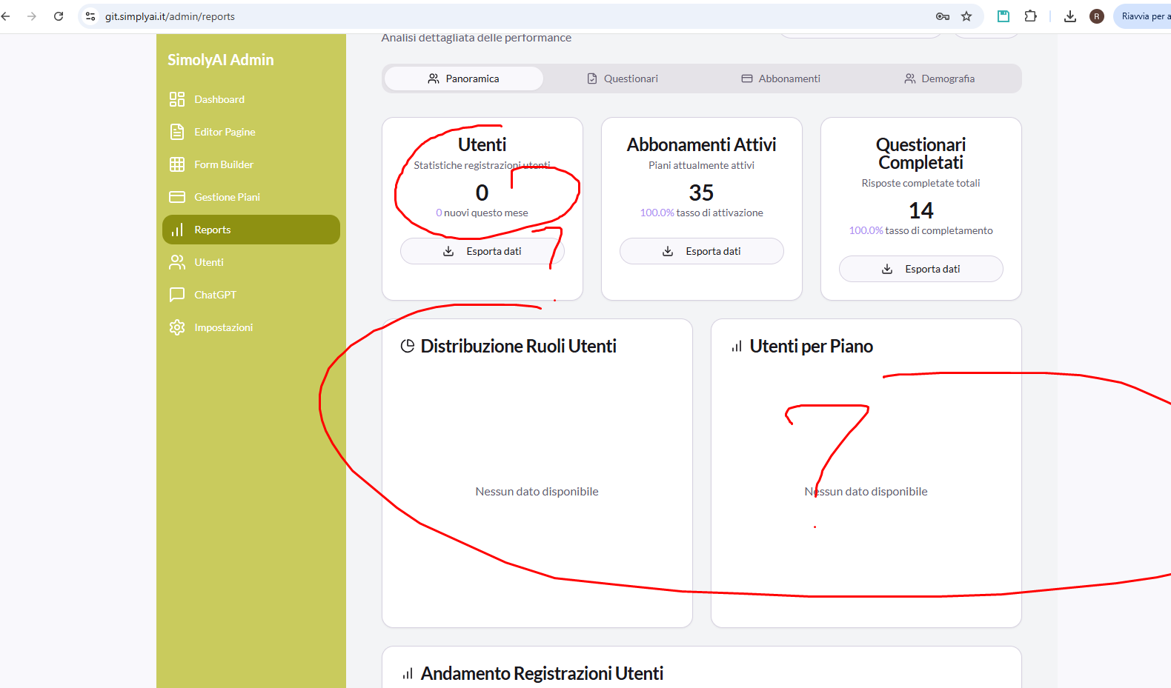 Don’t work more the page Report. Why??

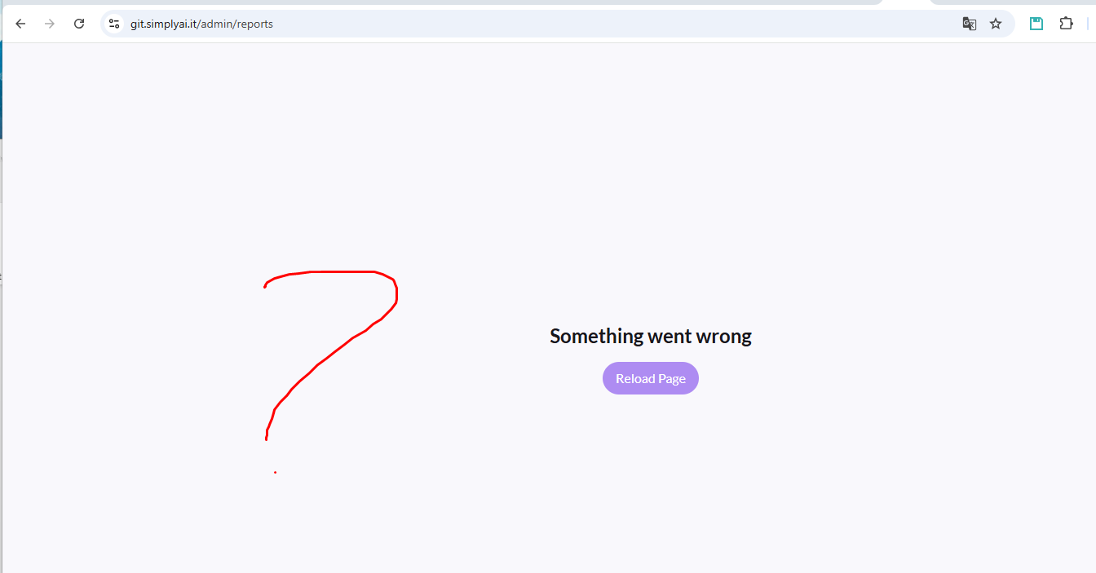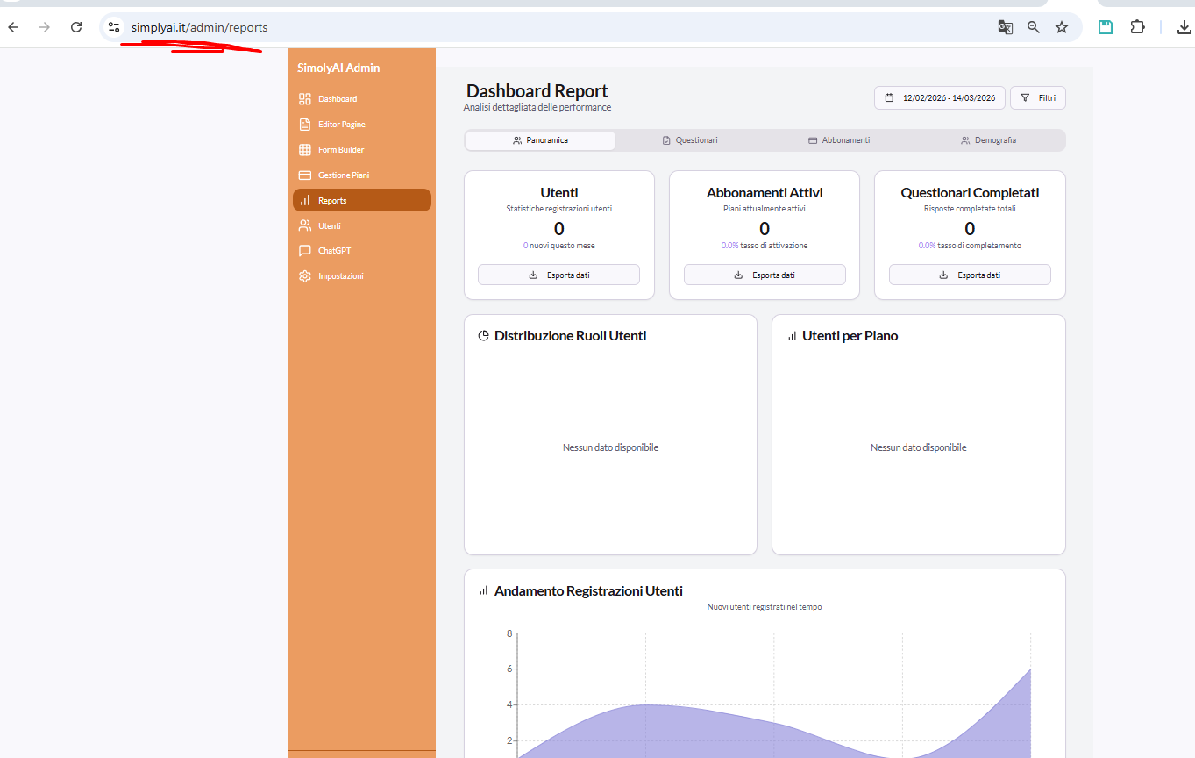
- Don’t work still. Also if I add the information show you assked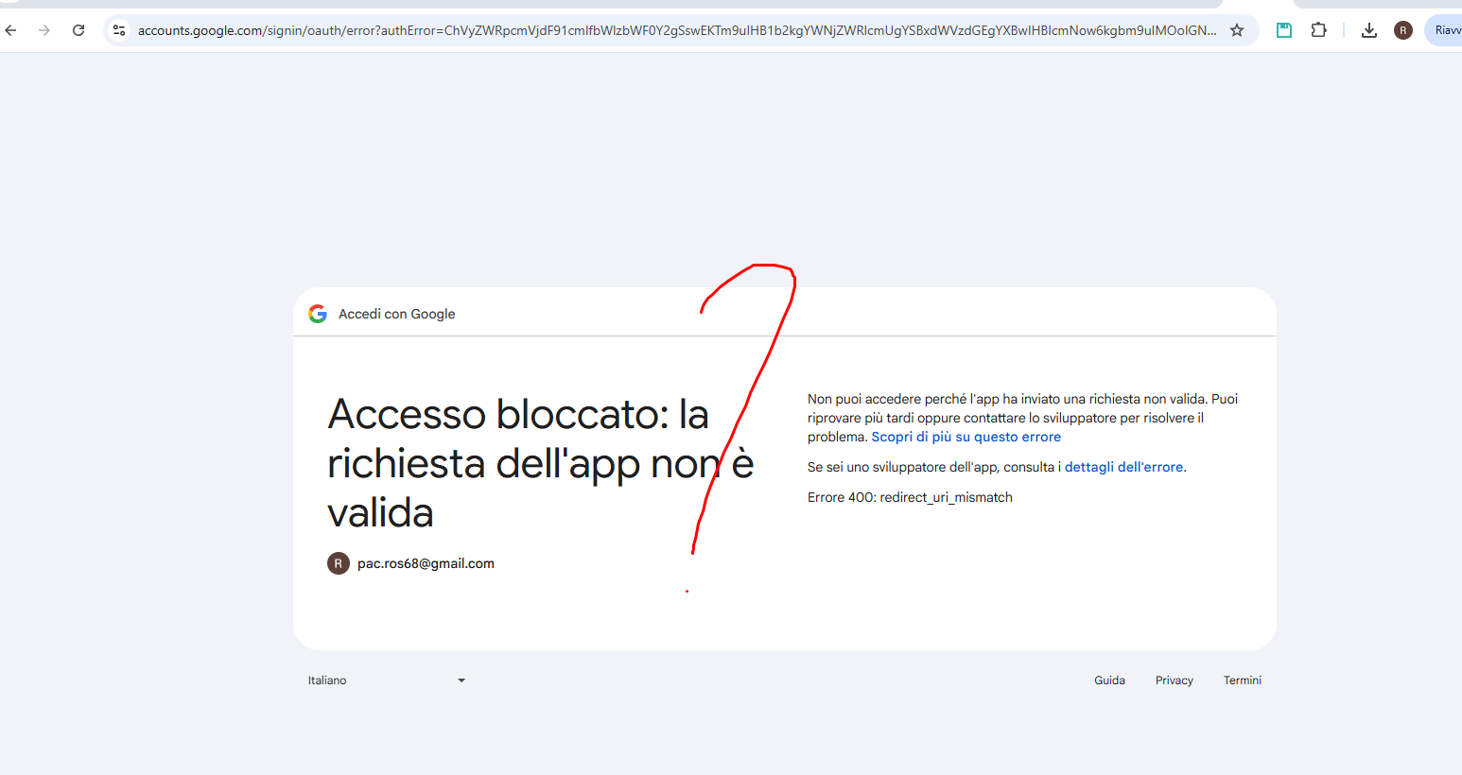
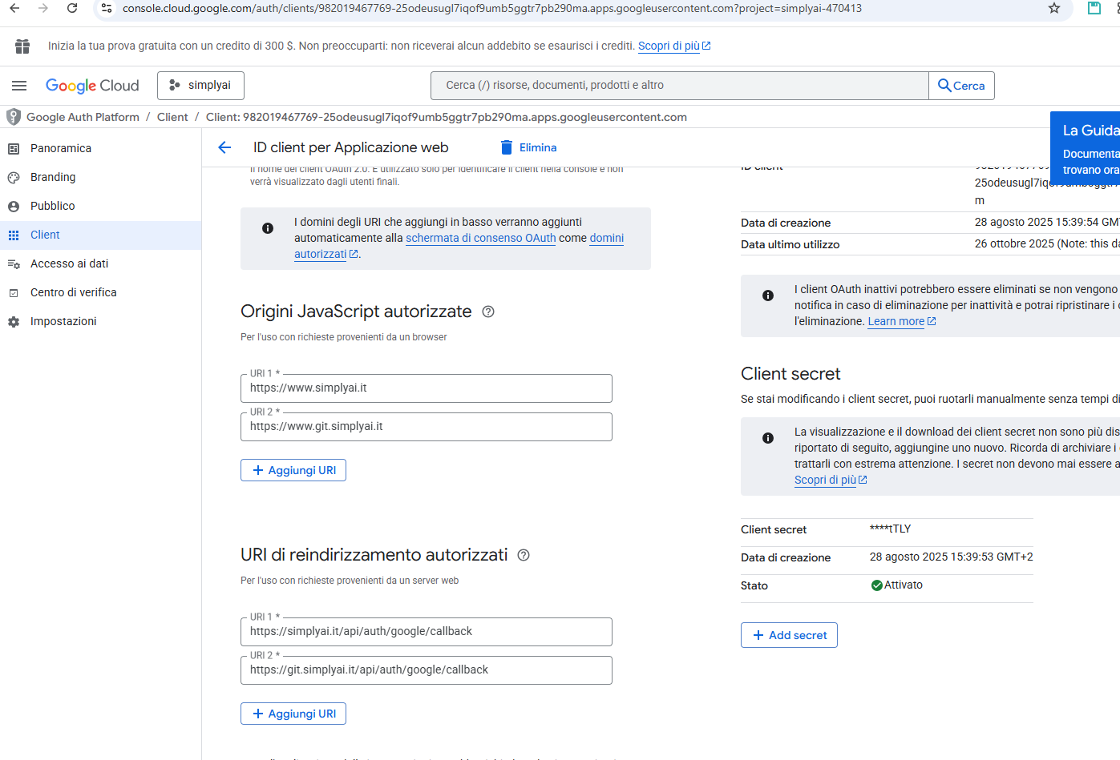
Don’t work registartion and login using google and facebook

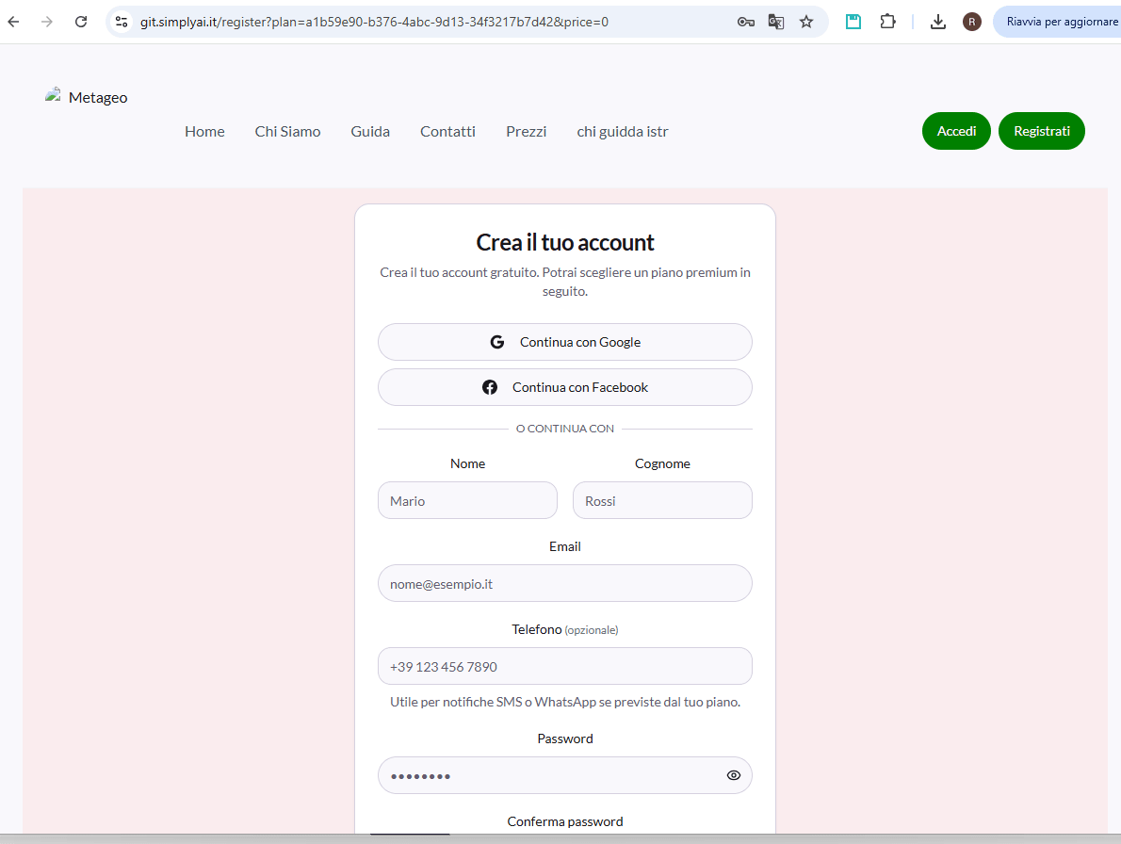

Don’t solved
- Why the import form builder page is different from original page??
(simplyai.it)

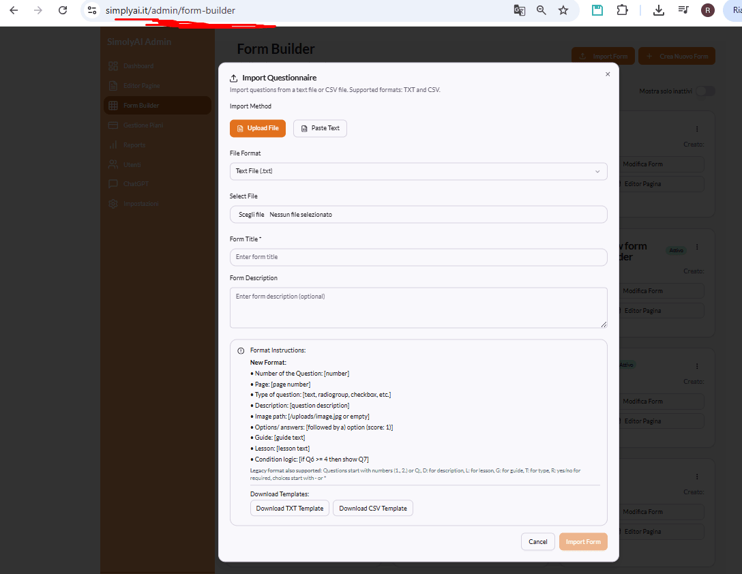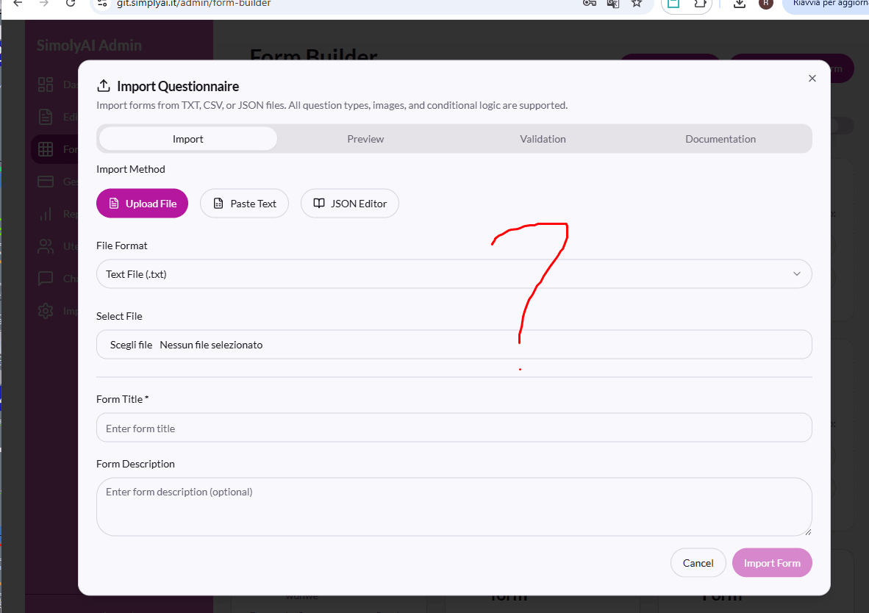

- The favicon don’t work
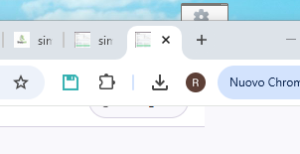

- Don’t work still. The colors have still problems
These the setting….
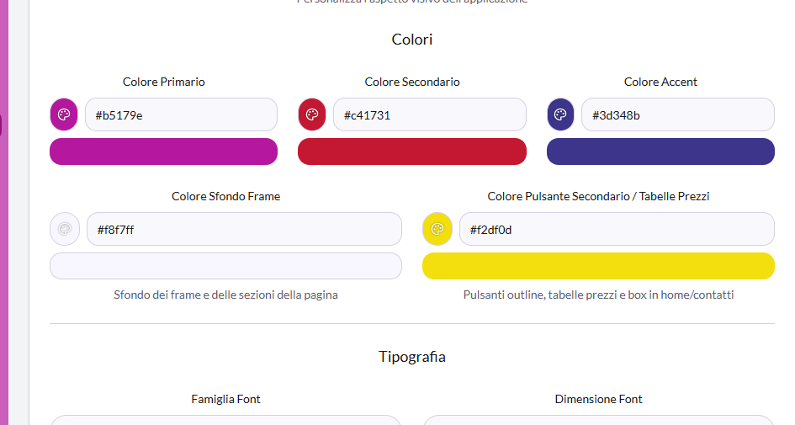
I saw only two colors of 4 colors. And where are the different colors of button of free plan (read my document). Wheer are the yellow and the ble???
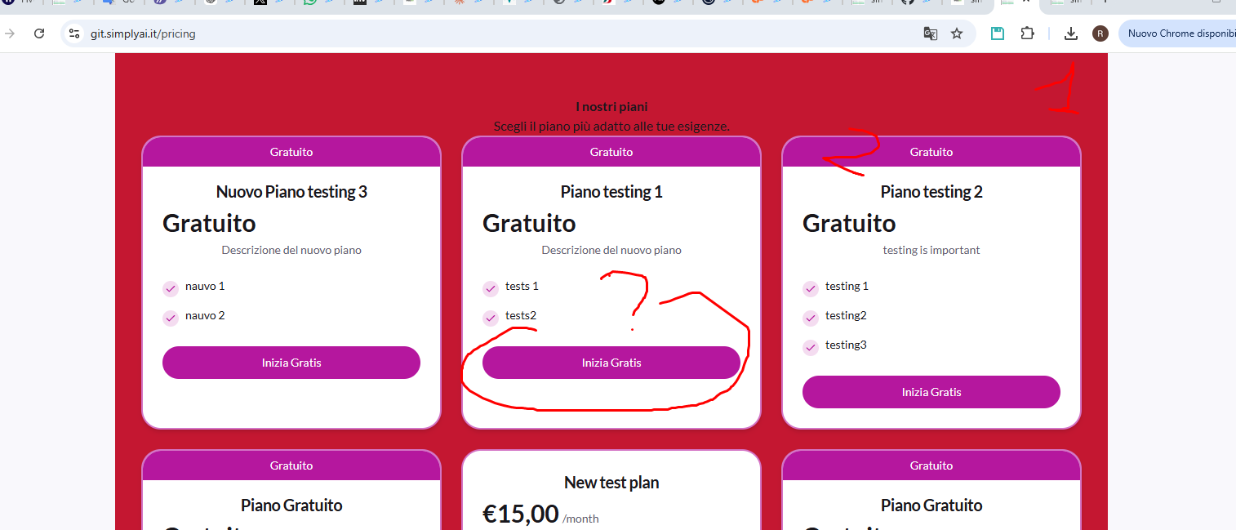

You didn’t solve thre colors that regard the questionnaires and report (survey.js)
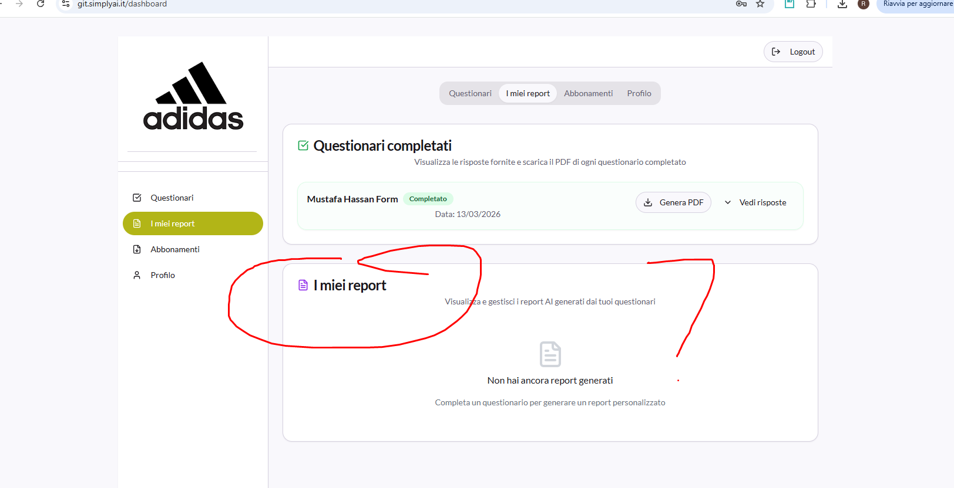
Why there are are in all page of form builder an other colors (i already told this) 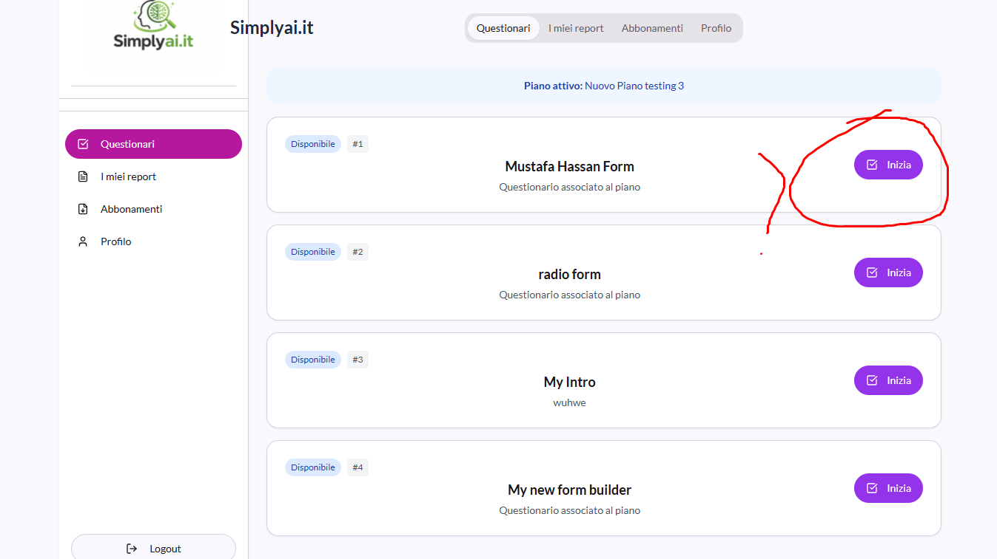

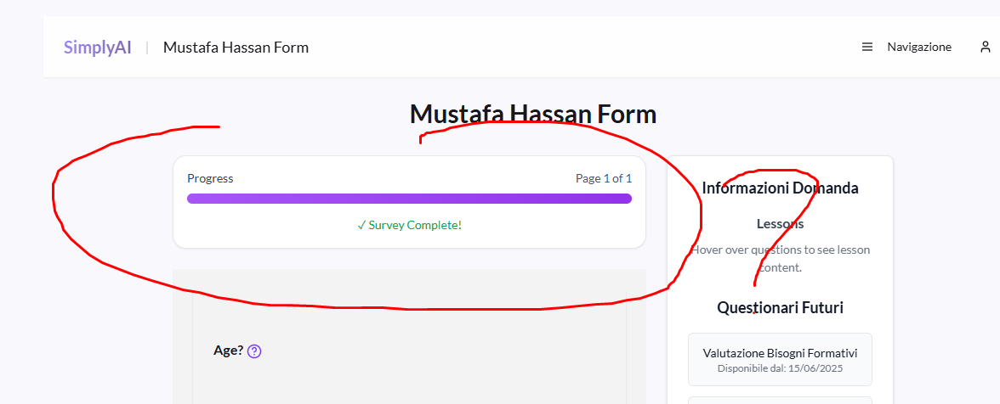
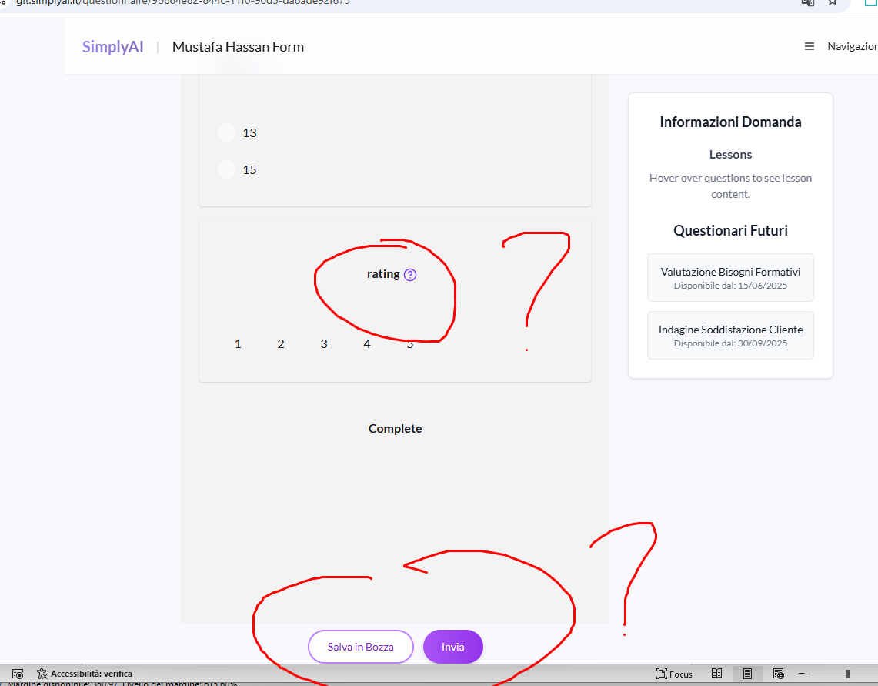

- Ok Why some box use a style and other an otehr style?? You must veridy all button and box of all application 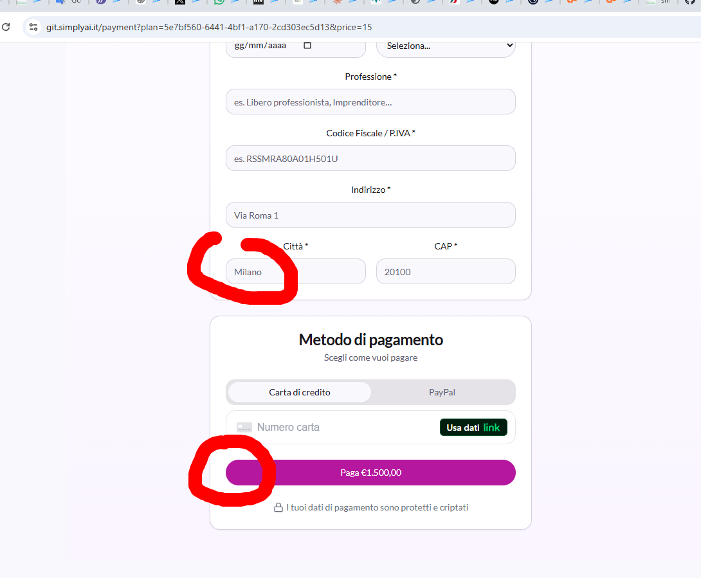

- I saw that you ddin’t make the point 3 (chatgpt) and otehr points of document

My email: pac.ros68@gmail.com

