TRAVEL ORDER
(No. [AUTO-GENERATED NO.])
DF: [Date Filed]

Name: | [Employee Full Name] | Salary: | [Salary Grade / Amount]
Position: | [Position/Designation] | Div./Sec./Unit: | [Division/Section/Unit]
Departure Date: | [MMM DD, YYYY] | Official Station: | [Office/Station]
 |  | Arrival Date: | [MMM DD, YYYY]

Destination: [Destination Office/Place]

Purpose of Travel:
[Full purpose/description of official travel]

Per Diems/Expense Allowed: ______________________________________________
Company/Assistant/Laborers: ______________________________________________
Appropriations to which travel should be charged: ______________________________________________
Remarks of Special Instructions: ______________________________________________

CERTIFICATION
This is to certify that the travel is necessary and is connected with the functions of the official/employee and this Div/Sec./Units.

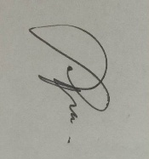  Recommending Approval:  DIVISION CHIEF’s name  [Name of Section/Division Chief]  [Position/Title] | 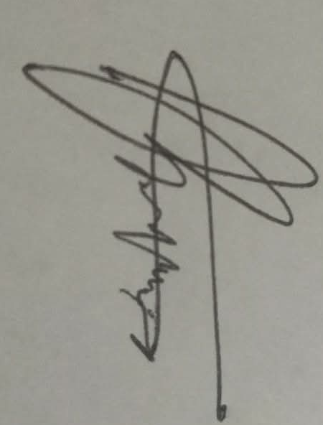  Approved by:  HEAD OF PENRO’s name  [Name of Head of PENRO/OIC]  [Position/Title]

DA: [Date Approved]

AUTHORIZATION
I hereby authorize the account to deduct the corresponding amount of the unliquidated cash advance from my succeeding salary for my failure to liquidate this travel within the prescribed thirty-day period upon return to my permanent official station pursuant to item 5.1.3 COA Circular 97-002 dated February 10, 1997, and Sec. 16 EO No. 248 dated May 29, 1995.
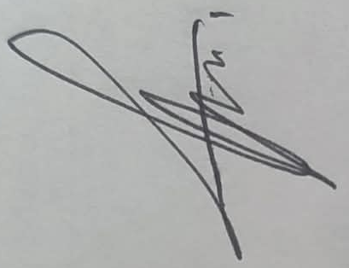

[EMPLOYEE FULL NAME]

This is an official travel order approved electronically and generated from the [SYSTEM NAME] Travel Authority Processing System (TAPS). No original signature is required.

