Radio Interferometric Positioning Java Tool Documentation

This documentation assumes that a number of motes are uploaded with the RipsMote application, and one mote is running the TOSBase application. Also the java code is compiled and running. See ‘compilingInstructin.txt’ for the compilation instructions. We use some notation from our Sensys’05 paper on RIPS throughout this documentation. Also it is assumed that the motes running RipsMote application have properly initialized routing engine. In particular we use Flooding Routing (located in code/tinyos-1.x/tos/lib/FloodRouting) with Gradient Policy which requires initialization of the gradient field in the network to work across multiple hops (see GradientPolicy.txt).

The main java application which is used is RipsDisplay.java. This application is used to control different parameters on the motes running RipsMote application, it sends out commands to start rips measurements on the motes and gathers the ranging data received from the motes. The same application is used to calculate the Dabcd ranges for a pair of receivers, and to localize the motes from the Dabcd ranges.

Step by step description of localization

Getting information on the participating motes:
The first step is to gather data about the motes that are present in network. This can be done by selecting the ‘MOTES tab’, right-clicking on the first line, and selecting ‘Query Motes’ from the list:
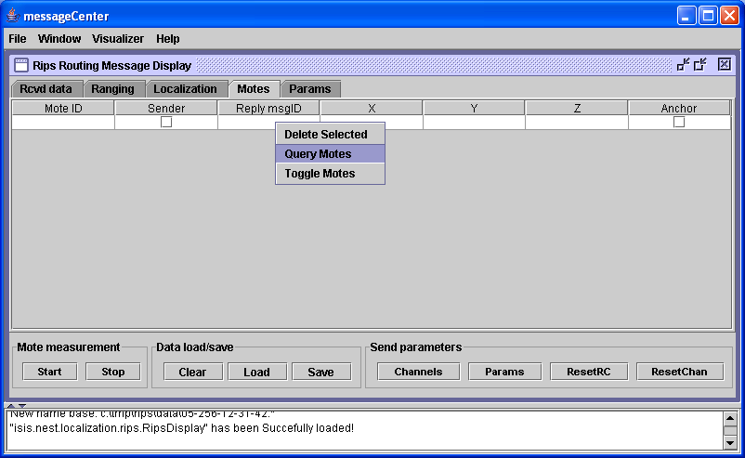

A short while after, entries with the mote id should start populating in the table (we call it a mote-list):
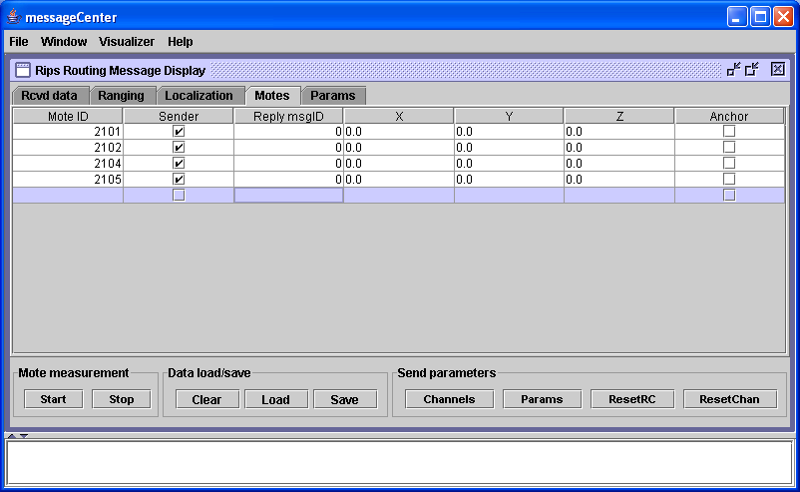

Motes tab allows us to specify X,Y,Z ground truth locations of each mote, and to specify the anchor motes for the localization evaluation purposes.

Starting the ranging measurement:
We can start measurements by clicking on the Start button in the Mote measurement window in the lower left part of the screen. We assume that the default settings are used: java creates a mote_pairs-list which is a list with all ordered pairs of the motes from mote-list; each of these mote pairs is used as a (‘master’, ‘assistant’) pair and defines a single Dabcd measurement round. Consequently, the whole measurement consists of $n*(n-1)/2$ rounds, if $n$ is the size of mote-list.

Receiving the ranging data from the motes:
For a single Dabcd measurement round, master and assistant produce an interference signal at 40 different radio channels which is received by multiple receivers. All receivers measure the frequency as well as the phase offset of this signal and report this information back to the base station. This data is shown in Rcvd data tab:
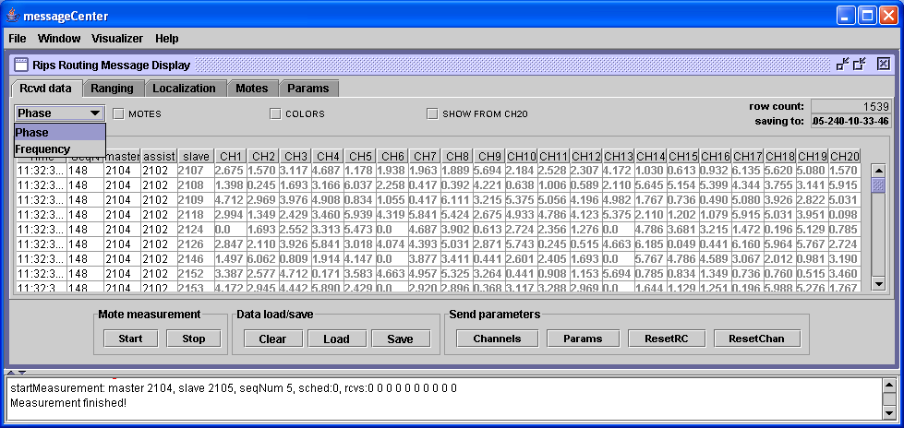

Each line in the Table contains data reported by a single receiver, for one master, assistant pair. We can either see channels 1 through 20 (as in the figure above), or channels 20 through 40, if we check the SHOW FROM CH20 check box. Also, we can either see the phase of the signal for each channel (as in the figure above), or the frequency of the signal, by choosing Frequency in the choice box in the upper left corner.

A single measurement round is time-bounded by a deadline (9 seconds by default). After this deadline passes, a new measurement is started which means that the next master, assistant pair is chosen from the mote-pairs-list. After the last pair was used, Measurement finished! message is printed out.

Calculating the ranges from the ranging data:
After each measurement round finishes, java will compute Dabcd ranges for all pairs of receivers that reported the data. This is done on background without any user interaction. Dabcd ranges are shown in Ranging tab:
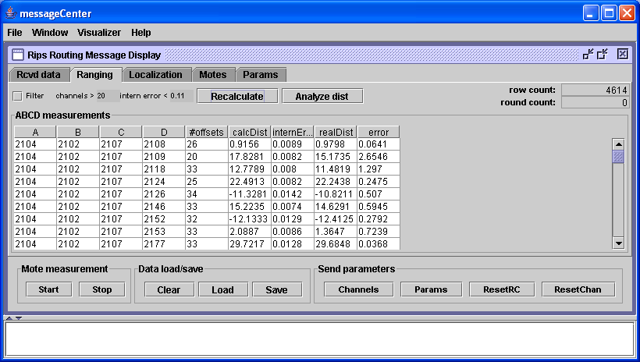

Here A stands for master, B for assistant, and C,D for the two receivers that reported the phase offsets and frequencies of the interference signal back to the base station. #offsets shows the size of intersection of radio channels where both receivers with good data for both receivers. calcDist shows the computed Dabcd distance from the phase offset measurements. InternErr shows the consistency of the data used to calculate Dabcd distance. realDist is the ground truth based Dabcd distance, and error is the absolute difference of calcDist and realDist. note, that realDist contains correct information, only if the ground truth positions were entered in Motes tab for the motes.

Only Dabcd distances which passed filtering are shown: the filtering can be done based on #channels and InternErr values and can be set through the GUI.

Localizing the motes:
Localization part needs to be invoked manually, after all measurements have finished and Dabcd ranges were calculated. We can select a set of motes that will act as anchors in Motes tab to have the GA solver compute absolute locations, or just compute the relative locations of the motes by not specifying any motes. The localization is started by clicking on the Start localization button in the Localization tab:
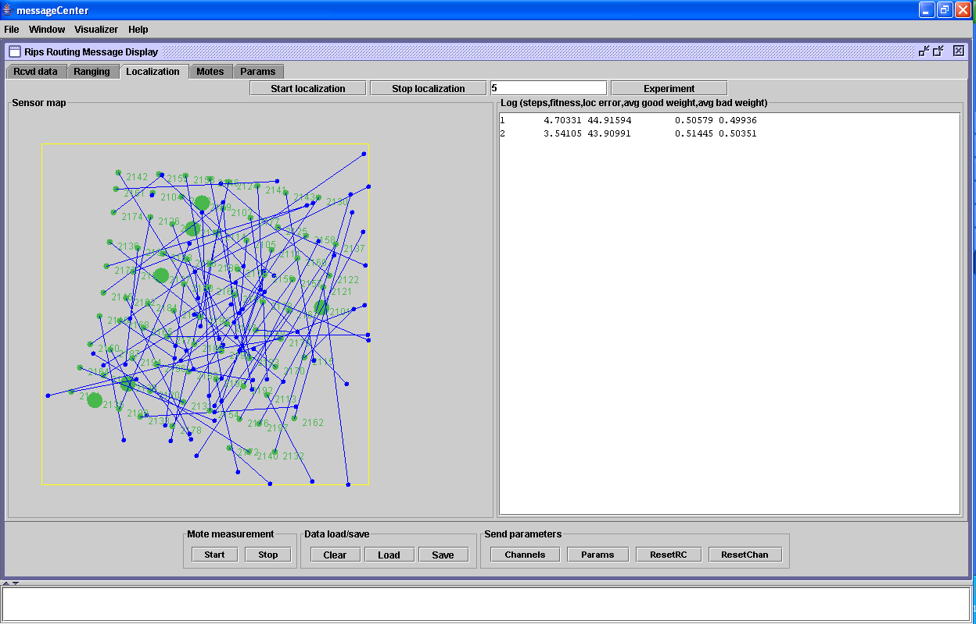

Based on the information from the Mote tab, the small green circles show the positions of the motes in the space with their IDs and the large green circles show the anchor motes. Based on the ongoing GA calculations, the small blue circles are the current calculated positions of the motes, and the blue line shows the error of the calculated location of a mote to its ground truth location. The log window on the right side shows the current average error of the locations of all the motes to the ground truth. Localization can be stopped by clicking on the Stop localization button.

Changing the measurement parameters:
Params tab can be used to specify different parameters of our java/TinyOS software. The most important parameters are:
Measurement time – specifies the deadline for a single measurement round to finish, this value should be increased if many receivers report data to the base station
Master power – specifies the TX power of the master, use smaller values (1) inside, larger values (16) outside
Assistant power – specifies the TX power of the assistant, use smaller values (1) inside, larger values (16) outside
Interference freq – specifies the value of interference frequency to which the master and assistant motes try to calibrate their radios
TS num hops – the receivers which are up to this many hops from the master will report back the data

If the parameters are changed, the actual values that are stored at the motes need to be synchronized with the java values. This can be done by clicking on the Params button in the bottom row of the buttons. The default values are shown:
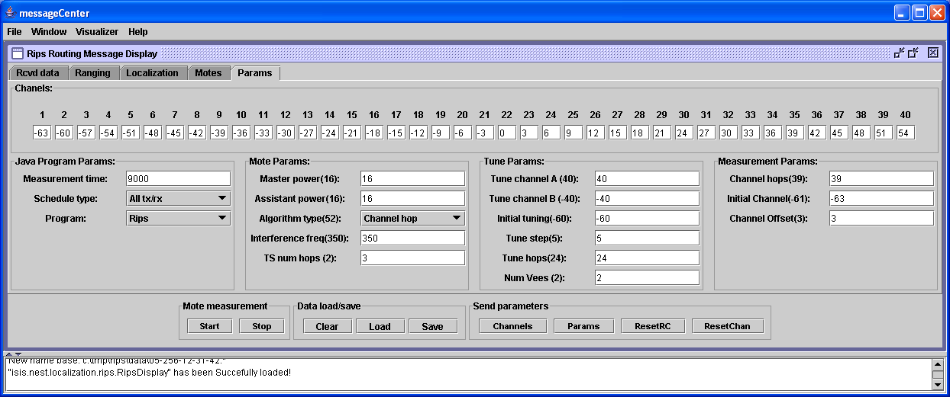

Loading and saving capability:
The measurements can be loaded and saved through the Load and Save buttons in the Data load/save window. We use a single directory for loading/saving which is hardwired to the java application: c:\tmp\rips\data. Each measurement is saved as a set of 4 files, which have a common file name (the date and time of the measurement) and differ only with the file extension (.freq, .phase, .pos, and .set extensions). The measurement can be loaded by clicking on any of these four files. Clear button will first save (!) and then clear the current measurements from the memory.

Scheduling options
Section 1 of this tutorial explained the localization process when scheduling all possible pairs of transmitters to become the master and assistant pairs, or in other words, using all ranging data available. This is not scalable for larger networks. However, much smaller amount of ranging data is required to calculate positions of the motes in theory. It is harder, in practice, to determine the right subset of the ranging data that is sufficient to solve the localization problem. We developed a scheduling algorithm that determines the proper set of transmitter pairs that yield the right subset of the ranging data.

The scheduling algorithm is executed before the localization algorithm and its output is pipelined into the localization algorithm. The following text describes, how we achieve this with our software tools.

Collecting the statistics on the motes’ connectivity
First, we need to gather radio connectivity statistics for all nodes in the network. This can be achieved through our GUI by selecting Scheduling in the Program choice box in Params tab. Now hitting the Start button will start the connectivity statistics collection process in the network. The process takes several minutes to complete and will result in motes sending their statistics data to the base station.

The connectivity statistics data are coming as routing messages to the base station and need to be recorded in some way, so that they can be later provided to our scheduling algorithm. We suggest to use the MessageTable application which is part of our MessageCenter tool suit. After the MessageTable is properly parameterized (as show in Figure below), it will automatically parse the incoming messages and store the data in the format as expected by our scheduling algorithm.
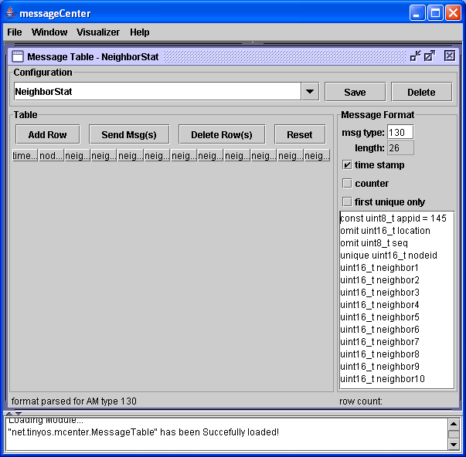

Running the scheduling algorithm
The input to the scheduling algorithm is a file, where each line provides connectivity data for a single mote. This file can be created using the information stored in the MessageTable described in the previous section by just copying all information from the message table (ctrl-a, ctrl-c works) and saving it in a file with .txt extension. We assume the file is saved as c:\tmp\rips\data\schedule.txt. The format of this file is:
time \t nodeID \t neighbor1 \t neighbor2 \t … \t neighbor10

The schedule.txt file is then loaded using our isis/nest/localization/rips/NeighborStatVis application by clicking on the Load Measurement button:
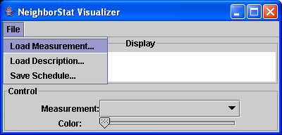

The connectivity statistics is loaded and shown in the screen, the schedule is computed and can be saved by clicking on the Save Schedule button into c:\tmp\rips\data\schedule.sch file:
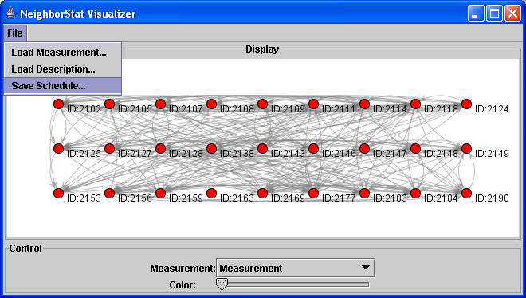

The schedule is a set of transmitter pairs followed by a list of up to 10 receivers. The important thing to note is that the synchronization with our main GUI assumes that the schedule file is stored as c:\tmp\rips\data\schedule.sch and should never be stored anywhere else.

Using the scheduled transmitter pairs
After the schedule was created and saved to the schedule.txt file, it can be used by our Rips Message Display tool. This is achieved by simply selecting the schedule option in the Schedule Type choice box in params tab. The value of Program choice box in Params tab needs to be returned back to Rips value. The Start button will started the collection of ranging data which will be guided by the schedule.sch file:
