Address CSV file convert using

https://people.sc.fsu.edu/~jburkardt/data/csv/csv.html (Addeessess.csv)

Converted by https://codebeautify.org/csv-to-sql-converter

Login to local host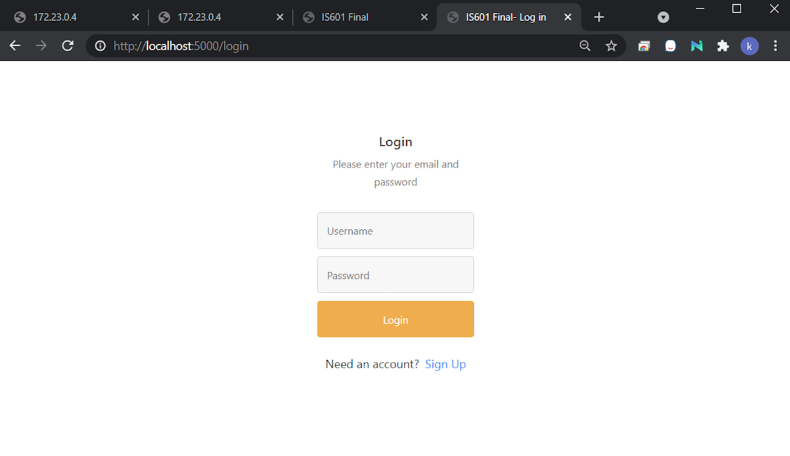

New User Registration

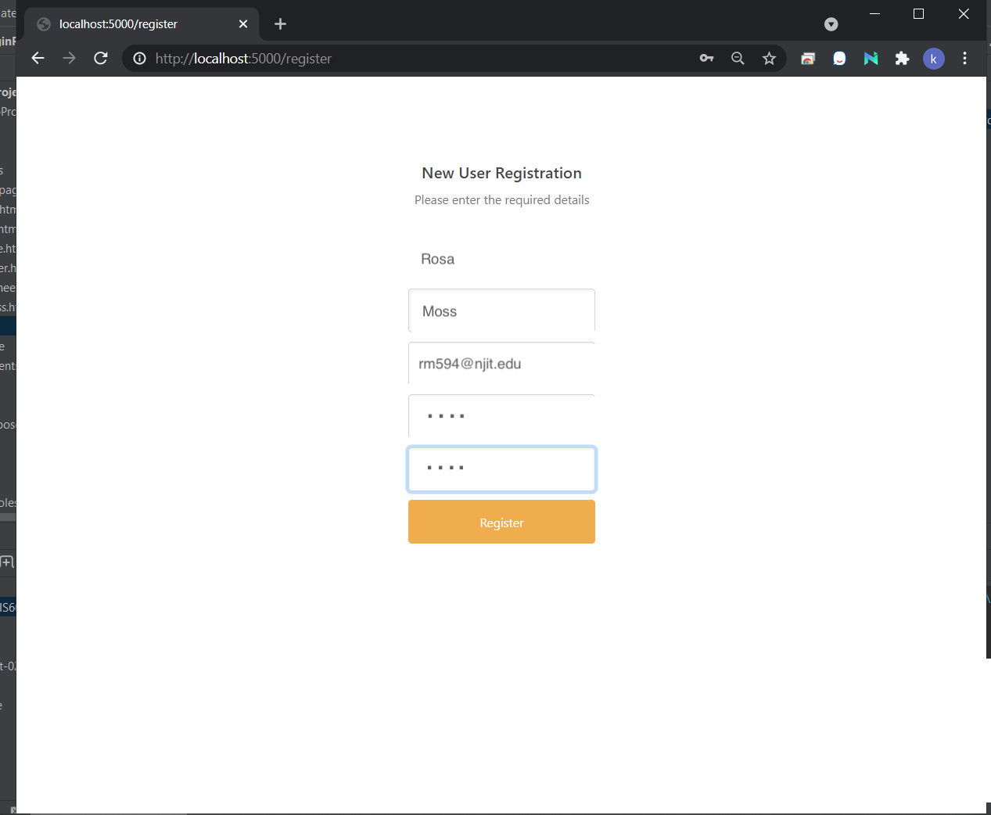

New User Information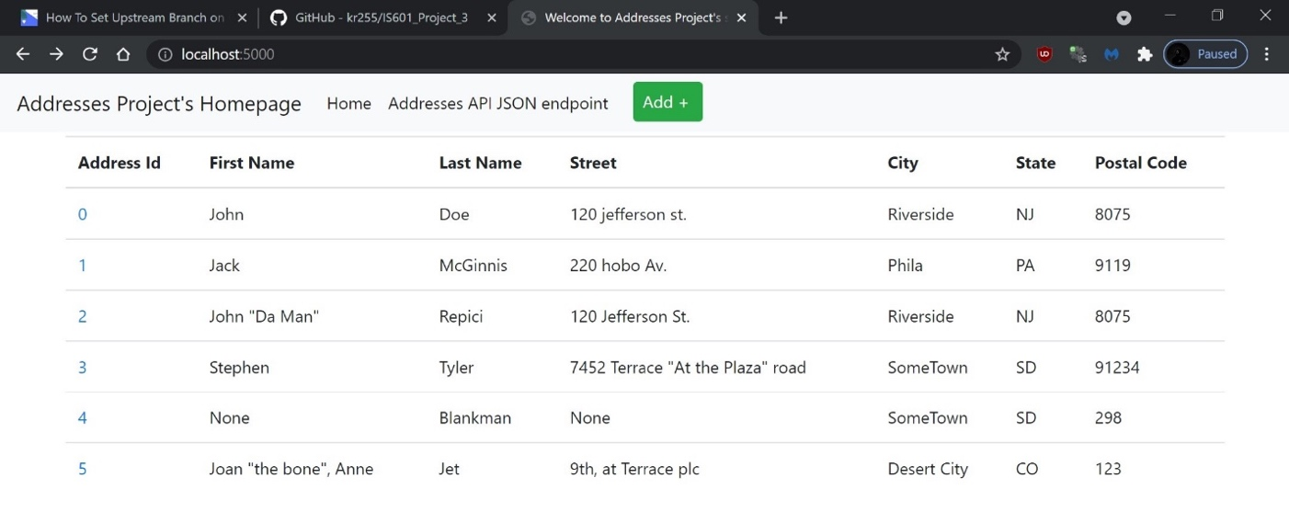

Fill out new user form

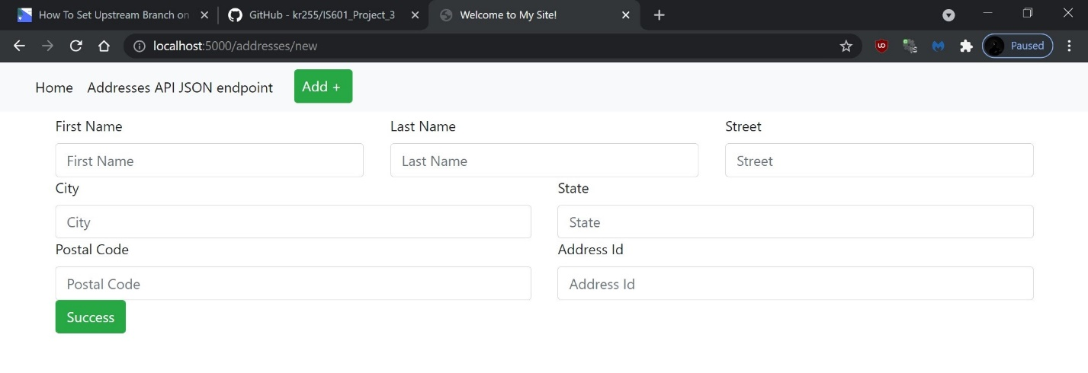

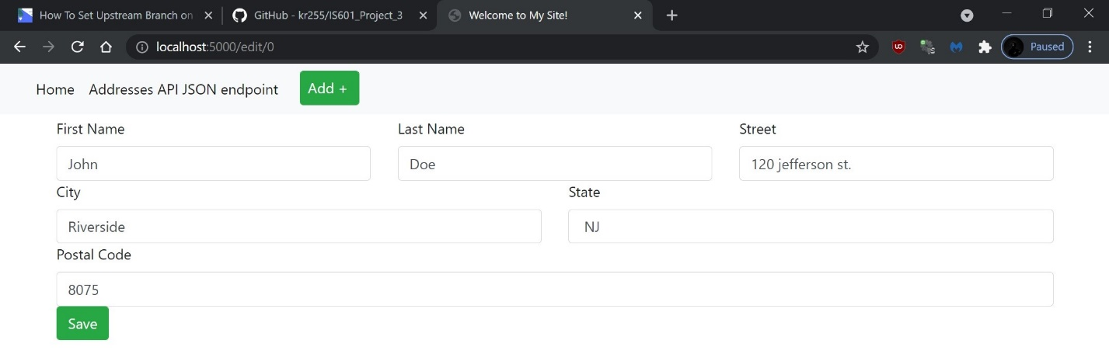

New User Info from Addresses.csv

