**Simple Inventory Manager Program Preliminary Design (C++)**

|  |  |
| --- | --- |
| ***Group Member:*** | ***Student ID:*** |
| Matthew Newberry | 6420459 |
| Rosabelle Armstead | 6402882 |
| Harry Pegrum | 6419920 |

**Class Diagram:**

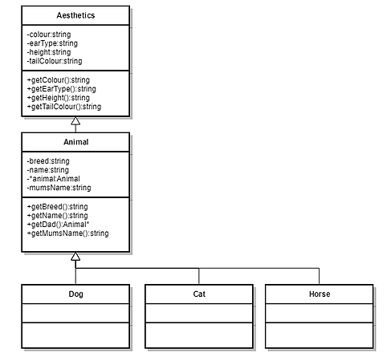

**Main Structure of main() Program:**

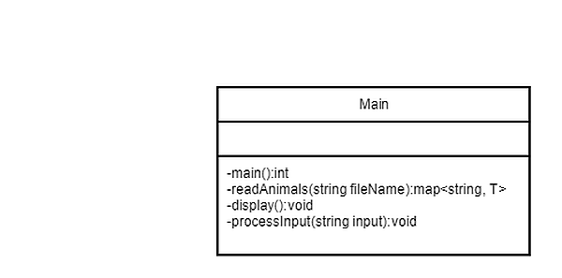

The structure of the main program has 4 methods as displayed in the Main class digram. The method “readAnimals(string fileName):map<string, T>” is used to read in each set of animals into their respective maps and return the map. The parameter fileName is the name of the file that is to be read. The function returns a mapping with keys as string and the values as a generic type T. This is because the function is a template and therefore can be used to create mappings of all dog, cat and horse types. The processInput(string input):void method is called when an input is detected by the main():int function, this method determines what data is to be displayed by the program. It will then call the display method. The display():void method displays the desired output with the given data so that the data is formatted correctly to the console. This display method shows the paternal tree of the animal whose name was input. The actual main() method has a loop that will continue to ask for an input after completing the required methods. If an input is detected then the input is passed to the processInput(string input):void method and then once the correct output is displayed it will return to the loop in the main():void method. The main():void method will also output the entire inventory and the size of each inventory, which is formatted to display as a table.

**Error Handling:**

There will be error handling so that if the input from the user is not found in the inventory of the chosen animal then the program will output an error message detailing that the input by the user was not found in the inventory of the chosen type. There will also be error handling so that the user can only select the type of animal they would like to search in by entering either “a” for all types, “d” for the dog type, “c” for the cat type or “h” for the horse type. If any other character is input preceding the name of the animal they’re searching for then an error message will display in the console detailing the possible inputs and their corresponding animal types.