RECONNAISSANCE & NETWORK SCANNING REPORT
Cybersecurity Internship — Week 2 Lab Report
W2-PM-FINAL | CYBERSECURITY | NETWORKWALKS
Intern Name | Rodah Mwikali
Role | Cybersecurity Intern
Program/Batch | B083-Networkwalks
Date | 18 September 2026
Modules completed | W2-PM1 (Multiple Kali Tools)  W2-PM5 (Zenmap Scanning)
Client/Target | 1. Networkwalks (secured written permission already)  2. My own local LAN Network
Permission secured from client? | Yes
Phases covered | Phase 1: Reconnaissance & Footprinting  Phase 2: Scanning & Network Discovery  Phase 3-5: In Progress

1. Liability Disclaimer
Every task described in this report was carried out either against a target for which written authorization had already been obtained (networkwalks.com, used here strictly as an educational training domain) or against infrastructure that belongs to me personally (my own home network). This document and the techniques it describes are intended purely for learning purposes as part of a structured cybersecurity training program. None of the content here should be used to access or test systems without the owner's explicit consent. I understand that unauthorised access to computer systems is treated as a criminal offence in most jurisdictions, regardless of whether any actual damage occurs, and that responsibility for how this information is used rests entirely with the person applying it.

2. Introduction
This report brings together two related exercises completed in Week 2 of my cybersecurity internship: footprinting the networkwalks.com domain with a set of Kali Linux command-line tools (Module W2-PM1), and mapping the devices on my own home network using the Zenmap scanning tool (Module W2-PM5). Read together, the two exercises trace the natural progression a real attacker would follow — starting from information that is already public, then moving on to actively probing a live network to see what devices respond.
The footprinting work was carried out inside a Kali Linux virtual machine, while the network-scanning work was carried out using Zenmap installed directly on my Windows host machine. For each task below, I have recorded the exact command that was run, a summary of what came back, supporting screenshots, and a short reflection on why that particular piece of information would matter to someone attempting to compromise the target.

3. Tools Used
The table below lists each tool used in this report and its purpose.
Tool | Purpose
Kali Linux & Windows | Operating systems used for reconnaissance activities
WHOIS | Find domain registration details (owner, dates, name servers).
whatweb | Fingerprint web technologies (server, CMS, plugins, IP).
nslookup | Resolve the domain name to its IP address using DNS.
curl -I | Read the HTTP response headers of the website.
wafw00f | Detect whether a Web Application Firewall protects the site.
dnsrecon | Enumerate all DNS records (NS, MX, SPF, TXT, SRV).
Zenmap (Nmap GUI) | Scan the local subnet to find live hosts, IPs and MAC addresses.
Windows CMD | Local IP and MAC address identification

4. Activities Performed

4.1 Footprinting & Reconnaissance
This part of the exercise walked through six different command-line tools, each pulling a different slice of information about networkwalks.com without ever making direct contact with the application itself.
The first tool, WHOIS, pulled the public domain registration record. This confirmed the registrar handling the domain, its creation and expiry dates, and — most usefully — its name servers, which point to HostGator and therefore reveal the hosting provider without needing any further lookup.
Next, WhatWeb was run against the site to fingerprint the technology stack. It came back showing WordPress 7.1 running alongside the WP Download Manager plugin (version 3.3.58), and also surfaced the server's IP address, 192.232.216.135, along with several other details embedded in the page's headers and metadata.
Nslookup was then used simply to resolve the domain name to an IP address. It returned 192.232.216.135, matching the IP already surfaced by WhatWeb and confirming where the server actually sits.
Running curl with the -I flag pulled back the raw HTTP response headers rather than the page content. Among the headers returned was a reference to /wp-json/, the REST API endpoint WordPress exposes by default — a small but useful clue about what's running behind the scenes.
Wafw00f was used to check whether any web application firewall was sitting in front of the site. It identified ModSecurity (SpiderLabs) as the WAF in place.
Finally, dnsrecon was run to pull a fuller set of DNS records in one go. It listed the name servers (running BIND version 9.16.23-RH), the mail server (mail.networkwalks.com), an SPF/TXT record describing the domain's approved mail senders, and confirmed that the domain has no SRV records and does not currently respond to DNSSEC queries.

4.2 Network Scanning with Zenmap
The second half of the week's work shifted from passive, public-record lookups to actively probing a live network using Zenmap. The goal was to work out my own network's address range, sweep it for active devices, and record their IP and MAC addresses before producing a visual map of what was found.
Running ipconfig on my Windows machine showed an IPv4 address of 192.168.5.193, a subnet mask of 255.255.255.0, and a default gateway of 192.168.5.1 - together, these describe a /24 network, written as 192.168.5.0/24. That range was entered as the target in Zenmap, and a Ping Scan was run to sweep it for responsive hosts.
Three devices answered the sweep:
- 192.168.5.1 — the network's gateway/router
- 192.168.5.72 — a separate device on the same network
- 192.168.5.193 — my own PC, the machine running the scan
Of these, only 192.168.5.72 came back with a MAC address directly in the scan output (6A:A8:51:47:D8:2D). A machine can't see its own MAC address through a scan of itself, so I pulled mine separately with ipconfig /all, which returned AA-B7-CD-85-6C-DA. The router at 192.168.5.1 didn't return a MAC at all — not unusual, since some routers don't respond to ARP or ping sweeps with that information.
With the scan complete, I switched to Zenmap's Topology view, turned on the legend to understand what the icons meant, and exported the resulting diagram as a PDF saved to the desktop.

5. Risk Analysis / Impact
Looking back over everything gathered across both exercises, a handful of findings stand out as worth tracking from a risk perspective, summarised below.
# | Risk / Finding | Evidence / Observation | Potential Impact | Risk Level
1 | Web technology information exposed | WhatWeb identified WordPress 7.1 and WP Download Manager 3.3.58 | Attackers may use exposed technology/version information to identify software requiring further security review | ● Medium
2 | Server IP address identifiable | Nslookup resolved the domain to 192.232.216.135 | Provides information about the network location of the web service | ● Low
3 | HTTP technical information exposed | Curl returned HTTP response headers and exposed /wp-json/ | May assist technology fingerprinting and further enumeration | ● Low
4 | WAF technology identifiable | Wafw00f identified ModSecurity (SpiderLabs) | Reveals information about the web application's security architecture | ● Low
5 | DNS infrastructure information exposed | DNSRecon identified DNS, mail, SPF and TXT records | DNS information can help build a broader infrastructure profile | ● Medium
6 | Multiple live hosts visible on local network | Zenmap identified 3 live hosts on the 192.168.5.0/24 network | Unknown or unauthorized devices may potentially be present on a network | ● Medium

Risk level key: ● Critical ● Medium ● Low
It's worth being clear about what these findings actually represent: they are things I observed while gathering information, not vulnerabilities that have been proven exploitable.
Both modules were scoped as discovery exercises — the goal was to see what information is available and which hosts respond, not to attempt exploitation or confirm that any weakness could actually be leveraged.
So while a detail like an exposed software version or an open DNS record is worth flagging, it doesn't on its own prove the target is vulnerable. Establishing that would require a separate, properly authorized round of testing.

6. Recommendations
Off the back of these findings, here's what I'd suggest as practical next steps for the organisation (or for anyone maintaining a similar setup):
- Audit what technology details are publicly visible — take stock of how much your CMS, plugins, and framework versions give away to anyone looking, and tighten that where possible.
- Stay current on patching — WordPress core and any installed plugins should be kept up to date and checked periodically against published advisories.
- Trim unnecessary detail from HTTP headers — response headers are worth a periodic review to strip out anything that isn't needed for the site to function.
- Revisit DNS records on a schedule — old or unnecessary DNS entries should be cleaned up so only what's actually required stays publicly resolvable.
- Keep the WAF tuned, not just switched on — ModSecurity is already doing useful work here, but it needs periodic review to stay effective against evolving attack patterns.
- Make internal network sweeps a habit — running a scan like this periodically is a cheap way to catch devices that shouldn't be there.
- Chase down anything unexpected — if a scan turns up a device nobody recognises, that's worth investigating rather than ignoring.
- Keep network documentation current — a topology diagram is only useful if it reflects what's actually connected, so it should be refreshed as the network changes.
- Only ever test with permission — footprinting and scanning, however routine they may feel, should always stay within an agreed and authorized scope.

7. Conclusion
This week's work took me through two connected pieces of the reconnaissance process: gathering information about a target purely from what's already public, and then actively sweeping a live network to see what answers.
The footprinting side showed how much can be pieced together about a website without ever touching it directly — WHOIS gave me ownership and hosting details, WhatWeb and curl exposed the underlying software stack, nslookup pinned down the server's IP, wafw00f flagged the firewall protecting it, and dnsrecon rounded things out with a fuller picture of the domain's DNS setup.
The Zenmap exercise was a different kind of exercise — instead of reading public records, it meant actively querying my own network to see who was on it, then pairing that with IP and MAC address details and a visual topology of what was found.
The biggest takeaway for me is how much groundwork happens before any actual exploitation would even be considered. A security professional can build a surprisingly detailed picture of an environment just from careful, methodical information gathering, well before any attempt to break in.
It also reinforced how a report needs to do more than list commands and outputs — it should connect each finding to what it actually means, what risk (if any) it introduces, and what a sensible next step looks like. That connective layer is what turns a set of screenshots into something actually useful.
And finally, all of it comes back to scope: every command run here was against a domain and a network I had explicit permission to test, and that boundary is one I intend to keep treating as non-negotiable going forward.

8. Evidences Collected

1. WHOIS Domain Lookup
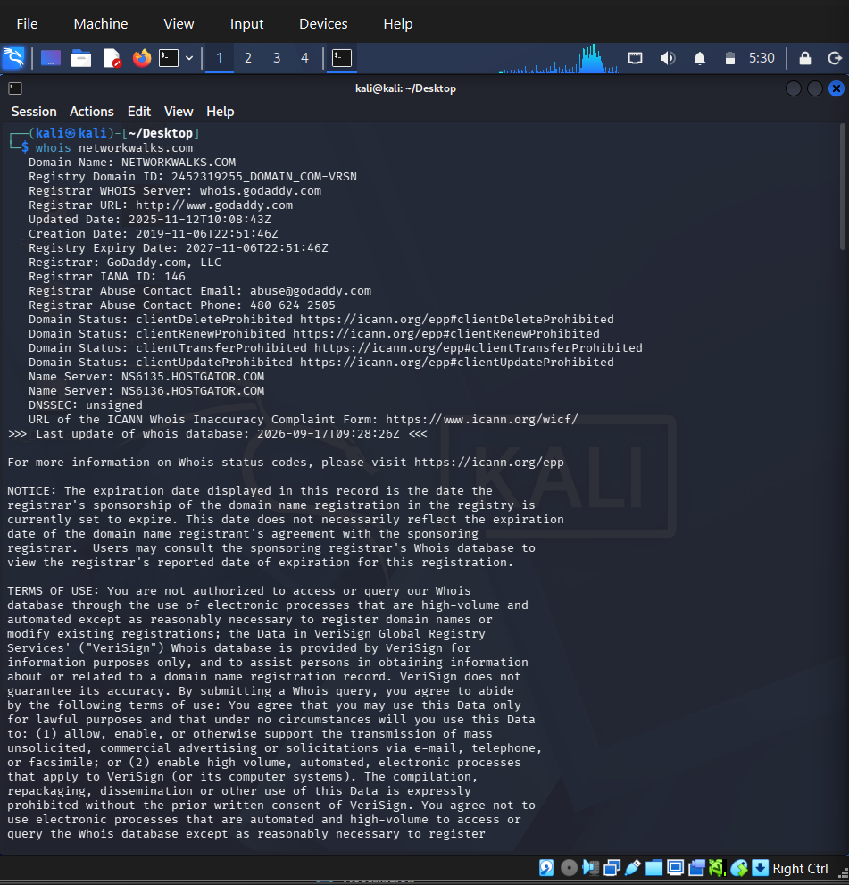
whois networkwalks.com — registrar GoDaddy, name servers pointing to HostGator

2. WhatWeb Technology Fingerprinting
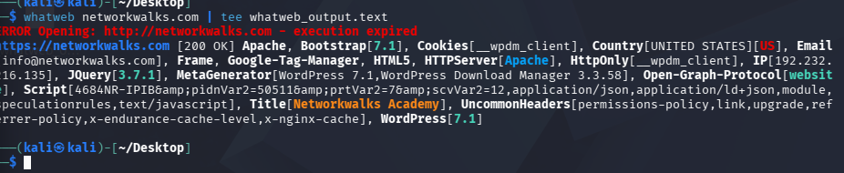
whatweb networkwalks.com — WordPress 7.1, Apache, IP 192.232.216.135

3. Nslookup DNS Resolution
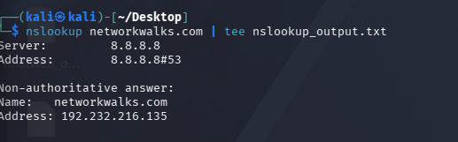
nslookup networkwalks.com — resolves to 192.232.216.135

4. Wafw00f WAF Detection
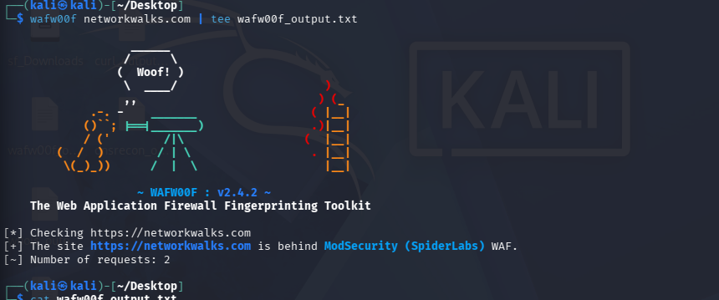
wafw00f networkwalks.com — ModSecurity (SpiderLabs) WAF detected

5. DNSRecon DNS Enumeration
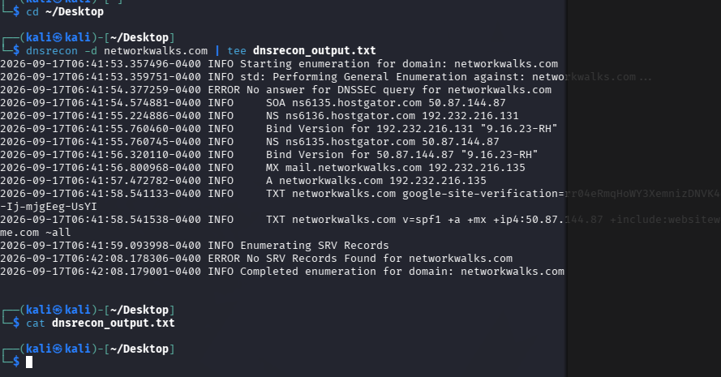
dnsrecon -d networkwalks.com — NS, MX, TXT/SPF records

6. Zenmap Ping Scan Results
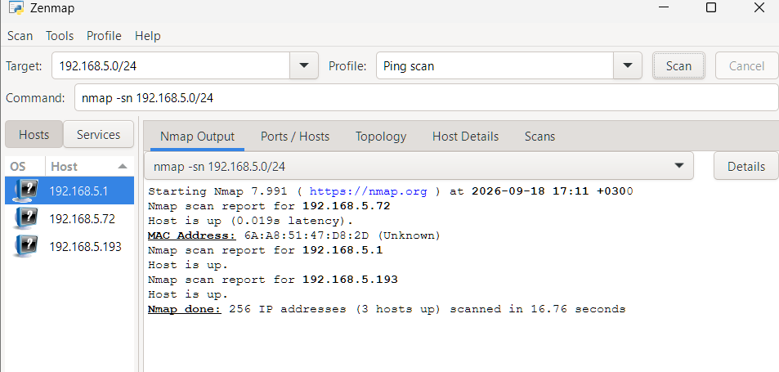
nmap -sn 192.168.5.0/24 — 3 hosts up

7. Zenmap Network Topology
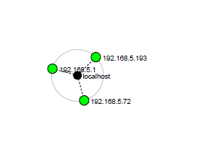
Topology diagram exported and saved as PDF

-End-
👤 Author
Rodah Mwikali
Cybersecurity Intern, Batch B083

📌 Project Information
Program Name: Cybersecurity program at Networkwalks | Week: 02 | Batch: B083

