Password Cracking Lab Report
Week 3 — Project Modules 1 & 2 | Networkwalks Cybersecurity & Ethical Hacking
Field | Value
Target files | My Locked PDF1.pdf (Module 1 copy), My Locked PDF1.pdf (Module 2 copy), My Locked PDF2.pdf, My Locked PDF3.pdf
Modules covered | Module 1 (JTR + Johnny, 3 files) and Module 2 (Networkwalks Tools, 1 file)
Module 1 results | good-luck (PDF1) / password1 (PDF2) / 1qaz2wsx (PDF3)
Module 2 result | password1 (PDF1, Module 2's own copy)
Author | Rodah Mwikali
Date | 9/23/2026
1. Background
Password cracking is the process of recovering a password from stored data or a protected file. Security professionals use it to test how strong a password is and to demonstrate the risk posed by weak or common passwords. Files such as PDF, ZIP, and Office documents store their protection as a hash — a scrambled representation of the password. Recovering the password requires extracting this hash and running it through a cracking tool that systematically tries candidate passwords until one produces a match.
This report documents two exercises that recover passwords from locked PDF files using two different toolchains: a locally installed command-line/GUI tool (John the Ripper with the Johnny front end), used against three files supplied with Module 1, and a pair of free browser-based tools provided by Networkwalks, used against a file supplied with Module 2. Both course modules happen to name their sample file My Locked PDF1.pdf; these are two distinct files bundled separately with each module, not the same file cracked twice, and each opens to its own uniquely worded flag confirming a correct, independent result.
2. Objective
- Crack the password of My Locked PDF1.pdf, My Locked PDF2.pdf, and My Locked PDF3.pdf (Module 1's files) using JTR John and JTR Johnny on a Windows PC (Module 1).
- Crack the password of My Locked PDF1.pdf (Module 2's file) using the Networkwalks Hash Calculator and Password Cracker tools (Module 2).
- Verify each recovered password by opening its file and confirming the resulting flag.
3. Module 1 — John the Ripper (JTR) + Johnny GUI
3.1 Tools used
- John the Ripper (jumbo) 1.9.0-jumbo-1, 64-bit Windows binaries — openwall.com/john
- Johnny GUI v2.2, Windows binaries — openwall.info/wiki/john/johnny
- Online PDF hash extractor — onlinehashcrack.com/tools-pdf-hash-extractor.php
3.2 Procedure
- Downloaded and extracted the John the Ripper jumbo 64-bit Windows archive.
- Downloaded and installed Johnny via johnnyInstaller.exe.
- In Johnny, navigated to Settings and browsed to john.exe, located at ...\john-1.9.0-jumbo-1-win64\run\john.exe. Johnny confirmed detection of John the Ripper 1.9.0-jumbo-1.
- Uploaded each of My Locked PDF1.pdf, My Locked PDF2.pdf, and My Locked PDF3.pdf (all supplied with Module 1) to the online hash extractor in turn, obtaining a pdf2john-format hash for each, beginning $pdf$4*4*128*...
- Copied all three hashes into Notepad, one per line, and saved as a single combined hash file, keeping track of which line corresponded to which source filename.
- In Johnny, used Open password file to load the combined hash file. Three rows appeared in the password table, each with format PDF.
- Clicked Start new attack. Johnny/John ran the default wordlist and mangling rules against all three hashes in a single pass.
- The status bar reported 100% (3/3: 3 cracked, 0 left) [format=PDF]. All three recovered passwords were displayed in the Passwords tab (shown below).
- Opened each locked PDF in Adobe Acrobat Reader and entered its recovered password, confirming each unlocked to its own flag page.
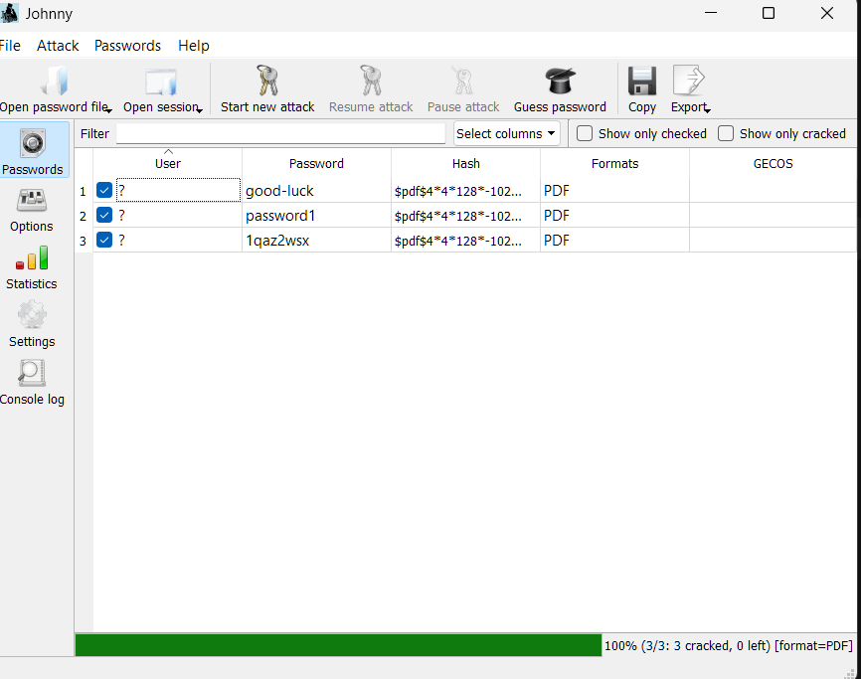
Johnny after the combined attack — all 3 hashes cracked: good-luck, password1, 1qaz2wsx.
3.3 Result
# | Target file | Cracked password | Flag captured
1 | My Locked PDF1.pdf (Module 1 copy) | good-luck | nw{cybersecurity_flag_captured_2608}
2 | My Locked PDF2.pdf | password1 | nw{networkwalks_flag1_jtr_270521_1}
3 | My Locked PDF3.pdf | 1qaz2wsx | nw{networkwalks_persistence_jtr_270521}
All three hashes used the $pdf$4*4*128*... format (pdf2john / hashcat-compatible) and were cracked in one combined attack run using JTR's default wordlist and mangling rules.

PDF1 (Module 1 copy) opened with good-luck — flag nw{cybersecurity_flag_captured_2608}.

PDF2 opened with password1 — flag nw{networkwalks_flag1_jtr_270521_1}.
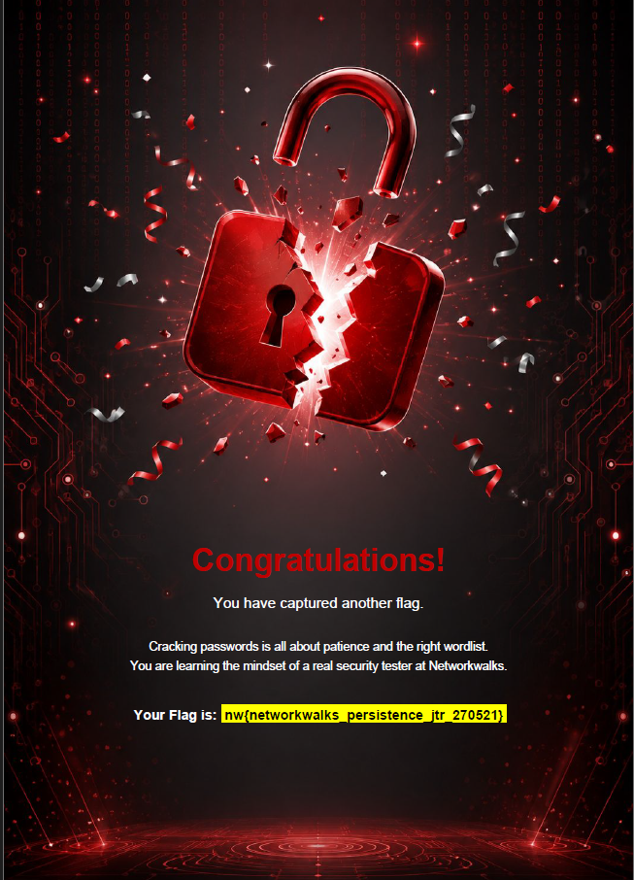
PDF3 opened with 1qaz2wsx — flag nw{networkwalks_persistence_jtr_270521}.
3.4 Notes / troubleshooting
- Windows hides file extensions by default, so john.exe displayed as john in File Explorer — confirmed as an Application-type file rather than a missing executable.
- Combining all three hashes into a single file (one per line) and loading them into Johnny together allowed a single attack run to crack all three, rather than repeating the full workflow three times.
- The cracked passwords appear on Johnny's Passwords tab, not the Settings tab — worth checking the correct view after an attack completes.
4. Module 2 — Networkwalks Hash Calculator + Password Cracker
4.1 Tools used
- Networkwalks Hash Calculator — networkwalks.com/hash-calculator/
- Networkwalks Password Cracker — networkwalks.com/password-cracker/
4.2 Procedure
- Downloaded Module 2's My Locked PDF1.pdf from the course lab page.
- Initial attempt used the wrong file's hash. The Hash Calculator's browser tab still showed a stale 'My Locked PDF1.pdf' label from an earlier session, but the hash it actually extracted and displayed belonged to My Locked PDF2.pdf. This hash was pasted into the Password Cracker (built-in 100-word list active) and returned Access Denied, since PDF2's real password was not in that list.
- Re-extracted the hash for the correct file (Module 2's actual PDF1) using the Hash Calculator's PDF tab.
- Pasted the corrected hash into the Password Cracker and clicked Start Cracking.
- The tool displayed "PASSWORD CRACKED SUCCESSFULLY" — password1.
- Opened Module 2's My Locked PDF1.pdf and entered password1. It unlocked to a congratulations page containing the flag nw{networkwalks_flag_260821_1}, confirming the correct password.
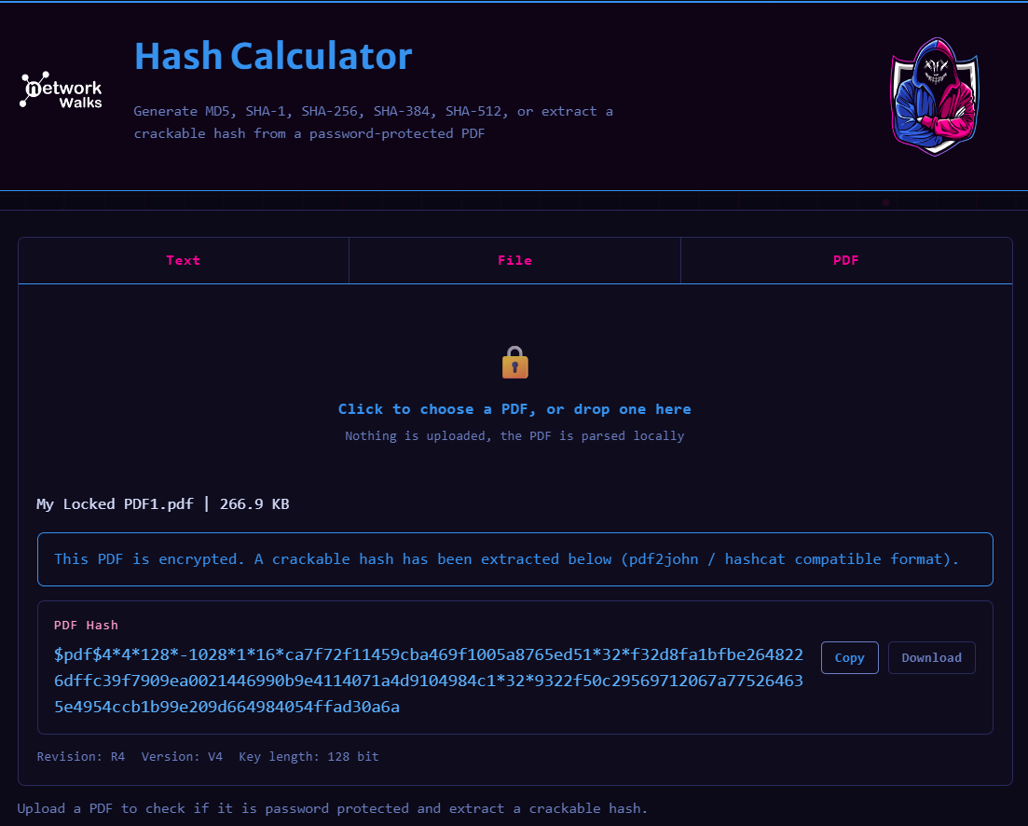
Hash Calculator output — this hash actually belongs to My Locked PDF2.pdf, despite the stale on-screen filename label.
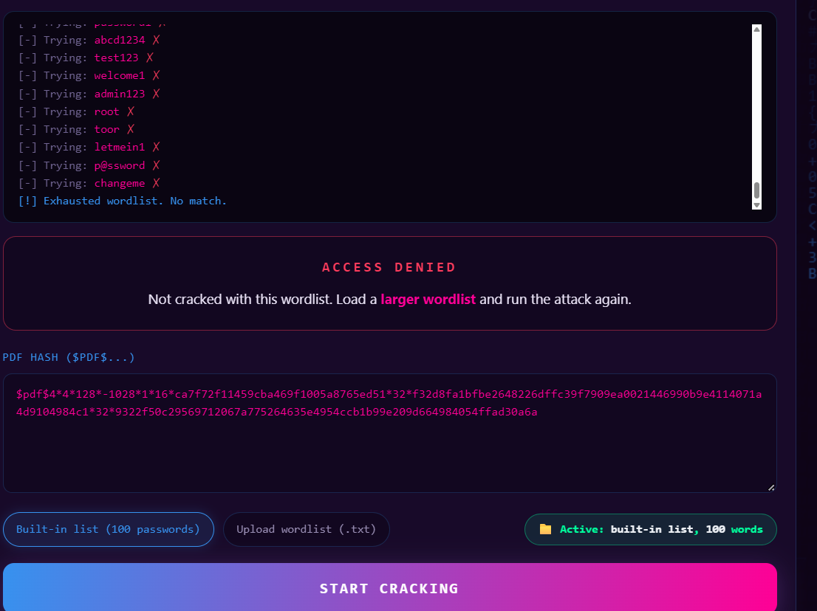
Password Cracker exhausts the built-in wordlist against the wrong (PDF2) hash — Access Denied.
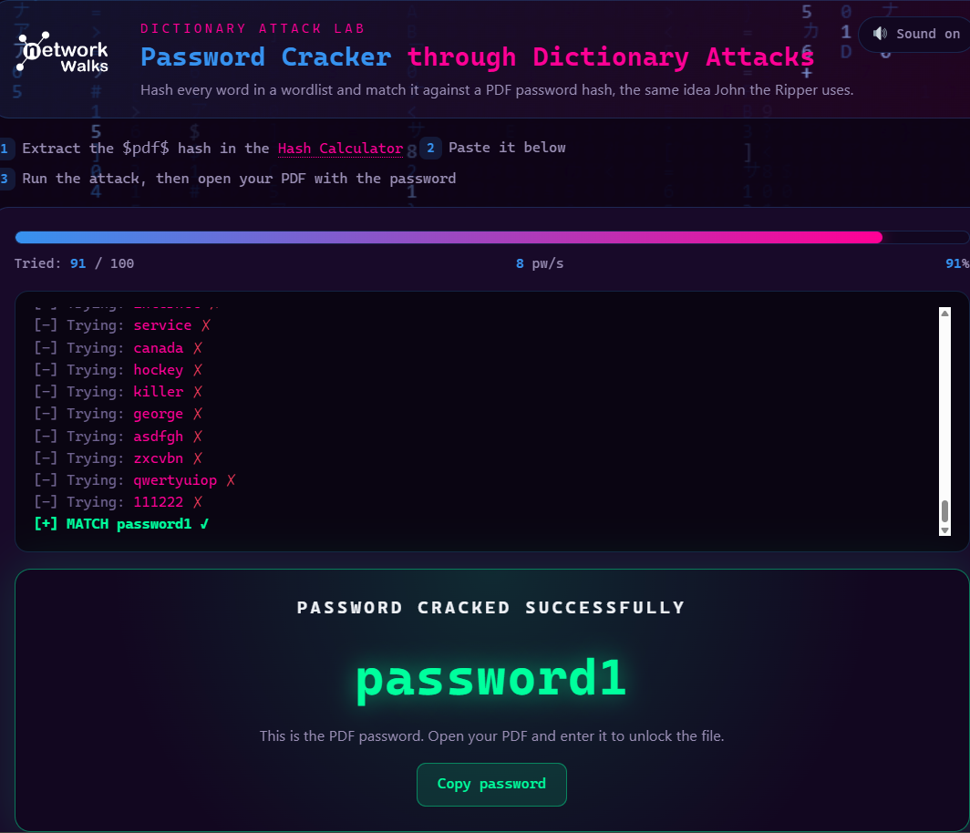
Password Cracker succeeds once the correct PDF1 hash is used: password1.
4.3 Result
Item | Value
Target file | My Locked PDF1.pdf (Module 2 copy)
Hash format | $pdf$4*4*128*...
Attack type | Built-in 100-word dictionary list
Cracked password | password1
Flag captured | nw{networkwalks_flag_260821_1}
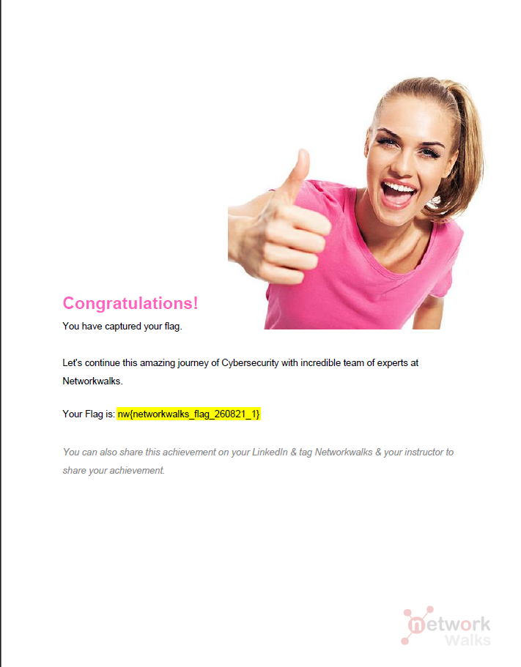
PDF1 (Module 2 copy) opened with password1 — flag nw{networkwalks_flag_260821_1}.
4.4 Notes / troubleshooting
- The 'Access Denied' result was not caused by a strong or uncrackable password — it was caused by attacking the wrong file's hash. The Hash Calculator's browser tab retained a stale filename label from a previous upload, which led to My Locked PDF2.pdf's hash being extracted and mistakenly treated as PDF1's. Once the correct file's hash was re-extracted, the built-in wordlist found the password immediately.
- Module 2 was only run against its own PDF1 file in this exercise; Module 1's PDF2 and PDF3 were cracked exclusively via JTR + Johnny.
5. Comparing the two PDF1 results
Aspect | Module 1 (JTR + Johnny) | Module 2 (Networkwalks Tools)
Installation required | Yes (JTR + Johnny) | No — runs entirely in browser
Source file | PDF1 bundled with Module 1 | PDF1 bundled with Module 2
Hash extraction | Third-party online extractor | Networkwalks Hash Calculator
Cracking engine | John the Ripper (local) | Networkwalks Password Cracker (browser)
Wordlist used | JTR default wordlist + rules | Built-in 100-word list
Password | good-luck | password1
Flag | nw{cybersecurity_flag_captured_2608} | nw{networkwalks_flag_260821_1}
The two toolchains recovered different passwords for a file with the same name, My Locked PDF1.pdf. This is not a discrepancy: Module 1 and Module 2 each ship their own independent copy of a file with that filename, and each password was verified by opening its file and confirming a distinct, correctly formatted flag unique to that module. The matching filename is a coincidence of how the two modules were packaged, not evidence of the same underlying file.
6. Conclusion
Passwords were recovered for every file attempted in this exercise: good-luck, password1, and 1qaz2wsx for Module 1's PDF1, PDF2, and PDF3 respectively (cracked together via John the Ripper and Johnny in a single combined attack run), and password1 for Module 2's own PDF1 (cracked via the Networkwalks Hash Calculator and Password Cracker, after an initial false start caused by a stale filename label). Every result was verified directly by opening its file and confirming a distinct, valid flag, so all recovered passwords are confirmed correct.
The exercise demonstrates the general workflow behind password cracking — extract a hash from the protected file, then run that hash through a dictionary attack until a match is found — and shows how that workflow scales cleanly to multiple targets by combining hashes into one file. It also illustrated two practical pitfalls and how to catch them: a browser tool retaining a stale filename and silently extracting the wrong file's hash (caught by the tool reporting no match, then traced back to the mismatched source file), and assuming two identically named files from different course modules are the same file (caught by checking each result against its own flag rather than against the other tool's output).
All passwords recovered in this exercise were found quickly using only default or small built-in wordlists, reflecting the weakness of the sample passwords rather than a limitation of the tools. Longer, non-dictionary passwords resist this class of attack far more effectively, which is the core lesson of the exercise: short or common passwords offer very little real protection.
7. Ethical note
This exercise was performed only against training files provided by the course, for educational purposes. Password-cracking tools and the techniques demonstrated here should only ever be used against systems and files you own or have explicit written authorization to test.

