Cybersecurity Incident Report:

Network Traffic Analysis
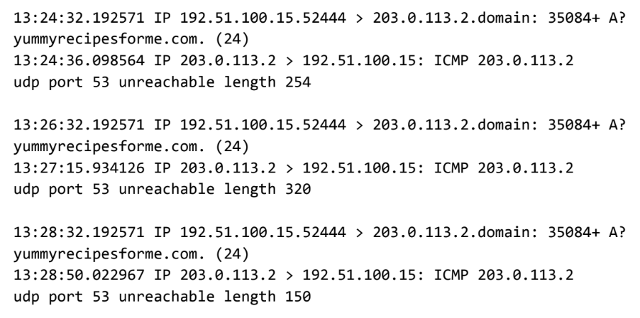
Part 1: Provide a summary of the problem found in the DNS and ICMP
traffic log.

The UDP protocol reveals that the UDP packet travels from the browser to the DNS server with a request to access www.yummyrecipesforme.com website’s IP address. But the UDP protocol could not retrieve the IP address for the website's domain name.

This is based on the results of the network analysis, which show that the ICMP protocol responded with an error message “udp port 53 unreachable length”.
The UDP message going from your browser to the DNS server is shown in the first two lines of every log event. The ICMP error response from the DNS server to your browser is displayed in the third and fourth lines of every log event with the error message, “udp port 53 unreachable.”
The port 53 noted in the error message is used for DNS protocol traffic we know there is an issue with the DNS server.

Issues with performing the DNS protocol are further evident because the plus sign after the query identification number 35084 indicates flags with the UDP message and the “A?” symbol indicates flags with performing DNS protocol operations. Due to the ICMP error response message about port 53, it is highly likely that the DNS server is not responding. This assumption is further supported by the flags associated with the outgoing UDP message and domain name retrieval.

Part 2: Explain your analysis of the data and provide at least one cause of the incident.
The incident occurred in the afternoon around 1:24 p.m when several customers reported to the IT team that they were not able to access the client company website www.yummyrecipesforme.com and saw the error “destination port unreachable” after waiting for the page to load.

The cybersecurity team providing IT services responded and attempted to visit the website themselves and received the error “destination port unreachable.” Then they started running tests with the network protocol analyzer tool tcpdump to troubleshoot the issue and attempt to load the webpage again to identify the issue in the network traffic.

The resulting logs revealed that port 53, which is used for DNS service, is not reachable. We are continuing to investigate the root cause of the issue to determine how we can restore access to the secure web portal. Our next steps include checking the firewall configuration to see if port 53 is blocked and contacting the system administrator for the web server to have them check the system for signs of an attack like Denial of Service (DoS) or a misconfiguration.

