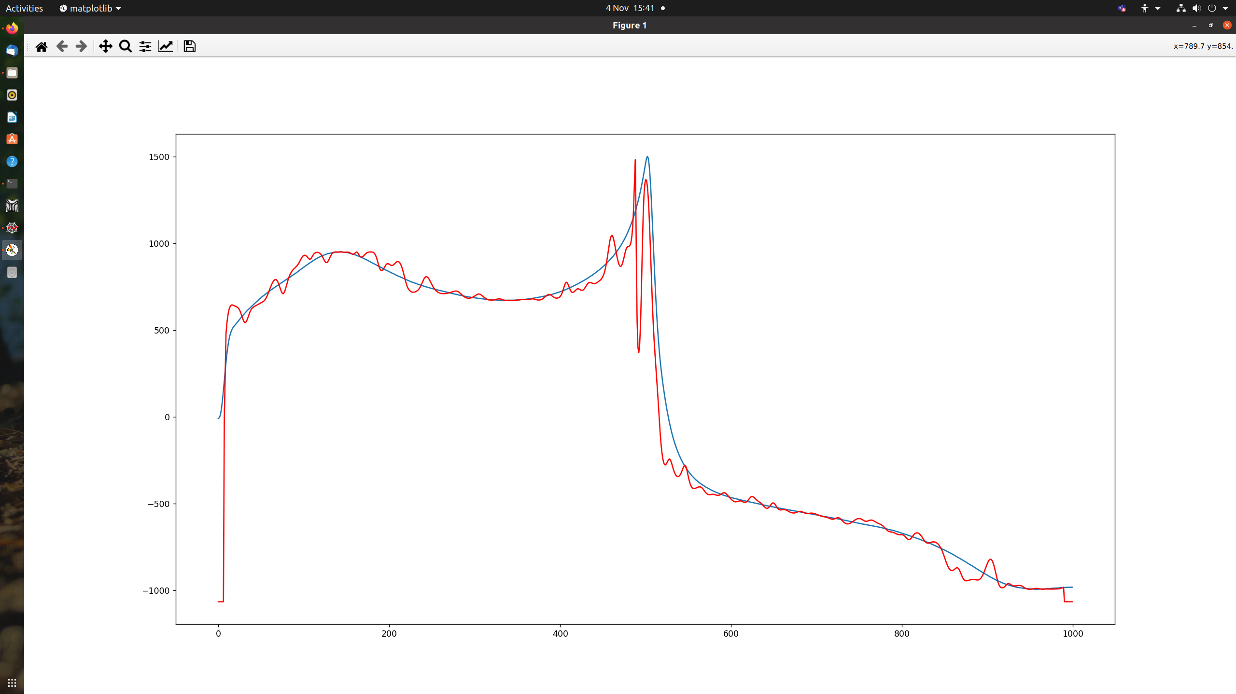 transform = tio.RandomElasticDeformation(

num_control_points=(160,160,16),

max_displacement=(4,120,0), #must have 0 for z dimension

locked_borders=2,

)

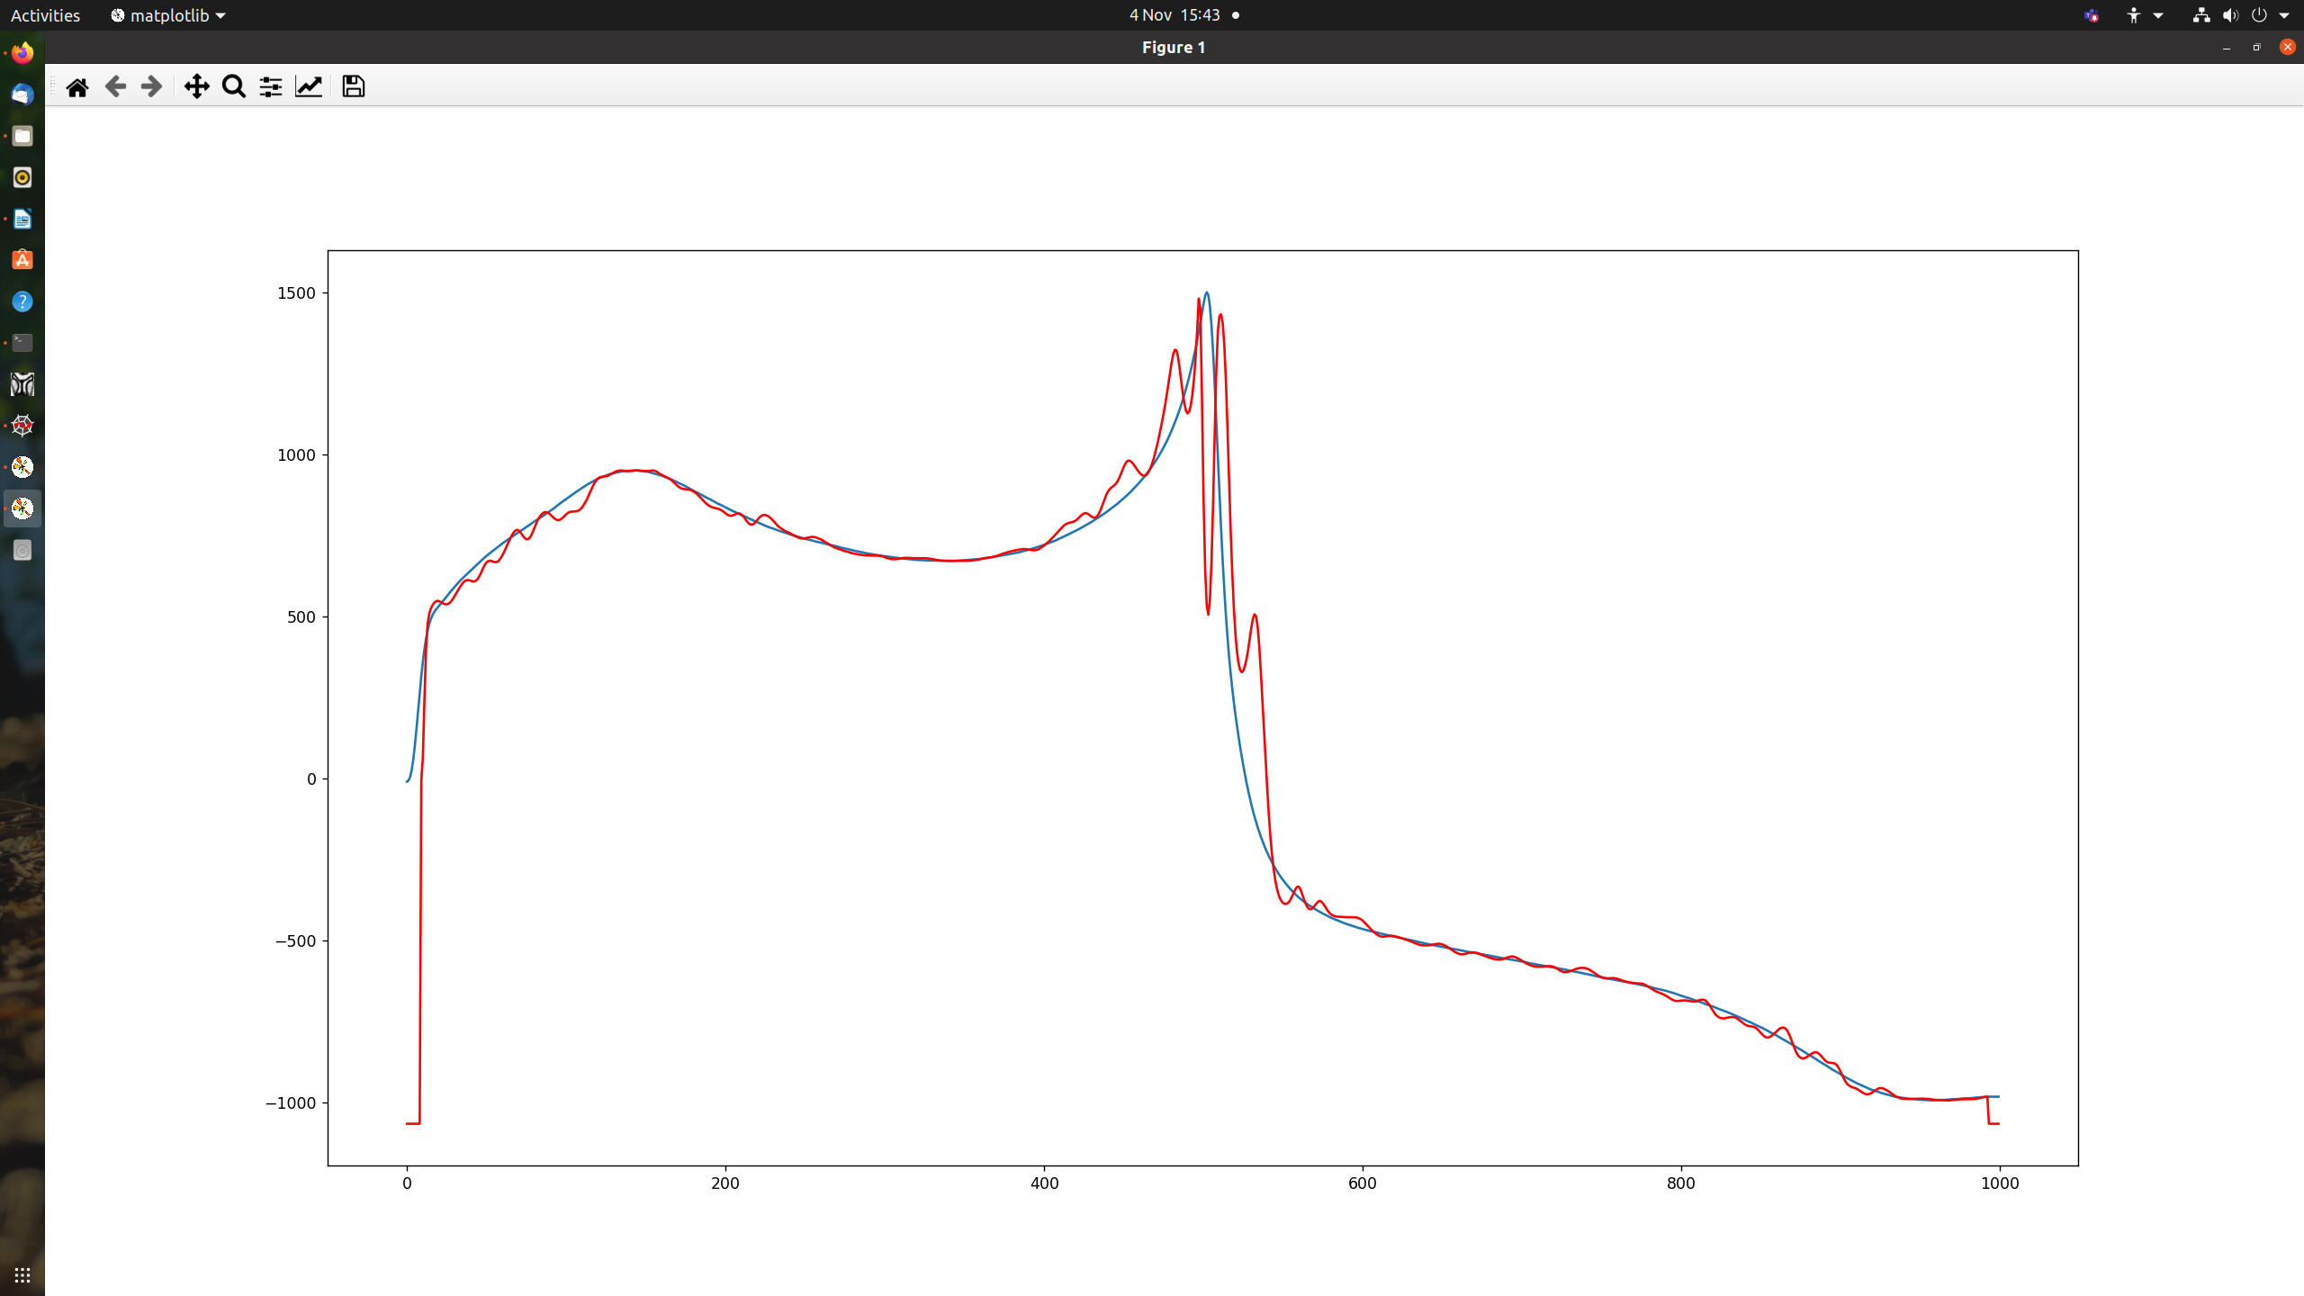

transform = tio.RandomElasticDeformation(

num_control_points=(160,160,16),

max_displacement=(4,60,0), #must have 0 for z dimension

locked_borders=2,

)

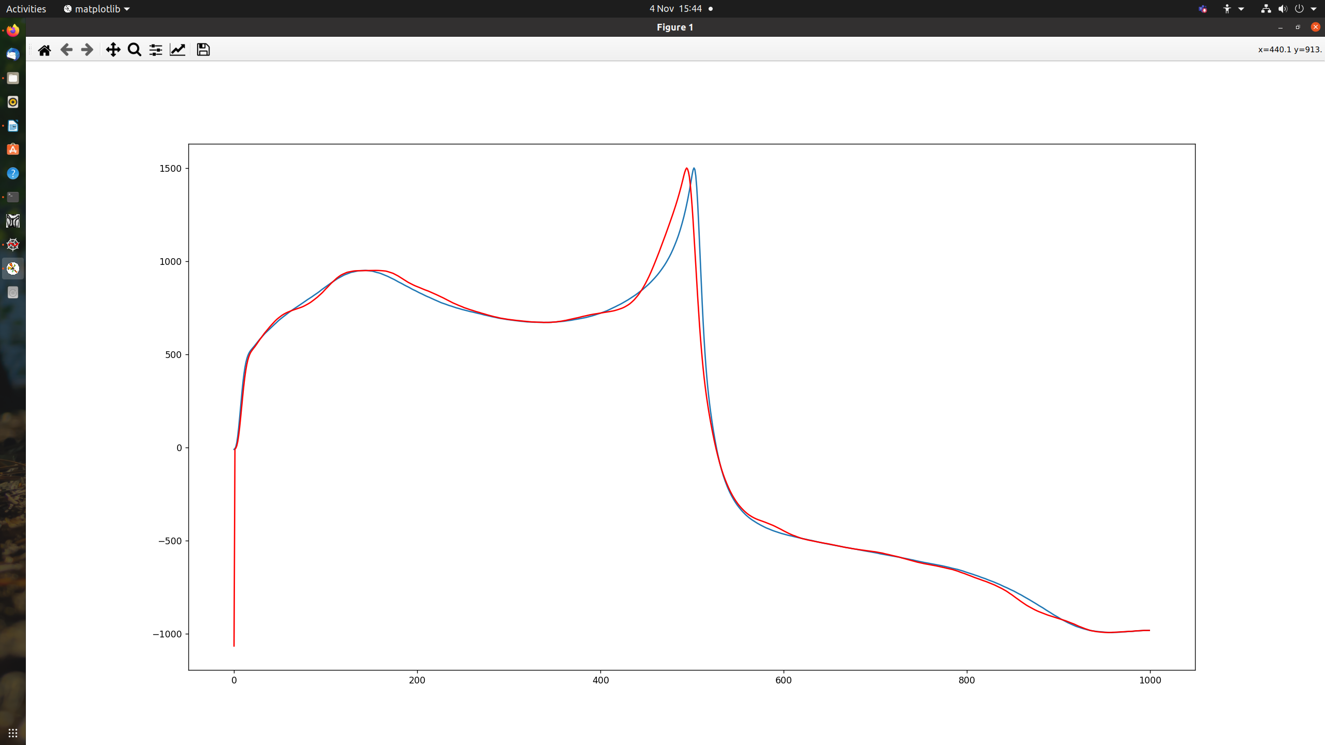 transform = tio.RandomElasticDeformation(

num_control_points=(160,40,16),

max_displacement=(4,60,0), #must have 0 for z dimension

locked_borders=2,

)

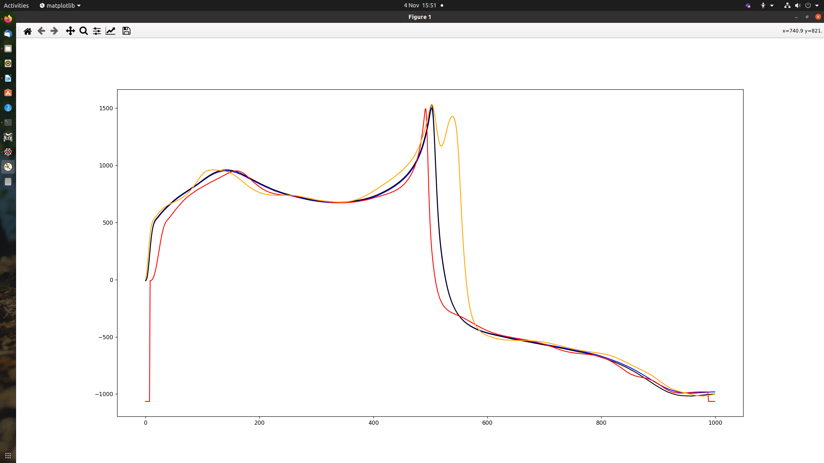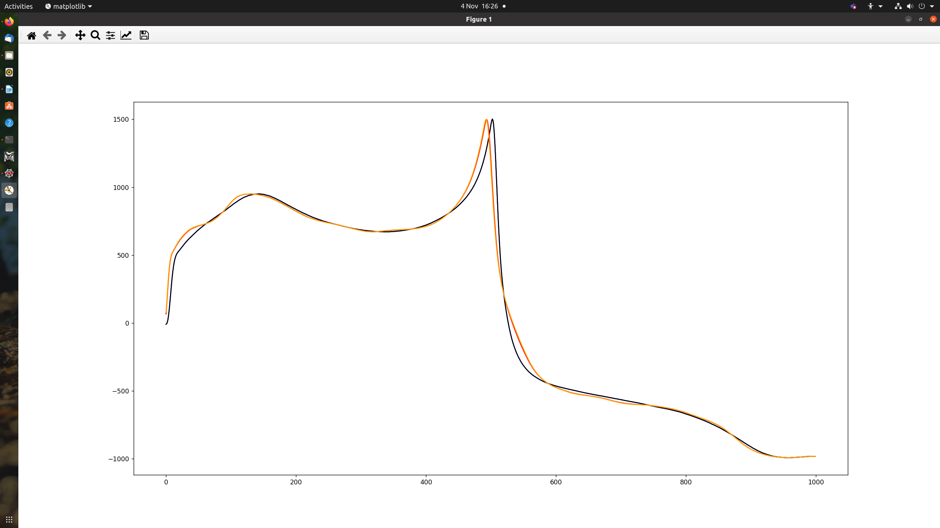 # Do morph along time dimension:

transform = tio.RandomElasticDeformation(

num_control_points=(6,30,16),

max_displacement=(4,240,0), #must have 0 for z dimension

locked_borders=2,

)

Elastic and affine

transform = tio.RandomAffine(scales = (0,0.1,0),

degrees =(0,30,0),

translation =(0,50,0))

