An Investigation into the Effectiveness of Open-Source Web Application Firewalls
COMP6015 Computer Science Project 1 | Group COMP6015-26S1-G11 | Supervisor: Mihai Lazarescu | 23 May 2026
Table 1. Group members and contribution summary.
Member | Student ID | Contribution summary
Sadaiba Kumar Acharya | 21647381 | Broad framework/lab support, testing support and documentation review.
Bishal Giri | 22902243 | Latest XSS/NAXSI evidence package, payload-level scripts, CSVs and screenshots.
Pabin Gurung | 22343460 | Final report consolidation, evidence mapping and submission preparation.
Roshan Kafle | 22393096 | Project support, review, documentation and result checking.

Declaration of Originality
We declare that this submission is our group work except where external sources, tools, datasets, screenshots or earlier project evidence are clearly identified. The final report consolidates the group’s scripts, result files, screenshots, datasets and analysis evidence.

Table of Contents
Declaration of Originality 2
Table of Contents 2
Executive Summary 3
Project Overview for Readers 4
1. Introduction and Motivation 5
Why this project matters 5
2. Research Problem, Aim, Objectives and Empirical Variables 5
How the project is framed as an empirical study 5
3. Background: What a WAF Is and Why Open-Source WAFs Matter 6
What a WAF can and cannot do 6
4. Background: What Each Tool Does 7
Why these tools were selected 7
5. Web Attack Classes Explained 8
Why different attack classes behave differently 8
6. Anatomy of an Attack Request 9
Step-by-step path of one request 9
7. Lab Architecture and Evidence Sources 10
How evidence priority was handled 10
8. Methodology 12
Why each method step matters 12
9. Broad Multi-Attack Evaluation 13
How to understand the broad result 13
10. Focused Reflected-XSS Payload-Level Evaluation 17
Why the focused XSS evidence goes deeper 17
11. Missed Attack and Missed Payload Analysis 20
Additional manual SQLi and CSRF validation from the updated evidence package 20
12. Reproducibility and Script Usage 24
How the scripts should be used 24
13. How to Interpret CSVs, Screenshots and Response Codes 25
How to read the evidence without being a specialist 25
14. Practical Recommendations for Small Organisations 26
What a small organisation should do with these findings 26
15. Limitations and Future Work 26
Why limitations do not make the project weak 26
16. Conclusion 27
17. References 27
Appendix A: Evidence Map Summary 28
Appendix B: Supervisor Feedback Coverage Map 28

If the page numbers are not visible, right-click the table of contents in Word and choose Update Field.

Executive Summary
The main idea of the project is simple. A normal website accepts requests from users, such as login attempts, search forms and profile updates. An attacker can use the same request path to send harmful input. A WAF sits between the user and the website and tries to decide whether a request looks normal or harmful before the website handles it.
The report does not claim that any open-source WAF is perfect. It also does not claim that a laboratory result automatically matches a live business system. The safer conclusion is that open-source WAFs can add value, but they must be tested, tuned and monitored for the specific application they protect.
For a non-specialist reader, the most important result is not only the overall percentage. It is also the pattern of misses. If a WAF misses a type of payload that the protected application can actually execute, that missed family may be important even if the overall detection rate looks high.
This project investigates whether open-source Web Application Firewalls can provide useful protection for web applications. A Web Application Firewall, or WAF, is a protective layer placed in front of a website. It examines web requests and blocks requests that appear to contain attacks. This matters because commercial WAF products can be expensive, so smaller organisations may consider open-source alternatives.
The project uses two evidence streams. the broad evaluation is a broad multi-attack evaluation using the cleaned result files in waf-project/analysis/final. It compares a no-WAF baseline with ModSecurity and Coraza across several attack classes. the focused XSS evaluation is a focused reflected-XSS payload-level evaluation using the latest focused XSS evidence package. It compares ModSecurity and NAXSI only for reflected Cross-Site Scripting payloads.
In the broad evaluation, the no-WAF baseline blocked 0.00% of controlled attack requests. Under medium mixed traffic, ModSecurity detected 34.947% and Coraza detected 35.069%. The available benign traffic showed 0.00% observed false positives. In the focused XSS evaluation, ModSecurity tested 1,774 reflected-XSS payloads, blocked 1,669 and missed 105, giving 94.08% detection. NAXSI tested the same 1,774 payloads, blocked 1,758 and missed 16, giving 99.10% detection. The evidence indicates that NAXSI performed better only for this specific reflected-XSS dataset. This does not prove that NAXSI is better for every attack class or in production.

Project Overview for Readers
This project is like testing different safety guards at the front door of the same building. The building is DVWA, the deliberately vulnerable web application. The guards are the WAFs. The visitors are the web requests. Some visitors are normal users and some are attack requests. The question is whether each guard lets normal visitors through while stopping harmful visitors.
The group carried out one integrated project with two evidence areas. The first evidence area gives a broad view across several attack classes. The second evidence area gives a deeper view of reflected XSS by testing many payload variations one by one. Both areas belong to the same group investigation and are included together because they answer different parts of the same research question.
Table 2. How the evidence fits into one group project.
Evidence area | What it adds to the group project | Important boundary
Broad multi-attack evaluation | Shows how ModSecurity and Coraza behaved across several web attack classes in the structured framework. | It does not prove broad NAXSI performance because broad NAXSI evidence is not present in the structured final CSVs.
Focused reflected-XSS evaluation | Shows how ModSecurity and NAXSI behaved against 1,774 reflected-XSS payloads in a detailed payload-level test. | It does not prove SQL injection, CSRF, brute force or other NAXSI attack-class performance.

The report therefore uses careful wording. For example, it says that NAXSI performed better for the focused reflected-XSS dataset, not that NAXSI is the best WAF overall.
The project can be understood as a controlled security experiment. The group used a deliberately vulnerable web application called DVWA as the target. The group then sent normal requests and attack requests to the target with different WAF conditions. The important question was whether the WAF blocked malicious requests without blocking normal user requests.
Table 3. Basic terms used throughout the report.
Term | Simple meaning | Why it matters
WAF | A Web Application Firewall that filters web requests. | It is the protection being evaluated.
Payload | The attack string placed into a request. | Different payloads test different evasion methods.
Detection rate | The percentage of attack requests blocked. | Higher is better, but it does not show which attacks were missed.
Miss | An attack request that was allowed. | One missed payload may still matter in a real application.
False positive | A normal request blocked by mistake. | False positives can stop real users from using the website.
Server error | A 500-level response from the server. | It is disruption, but it is not counted as a clean WAF block.
Confusion matrix | A table of true positives, false negatives, false positives and true negatives. | It explains both security and usability outcomes.

1. Introduction and Motivation

Why this project matters
Many organisations depend on websites for ordinary work: students submit forms, customers log in, staff manage records and administrators change settings. If an attacker can abuse those same forms, the organisation may face data loss, account misuse or service disruption.
Commercial WAF services can reduce this risk, but they may be too expensive or complex for smaller organisations. Open-source WAFs are attractive because they can be deployed without commercial licence fees. However, free availability is not the same as proven protection. This is why the project measures what the WAFs actually did in a controlled lab.
The project is not only about whether a request was blocked. It is also about whether the test was understandable and repeatable. A reader should be able to see the scripts, find the result files, understand the meaning of each metric and know what the evidence can and cannot prove.
Web applications handle logins, forms, payments, administration and public services. These applications receive input from users, and attackers often try to place malicious input into those same fields. A WAF is intended to inspect that input before the application processes it.
Commercial WAF systems can provide managed protection, but they can be expensive for small organisations, student projects and community organisations. Open-source WAFs are attractive because they are available without licence cost, can be inspected, and often have public communities around them. However, open-source availability does not automatically mean strong protection. The value of a WAF must be measured against realistic attack patterns and normal user activity.
This report therefore treats WAF evaluation as an empirical study. It does not ask whether a WAF is generally good or bad. It asks what happened in a controlled lab, under tested configurations, with recorded payloads, response codes and CSV result files.

2. Research Problem, Aim, Objectives and Empirical Variables

How the project is framed as an empirical study
An empirical study uses observations rather than opinion. In this project, the observations are response codes, response times, CSV rows, screenshots and summary metrics. The group changed the WAF condition and observed how the result changed.
The independent variable is the condition that changes, such as no WAF, ModSecurity, Coraza or NAXSI where evidence supports it. The dependent variables are the measured outcomes, such as detection rate, miss rate, false positives, confusion matrix counts and response time.
Controlled variables are kept the same so that the evaluation is fair. For example, the target application, payload set, classification logic and traffic generation approach should remain consistent within a study. Without these controls, a difference in results might come from a changed test environment rather than from the WAF.
Table 4. Simple meaning of the main measurements.
Measurement | Simple meaning | Why the reader should care
Detection rate | Out of all malicious requests, how many were blocked. | This shows security coverage but not the details of what was missed.
Miss rate | Out of all malicious requests, how many were allowed. | A small number of misses can still matter if they are realistic.
False positive rate | Out of normal requests, how many were blocked by mistake. | False positives can stop real users from completing normal tasks.
Response time | How long the request took to complete. | A WAF that slows a website too much may affect usability.
Confusion matrix | A table that separates correct blocks, missed attacks, wrong blocks and correct allows. | It explains both security and user impact.

The research problem is: can open-source WAFs provide meaningful protection against common web attacks, and where do default or tested configurations leave gaps? The aim is to evaluate open-source WAF effectiveness using repeatable scripts and evidence-backed metrics.
- Measure how much malicious traffic is blocked compared with a no-WAF baseline.
- Identify which attack classes are blocked well and which are not.
- Explain missed attacks so the results can guide tuning, not only reporting totals.
- Record false positives because a WAF that blocks normal users can create operational problems.
- Provide scripts, result files and interpretation so another reader can understand and reproduce the work.
Table 5. Empirical variables used in the study.
Variable type | Variable | Meaning in this project
Independent variable | WAF type/configuration | No WAF, ModSecurity, Coraza and NAXSI where supported by evidence.
Dependent variable | Detection rate | The percentage of attack requests cleanly blocked.
Dependent variable | False positive rate | The percentage of benign requests blocked by mistake.
Dependent variable | Confusion matrix counts | True positives, false negatives, false positives and true negatives.
Dependent variable | Response time | Time taken to receive a response.
Controlled variable | Target application | DVWA was used as the controlled vulnerable target.
Controlled variable | Classification logic | 403/406/501 as clean blocks where the script uses that rule; 200-299 as allowed; 500+ as server errors.
Attack variable | Attack class and payload variation | SQLi, XSS, brute force, CSRF, JavaScript tampering, weak sessions, authorisation bypass, and encoded/evasion payloads.

3. Background: What a WAF Is and Why Open-Source WAFs Matter

What a WAF can and cannot do
A WAF is useful when an attack has a recognisable pattern in the web request. For example, some SQL injection attempts contain database keywords and unusual symbols. Some XSS attempts contain script tags, event-handler words or encoded characters. A WAF rule can look for these signs.
A WAF is weaker when the attack depends on business logic rather than suspicious text. For example, if a user is allowed to open another user's record because the application forgot to check permissions, the request may look normal to the WAF. This is why authorisation bypass, weak sessions and CSRF cannot be solved by a WAF alone.
This distinction is important for the conclusion. Open-source WAFs can provide value, especially against recognisable input-based attacks, but they must sit beside secure coding, access control, session management, logging and monitoring.
A normal network firewall usually works with network information such as IP addresses, ports and protocols. For example, it may allow web traffic on port 443 and block traffic on a different port. A Web Application Firewall works at the application layer. It looks inside the web request itself, including the URL path, query parameters, form fields, cookies and sometimes the request body.
This difference is important. A network firewall may see that a request is going to a web server, but it may not understand that the request contains a SQL injection string or a script tag. A WAF is designed to inspect those web-specific details. However, a WAF is not a complete replacement for secure application code. It is best treated as defence in depth: one layer among several controls.
Open-source WAFs matter because they may be affordable for organisations that cannot pay for commercial WAF services. They also provide transparency: rules and code can often be reviewed. The selected WAFs are practical choices because they are open source, known in web security communities, and relevant to common web server deployments.

4. Background: What Each Tool Does

Why these tools were selected
The selected WAFs and tools are practical rather than theoretical choices. ModSecurity is widely known and often used with OWASP CRS. Coraza is relevant because it follows similar rule ideas in a modern open-source implementation. NAXSI is relevant because it is an open-source WAF for NGINX and is supported by the focused XSS evidence package.
DVWA was selected because it is intentionally vulnerable. This means the group could test attacks safely without targeting a real organisation. OWASP ZAP and Burp Suite are proxy tools. A proxy sits between the browser or script and the website, records the request and response, and helps the tester understand exactly what was sent.
sqlmap and Nikto are included because they are common security testing tools. sqlmap focuses on SQL injection testing. Nikto checks web servers for known risky files and configuration issues. Python scripts are included because they make the experiments repeatable: the same script can send the same type of request and produce a CSV result file.
Table 6. What a proxy does in this project.
Proxy role | Simple explanation | Value for the report
Records requests | It captures the URL, parameters, headers and response. | This creates evidence of what was tested.
Supports inspection | It lets the tester examine whether the request was normal, malicious, blocked or allowed. | This helps explain results instead of only reporting numbers.
Supports replay and variation | A tester can send similar requests with small changes. | This helps show why payload variation matters.

Table 7. Tools and technologies explained for non-specialist readers.
Tool or technology | Simple explanation | Reason for inclusion
ModSecurity | An open-source WAF engine commonly used with Apache or NGINX. | It is widely used and commonly paired with OWASP CRS.
OWASP CRS | A community rule set that tells a WAF what attack patterns to look for. | It provides standard rules for common web attacks.
Coraza | A modern open-source WAF engine compatible with ModSecurity-style rule ideas. | It provides a second open-source WAF path for the broad evaluation.
NAXSI | An open-source WAF for NGINX that uses rule and scoring ideas. | It is used in the focused reflected-XSS payload study.
DVWA | A deliberately vulnerable web application for training and testing. | It provides safe test pages for attacks in a controlled lab.
OWASP ZAP | A proxy and scanner that records requests and responses. | It helps capture traffic and inspect what happened.
Burp Suite | A proxy tool that lets a tester intercept and manually change web requests. | It helps explain how attack requests can be varied.
sqlmap | A tool that automates SQL injection testing. | It supports SQLi testing evidence.
Nikto | A web server scanner that checks for known risky files and configuration issues. | It supports broader web server assessment evidence.
Python scripts | Automation code used to send requests and write CSV files. | They make the experiments repeatable and easier to audit.

5. Web Attack Classes Explained

Why different attack classes behave differently
Not all web attacks look the same. SQL injection tries to affect database queries. XSS tries to make a browser run unwanted script. Brute force uses repeated login attempts. CSRF tricks a logged-in user into sending an unwanted request. Authorisation bypass tries to access something the user should not be allowed to access.
Because these attacks are different, one overall detection number is not enough. A WAF may detect many XSS payloads but miss CSRF because CSRF is usually solved by application-side tokens. It may detect obvious SQL injection but miss a business-logic mistake because the request does not contain a suspicious pattern.
Reflected, stored and DOM-based XSS are also different. Reflected XSS is immediately returned in the response. Stored XSS is saved by the application and shown later. DOM-based XSS happens mainly in the browser when unsafe JavaScript changes the page. The focused reflected-XSS evidence covers reflected XSS only, so it should not be used as proof for stored or DOM-based XSS.
Table 8. Attack classes used or discussed in the project.
Attack class | Simple explanation | How it relates to WAF testing
SQL injection | An attacker puts database logic into an input field so the application may change a database query. | Often detectable when SQL keywords and symbols are visible.
Reflected XSS | A script is sent in a request and immediately reflected in the response page. | This is the focus of the focused XSS evaluation.
Stored XSS | A script is saved by the application and later shown to users. | Not proven by the focused XSS evaluation; it needs a separate stored-XSS test.
DOM-based XSS | Unsafe browser-side JavaScript changes the page and causes script execution. | A WAF may not see the final browser-side behaviour.
Brute force | Repeated attempts try to guess a password. | A WAF may help, but rate limiting and account lockout are also needed.
CSRF | A victim’s browser is tricked into sending an unwanted request. | Usually needs application-side CSRF tokens.
JavaScript tampering | A user changes client-side values or tokens. | Detection depends on whether the request contains recognisable attack syntax.
Weak session IDs | Session identifiers are predictable or insecure. | Usually a session design issue rather than a suspicious request string.
Authorisation bypass | A user accesses a page or action without permission. | Usually requires correct application permission checks.

6. Anatomy of an Attack Request

Step-by-step path of one request
Table 9. Request path in simple steps.
Step | What happens | Why it matters
1. Script or tool sends request | The request may be normal or malicious. | This is the input to the experiment.
2. Proxy records traffic | ZAP or Burp can capture the request and response. | This creates inspectable evidence.
3. WAF inspects request | The WAF checks the request against rules or scores. | This is where a block may happen.
4. DVWA receives allowed requests | If the WAF allows the request, DVWA processes it. | Allowed malicious requests become misses.
5. Response is logged | The script records status code, timing and outcome. | This becomes the CSV evidence.
6. Analysis script summarises | Rows are counted into results and confusion matrices. | This turns raw logs into report tables.

For example, a reflected-XSS test sends a script-like string inside a parameter. If the WAF returns a blocking status such as 403, the result is counted as a clean block. If the application returns a normal 200-level page, the payload is counted as allowed. The report then asks whether the allowed payload is realistically dangerous or only a low-context fragment.
The same idea applies to SQL injection. The payload is not a normal name or number; it contains text intended to change how a database query behaves. A WAF may block it if the pattern is clear. If the payload is heavily encoded or unusual, detection may become harder.
An attack request in this project followed a clear path: attacker script or testing tool -> proxy -> WAF -> DVWA -> response -> CSV or log analysis. The proxy could be OWASP ZAP or Burp Suite. The proxy is useful because it records the request and response, making the experiment easier to inspect.
A safe reflected-XSS example is a request to the DVWA reflected-XSS page with a short script-like value in the name parameter. The purpose is to see whether the WAF recognises the script pattern and blocks it. A safe SQL injection example is a request to the DVWA SQL injection page with a value that attempts to change a database condition.
Encoding is important. The same payload can be written in different forms. A less-than sign can appear as a normal character, as URL encoding such as %3C, or as an HTML entity such as &#60;. A browser or application may decode the value later. If the WAF checks the request before decoding it properly, the attack may be missed. This is why encoded missed payloads require careful attention.

7. Lab Architecture and Evidence Sources

How evidence priority was handled
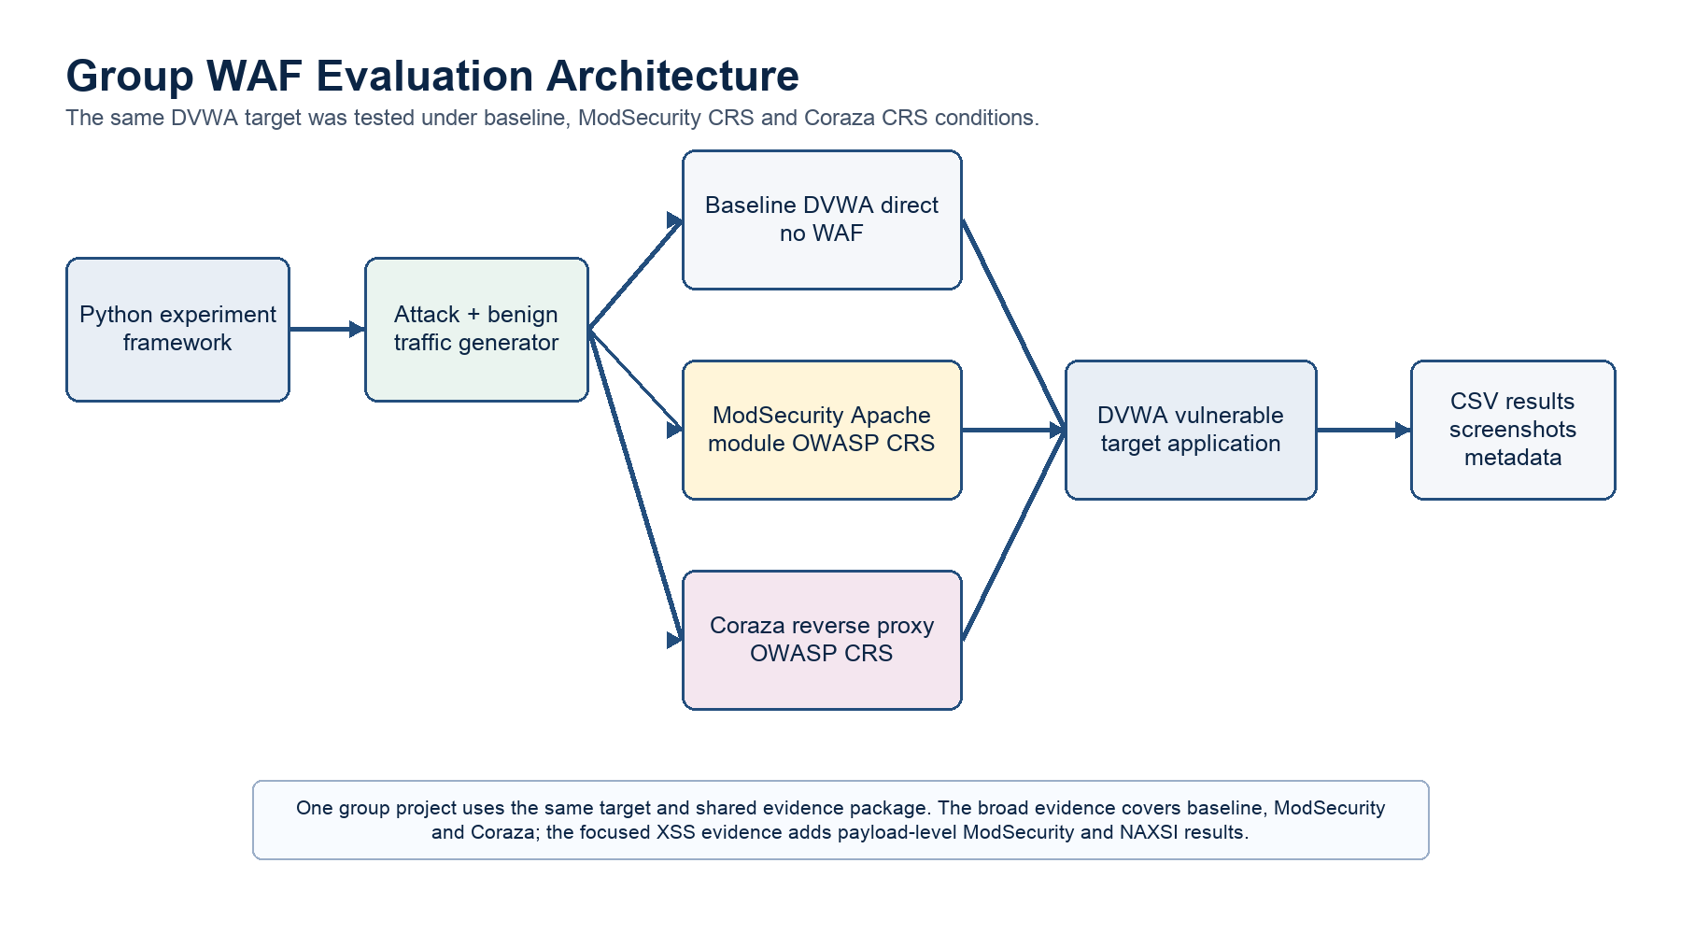
Figure 1. Integrated group WAF evaluation architecture.
The report gives priority to cleaned structured CSV outputs because they are easier to audit than screenshots alone. Screenshots are useful support, but they can show only one moment. CSV files can be counted, filtered and checked against the tables.
Historical folders are included in the submission because they show earlier work and supporting material. However, they are not mixed into the latest validated result tables unless the evidence clearly supports the same claim. This protects the report from accidentally combining early runs with final runs.
The final ZIP is designed to satisfy the supervisor's request for more than a report. It includes the report, README, evidence map, scripts, datasets, result CSVs, screenshots and historical support folder. This means a marker can inspect both the writing and the supporting evidence.
Table 10. Updated evidence package audit.
Evidence area | What it contains | How it is used in the report
analysis/final | Final CSV and Markdown outputs for broad evaluation. | Used for broad detection, confusion matrix, attack-class, benign and missed-attack tables.
output/*/*/*/run_* | Raw run folders with detailed.csv, summary.csv, metadata and validation files. | Supports traceability from final numbers back to raw request rows.
manual_tests | Updated manual SQLi and CSRF validation scripts, payloads and result CSVs. | Added as targeted validation evidence, not a replacement for headline automated results.
docs/week3 to docs/week10 | Historical weekly testing notes and tool outputs. | Used as background and traceability evidence only where consistent with final validated CSVs.
RESULTS_INDEX.md and ANALYSIS_GUIDE.md | Supervisor-facing maps of completed datasets and analysis outputs. | Used to confirm dataset coverage and missing broad NAXSI structured data.
latest_xss_evidence | Focused reflected-XSS payload-level scripts, screenshots and CSVs. | Supports ModSecurity and NAXSI reflected-XSS results only.

Table 11. Completed structured run folders in the updated package.
Run | Folder | Coverage | Use
Baseline attack-only | output/baseline/attack_only/none/run_20260519_063833 | 468 attack rows, 0 benign rows | Structured raw detailed.csv, summary.csv and validation evidence.
Baseline mixed-medium | output/baseline/mixed/medium/run_20260519_074733 | 665 attack rows, 5,325 benign rows | Main no-WAF mixed reference point.
ModSecurity attack-only | output/modsec/attack_only/none/run_20260519_064610 | 465 attack rows, 0 benign rows | Structured ModSecurity attack-only evidence.
ModSecurity mixed-medium | output/modsec/mixed/medium/run_20260519_033300_rerun | 661 attack rows, 5,278 benign rows | Main ModSecurity mixed result used in broad evaluation.
Coraza attack-only | output/coraza/attack_only/none/run_20260519_074907 | 463 attack rows, 0 benign rows | Structured Coraza attack-only evidence.
Coraza mixed-medium | output/coraza/mixed/medium/run_20260519_064803 | 653 attack rows, 5,220 benign rows | Main Coraza mixed result used in broad evaluation.

The lab used DVWA as the controlled vulnerable application. The broad framework used repeatable Python modules and analysis scripts. The focused XSS study used payload-building and replay scripts with CSV outputs. The historical evidence folder contains supporting material from earlier work, but it is not treated as the latest validated data.
Table 12. Evidence source priority.
Evidence source | Role in the final report | Limitation
waf-project/analysis/final | Primary evidence for the broad evaluation broad multi-attack results. | Does not provide broad structured NAXSI results.
latest_xss_evidence/zap-waf-framework/results/xss | Primary evidence for the focused XSS evaluation focused reflected-XSS results. | Reflected-XSS only.
latest_xss_evidence scripts | Reproducibility evidence for payload building and replay. | Requires matching lab setup.
waf-project/framework and scripts | Broad experiment and analysis code. | Commands must be run in the correct lab state.
historical_evidence/WAF Ongoing | Historical supporting screenshots and scripts. | Historical support only, not latest validated results.

8. Methodology

Why each method step matters
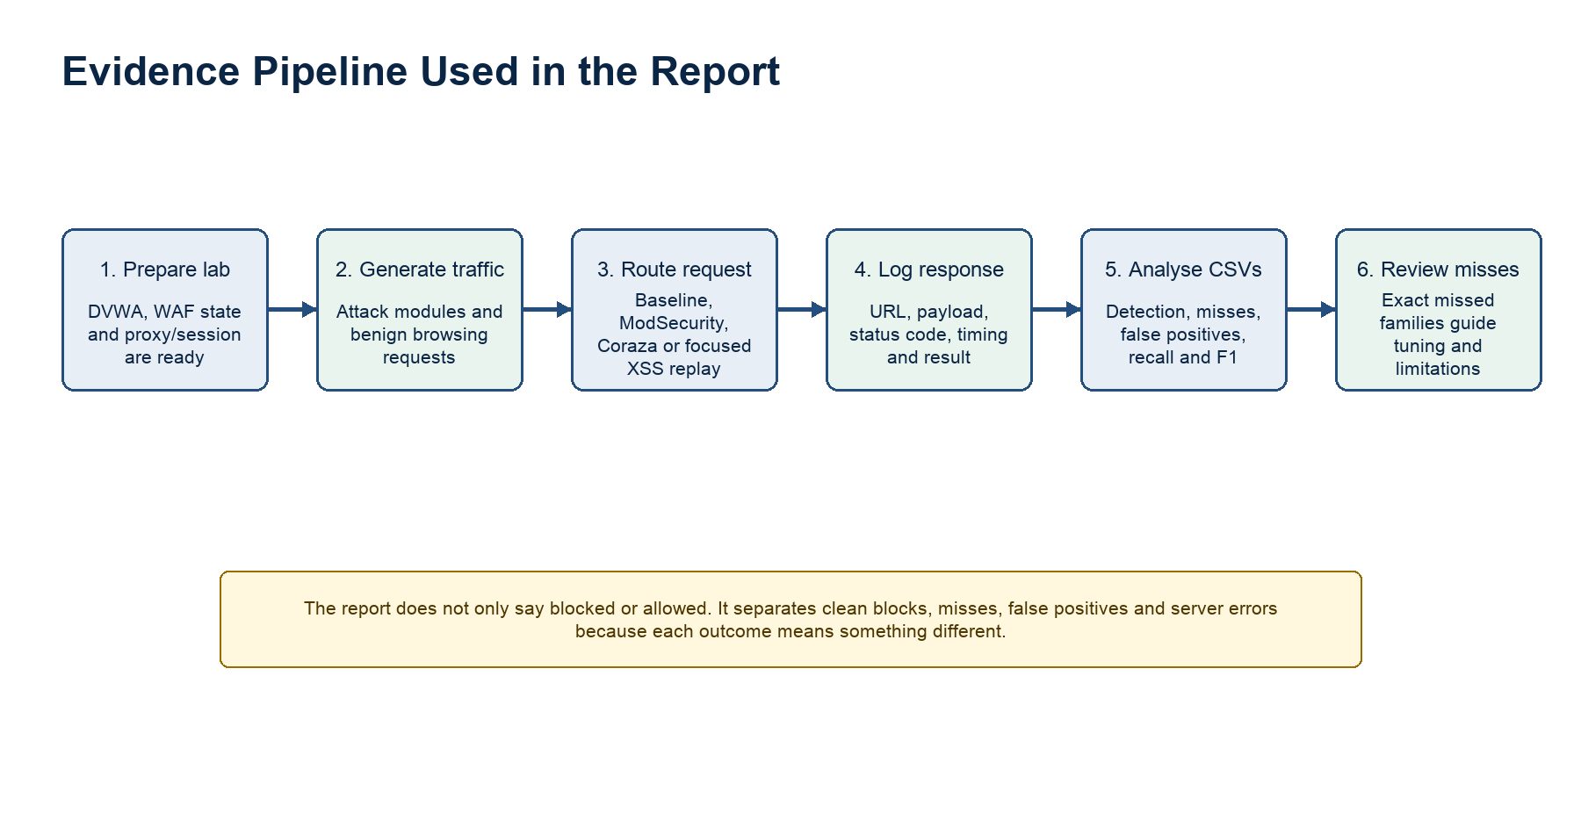
Figure 2. Evidence pipeline showing how requests become report results.
The no-WAF baseline matters because it proves the target application itself did not block the attack requests in the same way. In the broad evaluation, the baseline blocked 0.00% of controlled attack requests. This gives a reference point for measuring the value added by the WAF.
Mixed traffic matters because real websites do not receive only attacks. They also receive normal users. If a WAF blocks attacks but also blocks normal users, the organisation may face operational problems. That is why false positives are included, even though they were 0.00% in the available benign traffic.
Manual missed-payload review matters because numbers alone can mislead. If 16 payloads are missed, the next question is which 16. Some may be weak fragments that do not execute by themselves. Others may be dangerous in the right HTML context. The report therefore explains missed families rather than only missed totals.
Table 13. Response-code classification used for interpretation.
Response type | How it is interpreted | Important caution
403, 406 or 501 | Treated as a clean block where the script uses that rule. | This suggests the request was stopped, but audit logs would provide stronger rule-level proof.
200-299 | Treated as allowed. | If the request is malicious, this becomes a miss.
500-level | Treated as server error. | A server error is not counted as a clean WAF block because it may not be an intentional detection.

The methodology is the most important part of the study because it explains how the numbers were produced. The group did not simply run a scanner and report the output. The work involved defining WAF conditions, sending controlled traffic, recording response codes and analysing results.
- First, the DVWA target was prepared so there was a vulnerable application to test safely.
- Second, one WAF condition was tested at a time. This matters because mixed configurations would make results unclear.
- Third, a no-WAF baseline was collected. The baseline shows what happens without WAF protection.
- Fourth, attack-only and mixed-traffic runs were generated. Mixed traffic is important because real systems receive normal and malicious traffic together.
- Fifth, status codes and response times were logged. These raw observations are the basis of the CSV results.
- Sixth, the analysis scripts produced summary tables, attack-class breakdowns and confusion matrices.
- Finally, missed attacks were reviewed because a high detection rate can still hide important bypass patterns.
A clean block means the WAF appears to have intentionally stopped the request. In this project, HTTP 403, 406 and 501 are treated as clean blocks where the script uses that classification. HTTP 200-299 responses are treated as allowed. HTTP 500-level responses are treated as server errors. Server errors can indicate disruption, but they are not counted as successful WAF detections.

9. Broad Multi-Attack Evaluation

How to understand the broad result
The broad evaluation shows that the WAFs improved protection compared with the baseline, but they did not block everything. The no-WAF baseline blocked 0.00%. ModSecurity and Coraza both detected about one third of malicious requests in the medium mixed run. This means they added measurable protection, but many attacks still required application-side controls or rule tuning.
The small difference between ModSecurity and Coraza should not be overstated. Their broad detection values are close: about 34.95% for ModSecurity and about 35.07% for Coraza. In a university report, this should be described as similar behaviour rather than a strong win for either WAF.
The broad attack-class result also teaches an important security lesson. WAFs are usually better at requests that contain recognisable attack text. They are less reliable for attacks that look like normal web actions but should be rejected because of business rules, user permissions or session design.
Table 14. Broad result interpretation for a non-specialist reader.
Finding | Simple interpretation | Practical meaning
Baseline 0.00% blocked | Without a WAF, the controlled attack traffic was not blocked by the WAF layer. | This shows why adding a WAF can make a measurable difference.
ModSecurity about 34.95% | ModSecurity blocked about one third of malicious requests in the tested mixed medium setting. | Useful protection, but not complete protection.
Coraza about 35.07% | Coraza behaved very similarly to ModSecurity in the tested broad setting. | Do not claim a clear broad winner from this small difference.
0.00% observed false positives | The available benign traffic was not blocked by mistake. | Good sign for tested usability, but real workflows still need testing.

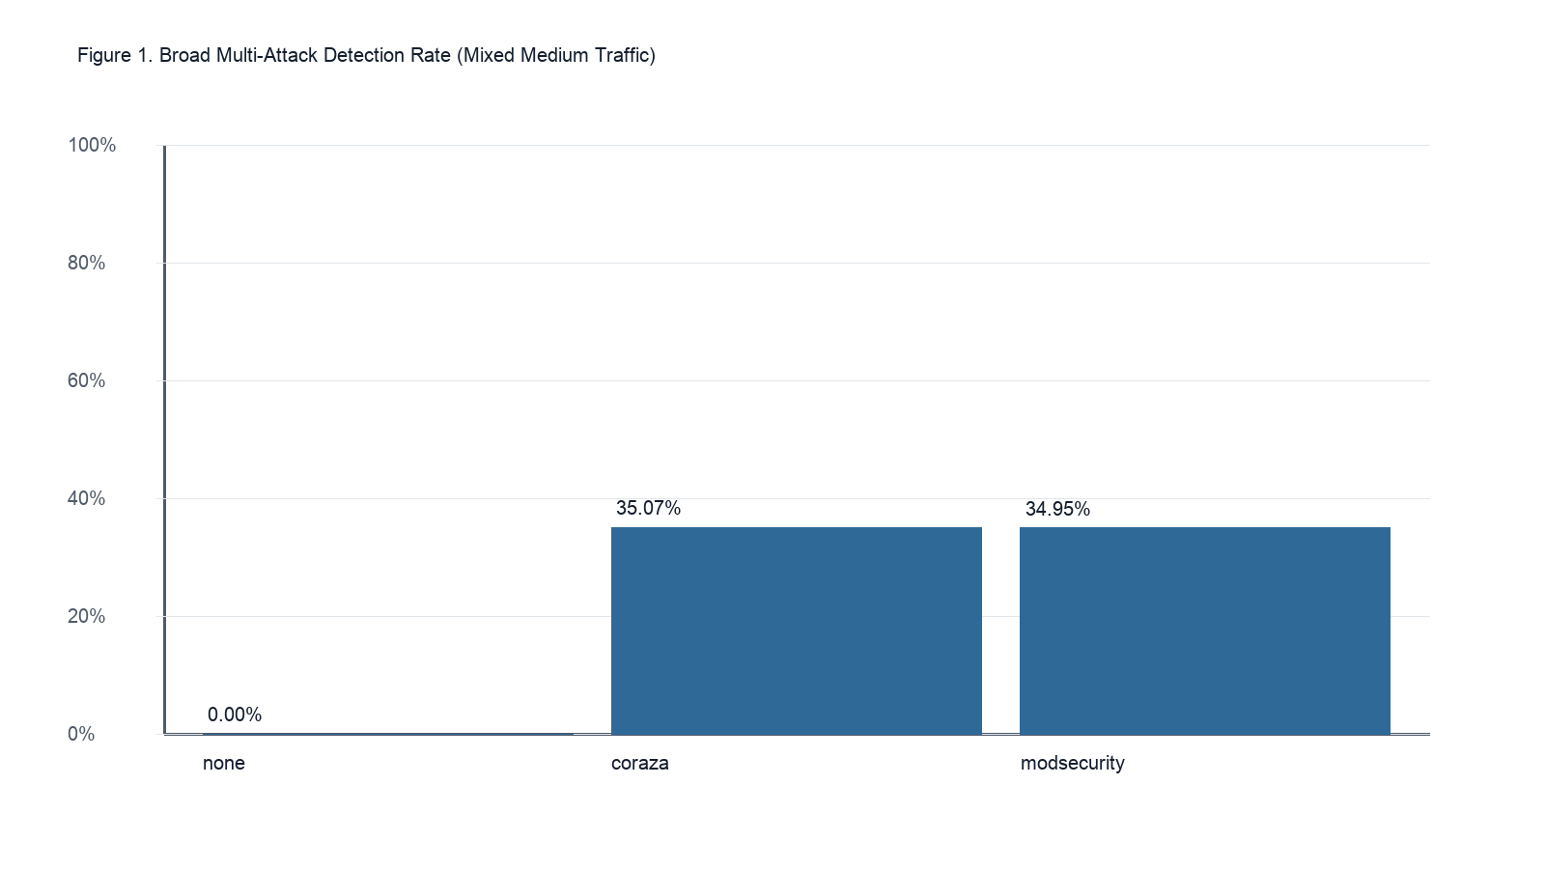
Figure 3. Broad multi-attack detection rate under medium mixed traffic.
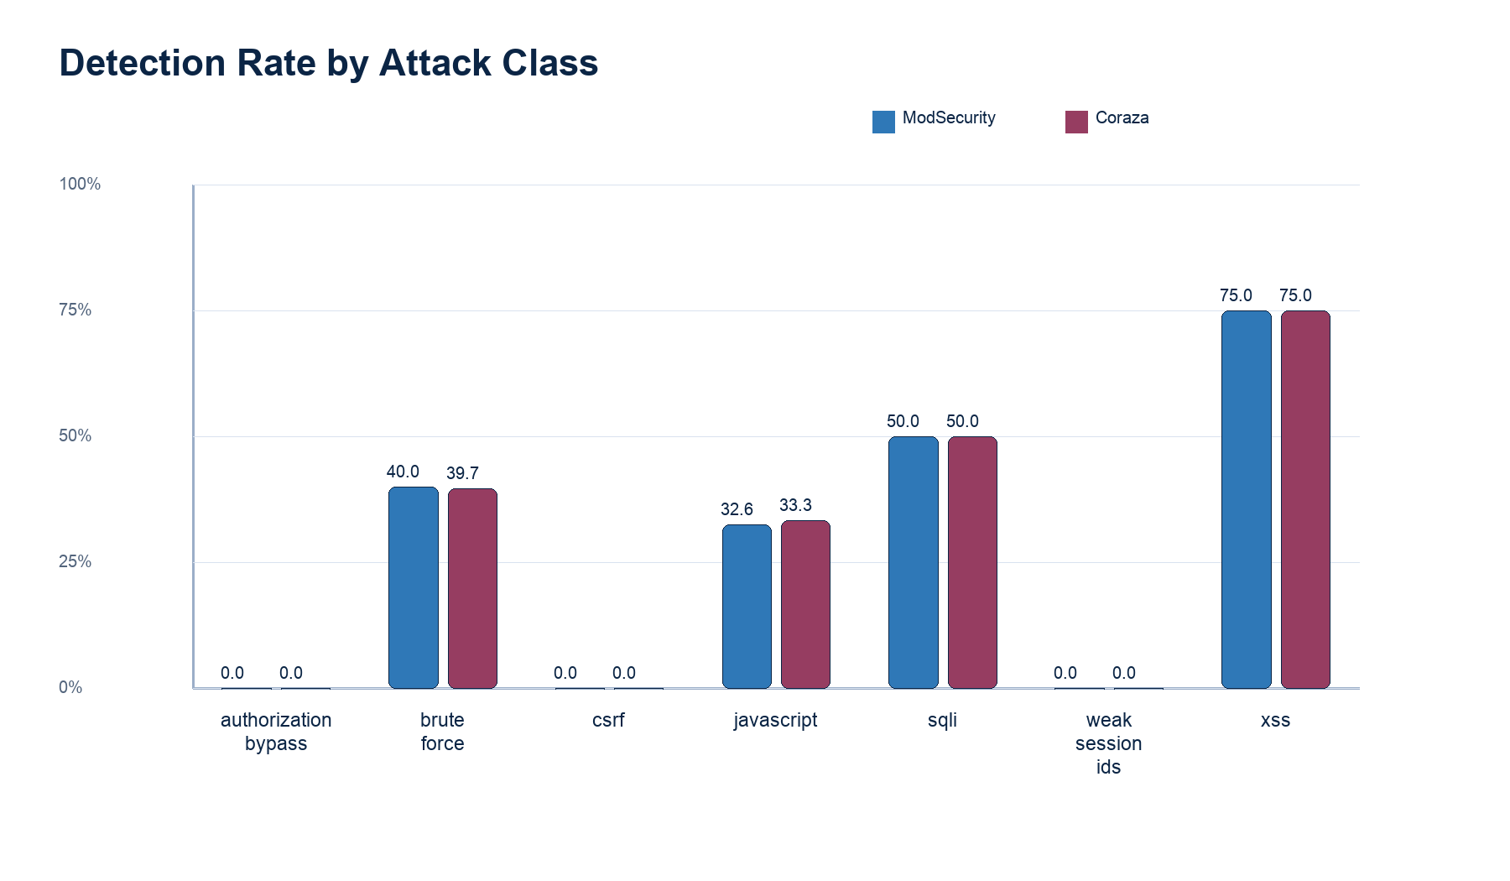
Figure 4. Detection rate by attack class for ModSecurity and Coraza.
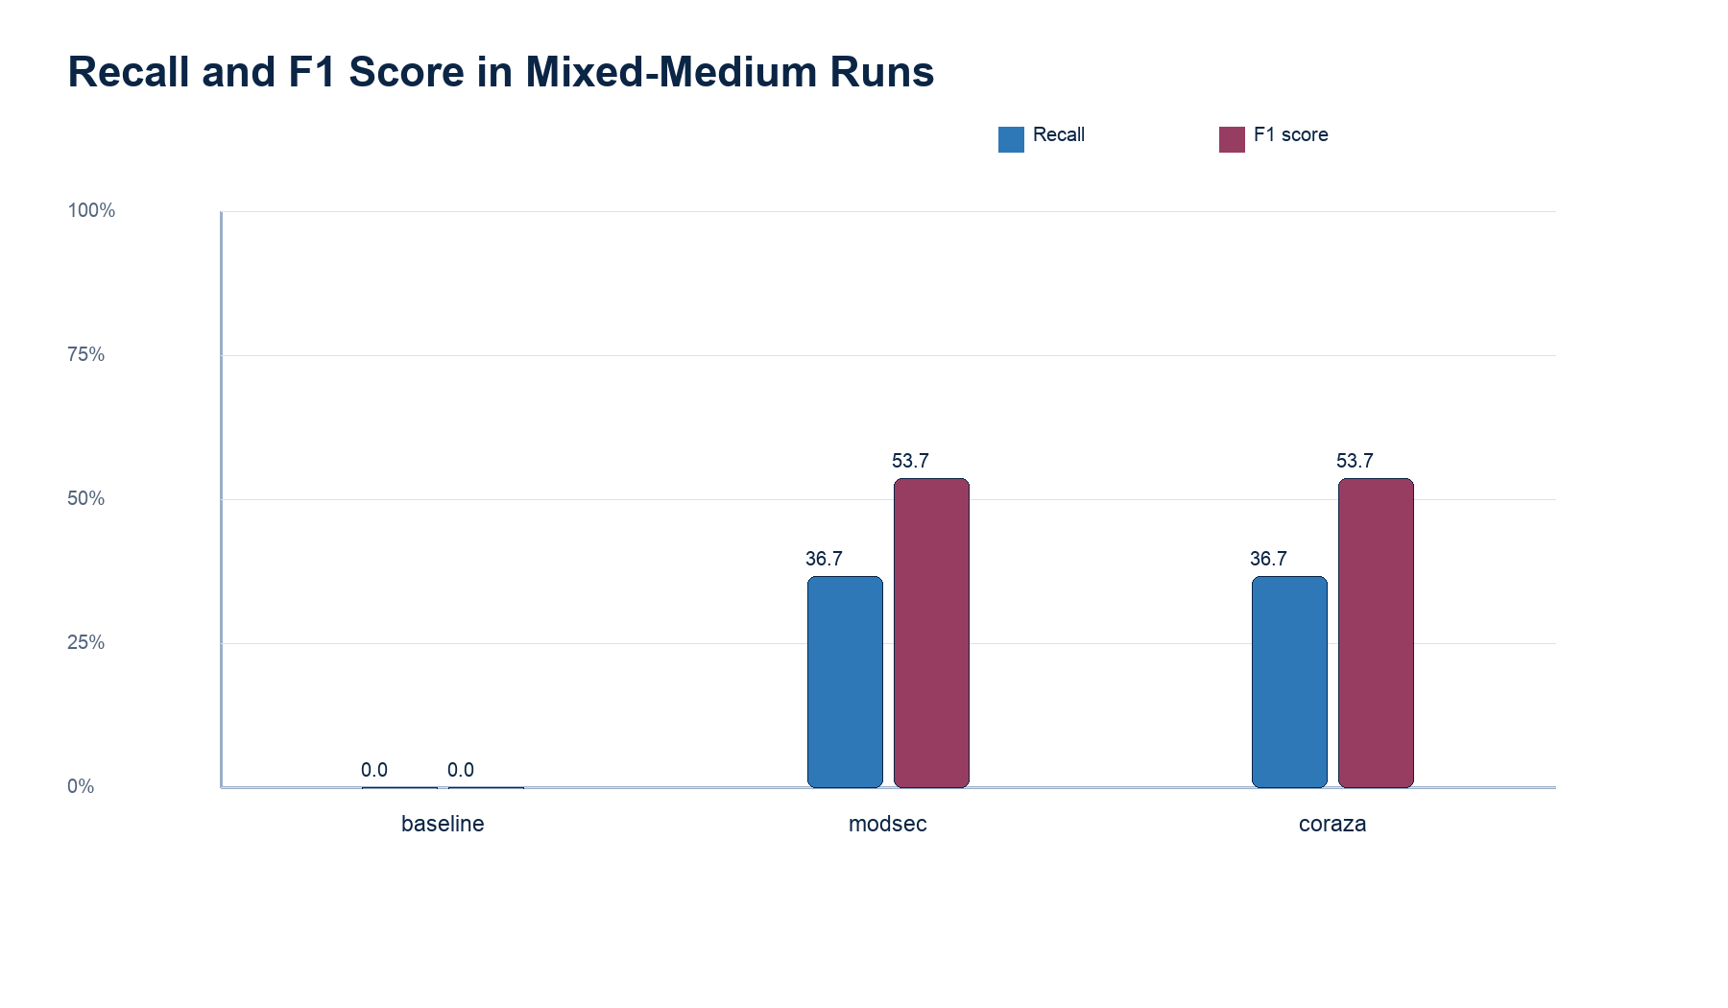
Figure 5. Recall and F1 score in the mixed-medium broad evaluation.
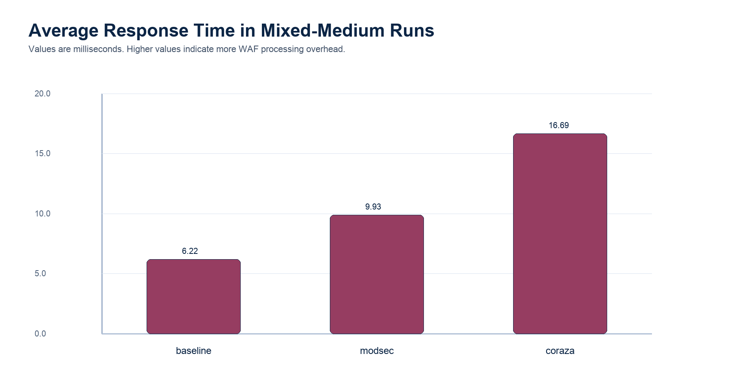
Figure 6. Average response time in the mixed-medium broad evaluation.
Table 15. Overall results from the broad multi-attack evaluation.
WAF | Phase | Load | Detection | False positive | Avg response ms | Server-error rate
none | attack_only | none | 0.00% | 0.00% | 6.196 | 4.49%
none | mixed | medium | 0.00% | 0.00% | 6.220 | 0.48%
coraza | attack_only | none | 34.77% | 0.00% | 9.022 | 4.54%
coraza | mixed | medium | 35.07% | 0.00% | 16.686 | 0.49%
modsecurity | attack_only | none | 34.84% | 0.00% | 7.946 | 4.52%
modsecurity | mixed | medium | 34.95% | 0.00% | 9.925 | 0.52%

Table 16. Broad confusion matrix under medium mixed traffic.
WAF | Attack rows | Benign rows | TP | FN | Excluded/server-error rows | FP | TN | Precision | Recall | F1
none | 665 | 5325 | 0 | 636 | 29 | 0 | 5325 | 0.000 | 0.000 | 0.000
coraza | 653 | 5220 | 229 | 395 | 29 | 0 | 5220 | 1.000 | 0.367 | 0.537
modsecurity | 661 | 5278 | 231 | 399 | 31 | 0 | 5278 | 1.000 | 0.367 | 0.537
Note: Attack rows include all malicious rows. Some rows produced server errors and are not counted as either clean blocks or clean misses. For this reason, TP + FN are lower than the total attack rows.

Table 17. Detection by attack class under medium mixed traffic.
WAF | Attack type | Sent | Blocked | Allowed | Server error | Detection | Avg ms
none | authorization_bypass | 56 | 0 | 56 | 0 | 0.00% | 5.165
none | brute_force | 145 | 0 | 145 | 0 | 0.00% | 5.559
none | csrf | 58 | 0 | 58 | 0 | 0.00% | 5.183
none | javascript | 87 | 0 | 87 | 0 | 0.00% | 5.165
none | sqli | 116 | 0 | 87 | 29 | 0.00% | 5.843
none | weak_session_ids | 87 | 0 | 87 | 0 | 0.00% | 4.715
none | xss | 116 | 0 | 116 | 0 | 0.00% | 4.902
coraza | authorization_bypass | 56 | 0 | 56 | 0 | 0.00% | 11.498
coraza | brute_force | 141 | 56 | 85 | 0 | 39.72% | 10.451
coraza | csrf | 56 | 0 | 56 | 0 | 0.00% | 12.194
coraza | javascript | 84 | 28 | 56 | 0 | 33.33% | 10.103
coraza | sqli | 116 | 58 | 29 | 29 | 50.00% | 8.642
coraza | weak_session_ids | 84 | 0 | 84 | 0 | 0.00% | 12.240
coraza | xss | 116 | 87 | 29 | 0 | 75.00% | 7.867
modsecurity | authorization_bypass | 56 | 0 | 56 | 0 | 0.00% | 7.851
modsecurity | brute_force | 145 | 58 | 87 | 0 | 40.00% | 7.226
modsecurity | csrf | 58 | 0 | 56 | 2 | 0.00% | 7.430
modsecurity | javascript | 86 | 28 | 58 | 0 | 32.56% | 6.136
modsecurity | sqli | 116 | 58 | 29 | 29 | 50.00% | 6.565
modsecurity | weak_session_ids | 84 | 0 | 84 | 0 | 0.00% | 7.025
modsecurity | xss | 116 | 87 | 29 | 0 | 75.00% | 6.091

The evidence indicates that ModSecurity and Coraza behaved very similarly in the broad framework. Under medium mixed traffic, ModSecurity detected 34.947% and Coraza detected 35.069%. This difference is very small, so it should not be presented as a clear victory for either WAF in the broad evaluation.
The attack-class table is more useful than the overall rate alone. XSS and SQL injection were the strongest broad detection categories. Brute force and JavaScript tampering were partially blocked. CSRF, weak session IDs and authorisation bypass were not blocked well because these problems often depend on application logic and session design rather than a visible malicious payload.
The false positive rate was 0.00% in the available benign traffic. This is positive for usability in the tested lab, because normal user actions were not blocked. However, the benign traffic model was limited, so a production deployment would still need testing with real user workflows.

10. Focused Reflected-XSS Payload-Level Evaluation

Why the focused XSS evidence goes deeper
XSS is not one single string. Attackers can change case, use different tags, use event handlers, encode characters or use fragments that become dangerous only in certain HTML positions. A payload-level study is useful because it shows which variations are detected and which variations are missed.
In the focused reflected-XSS evaluation, both WAFs were tested against the same 1,774 reflected-XSS payloads. ModSecurity blocked 1,669 and missed 105, giving 94.08% detection. NAXSI blocked 1,758 and missed 16, giving 99.10% detection. This is strong evidence for NAXSI in this particular reflected-XSS evidence area, but not proof of broad superiority.
For a non-specialist reader, reflected XSS can be imagined as a website echoing back unsafe input. If a user enters a script-like value and the website prints it back into the page without safe handling, the browser may treat it as code. A WAF tries to stop the request before that happens.
The broad evaluation and focused XSS evaluation are not directly comparable because they used different datasets, attack scopes and test scripts. the broad evaluation measures broad multi-attack behaviour across several web attack classes, while the focused XSS evaluation measures reflected-XSS payload-level detection only. The two evidence areas are therefore used together to understand different aspects of open-source WAF effectiveness rather than to rank every WAF across every possible attack.
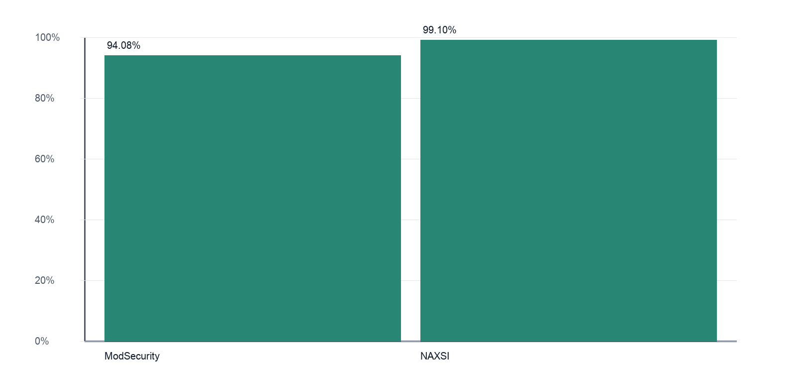
Figure 7. Focused reflected-XSS detection rate.

Table 18. Focused reflected-XSS summary.
WAF | Payloads tested | Blocked | Missed | Detection
ModSecurity + OWASP CRS | 1774 | 1669 | 105 | 94.08%
NAXSI | 1774 | 1758 | 16 | 99.10%

Table 19. ModSecurity reflected-XSS category results.
WAF | Category | Total | Valid tested | Blocked | Missed | Block rate
ModSecurity | misc_xss | 205 | 205 | 178 | 27 | 86.83%
ModSecurity | html_entity_encoded_xss | 165 | 165 | 104 | 61 | 63.03%
ModSecurity | javascript_uri_xss | 545 | 545 | 545 | 0 | 100.00%
ModSecurity | svg_xss | 76 | 76 | 76 | 0 | 100.00%
ModSecurity | event_handler_xss | 377 | 377 | 365 | 12 | 96.82%
ModSecurity | iframe_xss | 11 | 11 | 11 | 0 | 100.00%
ModSecurity | script_tag_xss | 329 | 329 | 329 | 0 | 100.00%
ModSecurity | url_encoded_xss | 17 | 17 | 17 | 0 | 100.00%
ModSecurity | polyglot_xss | 26 | 26 | 26 | 0 | 100.00%
ModSecurity | img_xss | 12 | 12 | 12 | 0 | 100.00%
ModSecurity | brutelogic_xss | 11 | 11 | 6 | 5 | 54.55%

Table 20. NAXSI reflected-XSS category results.
WAF | Category | Total | Valid tested | Blocked | Missed | Block rate
NAXSI | misc_xss | 205 | 205 | 202 | 3 | 98.54%
NAXSI | html_entity_encoded_xss | 165 | 165 | 165 | 0 | 100.00%
NAXSI | javascript_uri_xss | 545 | 545 | 545 | 0 | 100.00%
NAXSI | svg_xss | 76 | 76 | 76 | 0 | 100.00%
NAXSI | event_handler_xss | 377 | 377 | 365 | 12 | 96.82%
NAXSI | iframe_xss | 11 | 11 | 11 | 0 | 100.00%
NAXSI | script_tag_xss | 329 | 329 | 329 | 0 | 100.00%
NAXSI | url_encoded_xss | 17 | 17 | 16 | 1 | 94.12%
NAXSI | polyglot_xss | 26 | 26 | 26 | 0 | 100.00%
NAXSI | img_xss | 12 | 12 | 12 | 0 | 100.00%
NAXSI | brutelogic_xss | 11 | 11 | 11 | 0 | 100.00%

For this specific reflected-XSS dataset, NAXSI blocked more payloads than ModSecurity. ModSecurity blocked 1,669 out of 1,774 payloads. NAXSI blocked 1,758 out of 1,774 payloads. The evidence therefore indicates stronger NAXSI performance only in this focused reflected-XSS payload-level study.
Detection rate alone is not enough. A WAF can block most payloads and still miss a family of payloads that matters for a particular application. This is why the missed-payload tables below are important.
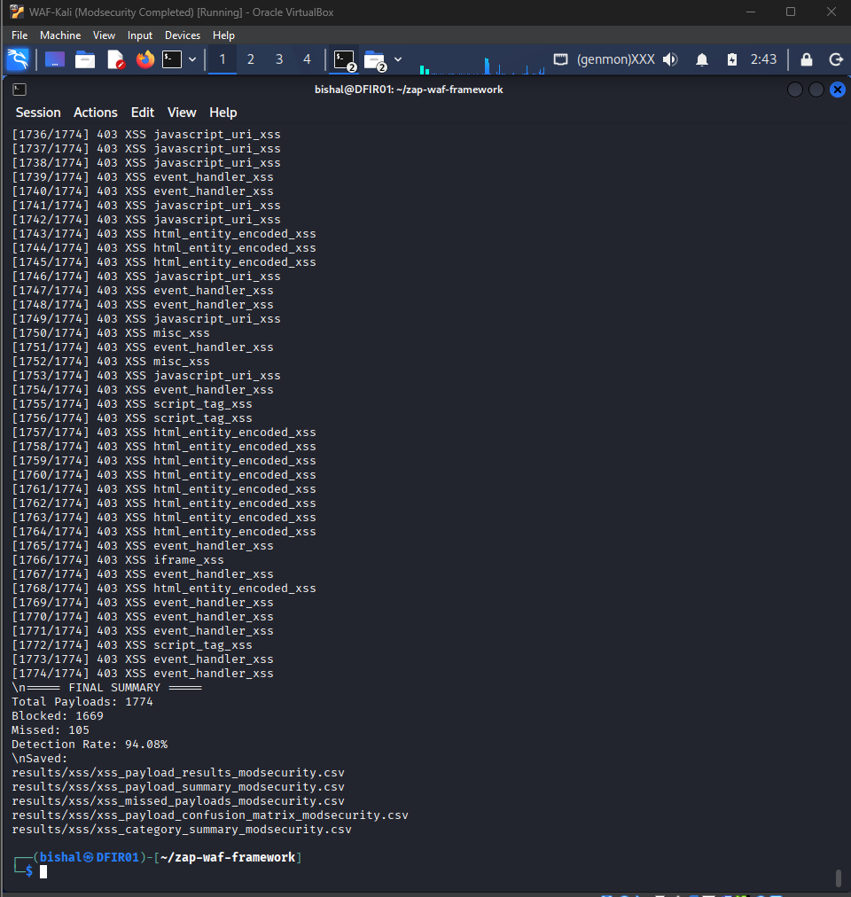
Figure 8. ModSecurity final reflected-XSS run summary.
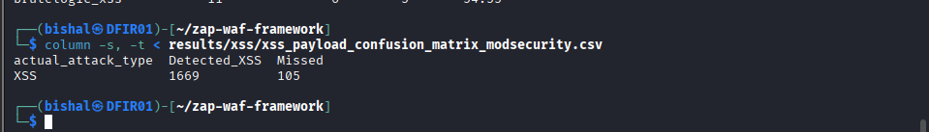
Figure 9. ModSecurity reflected-XSS confusion matrix.
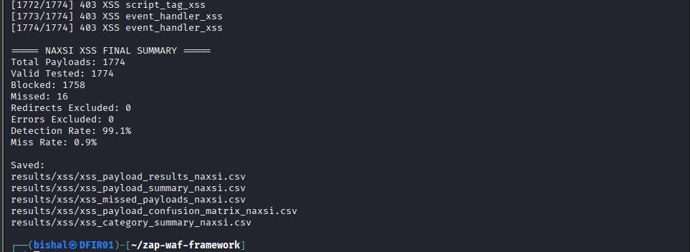
Figure 10. NAXSI final reflected-XSS run summary.
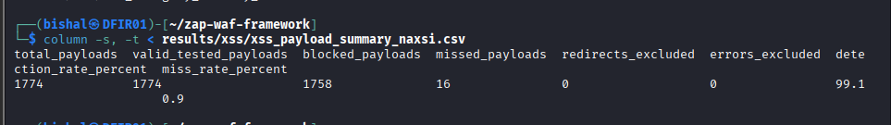
Figure 11. NAXSI reflected-XSS confusion matrix.

11. Missed Attack and Missed Payload Analysis

Additional manual SQLi and CSRF validation from the updated evidence package
The updated evidence package adds a manual_tests folder. This folder does not replace the main automated broad results or the focused reflected-XSS results. It adds targeted manual validation for SQL injection and CSRF-style requests, using small controlled payload sets so that each outcome can be inspected.
For SQL injection, the manual scripts tested 12 payloads against the baseline, ModSecurity and Coraza. The baseline allowed 10 of 12 payloads and produced 2 server errors. ModSecurity and Coraza each cleanly blocked 10 of 12 payloads. The two remaining SQLi cases produced HTTP 500 server errors, so they are not counted as clean WAF blocks.
For CSRF, the manual scripts tested 5 password-change style requests. Baseline allowed all 5 requests. ModSecurity and Coraza each produced 1 clean block and 4 redirects. The report treats those redirects as not clean WAF detections. The single CSRF clean block is interpreted carefully because it may reflect generic input inspection of special characters rather than true understanding of the CSRF workflow.
Table 21. Manual SQL injection validation summary.
Environment | Sent | Clean blocked | Allowed | Server errors | Detection | Allowed rate | Avg ms
baseline | 12 | 0 | 10 | 2 | 0.00% | 83.33% | 1.89
coraza | 12 | 10 | 0 | 2 | 83.33% | 0.00% | 2.89
modsec | 12 | 10 | 0 | 2 | 83.33% | 0.00% | 2.18

Table 22. Manual CSRF validation summary.
Environment | Sent | Clean blocked | Allowed | Redirected | Clean block rate | Redirect rate | Avg ms
baseline | 5 | 0 | 5 | 0 | 0.00% | 0.00% | 1.94
coraza | 5 | 1 | 0 | 4 | 20.00% | 80.00% | 4.37
modsec | 5 | 1 | 0 | 4 | 20.00% | 80.00% | 2.94

Table 23. Manual confusion-style summary.
Attack family | Environment | Attack requests | TP clean blocks | FN allowed | Redirected not clean | Server error not clean | Clean block recall
csrf | coraza | 5 | 1 | 0 | 4 | 0 | 20.00%
csrf | modsec | 5 | 1 | 0 | 4 | 0 | 20.00%
sqli | coraza | 12 | 10 | 0 | 0 | 2 | 83.33%
sqli | modsec | 12 | 10 | 0 | 0 | 2 | 83.33%
Note: this is attack-only manual evidence. It does not provide benign true negatives or false-positive rates; those should be read from the mixed/benign broad evidence.

Table 24. Manual SQLi cases not cleanly blocked.
Environment | Payload ID | Subtype | Evasion type | Payload | Status | Interpretation
modsec | SQLI001 | entry_point_detection | single_quote | ' | 500 | Server error, not a clean WAF block.
modsec | SQLI005 | error_based | basic_error | 1' | 500 | Server error, not a clean WAF block.
coraza | SQLI001 | entry_point_detection | single_quote | ' | 500 | Server error, not a clean WAF block.
coraza | SQLI005 | error_based | basic_error | 1' | 500 | Server error, not a clean WAF block.

Table 25. Manual SQLi transport baseline coverage.
Transport location | Count | Evidence status | Interpretation
cookie | 1 | Baseline-only transport evidence | Shows SQLi payload placement in query, form, JSON, header or cookie contexts. No WAF-side transport conclusion is made from this baseline-only file.
get_param | 2 | Baseline-only transport evidence | Shows SQLi payload placement in query, form, JSON, header or cookie contexts. No WAF-side transport conclusion is made from this baseline-only file.
header | 1 | Baseline-only transport evidence | Shows SQLi payload placement in query, form, JSON, header or cookie contexts. No WAF-side transport conclusion is made from this baseline-only file.
json_body | 2 | Baseline-only transport evidence | Shows SQLi payload placement in query, form, JSON, header or cookie contexts. No WAF-side transport conclusion is made from this baseline-only file.
post_form | 2 | Baseline-only transport evidence | Shows SQLi payload placement in query, form, JSON, header or cookie contexts. No WAF-side transport conclusion is made from this baseline-only file.
Note: the transport CSV in the updated package is baseline-only evidence. It shows how payload placement was considered, but it is not used to claim WAF transport-specific detection.

Table 26. ModSecurity missed reflected-XSS groups.
WAF | Missed family | Count | Identifying pattern | Example IDs | Practical interpretation
ModSecurity | html_entity_encoded_xss | 61 | Encoded characters such as numeric entities or named HTML entities. | XSS-00042, XSS-01249, XSS-01250 and related encoded variants. | Important where the application or browser decodes the input after inspection.
ModSecurity | misc_xss | 27 | Short JavaScript fragments, alert examples or documentation-like strings. | XSS-00047, XSS-00048, XSS-00078 and related JavaScript fragment examples. | Context-dependent; some strings may be low-signal until placed in code context.
ModSecurity | event_handler_xss | 12 | Event-handler words or fragments such as onload, onclick or onerror. | XSS-00216, XSS-00965, XSS-00966 and related event-handler examples. | Often not executable alone, but dangerous if inserted into an HTML attribute.
ModSecurity | brutelogic_xss | 5 | Evasion-style payloads designed to bypass simple filters. | XSS-01315 to XSS-01320, including BruteLogic-style evasion payloads. | Useful for custom-rule development and retesting.

Table 27. NAXSI missed reflected-XSS groups.
WAF | Missed family | Count | Identifying pattern | Example IDs | Practical interpretation
NAXSI | event_handler_xss | 12 | Event-handler words or fragments such as onload, onclick or onerror. | XSS-00216, XSS-00965, XSS-00966 and related event-handler examples. | Often not executable alone, but dangerous if inserted into an HTML attribute.
NAXSI | misc_xss | 3 | Short JavaScript fragments, alert examples or documentation-like strings. | XSS-00047, XSS-00048, XSS-00078 and related JavaScript fragment examples. | Context-dependent; some strings may be low-signal until placed in code context.
NAXSI | url_encoded_xss | 1 | URL-encoded characters or encoded script text. | XSS-01174 and related URL-encoded payload examples. | Suggests normalisation should be checked before rule matching.

Table 28. Broad missed-attack interpretation.
WAF | Attack type | Rows | Result types | Example request names | Simple interpretation
coraza | authorization_bypass | 56 | allowed: 56 | authorization_bypass_page_visit; authorization_bypass_controlled_admin_hint; authorization_bypass_page_visit | Usually requires application permission checks.
coraza | brute_force | 85 | allowed: 85 | brute_force_wrong_password_normal; brute_force_wrong_password_repeated_1; brute_force_wrong_password_repeated_2 | Often needs rate limiting, lockout or MFA.
coraza | csrf | 56 | allowed: 56 | csrf_page_visit; csrf_controlled_password_change_mismatch; csrf_page_visit | Usually requires application CSRF-token controls.
coraza | javascript | 56 | allowed: 56 | javascript_page_visit; javascript_expected_input; javascript_page_visit | Depends on whether tampering produces recognisable attack syntax.
coraza | sqli | 58 | allowed: 29, server_error: 29 | sqli_safe_id_1; sqli_single_quote; sqli_safe_id_1 | Some rows became server errors; server errors are not clean blocks.
coraza | weak_session_ids | 84 | allowed: 84 | weak_session_ids_page_visit_1; weak_session_ids_page_visit_2; weak_session_ids_generate | Usually requires stronger session generation and validation.
coraza | xss | 29 | allowed: 29 | xss_safe_name_test; xss_safe_name_test; xss_safe_name_test | Some simple or context-dependent XSS patterns were allowed.
modsecurity | authorization_bypass | 56 | allowed: 56 | authorization_bypass_page_visit; authorization_bypass_controlled_admin_hint; authorization_bypass_page_visit | Usually requires application permission checks.
modsecurity | brute_force | 87 | allowed: 87 | brute_force_wrong_password_normal; brute_force_wrong_password_repeated_1; brute_force_wrong_password_repeated_2 | Often needs rate limiting, lockout or MFA.
modsecurity | csrf | 58 | allowed: 56, server_error: 2 | csrf_page_visit; csrf_controlled_password_change_mismatch; csrf_page_visit | Usually requires application CSRF-token controls.
modsecurity | javascript | 58 | allowed: 58 | javascript_page_visit; javascript_expected_input; javascript_page_visit | Depends on whether tampering produces recognisable attack syntax.
modsecurity | sqli | 58 | allowed: 29, server_error: 29 | sqli_safe_id_1; sqli_single_quote; sqli_safe_id_1 | Some rows became server errors; server errors are not clean blocks.
modsecurity | weak_session_ids | 84 | allowed: 84 | weak_session_ids_page_visit_1; weak_session_ids_page_visit_2; weak_session_ids_generate | Usually requires stronger session generation and validation.
modsecurity | xss | 29 | allowed: 29 | xss_safe_name_test; xss_safe_name_test; xss_safe_name_test | Some simple or context-dependent XSS patterns were allowed.

The ModSecurity missed groups were mainly HTML entity encoded XSS, miscellaneous JavaScript fragments, event-handler fragments and BruteLogic-style payloads. Encoded payloads matter because the application or browser may decode them after the WAF has inspected the request. Event-handler strings may not execute by themselves, but they can become dangerous if placed into an HTML attribute.
The NAXSI missed groups were smaller in this dataset. Many were event-handler fragments or low-signal strings. This does not mean they should be ignored. Instead, they should be reviewed in the context of the application. If a parameter should never contain event-handler text, a custom rule may be appropriate.
Missed attack analysis can guide tuning. Custom rules should target the missed family, not just one exact payload. After tuning, the WAF should be retested with both malicious and benign traffic because stronger rules can accidentally increase false positives.

12. Reproducibility and Script Usage

How the scripts should be used
The scripts should be read as a workflow. First, the lab must be running. DVWA, the selected WAF and any proxy settings must be ready. Second, the experiment script sends traffic. Third, the logger writes raw rows. Fourth, the analysis script turns raw rows into final summaries. Running the analysis without the correct raw output folder will not reproduce the same tables.
The README in the submission package explains the expected folder organisation. The evidence map explains which files support which report claims. This is important because the final submission is not only a written report; it is also a reproducible evidence package.
If the group reruns the tests, old result folders should be kept apart from new result folders. This prevents accidentally mixing historical evidence with final validated evidence.
Table 29. Script usage and reproducibility guide.
Script | Purpose | Example command | Expected output | How to interpret output
framework/experiment_runner.py | Runs broad framework experiments. | python3 -m framework.experiment_runner --env modsec --phase mixed --load-level medium --duration 180 --output-root output --use-zap-proxy --assume-ready | Structured run folders and request logs. | Used later by metrics_analysis.py to calculate detection and false positive rates.
framework/attack_modules.py | Defines attack request families. | Imported by experiment_runner.py | Generated attack traffic. | Shows which attack classes were represented in broad runs.
framework/traffic_generator.py | Generates benign traffic. | Imported by experiment_runner.py | Normal user-like requests. | Supports false positive measurement.
framework/zap_controller.py | Connects framework runs to OWASP ZAP. | Use experiment_runner.py with --use-zap-proxy | ZAP-assisted request capture. | Helps preserve request and response evidence.
framework/data_logger.py | Writes request-level evidence. | Imported by experiment_runner.py | CSV/log rows with status and timing. | Raw basis for later summaries.
analysis/metrics_analysis.py | Calculates final broad metrics. | python3 analysis/metrics_analysis.py output/ --out analysis/final/final_summary.csv | final_summary.csv and related CSVs. | Main source for the broad evaluation result tables.
scripts/validate_structure.py | Checks project folder structure. | python3 scripts/validate_structure.py | Validation output. | Helps confirm submission layout.
scripts/list_experiment_coverage.py | Lists available experiment coverage. | python3 scripts/list_experiment_coverage.py | Coverage report. | Helps identify missing or available runs.
build_big_xss_dataset.py | Builds the focused XSS payload dataset. | python3 build_big_xss_dataset.py | research_xss_payloads_big.csv. | Shows how the XSS payload set was constructed.
xss_payload_replay_modsecurity.py | Replays focused XSS payloads against ModSecurity. | python3 xss_payload_replay_modsecurity.py | ModSecurity XSS result CSVs. | Source for ModSecurity the focused XSS evaluation totals and misses.
test_naxsi_xss_payloads.py | Replays focused XSS payloads against NAXSI. | python3 test_naxsi_xss_payloads.py | NAXSI XSS result CSVs. | Source for NAXSI the focused XSS evaluation totals and misses.
manual_tests/manual_sqli_runner.py | Runs targeted manual SQL injection payload tests. | python3 manual_tests/manual_sqli_runner.py --env modsec | Manual SQLi result CSVs. | Supports the additional manual SQLi validation section.
manual_tests/manual_csrf_runner.py | Runs targeted manual CSRF-style password-change request tests. | python3 manual_tests/manual_csrf_runner.py --env coraza | Manual CSRF result CSVs. | Supports the additional manual CSRF validation section.
manual_tests/analyse_manual_evidence.py | Classifies manual SQLi and CSRF outcomes. | python3 manual_tests/analyse_manual_evidence.py | manual_classification_summary.csv and manual_confusion_style_summary.csv. | Separates clean WAF blocks from redirects and server errors.

13. How to Interpret CSVs, Screenshots and Response Codes

How to read the evidence without being a specialist
A CSV row is one recorded observation. It may contain the request type, WAF condition, response status, timing and classification. The final tables are created by counting many rows together. This is why the report can say how many payloads were blocked or missed.
Screenshots help the reader trust that the environment and outputs existed, but the numerical claims should come from CSVs where possible. If a screenshot and a CSV appear to disagree, the CSV should be checked first because it is easier to count and reproduce.
The confusion matrix is a simple four-way summary. A true positive is a malicious request correctly blocked. A false negative is a malicious request missed. A false positive is a normal request blocked by mistake. A true negative is a normal request correctly allowed.
Table 30. Confusion matrix terms in everyday language.
Term | Everyday meaning | Security meaning
True positive | A bad request was stopped. | The WAF correctly blocked an attack.
False negative | A bad request got through. | The WAF missed an attack.
False positive | A normal request was stopped by mistake. | The WAF disrupted a legitimate user action.
True negative | A normal request went through. | The WAF correctly allowed benign traffic.

CSV files are structured text files where each row records a result. The most important CSVs are final_summary.csv, confusion_matrices.csv, attack_class_breakdown.csv and the XSS result files. These files support the report tables. Screenshots are supporting evidence that show the test environment, WAF state or summary output, but CSVs are the main source for numerical claims.
A 403, 406 or 501 status is treated as a clean block where the script uses that classification. A 200-level status is treated as allowed. A 500-level status is a server error. Server errors should be reported, but they should not be counted as clean WAF detections because the WAF may not have intentionally blocked the request.

14. Practical Recommendations for Small Organisations

What a small organisation should do with these findings
The practical recommendation is not to install a WAF and assume the website is safe. The safer approach is to install the WAF, run tests against the actual application, review what was missed, tune rules carefully and then test normal user workflows to check for false positives.
For SQL injection and XSS, the organisation should also fix the application code. A WAF can reduce risk, but secure coding controls such as prepared database statements and safe output encoding are still needed. For CSRF, authorisation and sessions, application-side controls are especially important because the WAF may not understand the intended business rules.
Monitoring is also important. A WAF log can show which requests were blocked, which rules triggered and whether attackers are changing payloads. Without log review, the organisation may not learn from attempted attacks or tune the system effectively.
- Use an open-source WAF as defence in depth, not as the only security control.
- Test the WAF against the actual application because results depend on application behaviour.
- Use missed-payload analysis to tune rules for the application’s real input fields.
- Retest after tuning because stronger rules can create false positives.
- Monitor WAF logs so blocked and allowed attack attempts are visible.
- Use application-side controls for CSRF, authorisation and session security.
- Use rate limiting, account lockout and multi-factor authentication for brute-force protection.

15. Limitations and Future Work

Why limitations do not make the project weak
Good security reporting should state limitations clearly. A limitation does not mean the work is useless. It means the conclusion is honest. This project provides useful evidence for a controlled lab, but it does not prove that the same WAFs will behave the same way for every website, every configuration or every attack.
The most important limitation is scope. The broad evaluation covers several attack classes but is not deeply payload-level for every attack. The focused XSS evaluation is very detailed but only for reflected XSS. These evidence areas therefore complement each other as parts of one group investigation.
Future work should focus on repeated runs, broader benign traffic, audit-log confirmation and additional attack classes. This would make the evidence stronger and more useful for production decisions.
The study used DVWA in a controlled lab, not a production application. This makes the experiment safe and repeatable, but it means the results should not be treated as production-wide proof. Real applications have different forms, authentication logic, user workflows and business rules.
The broad structured framework supports baseline, ModSecurity and Coraza results. It does not support broad NAXSI claims. NAXSI is supported in the focused reflected-XSS study only. The focused XSS study does not prove SQL injection, path traversal, command injection or CSRF performance for NAXSI.
The available benign traffic produced 0.00% observed false positives, but real organisations should test a wider range of normal user workflows. Performance results also need more controlled repetition before strong production claims are made.
- Add NAXSI to the broad structured framework.
- Repeat runs and calculate statistical confidence.
- Test stored XSS, DOM-based XSS, path traversal, command injection, file upload and SSRF.
- Add richer benign workflows based on real user actions.
- Retest with tuned rules and different CRS paranoia levels.
- Add audit-log validation so response-code results can be linked more directly to WAF rule decisions.

16. Conclusion
For a non-technical reader, the final message is straightforward: open-source WAFs can help, but they are not magic shields. They can block many recognisable malicious requests, especially when rules match the payload pattern. They can also miss attacks, especially when the attack is encoded, context-dependent or based on application logic.
The strongest contribution of the project is the full evidence package. The report explains the method, the scripts show how the work was performed, the CSVs show the results, and the missed-payload analysis shows how results can guide practical tuning.
The evidence indicates that open-source WAFs can provide useful protection in a controlled laboratory setting. In the broad evaluation, ModSecurity and Coraza improved detection compared with the no-WAF baseline but did not block all attack classes. In the focused XSS evaluation, NAXSI performed better than ModSecurity for the specific reflected-XSS payload dataset. These findings support open-source WAFs as a cost-effective defence-in-depth layer, but not as complete protection.
The most useful outcome of the project is not a single winner. The useful outcome is an evidence-based method for testing WAFs, interpreting results and identifying missed payload families that can guide custom tuning.

17. References
- OWASP. OWASP Top 10. https://owasp.org/Top10/
- OWASP Core Rule Set Project. OWASP CRS documentation. https://coreruleset.org/
- OWASP ZAP Project. ZAP documentation. https://www.zaproxy.org/docs/
- Digininja. Damn Vulnerable Web Application (DVWA). https://github.com/digininja/DVWA
- Coraza WAF Project. Coraza Web Application Firewall. https://github.com/corazawaf/coraza
- NBS System. NAXSI Web Application Firewall for NGINX. https://github.com/nbs-system/naxsi
- sqlmap project. Automatic SQL injection and database takeover tool. https://github.com/sqlmapproject/sqlmap
- Sullo. Nikto web server scanner. https://github.com/sullo/nikto
- PortSwigger Web Security Academy. Cross-site scripting guidance. https://portswigger.net/web-security/cross-site-scripting
- PayloadsAllTheThings. XSS Injection payload repository. https://github.com/swisskyrepo/PayloadsAllTheThings/tree/master/XSS%20Injection

Appendix A: Evidence Map Summary
Table 31. Evidence map summary.
Evidence item | File or folder path | Claim supported | Notes
Broad final results | waf-project/analysis/final/*.csv | the broad evaluation detection, false positives, confusion matrices and attack-class results. | Primary broad evidence.
Focused XSS results | latest_xss_evidence/zap-waf-framework/results/xss/*.csv | the focused XSS evaluation totals, category results and missed payloads. | Reflected-XSS only.
Broad framework scripts | waf-project/framework, waf-project/analysis, waf-project/scripts | Reproducibility for broad framework. | Requires lab setup.
Focused XSS scripts | latest_xss_evidence/zap-waf-framework/*.py | Reproducibility for focused XSS replay. | Requires lab setup.
Historical support | historical_evidence/WAF Ongoing | Historical screenshots and earlier supporting files. | Not treated as latest validated evidence.
Manual SQLi and CSRF validation | waf-project/manual_tests | Additional targeted SQLi and CSRF evidence, manual classification summaries and supporting scripts. | Attack-only validation evidence; not used to replace headline broad or XSS result anchors.

Appendix B: Supervisor Feedback Coverage Map
This appendix maps the supervisor's main feedback to the final report sections. It shows that the report explains the method, tools, scripts, results, missed attacks and limitations in a way that supports both technical and non-technical readers.
Table 32. Supervisor feedback coverage.
Supervisor requirement | Where addressed
Scripts and how to use them | Reproducibility and script usage table.
Results and interpretation | the broad evaluation, the focused XSS evaluation and CSV interpretation sections.
Methodology and empirical variables | Research variables and methodology sections.
Confusion matrices | the broad evaluation confusion matrix table.
Detailed attack-class discussion | Attack class explanation table and the broad evaluation interpretation.
Missed attacks, not only totals | Missed attack and missed payload analysis.
Non-expert explanation of tools | Tool explanation table.
Attack anatomy | Anatomy of an attack request section.
Reflected, stored and DOM-based XSS | Attack class explanation table.
Why selected WAFs were chosen | Background and tool explanation sections.

