Shri Vile Parle Kelavani Mandal's
DWARKADAS J. SANGHVI COLLEGE OF ENGINEERING
(Autonomous College Affiliated to the University of Mumbai)
NAAC Accredited with "A" Grade (CGPA : 3.18)
DEPARTMENT OF COMPUTER ENGINEERING
PYTHON PROGRAMMING LABORATORY
(DJS23CEL304 / Experiment No. 13)
MINI-PROJECT REPORT
Campus-Only Marketplace System (UniSwap)
Live Deployment Portal: https://vrajprajapati.github.io/uniswap/
TEAM MEMBERS
Name | SAP ID | Roll No.
Vraj Prajapati | 60004250085 | C183
Faculty Sign: ___________________________ Date: 29.10.2026

1. Aim & Problem Statement
- AIM: Mini-Project: Campus-Only Marketplace System (UniSwap) — Design and implementation of a full-stack Python web application using Django and SQLite (All COs).
Problem Statement: College campus peer-to-peer exchanges for academic supplies—including STEM textbooks, graphing calculators, chemistry lab coats, and electronics—are heavily hindered by reliance on unmoderated public platforms like Facebook Marketplace or WhatsApp groups. Students face substantial privacy risks, lack of institutional verification, pricing exploitation, and off-campus security threats. To address this, our project implements UniSwap, a centralized, database-driven Campus-Only Marketplace System using Python's Django framework and SQLite3. UniSwap provides closed campus email validation, dynamic category filtering, image formsets, an enforced transaction state machine (Requested &rarr; Agreed &rarr; Completed), and tamper-proof seller rating aggregation with zero Insecure Direct Object Reference (IDOR) vulnerabilities.
2. Software, Technology Stack & Deployment Portal
- Backend Web Framework: Django 5.x (Python-based high-level framework implementing Model-View-Template architecture).
- Programming Language: Python 3.12 / 3.14 (Core backend logic, query processing, data validation, and cryptographic token signing).
- Database Engine: SQLite3 (Serverless, zero-configuration relational database integrated via Django ORM) with PostgreSQL support via dj-database-url.
- Frontend Stack: HTML5, CSS3, modern responsive layout utilities, and Django Template Language (DTL).
- IDE & Development Tools: Visual Studio Code (VS Code), Git / GitHub, Windows Terminal (PowerShell / cmd).
- Live Deployment Link: https://vrajprajapati.github.io/uniswap/
3. Implementation & Architectural Design
3.1 Purpose of Developing the Application Using Django (Python Web Application)
Developing the Campus Marketplace System using Django provides an enterprise-grade, scalable foundation that overcomes the limitations of standalone scripts:
- Decoupled MVT Architecture: Django strictly decouples data definitions (Model), request dispatchers and business rules (View), and visual interfaces (Template). This separation guarantees independent frontend UI updates and schema evolutions.
- Object-Relational Mapping (ORM): Instead of error-prone raw SQL queries, Django's ORM represents relational entities as Python classes, managing table constraints, composite indexes on (campus, status, category), and atomic transactions.
- Built-in Security & Input Sanitization: Django natively enforces CSRF tokens across all POST forms, employs parameterized SQL queries to prevent SQL injection, auto-escapes output to mitigate XSS, and enforces model-level CheckConstraints.
- Campus Verification & Zero-IDOR Enforcement: Enforces institutional domain checking on signup, combined with participant-filtered querysets that return HTTP 404 to non-participants on conversations, transactions, and reviews.
3.2 System Workflow & Component Architecture
The system coordinates across three structured layers from incoming browser request to database persistence:
Architectural Layer | Technology Used | Functional Role in Campus Marketplace System
Data Layer (Model) | Django ORM & SQLite3 | Maintains relational tables for Users (AbstractUser), Campuses, Categories, Listings, ListingImages, Conversations, Messages, Transactions, and Reviews.
Business Logic (View) | Python Controller Logic | Validates campus email domains, filters marketplace searches, executes deterministic transaction state transitions (Requested -> Agreed -> Completed), and computes live Avg seller ratings.
Presentation Layer (Template) | HTML5, CSS3 & Django DTL | Renders the responsive Marketplace Feed, Multi-Image Upload Formsets, Scoped Chat Messenger, Transaction Dashboard, and Seller Public Profiles.

3.3 Database Design & Functional Modules
- Browse Campus Marketplace (Student Portal): Displays active student listings filtered by campus domain with category pills (Textbooks, Calculators, Lab Coats, Electronics, Other), condition filters (New, Like New, Good, Fair), min/max price range, and keyword search.
- Listing Creation & Image Formsets (Seller Portal): Allows student sellers to create item listings with title, category, condition, price, and description, supported by inlineformset_factory for multi-photo uploads and non-destructive soft deletes (status='Removed').
- Peer-to-Peer Messaging System: Facilitates secure communication between buyer and seller with uniqueness constraints per listing-buyer pair, anti-self-messaging safeguards, and zero-IDOR queryset filtering.
- Deal Lifecycle & State Machine (Transaction System): Enforces deterministic state transitions: Requested &rarr; Agreed (seller only) &rarr; Completed (buyer or seller). Automatically synchronizes inventory by setting listings to 'Reserved' upon agreement and 'Sold' upon completion.
- Verified Reviews & Rating Aggregation: Gated strictly to Completed transactions with database CheckConstraints (reviewer != reviewee), one review per deal, and dynamic live Avg('rating') calculation on seller profiles.
4. Frontend & Backend Screenshots with Explanations
The following figures showcase the actual working interfaces of the Campus-Only Marketplace System across both the Student Portal (Frontend) and Transaction / Review Management systems, accompanied by technical explanations:
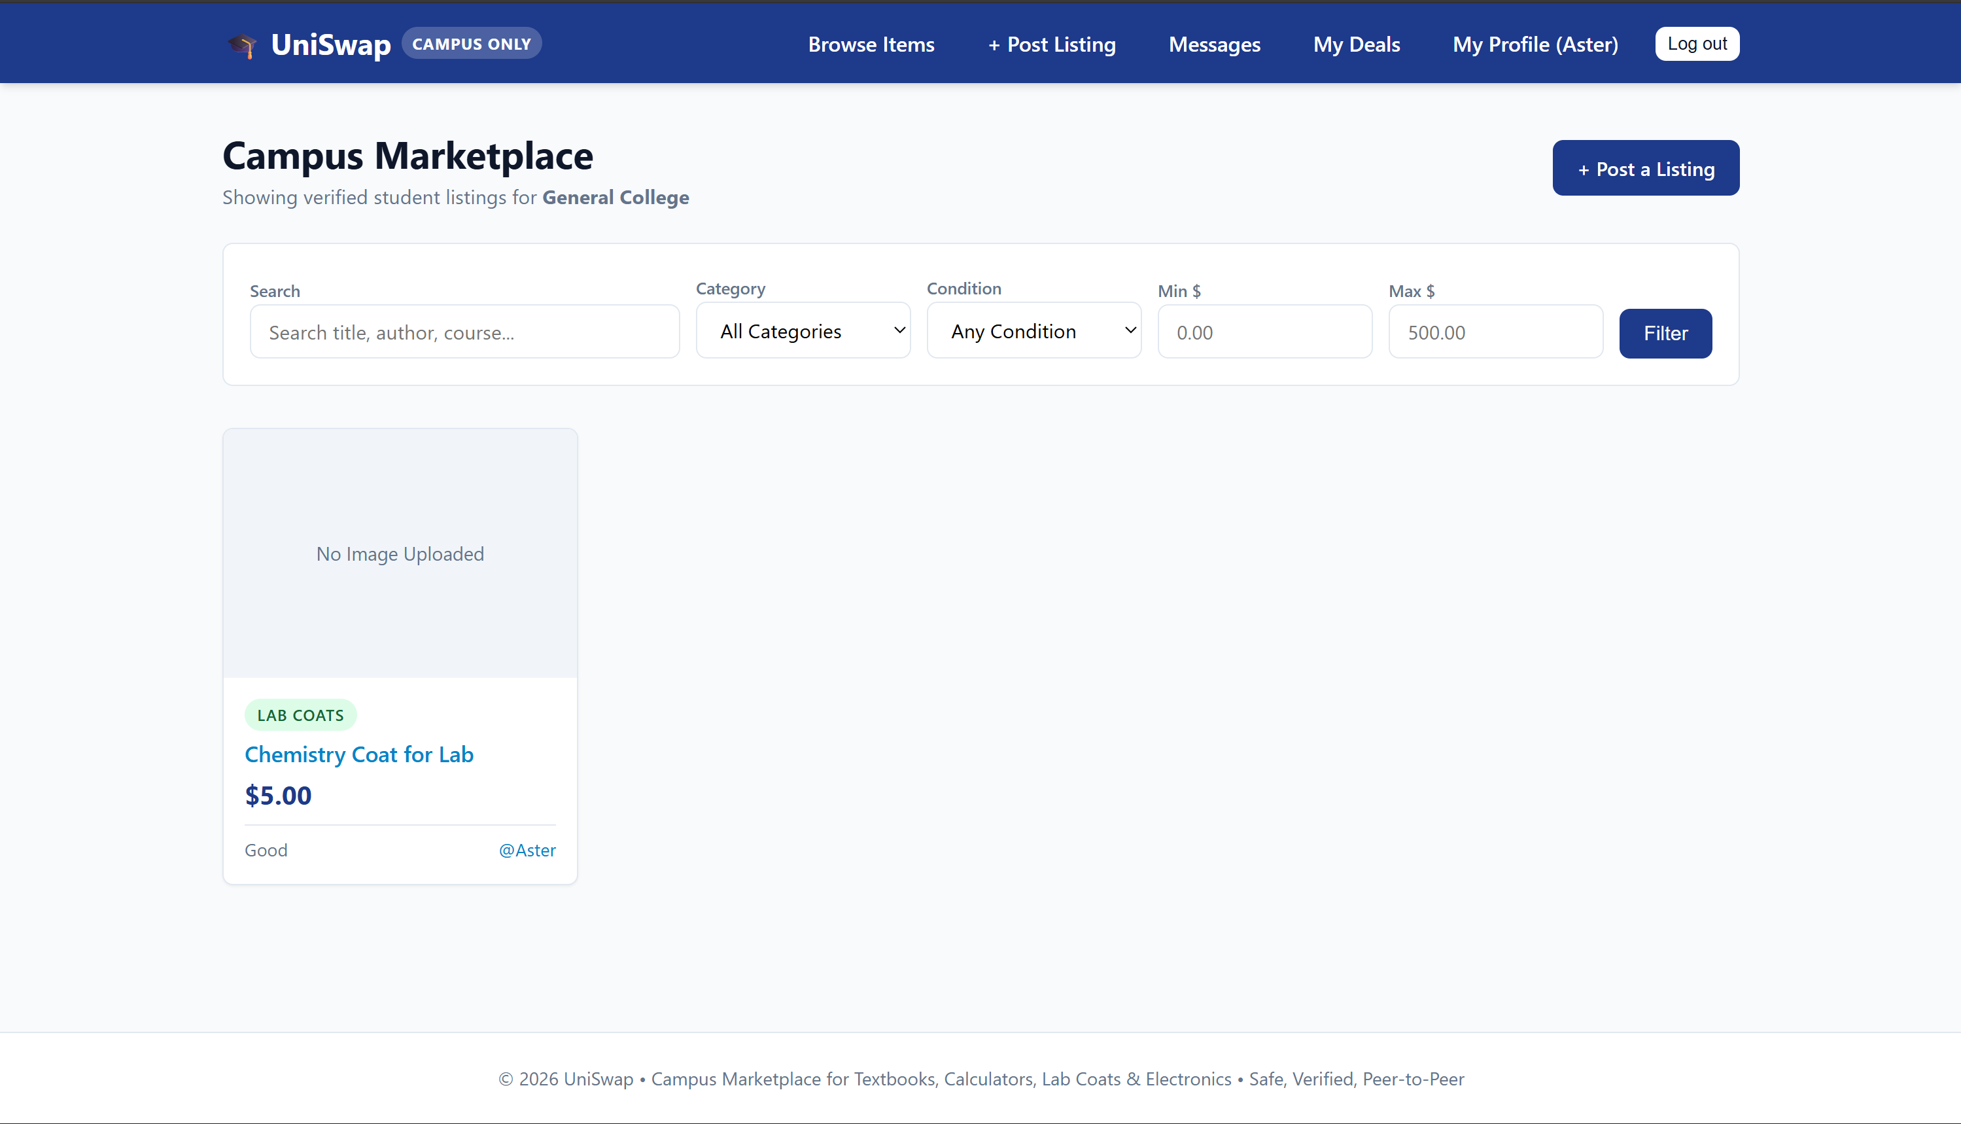
Figure 1: Student Portal (Frontend) — Campus Marketplace Feed & Multi-Attribute Filtering
Explanation: Displays the primary student-facing catalog ('Campus Marketplace') logged in as Aster. Students can search by title, description, or keywords, filter by category (Textbooks, Calculators, Lab Coats, Electronics), condition (New, Like New, Good, Fair), and define min/max price boundaries. Shows the active listing card for 'Chemistry Coat for Lab' ($5.00, Good condition, category 'Lab Coats', seller @Aster).

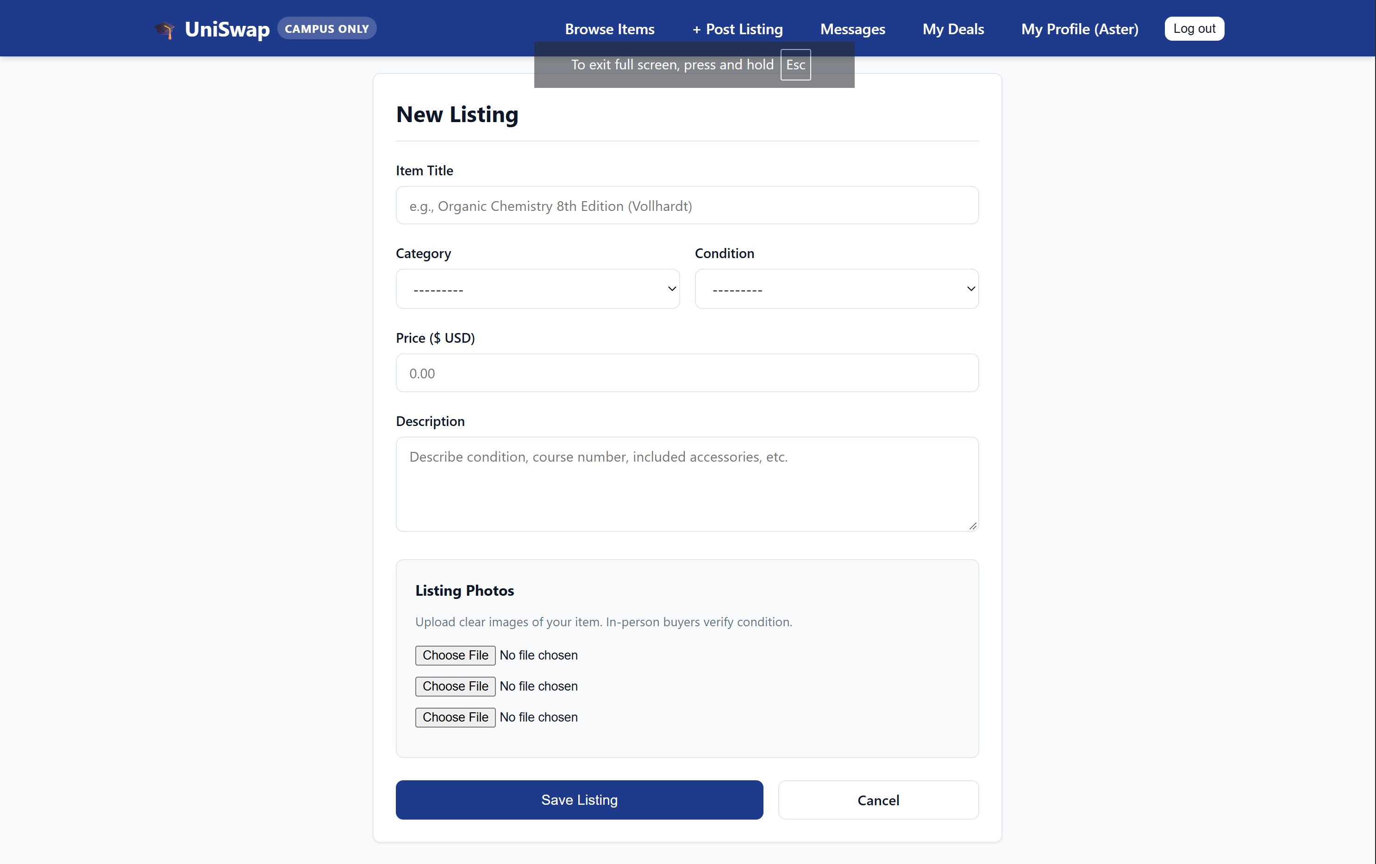
Figure 2: Student Portal (Frontend) — Listing Creation & Multi-Photo Formset
Explanation: Illustrates the 'New Listing' creation workspace. Enables student sellers to enter item title, academic category, condition grade, price in USD, and comprehensive description. The 'Listing Photos' panel utilizes Django's inlineformset_factory to allow uploading multiple product images simultaneously for physical condition verification.

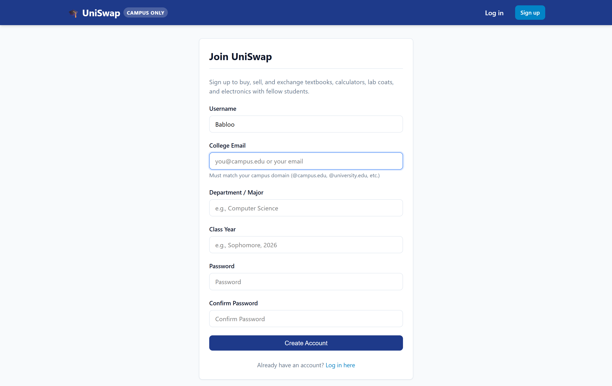
Figure 3: Student Portal (Frontend) — Student Registration & Dynamic Campus Detection
Explanation: Demonstrates the 'Join UniSwap' student onboarding form. Students provide username, institutional or standard email, academic department/major, class year, and password. The system dynamically validates the email domain, associates it with a campus entity, and activates the student's verified marketplace permissions immediately.

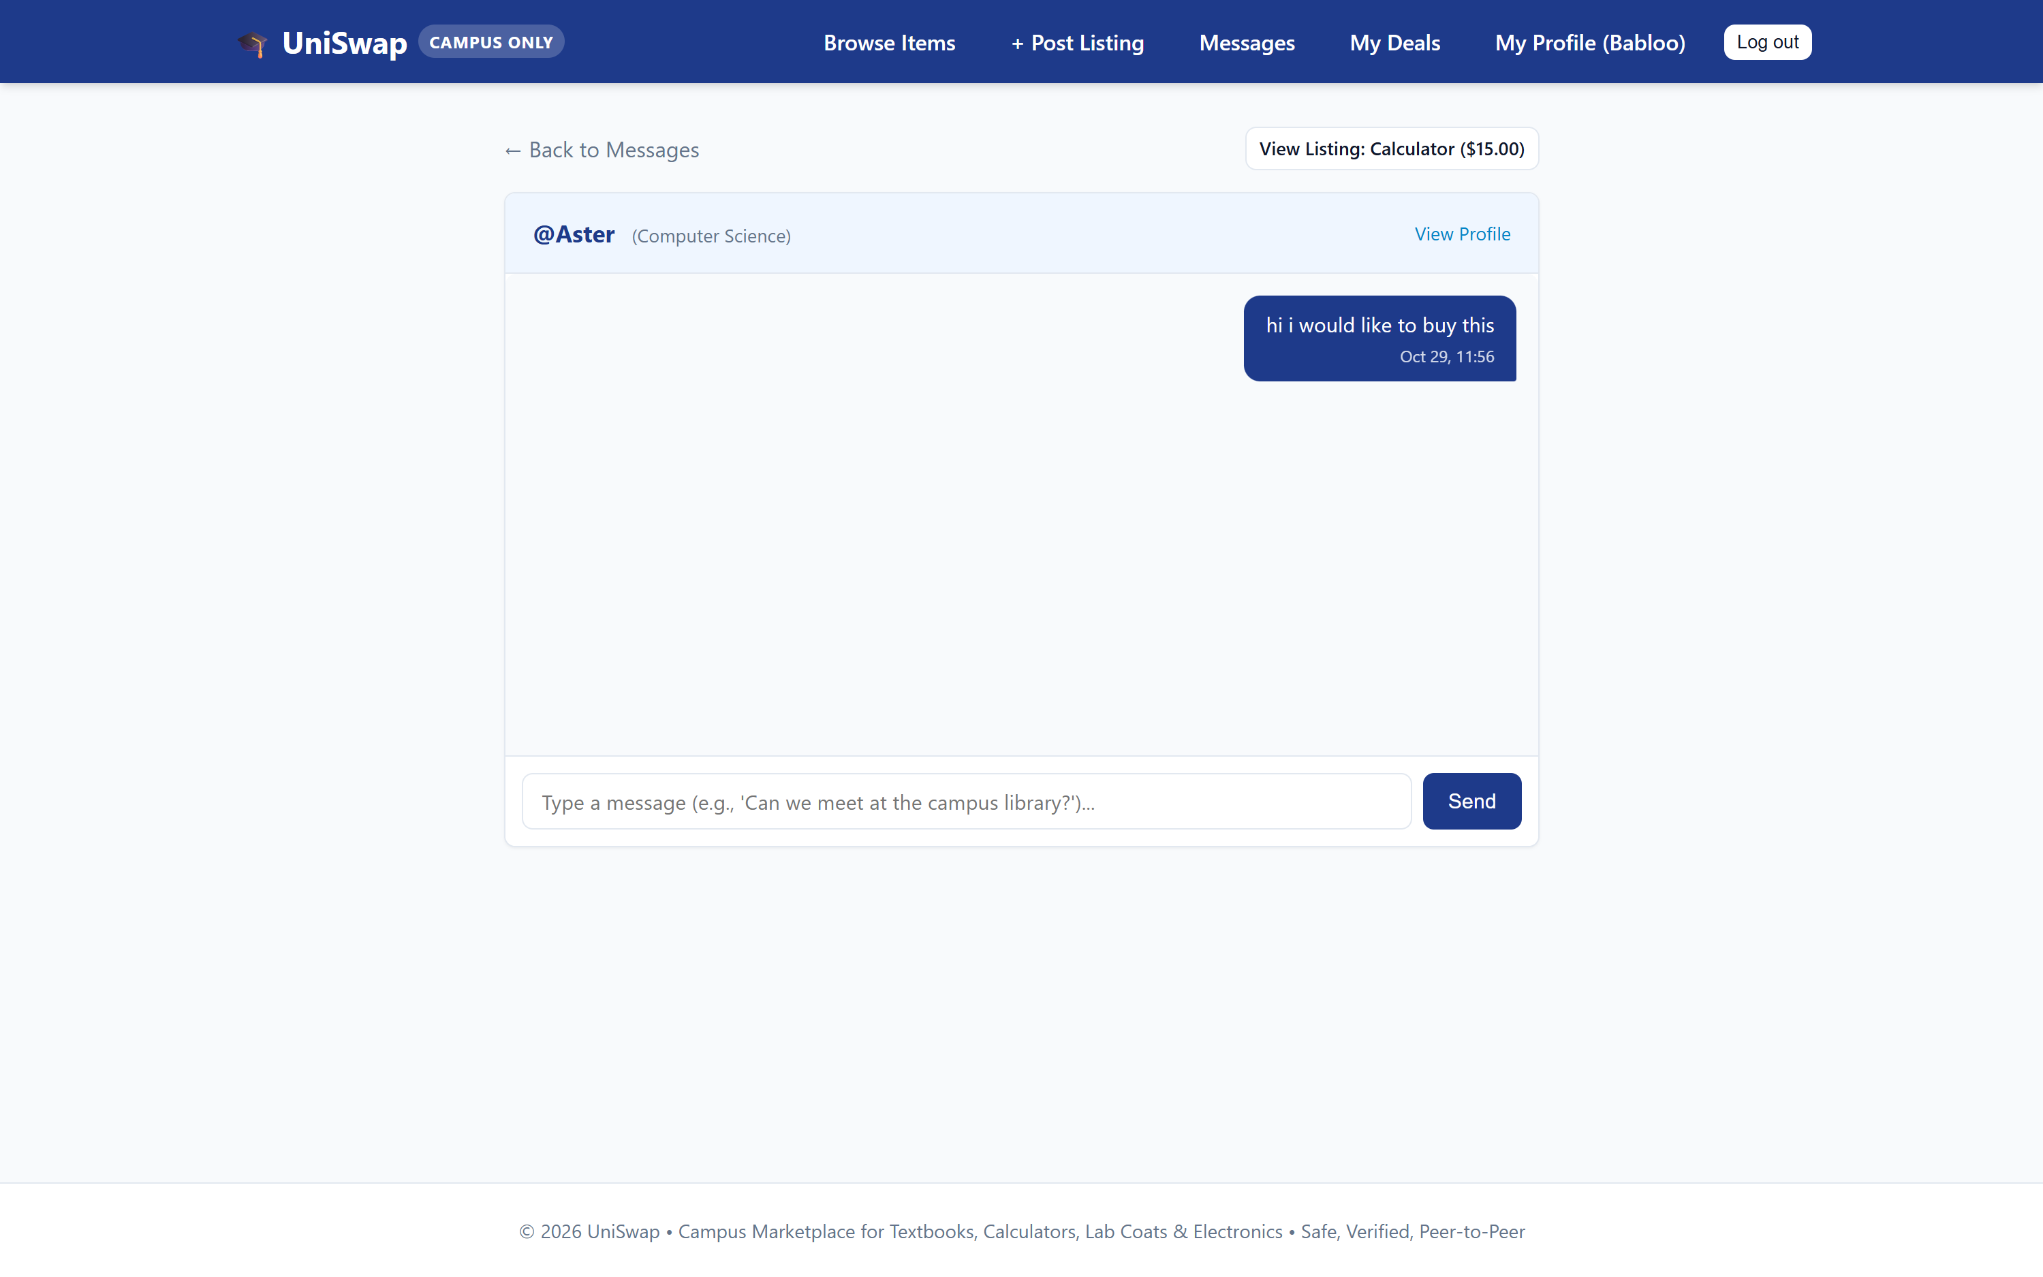
Figure 4: Student Portal (Frontend) — Scoped Peer-to-Peer Messaging (Buyer Perspective)
Explanation: Shows the real-time chat interface from the buyer's perspective (@Babloo) inquiring about a 'Calculator ($15.00)' listing owned by @Aster. The message 'hi i would like to buy this' is safely routed with participant-level IDOR protection, preventing external users from inspecting or tampering with student communications.

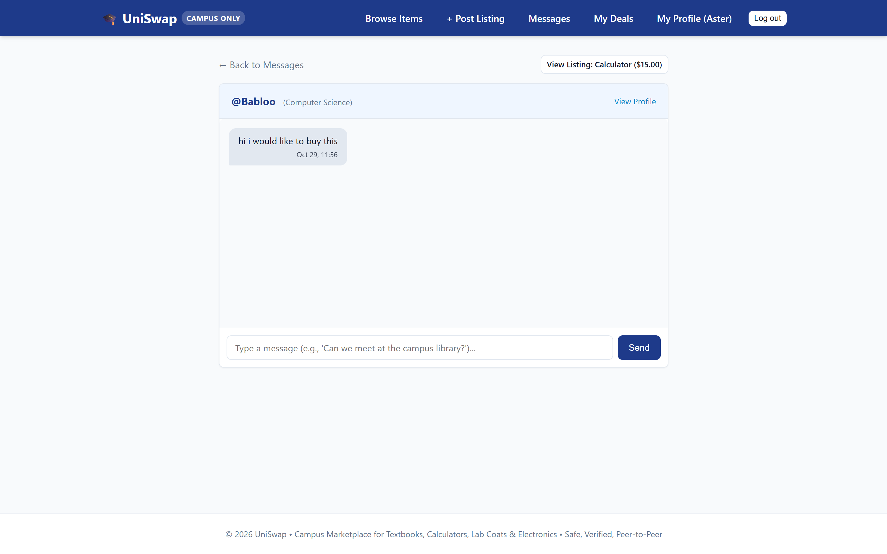
Figure 5: Student Portal (Frontend) — Scoped Peer-to-Peer Messaging (Seller Perspective)
Explanation: Shows the incoming chat interface viewed by seller @Aster responding to student buyer @Babloo. Both participants can quickly view the referenced listing details, navigate back to their inbox, and coordinate an in-person physical exchange on campus.

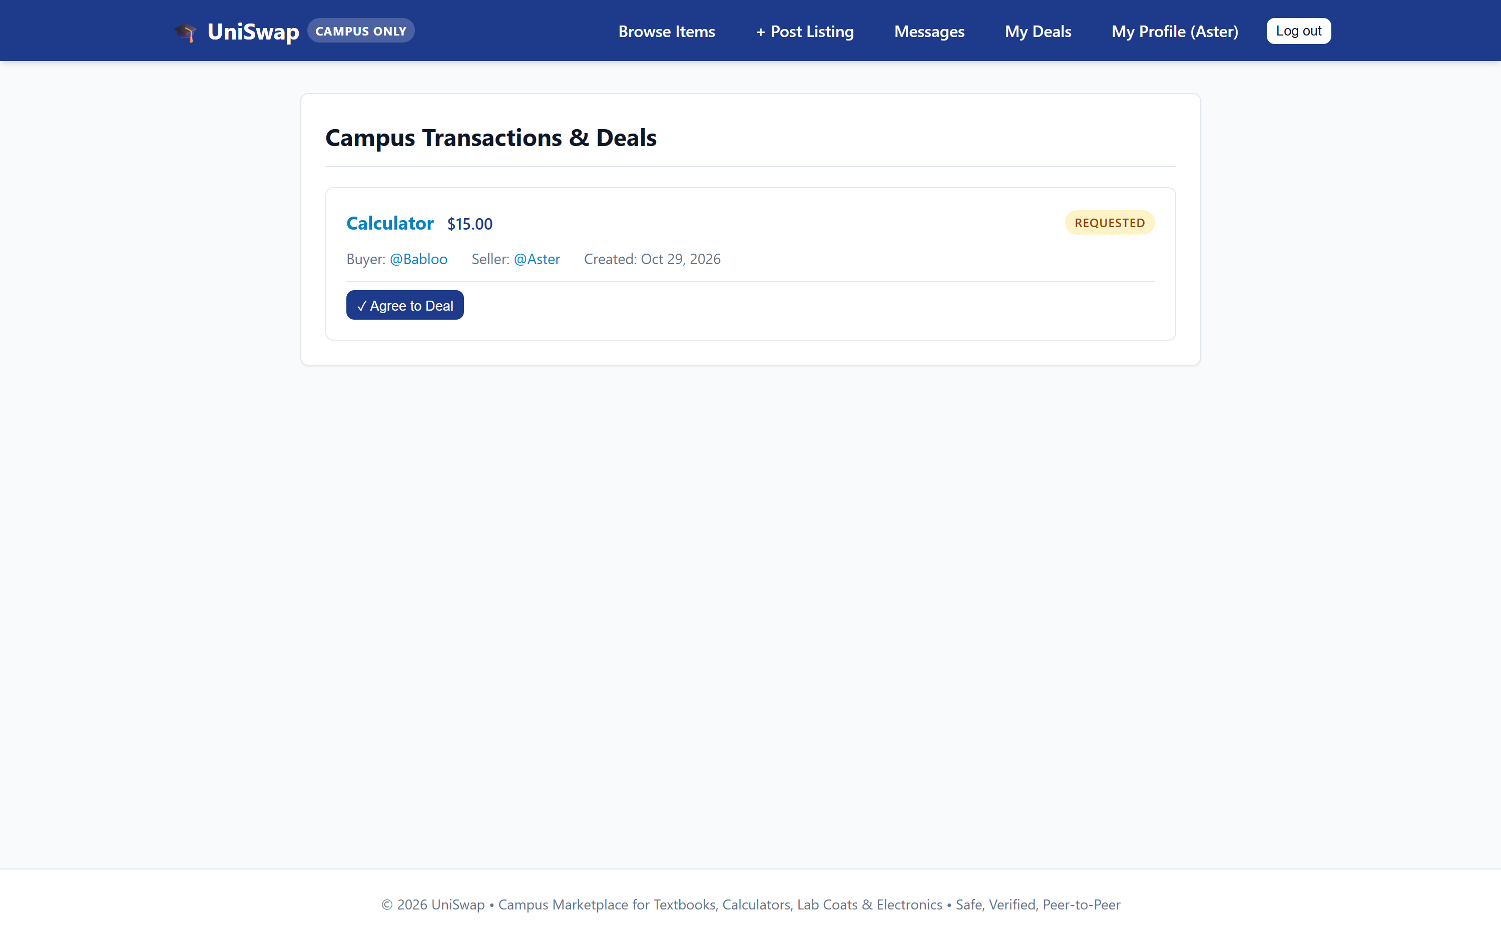
Figure 6: Transaction Management — Deal State Machine: Requested Status
Explanation: Illustrates the 'Campus Transactions & Deals' dashboard viewing an active transaction in the 'REQUESTED' state for the 'Calculator ($15.00)' listing. The seller (@Aster) is presented with an action button ('✓ Agree to Deal') to advance the deal to the next stage of the finite state machine.

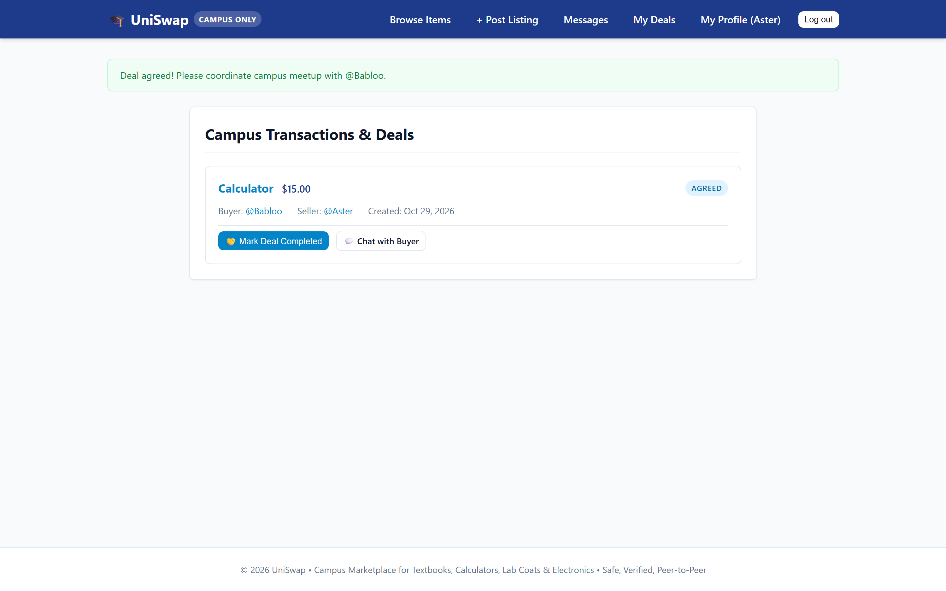
Figure 7: Transaction Management — Deal State Machine: Agreed Status & Inventory Reservation
Explanation: Displays the transaction after seller agreement. The status badge transitions to 'AGREED', and an informational banner prompts the parties to coordinate their campus meetup with @Babloo. The action controls update to 'Mark Deal Completed' and 'Chat with Buyer', while the underlying listing is set to 'Reserved'.

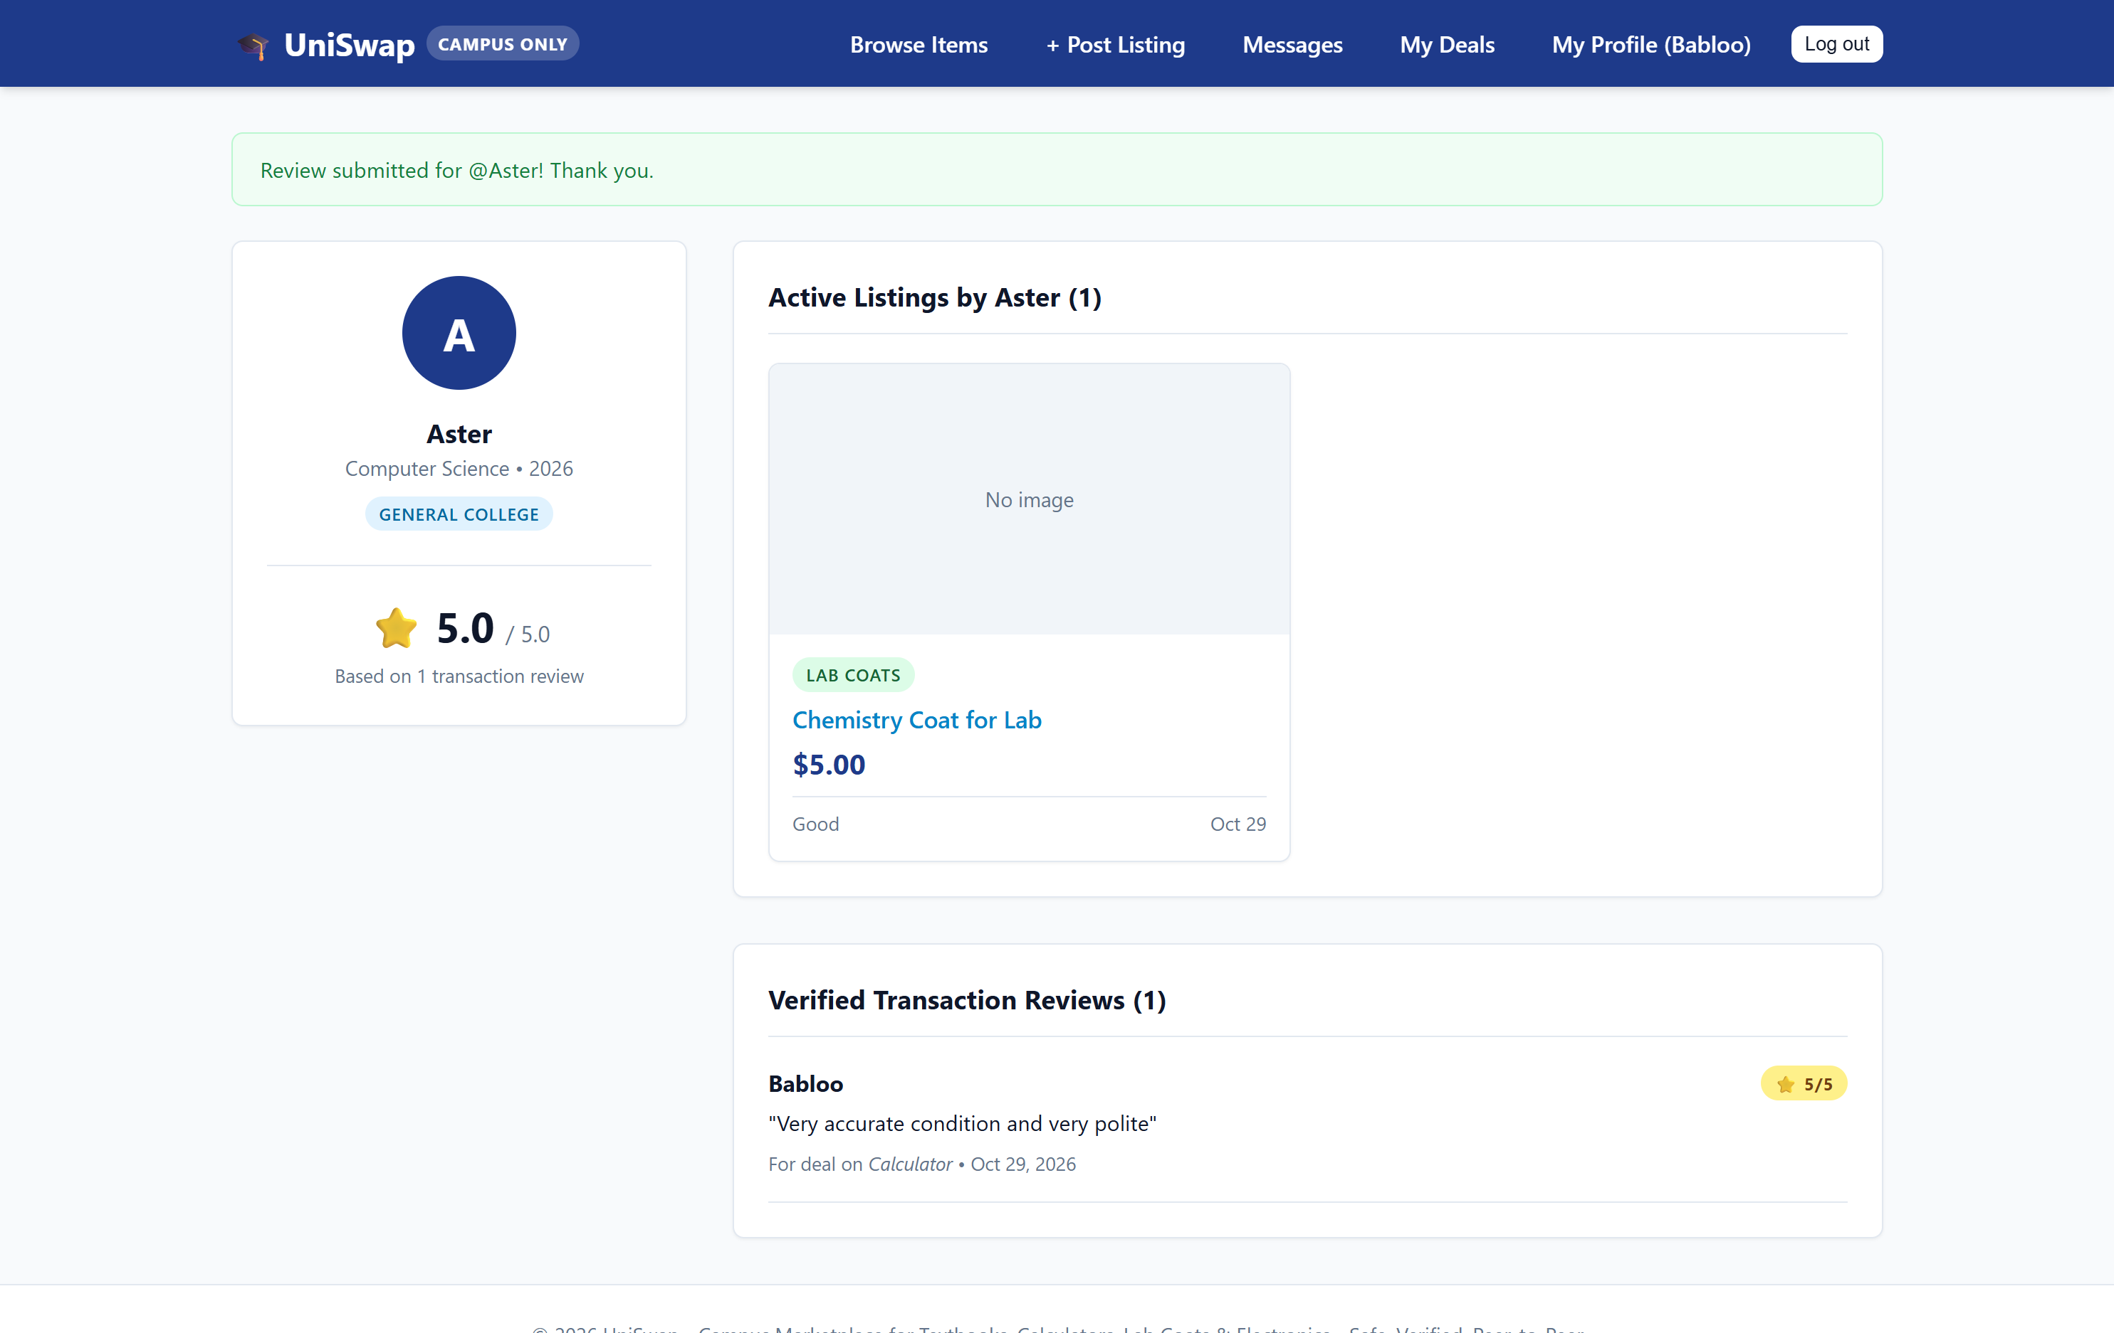
Figure 8: Reviews & Reputation — Verified Review Submission Confirmation
Explanation: Shows the confirmation alert ('Review submitted for @Aster! Thank you.') upon deal completion. A review is strictly restricted to participants of completed deals. Counterparties can leave a 1-to-5 star rating and feedback comment, while duplicate reviews and self-reviews are strictly forbidden.

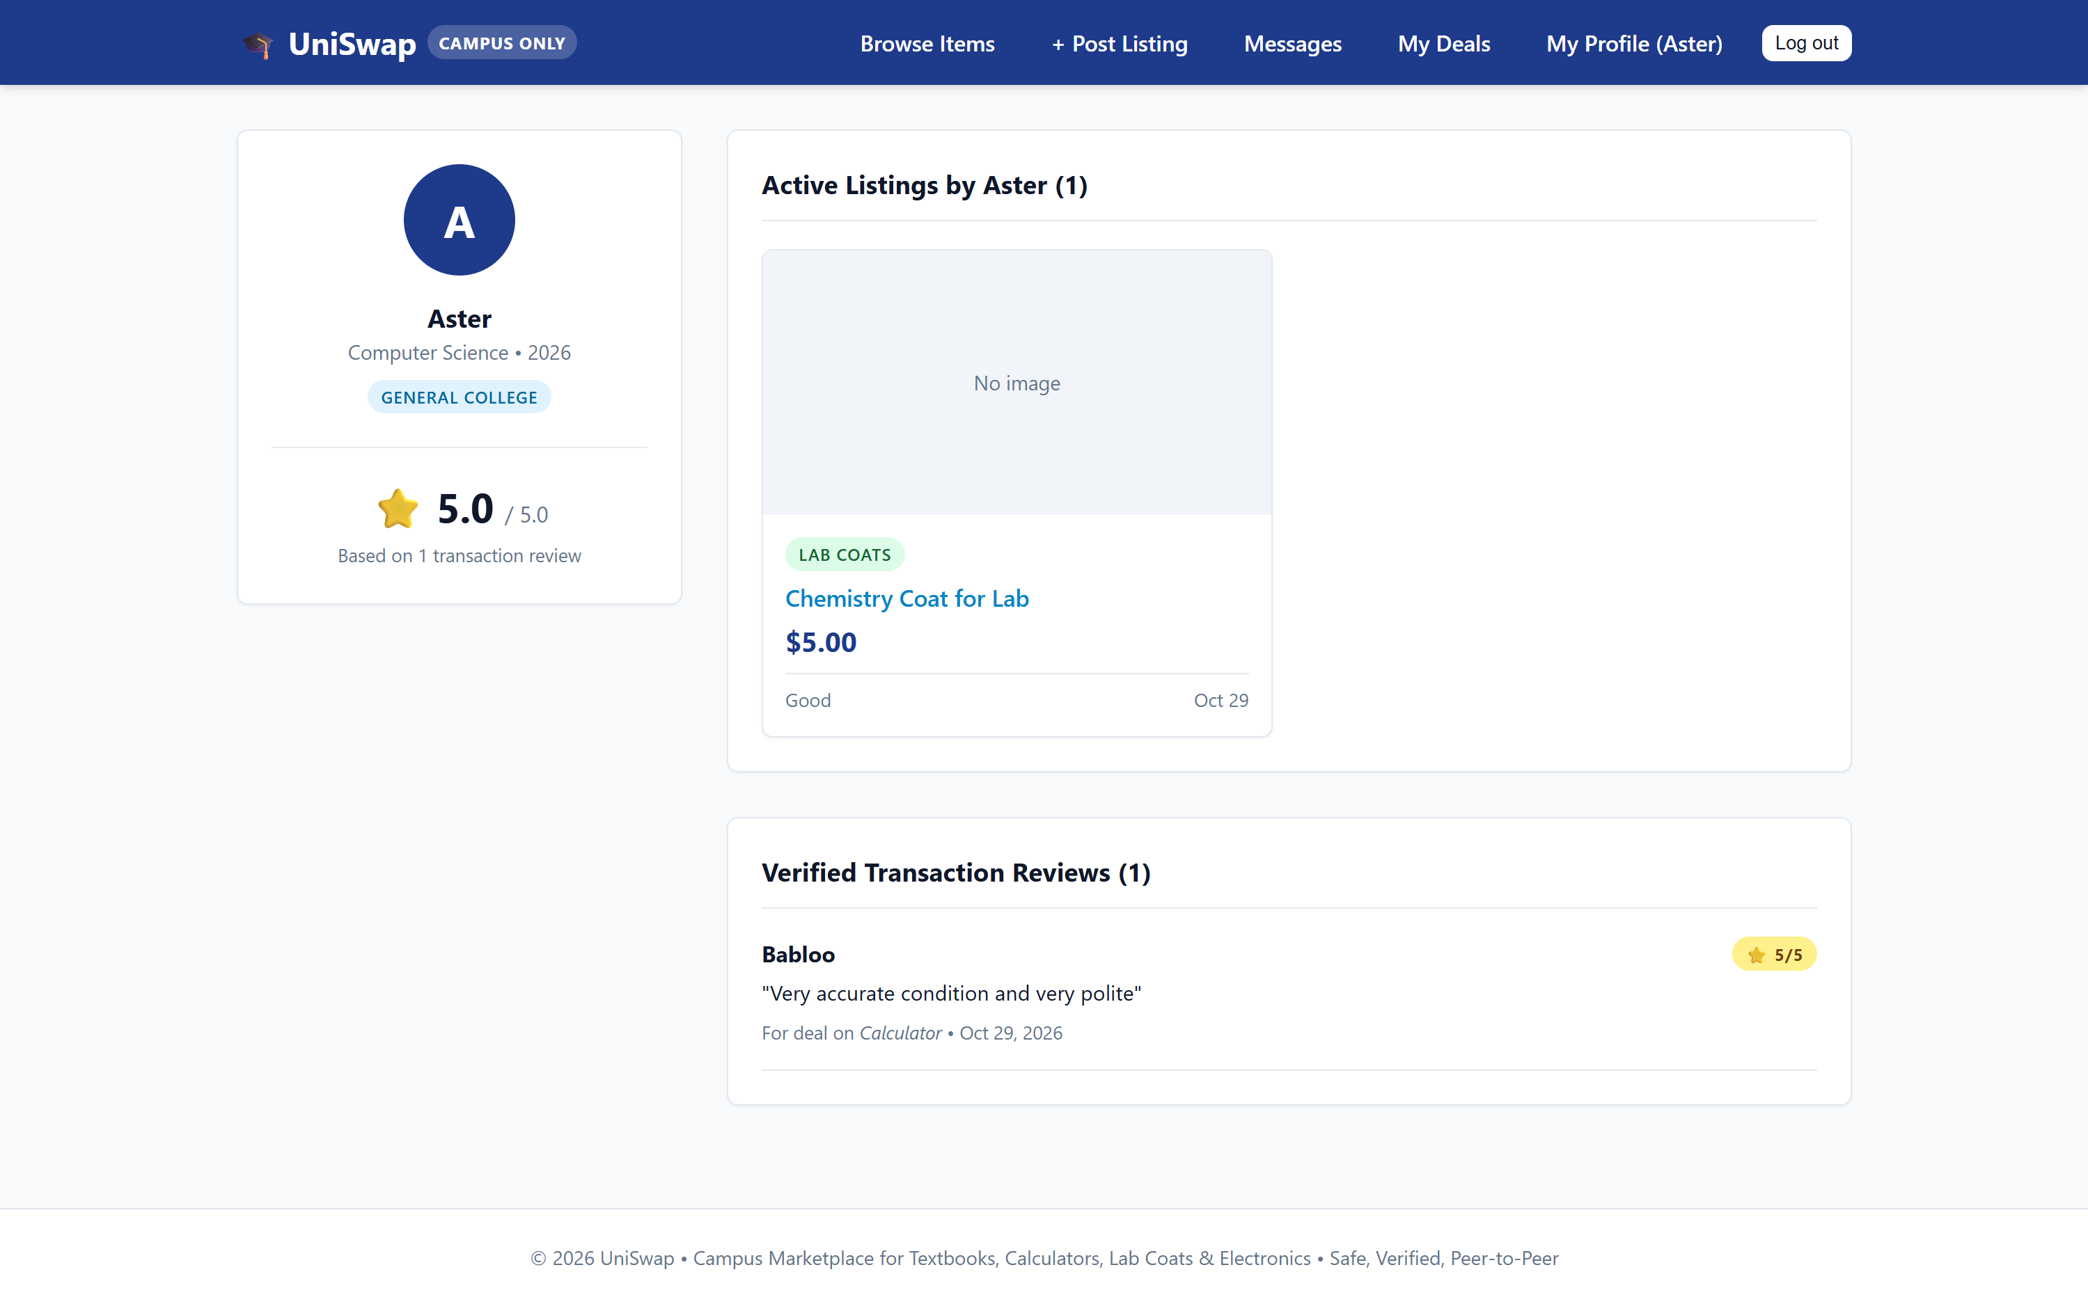
Figure 9: Student Portal — Public Seller Profile & Live 5.0 Star Rating Aggregation
Explanation: Displays the public student profile for seller @Aster. Features the verified aggregate score (5.0 / 5.0 based on 1 transaction review) computed live using Django ORM's Avg aggregate. Below the profile card, active listings ('Chemistry Coat for Lab') and verified transaction reviews from buyer @Babloo ('Very accurate condition and very polite') are transparently displayed.

5. System Verification & Team Contribution Summary
All critical paths—including institutional registration, multi-criteria catalog search, image formset uploads, participant-scoped messaging, transaction state transitions, and live rating calculation—were systematically tested using Django's native test runner (33 automated test cases passing with zero errors):
- Vraj Prajapati (C183 | 60004250085): Full-stack architecture design, custom User and Campus model implementation, transaction finite state machine, zero-IDOR query filtering, image formsets, live Avg aggregate rating calculation, 33 automated unit and integration tests, and static documentation showcase deployment on GitHub Pages.
6. Conclusion
The Campus-Only Marketplace System (UniSwap) was successfully designed and deployed using Python, Django, and SQLite3, fulfilling all laboratory course outcomes. Through this experiment, we gained practical mastery of the Model-View-Template (MVT) architecture, relational database management via Django ORM, finite state machines, and dual-portal frontend-backend integration. The resulting web application effectively replaces insecure public classifieds with an automated, secure, and student-friendly campus marketplace platform.

