**# Module 3 – Developing your professional network**

## JUNIOR AND SENIOR

If you've ever searched for job openings on websites, you've probably seen terms like junior and senior. But what is the difference between these positions in a company? That's what we'll see now. One of the main differences is how long the person has been in the job market and the degree of experience. When the employee has been in a company for a long time, they are supposed to go up in level because they know most of the processes with excellence. Another difference that we can highlight is the degree of knowledge and educational background of the employee. The more relevant their educational background is, the higher salaries and positions they can achieve. The knowledge related to speaking a second or third language also makes difference to an employee's promotion. Today, with the globalization of the job market, especially when we talk about technology, it's important to be a multilingual citizen. We cannot forget to talk about the degree of responsibility that each position has. The complexity of the tasks and the level of responsibility are important aspects as well. Inside a company, it's really common to find three different job levels: one that performs simpler tasks because the employee has just entered the job market and is learning about its area of expertise; another level that performs more technical tasks because of their experience in the company and knowledge acquired and finally, a function that has much more responsibility, managing projects and processes and having greater autonomy in the decisions.

## APPLYING FOR A JOB

When you are  for a job, it is essential to do your best to  among the other candidates. And to start attracting recruiters' attention, it is necessary to impress from the first contact, which would be when you send a  or when filling out a form. Therefore, it is necessary to prepare it properly, creating a model that, in addition to having clear information, is also complete and goes . That's why, when preparing your CV or an application, it's always good to have your  in your hand so you don't forget any details. After that, focus on  your academic background and work experience and don't forget to include certificates and . You can also focus on answering the requests of the position in a way that the needs of the job are covered on your resume

## WRITING A COVER LETTER

Hey guys, welcome back to my YouTube channel. How are you today? Let's learn how to write a cover letter, which is a really important strategy that you must learn to find a great position.

But do you know what a cover letter is?

A cover letter is a written document sent with a job application describing the personal aims and the job skills of the person that is applying.

Let's check out the structure that you will need to follow:

The first step is to insert your contact details, for example: your name, job position, email address, phone number, location and professional social medias.

Then, following information: is the name of the manager, the job position, location, email address and date.

Start the message with a greeting to the hiring manager.

Then in your opening paragraph you should grab the recruiter's attention by making it personal and suitable for the job you're applying for.

Then in the body of the letter: make it clear why you're a good match for the job opening and the company's values and culture.

Give reasons you are perfect for the company and the company is perfect for you.

Build a closing paragraph with a strong and compelling message to the reader and use a right formal closing.

Now it's your turn! Let's try to produce your own cover letter! Bye, guys.

## GRAMMAR

MUST – personal obligations, written obligations

They must not wear the uniform

He must wear the uniform

SHOULD – an opinion, an advice

You should wear that uniform

I think she should wear that uniform

HAVE TO – general and external situational spoken obligations (3rd person HAS TO)

She has to go to work everyday

We have to go to work even when it´s raining

In the past obligation is NOT “must” is “had to”

Last year, teachers HAD TO make a report on each child every week

## APOSTROPHE + S

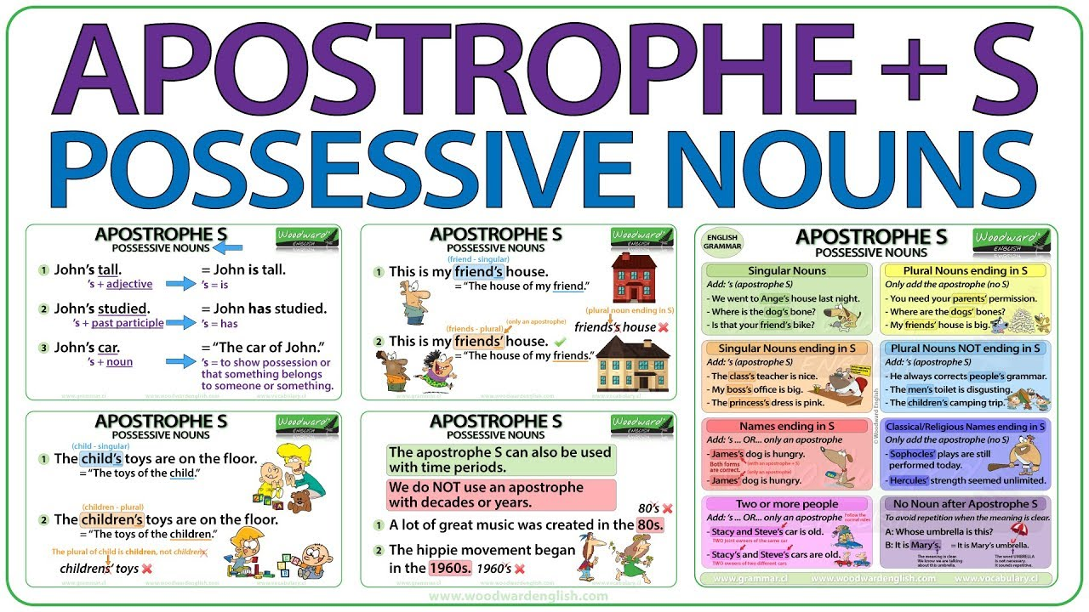

My boss´s car was stolen – It´s not My boss´ car

Getting a job with better salary and more flexible hours can be just a letter away from you. Wouldn't it be a good idea if you had more time and more money to enjoy life? If you want to grow professionally, increase stability and spend more time with your family, it's worth looking for a better job, right? And a cover letter during this process will help you stand out and be noticed more easily. Knowing how to prepare a cover letter can be what will ensure that you are called for an interview and finally find a new and better position in the job market. Once you understand what a cover letter is, it is worth knowing that it is used as an extra selection mechanism. By sending it along with your resume, you will be able to present yourself in a personalized way to the company and make your profile considered. In addition, it is a method used to avoid mass submission of resumes without evaluating job-specific questions. But how should I write a cover letter? What are the basic steps? Before introducing yourself, start with the date, which must be written in full. Then include your contact details, recipient and address — without any abbreviations. The greeting can be personal if you know who your recruiter is. Use “Dear Mr, Dear Mrs or Dear Ms" followed by the last name, for example: "Dear Mr Curry", "Dear Mrs Curry" and "Dear Ms Curry". Then, say which position you want to apply for and express your interest. In the body of the letter, briefly point out your academic background. Discuss your strengths and how you are a good fit for the company. The intention is not to pass on the resume, but to explain why you are the best option for the job opening. Indicate that you are ready to get the job done and to give your best. Try to keep the contact simple but effective. After presenting the reasons, make sure to request the opportunity to have your resume evaluated by them. Make yourself available to meet the recruiter and discuss the job opportunity. To finish your cover letter, end it with a formal and professional closing, like 'Sincerely,' 'Best regards' or 'Thank you for your consideration'. Don't forget to end it with your name to complete the element and give a good impression.

Nowadays, the  processes are very competitive. In this professional scenario, small details make all the difference to stand out among other candidates. One of these details is the , which along with the CV presents the candidate and his/her characteristics. This document is a strategy to cause a  on the recruiter, so you need to be as succinct as possible in the construction and always try to highlight your greatest personal and , your academic background and . And It is always necessary to remember that the cover letter is not a summary of the CV, but an opportunity for the candidate to present himself/herself better and speak directly about his/her intentions and  in relation to the position he/she is applying for.

Let me check my mail box...

Wow! I got reply from my job interview last week.

How nice! I was so anxious. So now I'm going to read the e-mail carefully and answer it right now.

But how can I answer it properly?

I'll check some examples but I'm going to need to negotiate my salary and the days that I'm going to work remotely. Okay, let's see.

I must remember that the job acceptance e-mail needs to:

Make the acceptance clear, use words that make it evident, for example: "I am pleased to accept your offer".

Repeat the position title and relevant terms, always expressing your thanks,

give an expected start date and clarify any doubts,

ask about additional paperwork or information that I might need to provide. Okay, so let me try.

Hello, Mr. Davis. Thank you for offering me the position of research analyst in your company.

I am so excited about the possibility of working with your team.

After reviewing the offer, I have a few questions I wanted to run by you—particularly about the bonus and the schedule.

How much was the bonus we previously discussed?

I checked it out on the e-mail that you sent me but the information didn't match, so I prefer to ask you again.

By the way, I have another question: How many days can I work from home?

If you prefer, we can talk to each other in an online call to discuss these topics. When are you available? Sincerely, Jane Maher

##### Examples

* He swims **well**.
* He ran **quickly**.
* She spoke **softly**.
* James coughed **loudly** to attract her attention.
* He plays the flute **beautifully**. (after the direct object)
* He ate the chocolate cake **greedily**. (after the direct object)

An adverb of manner cannot be put between a verb and its direct object. The adverb must be placed either before the verb or at the end of the clause.

##### Examples

* He ate **greedily** the chocolate cake. **[incorrect]**
* He ate the chocolate cake **greedily**. **[correct]**
* He **greedily** ate the chocolate cake. **[correct]**
* He gave us **generously** the money. **[incorrect]**
* He gave us the money **generously**. **[correct]**
* He **generously** gave us the money. **[correct]**

If there is a preposition before the verb's object, you can place the adverb of manner either before the preposition or after the object.

##### Examples

* The child ran **happily** towards his mother.
* The child ran towards his mother **happily**.

Adverbs of manner should always come immediately after verbs which have no object (intransitive verbs).

##### Examples

* The town grew **quickly** after 1997.
* He waited **patiently** for his mother to arrive.

These common adverbs of manner are almost always placed directly after the verb: well, badly, hard, & fast

##### Examples

* He swam **well** despite being tired.
* The rain fell **hard** during the storm.

The position of the adverb is important when there is more than one verb in a sentence. If the adverb is placed before or after the main verb, it modifies only that verb. If the adverb is placed after a clause, then it modifies the whole action described by the clause. Notice the difference in meaning between the following sentences.

| **Example** | **Meaning** |
| --- | --- |
| She **quickly** agreed to re-type the letter. | the agreement is quick |
| She agreed **quickly** to re-type the letter. | the agreement is quick |
| She agreed to re-type the letter **quickly**. | the re-typing is quick |
| He **quietly** asked me to leave the house. | the request is quiet |
| He asked me **quietly**to leave the house. | the request is quiet |
| He asked me to leave the house **quietly**. | the leaving is quiet |

###### Literary usage

Sometimes an adverb of manner is placed before a verb + object to add emphasis.

##### Examples

* He **gently** woke the sleeping woman.
* She **angrily** slammed the door.

Some writers put an adverb of manner at the beginning of the sentence to catch our attention and make us curious.

##### Examples

* **Slowly** she picked up the knife.
* **Roughly** he grabbed her arm.

EXCEPTIONS:

Well

Bad

Late

Early

Hard

The email is a powerful form of communication especially in the commercial and corporate environment. That's why you need to give a lot of attention when writing or answering it to a client or a co-worker. Therefore, there are some important points that we should pay attention to during the production of this document. Let's see some of them: 1- Email address The first step is to check the email address by which you will write or reply to your client or co-worker. The message should be sent from a corporate email address, bearing your name and also the name of the company you work for. 2- Greeting/Identification It is important to always start the email with a greeting and then immediately identify yourself with your name and position, for example. It is always necessary to remember that, as it is an e-mail with corporate topics, it needs to have a more formal character. 3. Content - The content of the email must be clear and objective, always covering the main topics to be discussed. However, avoid being too succinct. Try to engage the reader and make him/her understand the information the best way possible. And don't forget to pay attention to grammar and spelling. This makes all the difference in understanding the message. 4. Closing - When writing a closing message at the end of the e-mail, you should make yourself available to the reader for questions or clarifications, and don't forget to thank them for their attention while reading your message. After you finish reading the email, you can review the content and see if you have made any mistakes.

 is essential for good communication in companies. We use it every single day to send data, request documents or information, for example. Corporate email has some characteristics that are different from emails you send to your friends or your communication on . That's why you need to pay attention to the way you write them because communication is always an important part of your  as an employee. Some tips when writing a corporate e-mail are the following:  repeating words,  to the grammar and spelling used when writing this document, use  and the most important tip:  and concise when writing.

Hey guys. Welcome back to my channel. Last week I bought a course that taught me how to use my LinkedIn.

In the course, I learned how to improve my profile so that it shows more credibility and authority. And now I'm learning to make my profile more attractive to recruiters.

I decided to invest more time and take care of my professional profile to find better job opportunities.

So I planned to organize my schedule day by day in order to make these little changes in my personal page.

Where can I start? Let me see... Oh yes, the first day.

April 1st - Choose the right profile and background photo for LinkedIn.

April 2nd - Increase my network with people with the same interests as mine.

April 3rd - Ask for recommendations from those who worked with me.

Then April 4th - Share relevant content on my LinkedIn feed related to my job skills, my knowledge and my experiences to make my profile more visible to recruiters and industry leaders.

Oh my God! I need to be careful with the days. Next Friday is a holiday.

So when should I start to plan my schedule again?

Oh, April 8th! That will be perfect.

April 8th - Follow relevant influences for my industry to connect with a wider professional network.

And April 9th - I'll craft an interesting summary telling my story.

Well.... What is missing?

Oh, I am going to write down the last and one of my most important tasks: Just keep my page active.

GERUND ING

Don’t mind -> I don’t mind working everyday

Finish -> I never finished reading this book

Avoid -> Avoid calling me at the night

Miss -> I miss living in California

Recommended – It´s recommended calling the police

GERUND TO

I planned to travel

He offered to help me

We decided to move

They can’t afford to travel abroad

Ill begin to code right now

I never learned to ride a bike

NEGATIVE

I miss NOT having bills to pay

We decided NOT to

QUESTION WORDS & SPECIFIC ANSWER

WH

Why Who Whose What When Where Which How

If you want to get a job abroad, you definitely need the help of LinkedIn. This social network can help you in this important choice of your personal and professional life. Therefore, the first step is to use the English language in your network making your profile more attractive and calling attention of recruiters and foreign companies. So it is important that you include your portfolio, courses and experiences to show that you are a good professional. If you still don't feel confident about the use of the English language, you can call a friend who understands it better or hire a professional to help you highlight your skills using the correct vocabulary and grammar. After that, it is very important that you update your profile regularly, with a good professional photo and a good title. It is essential that you also make posts about your area of ​​expertise, always talking about relevant topics to your area that can help another co-worker as well. Don't forget to interact on this social network whenever possible, commenting on interesting posts and liking publications of your professional interest. These actions will help your profile to grow and make it more evident, which significantly increases your chances of getting good opportunities. Another tip to help you find a job abroad is to have a clear summary with your goals and a little bit of your professional trajectory. In addition, asking for 'recommendations' from other professionals, whether from colleagues from previous jobs or heads, helps at the time of hiring process, providing you more credibility about your profile. In addition to the recommendations, we have an option on LinkedIn called “search”. In this section, you will be able to place the positions in which you are interested and most importantly: the location where you are interested, for example, the United States, Canada or England. In this search, you can even know if the vacancy is remote, face-to-face or hybrid. This helps a lot because you can find the job you were exactly looking for, in the place you want and in the modality that best fits your lifestyle. And finally, an extremely important factor is your network of friends. If you are interested in working in Australia, for example, it is essential to make connections with people who already reside in the country and who have the same area of ​​expertise as yours. With that, you start to create your cycle of contacts, increasing your networking. It is always good to remember that LinkedIn is a powerful social network and every day it gains more strength in the world especially in the area of ​​technology

 indispensable tools nowadays. They have even become a fundamental part of the globalized world.I say this because through them, we can get closer to friends, keep in touch with our family and even find a partner. Using it, we can also do business and especially find the vacancy of our dreams. There are today, social networks that are specialized and .With it, you register your personal information, your academic trajectory and your professional . After that, you start  with other people and networking professionally. Bearing in mind that the more connections you make, the more you are noticed by companies and recruiters. Also, within this website, you can search for vacancies that best fit your profile and be directed to another page that matches your characteristic by means of the pre-fill. Social networks aimed at getting a job are very important nowadays because they bring people closer to  around the world, making you even find a vacancy in a company abroad. Do you know any social networks that have these characteristics? So it is necessary to remind you of the importance of .

