|  |
| --- |
| Proclaim  UtilitY Guide |
| https://github.com/ktrue/proclaim-utility 400 W. Campbell Ave.  Campbell, CA 95008  Ken True |



## Proclaim Utility Guide

### **Background**

For many years, our church had used a Worship Roadmap process to construct the the detailed order of worship for a service. This involved a Word document which was passed around the worship team (Pastor, Music Director, AV tech, Song Leader) with multiple revisions, then copy/pasted into a set of PowerPoint slides for projection during the service. This was a time-consuming process that needed refinement, and that is the main reason a search for a better method was undertaken. After trying out multiple worship software projection packages, the [Faithlife Proclaim](https://proclaim.faithlife.com/) software was selected as it had the necessary features to minimize the ‘touch’ required to create slides for worship service use.

Additional web-based software was developed to allow automatic creation of a Worship Roadmap for the worship team based on the slide content, so the worship team could still have overall visibility to the service order and AV techs could have the proper cues for actions. In essence, the process is now to collaboratively create projection-ready worship slides, and a worship roadmap is automatically produced thereby eliminating a lot of clerical work in the process.

### **Overview**

Proclaim Software is used for projection of slides for the worship service. Authoring (or modifying) a Proclaim slide set requires Proclaim software installed on a Mac or PC and a Faithlife userid that is a member of the church’s Faithlife Presentation team. All slide presentations are stored on the Faithlife cloud and multiple people may edit the presentation at the same time – the software will synchronize all changes to the master copy on the cloud.

A slide set for a worship service has four parts:

-- ‘pre-show’ set of slides that repeat before the service.

-- ‘warm-up’ set of slides that show once just before the service

-- ‘service’ set of slides that manually advance for the service

-- ‘post-show’ set of slides that repeat after the service

The ‘pre-show’, ‘warm-up’ and ‘post-show’ slides are optional – the important ones are the slides in the ‘service’ section for conducting the worship service using the projectors. The slides in the ‘service’ section are the ones used in the worship roadmap.

The Proclaim software has two modes ‘Off Air’ and ‘On Air’. Editing of the slides should be done ‘Off Air’. To project the slide set, just press the ‘On Air’ and the slides will be sent to the projectors.

Individual slides may contain Content (text to display on the slide) and optionally Notes (text to show in the Worship Roadmap including AV cues and/or liturgy to be read by the worship team). The names of the slides in the left-hand list will appear as underlined section names in the worship roadmap.

#### Starting a new slide set

Open Proclaim software on a PC or Mac and sign-in to Faithlife (if you haven’t done so before). All members of the church’s Presentation Team on Faithlife may edit the slides. All the slide data is stored in the ‘cloud’ and there is only one instance of slides for a service. Here’s how to start a new set:

1. In Proclaim, open the most recent service.
2. Use File, Duplicate, and select the most recent service.
3. When the Duplicate appears,
   1. Use the date selector to change to the new service date
   2. Change the name of the set to reflect the new service date
4. Use File, Backup Presentation… to create a snapshot backup of the new presentation (so you can start again if something unfortunate happens).

### **Overview**

Proclaim has several types of slides available – here are the types we use for the worship service:

* **Announcement** – used for individual slides with major parts of the service
* **Content** – used for responsive liturgy slides in which the congregation shares in reading/response.
* **Song** – used for lyrics of worship hymns/songs
* **Bible** – for scripture from selected bible book, chapter, verses
* **Cues** – for auto-record start/stop, or for **Stage Directions** (appears in roadmap)
* **Video** – to autoplay a video from the web
* **WebPage** – to display a page from the internet

The *Announcement*, and *Content* slides have tabs for both Content (appears in slides) and Notes (appears only on roadmap) areas. The *Song*, *Bible*, *Cues*, *Video*, and *WebPage* slides also have a Notes tab (appears only on roadmap) with the main content determined by the song name (*Songs*), bible verse (*Bible*), *Stage Direction Cue* (appears in roadmap), *Video* (URL to video), *WebPage* (URL to website).

Note that ‘Rich Text’ can be used for both Content, Notes and Cue tabs with available formatting of **bold**, *italic*, ***bold-italic***, or SMALL-CAPS.

Use the Content tab (on *Content* or *Announcement* slides) to have that projected on a slide for the congregation to read. You can use copy/paste for liturgy items from Word files (.rtf, .doc, .docx) or text files. From Word files, the bold, italic (etc.) formats should be preserved in the copy/paste.

Our convention is to use *italic* for reading by ‘One’ and **bold** for reading by the congregation. We have also used ‘*One:*’ and ‘**ALL:**’ prefixes to the liturgy (but I think we’re trying to avoid that in the future to minimize the extra editing needed to produce a worship slide set)

The Notes tab is used to provide both AV cues (appears in Blue before a slide name in the roadmap, and for optional liturgy to be read by the worship team – the latter only appears in the roadmap.  
   
The first line(s) in a Notes tab are AV cues.   
If there is a line with just **** (4 asterisks), then any lines after that will be printed in the roadmap (and not shown on the slides).

The names of the slides in the left-hand slide list are used as the underlined names in the roadmap.

The following figure illustrates how this works.

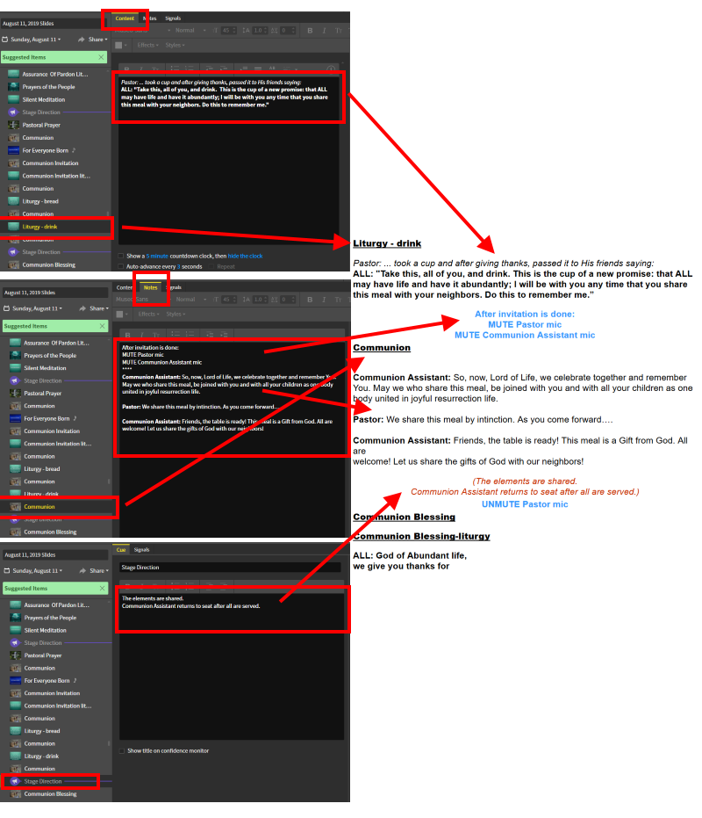

An alternative method of embedding either participant directions and/or directions can use the **Stage Directions** Cue tab. The Stage Directions can be inserted between any two slides, and the content only shows on the roadmap.

The Cue tab has two parts. The part above an optional ‘****’ line will show in Red text for participant instructions. The part below the ‘****’ line will show as normal text (with bold/italic formatting, if included) in the roadmap. The following picture illustrates that usage.

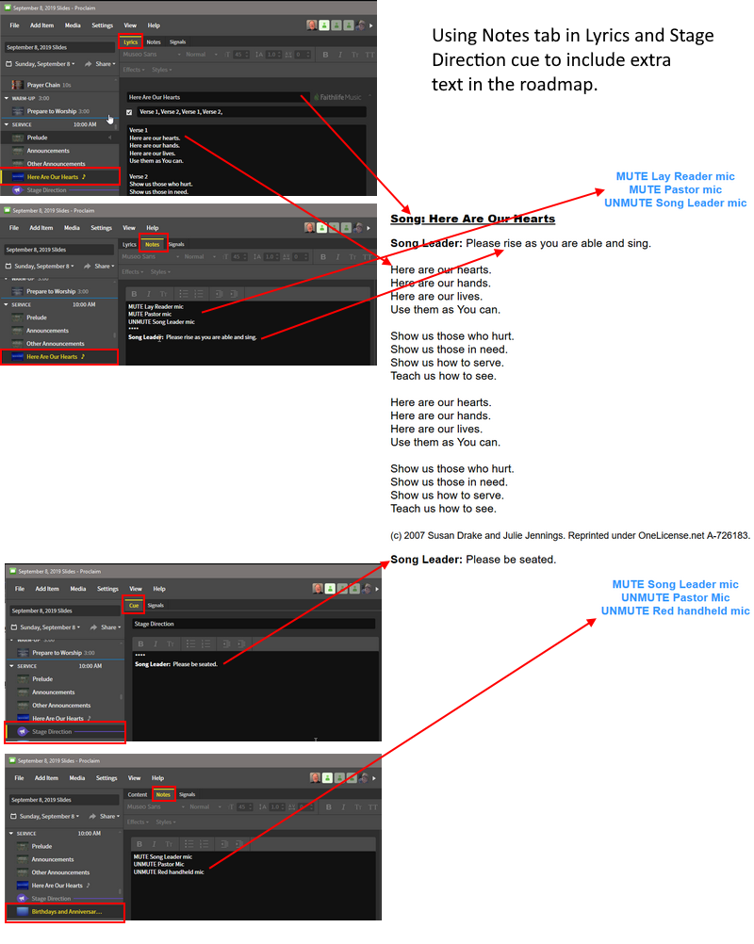

Suggested editing methodology:

* Always take frequent File, Backup Presentation to have a good starting point in case of a problem.
* Gather the Song list from the Music Director – it will have song titles, verses used, source (Hymnal # or CCLI #) and copyright info.
* Gather the worship liturgy file from the Pastor and have open in Word for easy copy/paste.
* Change the scripture reading in the Bible (Scripture) slide to the one to be used in the lesson. If more than one scripture is to be read, you’ll need to duplicate the slide and use the second slide for the second scripture. The Bible slides can only do one book and chapter at a time.
* Copy the Call To Worship into the Notes part of the Call to Worship slide (if it is to be read by the worship team only), or into the ‘Call to Worship-call-response’ item (if to be responsively read)
* Copy the Invocation into the Notes section of the ‘Prayer of Invocation’ slide after the **** marker.
* Change the Message slide with the sermon name (in Description field)
* Change the Anthem slide with the new anthem name (in Description field)
* Copy the Offering Dedication into the Prayer of Dedication slide Notes area after the **** marker.
* Copy the Unison Prayer of Reconciliation contents to the Prayer Of Reconciliation Contents. Use one blank line to separate the sets of One:/ALL: call/response. It would be nice to make the One responses italic and the ALL responses bold (if they aren’t already that way).
* Copy the Assurance of Pardon contents to the corresponding slides. If the congregation has liturgy responses, copy them (and format as needed) to the Assurance of Pardon call-response slide.
* Copy the Pastoral Prayer to the Notes tab (after the ‘****’ line) of the Pastoral Prayer slide.
* Change the Communion set of slides if needed.
* Copy the Communion Blessing to the corresponding set of Communion Blessing slides.
* Copy the Benediction to the Notes section (after the ‘****’ line) of the Benediction slide.
* Then go to the start of the service and enter the service’s Song entries – this may involve creating new song entries using the web tool if the song is not already in our library.
* If you moved slides around, please check the AV cues in the Notes section of the moved slide to ensure the AV crew gets the correct instructions.
* When you have finished editing, do a File, Backup Presentation… to save a copy of the presentation locally.
* Go to the **make-roadmap.php** page and click the Browse button. In the file dialog, select the saved .prs file created with the Backup Presentation, press OK then click the Upload button. It will run for a while as uploading the 10 to 20Mbyte .prs file takes time (maybe 60 seconds or more).
* When a Worship Roadmap page is displayed, you are now done with the initial creation of a service slide set and worship roadmap.
* Whenever you do revisions to the slide set, do the Backup, webpage, select .prs file, upload process again so that the Worship Roadmap matches the current slide set.

### **Adding Songs to the library**

Many of the songs used in the service are already added to the Proclaim library. If so, then specifying a song in a Song slide may be as easy as typing the first few characters of the song title (or the CCLI number), seeing the song in a drop-down list and clicking on it in order to add the song to the service. You may have to change the lyrics a bit to make them more visible (larger fonts) by splitting lines and adding ‘—’ (two hyphens/dashes) new page indicators, and/or selecting verses to be sung.

If the song is not in the list, then here’s a process you can use to add a song to the library:

* Go to **make-openlp.php** page and you’ll see a page  
  like:  
  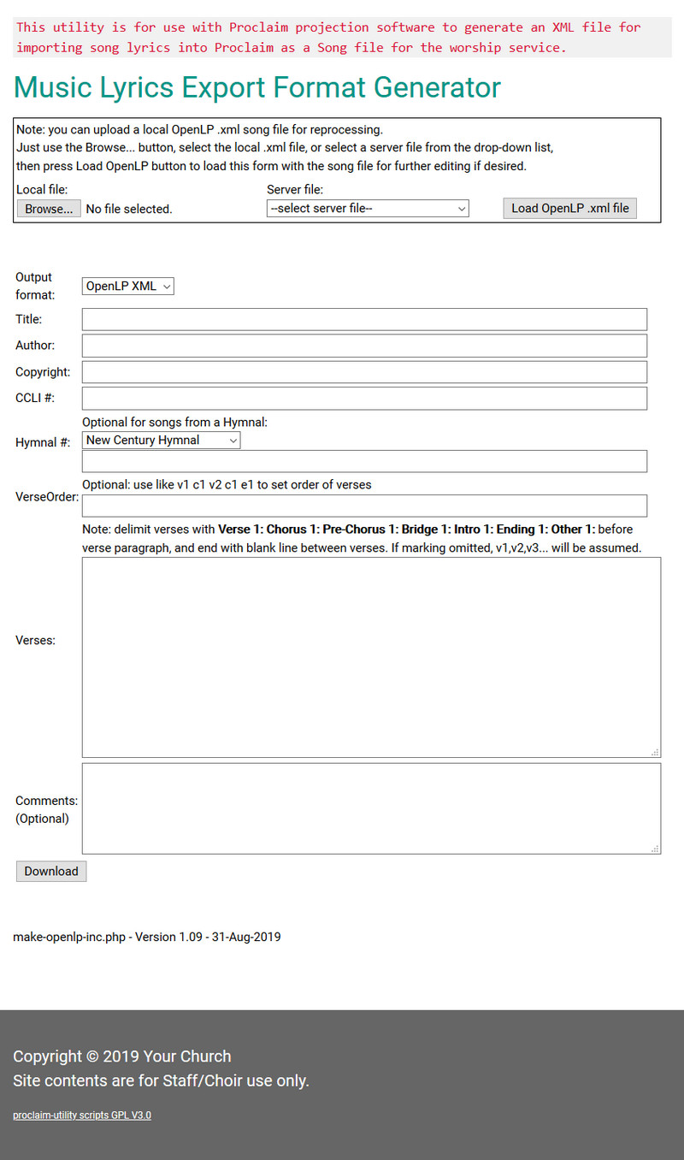

Gather the song Title, Author, Copyright and lyrics text from the reference sources to use in the form.

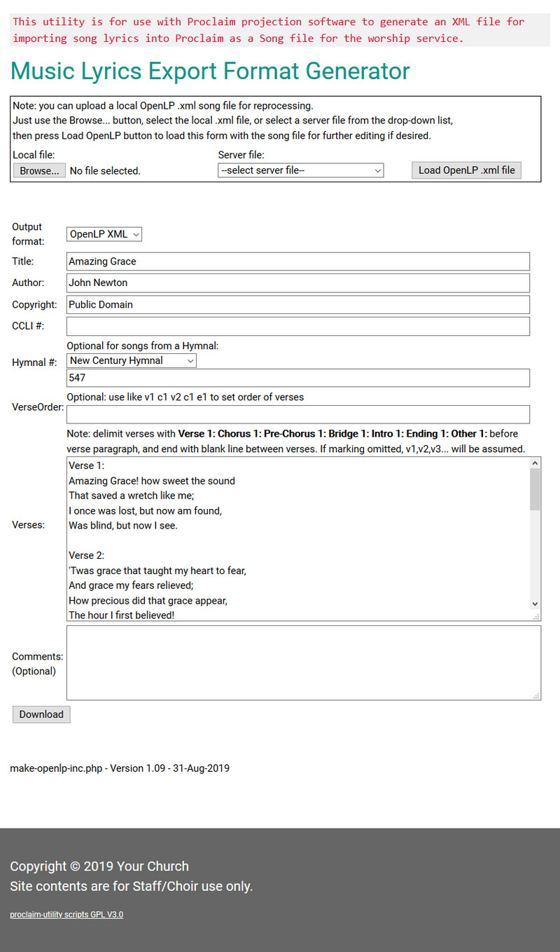

Then press the Download key, save the .XML file locally and switch to Proclaim.

In Proclaim, use the Media, Import Media, Song Lyrics menu as shown in the following images.

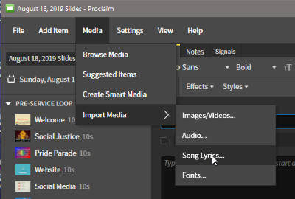

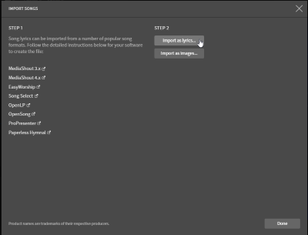

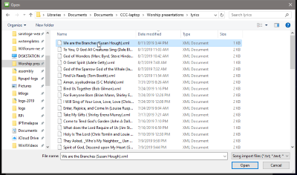

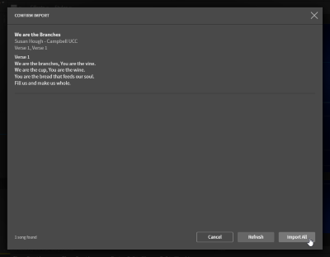

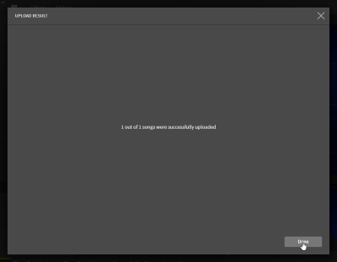

Then you can add the song to the slide:

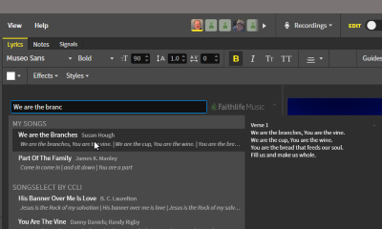

You may have to adjust the lyrics to make good slides.

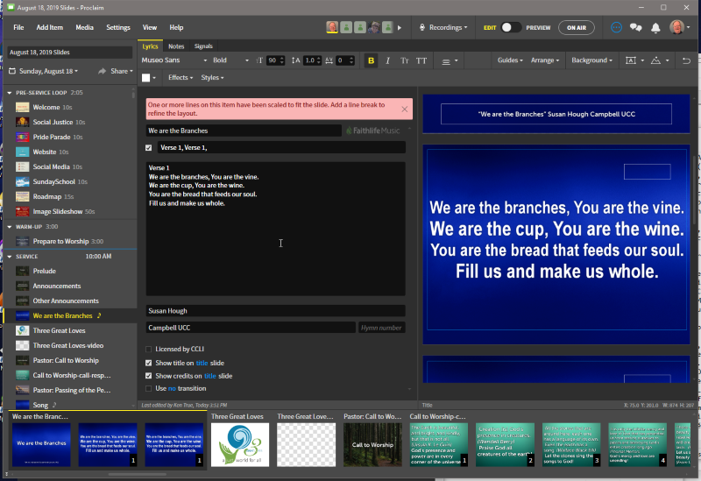

After adjusting, the song will be more readable to the congregation.

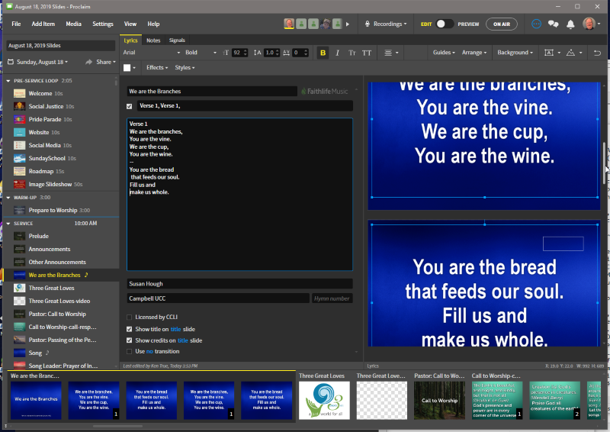

### **Creating a Worship Roadmap**

After completing your edits of a slide set for a service, please use the following procedure to create a Worship Roadmap for the service:

1. In Proclaim, use File, Backup Presentation… menu item to save a copy of the current roadmap to a .prs file on your local system.
2. Use a browser to go to **make-roadmap.php** page.
3. Click the Browse button, use the File dialog to navigate to the directory where the .prs file from (1) was saved, highlight the file, and press Ok.
4. The file name should appear next to the Browse button.
5. Press the Upload button to start the upload process. It will take quite a while (maybe 60 seconds or more) as uploading a 10 to 20Mbyte file is slow on most internet connections.
6. Success will be indicated by a display of the roadmap in the browser. Repeat step (5) if the page times-out without showing a roadmap.