Assignment 2

Seturile de date folosite:

alik05\_forest-fire-dataset (https://www.kaggle.com/datasets/alik05/forest-fire-dataset)
elmadafri\_the-wildfire-dataset (https://www.kaggle.com/datasets/elmadafri/the-wildfire-dataset)
kutaykutlu\_forest-fire (https://www.kaggle.com/datasets/kutaykutlu/forest-fire)
mohnishsaiprasad\_forest-fire-images (https://www.kaggle.com/datasets/mohnishsaiprasad/forest-fire-images)
phylake1337\_fire-dataset (https://www.kaggle.com/datasets/phylake1337/fire-dataset)

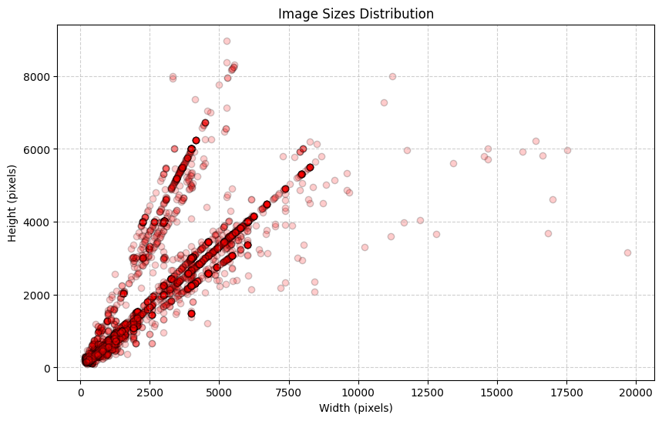
distributia marimilor imaginilor din toate seturile de date

Imaginile au fost redimensionate la 265x265 pixeli.

