A full-spectrum cynomolgus monkey [¹⁸F]FDG PET-MRI stereotaxic brain template set across the lifespan
Our constructed age-specific stereotaxic brain template set of cynomolgus monkey spanning 7 age stages is presented in Fig.1. The T1WI MRI structural brain template images and the population intracranial TPM (GM, WM and CSF) are shown in greyscale, with voxel sizes of 0.25 × 0.25 × 0.25 mm³. The [¹⁸F]FDG PET functional brain template image is shown in false color with a voxel size of 1 × 1 × 1 mm³. The T1WI MRI structural brain template, [¹⁸F]FDG PET template and TPM share a common space.
Fig. 1. Lifespan-wide age-specific brain templates and TPMs in cynomolgus monkeys. Axial views of the T1WI MRI structural templates (Row 1), TPMs for GM, WM, and CSF (Rows 2–4, grayscale), and [18F]FDG PET templates (Row 5, pseudo color) are shown across seven age groups. All modalities share a unified coordinate space, enabling harmonized multi-modality analysis across different developmental stages.

Our constructed age-specific brain atlases of cynomolgus monkey spanning 7 age stages is presented in Fig.2. To maximize methodological flexibility, three distinct versions of the atlas were generated and made available. A functional parcellation atlas, which differentiates 90 left-right paired sub-anatomical regions, designed specifically for constructing brain metabolic networks and performing fine-grained connectivity analyses as shown in Fig.2A. A macrostructural atlas was intended primarily for defining reference regions in quantitative PET workflows or for extracting time-activity curves (TACs) from various tracers during dynamic PET imaging as shown in Fig.2B. A tri-tissue label atlas​ (GM, WM, and CSF), which serves as the foundational input for generating MRI-free PVE correction label maps—as detailed in our previous pipeline as shown in Fig.2C. The atlases were shown in pseudo-color and overlaid on its corresponding structural template. Collectively, this multi-scale atlas resource provides a robust anatomical framework for both structural MRI assessments and PET radiotracer quantifications across the entire developmental continuum.

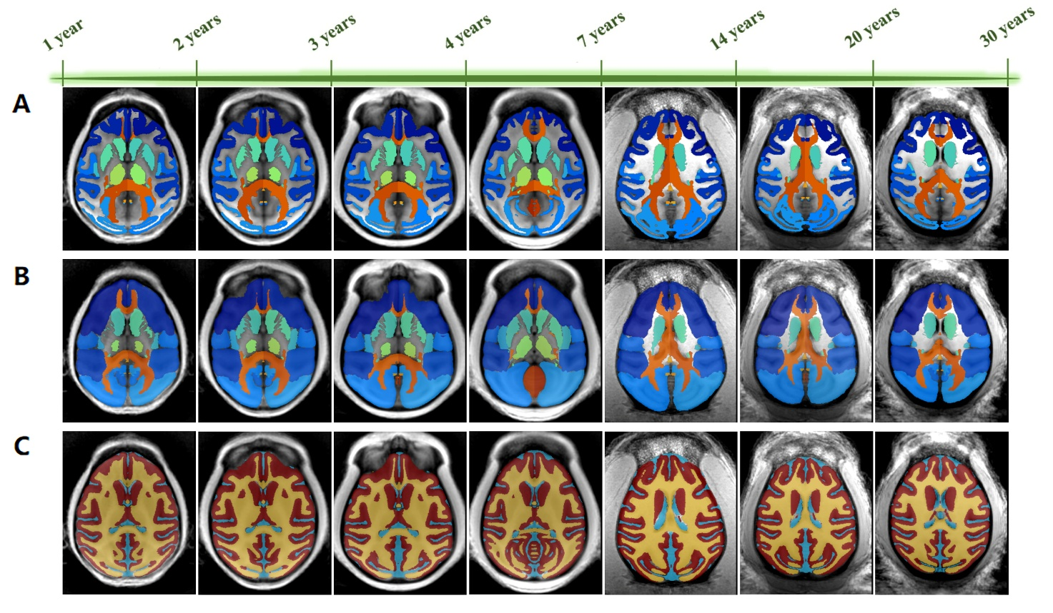
Fig.2. Lifespan-wide multi-scale brain atlases for cynomolgus monkeys. Axial overlays of the age-specific atlases on T1WI templates. (A)​ Functional parcellation atlas for metabolic network and connectivity analyses. (B)​ Macrostructural atlas for PET quantitative regions of interest (ROIs) and dynamic TAC extraction. (C)​ Tri-tissue label atlas (GM, WM, CSF) for MRI-free partial volume effect (PVE) correction. Complete parcellation details are available in the Supplementary Tables..

