**CD01:** AccountContrller

**Package:** Controller

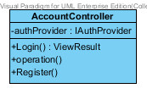

**Attribute Details**

|  |  |  |  |
| --- | --- | --- | --- |
| **No.** | **Name** | **Description** | **Type** |
| 1 | authProvider | The variable of username and password | IAuthProvider |

**Method Details**

|  |  |  |  |  |
| --- | --- | --- | --- | --- |
| **No.** | **Name** | **Parameter** | **Description** | **Return** |
| 1 | Login | none | The method is to validate username and password | ViewResult |
| 2 | operation | none | The method is to operated authProvider is working | N/A |
| 3 | Register | none | The method is to send to registration page | N/A |

**CD02:** AdminContrller

**Package:** Controller

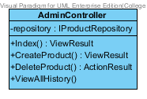

**Attribute Details**

|  |  |  |  |
| --- | --- | --- | --- |
| **No.** | **Name** | **Description** | **Type** |
| 1 | repository | To use information from product repository | IProductRepository |

**Method Details**

|  |  |  |  |  |
| --- | --- | --- | --- | --- |
| **No.** | **Name** | **Parameter** | **Description** | **Return** |
| 1 | Index | None | The method is to send information to view | ViewResult |
| 2 | CreateProduct | None | The Administrator can add product | ViewResult |
| 3 | DeleteProduct | None | The Administrator can delete product | ActionResult |
| 4 | ViewAllHistory | None | The Administrator can View all shopping history | N/A |

**CD03:** NavContrller

**Package:** Controller

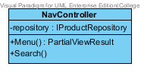

**Attribute Details**

|  |  |  |  |
| --- | --- | --- | --- |
| **No.** | **Name** | **Description** | **Type** |
| 1 | repository | To use information from product repository | IProductRepository |

**Method Details**

|  |  |  |  |  |
| --- | --- | --- | --- | --- |
| **No.** | **Name** | **Parameter** | **Description** | **Return** |
| 1 | Menu | None | The method is to display list of product and show navigation of product | PartialViewResult |
| 2 | Search | None | The customer can search product | N/A |

**CD04:** ProductContrller

**Package:** Controller

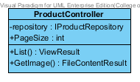

**Attribute Details**

|  |  |  |  |
| --- | --- | --- | --- |
| **No.** | **Name** | **Description** | **Type** |
| 1 | repository | To use information from product repository | IProductRepository |
| 2 | PageSize | Count page in list of product | int |

**Method Details**

|  |  |  |  |  |
| --- | --- | --- | --- | --- |
| **No.** | **Name** | **Parameter** | **Description** | **Return** |
| 1 | List | None | The method is to display list of product | ViewResult |
| 2 | GetImage | None | The method is to get image of product | FileContentResult |

**CD05:** CartContrller

**Package:** Controller

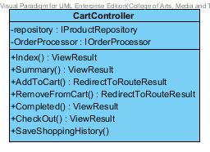

**Attribute Details**

|  |  |  |  |
| --- | --- | --- | --- |
| **No.** | **Name** | **Description** | **Type** |
| 1 | repository | To use information from product repository | IProductRepository |
| 2 | OrderProcessor | Construct the cart | IOrderRepository |

**Method Details**

|  |  |  |  |  |
| --- | --- | --- | --- | --- |
| **No.** | **Name** | **Parameter** | **Description** | **Return** |
| 1 | Index | None | The method is to send information to view | ViewResult |
| 2 | Summary | None | The method is to summarize cart | ViewResult |
| 3 | AddTOCart | None | Customer can add product to cart | RedirectToRouteResult |
| 4 | RemoveFromCart | None | Customer can remove product from cart | RedirectToRouteResult |
| 5 | Completed | None | Construct all list of product in a cart | ViewResult |
| 6 | CheckOut | None | Customer can check out after finish add cart | ViewResult |
| 7 | SaveShoppingCart | None | Customer can save their shopping list cart | N/A |

**CD06 :**Product

**Package:** Model

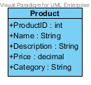

**Attribute Details**

|  |  |  |  |
| --- | --- | --- | --- |
| **No.** | **Name** | **Description** | **Type** |
| 1 | ProductId | The variable of the product id | Integer |
| 2 | Name | The variable of the product name | String |
| 3 | Description | The variable of the product description | String |
| 4 | Price | The variable of the product price | Double |
| 5 | Category | The variable of the product category | String |

**CD07 :**CartIndexViewModel

**Package:** Model

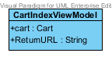

**Attribute Details**

|  |  |  |  |
| --- | --- | --- | --- |
| **No.** | **Name** | **Description** | **Type** |
| 1 | cart | The variable of cart | Cart |
| 2 | ReturnURL | To return cart url back to view | String |

**CD08 :**Cart

**Package:** Model

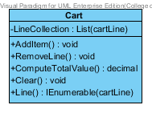

**Attribute Details**

|  |  |  |  |
| --- | --- | --- | --- |
| **No.** | **Name** | **Description** | **Type** |
| 1 | lineCollection | The list of the cart | List<CartLine> |

**Method Details**

|  |  |  |  |  |
| --- | --- | --- | --- | --- |
| **No.** | **Name** | **Parameter** | **Description** | **Return** |
| 1 | AddItem | None | Cart can add product item to cart line | void |
| 2 | RemoveLine | None | Cart can removed line of product | void |
| 3 | ComputeTotalValue | None | Calculate cart | Decimal |
| 4 | Clear | None | Clear the line of cart | void |
| 5 | Line | None | To display the product | IEnumerable<cartLine> |

**CD09 :**PaymentSelection

**Package:** Model

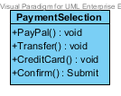

**Method Details**

|  |  |  |  |  |
| --- | --- | --- | --- | --- |
| **No.** | **Name** | **Parameter** | **Description** | **Return** |
| 1 | paypal | None | Selection of paypal | void |
| 2 | Transfer | None | Selection of Transfer money | void |
| 3 | CreditCart | None | Selection of Credit Cart | void |
| 4 | Confirm | None | Confirm to pay | submit |

**CD10 :**CustomerAccount

**Package:** Model

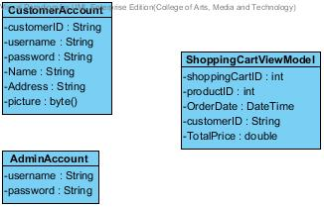

**Attribute Details**

|  |  |  |  |
| --- | --- | --- | --- |
| **No.** | **Name** | **Description** | **Type** |
| 1 | CustomerID | The variable of the customer ID | String |
| 2 | username | The variable of the username of customer | String |
| 3 | password | The variable of the password of customer | String |
| 4 | name | The variable of the customer name | String |
| 5 | Address | The variable of the customer Address | String |
| 6 | picture | The variable of the customer’s picture | Byte[] |

**CD11 :** AdminAccount

**Package:** Model



|  |  |  |  |
| --- | --- | --- | --- |
| **No.** | **Name** | **Description** | **Type** |
| 1 | username | The variable of the username of the administrator | String |
| 2 | password | The variable of the password of administrator r | String |

**CD12 :** ShoppingCartViewModel

**Package:** Model



|  |  |  |  |
| --- | --- | --- | --- |
| **No.** | **Name** | **Description** | **Type** |
| 1 | shoppingCartId | The variable of the shopping cart id | Integer |
| 2 | CustomerID | The variable of the customer id | Integer |
| 3 | productId | The variable of the product id | Integer |
| 4 | orderDate | Date and Time that the customer order | DateTime |
| 5 | totalPrice | The total price of the product in shopping cart | Decimal |