**URS 01 The User can log in as an Administrator**

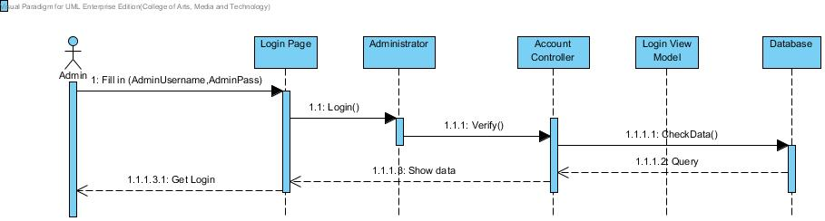

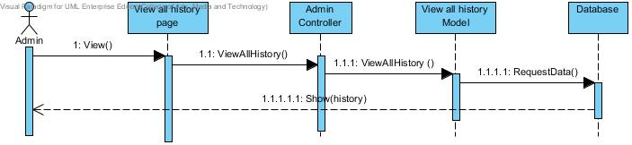**URS 02 The Admin can view the shopping history of all Customers**

**URS 03 The Admin can add product**

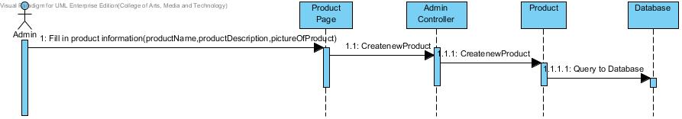

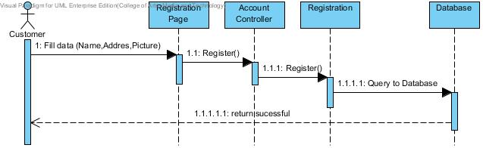**URS 04 The Customer can register**

**URS 05 The Customer can edit profile**

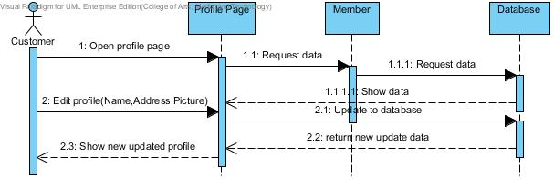

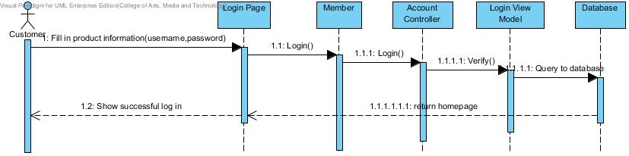**URS 06 The User can login as a Customer**

**URS 07 The Customer can browse category**

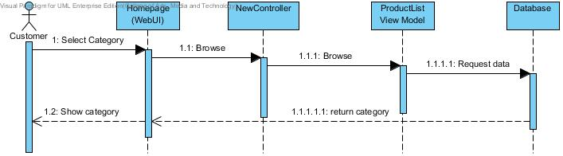

**URS 08 The Customer can search product**

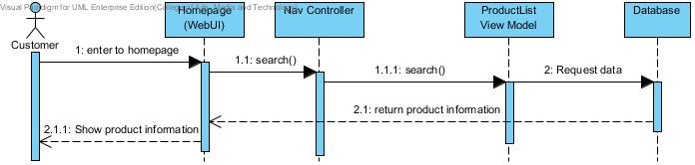

**URS 09 The Customer can check out product**

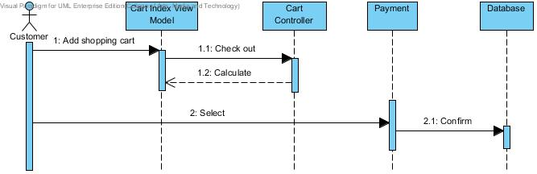

**URS 10 The Customer can save the shopping cart**

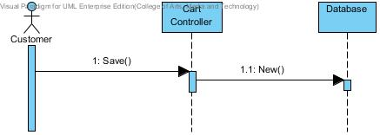

**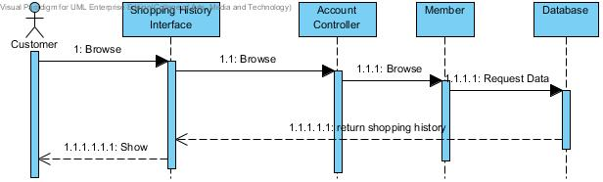  
URS 11 The Customer can view shopping history**

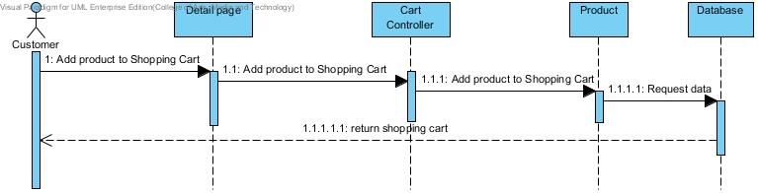**URS12 The customer can add product to shopping cart**

**URS13 The customer can confirm payment method selection**

