目前阶段完成的代码与功能如下所示：

1. 检测是否有水

#include "water.h"

#include "delay.h"

#define WA GPIO_Pin_11

/*************** 配置LED用到的I/O口 *******************/

void Water_GPIO_Config(void)

{

GPIO_InitTypeDef GPIO_InitStructure;

RCC_APB2PeriphClockCmd( RCC_APB2Periph_GPIOB, ENABLE); // 使能端口时钟

GPIO_InitStructure.GPIO_Pin = WA;

GPIO_InitStructure.GPIO_Mode = GPIO_Mode_Out_PP;

GPIO_InitStructure.GPIO_Speed = GPIO_Speed_50MHz;

GPIO_Init(GPIOB, &GPIO_InitStructure); //初始化端口

//GPIO_SetBits(GPIOB, WA); // 关闭所有LED

}

int Water_state(GPIO_TypeDef* GPIOx, uint16_t GPIO_Pin_x)

{

Delay_ms(10);

if( GPIO_ReadInputDataBit(GPIOx, GPIO_Pin_x) == 0)

{

return 1;

}

else

{

return 0;

}

}

if( Water_state(GPIOB, GPIO_Pin_11)== 0)

{

printf("\r\n有水");

}

else

printf("\r\n无水");

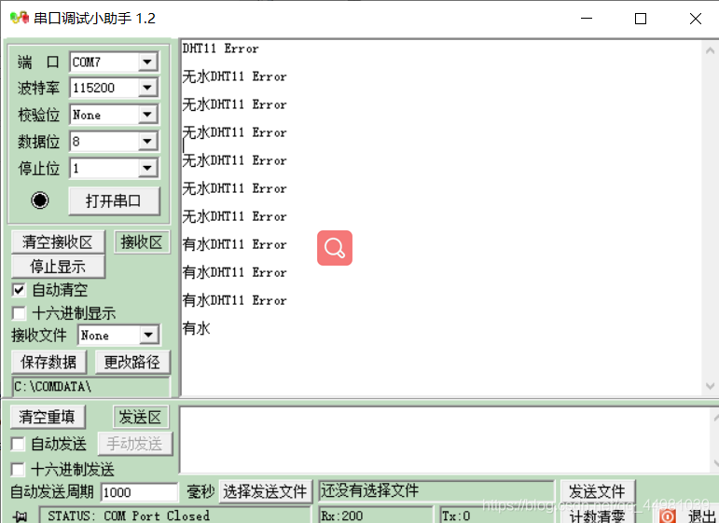

1. 测量水位

/************************************

* 文件名 ：adc.c

* 描述 ：DMA方式读取ADC值应用函数库

**********************************************************************************/

#include "adc.h"

#define ADC1_DR_Address ((u32)0x4001244C)

__IO u16 ADC_ConvertedValue;

/*配置采样通道端口 使能GPIO时钟 设置ADC采样PA0端口信号*/

void ADC1_GPIO_Config(void)

{ GPIO_InitTypeDef GPIO_InitStructure;

RCC_APB2PeriphClockCmd(RCC_APB2Periph_GPIOA, ENABLE);

GPIO_InitStructure.GPIO_Pin = GPIO_Pin_0;

GPIO_InitStructure.GPIO_Mode = GPIO_Mode_AIN; //GPIO设置为模拟输入

GPIO_Init(GPIOA, &GPIO_InitStructure);

}

/*配置ADC1的工作模式为MDA模式 */

void ADC1_Mode_Config(void)

{

DMA_InitTypeDef DMA_InitStructure;

ADC_InitTypeDef ADC_InitStructure;

RCC_AHBPeriphClockCmd(RCC_AHBPeriph_DMA1, ENABLE); //使能MDA1时钟

/* DMA channel1 configuration */

DMA_DeInit(DMA1_Channel1); //指定DMA通道

DMA_InitStructure.DMA_PeripheralBaseAddr = ADC1_DR_Address;//设置DMA外设地址

DMA_InitStructure.DMA_MemoryBaseAddr = (u32)&ADC_ConvertedValue; //设置DMA内存地址，ADC转换结果直接放入该地址

DMA_InitStructure.DMA_DIR = DMA_DIR_PeripheralSRC; //外设为设置为数据传输的来源

DMA_InitStructure.DMA_BufferSize = 1; //DMA缓冲区设置为1；

DMA_InitStructure.DMA_PeripheralInc = DMA_PeripheralInc_Disable;

DMA_InitStructure.DMA_MemoryInc = DMA_MemoryInc_Disable;

DMA_InitStructure.DMA_PeripheralDataSize = DMA_PeripheralDataSize_HalfWord;

DMA_InitStructure.DMA_MemoryDataSize = DMA_MemoryDataSize_HalfWord;

DMA_InitStructure.DMA_Mode = DMA_Mode_Circular;

DMA_InitStructure.DMA_Priority = DMA_Priority_High;

DMA_InitStructure.DMA_M2M = DMA_M2M_Disable;

DMA_Init(DMA1_Channel1, &DMA_InitStructure);

/* Enable DMA channel1 */

DMA_Cmd(DMA1_Channel1, ENABLE); //使能DMA通道

RCC_APB2PeriphClockCmd(RCC_APB2Periph_ADC1, ENABLE); //使能ADC1时钟

/* ADC1 configuration */

ADC_InitStructure.ADC_Mode = ADC_Mode_Independent; //使用独立模式，扫描模式

ADC_InitStructure.ADC_ScanConvMode = ENABLE;

ADC_InitStructure.ADC_ContinuousConvMode = ENABLE; //无需外接触发器

ADC_InitStructure.ADC_ExternalTrigConv = ADC_ExternalTrigConv_None; //使用数据右对齐

ADC_InitStructure.ADC_DataAlign = ADC_DataAlign_Right;

ADC_InitStructure.ADC_NbrOfChannel = 1; // 只有1个转换通道

ADC_Init(ADC1, &ADC_InitStructure);

/* ADC1 regular channel11 configuration */

ADC_RegularChannelConfig(ADC1, ADC_Channel_0, 1, ADC_SampleTime_55Cycles5); //通道1采样周期55.5个时钟周期

/* Enable ADC1 DMA */

ADC_DMACmd(ADC1, ENABLE); //使能ADC的DMA

/* Enable ADC1 */

ADC_Cmd(ADC1, ENABLE); //使能ADC1

/* Enable ADC1 reset calibaration register */

ADC_ResetCalibration(ADC1);

/* Check the end of ADC1 reset calibration register */

while(ADC_GetResetCalibrationStatus(ADC1));

/* Start ADC1 calibaration */

ADC_StartCalibration(ADC1);

/* Check the end of ADC1 calibration */

while(ADC_GetCalibrationStatus(ADC1));

/* Start ADC1 Software Conversion */

ADC_SoftwareStartConvCmd(ADC1, ENABLE); //开始转换

}

/*初始化ADC1 */

void ADC1_Init(void)

{

ADC1_GPIO_Config();

ADC1_Mode_Config();

}

AD_value = 3300000/4096*ADC_ConvertedValue/1000;

val=(exp(0.0056*AD_value))*0.467;

printf("水位深度 = %d mm \r\n", val);

Delay_ms(1000);

