**TicketReturn partners with Izenda – offers**

**box office users cutting-edge solutions**

They needed flexible solutions for their diverse client base – Izenda had the perfect platform

# Company Profile

TicketReturn, LLC, is a leading provider of Box Office and Internet ticketing services, with innovative event marketing, access control, attendance reporting, accounting, and fund-raising features for sports and entertainment venues nationwide.

The Charlotte, NC-based company services more than 130 venues in 40 U.S. states and British Columbia, and issues more than 22 million tickets annually. Since it was founded in 2001, TicketReturn has also become the largest single provider of ballpark ticketing services in Minor League Baseball (MiLB), and is licensed by Major League Baseball Advanced Media to provide online ticketing to fans at [www.milb.com](http://www.milb.com) affiliate websites.

TicketReturn’s diverse range of client venues includes theaters, casino showrooms, motorsports and horse racing facilities, university arenas, and sports stadiums – this wide variety reflects the scalability and ease of use of its products. The company also provides custom online student ticketing services for the Universities of Maryland, Virginia, West Virginia, South Carolina, as well as Georgia Tech, NC State, and University of Pittsburgh, to name a few.

TicketReturn is a pioneer in paperless Card Access Ticketing, which allows a single encoded card to serve as a season or partial-season ticket for any number of events. These cards come with online ticket management services such as ticket forwarding, exchange, donation, and resale.

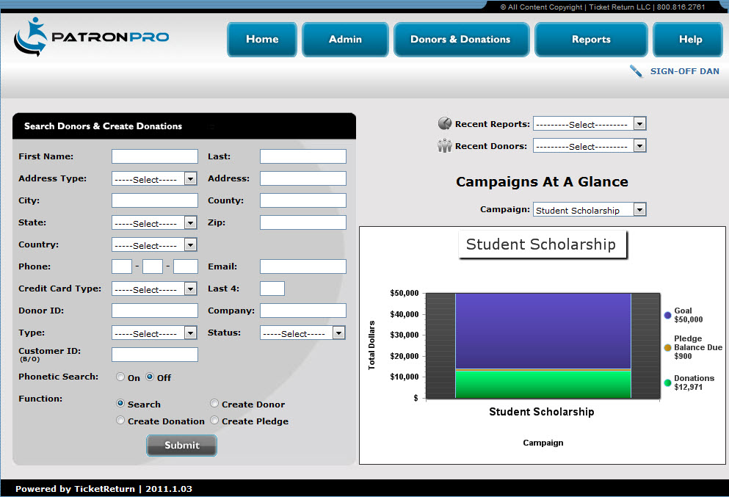

# Business Situation

TicketReturn was looking for integration with a web-based ad-hoc reporting tool for their new Donor Management, Fundraising, and Priority Seating software module “PatronPro.” PatronPro was developed to support specific features required by University Athletic Departments. PatronPro is a standalone module with backend integration into TicketReturn’s other ticketing modules.

TicketReturn had the option of creating its own reporting interface, but decided it would be more efficient to look for a viable ASP.NET reporting tool if the solution existed.

TicketReturn clients using PatronPro have the option of site-based and/or hosted installations.

# Technical Situation

TicketReturn needed to find an ASP.NET web-based, ad-hoc reporting tool that could be deployed in both a site-based and hosted installation. Specific requirements included the following:

* Ad-hoc report designer
* Charting tools
* Scheduled reporting
* User permissions
* Exporting report flexibility
* Flexibility for a user to add/change filters or viewable fields for standard reports (minimize the need for new custom reports to be created)

# Solution

TicketReturn integrated Izenda Reports into PatronPro applications, implementing the following solutions:

* Customized Report List Page
* Custom Report Scheduler
* Ability to create reports with visual aids (charts, gauges, etc.)
* Incorporated lyte box pop-ups to present users with filters that are applied when the reports is run (e.g., dates, users)
* Incorporated lyte box pop-ups in report designer, allowing users to select specific views with pre-joined tables

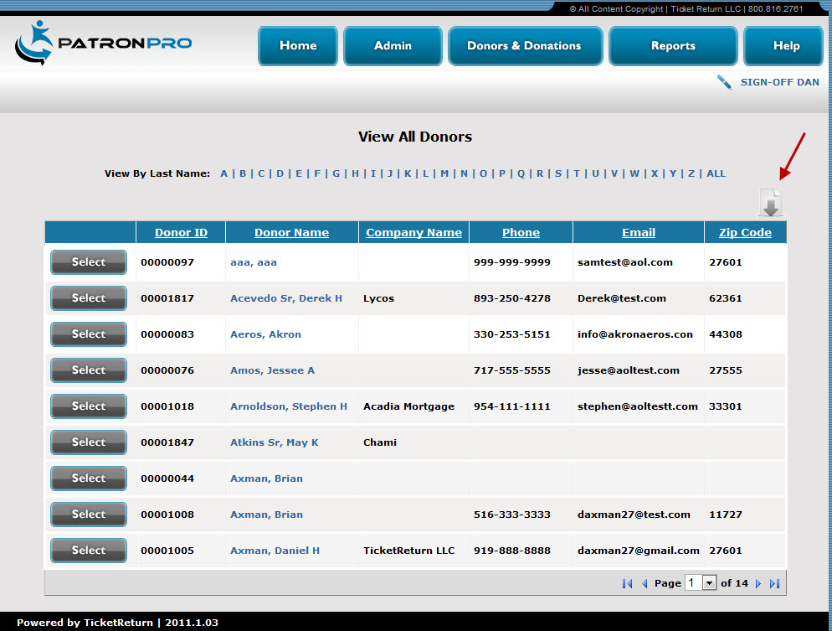

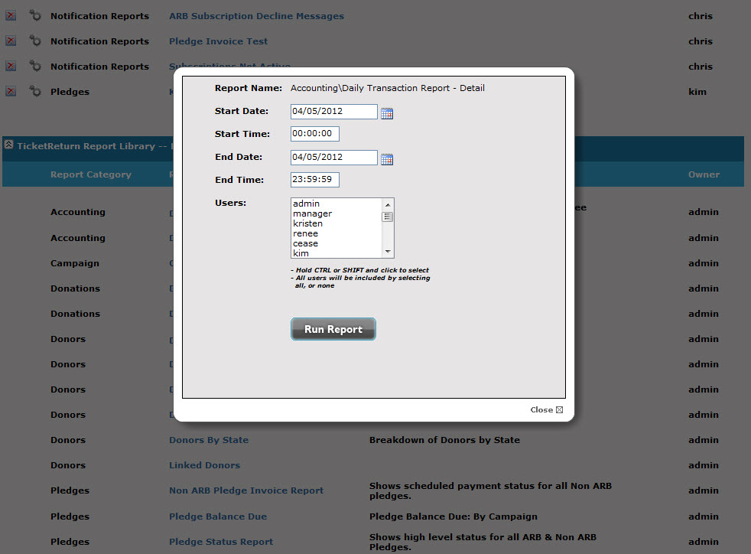

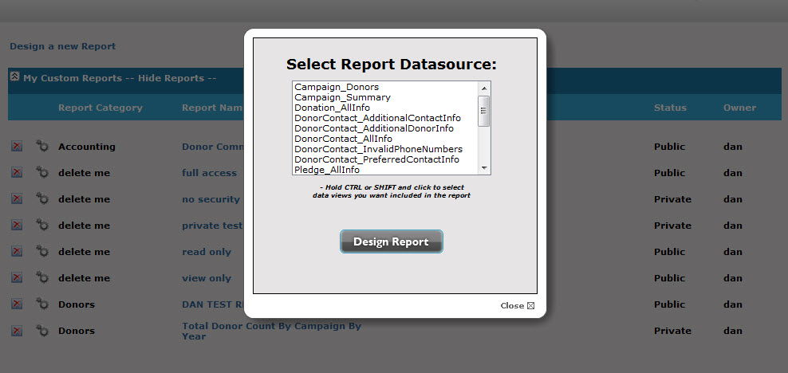

# Benefits

This solution provides ample benefit to TicketReturn. Integrating Izenda reports resulted in the following:

* Significantly less development time for standard reports and an ad-hoc report builder
* The ability to deploy the reporting platform in both site-based and hosted implementations
* Access and use of visual aids, to better track results

There are many benefits to TicketReturn’s end users as well, including:

* Ad-hoc reporting with state-of-the-art features— including scheduled reporting, charting, and exporting capabilities
* Users can create custom reports with just a few clicks
* Users can add to and change standard reports with ease

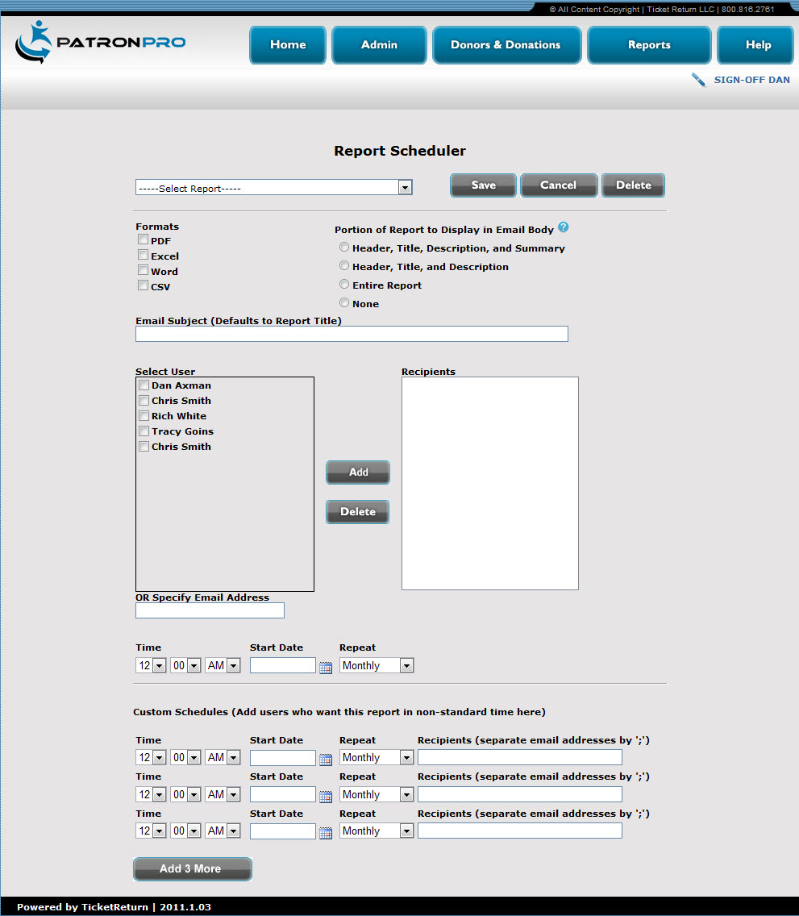

Does your reporting need an upgrade? Contact Izenda today at 1-678-500-9136.