- Introduction
1.1 Project Overview
Students often study for long periods without taking proper breaks. They push through fatigue and stress to keep up with school tasks. Over time, this reduces focus and weakens cognitive recovery. Many students also lack a clear system to decide what type of break they need. The app design shows a need for simple tools like mood check-ins and guided activity options to support better study routines.
The problem is that there is no easy way for students to know what kind of break they actually need. Unplanned breaks do not always help students recover. A student who is physically tired needs a different break than one who is mentally stressed or short on time. Some take breaks that do not match their current state. This leads to low refreshment after breaks and poor focus in the next study session. Without tracking fatigue, stress, and break results, students cannot improve their study habits or know which activities work best for them.
BreakSense solves this by recommending the right break activity based on how the student is feeling at that moment. It is a mobile study habits tracker that uses machine learning and database systems to recommend break activities for students. The user simply inputs their fatigue level, stress level, and how many minutes they have available. The system then uses a K-Nearest Neighbors (KNN) model to match them to the best break category, such as physical movement, mindfulness, nutrition, or rest, suggesting suitable activities like stretching, breathing exercises, short walks, or rest. The goal is to help students avoid burnout and improve focus during study sessions. Over time, the system stores user data and feedback to improve future recommendations, supporting better cognitive recovery and helping students maintain steady focus across study sessions.
1.2 Learning Objectives
This project helps students gain knowledge in database design, machine learning, mobile app development, and data management. It also gives experience in creating a system that uses user data to generate recommendations.

General Objective
- To build a niche student productivity tool that uses machine learning to recommend personalized break activities, matched to the user's current emotional and physical state that each break maximizes mental restoration and focus for the next study session.

Specific Objectives
- Design a mood check-in interface where users input their current fatigue level, stress level, and available break time through simple sliders or quick-select options before each break.
- Build and train a K-Nearest Neighbors (KNN) classification model that maps user state inputs to an optimal break category such as physical movement, mindfulness, nutrition, or rest.
- Create a curated break activity library with timed, guided activities for each category, such as a 5-minute walk prompt, breathing exercises, or a healthy snack suggestion.
- Implement a Logs database table that records each break session's input state, activity chosen, and post-break refreshment rating, serving as the dataset the model learns from over time.
- Measure system effectiveness by tracking average post-break refreshment scores and comparing study session focus ratings before and after the tool's recommendations.

- Background
2.1 Introduction to Database Systems
A Database Management System (DBMS) is software that allows users to store, organize, retrieve, and manage data in a structured and efficient way. The most common type is a relational database, where data is organized into tables made up of rows and columns that can be linked to each other using keys. A common language used to interact with relational databases is SQL, which allows developers to insert, update, delete, and retrieve data. In the context of mobile applications, a DBMS is important because it allows the app to persist user data, meaning information is saved and can be accessed again in future sessions. For a student productivity app like BreakSense, this means user accounts and study session progress can be stored and retrieved every time the app is used.

2.2 Chosen Advanced Database Model/Technology
BreakSense uses MySQL hosted on Railway as its database technology — a widely used, open-source relational DBMS that stores and manages structured data through tables, relationships, and SQL queries. Unlike embedded databases, MySQL operates as a cloud-hosted server, allowing the application to communicate with the database remotely over the internet.
Railway was chosen as the hosting platform for its simple deployment process, free-tier accessibility, and reliable cloud infrastructure that eliminates the need to manage a local or dedicated database server. This setup allows BreakSense to store and retrieve data from anywhere, as long as the device has an internet connection.
In tandem with cloud-managed data storage, the computational and application layers of BreakSense are deployed on Render, a unified cloud application platform operating as a Platform as a Service (PaaS). A microservices architecture was selected to separate the primary application logic from the heavy resource demands of machine learning processing.
The system architecture utilizes two decoupled services running simultaneously:
breaksense-backend: A web application backend managed within a Node.js runtime environment that processes API requests and communicates directly with the MySQL database.
breaksense-ml: An isolated service hosted within a Python 3 runtime environment dedicated exclusively to handling user state inputs and executing the K-Nearest Neighbors (KNN) classification model.
By utilizing Render, the infrastructure abstracts low-level server configuration, provisioning, and firewall management. This ensures secure, low-latency inter-service communication between the Node.js API and the Python machine learning module while maintaining separate, dedicated resource allocations for each component of the system.
K-Nearest Neighbors (KNN) is a simple machine learning algorithm that works by comparing a new input to a set of predefined data points and finding the closest matches. Based on those matches, it returns the most suitable category as the result. In BreakSense, the KNN model takes three inputs from the user: fatigue level, stress level, and available break time. It then compares these inputs against predefined combinations to determine which break category fits best.
The model maps user inputs to four break categories based on research-backed reasoning:
Physical Movement is recommended when the user has low stress but has been sitting for a long time or has high energy. Ratey found that brief physical intervals stimulate cerebral vascular flow and the release of Brain-Derived Neurotrophic Factor (BDNF), which reinforces sustained cognitive performance [1]. Activities like Sun Salutation, Jumping Jacks, or a 5-Min Walk help re-energize the body and improve circulation.
Mindfulness is recommended when the user has high stress but is not physically tired. Porges’ Polyvagal Theory highlights how deep breathing stimulates the vagus nerve and reduces stress responses [2]. Kaplan also found that shifting attention away from demanding tasks helps restore mental capacity [3]. Activities like Box Breathing or 5-4-3-2-1 Grounding help calm the mind and reduce anxiety.
Rest and Recovery is recommended when the user is both highly stressed and highly fatigued. Hobfoll states that when a person’s resources are fully depleted, active tasks worsen the condition [4]. Rosekind et al. also validated that short naps of up to 20 minutes effectively restore alertness without causing grogginess [5]. Activities like Power Nap or Progressive Relaxation help the body and mind fully recover.
Nutrition is recommended when the user is in a neutral or moderate state. Lieberman and Armstrong et al. found that even mild dehydration impairs memory and focus [6] [7]. Gailliot and Baumeister also found that glucose availability directly affects self-control and concentration [8]. Activities like Hydration Reset or Brain Snack help maintain focus and energy levels through proper nourishment.

- System Design
3.1 System Architecture
BreakSense is built as a mobile web application with three main components working together: the frontend interface, the backend database, and the KNN recommendation model.
The frontend is what the student interacts with directly. It includes a Login and Sign Up screen, a Home dashboard showing break analytics, a Study Timer with Pomodoro sessions, a Mood Check-in screen, a Recommendation page, an Activity Library, and a Logs page. When a user submits a check-in by selecting their fatigue level, stress level, and available break time, the input is encoded into a live feature vector and passed to the KNN model running in JavaScript on the frontend.
The backend manages all data using MySQL hosted on Railway with two tables. The Users table stores each user’s id, first name, last name, email, and password. The breaks_history table records study session data including sessions completed today, total study time today, day streak, and last study date. SQL queries are used to insert and update records when a user logs in or completes a study session, and to retrieve data for the home dashboard.
The KNN model runs entirely on the frontend using JavaScript. It takes the three check-in inputs of fatigue level, stress level, and available break time, and uses predefined rules based on those input combinations to determine the most suitable break category. Depending on how tired or stressed the user is and how much time they have available, the model suggests either Physical Movement, Mindfulness, Nutrition, or Rest and Recovery. The recommended category is then displayed on the Recommendation page where the user can proceed to a guided activity.

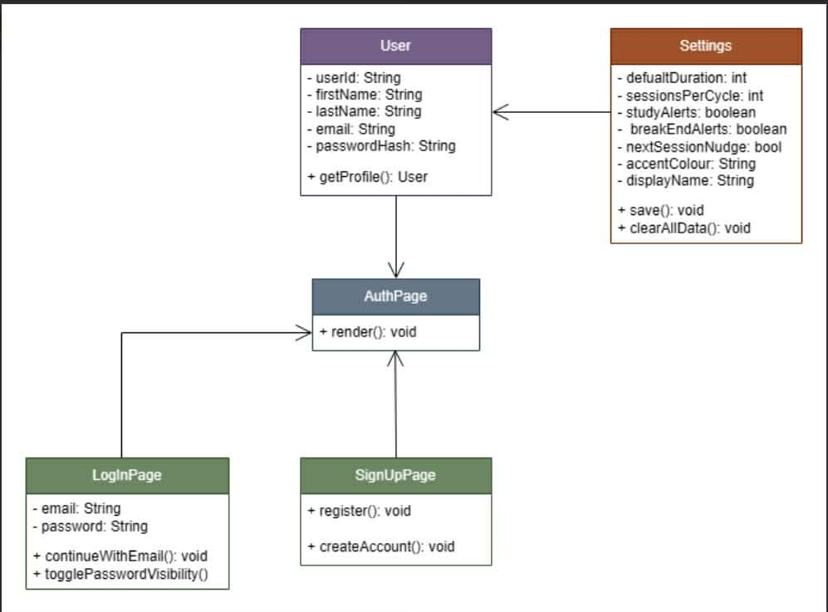
3.2 Design Diagrams

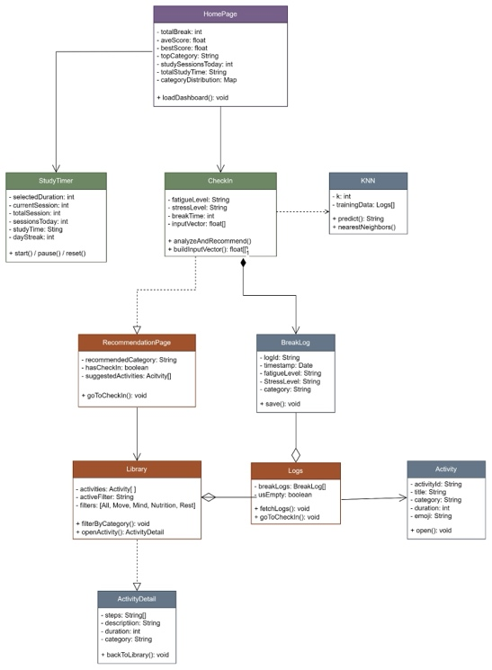
Figure 1 shows the authentication class diagram of BreakSense, covering the user login and sign up flow, session handling, and app settings structure.

Figure 2 shows the full system class diagram of BreakSense, illustrating all major components of the app including the home dashboard, study timer, mood check-in, KNN model, recommendation page, activity library, logs, and activity detail pages, and how they interact with each other.
- Implementation
4.1 Technology Stack
The system is implemented using the following technologies:
- React Native — used for building the mobile application
- Expo Go — used for initial testing and development on mobile
- Gradle — used to build the standalone APK for Android
- Railway — used for cloud hosting the database
- Render — used as the primary Platform as a Service (PaaS) to cloud-host and manage the microservice architecture.
- Figma — used for UI design and prototyping
- JavaScript — used for frontend logic and KNN recommendation
- Android Studio — used for mobile application
- GitHub — used for version control, collaborative development, and public source code hosting
These technologies collectively support the database layer, application development, and interface design.

4.2 Implementation Process
The implementation of BreakSense followed a phased lifecycle, beginning with the development of a cross-platform mobile interface using the React Native framework. Initially, the project utilized the Expo Go sandbox for rapid prototyping and live testing on physical devices. However, the development team encountered significant technical constraints, including inconsistencies in synchronizing custom typography specifically the Michroma and Outfit font families and limitations in native module integration within the Expo environment. To resolve these challenges, the implementation workflow was migrated to a native build process using the Gradle Wrapper. This transition allowed for the generation of standalone Android Package (APK) files, providing the granular control necessary to bundle specific assets and ensure stable performance across various hardware configurations.
Following the frontend establishment, a robust backend infrastructure was constructed using a Node.js and Express architecture to manage data flow and inter-service communication. For data persistence, a MySQL relational database was implemented to store complex user metrics, including break history and longitudinal study session statistics. A primary implementation hurdle involved securing sensitive user data, which was addressed by integrating the bcryptjs library for salted password hashing. As demonstrated in the following implementation of the authentication route, the system enforces secure registration by hashing credentials before they are committed to the database:
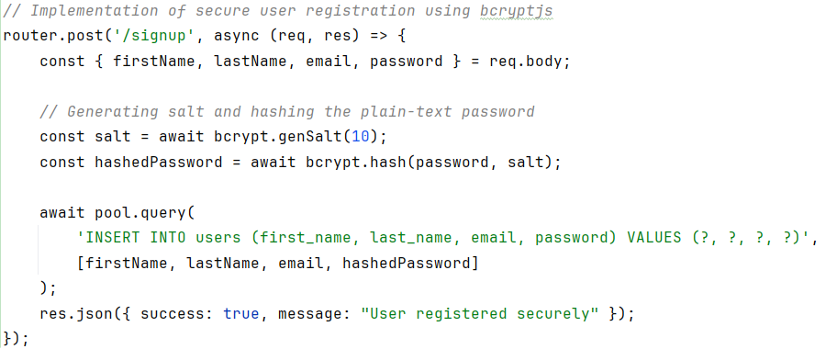
To facilitate intelligent decision-making within the application, a specialized microservice, breaksense-ml, was developed using a Python-based Flask environment. This service implements a K-Nearest Neighbors (KNN) model built with the scikit-learn library to analyze user inputs such as mood ratings, stress levels, and work duration. To maintain high performance, the model and its associated preprocessing encoders were serialized using the joblib library, allowing the system to execute predictions with minimal latency. The logic for processing these recommendations is encapsulated in a RESTful endpoint, as shown in the following script which serves as the primary interface between the core API and the machine learning engine:
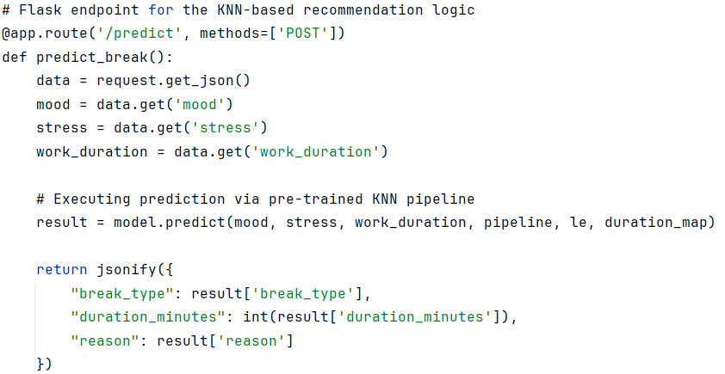
The final phase of implementation involved deploying the decoupled microservices on the Render platform as a Platform as a Service (PaaS). A significant challenge during this stage was ensuring seamless communication between the Node.js backend and the Python ML module while maintaining system reliability. To address potential service interruptions, a fallback mechanism was integrated into the backend logic; if the machine learning service fails to respond within a specified timeout, the system automatically provides a pre-defined "eye rest" recommendation to ensure an uninterrupted user experience. This architecture is managed through a continuous deployment (CD) pipeline linked to the project’s version control system, allowing for automated builds and secure environment variable management across the distributed infrastructure.

- Evaluation
  - Evaluation Criteria
The BreakSense application was evaluated based on five criteria:
- Functionality — whether the app works as expected, including the mood check-in, KNN recommendation, study timer, break timer, and activity library.
- Usability — whether the app is easy to navigate and use without guidance, and whether the design is clear and appropriate for students.
- Effectiveness — whether the recommended break activities match the user’s current state and whether the app helps improve focus and refreshment after breaks.
- Performance — whether the app loads quickly, runs smoothly, and performs consistently without crashes or errors.
- Overall Satisfaction — whether users are satisfied with the app, would recommend it to others, and would use it regularly during study sessions.

  - Testing Methodology
The system was evaluated through a user survey distributed via Google Forms. A total of 10 respondents participated in the evaluation. Each respondent was asked to use the BreakSense application and then answer a 24-item questionnaire covering the five evaluation criteria listed above.
Each item was rated using a 5-point Likert scale where 1 means Strongly Disagree and 5 means Strongly Agree. The responses were collected and the average score for each category was computed to identify the strengths and weaknesses of the system. The evaluation sheet used in this study is included in Appendix E.

  - Evaluation Results
A total of 10 respondents evaluated the BreakSense application. The app received strong feedback across all five categories.
Functionality scored 4.56, meaning most users agreed the app worked as expected. Usability scored the highest at 4.86, showing that users found the app easy to navigate and visually clear. Effectiveness scored 4.70, with most users feeling the recommended activities matched how they were feeling. Performance scored 4.68, with the app running smoothly for most users. Overall Satisfaction scored 4.55, with most users saying they would recommend the app to other students.
The overall average score was 4.67 out of 5, which shows that BreakSense was well received as a useful and functional study tool for students.

- Discussion
6.1 Software Solutions for Data Manipulation
For BreakSense, the main software solutions used for data manipulation were MySQL, Railway, and JavaScript.
MySQL handled all CRUD operations for the two database tables. Creating new records was used when a user signs up or when study session data needs to be saved. Reading records was used to retrieve user account information during login and to load study progress data for the dashboard. Updating records was used to keep the breaks_history table current as the user completes more study sessions. MySQL proved to be reliable and straightforward for these operations, though it requires a constant internet connection since it is cloud-hosted on Railway.
Railway managed the hosting and deployment of the database. Its main strength was making the database accessible remotely without any complex server setup. The limitation is that the free tier has usage restrictions, which occasionally caused the app to respond slowly.
JavaScript on the frontend handled the KNN recommendation logic and check-in input processing. Its strength is speed since it runs directly in the browser without needing to contact the server. The limitation is that it is less secure compared to running the same logic on a backend server.

6.2 Implementation of SQL Storage Systems
BreakSense uses MySQL hosted on Railway as its SQL storage system. The database contains two tables: Users and breaks_history. The Users table stores each user’s id, first name, last name, email, and password. The breaks_history table records study session data including sessions completed today, total study time today, day streak, and last study date. SQL queries are used to insert and update records when a user logs in or completes a study session, and to retrieve data for the home dashboard. The KNN recommendation logic runs separately on the frontend using JavaScript, where it processes the check-in inputs and generates a break category recommendation in real time without storing the input data to the database.
One of the main challenges we encountered was syncing everything together. BreakSense has multiple moving parts including the MySQL database hosted on Railway, the frontend interface, the KNN recommendation logic running in JavaScript, and the user authentication system. Making sure that all these components communicated correctly with each other at the same time was difficult. For example, ensuring that the right user’s data was being read and written correctly, that the study timer stats updated properly in the breaks_history table, and that the KNN model was receiving the correct input values from the check-in all had to work together seamlessly. Any small error in one part would cause other parts of the app to break or display incorrect data.

- Conclusion
7.1 Project Summary
BreakSense is a mobile web application that helps students take better breaks by recommending the right activity based on how they are feeling. Users check in by selecting their fatigue level, stress level, and available time, and the app uses a KNN model to suggest the best break category. The app also includes a Pomodoro study timer, a break timer, a guided activity library with 24 activities, a logs system, and an analytics dashboard to track break history and ratings. The database is built on MySQL hosted on Railway with two tables, Users and breaks_history, which allowed the team to store and retrieve data remotely without managing a local server. Overall, the project successfully combined a cloud-hosted relational database with a simple machine learning model to create a personalized and practical study tool for students.

7.2 Limitations and Future Improvements
As students, we noticed a few limitations while building and testing BreakSense. The app cannot be installed on iOS yet and can only be opened on Android. It also does not work without a Wi-Fi connection, so students in areas with no internet cannot use it. The app can also be slow at times, especially when loading the activity library or generating a recommendation. Another issue we found is that the app logs the user out every time they close or exit it, which means they have to sign in again each time they want to use it.
In the future, we would like to make BreakSense available as a proper app on iOS and Android. We also want to add offline support, improve the overall speed, and keep users logged in so they do not have to sign in every time they open the app.

7.3 Contribution to Advanced Database Systems
BreakSense shows how a relational database can be used as part of a real-world student productivity application. Even with a simple two-table structure, the database handles user authentication and study session tracking in a practical and functional way. The project demonstrates that a lightweight cloud-hosted database like MySQL on Railway can effectively support a mobile web application without the need for complex infrastructure. More importantly, it shows how a database and a frontend machine learning model can work together in the same system, where the database manages persistent user data while the KNN logic handles real-time recommendations on the frontend. This kind of integration is a pattern commonly seen in modern applications and serves as a practical example of applied database systems in a student-built project.

- References
[1] | J. Ratey, Spark: The Revolutionary New Science of Exercise and the Brain, 2008.
[2] | S. Porges, The Polyvagal Theory: Neurophysiological Foundations of Emotions, Attachment, Communication, and Self-Regulation, New York: W. W. Norton & Company, 2011.
[3] | S. Kaplan, "The restorative benefits of nature: Toward an integrative framework," Journal of Environmental Psychology, vol. 15, no. 3, pp. 169-182, 1989.
[4] | S. Hobfoll, "Conservation of resources: A general theory of stress," American Psychologist, vol. 44, no. 3, pp. 513-524, 1989.
[5] | M. Rosekind, "Alertness management: Strategic naps in operational settings," Journal of Sleep Research & Sleep Medicine, vol. 4, no. Suppl. 2, pp. 62-66, 1995.
[6] | H. Lieberman, "Hydration and cognition: A critical review and recommendations for future research," Journal of the American College of Nutrition, vol. 26, no. Suppl. 5, pp. 555S-561S, 2007.
[7] | L. Armstrong, "Mild dehydration affects mood in healthy young women," The Journal of Nutrition, vol. 142, no. 2, pp. 382-388, 2012.
[8] | M. Gailliot and R. Baumeister, "The physiology of willpower: The link between blood glucose and self-control," Personality and Social Psychology Review, vol. 11, no. 4, pp. 303-327, 2007.

- Appendices
Appendix A: Screenshots of the application
- Login & Sign Up
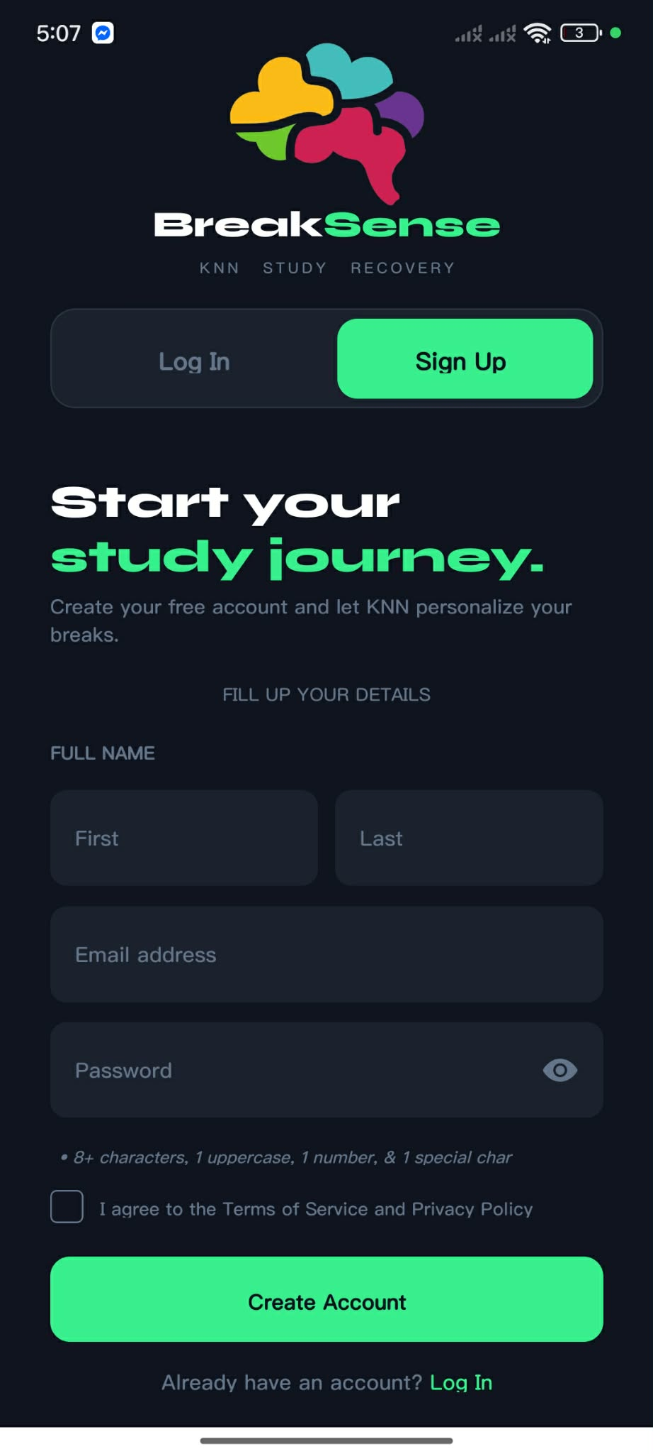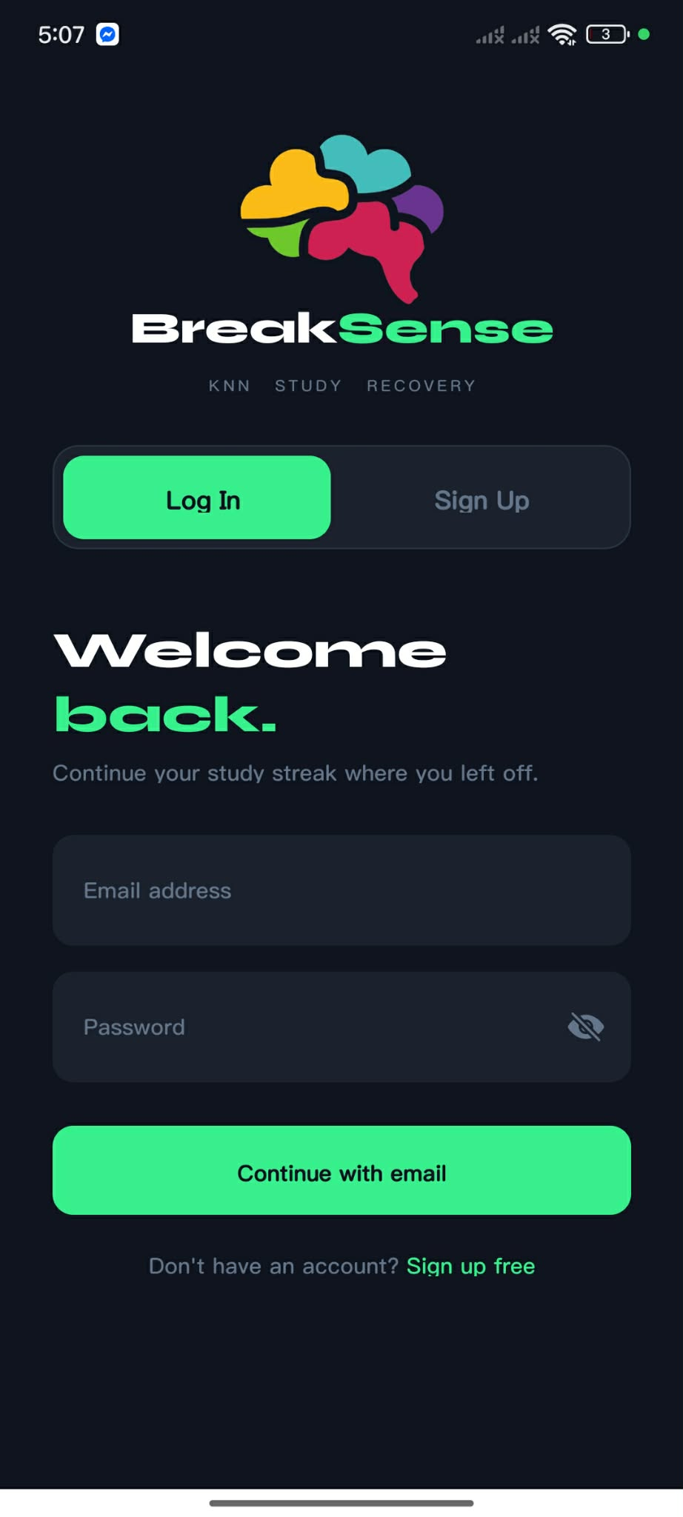
- Home & Navigation
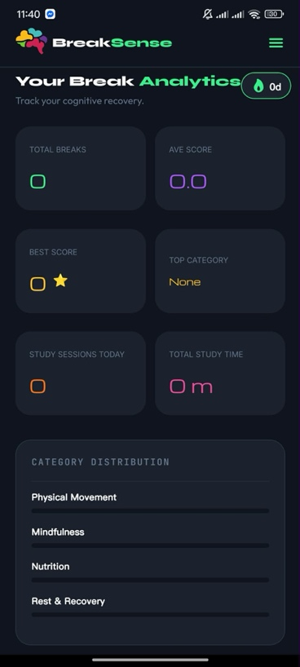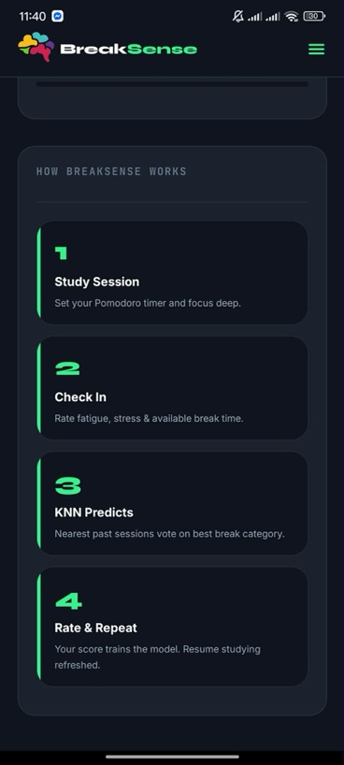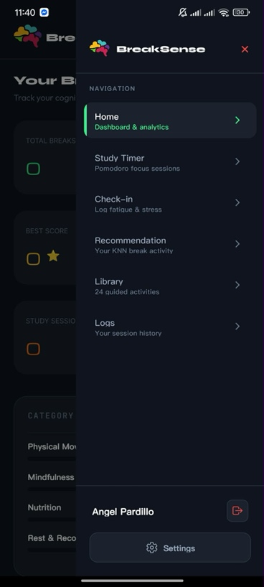

- Study Timer & Settings
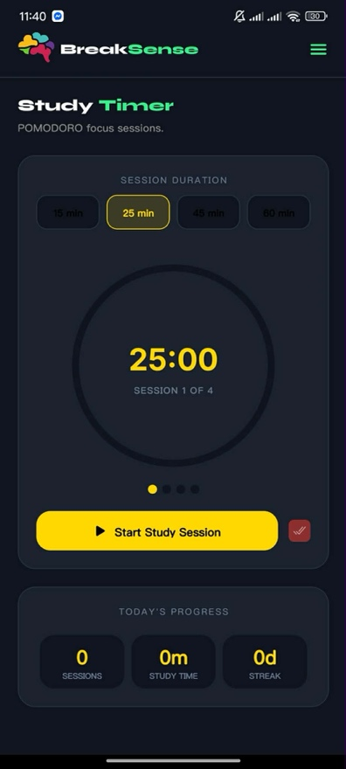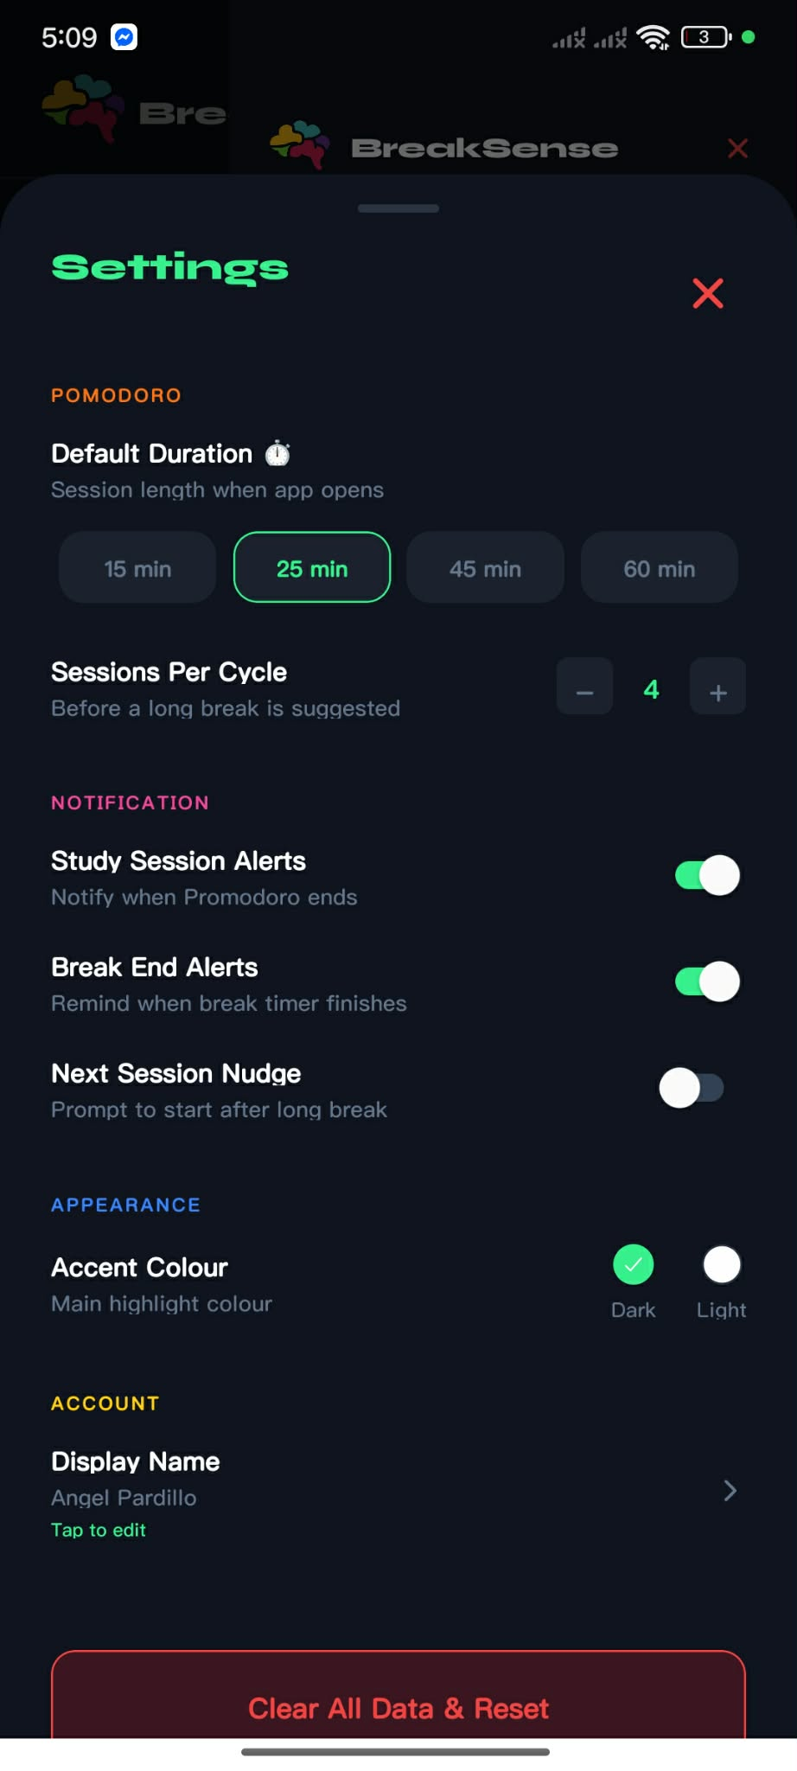
- Mood Check-in
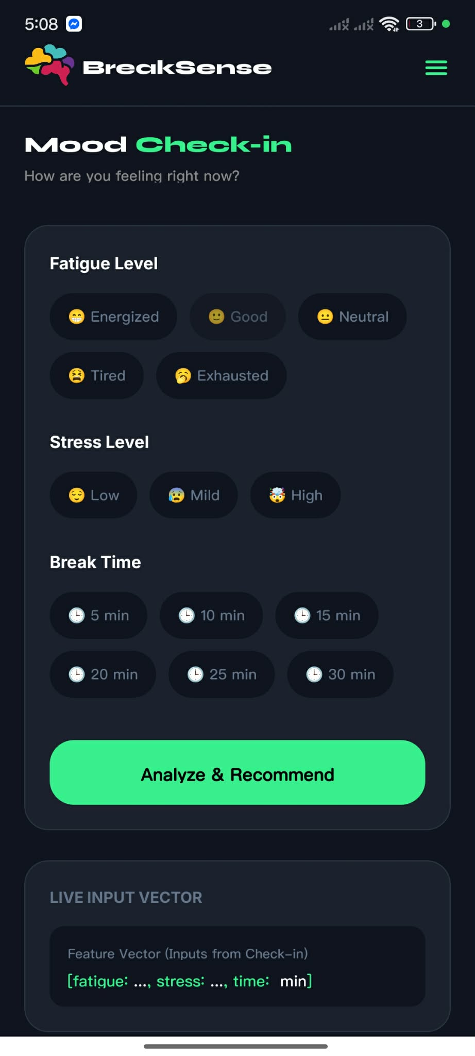
- Activity Library
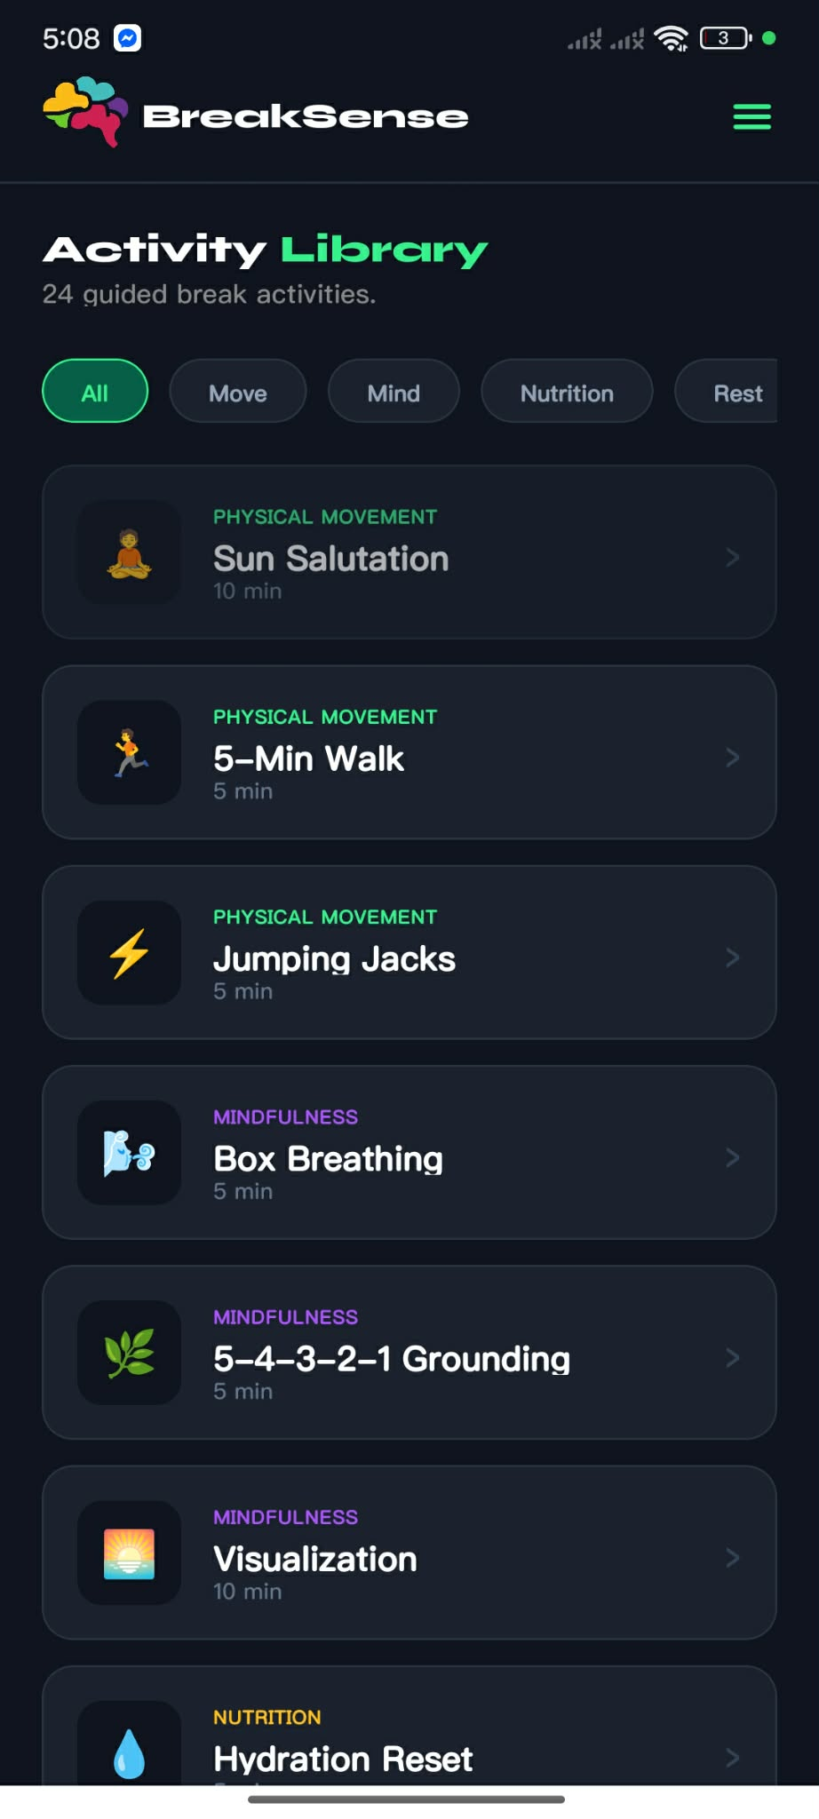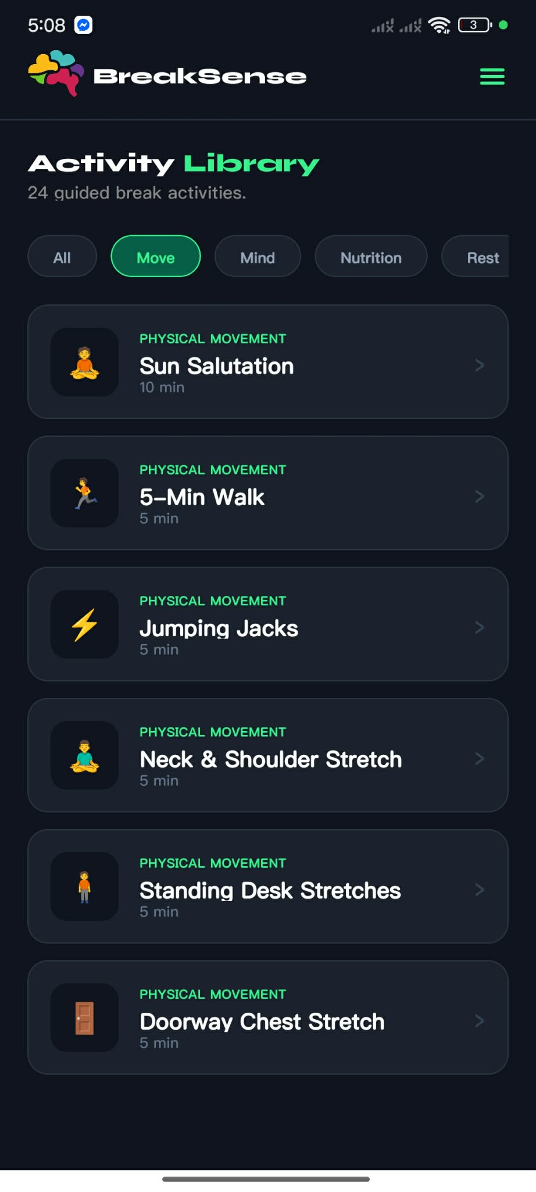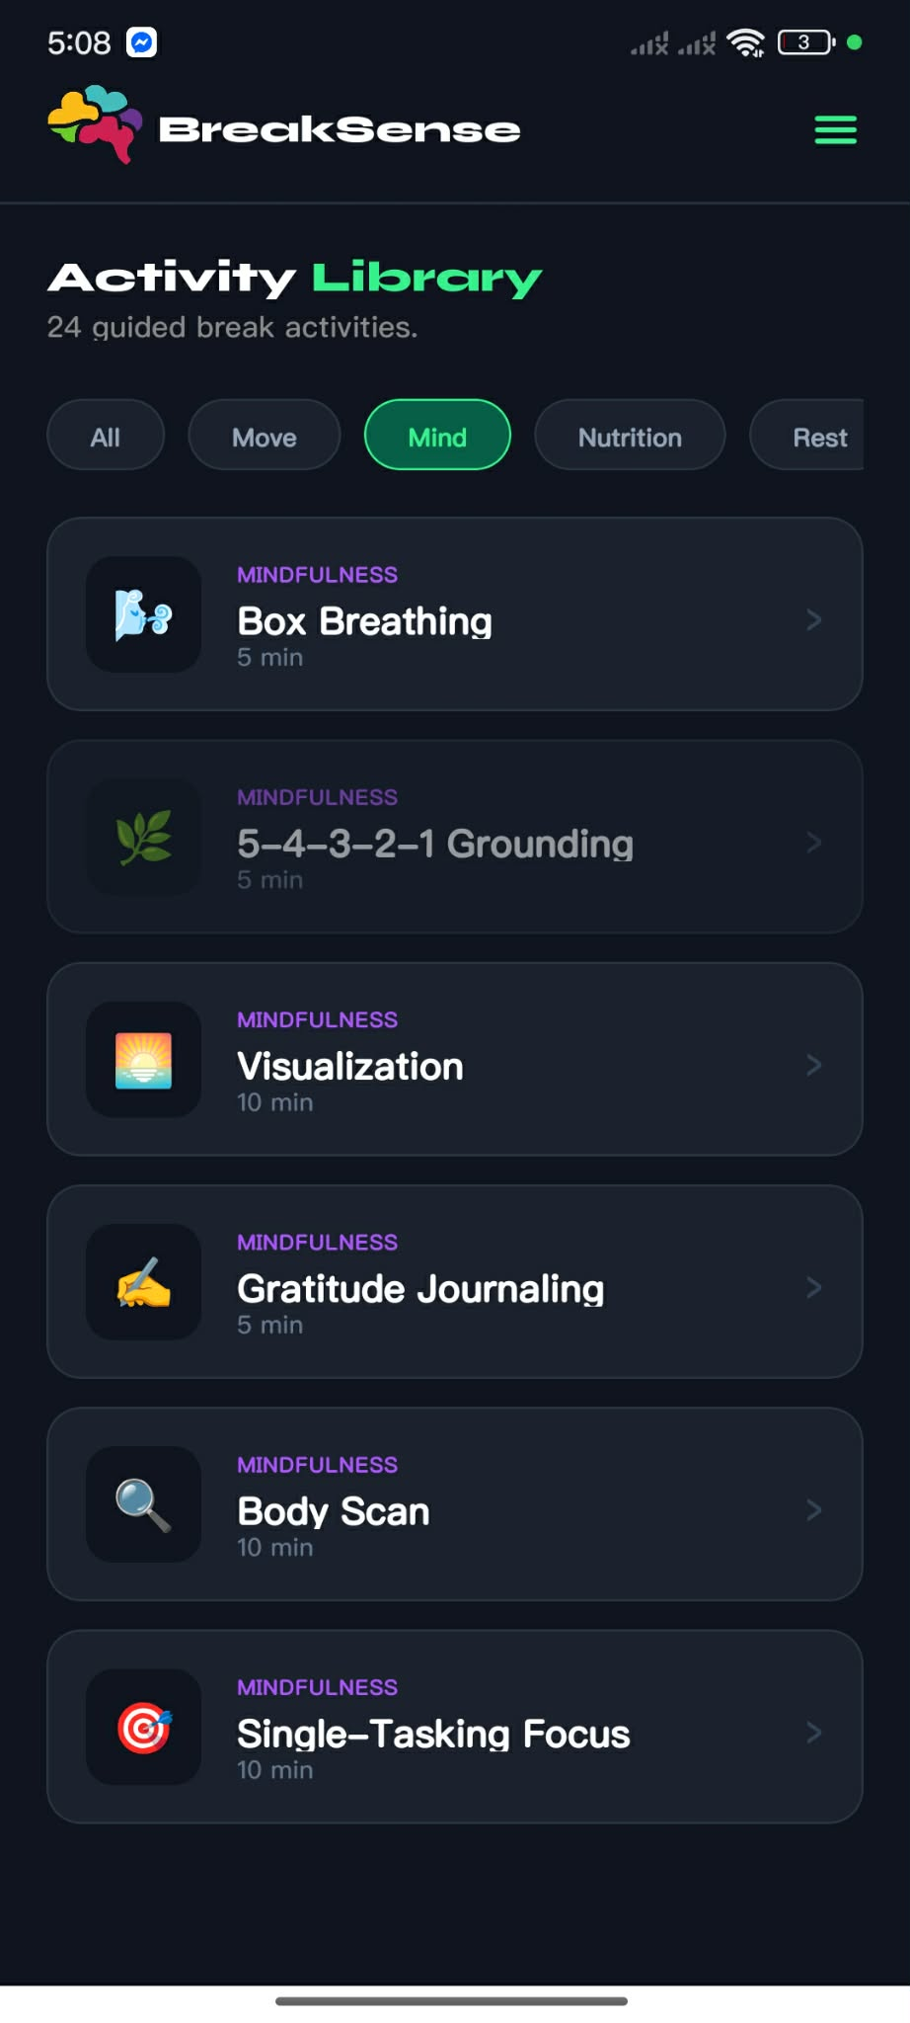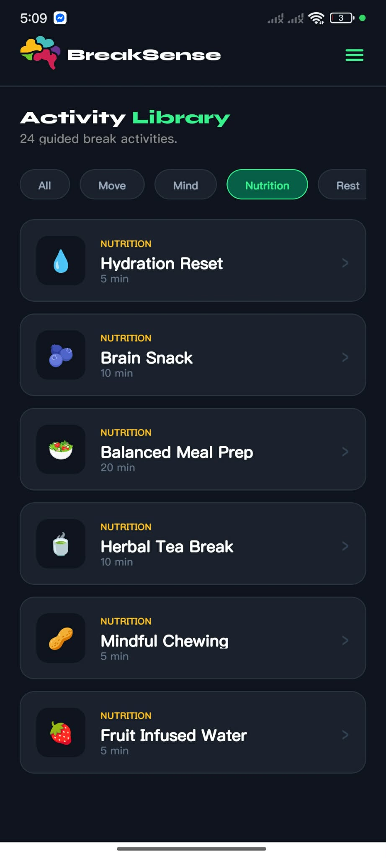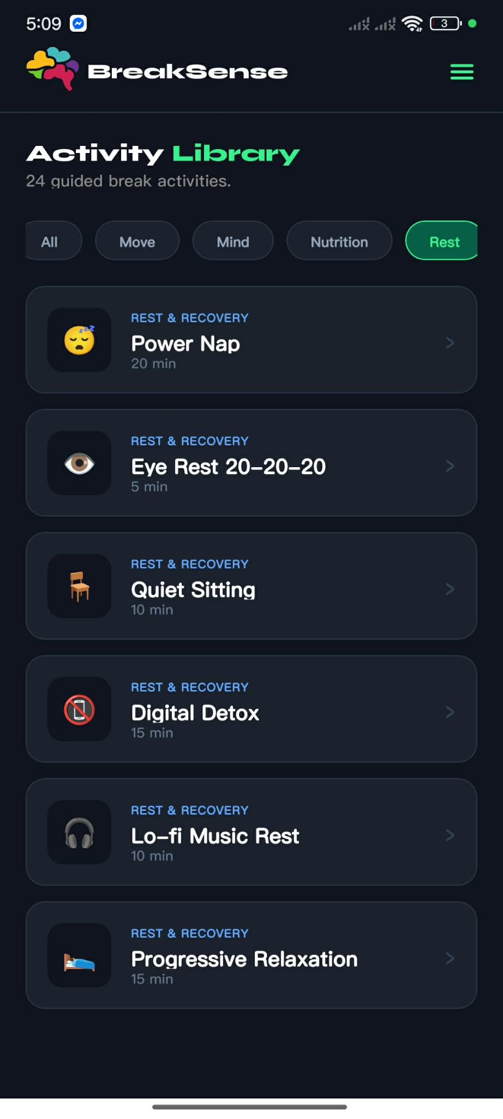

- Activity Details
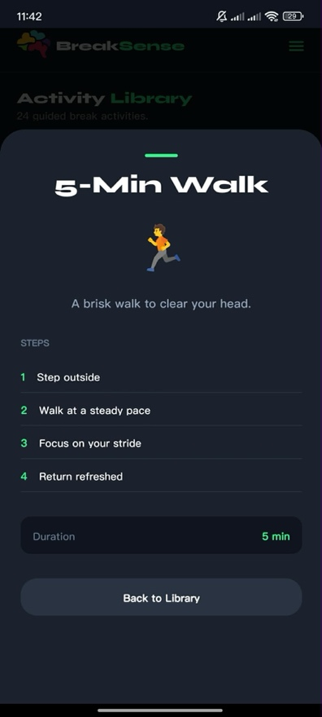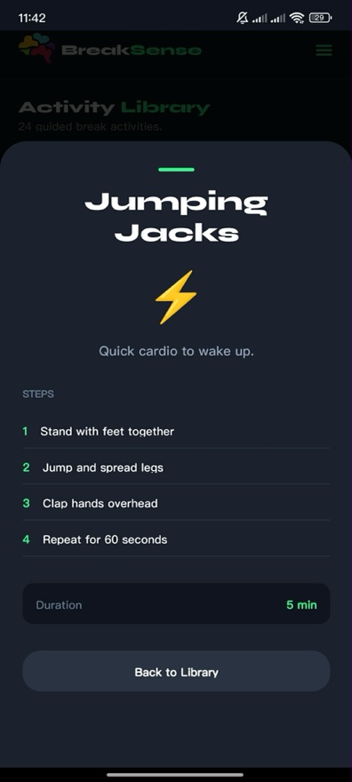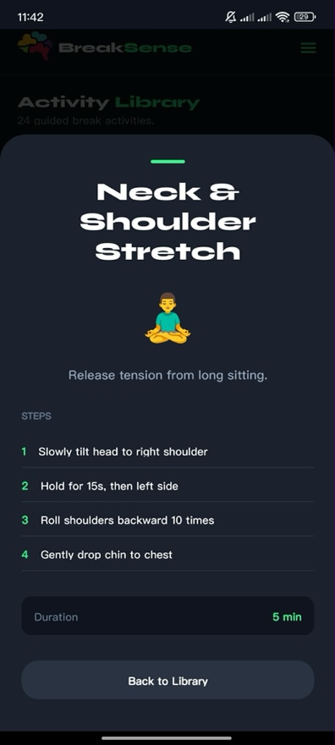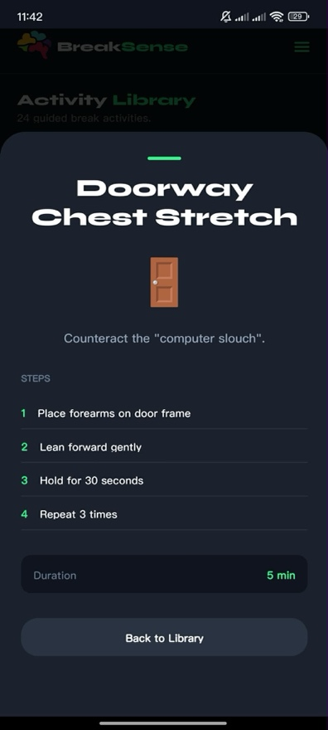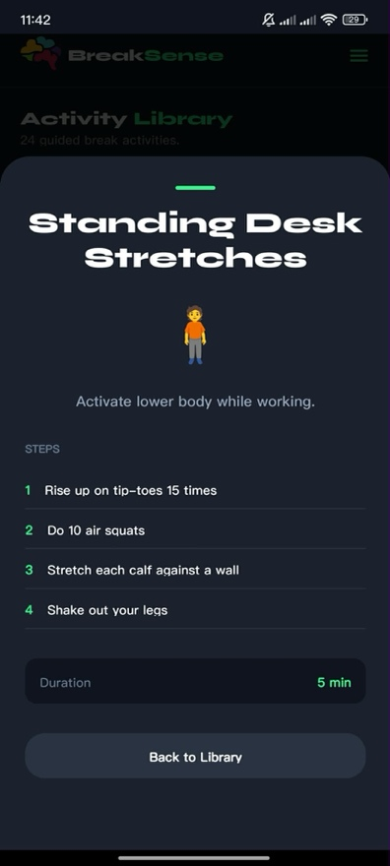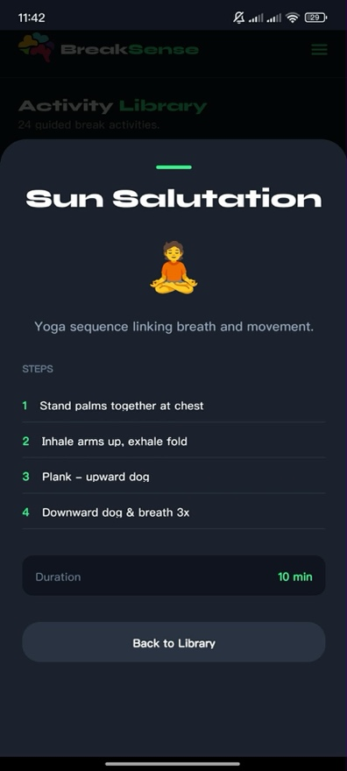
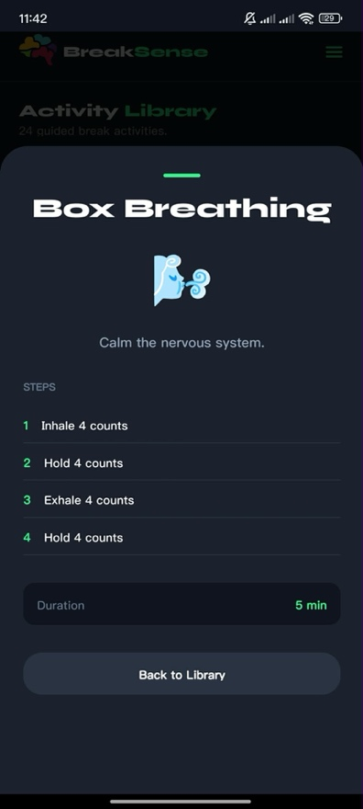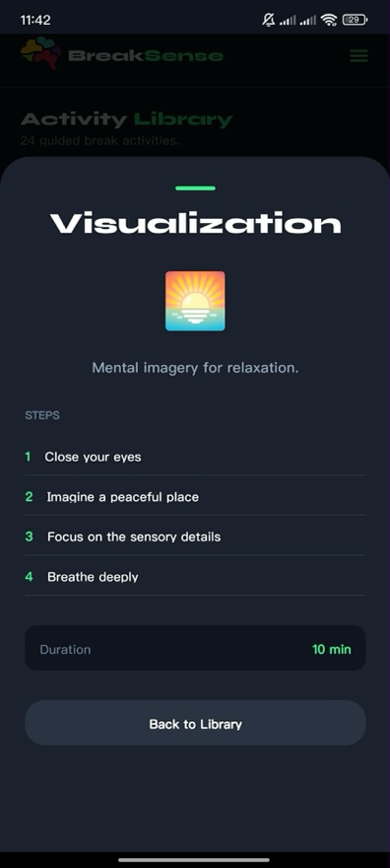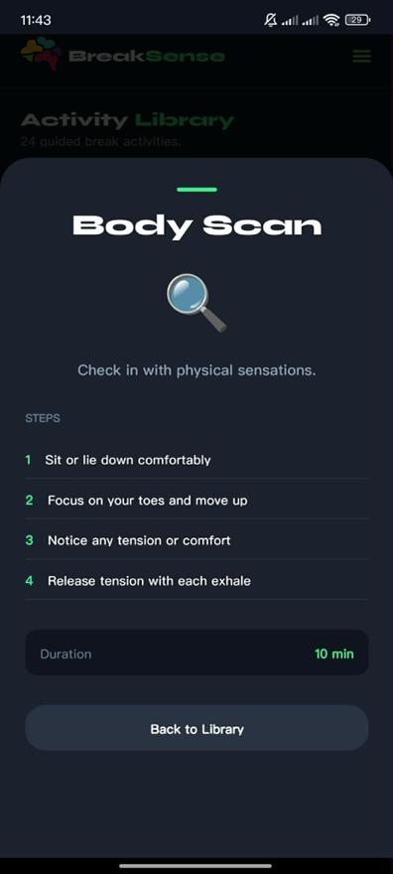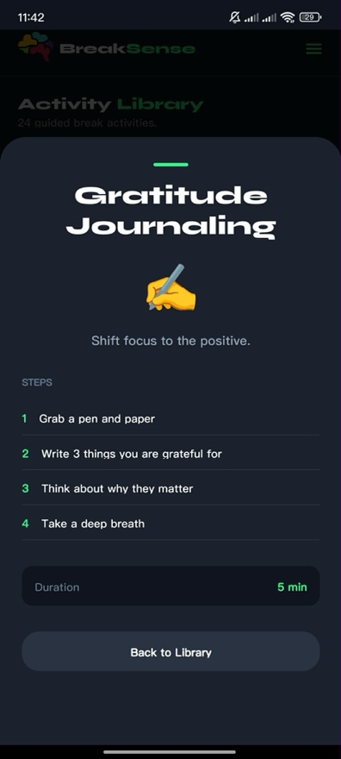
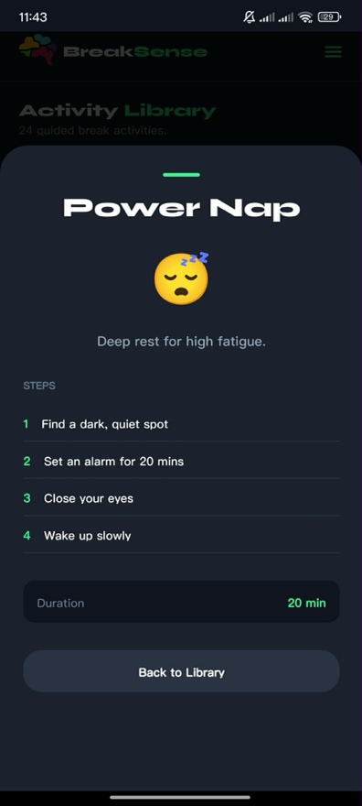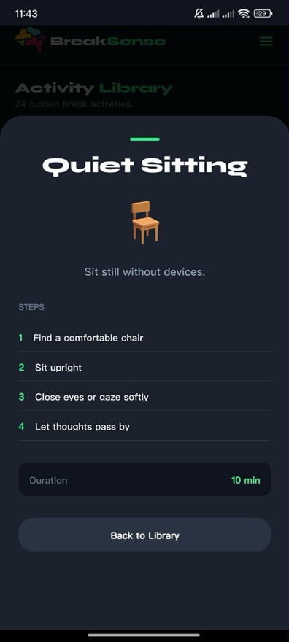


Appendix B: SQL Statements used
- Users table
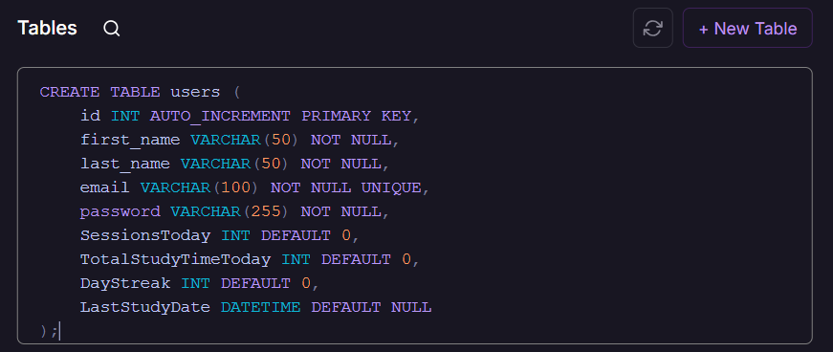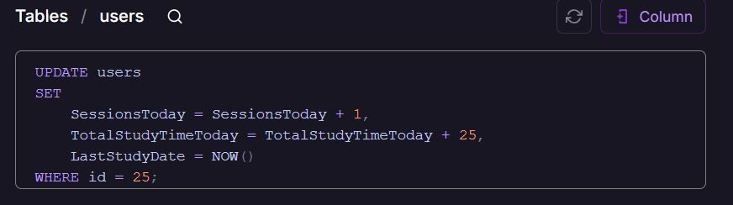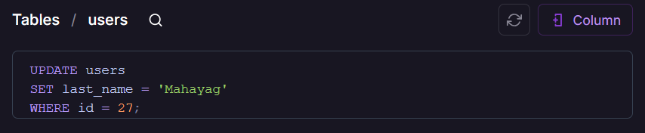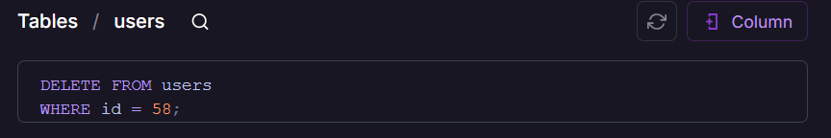

breaks_history table
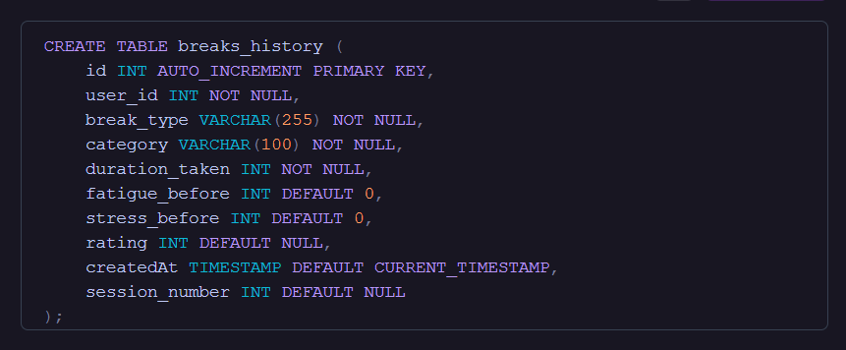
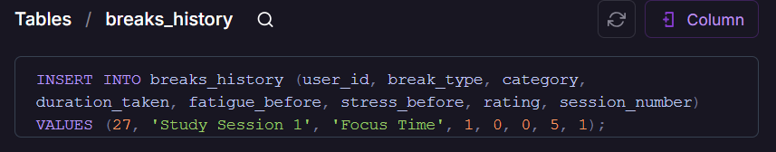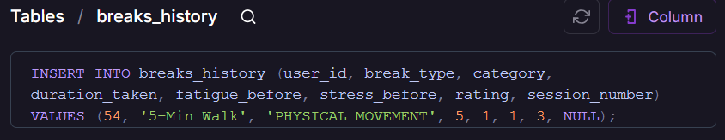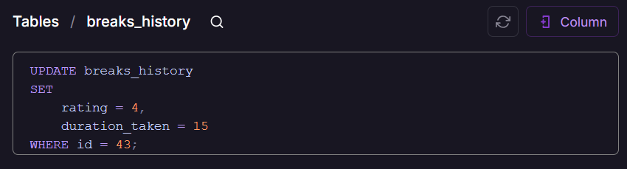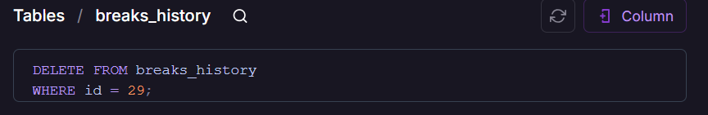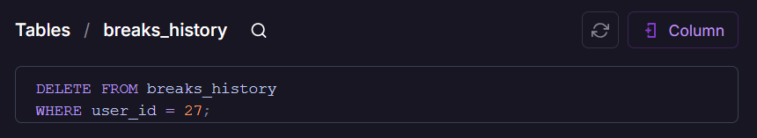

SELECT query
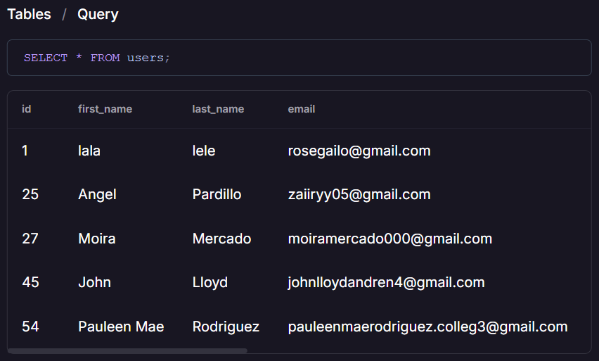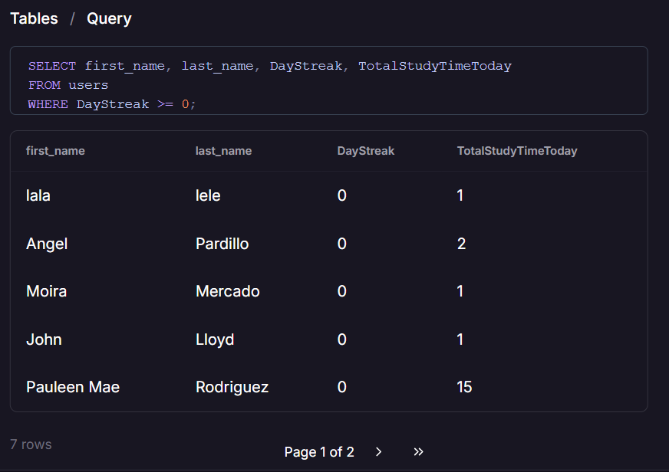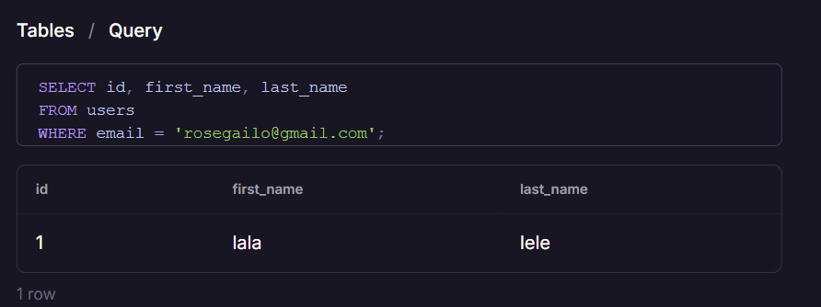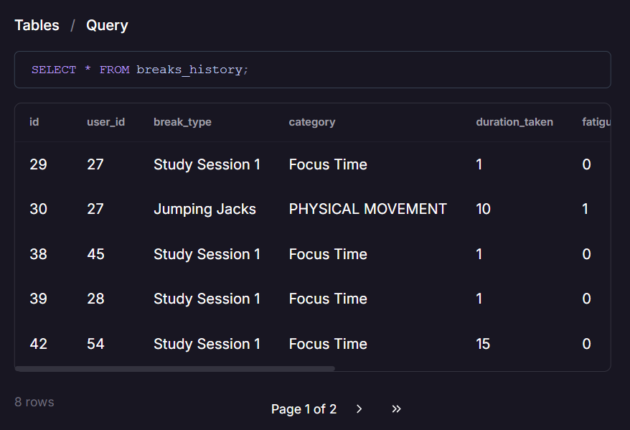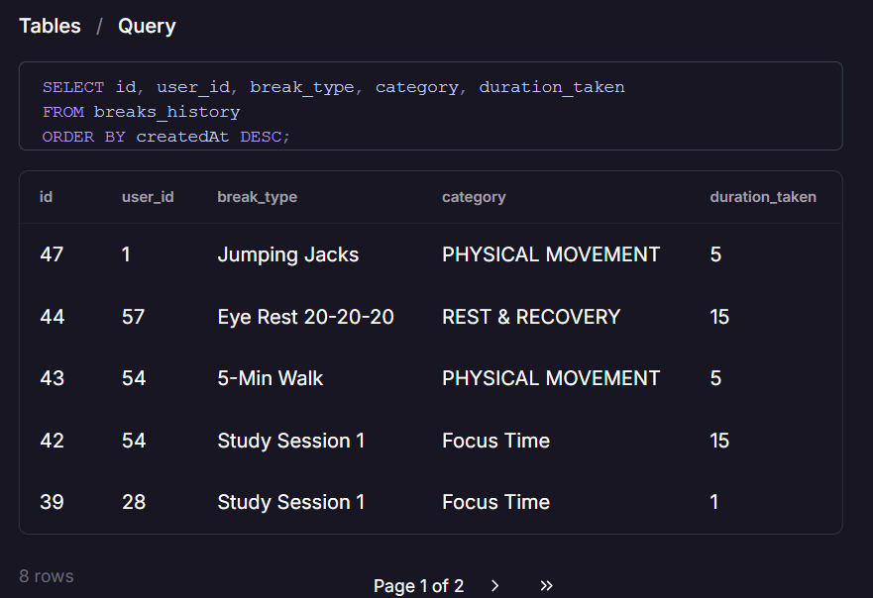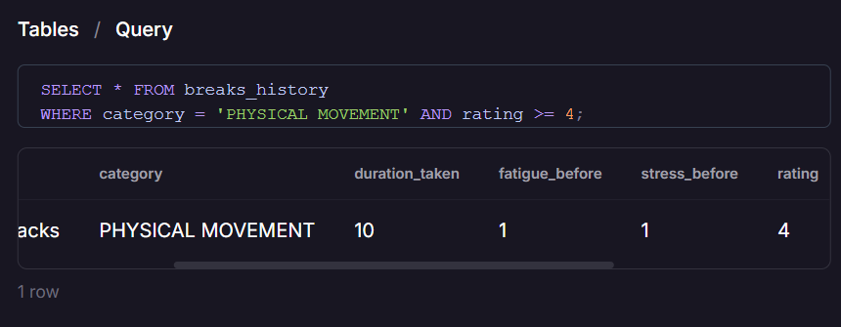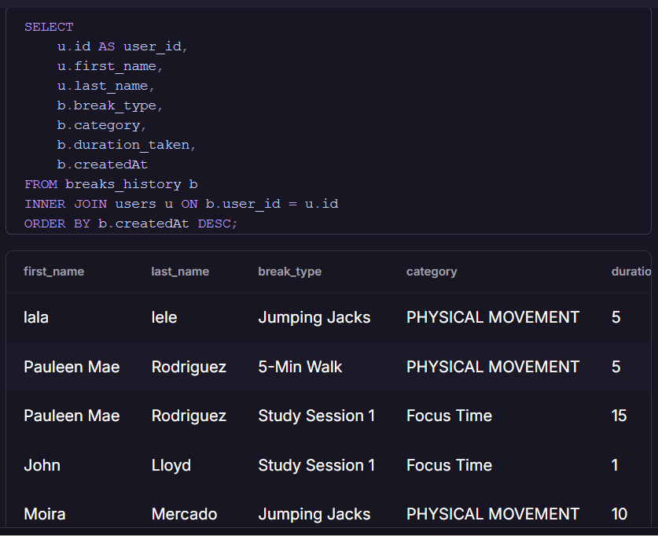

Appendix C: Source Code
- Backend
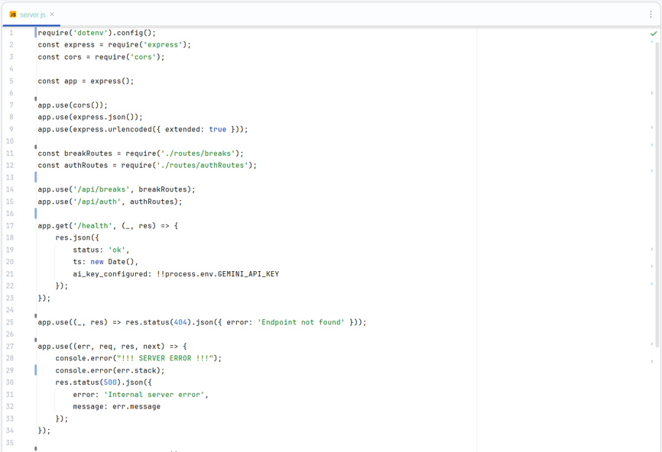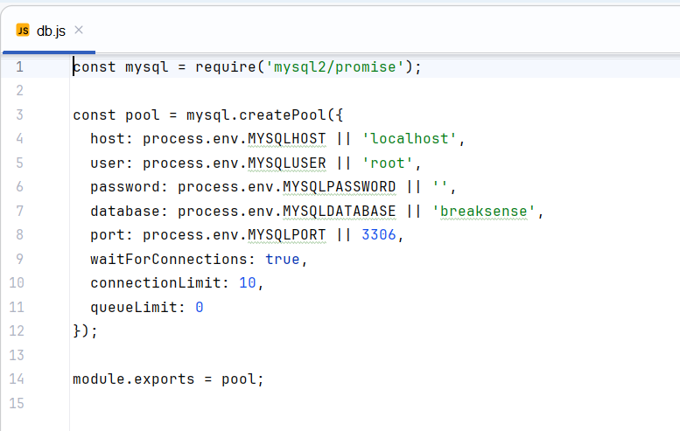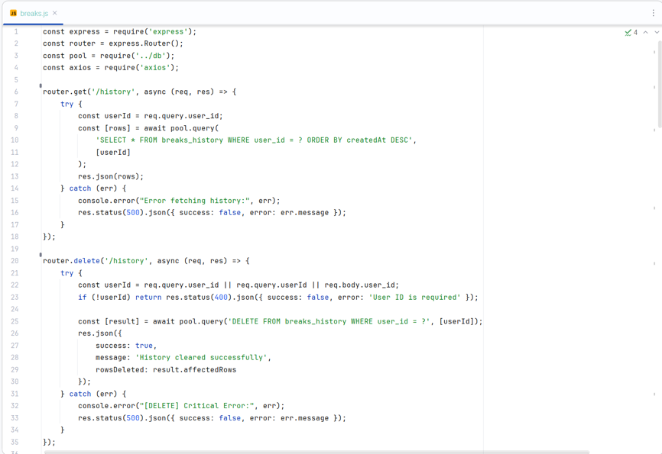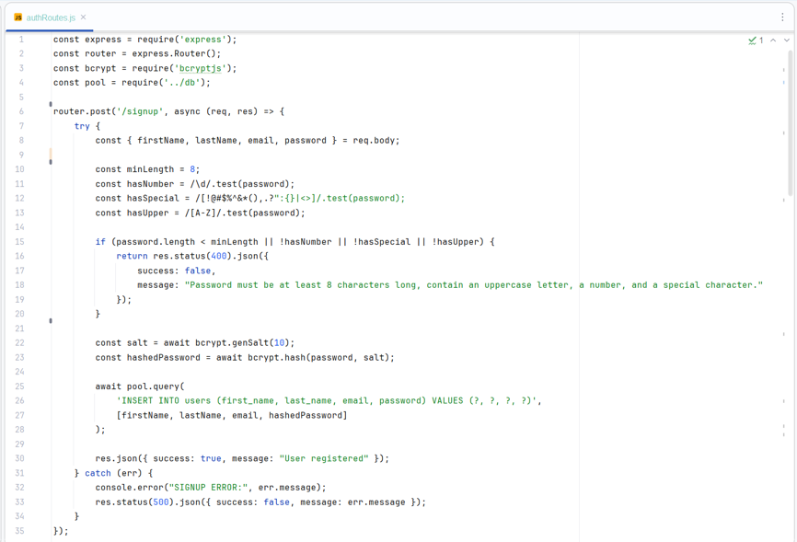

- ML_service
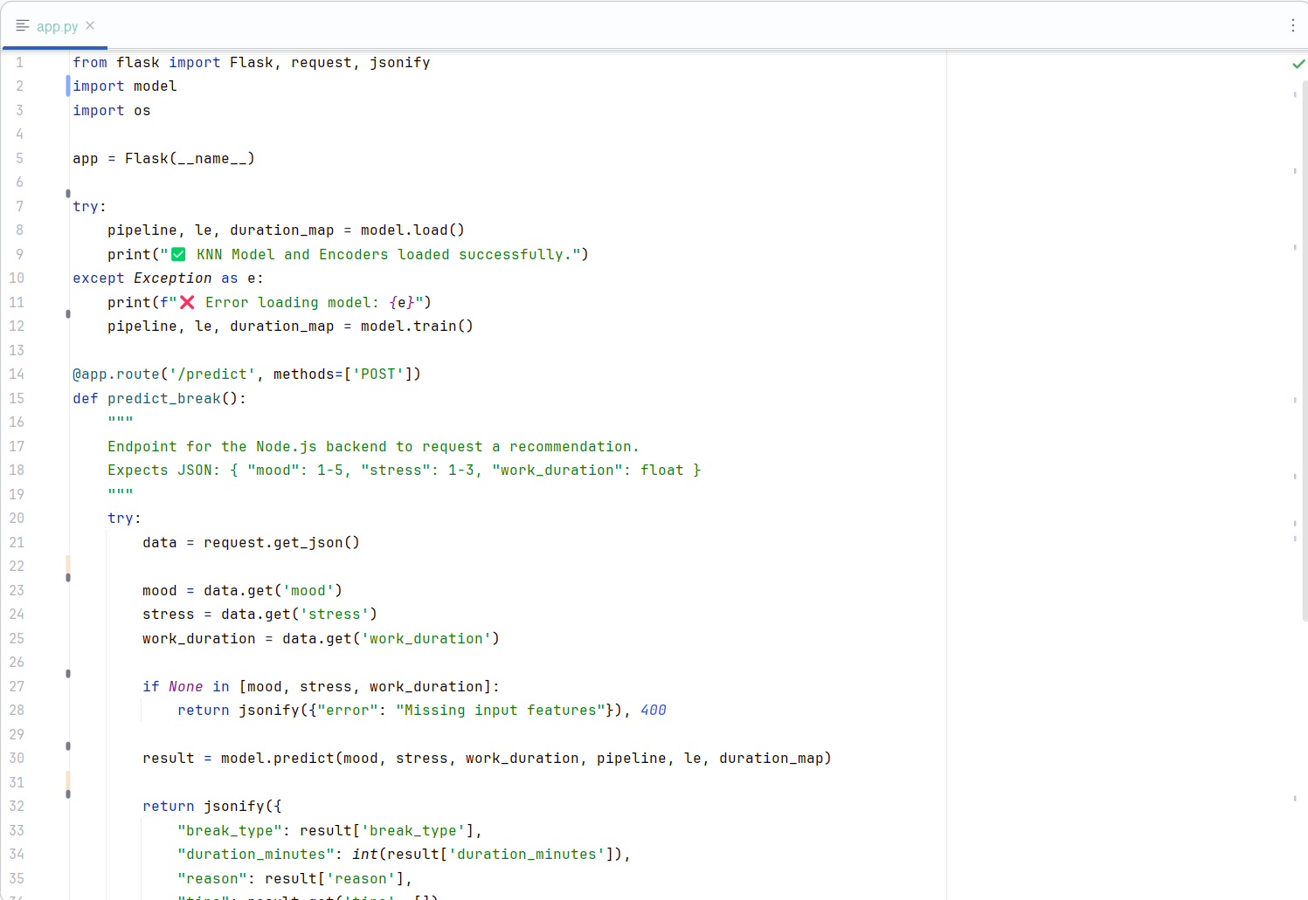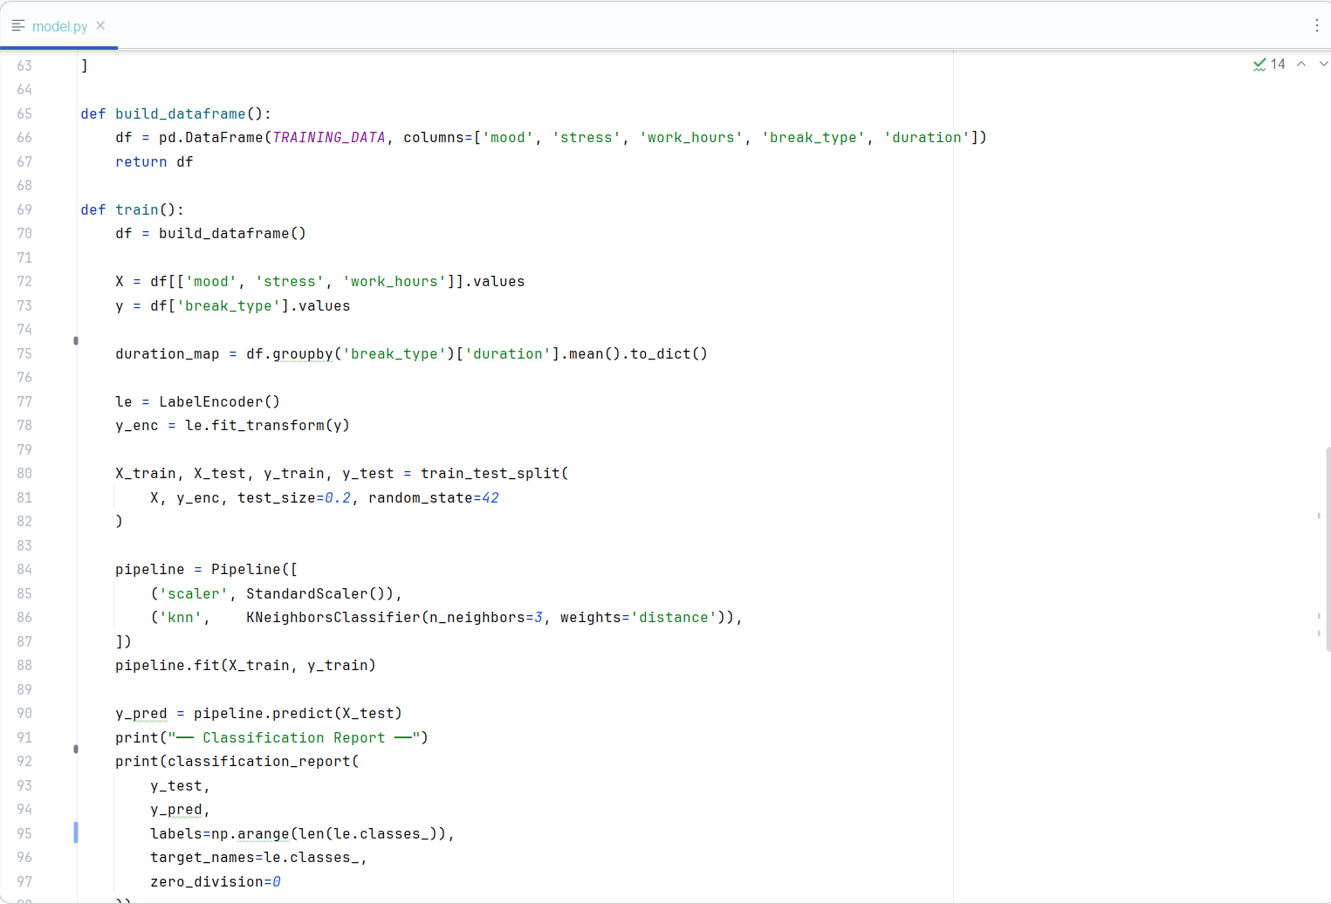

- Frontend
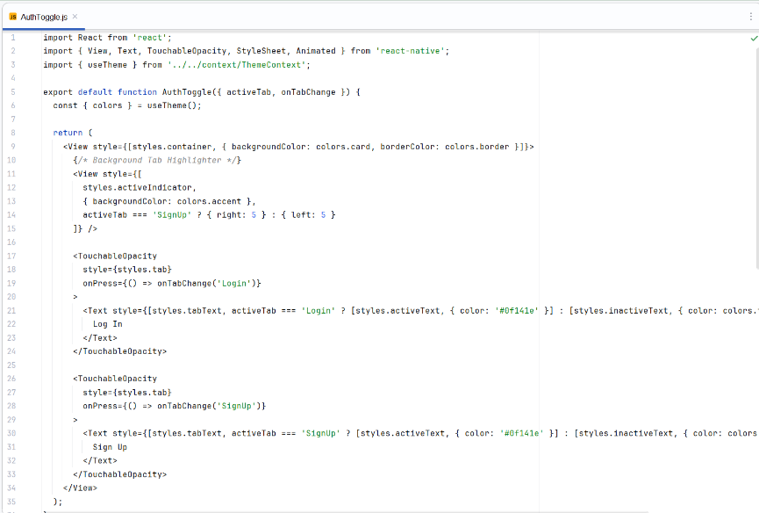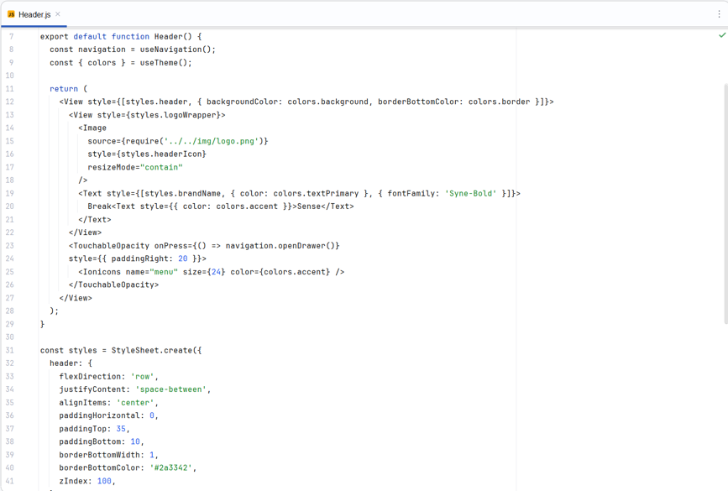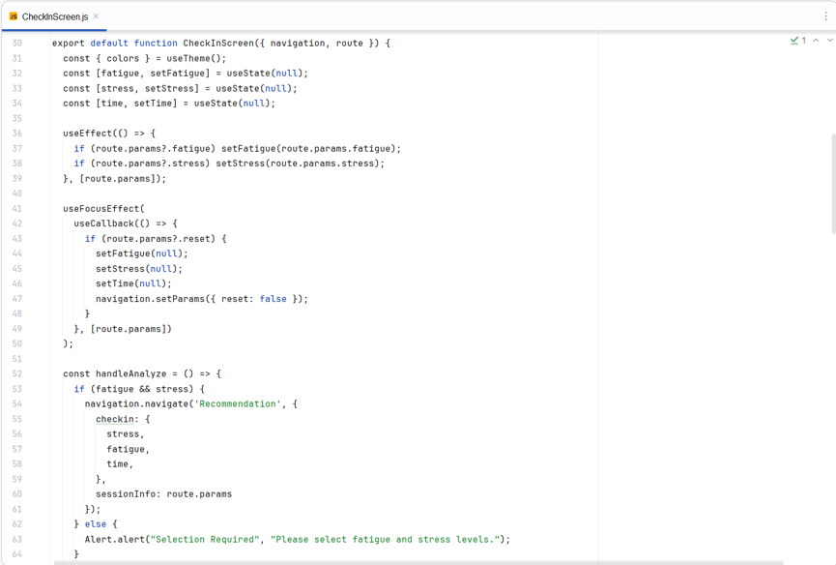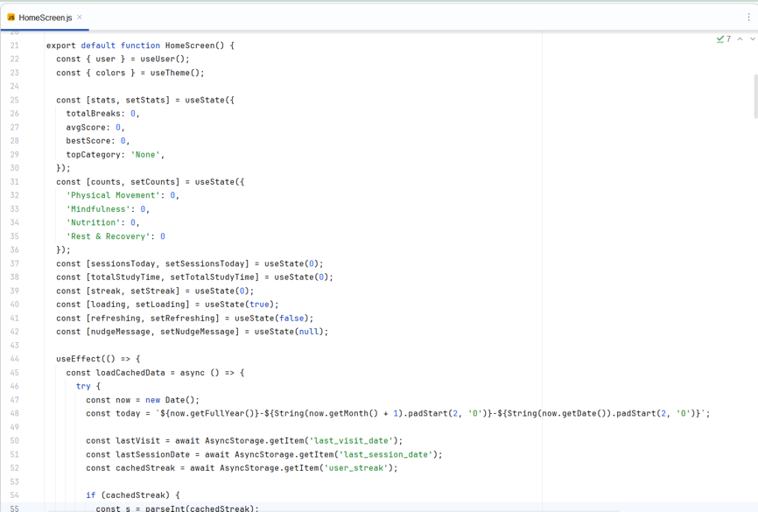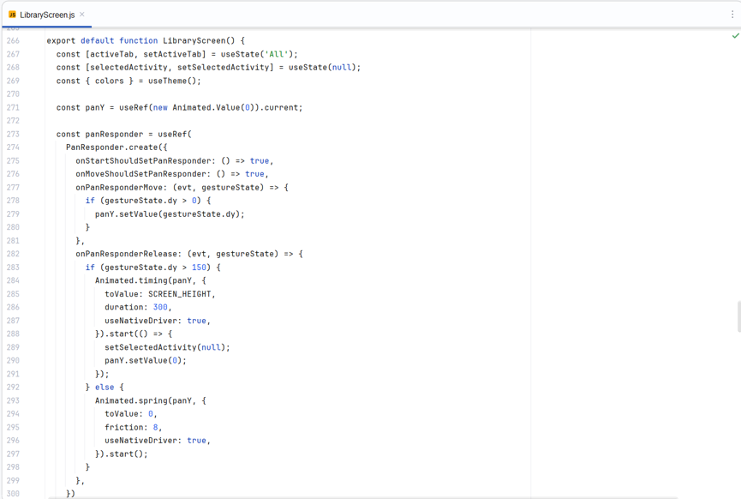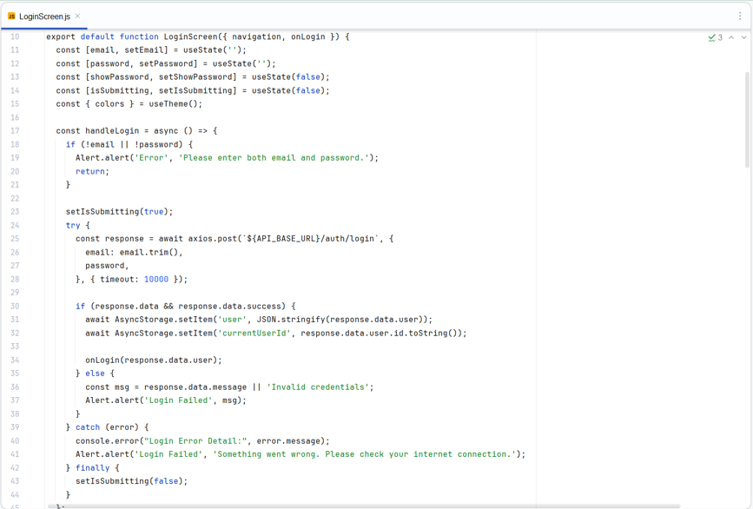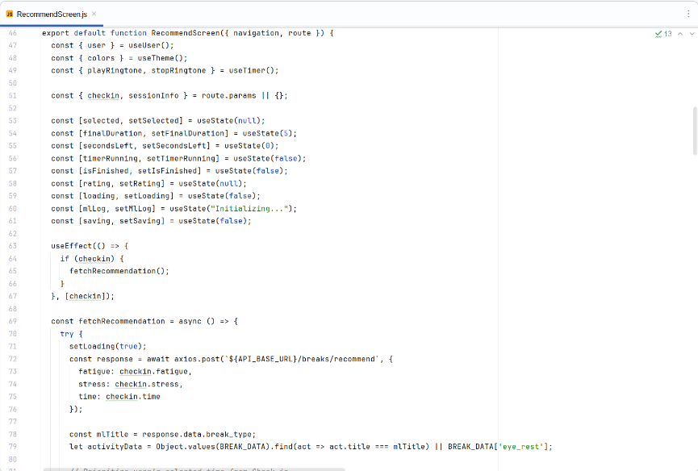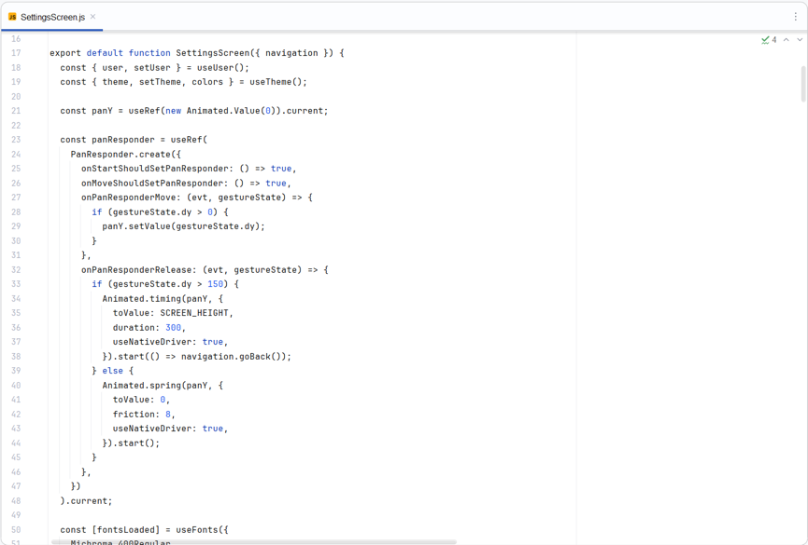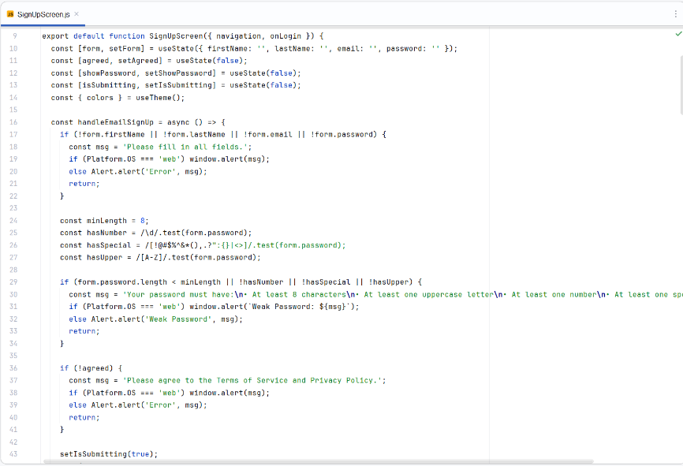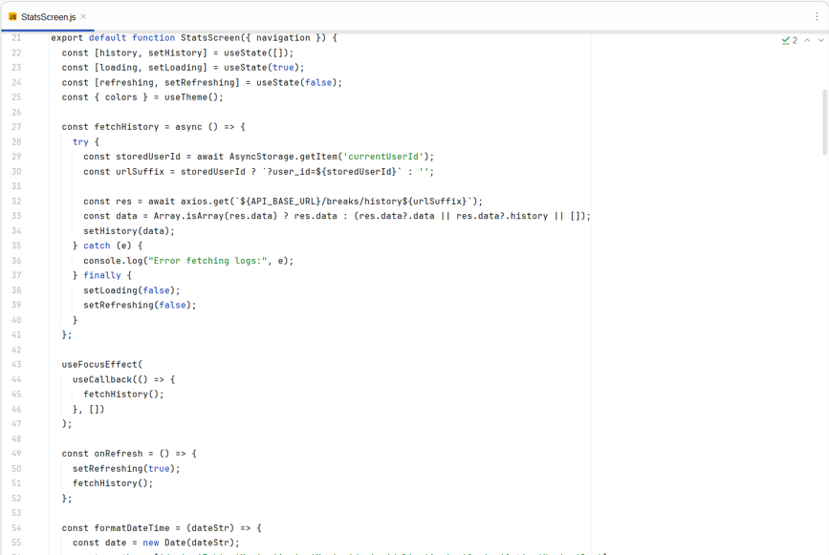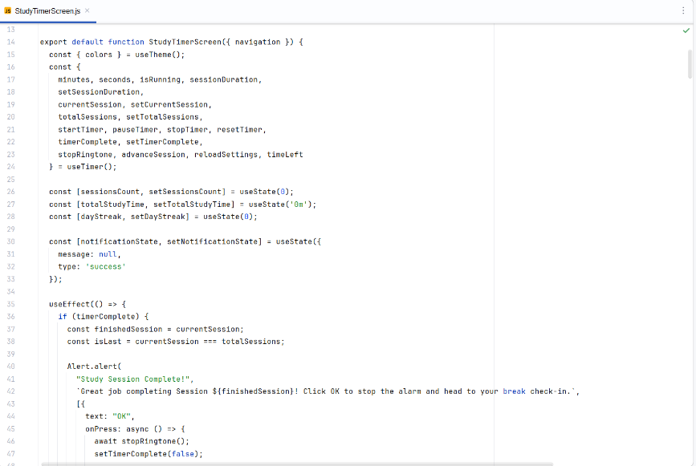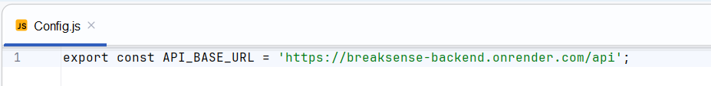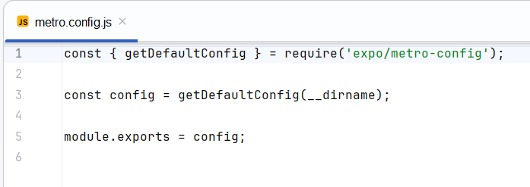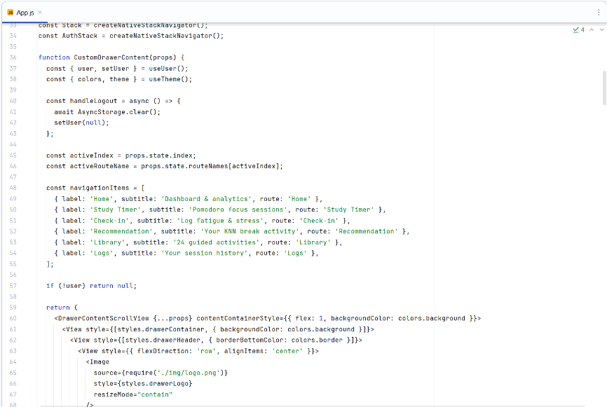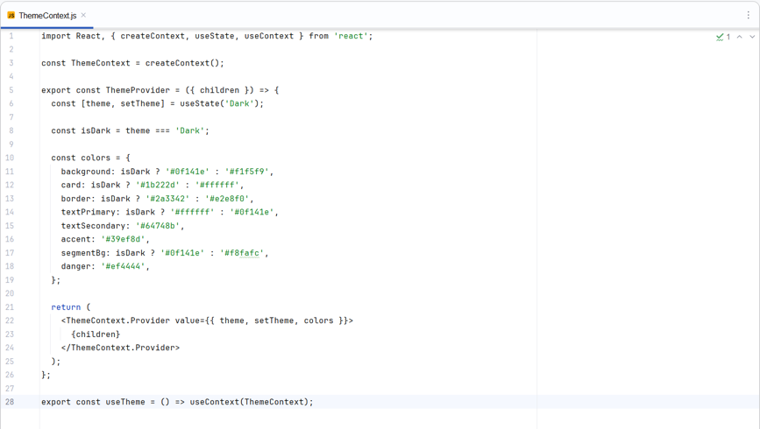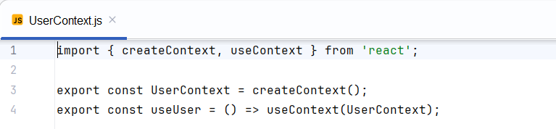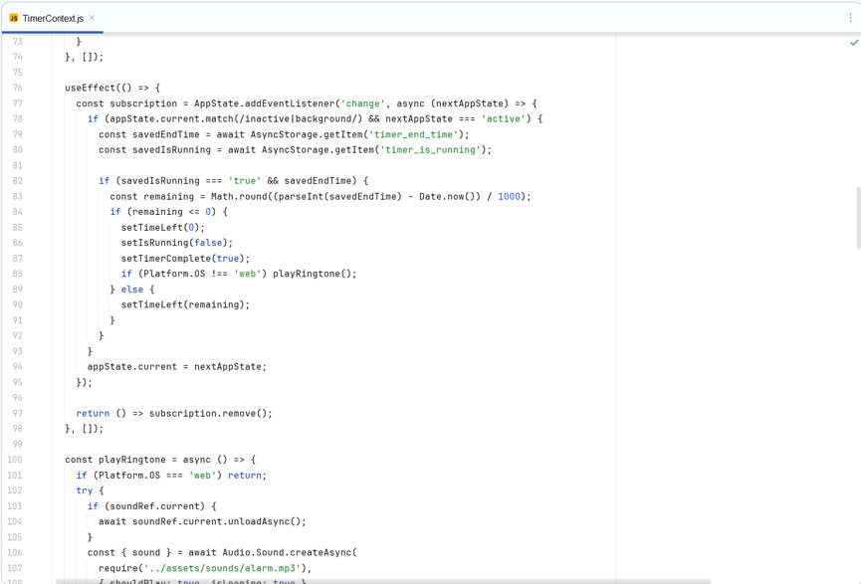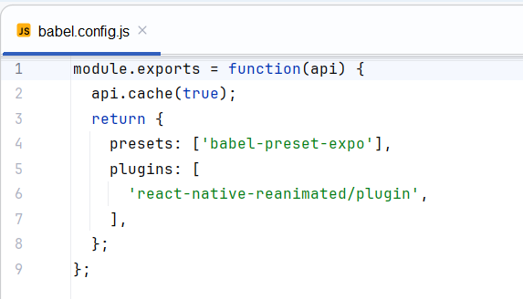

Appendix D: Data Dictionary
- Users table
Column | Data Type | Nullable? | Key / Constraints | Description
id | INT | No | PRIMARY KEY, AUTO_INCREMENT | Unique identifier for each user profile.
first_name | VARCHAR(50) | No | None | User’s first name
last_name | VARCHAR(50) | No | None | User’s last name
email | VARCHAR(100) | No | UNIQUE | User’s email address (used for logging in)
password | VARCHAR(255) | No | None | Hashed password string for user security
SessionsToday | INT | No | DEFAULT 0 | Total number of focus/study sessions completed today
TotalStudyTimeToday | INT | No | DEFAULT 0 | Total accumulated study time today (in minutes)
DayStreak | INT | No | DEFAULT 0 | Consecutive days the user has completed at least one session
LastStudyDate | DATETIME | Yes | DEFAULT NULL | Timestamp of the last time the user logged a study activity

- breaks_history table
Column | Data Type | Nullable? | Key / Constraints | Description
id | INT | No | PRIMARY KEY, AUTO_INCREMENT | Unique identifier for each history entry
user_id | INT | No | FOREIGN KEY references users(id) | Links the activity record to a specific user
break_type | VARCHAR(255) | No | None | Name of the activity (e.g., 'Study Session 1', '5-Min Walk')
category | VARCHAR(100) | No | None | Higher-level classification (e.g., 'Focus Time', 'PHYSICAL MOVEMENT')
duration_taken | INT | No | None | Length of the session or break in minutes
fatigue_before | INT | No | DEFAULT 0 | Self-reported fatigue scale score before starting (e.g., 1–5)
stress_before | INT | No | DEFAULT 0 | Self-reported stress scale score before starting (e.g., 1–5)
rating | INT | Yes | DEFAULT NULL | User's post-activity rating/satisfaction score
createdAt | TIMESTAMP | No | DEFAULT CURRENT_TIMESTAMP | The exact date and time the activity was logged
session_number | INT | Yes | DEFAULT NULL | Sequence tracker for the user's consecutive focus blocks

Appendix E: Sample Software Evaluation Sheet
BreakSense: A KNN-Based Adaptive Break Activity Recommender System
Thank you for taking the time to evaluate the BreakSense application. This survey is part of our academic project requirement and aims to gather feedback on the functionality, usability, effectiveness, and overall performance of the app.
Please answer each question honestly based on your experience using the app. This will only take about 3 to 5 minutes to complete. All responses are anonymous and will only be used for academic purposes.
5 - Strongly Agree | 4 - Agree | 3 - Neutral | 2 - Disagree | 1 - Strongly Disagree
- Functionality
Statement | 5 | 4 | 3 | 2 | 1
The app works as expected without major errors
The mood check-in feature is easy to complete
The KNN recommendation matches my current state
The study timer and break timer work correctly
The activity library shows relevant break activities

- Usability
Statement | 5 | 4 | 3 | 2 | 1
The app is easy to navigate
The design is visually clear and easy to read
I was able to use the app without guidance or instructions
The steps to get a recommendation are simple and straightforward
The app feels appropriate for student use

- Effectiveness
Statement | 5 | 4 | 3 | 2 | 1
The recommended break activity felt suitable for how I was feeling
I felt more refreshed after completing the recommended activity
The app helped me decide what kind of break to take
Using the app improved my focus after a break
The activity library has enough variety to support different needs

- Performance
Statement | 5 | 4 | 3 | 2 | 1
The app loads quickly
The recommendation is generated without noticeable delay
The app ran smoothly throughout my use
I did not experience any crashes or unexpected errors
The app performed consistently across multiple uses

- Overall Satisfaction
Statement | 5 | 4 | 3 | 2 | 1
I would recommend BreakSense to other students
I would use this app regularly during my study sessions
The app addressed my need for better break management
Overall I am satisfied with the BreakSense application

