RoseArts
E-Commerce Art Store Deployment on AWS
Project Documentation
Prepared by: Roselin R
Technology: Amazon Web Services (AWS)
Region used: Asia Pacific (Sydney) — ap-southeast-2
Project type: Two-tier web application deployment

Document Guide
This document describes the design, deployment, configuration, and validation of the RoseArts e-commerce art store hosted on AWS. Replace each screenshot placeholder with the matching screenshot captured from your own AWS console or website. Verify all resource details against your AWS account before publishing this report.
- Project Overview
- Objectives and Scope
- Architecture Design
- AWS Services Used
- Network Configuration
- Application Deployment
- Load Balancer and Target Group
- Custom Domain with Route 53
- Testing and Validation
- Troubleshooting
- Security and Cost Considerations
- Conclusion

1. Project Overview
RoseArts is a web-based art store created to present handmade paintings through a simple online interface. The project demonstrates how a web application can be deployed on Amazon Web Services (AWS) and accessed through a custom domain. The deployment uses an Amazon VPC for network isolation, an Amazon EC2 instance to host the application, an Application Load Balancer (ALB) to receive and forward web traffic, and Amazon Route 53 for domain-name resolution.
The application includes a homepage, a paintings gallery, painting-detail pages, and an inquiry page where implemented. The project focuses on AWS networking and application access rather than on building a large application stack.

2. Objectives and Scope
The main objectives of the project are:
- Create a dedicated VPC and configure the required subnet and routing resources.
- Deploy the RoseArts web application on an EC2 instance.
- Configure an Application Load Balancer and target group to route incoming HTTP requests to the application.
- Connect a custom domain to the load balancer using Amazon Route 53.
- Test application access and investigate deployment issues encountered during configuration.
Scope note: The implemented setup described here uses one EC2 application instance and two public subnets across two Availability Zones. Private subnets were not used for the application workload. A single EC2 instance does not provide application-level compute redundancy, even when the load balancer is configured across two Availability Zones.

3. Architecture Design
A user opens the RoseArts custom domain in a web browser. Amazon Route 53 resolves the domain to the Application Load Balancer. The ALB accepts HTTP traffic on port 80 and forwards requests to its target group. The target group routes the request to the registered EC2 instance, where the RoseArts application runs on port 5000. The application returns the requested page to the user through the same traffic path.
The VPC contains two public subnets: Public Subnet A (10.0.1.0/24) and Public Subnet B (10.0.2.0/24), placed in two Availability Zones. The ALB can use both subnets, while the application is hosted on one EC2 instance in the subnet where it was launched. Confirm the actual EC2 subnet, VPC CIDR, and ALB subnet mappings in the AWS console before finalizing the diagram.
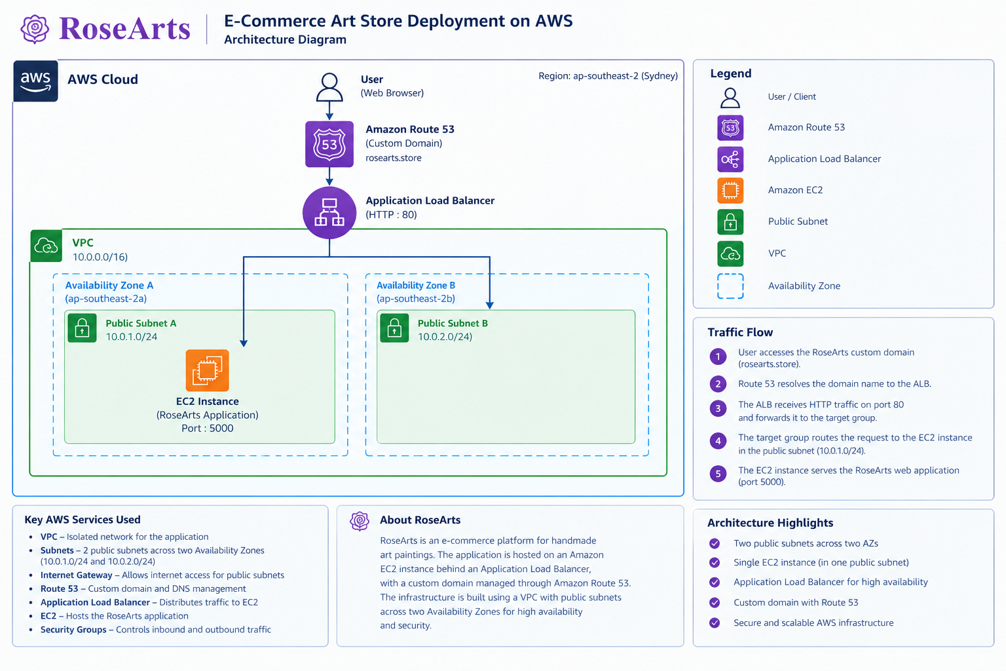
Figure 1. RoseArts AWS architecture diagram.

4. AWS Services Used
- Amazon VPC: Provides the logically isolated network in which the project resources are configured.
- Subnets: Divide the VPC address range into smaller network segments. This project uses two public subnets across two Availability Zones.
- Internet Gateway: Provides a path between the VPC and the public internet for resources whose routing and security configuration permit it.
- Amazon EC2: Runs the RoseArts application. The application listens on port 5000 in the configured deployment.
- Elastic Load Balancing — Application Load Balancer: Receives HTTP requests on port 80 and forwards them to the registered target group.
- Target Group: Registers the EC2 instance and uses health checks to determine whether it can receive traffic.
- Amazon Route 53: Hosts DNS records that direct the custom domain to the load balancer.
- Security Groups: Act as stateful virtual firewalls that control permitted inbound and outbound traffic for the load balancer and EC2 instance.

5. Network Configuration
The VPC and subnet configuration establishes the network foundation for the deployment. The two public subnet CIDR ranges provided for this project are listed below. Availability Zone names, VPC CIDR, route-table associations, and gateway details should be checked against the AWS console.
Network component | Configured value | Purpose
Public Subnet A | 10.0.1.0/24 | Public subnet in one Availability Zone
Public Subnet B | 10.0.2.0/24 | Public subnet in a second Availability Zone
AWS Region | ap-southeast-2 (Sydney) | Region used for the deployment
VPC CIDR | 10.0.0.0/16 | Overall IPv4 range assigned to the VPC
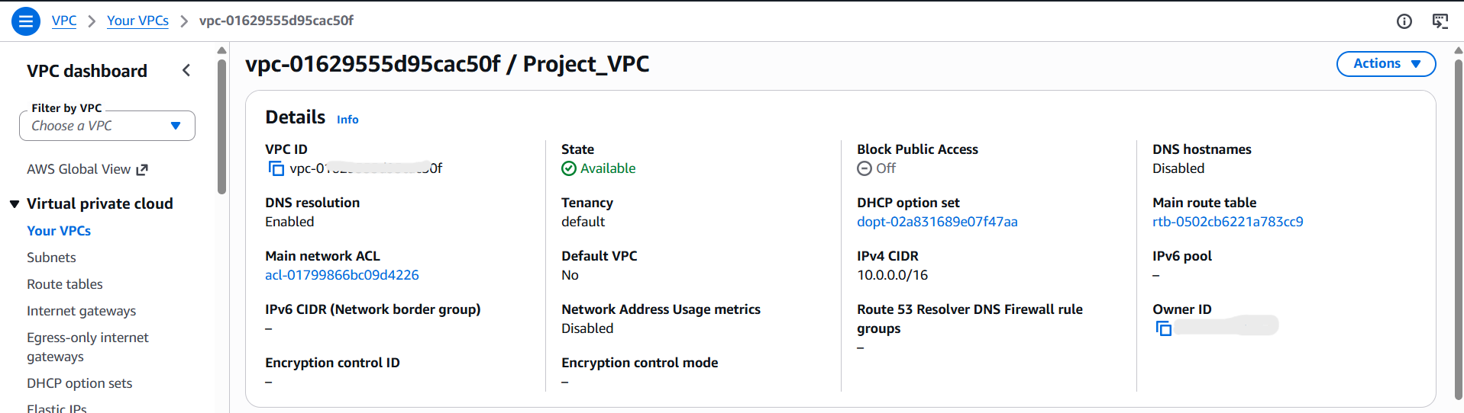
Figure 2. VPC details: The VPC provides the network boundary for the AWS resources used by RoseArts.
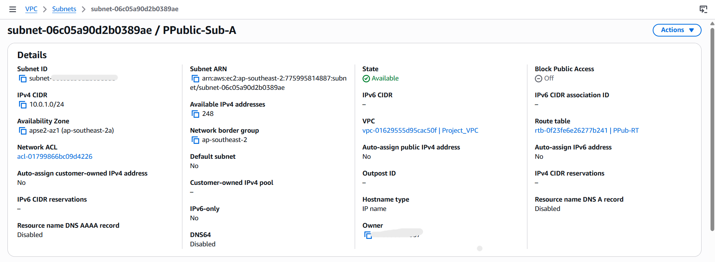
Figure 3.1 Subnet configuration.

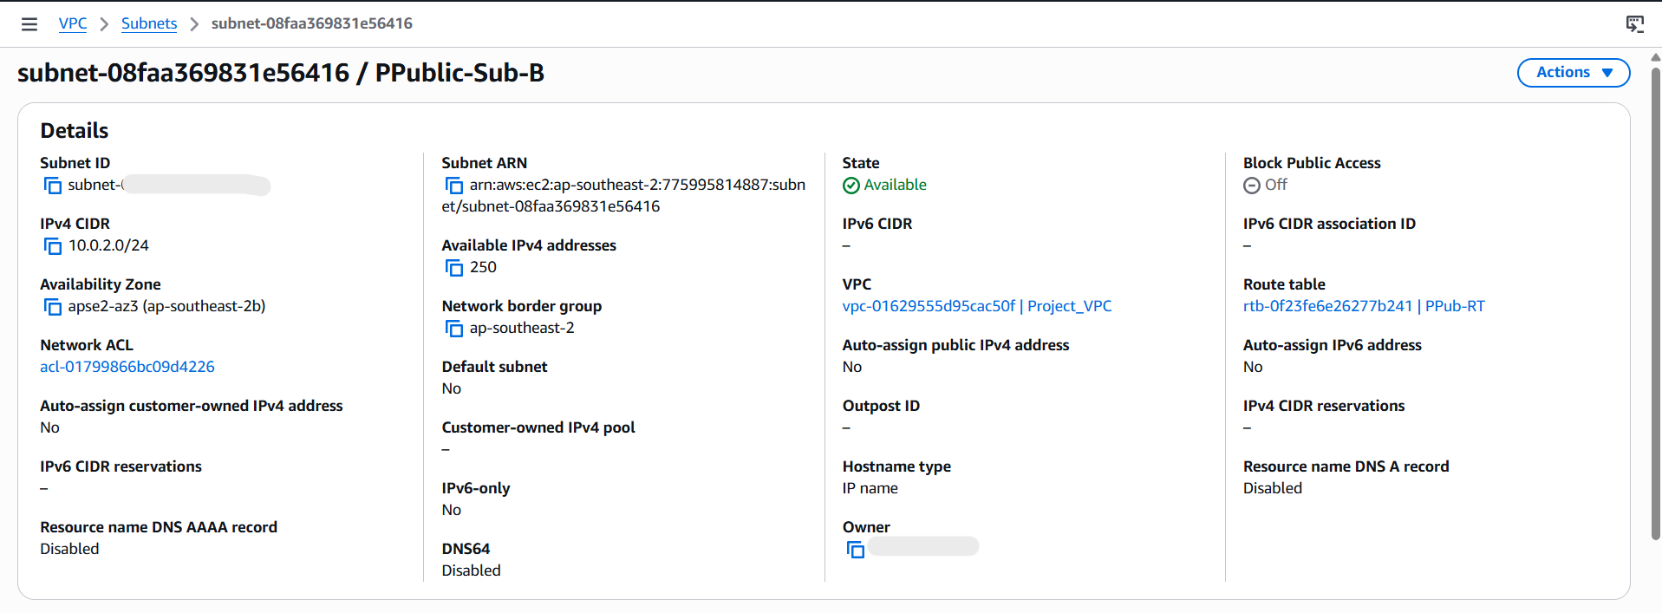
Figure 3.2 Subnet configuration.

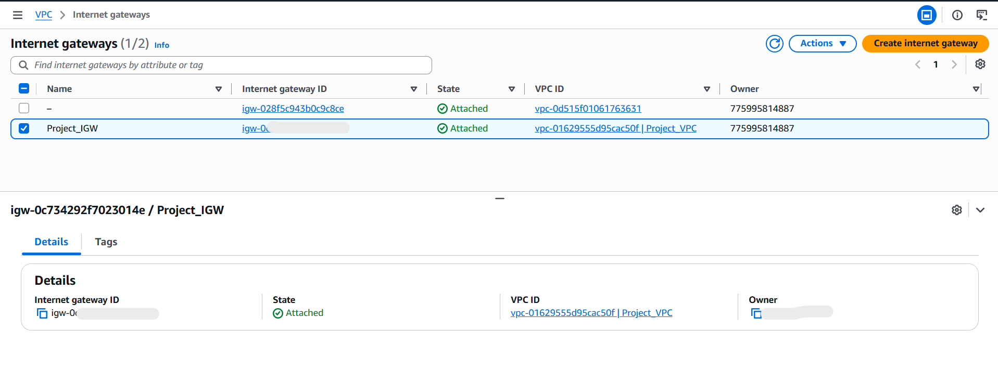
Figure 4. Internet Gateway attachment.

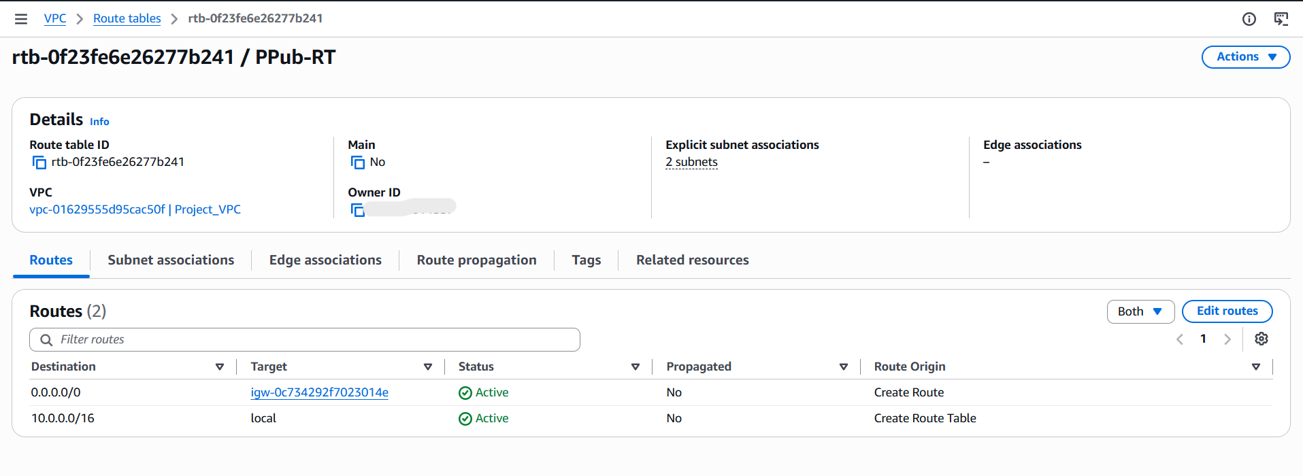
Figure 5. Route table configuration.
A public subnet normally has a route to an Internet Gateway in its associated route table. Internet reachability also depends on public IP addressing and security rules. Verify the actual route table before stating that a resource is publicly reachable.

6. Security Group Configuration
Security groups control which network traffic is permitted to reach AWS resources. The load balancer security group should permit the intended client-facing listener traffic. The EC2 security group should permit application traffic from the load balancer security group on the application's listening port. Administrative SSH access should be limited to a trusted source IP where practical.

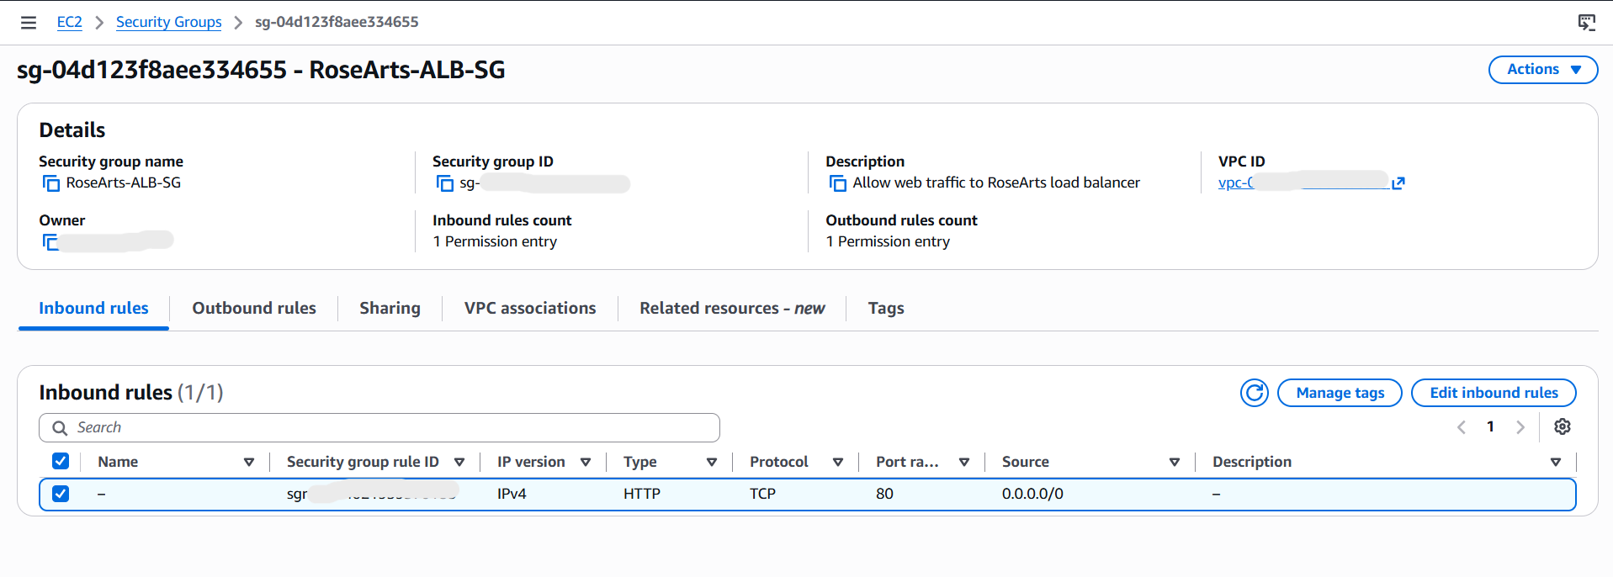

Figure 6. ALB security group.

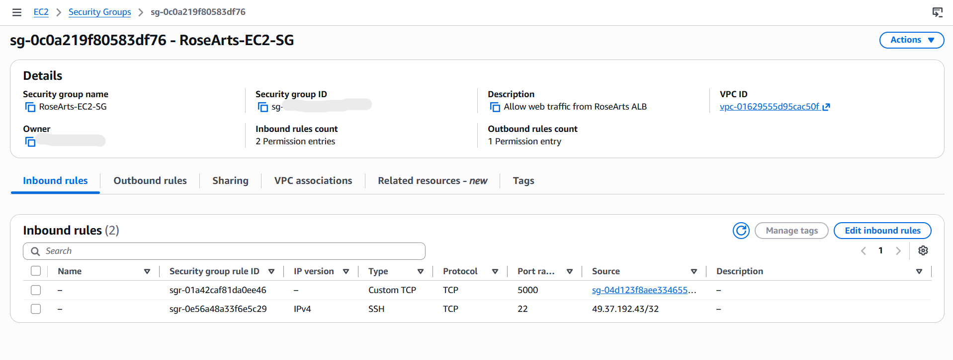

Figure 7. EC2 security group.

7. Application Deployment on EC2
The RoseArts application was deployed to an Amazon EC2 instance. The application was developed using Python and Flask, with HTML templates and static assets for the user interface. In the configured deployment, the application listens on port 5000 and is reached through the Application Load Balancer.
Application Deployment on Amazon EC2
The RoseArts Flask application was deployed on a Red Hat Enterprise Linux EC2 instance. I connected to the instance using PuTTY with the appropriate SSH credentials and the username configured for the instance. After connecting, I navigated to the application directory, activated the Python virtual environment, and started the Flask application.
Deployment procedure:
- Connect to EC2 using PuTTY: Open PuTTY, enter the EC2 instance's public IPv4 address or public DNS name, and connect using SSH. Authenticate using the appropriate username and private key.
- Navigate to the application directory: cd /path/to/rosearts
Replace /path/to/rosearts with the actual directory where the application files are stored.
- Activate the virtual environment: source .venv/bin/activate
Use this command if the virtual environment is named .venv and is located in the application directory.
- Start the Flask application: python app.py
The application runs on port 5000, provided that the Flask application is configured to use that port.
- Verify the application: Confirm that the Flask application starts without errors and that the EC2 instance can respond to requests on port 5000.(Use loop back command to check the Application)
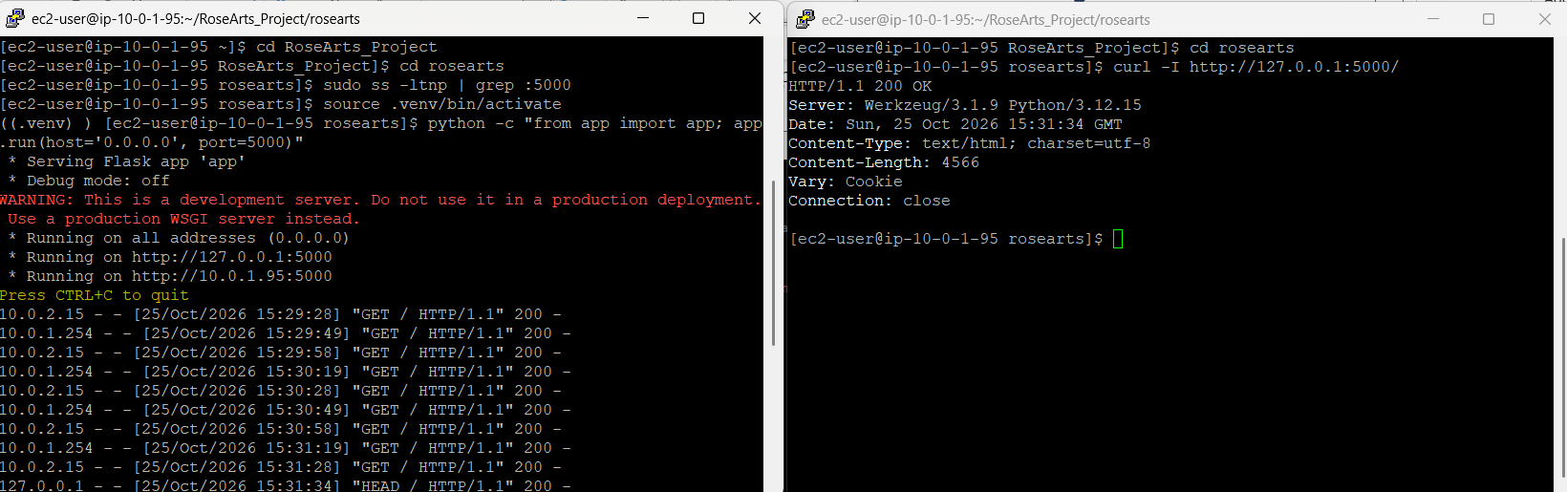
- Validate access through the load balancer: Open the RoseArts domain in a browser and verify that the website pages load through the Application Load Balancer.
The Application Load Balancer listens on HTTP port 80 and forwards requests to the EC2 application on port 5000. Amazon Route 53 routes the configured domain names to the load balancer.

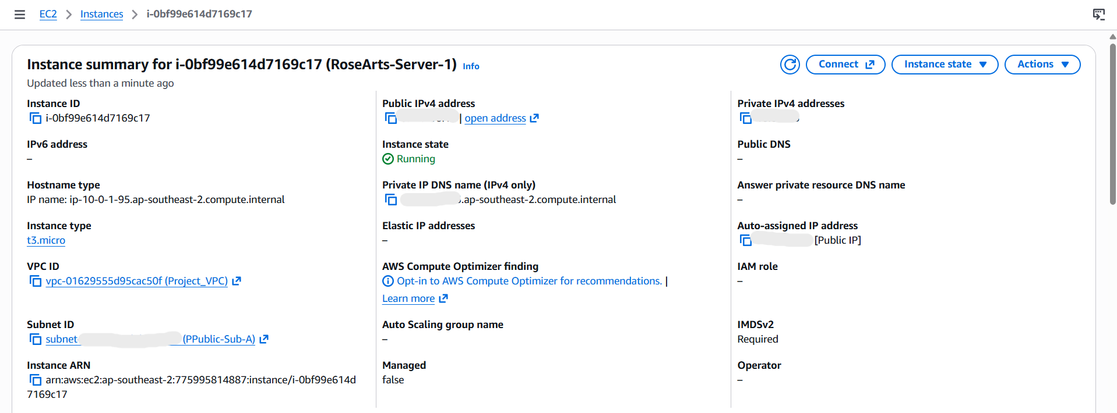

Figure 8. EC2 instance.

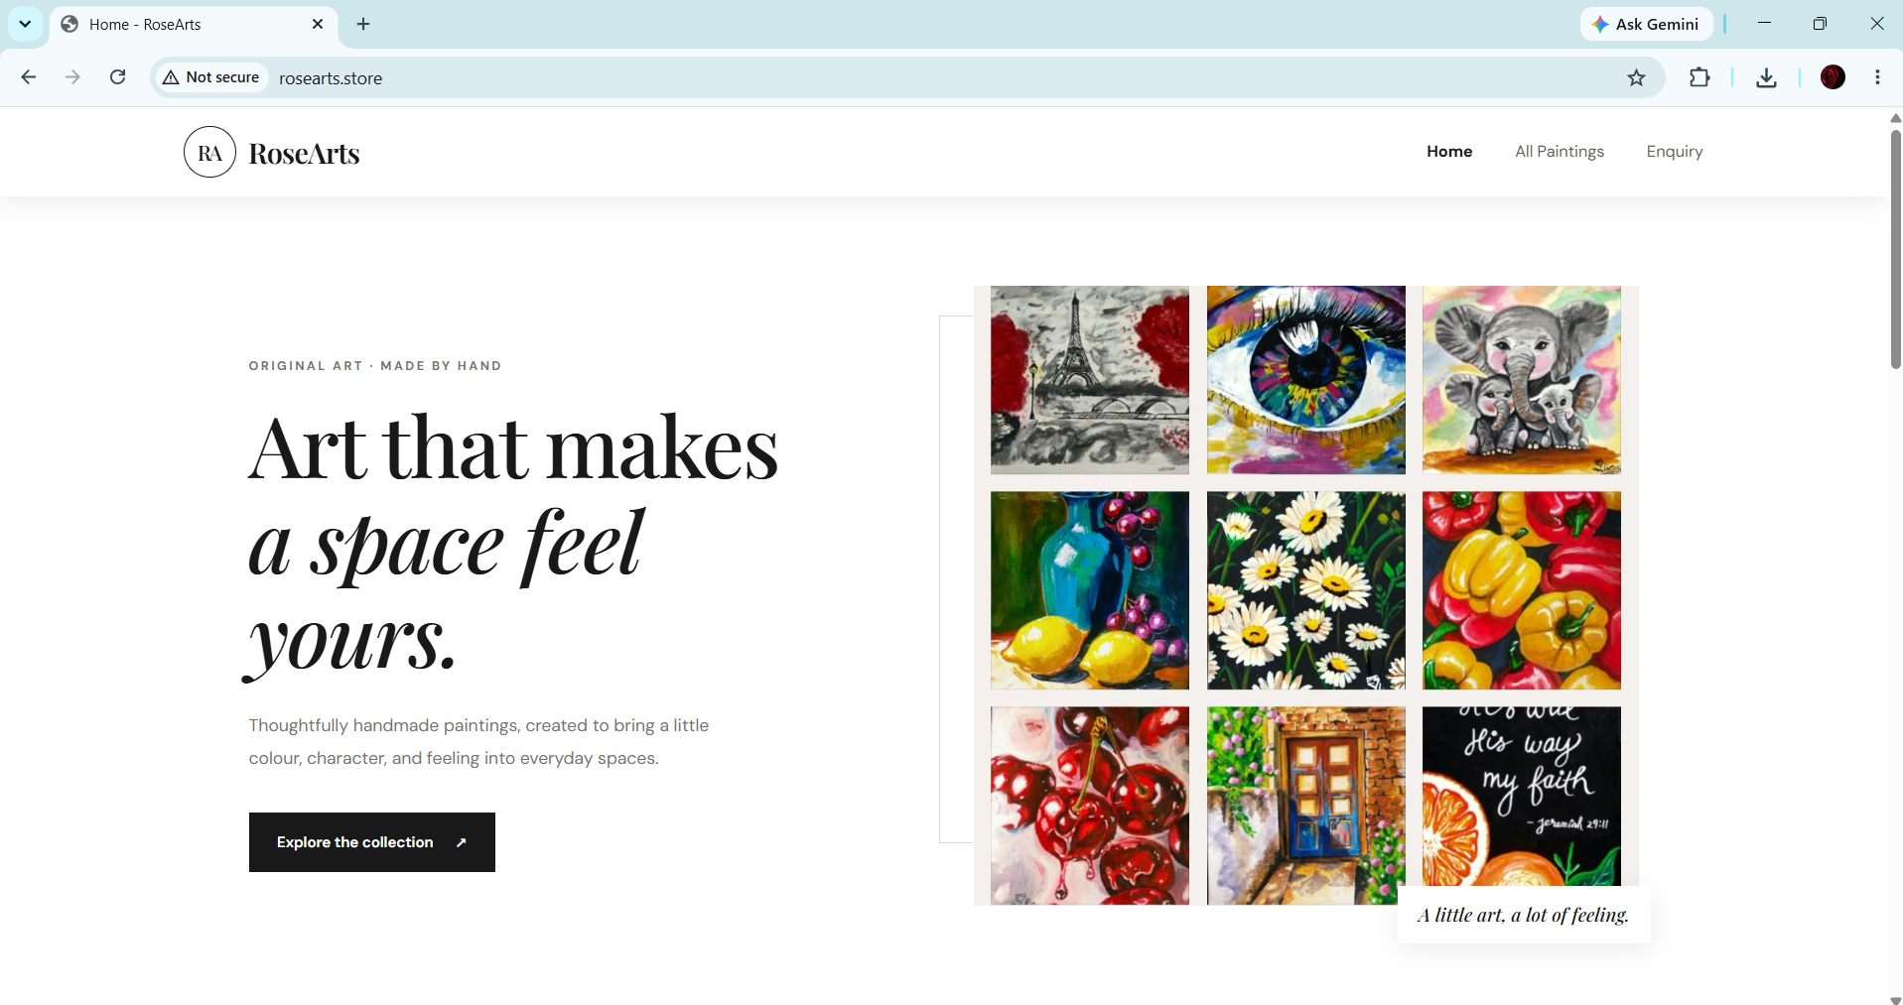

Figure 9. RoseArts homepage.
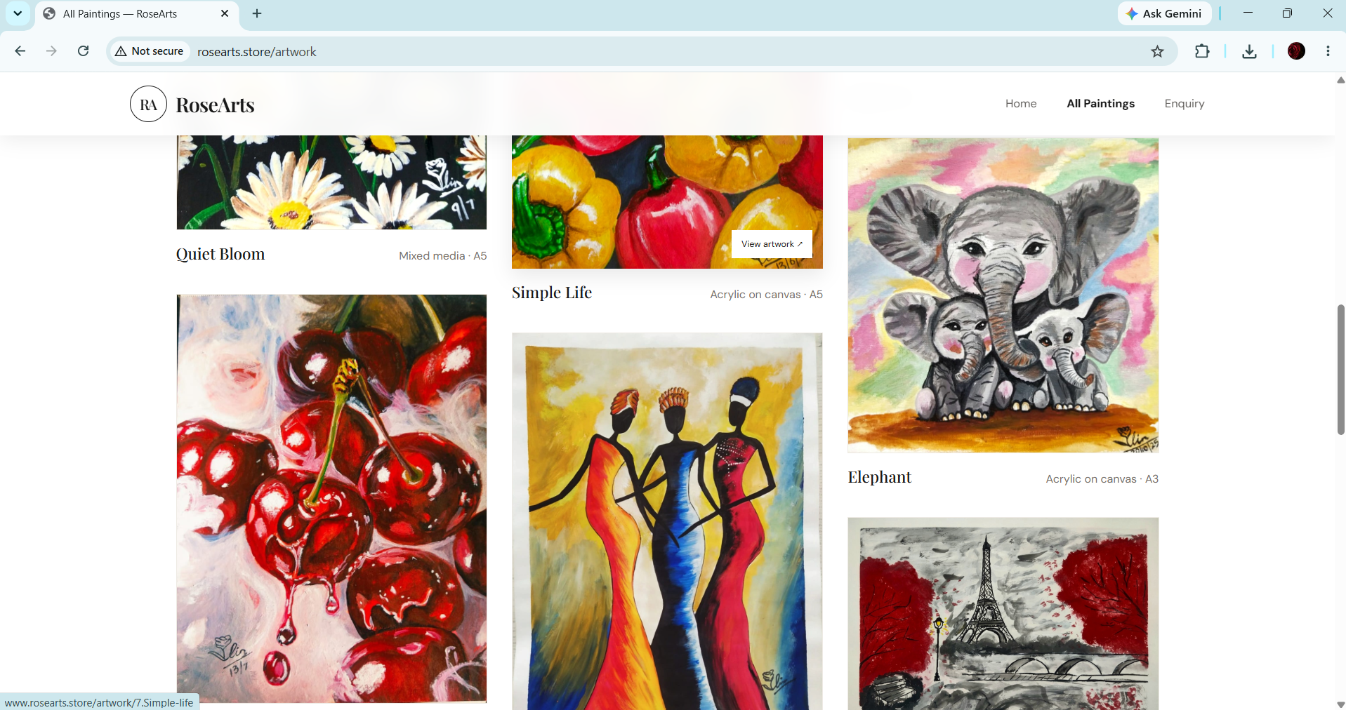

Figure 10. Paintings gallery.

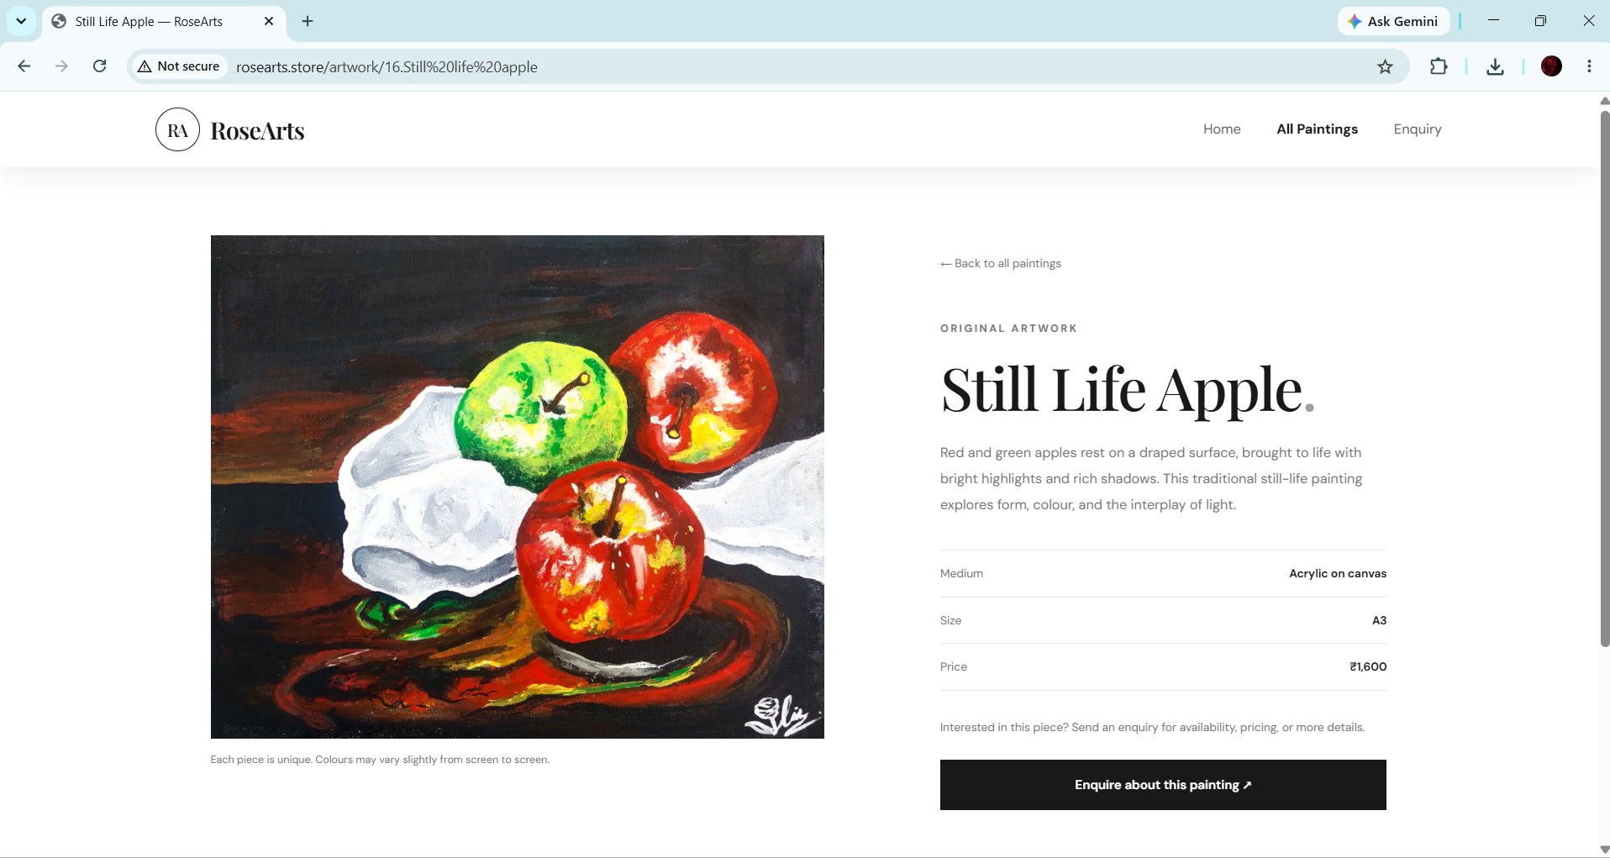

Figure 11. Painting detail page.
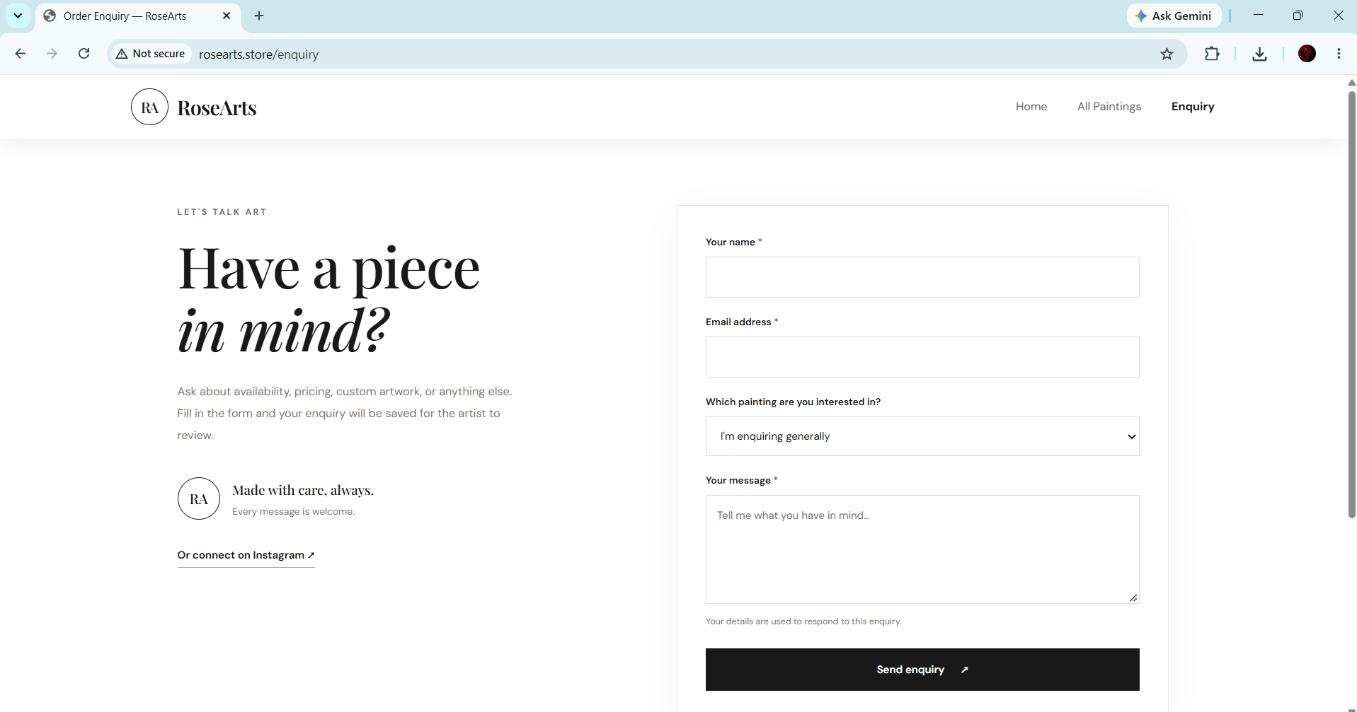

Figure 12. Enquiry page.

8. Application Load Balancer and Target Group
The Application Load Balancer provides a single entry point for HTTP requests and forwards traffic to the registered target group. The ALB listener receives HTTP requests on port 80. The target group forwards requests to the EC2 application on port 5000, according to the configured target and health-check settings.
The ALB is configured with subnets in two Availability Zones. However, because this project uses one EC2 instance, the application itself does not have redundant compute capacity. If that instance becomes unavailable, the ALB cannot serve the application from a second EC2 instance.
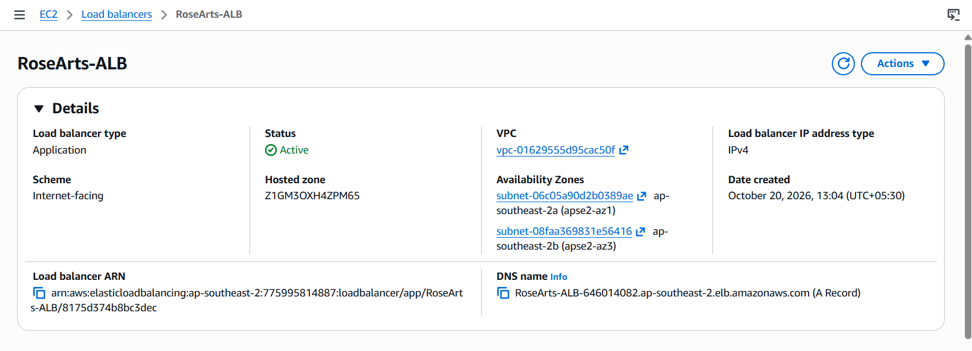
Figure 13. Application Load Balancer.
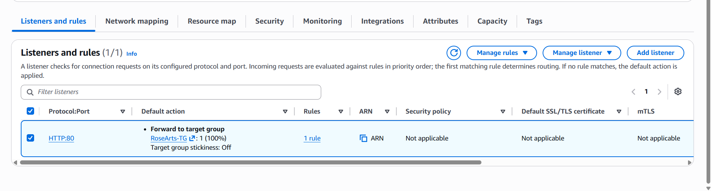
Figure 14. ALB listener.
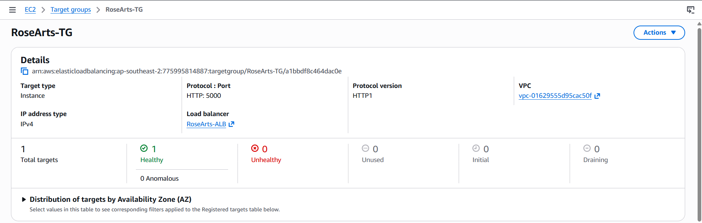
Figure 15. Target group health.

9. Custom Domain Configuration with Route 53
Amazon Route 53 manages the DNS records for the RoseArts custom domain. The configured domain record points users to the Application Load Balancer. DNS resolution maps the human-readable domain name to the load balancer endpoint; it does not host the application files itself.
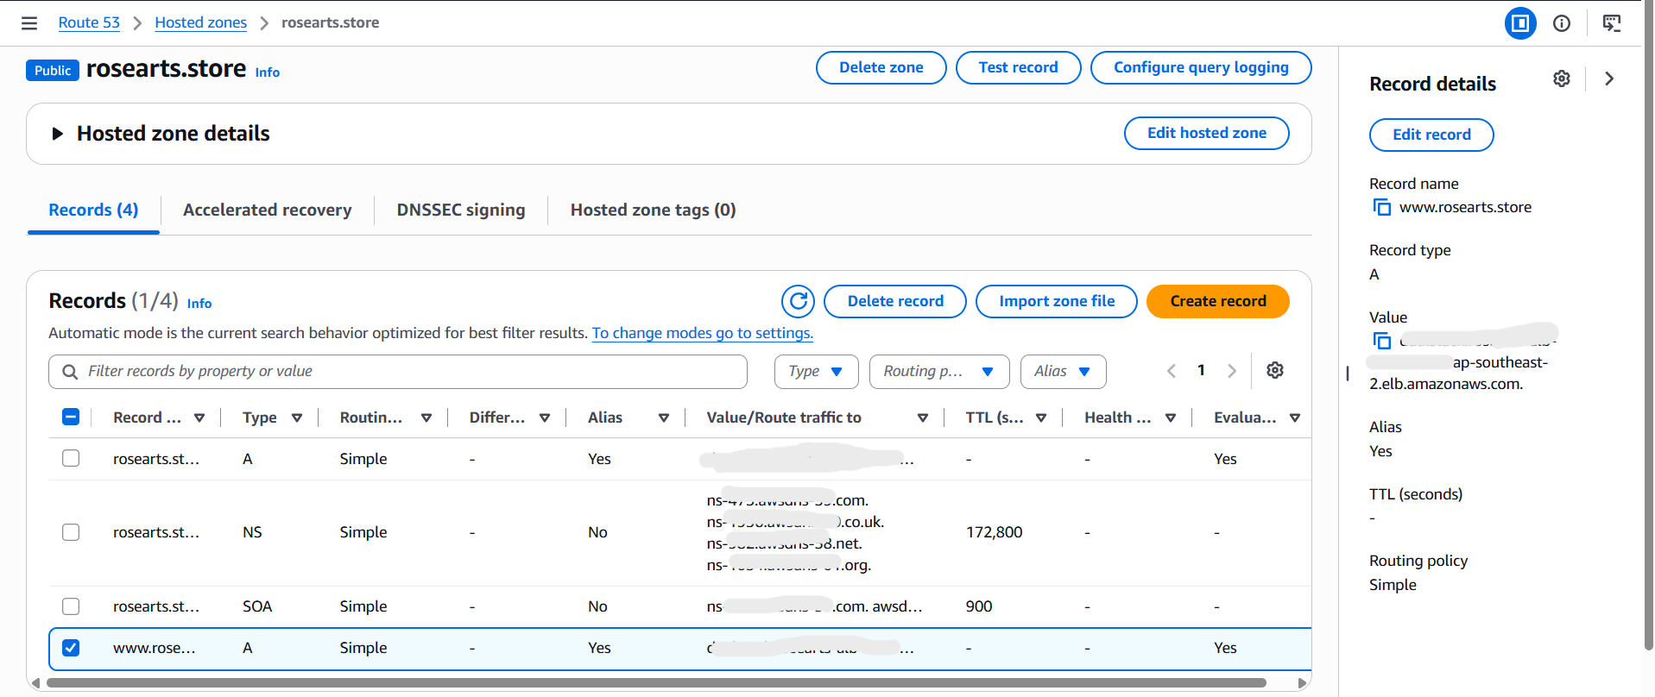
Figure 16. Route 53 DNS records.
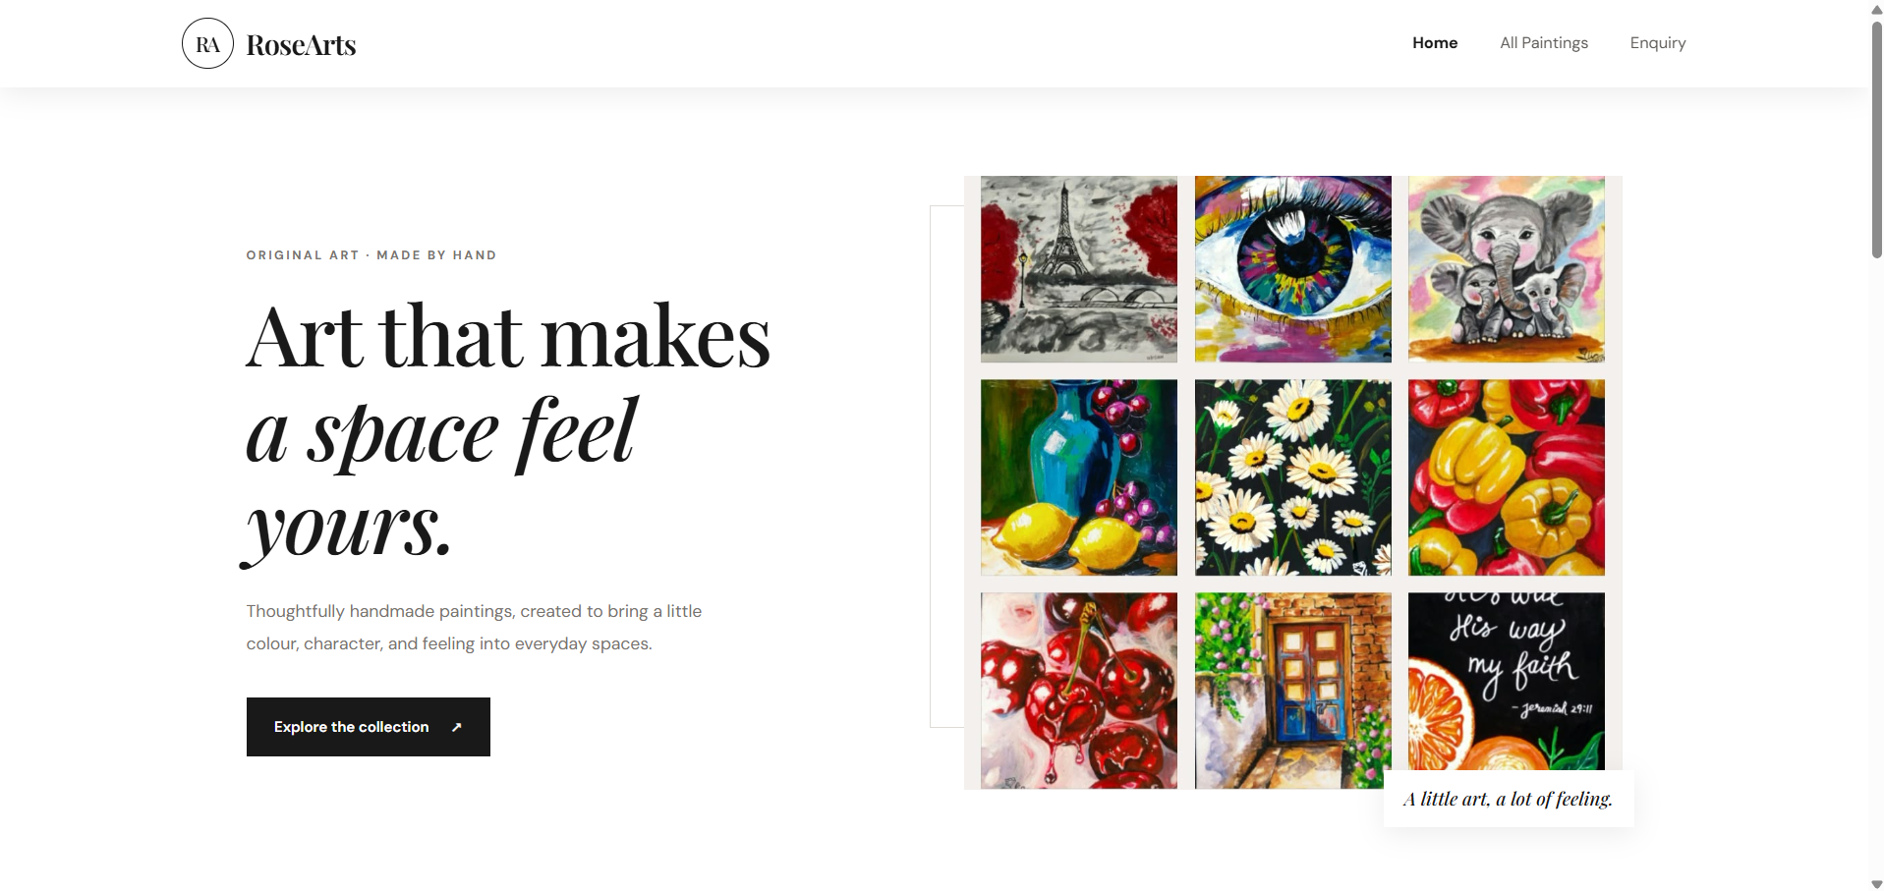

Figure 17. RoseArts accessed through the custom domain.

10. Testing and Validation
The RoseArts deployment was validated using the following checks:
Test | Validation
- EC2 instance | Confirmed that the instance was running.
- Flask application | Verified that the application started and responded on port 5000.
- Application Load Balancer | Confirmed that the target group became healthy and the website could be accessed through the load balancer.
- Route 53 | Verified that rosearts.store and www.rosearts.store resolved to the deployed website.
- Website functionality | Checked the homepage, painting gallery, painting details, and inquiry page.
The validation results were documented using AWS Console, terminal, and browser screenshots included in this report.

11. Troubleshooting

11.1 HTTP 502 Bad Gateway
A 502 response indicates that the gateway or load balancer received an invalid or unsuccessful response from an upstream target. In this project, investigate the target-group health, EC2 security-group rules, application process, listening port, and whether the application responds locally on the instance. Document the exact cause and fix that you observed during your troubleshooting; do not present a possible cause as the confirmed cause unless you verified it.

11.2 HTTP 504 Gateway Timeout
A 504 response indicates that the load balancer did not receive a timely response from its target. Possible checks include whether the Flask process is running, whether it listens on the expected port, whether security groups permit traffic from the ALB to the target, and whether the target is healthy. Record the actual sequence of checks and the change that resolved the issue in your deployment..

12. Security and Cost Considerations
Security groups should allow only the ports and sources required for the project. SSH access should be restricted to a trusted source, and application traffic should be allowed from the load balancer as appropriate. Credentials, private keys, account identifiers that are not needed, and secrets must not be included in the public GitHub repository.
AWS resources such as EC2 instances, load balancers, public IPv4 addresses, and DNS-related services may incur charges depending on configuration and usage. Stopping EC2 does not necessarily stop charges for other resources. Review the AWS Billing console and stop or remove resources that are not needed, while keeping in mind that stopping the instance will make the application unavailable.

13. Conclusion
The RoseArts project demonstrates a practical deployment of a web application on AWS using a VPC, public subnets across two Availability Zones, an EC2 instance, an Application Load Balancer, a target group, and Amazon Route 53 for a custom domain. The project provided hands-on experience with cloud networking, application hosting, traffic routing, DNS configuration, health checks, and troubleshooting web access issues. Future improvements could include deploying additional EC2 instances across Availability Zones, using private subnets for application instances, enabling HTTPS with an appropriate certificate, and adding monitoring and alerting.

