TOPIC 2 • NLP FOR SOCIAL MEDIA ANALYTICS
Syntactic Analysis: POS Tagging and Dependency Parsing
Group report | Members: [add names] | Tool: Python + spaCy (en_core_web_sm)
1 What is syntactic analysis?
- Definition: working out the grammatical structure of a sentence: word categories, phrases, and which word depends on which.
- Why it matters: meaning depends on word order and roles. “The airline lost my luggage” and “My luggage lost the airline” use the same words but mean different things.
- Used for: information extraction, question answering, opinion mining, machine translation.
- In social media: it links an opinion to its target, e.g. “the camera is amazing” (camera praised) vs. “amazing, my camera broke”.
2 Common syntactic constructs
- POS tagging: gives every token a category. Universal tags (NOUN, VERB, ADJ, ADV, PRON, ADP) are coarse; Penn Treebank tags (NN, VBD, JJ, RB) are finer.
- Context matters: “post” is a NOUN in “a post went viral” but a VERB in “I post daily”.
- Dependency parsing: builds a tree of labelled head-to-dependent links. The main verb is the ROOT.
- Versus constituency parsing: constituency groups words into nested phrases (NP, VP); dependency exposes subject-verb-object directly, so it suits social media work.

Relation | Meaning | Example in our data
nsubj | Subject of a verb | camera → is (Post 1)
dobj | Direct object | luggage → lost (Post 3)
amod | Adjective modifier | new → camera (Post 1)
acomp | Adjective complement | amazing → is (Post 1)
advmod | Adverb modifier | absolutely → amazing (Post 1)

Worked example. Post 1: “The new phone camera is absolutely amazing!” The parser makes “camera” the subject and “amazing” its complement, so the praise attaches to the camera. In Post 3 (“I can’t believe the airline lost my luggage again”) it extracts the triple (airline, lose, luggage).
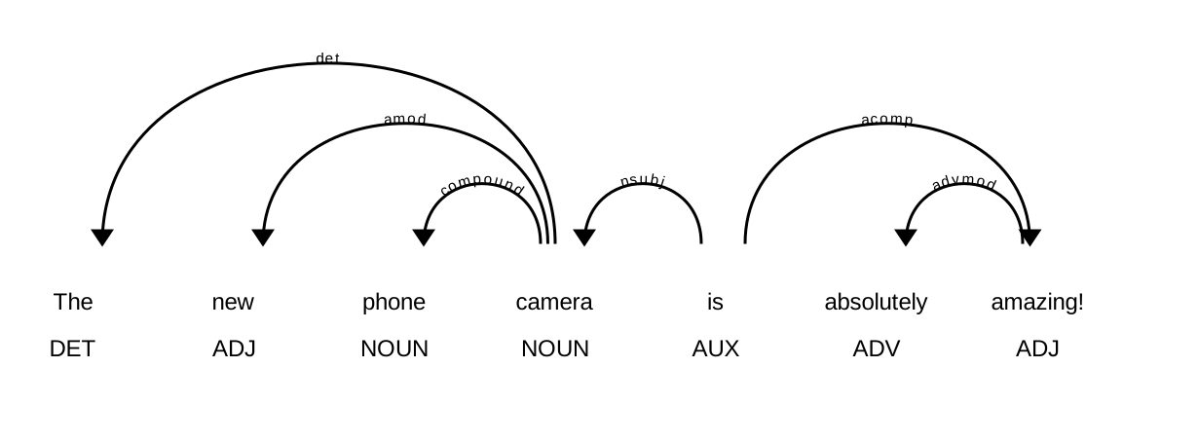
Figure 1. Dependency parse of Post 1 (spaCy displaCy). Arrows run from head to dependent; labels below are POS tags.
3 Challenges with social media text
Parsers are trained on edited text such as news, so informal language degrades them. Failures from our own run:
Post | What went wrong
“omg the concert last night was sooo good lol” | “omg” tagged as a preposition (ADP); “lol” tagged as a noun (Figure 2)
“Traffic on Mombasa Road is terrible today #nightmare” | “nightmare” tagged as a VERB; “#” tagged SYM; both get the vague label dep
“@SafaricomPLC why is my internet so slow???” | “???” split into three separate punctuation tokens
“I can’t believe…” | Contraction split into “ca” + “n’t” (correct, but surprising)
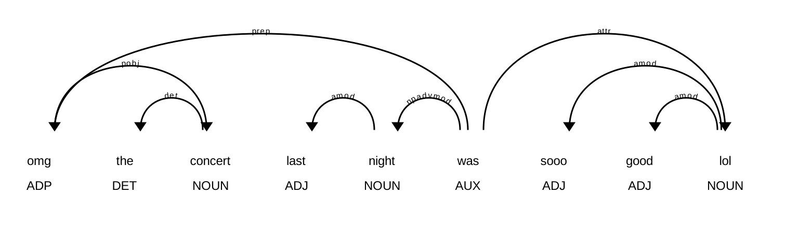
Figure 2. Parse of the noisy Post 6: “omg” is treated as a preposition and “lol” as a noun.
Other challenges
- Misspellings and elongation (“sooo”), emojis and emoticons with no grammatical category.
- Missing punctuation and capitalisation; verbless fragments; sarcasm.
- Code-switching, e.g. English mixed with Swahili or Sheng.
Mitigations
- Normalise text first; separate hashtags, mentions and URLs before tagging.
- Use tweet-trained models (TweeboParser, Gimpel et al. Twitter POS tag set) or fine-tune a transformer on domain data.
4 Summary of coding results
- Dataset: 10 sample social media posts; script outputs POS tags, dependencies, subject-verb-object triples and SVG parse diagrams.
- Adjectives and their head nouns (amod, acomp) identify opinion targets; triples summarise complaints.
- Files in the ZIP: Python script, full output, two CSV tables, parse diagrams.

Key takeaways
- Clean posts parse accurately; slang, hashtags and chat-speak cause tagging and parsing errors.
- Most frequent tags in our 10 posts: NOUN (21), PUNCT (12), VERB (11), ADJ (10).
- Dependency relations (nsubj, amod, acomp) link opinions to what they describe, which sets up Topic 3 (sentiment).

