**项目中安装echarts**

在项目的vue文件夹的终端下使用以下命令

npm install echarts vue-echarts

**调用echarts的基本格式(静态数据)**

只改变这两个部分就行

[官网](https://echarts.apache.org/zh/index.html)的示例要选完整代码(按需引入和ES Modules)还要是js

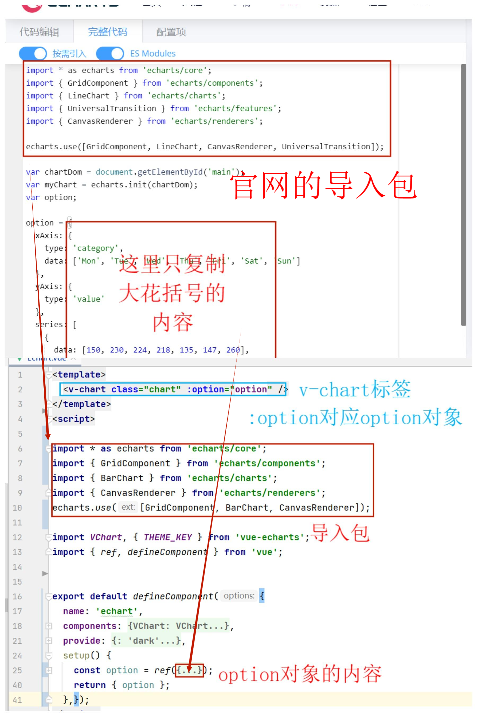

<template>

<v-chart class="chart" :option="option" />

</template>

<script>

import * as echarts from 'echarts/core';

import { GridComponent } from 'echarts/components';

import { BarChart } from 'echarts/charts';

import { CanvasRenderer } from 'echarts/renderers';

echarts.use([GridComponent, BarChart, CanvasRenderer]);

import VChart, { THEME_KEY } from 'vue-echarts';

import { ref, defineComponent } from 'vue';

export default defineComponent({

name: 'echart',

components: {

VChart,

},

provide: {

[THEME_KEY]: 'dark',

},

setup() {

const option = ref({

xAxis: {

type: 'category',

data: ['Mon', 'Tue', 'Wed', 'Thu', 'Fri', 'Sat', 'Sun']

},

yAxis: {

type: 'value'

},

series: [

{

data: [120, 200, 150, 80, 70, 110, 130],

type: 'bar'

}

]

});

return { option };

},});

</script>

<style scoped>

.chart {

height: 20vh;

}

</style>

**更新数据**

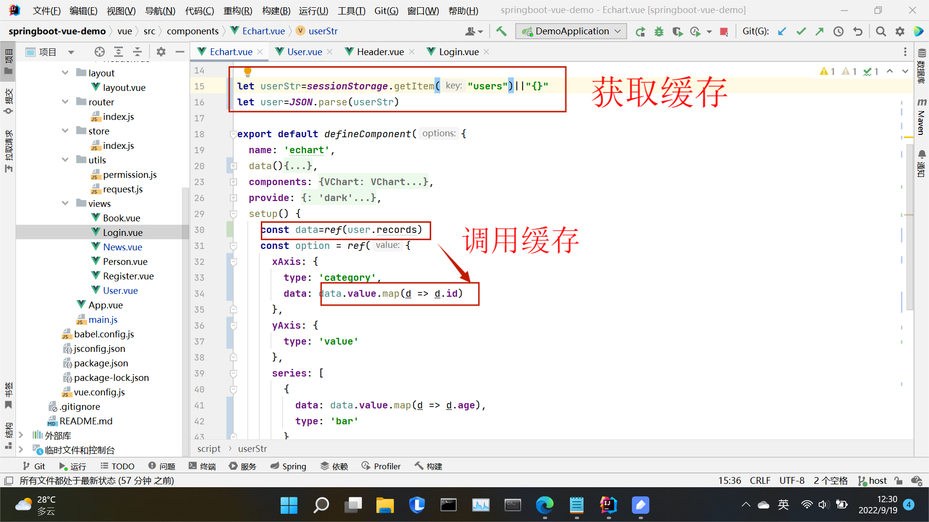

<template>

<v-chart class="chart" :option="option" />

</template>

<script>

import * as echarts from 'echarts/core';

import { GridComponent } from 'echarts/components';

import { BarChart } from 'echarts/charts';

import { CanvasRenderer } from 'echarts/renderers';

echarts.use([GridComponent, BarChart, CanvasRenderer]);

import VChart, { THEME_KEY } from 'vue-echarts';

import { ref, defineComponent,computed } from 'vue';

let userStr=sessionStorage.getItem("users")||"{}"

let user=JSON.parse(userStr)

export default defineComponent({

name: 'echart',

data(){

return{}

},

components: {

VChart,

},

provide: {

[THEME_KEY]: 'dark',

},

setup() {

console.log(user.records)

const data=ref(user.records)

const option = ref({

xAxis: {

type: 'category',

data: data.value.map(d => d.id)

},

yAxis: {

type: 'value'

},

series: [

{

data: data.value.map(d => d.age),

type: 'bar'

}

]

});

return { option };

},

});

</script>

<style scoped>

.chart {

height: 50vh;

}

</style>