**Testing for Errors**

Test 1)Save Error when tring to save data with empty textboxes

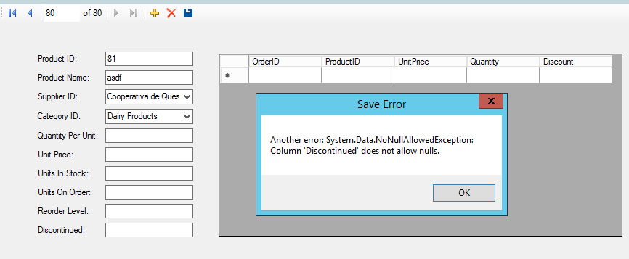

Test 2) Deleting a record that is referenced

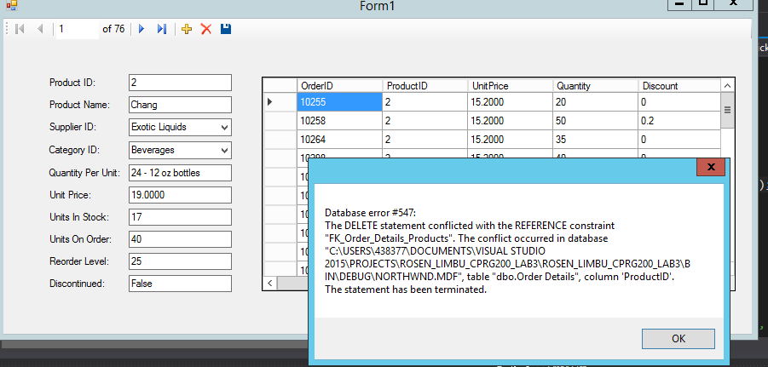

Test 3) Able to Save New Record

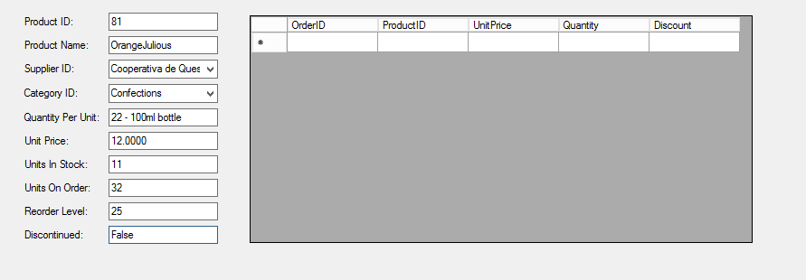

Test 4) Application won’t allow changes when units on order is negative value.

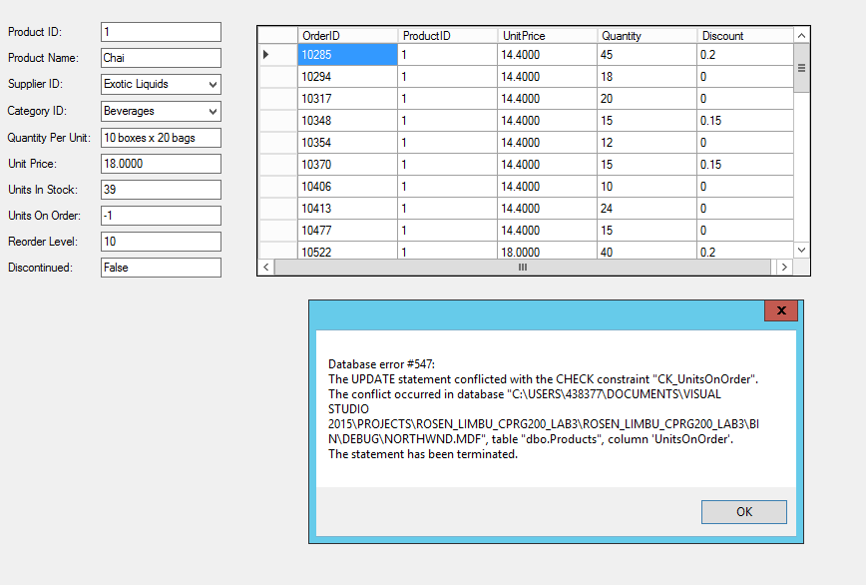

Test 5) When, in the process of creating a new record, the user clicks the back button prompts the following message

