Image Previewer

Project developed for New Bulgarian University’s ‘Web programming with HTML and JavaScript’ course

### Project description

Simple image previewer created with plain HTML, CSS and JavaScript with no external libraries. It features responsive design, using CSS Flex property, previewed image section, stored images to choose from section, search bar to search for a specific image name in the stored images and a upload image section that lets you enter image name and url and add it to the previewer. Additionally the uploading functionality saves the entered name and url in the local storage and the image stays part of the application, even after refreshing.

### Screenshot

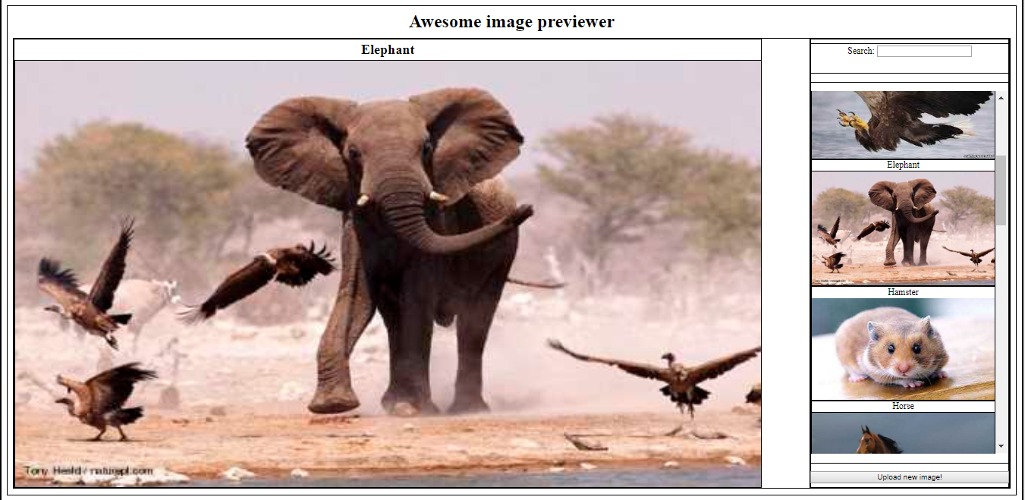

### Credits

* Developed by Rosen Urkov