Studio 5&6

Name and Student Id: Xiangyu Liu 27503410

Self-Evaluation High Distinction

|  |  |  |  |  |  |
| --- | --- | --- | --- | --- | --- |
| Need Help | Work in Progress | Pass | Credit | Distinction | High Distinction |

Task 5.1

Task 5.2

Task 6.1

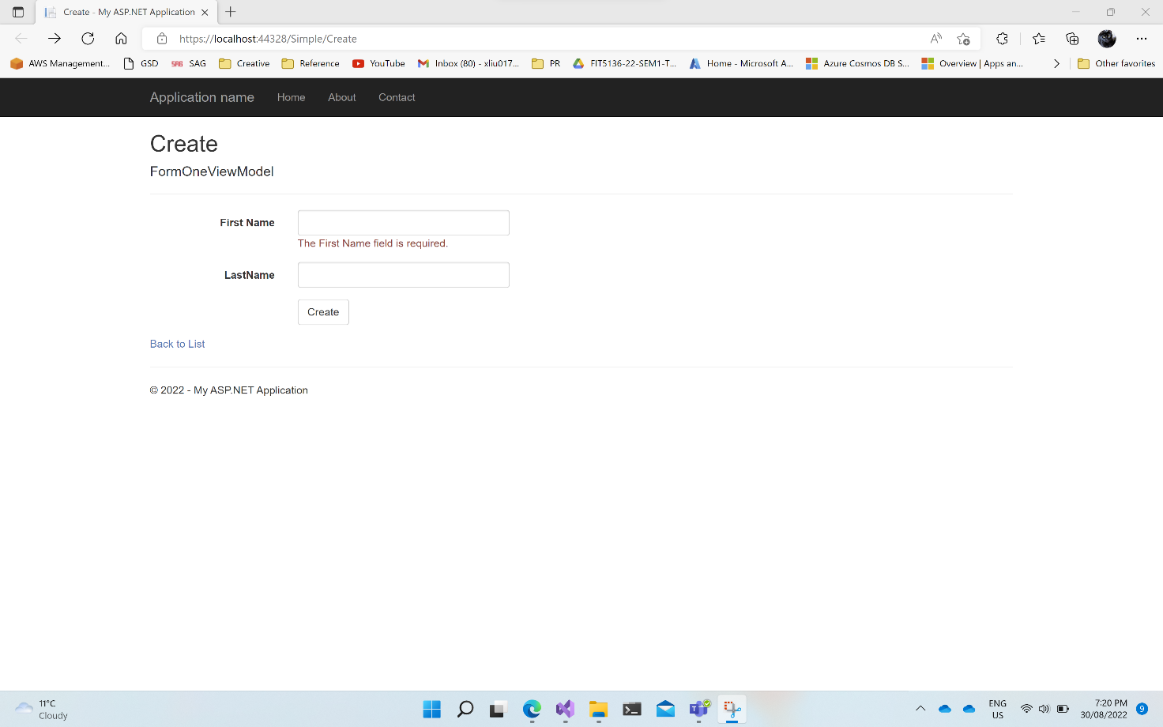

Task 6.2