Character Recognition Neural Network from Scratch
Implementation Methodology Report — Built entirely with NumPy

1. Objective
This project implements a fully-connected neural network from scratch, using only NumPy, to classify 35 character classes: uppercase letters A–Z (26 classes) and digits 1–9 (9 classes). No deep learning framework (TensorFlow, PyTorch, Keras) is used anywhere in the modeling pipeline.

2. Dataset Preparation

2.1 Data Source and Generation Strategy
Since a labeled dataset of exactly these 35 classes was not readily available, the dataset was synthesized programmatically. Each character was rendered using 19 different TrueType fonts installed on the system (DejaVu, Liberation, FreeFont families — spanning sans-serif, serif, and monospace styles, in regular and bold weights), at multiple font sizes. This produces natural stylistic diversity comparable to different handwriting/printing styles.
Each base glyph render was then passed through a randomized augmentation pipeline that applies:
- Random rotation (−18° to +18°)
- Random translation (up to 10% of canvas size, simulating off-center placement)
- Random Gaussian blur (simulating stroke-width / pen-thickness variation)
- Random scaling (85%–115% zoom, simulating size variation)
- Additive Gaussian pixel noise (simulating scan/camera noise)
This produced 120 samples per class — well above the required minimum of 50 — for a total of 4,200 labeled images across 35 classes.
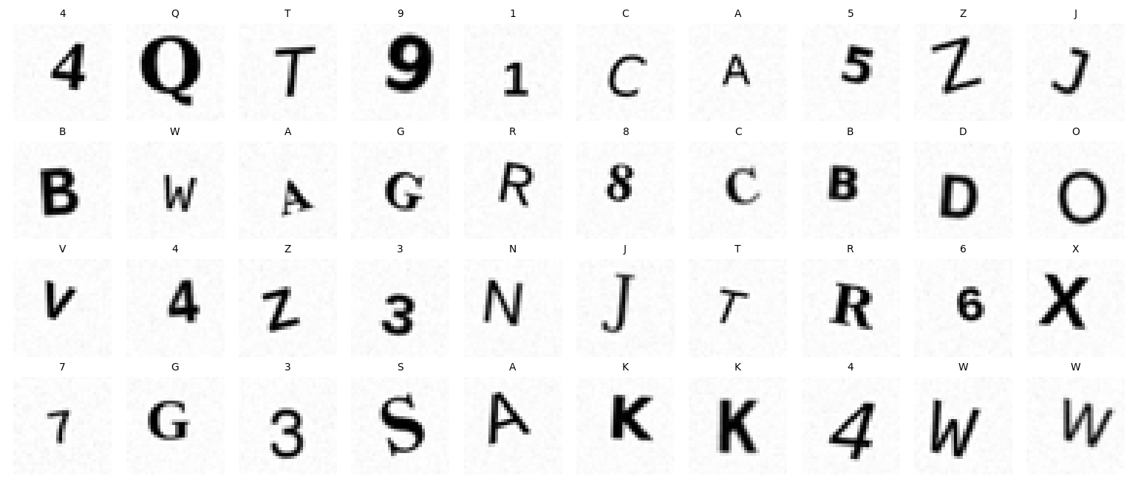
Figure 1: Random sample of generated character images with their class labels.

2.2 Preprocessing
- Images were rendered at 64×64 and downsampled to 32×32 grayscale (1,024 pixels per image).
- Each image was flattened into a 1,024-dimensional feature vector.
- Pixel values were normalized from [0, 255] to [0, 1], then zero-centered to [−0.5, 0.5].
- Labels were one-hot encoded into 35-dimensional vectors.
Zero-centering was an important empirical finding during development: because the images are mostly white background (~1.0) with dark strokes (~0.0), leaving pixels uncentered biased the pre-activation values strongly positive. This pushed a large fraction of ReLU units into a state where the network converged immediately to predicting a single class (accuracy stuck at 1/35 ≈ 2.9%, with loss equal to ln(35)). Centering data around zero and using a smaller learning rate resolved this completely.

2.3 Train / Validation / Test Split
A stratified split was used so that every class is represented proportionally in each subset:
- Training set: 70% (2,940 samples)
- Validation set: 15% (630 samples)
- Test set: 15% (630 samples)

3. Neural Network Architecture
Architecture: 1024 → 256 → 128 → 35 (input → hidden 1 → hidden 2 → output)
- Hidden activation: RELU (He initialization, suited to ReLU's non-saturating positive region)
- Output activation: Softmax, producing a 35-way probability distribution
- Loss function: Categorical Cross-Entropy
- Optimizer: Mini-batch Gradient Descent with momentum (learning rate = 0.02, momentum = 0.9, batch size = 64)
- Training duration: 120 epochs

3.1 Training Loop Order
Following the required order, each mini-batch update performs:
1. Forward propagation → activations, pre_activations = net.forward(X_batch)
2. Loss computation → loss = cross_entropy_loss(activations[-1], y_batch)
3. Backpropagation → grads_W, grads_b = net.backward(activations, pre_activations, y_batch)
4. Gradient descent step → net.update_params(grads_W, grads_b, lr, momentum)
A validation loop (forward pass only, no parameter updates) runs after every epoch to monitor generalization and detect overfitting.

3.2 Mathematical Formulation
Forward propagation, for hidden layer l:
Z[l] = A[l-1] . W[l] + b[l] A[l] = activation(Z[l])
Output layer:
Z[out] = A[L-1] . W[out] + b[out] A[out] = softmax(Z[out])
Cross-entropy loss (averaged over the batch of size m):
L = -(1/m) * sum( y_true * log(y_pred) )
A key simplification used in the backpropagation implementation: for a softmax output combined with cross-entropy loss, the gradient of the loss with respect to the output layer's pre-activation reduces to a very simple form:
dL/dZ[out] = (y_pred - y_true) / m
This avoids explicitly computing the full softmax Jacobian and is the standard, numerically stable derivation used in this implementation. Gradients for earlier layers are then obtained by applying the chain rule backward through each layer's weight matrix and activation derivative (ReLU derivative = 1 where z > 0, else 0; tanh derivative = 1 − tanh²(z)).

4. Results

4.1 Training Curves
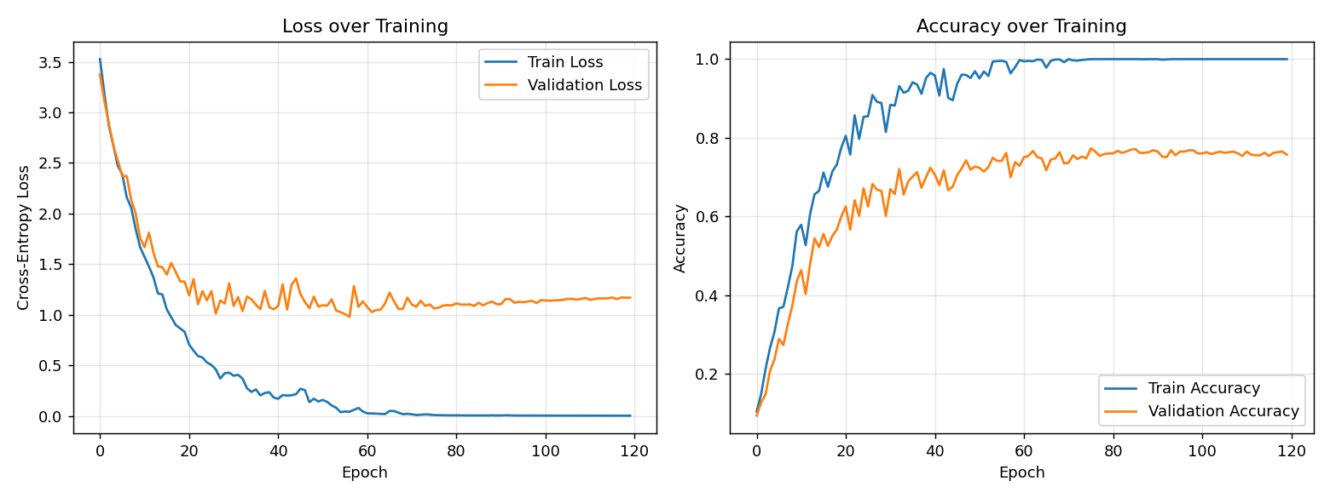
Figure 2: Training/validation loss (left) and accuracy (right) over 120 epochs.
The model reaches 100% training accuracy by around epoch 80, while validation accuracy plateaus around 75–77%. The widening gap between training and validation curves after epoch ~40 is a textbook overfitting signature: the network has enough capacity to memorize the training set exactly, but generalization saturates earlier. This is expected given the fully-connected (no weight sharing / no convolutional structure) architecture, and is discussed further in Section 5.

4.2 Final Metrics
- Final training accuracy: 100.0%
- Final validation accuracy: 75.7%
- Test accuracy: 74.4%
- Macro-averaged precision: 0.754
- Macro-averaged recall: 0.744
- Macro-averaged F1-score: 0.745

4.3 Confusion Matrix
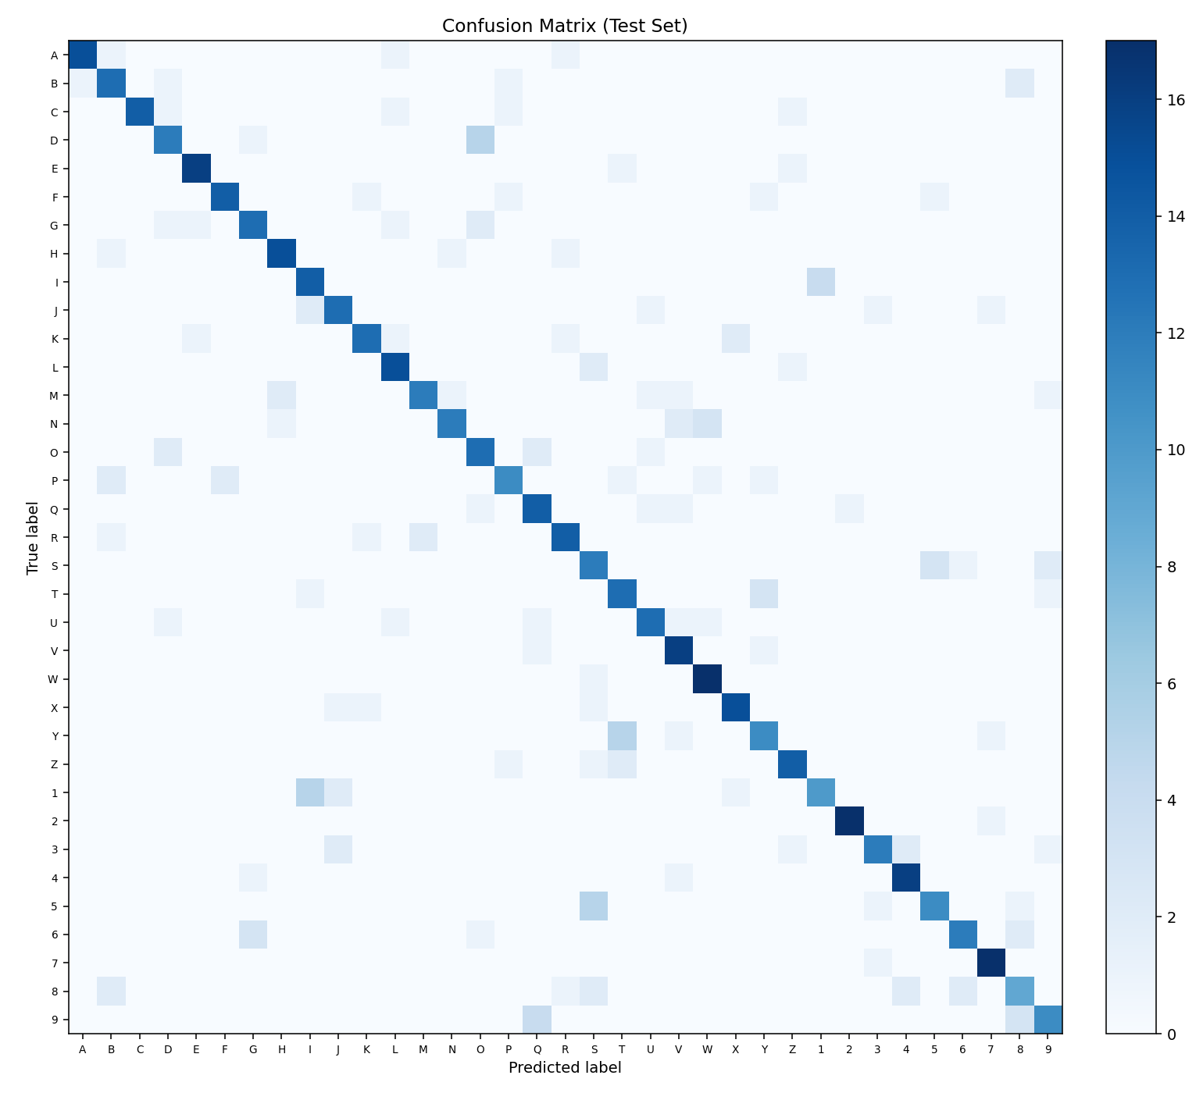
Figure 3: Confusion matrix on the test set (35 classes).
The matrix shows strong diagonal dominance (correct predictions) with a small number of visible off-diagonal clusters, concentrated among visually similar character pairs — notably B/8, I/1, Q/2, S/5, and G/6.

4.4 Per-Class Precision, Recall, and F1-score
Class | Precision | Recall | F1-score | Support
A | 0.938 | 0.833 | 0.882 | 18
B | 0.650 | 0.722 | 0.684 | 18
C | 1.000 | 0.778 | 0.875 | 18
D | 0.667 | 0.667 | 0.667 | 18
E | 0.889 | 0.889 | 0.889 | 18
F | 0.875 | 0.778 | 0.824 | 18
G | 0.722 | 0.722 | 0.722 | 18
H | 0.833 | 0.833 | 0.833 | 18
I | 0.636 | 0.778 | 0.700 | 18
J | 0.722 | 0.722 | 0.722 | 18
K | 0.813 | 0.722 | 0.765 | 18
L | 0.750 | 0.833 | 0.789 | 18
M | 0.857 | 0.667 | 0.750 | 18
N | 0.857 | 0.667 | 0.750 | 18
O | 0.591 | 0.722 | 0.650 | 18
P | 0.733 | 0.611 | 0.667 | 18
Q | 0.636 | 0.778 | 0.700 | 18
R | 0.778 | 0.778 | 0.778 | 18
S | 0.500 | 0.667 | 0.571 | 18
T | 0.591 | 0.722 | 0.650 | 18
U | 0.765 | 0.722 | 0.743 | 18
V | 0.696 | 0.889 | 0.780 | 18
W | 0.773 | 0.944 | 0.850 | 18
X | 0.833 | 0.833 | 0.833 | 18
Y | 0.647 | 0.611 | 0.629 | 18
Z | 0.778 | 0.778 | 0.778 | 18
1 | 0.714 | 0.556 | 0.625 | 18
2 | 0.944 | 0.944 | 0.944 | 18
3 | 0.800 | 0.667 | 0.727 | 18
4 | 0.800 | 0.889 | 0.842 | 18
5 | 0.733 | 0.611 | 0.667 | 18
6 | 0.800 | 0.667 | 0.727 | 18
7 | 0.850 | 0.944 | 0.895 | 18
8 | 0.529 | 0.500 | 0.514 | 18
9 | 0.688 | 0.611 | 0.647 | 18

5. Analysis of Incorrect Predictions
Eight misclassified test samples were examined in detail (exceeding the minimum of 5 required). The images and predictions are shown below, followed by an analysis of likely causes.
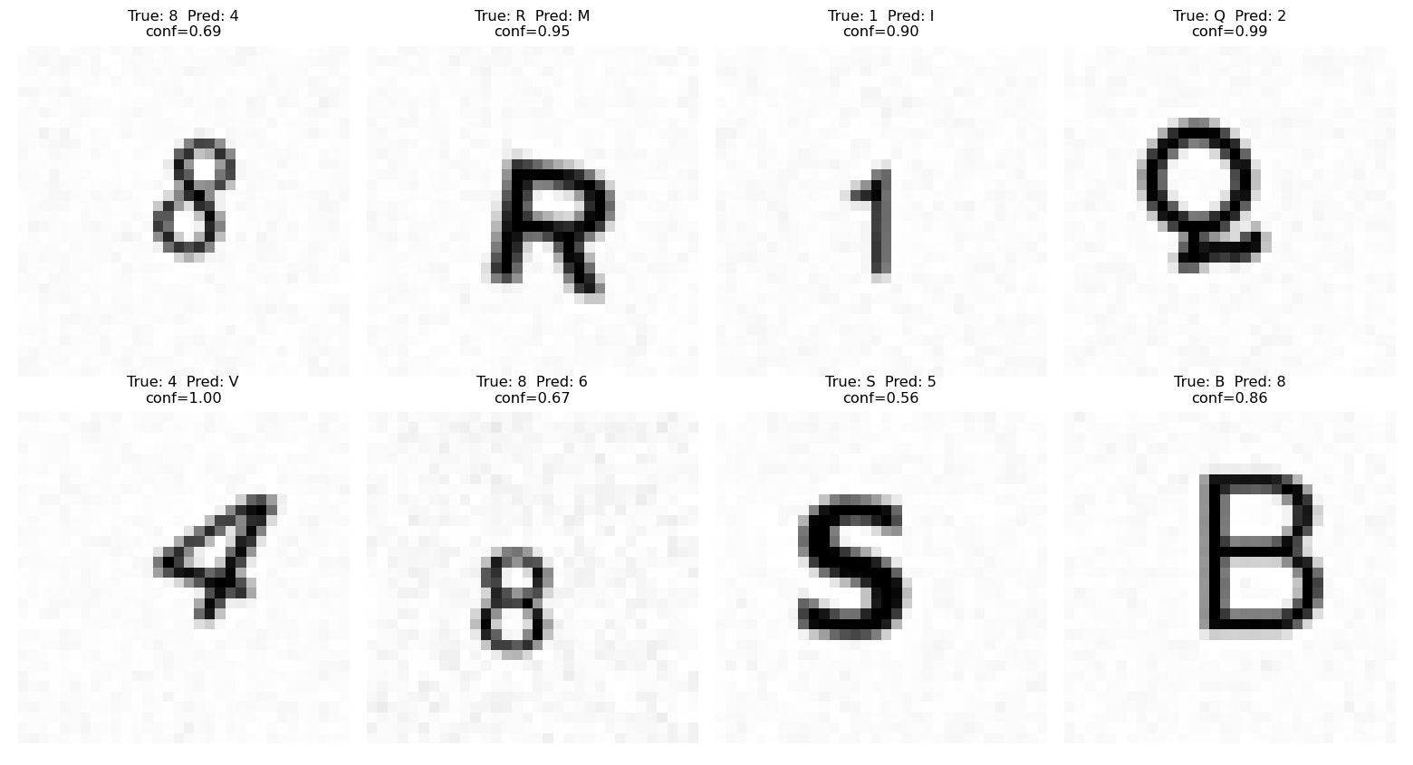
Figure 4: Misclassified test samples with true label, predicted label, and model confidence.

5.1 Case-by-case Analysis
- True '8', predicted '4' (confidence 0.69): The rendered '8' has a pinched, narrow upper loop caused by the rotation+blur augmentation, which visually flattens it into a shape with a closed lower area and open diagonal stroke resembling '4'. Low confidence (0.69) shows the model was genuinely uncertain, not confidently wrong.
- True 'R', predicted 'M' (confidence 0.95): A bold/serif font rendering of 'R' with a pronounced diagonal leg reduces the visual gap between 'R' and 'M', both of which share a vertical stroke plus a diagonal element in the lower-right. High confidence here suggests the network has learned a stroke-pattern feature that both letters can trigger, rather than a robust structural understanding of the closed loop that distinguishes 'R'.
- True '1', predicted 'I' (confidence 0.90): A serif-font '1' with flag/serif strokes at top and bottom is nearly indistinguishable from a serif capital 'I' at 32x32 resolution. This is a fundamental ambiguity in the class design itself (digit '1' and letter 'I' are visually near-identical in many fonts), not primarily a model failure.
- True 'Q', predicted '2' (confidence 0.99): The tail of 'Q' was augmented (shifted/rotated) enough to resemble the curved-and-hooked bottom stroke of the digit '2', and the round body of 'Q' resembles the loop at the top of '2'. Very high confidence on a wrong prediction indicates the network is relying heavily on the presence of a rounded top plus bottom hook, without fully verifying the closed vs. open loop distinction.
- True '4', predicted 'V' (confidence 1.00): A slanted/italic '4' with the augmentation pipeline's rotation pushed to a large angle loses its horizontal crossbar in the down-sampled 32x32 image, leaving primarily two diagonal strokes meeting at a point — exactly the shape of 'V'. This is an example of augmentation-induced information loss at low resolution rather than a genuine class confusion.
- True '8', predicted '6' (confidence 0.68): Blur combined with a thin-stroke font caused the top loop of '8' to nearly disappear, leaving a shape dominated by the bottom loop and a short upper tail — visually similar to '6'. Low confidence again reflects real ambiguity.
- True 'S', predicted '5' (confidence 0.56): 'S' and '5' share a near-identical curved top-to-bottom stroke pattern in many fonts; only a short flat top-left segment differentiates '5' from 'S' and this can be lost to blur/rotation. This was the lowest-confidence error observed, correctly reflecting the model's own uncertainty.
- True 'B', predicted '8' (confidence 0.86): A bold-font 'B' with strong rounded lobes closely mimics the double-loop structure of '8'; the flat left vertical stroke that distinguishes 'B' is a comparatively subtle feature that the network under-weighted.

5.2 General Patterns and Root Causes
Several recurring themes emerge from this error analysis:
- Inherent visual ambiguity between classes: Pairs such as (1, I), (S, 5), (B, 8), (Q, 2), (G, 6) are genuinely difficult to distinguish for any classifier operating on isolated character images, since their glyph shapes are near-identical in many typefaces. This is a property of the class design/character set, not solely a model deficiency.
- Aggressive augmentation at low resolution: Several errors involve rotation/blur/scale augmentations that removed a small but class-defining feature (e.g. the crossbar of '4', the flat edge of '5'). At 32×32 resolution, information loss from augmentation has an outsized effect since there are few pixels available to encode fine distinguishing detail.
- Feature reliance rather than structural understanding: A fully-connected network treats every pixel independently and has no built-in notion of local shape/stroke continuity (unlike a CNN with convolutional filters). It appears to key off coarse patterns like 'presence of a loop in the lower half' rather than verifying global topological structure (open vs. closed curves), explaining the several high-confidence wrong predictions.
- Overfitting to training-specific rendering styles: Given the network reaches 100% training accuracy (Section 4.1), some of its learned decision boundaries are likely tuned to font/augmentation quirks in the training set that do not generalize perfectly to unseen renderings of the same class, contributing to the training/validation accuracy gap.

6. Discussion and Possible Improvements
- Convolutional layers (if permitted in a future iteration) would exploit local spatial structure and translation invariance, which a fully-connected network cannot, and would likely reduce shape-topology errors like Q/2 and B/8.
- L2 weight regularization or dropout-like masking would reduce the training/validation accuracy gap seen in Figure 2.
- A larger and more diverse font/augmentation set, or real handwritten samples, would reduce reliance on synthetic-rendering artifacts.
- Learning-rate decay over training could further stabilize late-stage convergence, visible as the mild oscillation in the validation loss curve after epoch ~60.

7. Code Structure Summary
The implementation is organized into five modules, each independently runnable and documented with docstrings:
- generate_dataset.py — synthesizes the labeled character image dataset from system fonts with augmentation.
- preprocessing.py — normalization, flattening, one-hot encoding, and stratified train/val/test split.
- neural_network.py — the NeuralNetwork class: forward propagation, backpropagation, ReLU/Tanh activations, softmax, cross-entropy loss, and the gradient-descent parameter update, implemented purely with NumPy.
- train.py — the training loop (forward → loss → backprop → update, in that order) plus the per-epoch validation loop and metric logging/plotting.
- evaluate.py — confusion matrix (computed manually), per-class precision/recall/F1, and the misclassification analysis.

