1、安装node.js

2、JDK

3、android\_home

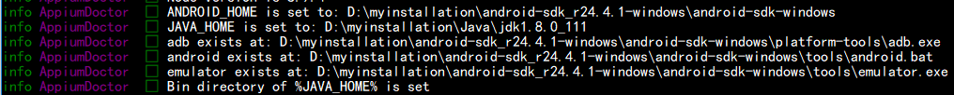

4、npm --registry [http://registry.cnpmjs.org](http://registry.cnpmjs.org/" \t "C:/Users/roseh/Documents/My%20Knowledge/temp/35f87a77-b0bf-4486-9afc-6689b7c8076b/128/_blank) install -g appium(以后不想输入ip的话可以输入以下命令：npm config set registry [http://registry.cnpmjs.org](http://registry.cnpmjs.org/" \t "C:/Users/roseh/Documents/My%20Knowledge/temp/35f87a77-b0bf-4486-9afc-6689b7c8076b/128/_blank)然后就可以直接输入 npm install -g appium 安装了)

5、pip install Appium-Python-Client

6、npm install -g appium-doctor

7、appium-doctor

8、appium -v

npm install appium-uiautomator2-driver