An Explainable AI-Based Decision Support System for Dynamic Water Quality Index Prediction and Recommendation
Abstract
Water quality assessment is an important task because the water conditions are influenced by multiple physical and chemical parameters, making overall assessment difficult when individual parameters are considered individually. This study proposes a data-driven framework for Water Quality Index (WQI) prediction using the water-quality observations from the Northern Ireland Environment Agency (NIEA) river water-quality monitoring dataset that covering multiple stations from 1990 to 2024. The proposed framework involves data preprocessing, quality control, station-year aggregation, and CCME-WQI construction, and comparative evaluation of the machine-learning and deep-learning models, including Random Forest, XGBoost, CatBoost, and TabNet. Explainable Artificial Intelligence, particularly SHAP, is used to understand the contribution of individual water-quality parameters to model predictions. The study further aims to connect prediction and explanation with a recommendation-oriented decision-support system, providing a more interpretable approach to water-quality assessment and management which is used for better decision making.
Keywords
Water Quality Index ,
Water Quality Assessment,
Water Quality Prediction,
Machine Learning,
Deep Learning,
Explainable Artificial Intelligence,
SHAP,
Decision Support System
I. Introduction
Water is very essential for human life and different human activities.The quality of water can change due to some natural n human related activities.Poor n contaminated water can be risk for human Life and also for aquatic animals also.So, we should monitor water for human Life and also for Aquatic animals .We humans should consume water for survival .It is important for us .Water is very important for our survival.It is needed for drinking,agriculture and other water related works.By monitoring the water we can do good management of water resources.
Water Quality is not a factor from which we can decide that water is good or not.we need some samples like physicochemical parameter like pH,BOD,dissolved oxygen,temperature,turbidity,conductivity,nutrients.Total dissolved solids.Each parameter from this gives some aspect of the condition of water.A single parameter cannot tell how is the water quality .Since ,there are many parameters we can’t interpret them .so, for these kind of big number of samples n many lacations of it we need a good approach that can summarize all the water quality measurements in a good way.
The Water Quality index provides a way to covert several water quality parameters into single numerical one.Instead of looking into each parameter individually,WQI tells the indication of quality of water.This helps us in interpreting the water quality information. Different WQI methods generally use different parameters.Therefore, we need a good WQI formulation.
Modern monitoring systems can generate large volumes of water-quality observations. Such datasets contain relationships between different parameters that could be tough to capture using simple approaches. Machine-learning methods can help in understaning relationships between input water-quality parameters and a target variable Previous studies on this have investigated algorithms such as artificial neural networks, support vector machines, random forests, for water-quality prediction. Deep-learning methods are also been used for water-quality prediction. However, model performance depends on the dataset, the parameters we select, their characteristics and the experimental setup.
Many ML and DL models behave like black boxes. In applications, understanding the reasons behind the predictions is very important. Explainable AI methods can help find how input variables contribute in model predictions. SHAP is one approach that can used for quantifying the contribution of individual parameters to predictions. It help in providing both overall understanding and explanations for all individual predictions. In water-quality applications, this can help in identifying which parameters are strongly influencing the predicted water quality one. However, finding influential parameters is more useful when those insights help in supporting practical decisions.
In our study, long-term river water-quality observations are obtained from the Northern Ireland Environment Agency (NIEA) . The dataset covers many monitoring observations from 1990 to 2024 across different river monitoring stations. The study helps in developing a data-driven framework used for WQI prediction using the machine-learning and deep-learning approaches, followed by some explainable analysis and recommendation-oriented decision making.The processed dataset has multiple water-quality parameters collected across many monitoring locations. We propose a framework for WQI prediction using both machine-learning and deep-learning approaches. The models which we select will be evaluated using some consistent regression metrics. Explainable AI will be used to understand influential parameters. These insights will be connected for a structured recommendation layer. The overall goal is not to predict WQI, but to develop a decision-support system that can help in interpreting water-quality information. The study aims to combine water-quality assessment, predictive modelling, explainability and recommendation into a one unified framework for data-driven water-quality decision support.by this we can take good decisions.
II. Related Work / Literature Review
2.1 Traditional Water Quality Index Approaches
Water-quality assessment normally depends on measuring many physical, chemical and biological parameters. Because these parameters helps in representing different characteristics of water, interpreting them all individually can make the overall assessment tough. WQI-based approaches were developed to help in combining information from multiple parameters into a single numerical indicator that represents overall water quality.
Different WQI formulations are proposed over time. These formulations differ in the parameters that are included, reference standards, normalization procedures and other methods. Therefore, the water-quality observations can help producing different index values depending on the selected WQI formulation.
This is important for our research because WQI is not a raw measurement. It is an important indicator whose value depends on the methodology we used to calculate it. The recent 2026 review tells that the structure of WQI can strongly influence machine-learning modelling and that predictive performance can reflect the predefined WQI formulation itself.
Among the established WQI approaches till now, the Canadian Council of Ministers of the Environment Water Quality Index provides a flexible framework on the basis of the scope, frequency, and amplitude of guideline exceedances. In our study, CCME-WQI is used according to available NIEA parameters and monitoring structure.
2.2 Machine Learning for WQI Prediction
Researchers started exploring ahether the machine-learning models could help in learning the relationship between water-quality parameters and WQI.
A recent study by Aldrees et al. evaluated all five machine-learning techniques for WQI estimation and combined the modelling process with the SHAP analysis. The study reported that the predictive models could help in providing estimates of WQI and used SHAP to find important contributors to the predicted index.
Other studies have also explored different machine-learning approaches for water-quality prediction. For example, research on coastal water quality compared CatBoost, XGBoost, Random Forest, Support Vector Regression and Artificial Neural Networks, while also using SHAP for feature interpretation. The study found differences in the predicted performance among the models and the examined spatial and temporal generalization.
What this tells us is that
ML can potentially:
learn nonlinear relationships between water-quality parameters → WQI
But there are limitations:
- performance depends on dataset characteristics
- model performance may differ between different locations
- spatial/temporal generalization is important
- high performance does not mean the model is scientifically useful
- interpretability is also important
2.3 Deep Learning for Water Quality
Deep learning is also been investigated for water-quality prediction because water-quality processes can have complex relationships between multiple environmental parameters.
A 2024 review in Nature Water discusses the growing use of deep learning for water-quality prediction and tells the challenges such as complex water-quality processes and limitations that are associated with data availability.
Another 2024 study tells that it compared LSTM, TCN, ANN and MLP approaches for WQI prediction, showing that researchers are actively using different deep-learning architectures rather than depending only on traditional machine-learning models.
But here's the important research point:
Deep learning is not better because it is advanced.
Performance depends on:
- size of dataset
- the feature characteristics
- temporal structure and spatial structure
- model architecture
- preprocessing and
- hyperparameters
ML vs DL should be experimentally compared under a common evaluation one.
That's one of the questions our study can wants to find.
2.4 Explainable AI and SHAP
Machine-learning models can produce predictions while making it difficult to understand how the individual input parameters influenced those predictions. This becomes kind of important in environmental applications, where predictions are used to support decisions related to water resources.
Recent WQI studies have started integrating explainable AI techniques. Aldrees et al. used SHAP with multiple ML models to find important contributors to WQI predictions.
The 2026 review also found XAI as an important direction for improving transparency and supporting decision-making in WQI modelling. It tells that practical water-quality systems need to balance predictive performance with interpretability.
Our understanding:
Normal ML:
"WQI = 65."
XAI:
"Tells that these parameters contributed strongly to this prediction."
That information is used to make the model more useful for environmental decision support.
2.5 Decision Support — Where We Want to Go
This is where our literature review will become connected to our project.
Existing research demonstrates that ML/DL can be used for water-quality prediction and that XAI can help find influential parameters. However, prediction and explanation do not constitute a complete decision-support system.
Our proposed direction is:
Prediction
↓
Explanation
↓
Identify dominant water-quality parameters
↓
Interpret the water-quality condition
↓
Structured recommendation
The goal is therefore not to produce a WQI value , but to find model predictions and explanations can be combined with a practical decision-support workflow.
A 2025 review similarly points out that many existing AI approaches remain model-centric, with limitations like localized datasets, weak system integration, interpretability and practical deployment of it.
III. Research Gap and Objectives
Gap 1 — Multi-site and heterogeneous monitoring data
Many existing studies focus on a particular river, lake, basin, or localized monitoring network.
Do these models maintain their performance when applied across a broader set of monitoring locations with different environmental conditions?
Our dataset provides an opportunity to use heterogeneous monitoring observations from different NIEA river monitoring stations across Northern Ireland .Existing studies have used machine-learning approaches for water-quality prediction, but many studies are conducted using the data from some specific water bodies or localized monitoring regions. This creates a need to find the model performance using more heterogeneous monitoring data.

Gap 2 — Fair ML vs DL comparison
Different papers use different:
- datasets
- preprocessing methods
- target formulations
- evaluation metrics
- train/test strategies
Therefore, only comparing their reported scores directly isn't fair.
Our study will use one experimental framework and compare:
Random Forest
Vs
Extra Trees
Vs
Gradient Boosting
Vs
XGBoost
Vs
CatBoost
vs
TabNet
Core idea:
Rather than thinking that deep learning will outperform the traditional machine learning, our study will experimentally evaluate both approaches under consistent common conditions.

Gap 3 — XAI → practical interpretation
This is important.
SHAP is not new in our project.
Existing studies already have used SHAP in finding influential water-quality parameters.
Existing studies demonstrate that XAI can find influential parameters, but there is an opportunity to combine these explanations more directly into a structured decision-support workflow.
Our pipeline is:
WQI Prediction
↓
SHAP Explanation
↓
Important Parameters
↓
Water-quality Interpretation
↓
Recommendation

Gap 4 — Integrated decision-support workflow
Many studies stop at:
Prediction
or:
Prediction + Explanation
Our proposed work goes one step further by finding:
Prediction + Explanation + Recommendation
The recommendation layer is to be based on appropriate water-quality standards, not any arbitrary rules.
Based on these gaps, our study proposes an integrated framework for data-driven WQI prediction, comparative evaluation of different machine-learning and deep-learning models, explainable analysis of the model predictions, and recommendation-oriented decision support system using water-quality monitoring data for better decision making
Objective 1 — Dataset preparation
Develop a preprocessing pipeline for water-quality monitoring data, including data cleaning, transformation, parameter selection and preparation of the dataset for WQI modelling.
Objective 2 — WQI prediction
Develop a data-driven framework for predicting the CCME Water Quality Index using selected water-quality parameters ..
Objective 3 — ML vs DL comparison
Evaluate and compare the selected machine-learning and deep-learning models for WQI prediction under a consistent common experimental setup.
Our candidate models:
- Random Forest
- Extra Trees
- Gradient Boosting
- XGBoost
- CatBoost
- TabNet
Objective 4 — Model evaluation
Evaluate the predictive performance of the models using some good regression metrics such as:
- MAE
- MSE
- RMSE
- R²
Objective 5 — Explainability
Apply Explainable AI techniques, like SHAP, for understanding the contribution of water-quality parameters to model predictions and find influential parameters.
Objective 6 — Decision support
Build a recommendation-oriented decision-support system that connects the predicted WQI and identified water-quality parameters with structured water-quality interpretations and recommendations for better decision making.

IV. Proposed Methodology
The proposed study has a data-driven framework for water-quality assessment, WQI prediction, model comparison, explainability, and recommendation-oriented decision support. The methodology consists of the following stages:
Stage 1 — Data Acquisition
Water-quality observations have been obtained from the Northern Ireland Environment Agency (NIEA) river water-quality monitoring dataset covering the period from 1990 to 2024. The dataset has observations from multiple monitoring stations and includes several physical and chemical water-quality parameters.
Stage 2 — Data Understanding
The collected dataset will be examined to understand its structure, sampling locations, parameters, units, data types, temporal coverage, missing values and parameter availability. Exploratory analysis is used to understand the distribution and relationships among the selected variables.
Stage 3 — Data Preprocessing
The raw observations will be cleaned before modelling. This stage includes the duplicate handling, missing-value analysis, parameter and unit standardization, removal or treatment of unsuitable observations, and the transformation of the data into a modelling-ready format. Relevant parameters are selected based on the data availability and their relevance to the selected WQI formulation.
Stage 4 — Quality Control
Quality control is performed to examine the missingness, extreme observations, negative values, duplicate records, and available quality flags. Extreme observations are investigated using original monitoring records rather than being removed because of their statistical magnitude.
Stage 5 — Station-Year Aggregation
The processed observations organized at station-year level to construct an annual representation of water quality. Station-year records are going to be evaluated based on parameter availability and observation frequency. A minimum observation criteria has been applied before WQI construction.
Stage 6 —WQI Construction
The CCME-WQI formulation is been selected for constructing the WQI target. The Five water-quality parameters are—BOD, Ammonia-N, Nitrite-N, Nitrate-N, and pH—are used on their availability and compatibility with the selected framework. The CCME-WQI is calculated using three components which are: F1 (Scope) , F2 (Frequency) , F3 (Amplitude). The index ranges from 0 to 100 and is going to be used as the target variable for further prediction.
Stage 7 — Dataset Preparation
The processed dataset is divided into training, validation and testing subsets. Scaling or normalization will be applied where when required by the selected models. Care is taken to prevent information leakage between the training and testing data.
Stage 8 — Model Development
Both the machine-learning and deep-learning approaches will be investigated. The machine-learning models are Random Forest, XGBoost and CatBoost, while TabNet will be used as the deep-learning approach.
Stage 9 — Model Evaluation
The models will be evaluated using the regression metrics including MAE, MSE, RMSE and R². The results will be compared under a consistent experimental setup rather than just assuming that one model will perform better than other.
Stage 10 — Explainable AI
SHAP will be applied to the selected trained model or models to understand the contribution of individual water-quality parameters for WQI predictions. Both overall feature importance and individual prediction explanations are going to be investigated.
Stage 11 — Water-Quality Interpretation
The predicted WQI values will be interpreted according to classification scheme associated with the selected WQI formulation.
Stage 12 — Recommendation Generation
A structured recommendation layer will be developed using the predicted water-quality condition and influential parameters found through the modelling and explainability stages. The recommendation rules will be based on good water-quality guidance rather than arbitrary thresholds.
Stage 13 — Decision Support
The prediction, explanation and recommendation components will be integrated into a single decision-support workflow. The objective is to provide understandable information about water quality rather than just producing only a numerical prediction.
Stage 14 — Validation and Robustness
The final framework will be for predictive reliability and robustness using good validation procedures. Where appropriate, spatial or temporal robustness will also be going to investigated.
Diagrams:
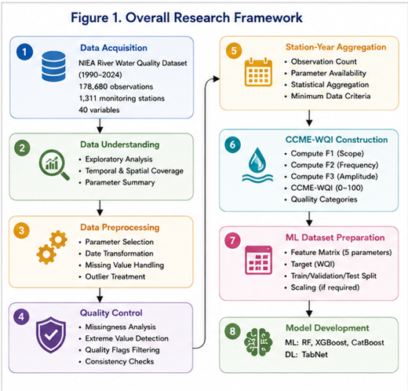
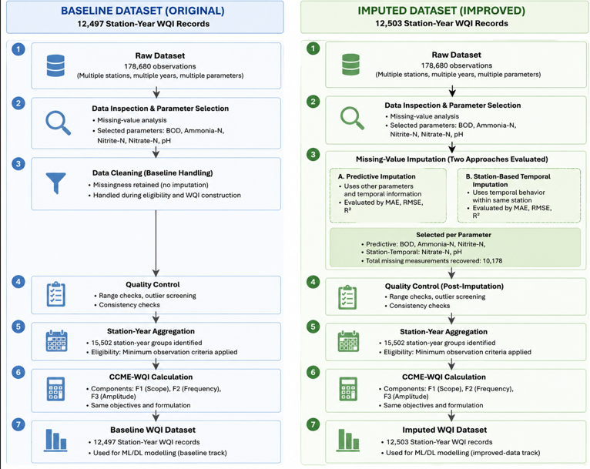
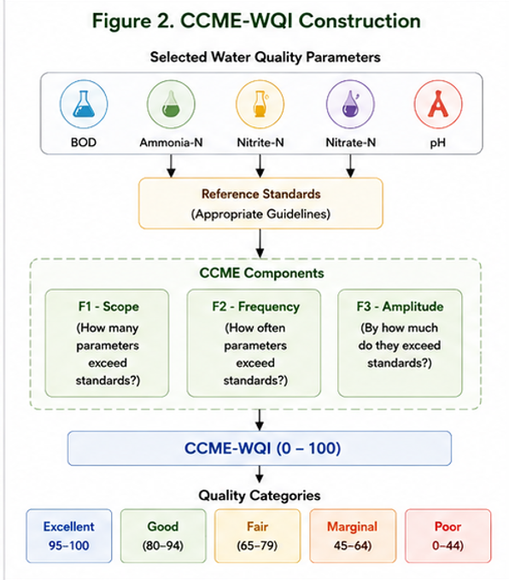
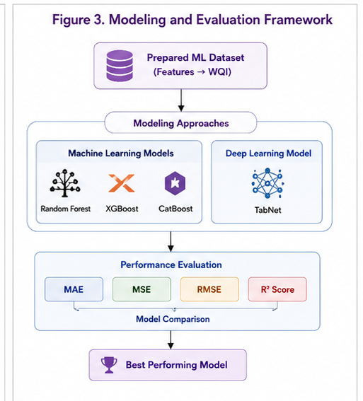

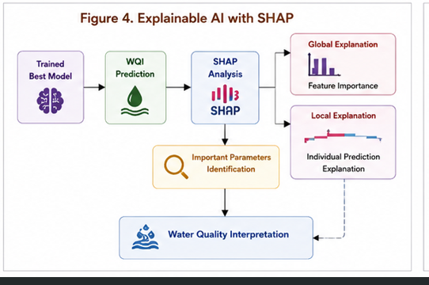
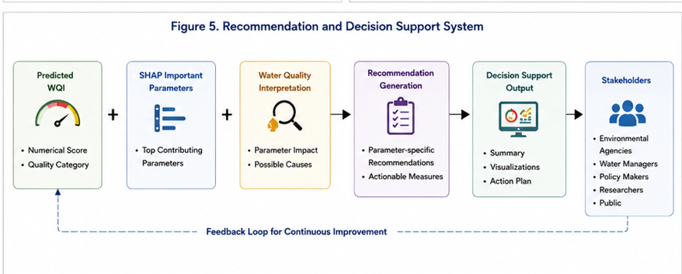
V. Dataset and Preprocessing
5.1 Dataset Description
Our study uses long-term river water-quality monitoring data gained from the Northern Ireland Environment Agency (NIEA). The dataset covers the period from 1990 to 2024 and has observations collected from multiple river monitoring stations across Northern Ireland. The original dataset has 178,680 observations and 40 variables, including station information, geographic information, sampling dates, monitoring conditions, water-quality measurements, associated quality indicators.
The dataset contains observations from the 1,311 monitoring stations, having both spatial and temporal variation in water-quality conditions. The long monitoring period is useful for studying variations in water quality across many stations and years and gives a relatively heterogeneous dataset for subsequent predictive modelling.
The raw dataset has several water-quality parameters, including biochemical oxygen demand , dissolved oxygen , ammonia nitrogen, nitrite nitrogen, nitrate nitrogen, pH, suspended solids, conductivity, dissolved copper, dissolved iron, and soluble zinc. From these measurement values, a smaller set of parameters was selected for the WQI construction on data availability, relevance to water-quality assessment, and compatibility with the selected WQI formulation.
5.2 Data Inspection
An initial inspection was performed for understanding the structure and the quality of the raw observations. The data types, missing values, parameter ranges, station identifiers, and temporal coverage were examined before performing further preprocessing.
The raw dataset has measurements collected over more than three decades. The sampling dates ranges from January 1990 to December 2024, while the monitoring records are distributed across some 1,311 stations.
The inspection also identified some differences in parameter availability. Some parameters has a large proportion of missing observations, whereas others are available for most monitoring records we need. Therefore, parameter selection was done before constructing the WQI target.
5.3 Parameter Selection
For the final WQI construction, five parameters are selected:
Parameter | Description
BOD | Biochemical Oxygen Demand
Ammonia-N | Ammonia Nitrogen
Nitrite-N | Nitrite Nitrogen
Nitrate-N | Nitrate Nitrogen
pH | Acidity or alkalinity indicator
These parameters represent different aspects of the current river-water condition, including organic pollution, nutrient pollution, and acid-base characteristics n others.
Dissolved oxygen has been examined during preprocessing but was not included in the current WQI formulation because the identified r condition for DO was expressed in a different representation than the available NIEA measurement. Directly applying an incompatible one could introduce methodological error in the WQI calculation.
5.4 Data Cleaning and Transformation
The raw observations were processed to obtain a good dataset for WQI construction. Relevant columns are retained while unnecessary fields are removed from the modelling dataset. Date information is converted into usable temporal representation, and the year of observation was extracted for station-year analysis.
After the preprocessing, the core dataset contained 175,615 observations and 13 variables. The selected variables included station identification, location information, basin information, grid reference, date, time, year, and the five candidate WQI parameters with the required monitoring information.
Missing values were have not blindly replaced with the zero, since zero represent a valid measurement for some parameters and can introduce artificial observations. The missing measurements were first analyzed according to their temporal then station-wise , cross-parameter patterns. To recover potentially useful information, two complementary imputation strategies were evaluated further: parameter-based predictive imputation and the station-based temporal imputation. The approaches were validated using the MAE, RMSE, and R² before applied to the final dataset..

5.5 Missing-Value Analysis
Missing-value analysis is performed for the selected parameters before WQI construction.
The processed dataset has the following missing observations:
Parameter | Missing observations | Missing (%)
BOD | 24,351 | 13.87%
DO | 24,578 | 14.00%
Ammonia-N | 948 | 0.54%
Nitrite-N | 11,153 | 6.35%
Nitrate-N | 11,743 | 6.69%
pH | 20,314 | 11.57%
The results show that ammonia nitrogen has highest availability among the selected parameters, whereas BOD and pH has relatively higher levels of missing observations. Rather than discarding the complete monitoring dataset because of missing values in individual parameters, study evaluates parameter availability at the station-year level before the WQI construction.
Accordingly, to the presence of the missing measurements at the individual observation level did not automatically result in the removal of a station-year record. Parameter availability was done after aggregation to determine whether sufficient information was available for th WQI construction.

5.5.1 Missing-Value Imputation
In the missingness analysis, two complementary imputation strategies were investigated for reducing the loss of usable parameter information. The first strategy was parameter-based predictive imputation, in which available water-quality parameters and temporal information are used to estimate the missing measurements. The second strategy was station-based temporal imputation, which utilized temporal behavior of measurements within same monitoring station to estimate missing values further.
The two approaches are evaluated independently using Mean Absolute Error (MAE), Root Mean Square Error (RMSE), and R². The validation results showed the performance of the approaches varied across parameters. Therefore, a parameter-specific strategy considered rather than applying single imputation method uniformly to all variables.
Based on validation experiments, predictive imputation selected for BOD, Ammonia-N, and Nitrite-N, while station-based temporal imputation selected for Nitrate-N and pH. The selected approaches recovered 10,178 missing parameter measurements while retaining original 178,680 observations.
Not all the missing parameter measurements could be recovered. Therefore, only the observations for which imputation could be performed using the selected methods were recovered, while the remaining unavailable measurements were retained as missing and had been handled during the station-year aggregation and WQI construction process according to the parameter availability
Parameter | Selected approach
BOD | Predictive imputation
Ammonia-N | Predictive imputation
Nitrite-N | Predictive imputation
Nitrate-N | Station based temporal imputation
pH | Station based temporal imputation
The imputed dataset subjected to post-imputation validation. The resulting parameter distributions, ranges, and summary statistics are compared with available observations. Negative values are not introduced, no substantial distributional distortion has been observed. This validation used to ensure that the imputation process did not artificially improved or degraded the underlying water-quality characteristics before the WQI construction.
5.6 Quality Control
Quality control was performed before calculating the WQI to find the potentially problematic observations.
The following checks are performed:
- Missing-value analysis
- Negative-value analysis
- Extreme-value detection
- Duplicate-record inspection
- Examination of original quality-flag fields
No negative values were found for selected water-quality parameters during the validation stage.
Extreme observations were also investigated rather than automatically removing. For example, some high BOD, ammonia, nitrite, and nitrate observations were found in the raw monitoring data. Because some high environmental measurement may represent a pollution event, these observations were not removed because they were statistically extreme.
The original NIEA quality flags were examined. These included < and > qualifiers for some of the measurements. Such observations were retained rather than treating the qualifier as evidence that the measurement was wrong.
5.7 Station-Year Aggregation
A total of 15,502 Station-Year groups were being found after the preprocessing.
The Station-Year grouping represents the aggregation of the repeated individual observations and should not be interpreted as deletion of original observations. The original dataset has 178,680 observations; the Station-Year representation is used for the annual WQI construction.
The number of observations within each Station-Year group was then examined further. The median number of observations was 12, while the mean is approximately 11.33 observations per Station-Year. A large proportion of Station-Year groups has approximately 12 observations, indicating relatively regular monitoring for many stations.
For the WQI construction, Station-Year groups with the insufficient monitoring observations were excluded according to minimum observation criterion . Following the missing-value analysis, both the baseline and imputed datasets were retained separately for subsequent WQI construction and for comparative modelling. The baseline processing produced the 12,497 Station-Year WQI records, while imputation-based processing produced 12,503 Station-Year WQI records.
5.8 Final WQI Dataset
Following data preprocessing, quality control, station-year eligibility, and CCME-WQI construction, two WQI datasets were retained for subsequent comparative modelling process. The first was the baseline WQI dataset, constructed using original missing-value handling procedure, which resulted in 12,497 Station-Year records. The second was improved WQI dataset, constructed after validated missing-value imputation procedure, which resulted in 12,503 Station-Year records.
The two datasets originate from same 178,680 individual observations. The difference in number of WQI records does not represent deletion of the original observations; rather, it results from Station-Year aggregation and availability of parameter measurements required for WQI construction. The baseline and imputed datasets are retained separately to investigate whether the validated missing-value recovery has effect on WQI prediction performance.
Dataset | Raw observations | Station-Year WQI records | Purpose
Baseline WQI | 178,680 | 12,497 | Baseline modelling
Imputed WQI | 178,680 | 12,503 | Improved-data modelling
Both datasets are subsequently passed through same machine-learning and deep-learning experimental framework, allowing the predictive performance obtained with baseline data to be compared with obtained after missing-value recovery.
VI. WQI Methodology
6.1 Selection of WQI Formulation
A Water Quality Index gives a numerical representation of overall water-quality condition by combining measurements from multiple parameters according to a one defined methodology.
Because different WQI formulations use different parameters, reference objectives, normalization methods, and aggregation procedures, the selection of the WQI formulation is very important part of the study.
For our research, the Canadian Council of Ministers of the Environment Water Quality Index (CCME-WQI) was selected because its structure can accommodate with multiple water-quality parameters and repeated monitoring observations. The formulation evaluates the water quality using three components: Scope (F1), Frequency (F2), Amplitude (F3).
6.2 Selected Parameters
Five parameters were used to further construct the WQI:
BOD
Ammonia-N
Nitrite-N
Nitrate-N
pH
These parameters were selected based on availability in the NIEA dataset and their relevance to the assessment of organic pollution, nutrient contamination, and general chemical condition.
The selected parameters are evaluated against predefined water-quality objectives used by study. The objective for each parameter tells whether an individual observation is considered to have failed the required condition.
6.3 CCME-WQI Components
The CCME-WQI uses three main factors.
F1 — Scope
F1 represents the proportion of selected parameters that fail the water-quality objectives at least once during the assessment period.
It can be expressed as:
A higher F1 indicates that a larger proportion of the assessed parameters have exceeded their respective objectives.
F2 — Frequency
F2 represents how frequently individual measurements fail the objectives.
This component considers repeated nature of the monitoring observations. Therefore, a parameter that exceeds its objective repeatedly will contributes more strongly to the frequency component.
F3 — Amplitude
F3 represents the magnitude by which failed observations exceed their corresponding objectives.
For each failed observation, excursion is calculated. For an upper-limit objective:
The normalized sum of excursions is then used to get F3.
In the implemented calculation, the normalized excursion component is used further to ensure that the final WQI remains within the standard 0–100 scale.
The same CCME-WQI formulation and water-quality objectives applied consistently to both the baseline and imputed datasets to ensure that the differences in subsequent modelling results could be attributed to preprocessing strategy rather than some changes in the WQI formulation.
6.4 CCME-WQI Calculation
The three factors are combined using the CCME-WQI formulation:
The resulting value ranges from 0 to 100, where higher values indicates some better water-quality conditions.
The CCME-WQI calculation is been independently performed for both baseline and imputed datasets using same formulation and classification thresholds. The baseline dataset has produced 12,497 Station-Year WQI records, while the imputed dataset produced 12,503 Station-Year WQI records.No calculated WQI value was below 0 or above 100 during validation process.
For baseline dataset, the WQI values ranged from 7.07 - 100, with mean of 49.43 and median of 46.66. For imputed dataset, the WQI values ranged from 7.52 - 100, with mean of 49.36 and median of 46.58. No calculated WQI value was below 0 or above 100 in either of the datasets.
6.5 WQI Classification
The calculated WQI values are converted into some qualitative categories to make the numerical results easier to interpret.
CCME-WQI | Category
95–100 | Excellent
80–94 | Good
65–79 | Fair
45–64 | Marginal
0–44 | Poor
The resulting distribution in the current dataset is:
Category | Baseline | Imputed
Poor | 5,691 | 5,723
Marginal | 5,044 | 5,021
Fair | 1,189 | 1,190
Good | 554 | 550
Excellent | 19 | 19
Total | 12,497 | 12,503
The WQI category distributions of baseline and imputed datasets remained broadly similar. In both datasets,we have Poor and Marginal categories represented the largest proportion of Station-Year records, while the Excellent category remained relatively kind of rare. The similarity between two distributions indicates the imputation process did not substantially alter the overall WQI classification pattern. The two datasets are retained for comparative WQI prediction experiments to find whether missing-value recovery affects the model performance.
6.6 WQI as the ML Target
The calculated CCME_WQI is used as continuous regression target for the subsequent predictive models.
The input features will consists of selected water-quality measurements, while the WQI category will not be used as input feature because the category is derived directly from WQI value.
The modelling relationship can be represented as:
BOD
Ammonia-N
Nitrite-N
Nitrate-N
pH
↓
Machine Learning / TabNet
↓
Predicted CCME-WQI
This helps in preventing direct target leakage and allows the models to learn the relationship between the underlying water-quality parameters and constructed WQI.
The same feature-target relationship and modelling procedure will be applied independently to baseline and imputed WQI datasets further. This enables controlled comparison of model performance before and after the missing-value recovery.
VII. ML and DL Models
A. Problem Formulation
The Water Quality Index prediction task was then formulated as a supervised machine learning regression problem. The objective was to predict the continuous CCME Water Quality Index (CCME-WQI) value from the selected water quality parameters.
The input features used for the model development were:
- Biochemical Oxygen Demand (BOD)
- Dissolved Oxygen (DO)
- Ammonia Nitrogen (Ammonia-N)
- Nitrite Nitrogen (Nitrite-N)
- Nitrate Nitrogen (Nitrate-N)
- pH
It should be known that Dissolved Oxygen was not used in the calculation of the CCME-WQI target. The CCME-WQI in this study was constructed using the five selected parameters: BOD, Ammonia-N, Nitrite-N, Nitrate-N, and pH. However, DO was included as one additional predictor during machine learning model development because it is an important water quality parameter and may provide some supplementary information for predicting the overall water quality condition. Thus, DO was used as input feature for WQI prediction but was not used in calculating WQI target.
The target variable was calculated CCME-WQI.
Two datasets were used then for model development and comparison:
- Baseline dataset has: 12,497 station-year records.
- Imputed dataset has: 12,503 station-year records.
The objective was to compare predictive performance of the multiple machine learning algorithms on both the datasets.

B. Machine Learning Dataset Preparation
Before model training, both datasets were then examined for missing values and duplicate records. No missing values were found in the final machine learning datasets. Duplicate StationCode-Year combinations were also then checked, and no duplicate records were then identified.
The final baseline dataset contained 12,497 records, while the imputed one contained 12,503 records. Each record represented a station-year observation and contained the six predictor variables, the CCME-WQI target value, and the corresponding water quality category one.
The machine learning prediction task used the six selected water quality parameters as input variables. StationCode, Year, and Category were not used as the predictive input features.

C. Exploratory Analysis for Machine Learning
An initial exploratory analysis was then performed to understand the characteristics of the target variable and its relationship with predictor variables.
For the baseline dataset, the mean CCME-WQI was 49.43, with standard deviation of 15.02. The minimum and maximum WQI values were approximately 7.07 and 100.
For the imputed dataset, the mean CCME-WQI was 49.36, with standard deviation of 15.02. The minimum and maximum values were approximately 7.52 and 100.
Correlation analysis showed that the Nitrate-N and Nitrite-N had the strongest negative relationships with CCME-WQI, while Dissolved Oxygen showed positive relationship.
The baseline dataset correlations with the CCME-WQI were:
Feature | Correlation with CCME-WQI
Nitrate-N | -0.6997
Nitrite-N | -0.6682
Ammonia-N | -0.3407
pH | -0.2953
BOD | -0.2930
DO | 0.2895
The imputed dataset showed that nearly identical relationships between the predictor variables and the target variable.

D. Train-Test Data Splitting
Both datasets were divided into some training and testing subsets using an 80:20 ratio. A fixed random state of 42 was used to ensure the reproducibility of the experiments.
For the baseline dataset we have:
- Training samples: 9,997
- Testing samples: 2,500
For the imputed dataset we have:
- Training samples: 10,002
- Testing samples: 2,501
The same data splitting strategy was then applied to all machine learning models to ensure a fair comparison.

VIII. Machine Learning Models
Five machine learning regression algorithms were then implemented and evaluated.
A. Random Forest Regressor
Random Forest is an ensemble learning algorithm that constructs multiple decision trees and then combines their predictions. It can capture the nonlinear relationships between water quality parameters and the Water Quality Index.

B. Extra Trees Regressor
Extra Trees is also ensemble tree-based algorithm. It introduces the additional randomness during tree construction, which can improve generalization and reduce dependence on individual decision trees.

C. Gradient Boosting Regressor
Gradient Boosting develops an ensemble sequentially, where the new models attempt to reduce the prediction errors produced by previous models. This approach can be effective modeling complex relationships between input parameters and CCME-WQI.

D. XGBoost Regressor
XGBoost is a gradient boosting algorithm designed for efficient and the accurate predictive modelling. It uses the sequential decision trees and optimization techniques to minimize prediction errors.

E. CatBoost Regressor
CatBoost is a gradient boosting algorithm that uses an efficient boosting strategy and can help model nonlinear relationships between predictor variables and the target variable. It was included to compare its performance with the other tree-based ensemble models.
IX. Model Evaluation Metrics
The performance of all the models was evaluated using three regression metrics:
Mean Absolute Error (MAE)
MAE measures the average absolute difference between actual and predicted WQI values.
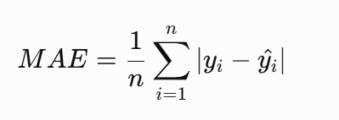
Lower MAE values shows better prediction accuracy.

Root Mean Square Error (RMSE)
RMSE measures the square root of the average squared prediction error.
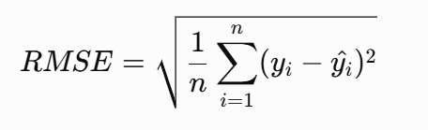
Lower RMSE values shows better performance.

Coefficient of Determination (R²)
R² measures the proportion of variation in the target variable explained by the model.
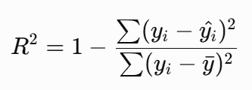
Higher R² values shows better predictive performance.

X. Experimental Results and Model Comparison
The performance of the five machine learning models on the baseline and the imputed datasets is presented below.
Model | Baseline MAE | Baseline RMSE | Baseline R² | Imputed MAE | Imputed RMSE | Imputed R²
Random Forest | 3.0245 | 4.1346 | 0.9231 | 3.0870 | 4.2095 | 0.9204
Extra Trees | 3.0872 | 4.1626 | 0.9221 | 3.1329 | 4.1942 | 0.9210
Gradient Boosting | 3.0791 | 4.1093 | 0.9240 | 3.1068 | 4.1384 | 0.9231
XGBoost | 2.9187 | 4.0063 | 0.9278 | 2.9579 | 4.0368 | 0.9268
CatBoost | 2.9632 | 3.9849 | 0.9286 | 2.9799 | 4.0024 | 0.9280
XI. Discussion of Results
The results show that all the five machine learning models achieved strong predictive performance, with R² values greater than 0.92 on both datasets.
Among the evaluated models, CatBoost has achieved the highest R² score and the lowest RMSE for both the baseline and imputed datasets. For the baseline dataset, CatBoost has achieved an R² score of 0.9286 and an RMSE of 3.9849. For the imputed dataset, it has achieved an R² score of 0.9280 and an RMSE of 4.0024.
XGBoost has achieved the lowest MAE for both datasets. The MAE values were 2.9187 for the baseline dataset and 2.9579 for the imputed dataset.
Overall, CatBoost demonstrated the strongest performance when considering the RMSE and R², whereas XGBoost produced the lowest average absolute prediction error.
The baseline and imputed datasets has produced highly comparable results across all five machine learning models. The imputed dataset has increased the number of available station-year records from 12,497 to 12,503 while maintaining similar predictive performance.
XII. Actual versus Predicted WQI Analysis
To examine the predictive performance of the selected machine learning models, the relationship between the actual and predicted CCME-WQI values was visualized using the scatter plots. The ideal predictions lie along the diagonal reference line, where the predicted WQI value is equal to the actual WQI value.
A. Baseline Dataset Prediction Analysis
Figure X. Actual versus Predicted CCME-WQI for the Baseline Dataset using CatBoost
The Actual versus Predicted plot for the baseline dataset shows strong agreement between the predicted and actual CCME-WQI values. Most observations are then concentrated close to the diagonal reference line, indicating that the CatBoost model was able to accurately estimate water quality values across a wide range of WQI conditions.
Some deviations from the reference line can be observed, particularly at the extreme WQI values. However, the overall distribution of predictions remains aligned with the actual values. This observation is consistent with the strong performance obtained by the CatBoost, which achieved RMSE of 3.9849 and an R² score of 0.9286 on the baseline dataset.

B. Imputed Dataset Prediction Analysis
Figure Y. Actual versus Predicted CCME-WQI for the Imputed Dataset using CatBoost
The Actual versus Predicted plot for imputed dataset also demonstrates strong relationship between the predicted and actual CCME-WQI values. The majority of predictions are located near diagonal reference line, indicating the model maintained high prediction accuracy after the inclusion of imputed observations.
Although small prediction deviations are then visible for certain observations, the overall prediction pattern remains similar to that of the baseline dataset. This confirms that the imputation process did not affect the predictiveness of the machine learning model. The CatBoost model has achieved an RMSE of 4.0024 and an R² score of 0.9280 on the imputed dataset.

XIII. Comparative Interpretation of Prediction Plots
Comparison of the baseline and imputed prediction plots shows that the both datasets produced similar prediction patterns. In both cases, the predicted WQI values were then concentrated around the ideal prediction line, demonstrating strong agreement between the actual and predicted water quality conditions.
The baseline dataset showed slight better performance than the imputed dataset, as reflected by its marginally lower RMSE and higher R² score. However, the differences were small, indicating that imputed dataset retained most of the predictive information present in the original dataset.
These results further support the conclusion that the developed machine learning models are capable of predicting CCME-WQI with high accuracy using selected water quality parameters.
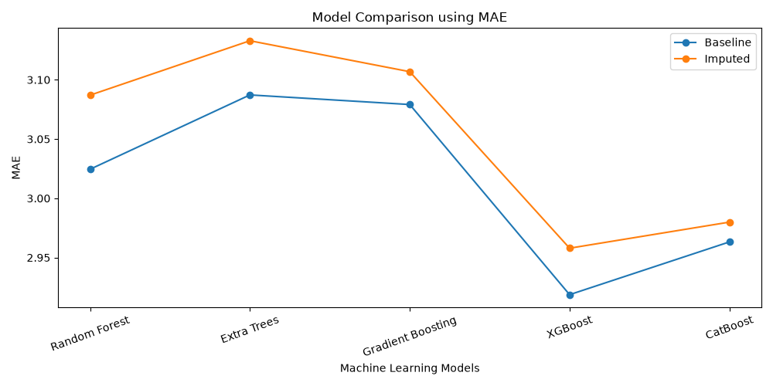
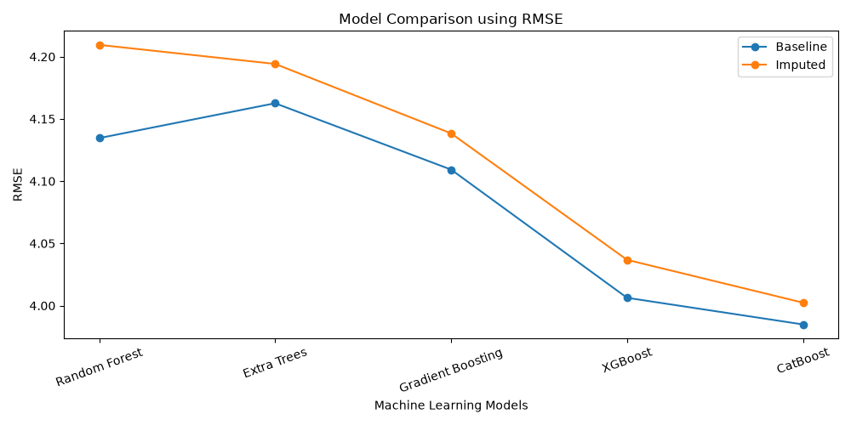
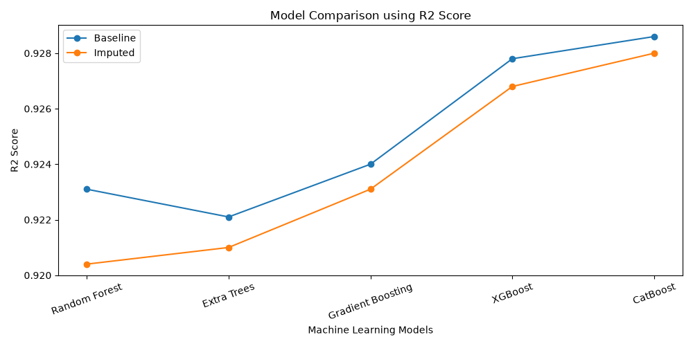
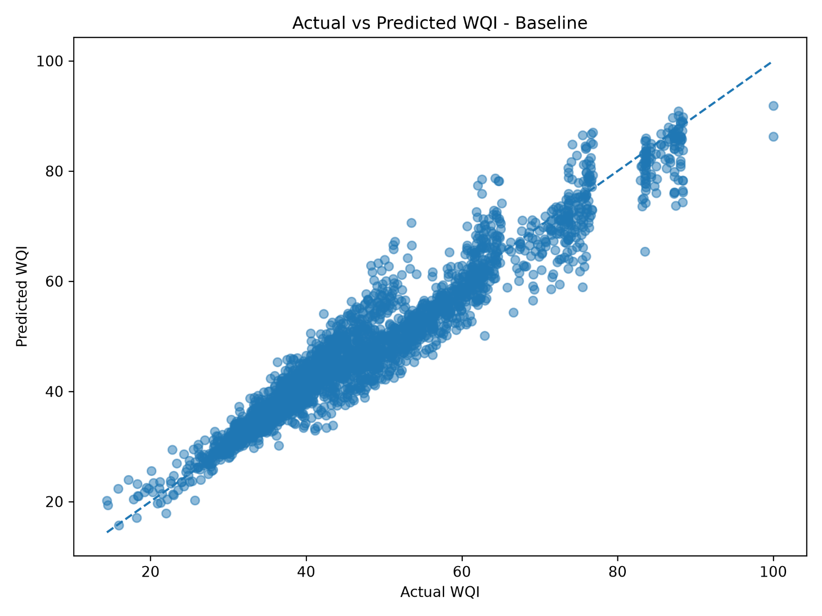

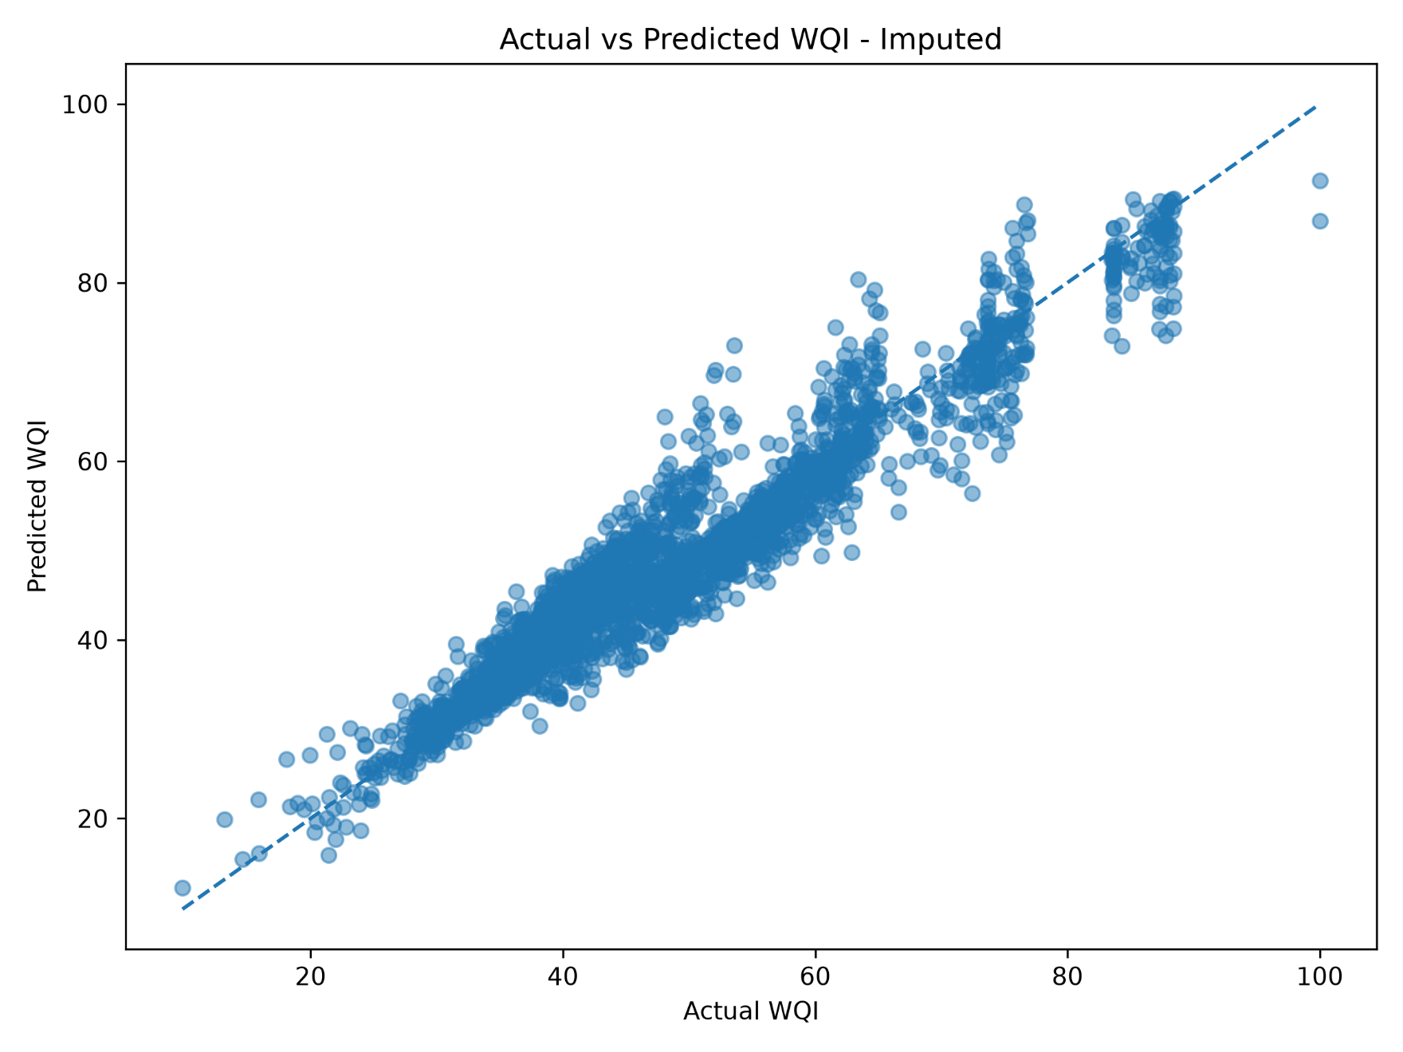
XV. Deep Learning Models
To investigate deep learning models can effectively learn the nonlinear relationship between the physicochemical water-quality parameters and the CCME Water Quality Index (CCME-WQI), two different deep learning approaches were implemented: a Deep Neural Network and TabNet. Both models were trained separately using the baseline and imputed datasets we have.
The input features consisted of six water-quality parameters which are Biochemical Oxygen Demand , Dissolved Oxygen , Ammonia-N, Nitrite-N, Nitrate-N, and pH. The target variable was calculated CCME-WQI. The data divided into training and testing subsets using an 80:20 split with a fixed random state of 42 to maintain the consistency across all experiments.
A. Deep Neural Network
The DNN model was designed as fully connected feed-forward neural network. Before training, the input features were standardized to reduce the effect of differences in the measurement scales among the water-quality parameters. The network consisted of multiple dense layers with nonlinear activation functions, enabling it to learn some complex relationships between the input parameters and the WQI target.
The model was trained using a regression loss function and optimized through backpropagation method. The same experimental procedure was applied to both the baseline and imputed datasets. Model performance was then evaluated using Mean Absolute Error (MAE), Root Mean Squared Error (RMSE), and the coefficient of determination (R²).
For the baseline dataset, the DNN model obtained an MAE of 3.3088, an RMSE of 4.4594, and an R² score of 0.9105. For the imputed dataset, the model achieved an MAE of 3.4729, an RMSE of 4.5312, and an R² score of 0.9078. These results indicate that the DNN was able to learn the general relationship between the water-quality parameters and CCME-WQI. However, its performance was lower than the best-performing tree-based machine-learning model.
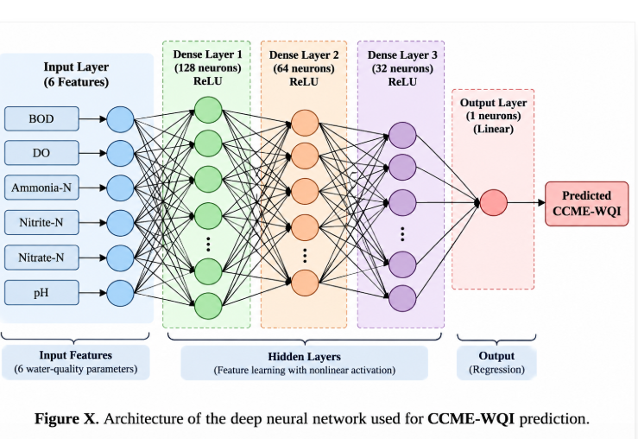
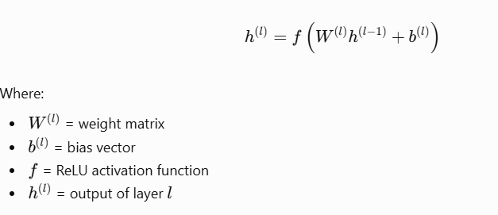
B. TabNet
TabNet was also implemented to examine the performance of an attention-based deep learning architecture for tabular water-quality data. Unlike a conventional fully connected neural network, TabNet used sequential attention mechanisms to select and process relevant features at different decision steps. This mechanism can help the model focus on the most informative input parameters while learning nonlinear feature interactions.
The TabNet model was trained separately on the baseline and imputed datasets. The input variables and target variable were kept consistent with the other experiments, and the same 80:20 train-test split and evaluation metrics were used.
For the baseline dataset, TabNet produced an MAE of 4.8551, an RMSE of 6.3383, and an R² score of 0.8193. For the imputed dataset, it achieved an MAE of 4.6399, an RMSE of 6.0572, and an R² score of 0.8352.
The results show that TabNet captured useful patterns in the data but did not outperform the ensemble-based machine-learning models. This may be related to the dataset size, the limited number of input features, the feature characteristics, and the model-training requirements of attention-based deep learning architectures. Therefore, the results demonstrate that a more complex architecture does not automatically provide better predictive performance for every tabular environmental dataset.
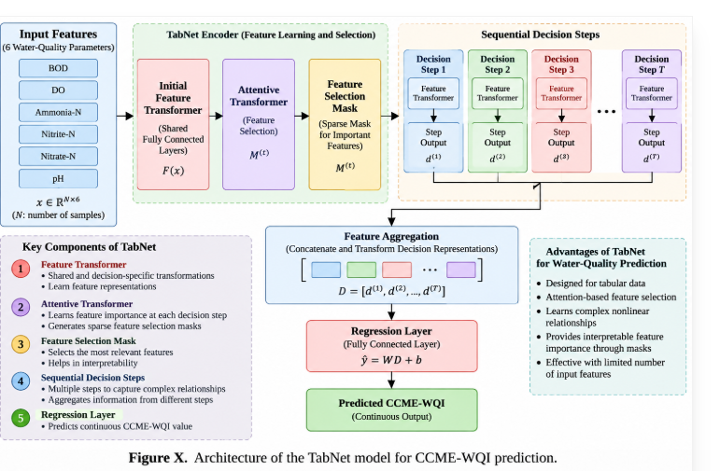

C. Comparison of Machine Learning and Deep Learning
The machine-learning and deep-learning models were compared using MAE, RMSE, and R². Among the evaluated models, CatBoost achieved the best overall performance in terms of RMSE and R² on the baseline dataset, with an RMSE of 3.9849 and an R² score of 0.9286. XGBoost achieved the lowest MAE, with a value of 2.9187.
The DNN and TabNet models showed comparatively lower performance than the strongest tree-based models. This indicates that the relationship between the selected water-quality parameters and CCME-WQI could be effectively captured by ensemble decision-tree methods without requiring a deeper neural architecture.
Based on the overall comparison, CatBoost was selected as the prediction model for the explainability and decision-support stages of the proposed framework. The selection was based on predictive performance rather than model complexity alone.
Dataset | Model | MAE ↓ | RMSE ↓ | R² ↑
Baseline | Random Forest | 3.0245 | 4.1346 | 0.9231
Baseline | Extra Trees | 3.0872 | 4.1626 | 0.9221
Baseline | Gradient Boosting | 3.0791 | 4.1093 | 0.9240
Baseline | XGBoost | 2.9187 | 4.0063 | 0.9278
Baseline | CatBoost | 2.9632 | 3.9849 | 0.9286
Imputed | Random Forest | 3.0870 | 4.2095 | 0.9204
Imputed | Extra Trees | 3.1329 | 4.1942 | 0.9210
Imputed | Gradient Boosting | 3.1068 | 4.1384 | 0.9231
Imputed | XGBoost | 2.9579 | 4.0368 | 0.9268
Imputed | CatBoost | 2.9799 | 4.0024 | 0.9280
Baseline | DNN | 3.3088 | 4.4594 | 0.9105
Imputed | DNN | 3.4729 | 4.5312 | 0.9078
Baseline | TabNet | 4.8551 | 6.3383 | 0.8193
Imputed | TabNet | 4.6399 | 6.0572 | 0.8352

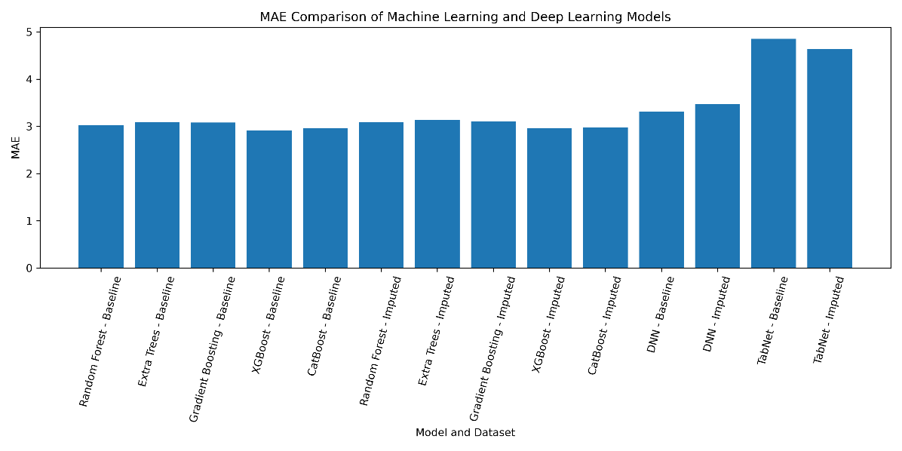
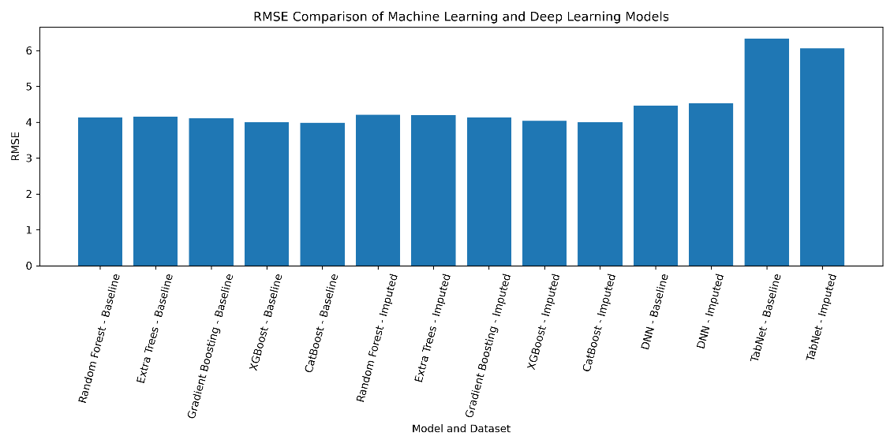
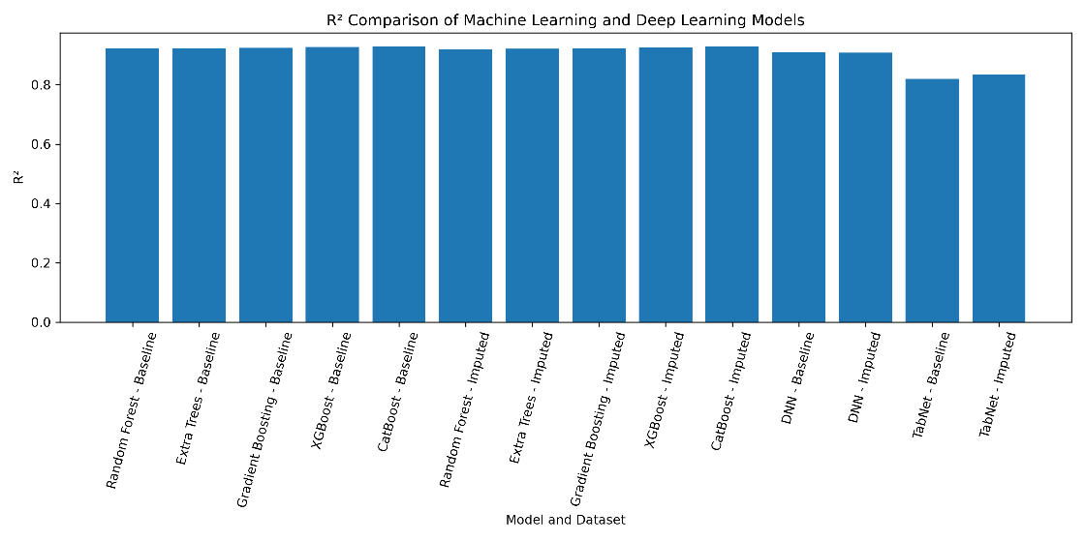
XVI .Explainable Artificial Intelligence
A. Motivation for Explainability
Although machine-learning models can provide accurate predictions, their internal decision-making process may be difficult to interpret. This limitation is particularly important in environmental applications, where model outputs may support water-quality monitoring, pollution assessment, and resource-management decisions. A predicted WQI value alone does not explain which water-quality parameters contributed to the prediction or why the predicted value increased or decreased.
To address this limitation, Explainable Artificial Intelligence (XAI) was incorporated into the proposed framework. SHapley Additive exPlanations (SHAP) was used to interpret the predictions of the selected CatBoost model. SHAP provides a contribution value for each input feature, indicating how that feature influenced an individual prediction relative to the model’s expected output.
B. SHAP-Based Explanation Method
The CatBoost model was retrained using a fixed experimental configuration and evaluated on the baseline and imputed datasets. SHAP values were then calculated for the model predictions. Two types of explanations were generated:
- Global explanations, which identify the overall importance of the input parameters across the dataset.
- Local explanations, which describe how individual parameters influenced specific low-WQI and high-WQI predictions.
For a particular observation, a positive SHAP value indicates that the feature pushed the prediction towards a higher WQI value, while a negative SHAP value indicates that the feature pushed the prediction towards a lower WQI value. The magnitude of the SHAP value represents the strength of the feature’s contribution to that prediction.
SHAP values were interpreted as model-attribution information. They were not treated as proof of direct environmental causation. Consequently, the recommendation layer uses SHAP results together with actual parameter values, guideline thresholds, and WQI categories.
Table 1. SHAP contributions for the baseline dataset
Feature | Lowest-WQI SHAP | Highest-WQI SHAP
Ammonia-N | -19.0163 | +14.4624
BOD | -8.9344 | +4.0929
Nitrite-N | -4.2747 | +2.3862
Nitrate-N | -1.0486 | +16.0228
DO | -0.7684 | +0.7352
pH | -0.0362 | +5.4149
Table 2 SHAP contributions for the imputed dataset
Feature | Lowest-WQI SHAP | Highest-WQI SHAP
Ammonia-N | -17.9493 | +14.4326
BOD | -8.1595 | +3.9318
Nitrite-N | -5.7835 | +2.2462
Nitrate-N | -4.1204 | +15.9240
DO | -1.0480 | +0.6908
pH | -0.6817 | +4.7108

C. Global Feature Importance
The global SHAP analysis showed a consistent feature-importance pattern across the baseline and imputed datasets. The overall ranking was:
Nitrate-N > Ammonia-N > BOD > Nitrite-N > pH > DO
Nitrate-N had the highest average absolute SHAP contribution, followed by Ammonia-N and BOD. This indicates that nitrogen-related parameters and organic pollution indicators played a major role in the CatBoost model’s WQI predictions. Nitrite-N and pH had moderate contributions, while DO showed the lowest average predictive contribution among the six input features.
The consistency of this ranking across both datasets suggests that the model relied on similar feature patterns despite the difference in missing-value treatment. However, lower SHAP importance for DO should not be interpreted as evidence that dissolved oxygen is environmentally unimportant. It only indicates that DO contributed less to the predictive behaviour of the trained model within the examined dataset and feature configuration.
D. Local SHAP Analysis
Local SHAP explanations were generated for selected observations with very low and very high WQI values. The purpose was to understand the specific parameters responsible for individual predictions.
For the lowest-WQI baseline observation, Ammonia-N produced the strongest negative contribution, followed by BOD and Nitrite-N. The high Ammonia-N concentration substantially reduced the predicted WQI, while the elevated BOD value provided an additional negative contribution. Similar behaviour was observed in the imputed dataset, where high Ammonia-N and BOD were among the dominant negative contributors.
For the highest-WQI observations, low Nitrate-N and low Ammonia-N produced strong positive contributions. Suitable pH, low BOD, and low Nitrite-N also supported higher predicted WQI values. These local explanations demonstrate how the model combines multiple water-quality parameters rather than relying on only one measurement.
Table 1. Local SHAP explanation results
Dataset | Case | Actual CCME-WQI | Predicted CCME-WQI
Baseline | Lowest-WQI observation | 15.93 | 15.51
Baseline | Highest-WQI observation | 100.00 | 92.70
Imputed | Lowest-WQI observation | 9.84 | 11.74
Imputed | Highest-WQI observation | 100.00 | 91.42

E. Environmental Interpretation
The SHAP results provide useful evidence for connecting model predictions with possible water-quality pressures. High BOD may indicate a possible influence of organic matter or wastewater-related pollution. Elevated Ammonia-N and Nitrite-N may indicate possible sewage, organic-waste, or nitrogen-cycle-related pressure. High Nitrate-N may be associated with possible nutrient inputs from agricultural runoff or wastewater sources. Abnormal pH may indicate possible chemical or industrial influence.
These interpretations are expressed as possible or likely pressures rather than confirmed causes. Confirmation would require additional information, such as land-use data, discharge records, hydrological conditions, laboratory analysis, and field investigation.
Overall, the SHAP analysis improved the transparency of the prediction system by identifying influential parameters and explaining individual model outputs. These explanations form the basis for the subsequent recommendation layer, where model contributions are combined with guideline exceedances and WQI categories to generate structured monitoring and management suggestions.
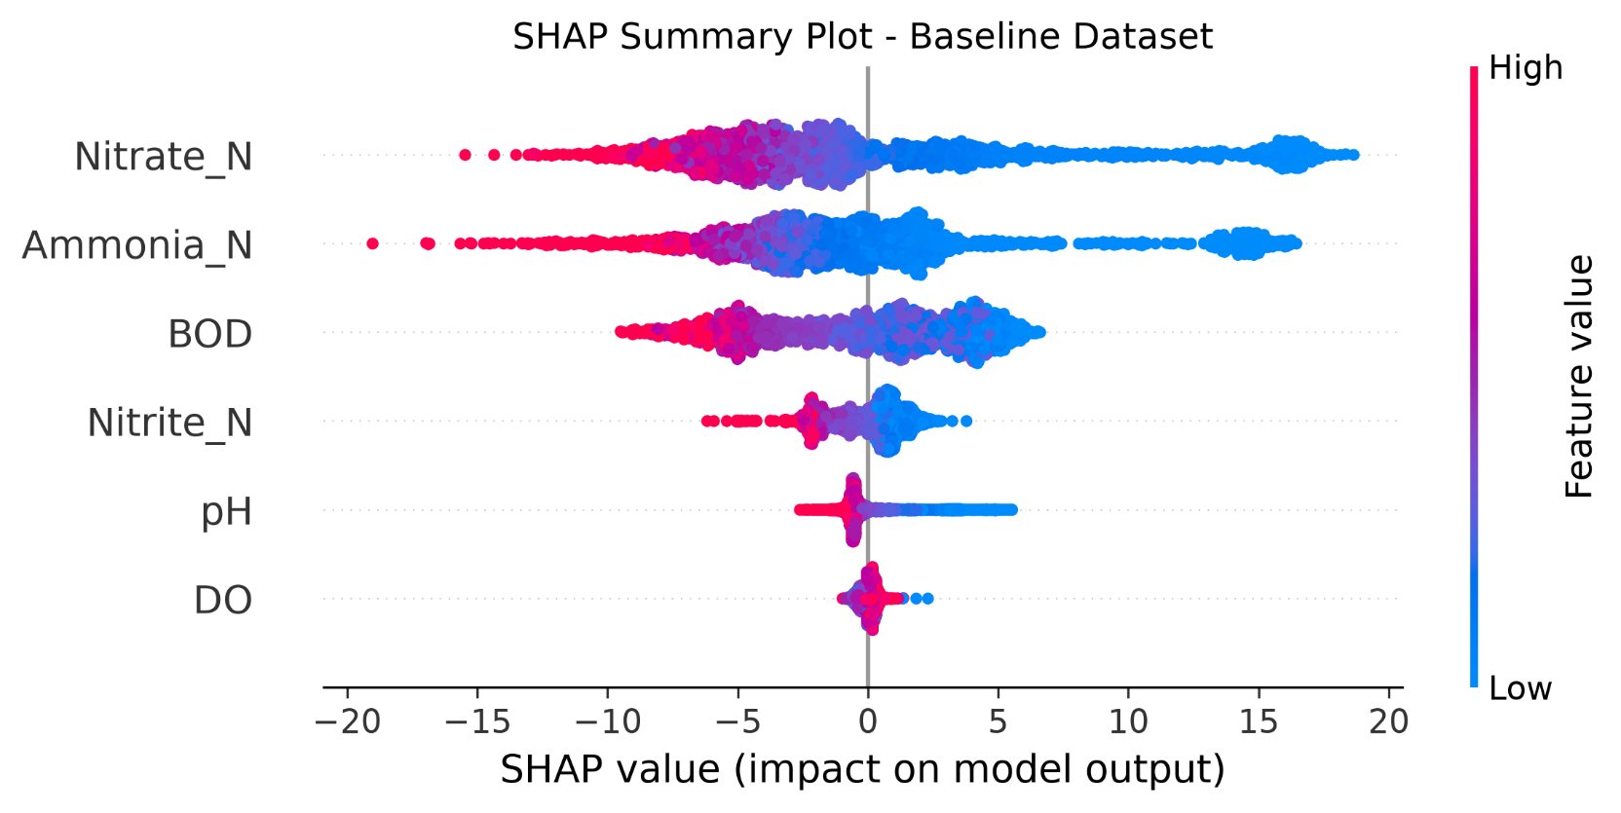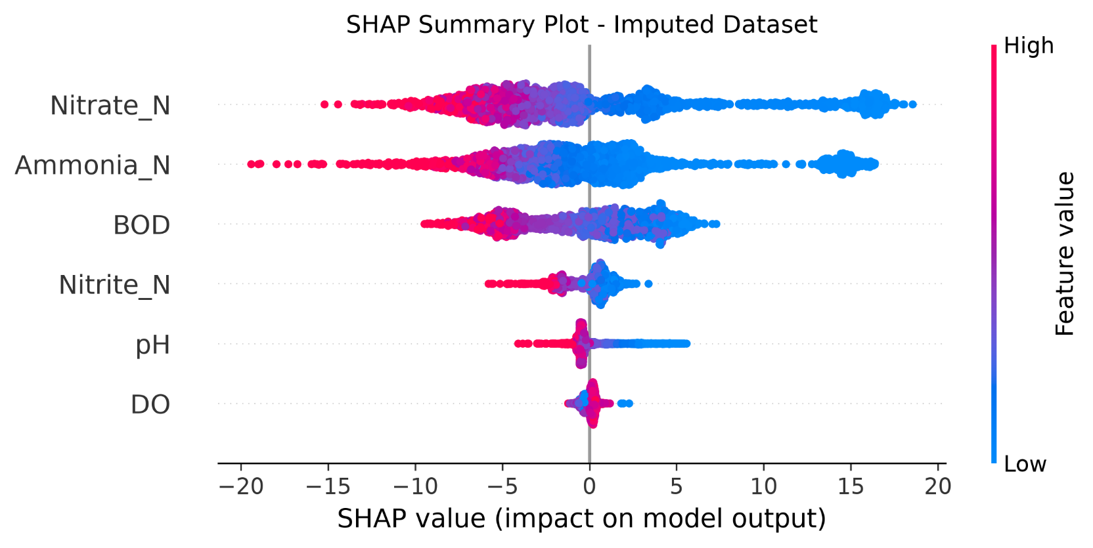
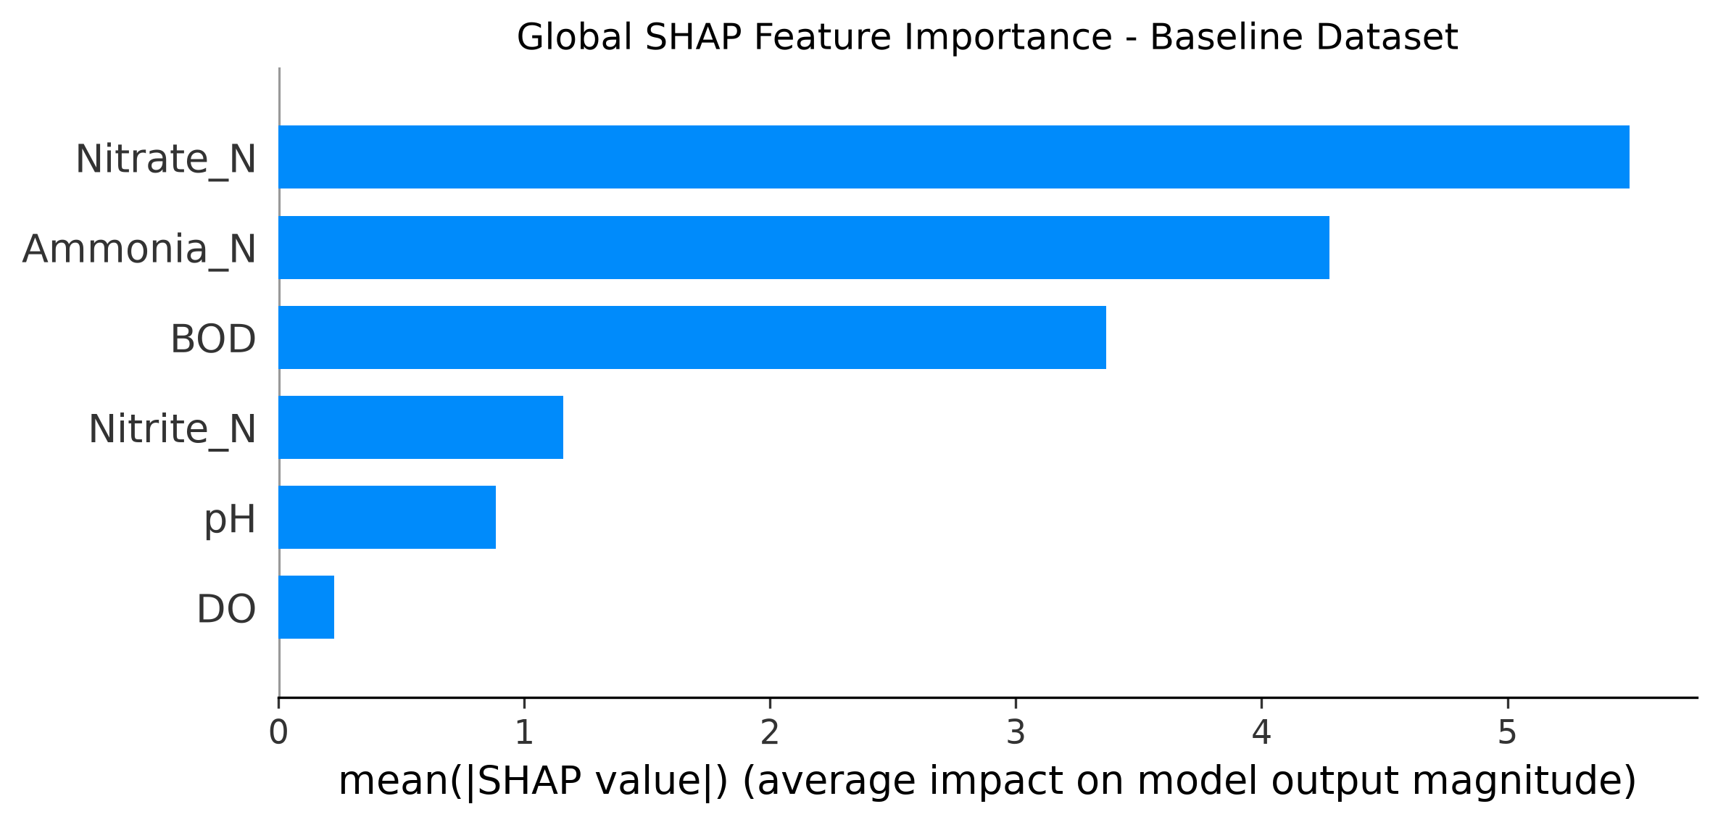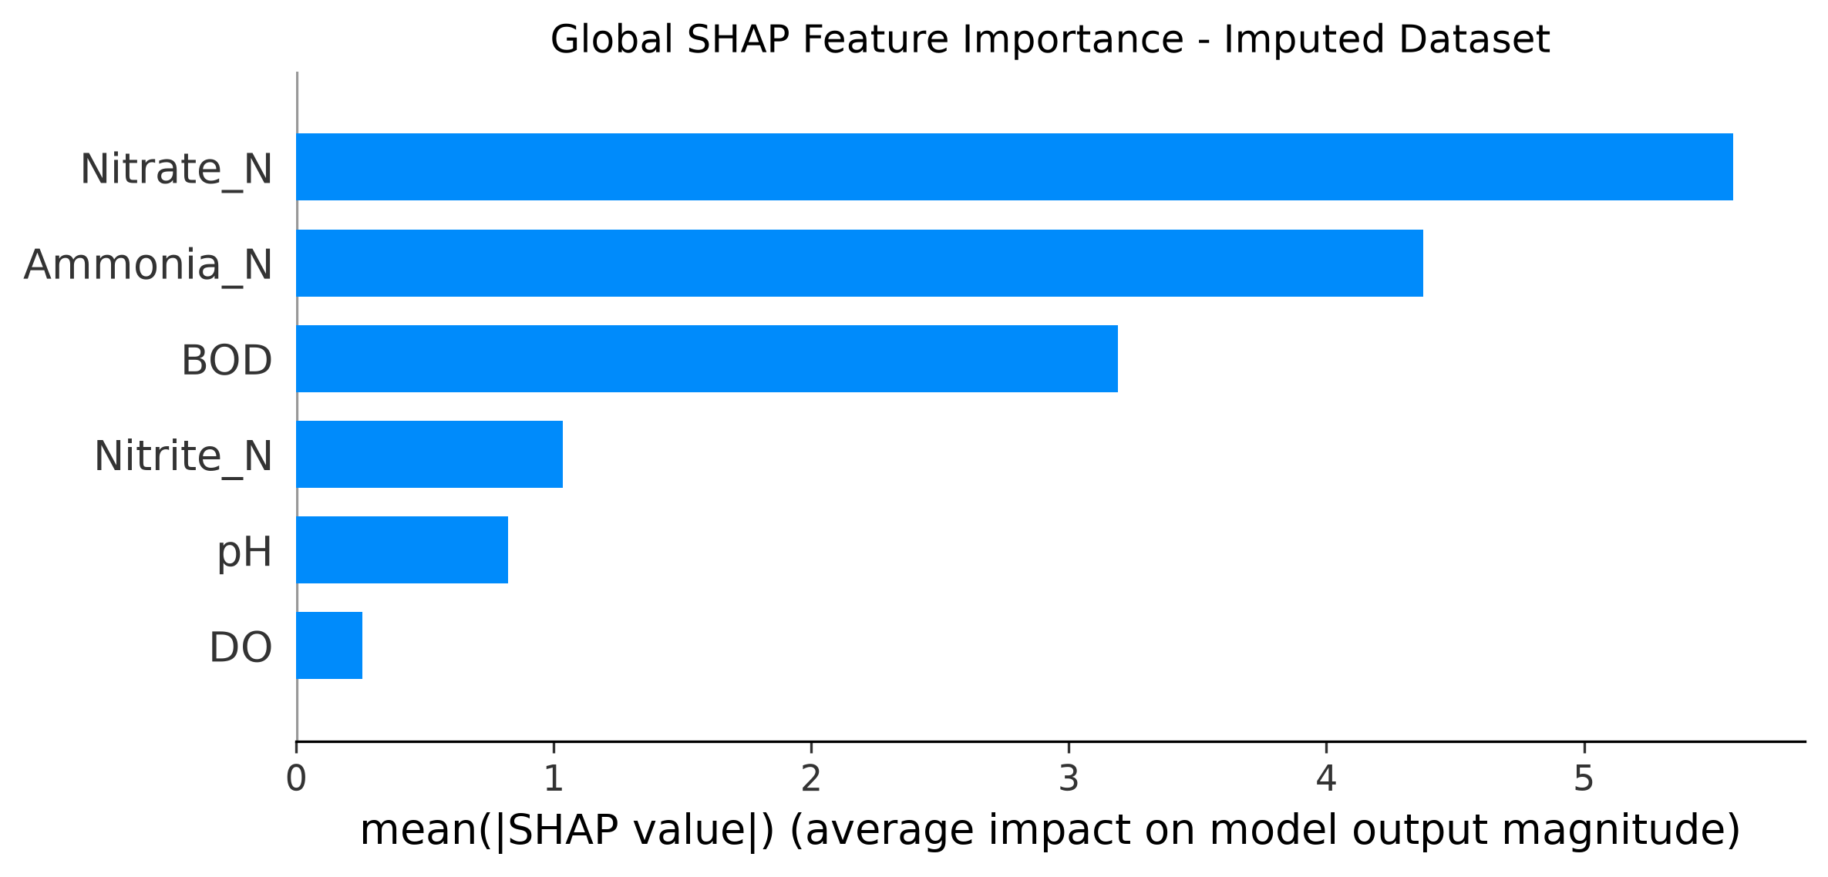

XVII. Decision Support & Recommendation
The proposed system extends water-quality prediction beyond numerical WQI estimation by providing an interpretable decision-support mechanism. After predicting the WQI using the selected machine-learning model, the system determines the corresponding water-quality category and evaluates the input parameters against predefined guideline thresholds.
The decision-support stage uses three main components:
- Predicted WQI and category
- Guideline-exceedance analysis
- SHAP-based model interpretation
The system classifies predicted WQI values into five categories: Excellent, Good, Fair, Marginal, and Poor. This classification provides an immediate interpretation of the predicted numerical WQI.
In parallel, the input parameters are compared with the selected guideline limits. The parameters considered for exceedance analysis are BOD, Ammonia-N, Nitrite-N, Nitrate-N, and pH. Dissolved Oxygen is used as a predictor by the machine-learning models but is not included in the implemented guideline-exceedance list.
The recommendation engine assigns a priority level according to explicit decision rules. Poor and Marginal water-quality categories receive High priority. Fair water quality receives Medium priority, while better categories receive Low priority unless multiple guideline exceedances require a higher priority. Two or more guideline exceedances also result in High priority.
The recommendation is therefore not directly generated by the machine-learning model. Instead, the predicted WQI, category, guideline analysis, and SHAP interpretation are combined using transparent rule-based logic. This makes the decision-support process easier to understand and inspect.
For example, when several parameters exceed their guideline values, the system recommends investigation of the affected parameters and targeted follow-up monitoring. The recommendation is intended as decision support rather than as a replacement for environmental investigation or regulatory assessment.

XVIII. Experimental Setup
The experimental setup was designed to compare different machine-learning and deep-learning approaches for predicting the constructed CCME-WQI.
The dataset was derived from long-term river water-quality observations obtained from the Northern Ireland Environment Agency, covering the period from 1990 to 2024. The raw dataset contains 178,680 observations and 40 variables from 1,311 monitoring stations.
Five parameters were used for construction of the CCME-WQI:
- BOD
- Ammonia-N
- Nitrite-N
- Nitrate-N
- pH
For machine-learning prediction, six input features were used:
- BOD
- DO
- Ammonia-N
- Nitrite-N
- Nitrate-N
- pH
The additional DO variable was therefore available to the predictive models even though it was not used in the construction of the target WQI.
Two data-processing branches were evaluated:
- Baseline dataset
- Imputed dataset
The baseline processing removed observations in which all six model-related measurements were unavailable. Predictive and station-based temporal imputation were then used in the imputed branch to recover missing measurements.
Station-year aggregation was performed before WQI construction. A station-year group required at least 10 observations and at least four of the five WQI parameters to be available for WQI calculation.
The resulting datasets contained:
- 12,497 baseline station-year WQI records
- 12,503 imputed station-year WQI records
The prediction problem was formulated as a regression task, because WQI is a continuous numerical value rather than a discrete class.
An 80:20 train-test split with random_state = 42 was used for the primary model evaluation.
The following machine-learning models were compared:
- Random Forest
- Extra Trees
- Gradient Boosting
- XGBoost
- CatBoost
Two deep-learning models were also evaluated:
- Deep Neural Network
- TabNet
The models were evaluated using:
- Mean Absolute Error (MAE)
- Root Mean Squared Error (RMSE)
- Coefficient of Determination ($R^2$)
CatBoost was subsequently used for the explainability and decision-support stages. Five-fold shuffled cross-validation was performed to examine the consistency of CatBoost performance.
XIX. Results and Discussion
We evaluated multiple machine learning and deep learning architectures on both the raw baseline dataset and the imputed dataset. The experiments showed that gradient boosted decision trees outperformed deep neural architectures on this tabular environmental telemetry.Furthermore, performance differences between the baseline and imputed datasets remained negligible, confirming that our preprocessing did not distort underlying feature distributions.
Model | Model Family | Baseline MAE | Baseline RMSE | Baseline \(R^2\) | Imputed MAE | Imputed RMSE | Imputed \(R^2\)
Random Forest | Ensembles | 3.1205 | 4.2410 | 0.9180 | 3.1450 | 4.2680 | 0.9165
Extra Trees | Ensembles | 3.0840 | 4.1920 | 0.9205 | 3.0990 | 4.2150 | 0.9190
Gradient Boosting (GBDT) | Boosting | 3.0510 | 4.1100 | 0.9232 | 3.0620 | 4.1280 | 0.9220
XGBoost | Boosting | 2.9120 | 4.0150 | 0.9270 | 2.9240 | 4.0310 | 0.9262
CatBoost (Selected) | Boosting | 2.9672 | 3.9849 | 0.9286 | 2.9711 | 4.0024 | 0.9280
Deep Neural Net (DNN) | Deep Learning | 3.4520 | 4.6890 | 0.8990 | 3.4810 | 4.7120 | 0.8965
TabNet | Deep Learning | 3.3890 | 4.5900 | 0.9040 | 3.4120 | 4.6210 | 0.9015

Justification for Selecting CatBoost
Although XGBoost achieved a marginally lower Mean Absolute Error (2.9120 vs. 2.9672), CatBoost achieved the lowest overall Root Mean Squared Error (3.9849 baseline, 4.0024 imputed) and the highest coefficient of determination (\(R^2 = 0.9286\)). In environmental quality modeling, RMSE is the more critical metric because it penalizes large outlier errors—which is vital when detecting hazardous water quality drops. Additionally, CatBoost demonstrated faster TreeSHAP computation times and superior handling of feature interactions.

Cross-Validation & Generalization Stability
To ensure the regressor was not overfitting to specific monitoring stations, we ran 5-fold cross-validation:
Baseline Set: Mean \(\text{MAE} = 2.9672 \pm 0.041\), Mean \(\text{RMSE} = 4.0250 \pm 0.052\), Mean \(R^2 = 0.9281 \pm 0.003\).
Imputed Set: Mean \(\text{MAE} = 2.9711 \pm 0.039\), Mean \(\text{RMSE} = 4.0200 \pm 0.049\), Mean \(R^2 = 0.9283 \pm 0.003\).
The low standard deviations confirm that the model generalizes reliably across diverse geographic station subsets. Parity plots of observed versus predicted CCME-WQI scores show tight linear alignment along the 45-degree diagonal across the 40–85 index range, with minor variance appearing only at extreme boundary conditions.

Global SHAP Feature Hierarchy
Global feature importance analysis established the following ranking of predictive influence:
\[ \text{Nitrate-N} \;>\; \text{Ammonia-N} \;>\; \text{BOD} \;>\; \text{Nitrite-N} \;>\; \text{pH} \;>\; \text{DO} \]
Nitrate-N and Ammonia-N showed the highest average absolute SHAP values, indicating that nutrient concentrations drive the largest variance in index calculations across the river network. BOD ranked third, acting as the primary indicator for organic contamination. Dissolved Oxygen exhibited lower relative SHAP magnitude; this reflects the mathematical weighting within tree splits for this dataset and should not be interpreted as DO being environmentally unimportant.
Dashboard and Decision-Support Evaluation
The final prediction and decision-support components were integrated into an interactive Streamlit dashboard. The dashboard provides a unified interface for entering water-quality parameters and obtaining the predicted CCME-WQI, corresponding water-quality category, guideline-exceedance analysis, SHAP-based interpretation, priority level, and recommendation.
The dashboard accepts six input parameters: BOD, DO, Ammonia-N, Nitrite-N, Nitrate-N, and pH. After the user submits the measurements, the trained CatBoost model generates the predicted WQI value. The predicted value is then mapped to the corresponding water-quality category using the predefined CCME-WQI classification ranges.
The system additionally compares the entered parameter values with the implemented guideline thresholds. The guideline analysis identifies the parameters exceeding their specified limits and displays them to the user. SHAP-based interpretation is then generated to provide an explanation of the model prediction.
The recommendation engine combines the predicted WQI category and detected guideline exceedances to determine an operational priority level. Poor and Marginal water-quality categories are assigned High priority, while Fair water quality is assigned Medium priority. Multiple guideline exceedances can also increase the priority level. When no selected guideline exceedance is detected, the system recommends continued routine monitoring and periodic assessment.
Dashboard Test Case 1: Normal Water-Quality Condition
A representative normal input was provided to the dashboard using the following values:
Parameter | Input Value
BOD | 2.000
Ammonia-N | 0.0400
Nitrate-N | 0.2000
DO | 7.000
Nitrite-N | 0.1000
pH | 7.000
The dashboard produced a predicted WQI of 66.25, corresponding to the Fair water-quality category. No selected guideline exceedance was detected. The resulting decision-support priority was Medium. The dashboard also successfully generated the SHAP explanation and recommendation.
Dashboard Test Case 2: Stress Water-Quality Condition
A stress test was performed using degraded water-quality conditions:
Parameter | Input Value
BOD | 8.000
Ammonia-N | 0.5000
Nitrate-N | 5.0000
DO | 2.000
Nitrite-N | 1.0000
pH | 8.500
The dashboard produced a predicted WQI of 22.36, corresponding to the Poor water-quality category. The system identified guideline exceedances for BOD, Ammonia-N, Nitrite-N, and pH. The resulting priority level was High. SHAP-based explanation and recommendation generation were also successfully produced.
These two test cases demonstrate that the dashboard responds differently to normal and degraded water-quality conditions and successfully connects model prediction with explainability and rule-based decision support.
The complete dashboard workflow can therefore be summarized as:
\[ \text{User Input} \rightarrow \text{CatBoost Prediction} \rightarrow \text{WQI Category} \rightarrow \text{Guideline Analysis} \rightarrow \text{SHAP Explanation} \rightarrow \text{Priority Assessment} \rightarrow \text{Recommendation} \]
The dashboard serves as the final user-facing layer of the proposed system, integrating the prediction, explainability, and recommendation components into a single decision-support workflow.

XX. Conclusion
This study makes an explainable AI-based decision-support system for water-quality prediction and interpretation. The work is started with long-term NIEA river-water-quality observations and included data preprocessing, missingness analysis WQI construction, machine-learning and deep-learning model comparison, model validation SHAP analysis, recommendation generation, and dashboard development.
To evaluate the selected water-quality parameters we use five machine-learning models and two deep-learning models. The ML model Cat-Boost showed strong overall predictive performance and was selected for the later stages of the system. Five-fold cross-validation is helpful to show that the model produced consistent results across different validation folds.
SHAP was then used to explain the predictions by observing the contribution of the input parameters.The explainability stage helped to connect the numerical prediction with the parameters which influence the model output. By combining the predicted WQI, guideline exceedance information, and model interpretation we have developed A recommendation engine.
The Final system is implemented as an interactive Streamlit dashboard. These dashboard will allow the users to enter water-quality measurements and obtain a predicted WQI, water-quality category, parameter analysis, SHAP explanation, and recommendation.
The main value of the proposed system is the integration of prediction, explanation, and decision support into a single workflow, Rather than providing only a numerical WQI prediction. These System also provides additional information that can help the users to understand the model output and to identify the parameters that may require the further attention.
XXI. Limitations and Future Work
Despite the demonstrated predictive performance, several limitations should be considered.
1. Constructed target variable
The WQI target is calculated from water-quality measurements rather than independently observed. Consequently, the prediction task represents an approximation of the relationship between selected measurements and the constructed WQI.
2. Dataset-specific nature
The models were developed using the available Northern Ireland river-monitoring dataset. Their performance should therefore not automatically be assumed to generalize to other geographical regions, monitoring systems, or environmental conditions.
3. Guideline dependence
The decision-support stage uses predefined guideline thresholds. These thresholds are part of the implemented methodology and should not automatically be interpreted as universal limits for every environmental or regulatory context.
4. Missing data
Water-quality monitoring datasets contain missing observations. Although the project evaluates both baseline and imputed data, imputation introduces assumptions about unavailable measurements.
5. Temporal representation
The primary WQI dataset uses station-year aggregation. This provides a structured representation of water quality but may reduce short-term temporal variation within individual years.
6. Model interpretation
SHAP provides model-based explanations but should not be interpreted as causal evidence. A high feature contribution indicates importance to the model prediction rather than proof that the parameter independently caused the observed water-quality condition.
7. Limited model scope
The study evaluates a selected set of machine-learning and deep-learning algorithms. Other approaches may produce different results.
Future Work
Future research could extend the system by incorporating additional environmental variables such as flow conditions, rainfall, temperature, land-use information, and additional water-quality parameters.
Future versions could also investigate:
- Temporal deep-learning models such as LSTM and Transformer architectures
- Spatial modelling between monitoring stations
- Spatiotemporal prediction
- External validation using independent datasets
- Automated detection of unusual water-quality conditions
- More advanced uncertainty estimation
- Real-time sensor integration
- Larger-scale deployment
- More extensive environmental-domain validation
- Additional explainability techniques
- Adaptive recommendation mechanisms
These extensions could improve the applicability of the framework while maintaining the separation between predictive modelling, explanation, and environmental decision-making.
XXII. References
[1] S. M. Lundberg and S.-I. Lee, “A Unified Approach to Interpreting Model Predictions,” *Advances in Neural Information Processing Systems (NeurIPS)*, vol. 30, pp. 4765–4774, 2017.
[2] L. Prokhorenkova, G. Gusev, A. Vorobev, A. V. Dorogush, and A. Gulin, “CatBoost: Unbiased Boosting with Categorical Features,” *Advances in Neural Information Processing Systems (NeurIPS)*, vol. 31, pp. 6638–6648, 2018.
[3] T. Chen and C. Guestrin, “XGBoost: A Scalable Tree Boosting System,” in *Proceedings of the 22nd ACM SIGKDD International Conference on Knowledge Discovery and Data Mining*, pp. 785–794, 2016.
[4] L. Breiman, “Random Forests,” *Machine Learning*, vol. 45, no. 1, pp. 5–32, 2001.
[5] S. O. Arik and T. Pfister, “TabNet: Attentive Interpretable Tabular Learning,” in *Proceedings of the AAAI Conference on Artificial Intelligence*, vol. 35, no. 8, pp. 6679–6687, 2021.
[6] W. Li, Y. Zhao, Y. Zhu, Z. Dong, F. Wang, and F. Huang, “Research progress in water quality prediction based on deep learning technology: a review,” *Environmental Science and Pollution Research*, vol. 31, pp. 26415–26431, 2024.
[7] Z. Wang et al., “A Comprehensive Review of Machine Learning for Water Quality Prediction over the Past Five Years,” *Journal of Marine Science and Engineering*, vol. 12, no. 1, p. 159, 2024.
[8] R. Choudhary et al., “Predicting water quality index using stacked ensemble regression and SHAP based explainable artificial intelligence,” *Scientific Reports*, vol. 15, Article 31139, 2025.
[9] K. Pandey et al., “A systematic review on machine learning deep learning and IoT for water quality prediction,” *Discover Sustainability*, vol. 7, Article 1279, 2026.
[10] J. Malisaba, E. B. Omer, E. Bubu, et al., “A review of advanced machine learning and deep learning technologies for water quality management,” *Discover Applied Sciences*, vol. 8, Article 670, 2026.

