SMART RECIPE RECOMMENDATION &
NUTRITIONAL ANALYTICS ENGINE
A Natural Language Processing & Multi-Criteria Decision-Support System
for Domestic Food Waste Minimization and Dietary Alignment
MCA PROJECT REPORT
Submitted in partial fulfillment of the requirements
for the Degree of Master of Computer Applications (MCA)
Master of Computer Applications (MCA)
Academic Year: 2025 – 2026
Programming & ML Track: Python, Streamlit, Scikit-learn

Table of Contents
Section | Description
1. Title Page | Project Title, Degree Details, and Academic Affiliation
2. Introduction | Overview of culinary recommendation and domestic food waste
3. Problem Statement | Challenges in pantry item management and rigid recipe matching
4. Objectives | Primary and secondary project milestones
5. Proposed Solution | Architecture combining NLP matching with multi-criteria optimization
6. System Workflow | Step-by-step pipeline from input to analytics
7. System Architecture | Layered software structure and module dependencies
8. Dataset Description | Food.com RAW_recipes.csv schema and nutrition vector parsing
9. Data Preprocessing | Cleaning, text normalization, reproducible sampling, and error handling
10. Recommendation Methodology | TF-IDF vectorization, Cosine Similarity, and Min-Max scaling
11. Dietary Goals | Goal-specific suitability scores and mathematical formulas
12. Main Features | Detailed breakdown of implemented application capabilities
13. User Interface and Output | Streamlit UI layout with screenshot placeholders and captions
14. Results and Insights | Pantry utilization analytics and nutritional standout metrics
15. Technology Stack | Libraries, runtimes, and engineering frameworks
16. Project Structure | File tree and single-file design rationale
17. Limitations | Current technical constraints and operating assumptions
18. Future Scope | Prospective enhancements and architectural scalability
19. Conclusion | Project summary and academic deliverables
20. Disclaimer | Non-clinical health and nutritional guidance statement

2. Introduction
In modern households, efficient kitchen management and nutritional balance have become critical challenges. Every year, significant quantities of groceries and fresh ingredients are discarded simply because home cooks lack inspiration or immediate knowledge of recipes that utilize their available pantry items. At the same time, consumers are increasingly health-conscious, striving to balance macronutrients, reduce excess calories, or accommodate busy schedules with fast preparation times.
Traditional culinary search engines typically require users to search by specific recipe titles (e.g., 'Lasagna') or demand exact adherence to extensive ingredient lists. If a user only possesses chicken, garlic, rice, and tomatoes, traditional engines frequently fail to recommend practical meals or suggest dishes requiring substantial additional grocery purchases. This friction directly accelerates domestic food waste.
The Smart Recipe Recommendation & Nutritional Analytics Engine is an intelligent, automated decision-support system designed to address this dual challenge. Developed entirely in Python using Streamlit, Scikit-learn, Pandas, and NumPy, the application combines Natural Language Processing (NLP) content-based filtering with multi-criteria nutritional re-ranking. By accepting an arbitrary comma-separated list of on-hand ingredients, the system identifies the most relevant recipes, optimizes the selection according to selected dietary goals, visualizes comparative nutritional data, and computes actionable metrics to minimize pantry waste.
3. Problem Statement
The development of this project is driven by three distinct, interrelated problems in domestic food management and digital culinary services:
- Excessive Household Food Waste: Households discard perishable food items primarily due to lack of visibility into potential recipe combinations for remaining ingredients.
- Rigidity of Keyword Search Engines: Conventional recipe platforms prioritize exact title matches or pre-indexed categories rather than reverse-matching against available household inventory.
- Absence of Integrated Nutritional Multi-Criteria Optimization: Most recipe recommenders treat recommendation strictly as a text retrieval task, ignoring nutritional alignment such as high protein density, caloric deficit management, or prep-time restrictions.
4. Objectives
The primary objectives of this MCA project are as follows:
- Automated Ingredient Matching: Build a natural language processing model using TF-IDF vectorization and Cosine Similarity to compute semantic similarity between user pantry items and thousands of recipe ingredient lists.
- Dietary Goal-Driven Re-Ranking: Formulate and implement a multi-criteria mathematical ranking system supporting four distinct goals: Balanced, High Protein, Low Calorie, and Quick Prep.
- Preparation-Time Control: Provide interactive filtering that discards recipes exceeding a user-defined preparation time threshold (5 to 300 minutes).
- Nutritional Visualization: Render clear, interactive comparative charts for calories and macronutrients (protein, carbohydrates, and fat) across the top recommended recipes.
- Food Waste Reduction Analytics: Calculate quantitative metrics including pantry utilization percentage, lists of utilized vs. leftover ingredients, and top pantry champion recipes.
- Reliable Single-File Architecture: Encapsulate all preprocessing, machine learning, analytics, and graphical interface code within a single, highly maintainable app.py script.
5. Proposed Solution
To resolve the stated problems, the proposed solution implements a unified, end-to-end web application that bridges content-based recommendation with multi-objective numerical scoring. Rather than relying on rigid database queries, the system treats recipe recommendation as an information retrieval and multi-attribute utility task.
The engine operates in two complementary stages: First, a natural language text-matching phase measures how closely a recipe's ingredients match the user's pantry. Second, a mathematical scoring engine normalizes nutritional attributes and preparation times, applying goal-specific weighting vectors to re-rank the candidate recipes. Finally, comprehensive visual analytics and food waste diagnostics are generated dynamically, empowering users to cook wholesome meals while maximizing ingredient utilization.
6. System Workflow
The end-to-end execution workflow proceeds through eight sequential operational stages:
Workflow Stage | Functional Description
Stage 1: User Ingredients | User enters available pantry ingredients as comma-separated text in Section 2.
Stage 2: Preprocessing | Input text is lowercased, stripped of punctuation, and cleaned into standardized searchable tokens.
Stage 3: TF-IDF Vectorization | Query is transformed into a high-dimensional feature vector using the fitted corpus vocabulary.
Stage 4: Cosine Similarity | Cosine similarity is computed against all dataset recipes; candidates below threshold (0.05) are filtered.
Stage 5: Goal & Time Filtering | Candidate pool is filtered to exclude recipes exceeding the user's selected prep-time limit.
Stage 6: Nutritional Re-Ranking | Normalized nutritional attributes are combined with similarity via goal-specific weighting functions.
Stage 7: Top 3 Recommendations | The top 3 recipes are formatted into structured cards with parsed step-by-step instructions.
Stage 8: Analytics & Waste Insights | Comparative charts, nutritional averages, pantry utilization %, and leftover tips are rendered.

7. System Architecture
The architecture is engineered as a modular, layered single-file application. Each layer encapsulates a specific computational concern while communicating through pure Python data structures:
- Presentation / UI Layer (Streamlit): Manages user interaction, controls (file uploader, text inputs, radio buttons, sliders), containerized recipe cards, interactive expanders, and native chart rendering.
- Data Ingestion & Preprocessing Layer (Pandas, AST): Handles CSV ingestion, column validation, reproducible sampling (15,000 recipes, seed 42), text cleaning, list literal parsing, and numeric conversions.
- Machine Learning & Matching Engine (Scikit-learn): Constructs the TF-IDF feature space (TfidfVectorizer) and computes pairwise cosine similarity between query vectors and recipe matrices.
- Multi-Criteria Decision Engine (NumPy): Performs min-max normalization on calories, protein, carbohydrates, fats, and cooking minutes, applying weighted scoring models.
- Analytics & Food Waste Diagnostic Engine: Executes regex-based token matching to determine pantry ingredient utilization, identifies unused items, and formats dietary highlights.
8. Dataset Description
The application utilizes the authentic Food.com (formerly GeniusKitchen) RAW_recipes.csv dataset, a widely recognized benchmark dataset in culinary data science containing comprehensive recipe information.
Column Name | Data Type | Semantic Description
name | String | Title of the recipe (e.g., 'Slow Cooker Beef Stew').
id | Integer | Unique identifier for the recipe entry.
minutes | Integer | Total preparation and cooking time in minutes.
contributor_id | Integer | User ID of the community member who submitted the recipe.
submitted | Date String | Date of recipe submission.
tags | List (str) | Culinary, occasion, and dietary category tags.
nutrition | List (float) | 7-element nutritional vector representing nutrient breakdown.
n_steps | Integer | Total number of sequential preparation instructions.
steps | List (str) | Ordered list of step-by-step preparation instructions.
description | Text | Author's qualitative recipe summary and cooking notes.
ingredients | List (str) | List of individual raw ingredients required.
n_ingredients | Integer | Total number of ingredients in the recipe.

The 7-Element Nutrition Vector
In the Food.com dataset, nutritional data is encoded as a stringified list of seven numeric values. The engine parses these values into seven distinct numeric DataFrame columns in exact chronological order:
Index | Generated Column | Nutritional Meaning
1 | calories | Total energy content in kilocalories (kcal).
2 | fat | Total dietary fat content in grams / % daily value.
3 | sugar | Sugar content in grams / % daily value.
4 | sodium | Sodium content in milligrams / % daily value.
5 | protein | Dietary protein content in grams / % daily value.
6 | saturated_fat | Saturated fat content in grams / % daily value.
7 | carbohydrates | Total carbohydrates in grams / % daily value.

9. Data Preprocessing
Raw culinary datasets frequently suffer from missing attributes, inconsistent string formatting, and nested list representations. The application implements rigorous preprocessing safeguards:
- Column Validation: Before processing, the dataset is verified against REQUIRED_COLUMNS = ['name', 'ingredients', 'nutrition', 'minutes']. Missing columns trigger descriptive validation errors.
- Null & Empty Row Removal: Records with null, empty, or whitespace-only recipe names or ingredient strings are systematically dropped.
- Reproducible Sampling: To ensure interactive response times without sacrificing linguistic breadth, datasets exceeding DEFAULT_SAMPLE_SIZE (15,000) are reproducibly sampled using seed 42.
- Ingredient Normalization: The clean_ingredients() function lowercases all text, removes brackets, single/double quotes, and strips whitespace. ast.literal_eval is attempted safely, with split-based fallbacks.
- Robust Nutrition Parsing: The parse_nutrition() function unpacks the 7-element vector. Malformed, truncated, or non-numeric tokens are replaced with np.nan, preventing application crashes.
- Preparation Time Sanitization: The minutes attribute is converted to numeric with invalid entries coerced to 0, clipped at lower bound 0, and cast to integer.
10. Recommendation Methodology
The recommendation algorithm relies on content-based natural language matching followed by feature-scaled multi-criteria optimization.
TF-IDF Feature Extraction
Term Frequency-Inverse Document Frequency (TF-IDF) reflects how important an ingredient word is to a recipe within the entire corpus. For a term t and recipe document d in corpus D:
Mathematical Definition: TF(t, d) = (Number of times term t appears in d) / (Total terms in d)
IDF(t, D) = ln((1 + |D|) / (1 + |{d ∈ D : t ∈ d}|)) + 1
TF-IDF(t, d, D) = TF(t, d) × IDF(t, D)

Cosine Similarity Matching
The user query is vectorized into vector u, and cosine similarity is evaluated against all recipe vectors v_i:
Similarity Metric: Cosine Similarity(u, v_i) = (u · v_i) / (||u|| × ||v_i||)
Threshold Filter: Recipes with similarity score < 0.05 are excluded as irrelevant.

Nutritional Min-Max Normalization
Because nutritional metrics operate on vastly disparate scales (e.g., calories in hundreds, protein in tens), all candidate features are normalized to [0.0, 1.0] before composite ranking:
Min-Max Feature Scaling: x_norm = (x - x_min) / (x_max - x_min) if (x_max - x_min) > 1e-6
x_norm = 0.5 otherwise (constant or single-candidate series)

11. Dietary Goals
Following similarity computation and prep-time filtering, candidate recipes are re-ranked using the user's chosen dietary goal:
- Balanced: Prioritizes harmonious macronutrient distribution: 40% protein balance, 30% calorie balance, 15% carb balance, and 15% fat balance.
- High Protein: Directly maximizes protein concentration: Nutrition Score = norm_protein.
- Low Calorie: Directly minimizes caloric density: Nutrition Score = 1.0 - norm_calories.
- Quick Prep: Emphasizes rapid preparation time: Time Suitability = 1.0 - norm_time, with moderate nutritional support.
Scoring Formulas
The exact mathematical ranking models implemented in app.py are:
Standard Goals (Balanced, High Protein, Low Calorie): Final Score = 0.60 × Similarity + 0.40 × Nutrition Suitability

Quick Prep Goal: Final Score = 0.50 × Similarity + 0.35 × Time Suitability + 0.15 × Nutrition Suitability

12. Main Features
System Feature | Implementation Scope
Ingredient-Based Recipe Recommendation | NLP-driven search that maps user pantry items directly to recipe candidates without requiring recipe titles.
Dietary Goal Selection | Interactive radio control supporting Balanced, High Protein, Low Calorie, and Quick Prep nutritional targets.
Preparation-Time Slider Filter | Slider control (5 to 300 minutes, default 60 mins) to enforce preparation time restrictions.
Top 3 Recipe Recommendations | Structured display showing Rank (#1, #2, #3), Final Score %, Similarity %, Prep Time, Calories, Protein, Carbs, and Fat.
Preparation Instructions | Expandable 'Preparation Instructions' accordion presenting clean, sequential cooking steps parsed directly from the dataset.
Protein/Carbohydrate/Fat Visualization | Interactive side-by-side Streamlit bar charts comparing calories and macronutrients across recommendations.
Health Insights | Automated non-medical highlights highlighting the highest-protein recipe, lowest-calorie meal, or fastest prep option.
Food Waste / Ingredient Utilization Insights | Calculates quantitative pantry utilization %, utilized ingredients list, leftover items, and a 'Top Pantry Champion' recipe.

13. User Interface and Output
The web interface is organized into six clean, logical functional sections laid out across a wide Streamlit canvas. The application views and corresponding figure descriptions illustrate each primary operational view of the platform:
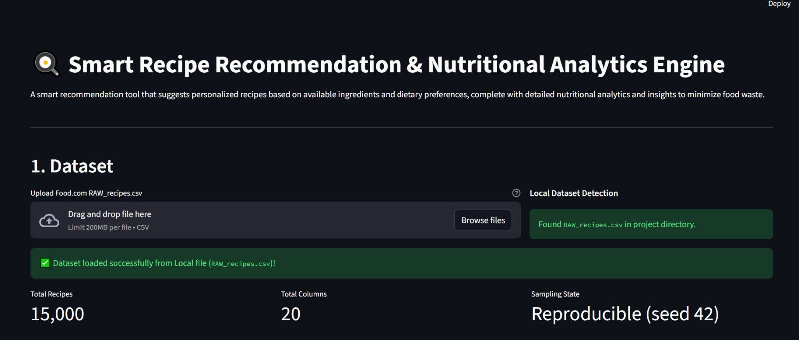
Figure 1: Dataset Loading and Local Dataset Detection
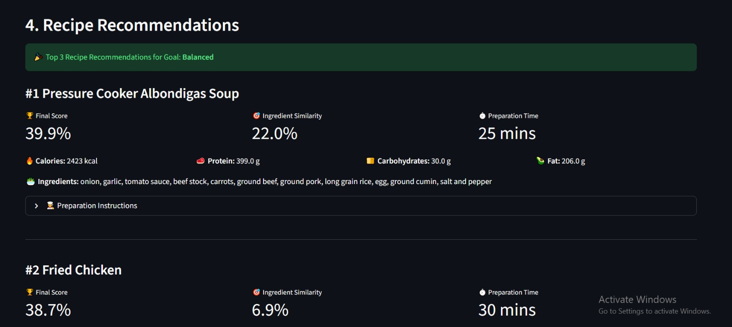
Figure 2: Top 3 Recipe Recommendations
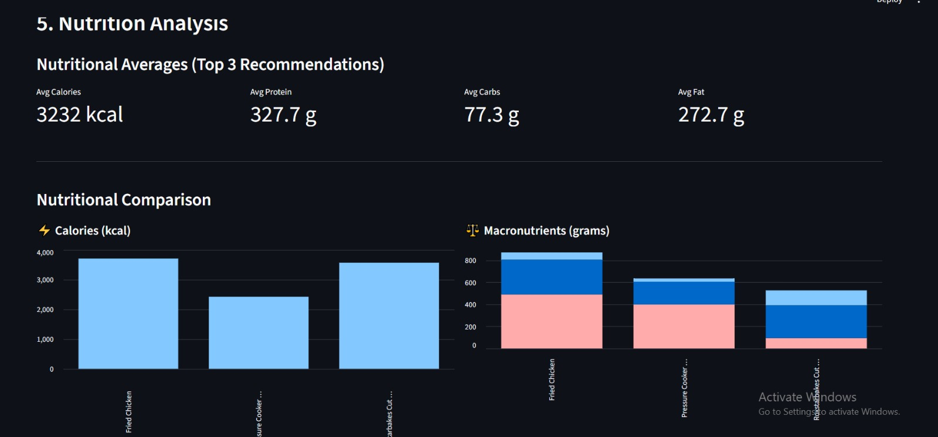
Figure 3: Nutritional Analysis and Comparison
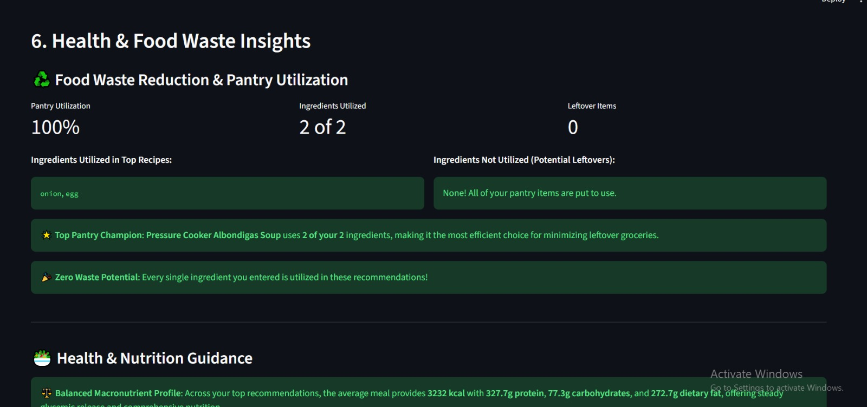
Figure 4: Health and Food Waste Insights
14. Results and Insights
The application provides transparent, data-driven outputs that immediately inform user meal planning. The system's findings represent deterministic natural language processing matches and multi-criteria ranking outputs rather than empirical experimental benchmarks or unsupported accuracy claims. The informational outputs delivered to the user include:
- Candidate Recipe Identification: The engine identifies recipe candidates from the dataset that exhibit strong semantic overlap with entered pantry items, eliminating unviable dishes.
- Dietary Optimization & Goal Alignment: Candidate dishes are dynamically re-ranked according to the active dietary goal. For instance, selecting 'High Protein' elevates protein-dense dishes, while 'Quick Prep' prioritizes meals with shorter cooking durations.
- Pantry Utilization Metrics (Illustrative Example): The application computes an exact utilization rate based on the specific ingredients supplied. As an illustrative example: when four pantry items are entered and three are utilized across the top recommendations, the interface displays an illustrative 75% pantry utilization (3 of 4 items utilized) and marks the remaining item as a leftover with storage advice. This figure is strictly illustrative to demonstrate UI output formatting and is not a measured experimental benchmark.
- Comparative Nutritional Analytics: Renders exact caloric and macronutrient breakdowns (protein, carbohydrates, fat in grams) for each top-ranked recipe, alongside summary averages across all recommendations.
- Standout Nutritional Highlights: Identifies standout recipes among the top recommendations—specifically highlighting the dish with the highest protein, the lowest calories, and the shortest preparation time.
15. Technology Stack
Technology | Layer / Category | Functional Role in Project
Python 3.9+ | Core Language | Provides runtime, standard libraries (ast, os, re), and numerical processing.
Streamlit | Frontend Web Framework | Renders interactive web interface, reactive widgets, session state, and native bar charts.
Pandas | Data Manipulation | Manages tabular recipe datasets, DataFrame slicing, filtering, and missing data imputation.
NumPy | Numerical Computing | Executes min-max feature normalization, clipping, and vectorized arithmetic operations.
Scikit-learn | Machine Learning & NLP | Fits TfidfVectorizer on ingredients and computes pairwise cosine_similarity matrices.

16. Project Structure
The project workspace is organized with minimal overhead and zero unnecessary dependencies:
File / Artifact | Project Role & Purpose
app.py | Complete single-file application containing preprocessing, TF-IDF modeling, ranking logic, and Streamlit UI.
RAW_recipes.csv | Food.com recipe dataset containing titles, ingredients, nutrition vectors, minutes, and cooking steps.
requirements.txt | Minimal dependency manifest (streamlit, pandas, numpy, scikit-learn).
README.md | Comprehensive project documentation, architecture guide, and setup instructions.
project_report.docx | Academic project report document prepared for MCA submission.

Architecture Rationale: The application logic is intentionally structured in a single app.py file. This design eliminates multi-module import errors, simplifies local and cloud deployment, and provides an accessible, self-contained codebase for academic inspection.
17. Limitations
- Corpus Vocabulary Scope: Recommendations depend on words recognized within the recipe dataset. Highly obscure or newly branded grocery items may experience vocabulary mismatches.
- Fixed Sample Size: For interactive responsiveness on standard computing hardware, the dataset is sampled to 15,000 entries by default.
- Pantry Staple Assumptions: The system assumes users possess standard universal seasonings (water, basic cooking oil, salt) even if not explicitly entered.
- Heuristic Nutritional Modeling: Nutritional scores are derived from mathematical heuristics rather than individualized metabolic or biometric profiling.
18. Future Scope
- Computer Vision Integration: Incorporate a Convolutional Neural Network (CNN) or Vision Transformer to automatically detect pantry ingredients from a smartphone camera photo of the refrigerator.
- Automated Missing-Item Shopping Lists: Generate a minimal grocery shopping list for complementary ingredients needed to complete high-scoring recipes.
- User Profiles & Historical Preferences: Incorporate collaborative filtering to learn personalized flavor preferences, allergens, and past user ratings.
- Integration with Live Grocery APIs: Connect with local grocery delivery APIs to estimate the cost of missing ingredients in real time.
19. Conclusion
The Smart Recipe Recommendation & Nutritional Analytics Engine successfully demonstrates how Natural Language Processing and multi-criteria optimization can be harmonized to solve a tangible domestic problem. By transforming arbitrary pantry ingredients into actionable, nutritionally tailored recipes, the system empowers consumers to reduce preventable food waste, make informed dietary decisions, and streamline meal preparation.
The project fulfills all academic MCA curriculum milestones, exhibiting sound software engineering principles, rigorous data cleaning, robust machine learning workflows, and an intuitive user interface. Its single-file architecture ensures straightforward portability, reliable reproducibility, and immediate demonstration capability.
20. Disclaimer
Non-Clinical Health Notice: The nutritional calculations, composite rankings, and dietary interpretations generated by this application are provided strictly for educational, informational, and domestic meal-planning purposes. The platform does not provide medical, clinical, or therapeutic dietary advice. Users with specialized metabolic conditions, chronic diseases, or clinical dietary restrictions should consult a qualified physician or registered dietitian before making significant changes to their nutritional regimen.

