roshan_sudhakar9@rediff.com

R.S Roshan -510922205053

**Author note**

R.S Roshan

Department of Information Technology, Global Institute of Engineering and Technology

**Code Ethics: Legal Frameworks for Responsible Software Development**

1

Legal Frameworks for Software Development

**Coding Ethics: Legal Frameworks for Responsible Software Development**

This study explores the intersection of coding ethics and legal frameworks, focusing on how regulatory standards influence responsible software development. As software increasingly governs critical aspects of modern life—from healthcare systems to financial services—the ethical responsibility of developers has never been more urgent. Despite growing public and academic discourse on ethical coding, there remains a lack of unified legal standards that developers and organizations can adhere to. This research addresses that gap by analyzing existing legal frameworks across jurisdictions and evaluating their impact on ethical software practices.

The primary objective is to identify how current laws either support or hinder ethical coding behavior, particularly in areas such as data privacy, algorithmic transparency, intellectual property, and cybersecurity. Through a comparative legal analysis and case study methodology, we examine notable legislative instruments like the General Data Protection Regulation (GDPR), the Digital Services Act, and the U.S. Algorithmic Accountability Act. Our findings reveal significant variations in legal obligations for developers, often resulting in inconsistent enforcement and ethical ambiguities.

Key results indicate that while some regulations promote accountability and transparency, others lack the specificity or enforceability needed to guide ethical decision-making in real-world scenarios. The study also highlights the role of organizational policies and professional codes of conduct in bridging the legal-ethical divide. Implications of this research suggest the need for an integrated legal-ethical framework that can standardize responsible software development practices globally, especially as technologies such as AI and machine learning become more pervasive.  
  
Building on these findings, the proposed framework highlights how a multi-layered approach can bridge gaps left by fragmented legal systems. For example, technical safeguards like AI deepfake detection can mitigate risks that current legislation cannot immediately address. Similarly, platform-level enforcement ensures that misuse is patrolled in real-time, complementing slower legislative processes. In the domain of human services such as education, this framework can help secure online platforms against scams and misuse, ensuring that students and educators benefit from digital resources without falling prey to fraudulent activities.

This paper contributes original insights into how a cohesive alignment between legal mandates and ethical imperatives can be achieved. It proposes a model legal framework grounded in ethical principles, regulatory best practices, and developer-centric guidelines. By fostering a shared responsibility between lawmakers, developers, and stakeholders, we aim to promote a sustainable and ethically sound future for software engineering.

**Keywords**: coding ethics, legal frameworks, responsible software development, algorithmic accountability, software law

Code Ethics: Legal Frameworks for Responsible Software Development

# A. Introduction

Software systems now permeate nearly every facet of modern life, from healthcare to financial transactions. With this growth comes the ethical responsibility of developers to ensure software is both secure and fair. This research examines the intersection of coding ethics and legal frameworks, with a focus on how laws and regulations shape responsible software development. Particular emphasis is placed on issues of privacy, algorithmic transparency, intellectual property, and cybersecurity.

# B. Literature Review

The academic debate surrounding coding ethics highlights the fragmentation of legal frameworks across jurisdictions. Scholars have emphasized that while global regulations like the GDPR and the U.S. Algorithmic Accountability Act are steps forward, they are insufficient to provide a uniform standard (Gogoll & Müller, 2021). The ACM and IEEE codes of ethics also highlight the role of professional standards in bridging legal gaps (ACM, 2018; IEEE, 2020).  
  
Recent literature expands this discourse to include the misuse of AI agents and the challenges posed by emerging technologies. For example, deepfake technologies have been widely criticized for enabling non-consensual content creation, raising legal and ethical concerns about consent and digital rights (Chesney & Citron, 2019). Similarly, AI-powered chatbots and autonomous agents, while useful in customer service, have been manipulated to spread misinformation or scams, particularly targeting vulnerable populations in education and healthcare (West et al., 2019). Software piracy remains another pressing issue, with studies indicating its persistence despite advances in intellectual property law (BSA, 2018). Cyber scams, including phishing attacks and online fraud, have escalated alongside the adoption of digital technologies, often exploiting human services such as online education platforms (Button et al., 2022). Collectively, these studies suggest that existing legal and ethical frameworks are not sufficiently adaptive to the rapid pace of technological innovation, further reinforcing the need for an integrated framework.

# C. Methodology

This research employs a comparative legal analysis combined with case studies. Key legal frameworks under review include the GDPR, the Digital Services Act, and the Algorithmic Accountability Act. Additionally, data was gathered from recent reports on software piracy, social media misuse, and ethical lapses in AI-driven applications. Graphs and charts were generated to visually demonstrate trends in software misuse despite existing regulations.  
  
To complement this, we propose a multi-layered ethical-legal-technical framework aimed at preventing misuse in software development and AI systems. The framework includes: **(1)** Legal and Policy reinforcement with international harmonization of deepfake and piracy laws;

**(2)** Ethical Governance through mandatory adherence to ACM/IEEE ethical codes;

**(3)** Technical mechanisms such as AI misuse detection, blockchain-based accountability, and digital provenance standards;

**(4)** Platform responsibilities like proactive monitoring, content labeling, and rapid takedown of harmful material;

**(5)** Educational outreach for developers and end-users. This framework forms the basis for subsequent analysis and discussion, where its practical implications and potential benefits are evaluated.

# D. Preferred Framework:

**The Integrated Legal-Ethical Framework for Responsible Software Development (ILEF-RSD)**

**Core Principle:** Responsible software development is a shared, multi-stakeholder responsibility achieved through the alignment of legal compliance, ethical imperatives, and technical implementation.

**Objective:** To provide a standardized, yet adaptable, structure for developers, organizations, and regulators to ensure software is developed and deployed in a lawful, secure, fair, and socially beneficial manner.

The framework is structured into five interconnected layers:

**Layer 1: Legal & Regulatory Compliance (The "Must-Do")**

This layer forms the mandatory foundation, based on existing and proposed laws.

* **1.1. Jurisdictional Adherence:** Mandate compliance with all applicable laws in every jurisdiction of operation.
  + **Data Protection:** Strict adherence to GDPR (EU), CCPA/CPRA (California), and other equivalent data privacy laws. Principles of Data Minimization, Purpose Limitation, and Lawful Processing are non-negotiable.
  + **Algorithmic Accountability:** Implement requirements from acts like the U.S. Algorithmic Accountability Act (proposed) and the EU AI Act. This includes pre-deployment impact assessments for high-risk AI systems.
  + **Platform Liability:** Comply with Digital Services Act (DSA) obligations for transparent content moderation, risk management, and external auditing for Very Large Online Platforms (VLOPs).
  + **Intellectual Property:** Respect copyright and software licensing (e.g., GPL, MIT licenses). Implement robust systems to avoid and prevent software piracy.
* **1.2. Proactive Legal Monitoring:** Establish a dedicated legal/compliance function to continuously monitor the global regulatory landscape and update development practices accordingly.

**Layer 2: Ethical Governance & Professional Standards (The "Should-Do")**

This layer bridges the gap where law is silent or lagging, using established ethical codes.

* **2.1. Mandatory Ethical Codes:** Formally adopt and integrate the **ACM Code of Ethics** and the **IEEE Code of Ethics** into all employment contracts, developer training, and project lifecycles.
* **2.2. Ethical Risk Assessment (ERA):** A mandatory, documented process (similar to a Legal Impact Assessment) conducted during the design phase of any project. It must answer:
  + **Fairness:** Could the software produce biased or discriminatory outcomes? How are we testing for this?
  + **Transparency:** Can we explain the software's decisions (especially AI) to a user? Is it a "black box"?
  + **Accountability:** Who is responsible if the software fails or causes harm?
  + **Social Benefit:** Does this software benefit society, or does it primarily create risk? (e.g., deepfake generation tools).
* **2.3. Institutional Review Boards (IRBs) for Technology:** Establish internal or industry-wide ethics review committees to approve projects with high ethical risk, mirroring the model used in medical research.

**Layer 3: Technical & Architectural Safeguards (The "How-To-Do")**

This layer translates legal and ethical principles into concrete technical implementations.

* **3.1. Privacy & Security by Design:** Architect systems with foundational principles:
  + **End-to-End Encryption** for sensitive communications.
  + **Differential Privacy** for data analysis to protect individual identities.
  + **Default Privacy Settings** that are maximally protective.
* **3.2. Algorithmic Transparency & Auditability:**
  + **Model Cards & Datasheets:** Create standard documentation detailing an AI model's purpose, performance, training data, and known biases.
  + **Audit Logs:** Maintain immutable, detailed logs of all significant algorithmic decisions, especially in content moderation or loan approvals, to enable post-hoc auditing.
* **3.3. Misuse Mitigation Technologies:**
  + **Provenance Standards:** Integrate standards like **C2PA** (Coalition for Content Provenance and Authenticity) to cryptographically sign media and detect deepfakes.
  + **Real-time Monitoring:** Deploy AI systems to proactively detect and flag platform misuse, scams, and fraudulent behavior (e.g., fake educational service bots).

**Layer 4: Organizational Policy & Enforcement (The "Culture")**

This layer ensures the framework is operationalized within the organization.

* **4.1. Developer Training & Certification:** Require mandatory annual training on coding ethics, relevant new laws, and responsible AI development.
* **4.2. Whistleblower Protection:** Establish secure, anonymous channels for employees to report unethical practices or legal violations without fear of retaliation.
* **4.3. Ethical Performance Metrics:** Tie executive and team bonuses not just to product launch dates and profitability, but also to compliance, security, and ethical audit outcomes.

**Layer 5: Stakeholder Education & Transparency (The "Dialogue")**

This layer addresses the external ecosystem, as highlighted by your research on scams in human services.

* **5.1. Public Transparency Reports:** Regularly publish reports detailing government data requests, content moderation actions, and findings from internal ethical audits (as inspired by DSA).
* **5.2. User Literacy & Control:** Develop clear, simple interfaces that give users **genuine control** over their data and privacy settings. Invest in educational campaigns to help users (e.g., students, elderly) identify online scams and misinformation.
* **5.3. Industry Collaboration:** Participate in consortia (like the **Partnership on AI**) to develop shared standards and best practices for ethical development.

**Implementation Roadmap for Verification:**

To move from theory to practice, an organization would:

1. **Conduct a Gap Analysis:** Audit current projects and practices against this framework.
2. **Prioritize Actions:** Address critical legal compliance gaps first (Layer 1), then move to ethical governance (Layer 2).
3. **Integrate into SDLC:** Weave the ERA (2.2) and technical safeguards (Layer 3) into the standard Software Development Lifecycle (SDLC), from requirements gathering to deployment.
4. **Seek External Audit & Certification:** Hire third-party auditors to verify compliance with this framework. Work towards certifications like **ISO 27001** (security) and emerging ethics-specific certifications to build trust and provide external verification.

This **ILEF-RSD** framework directly supports your research conclusions by providing the "integrated legal-ethical framework" you called for, standardizing practices through a multi-layered approach that is both legally rigorous and ethically comprehensive.

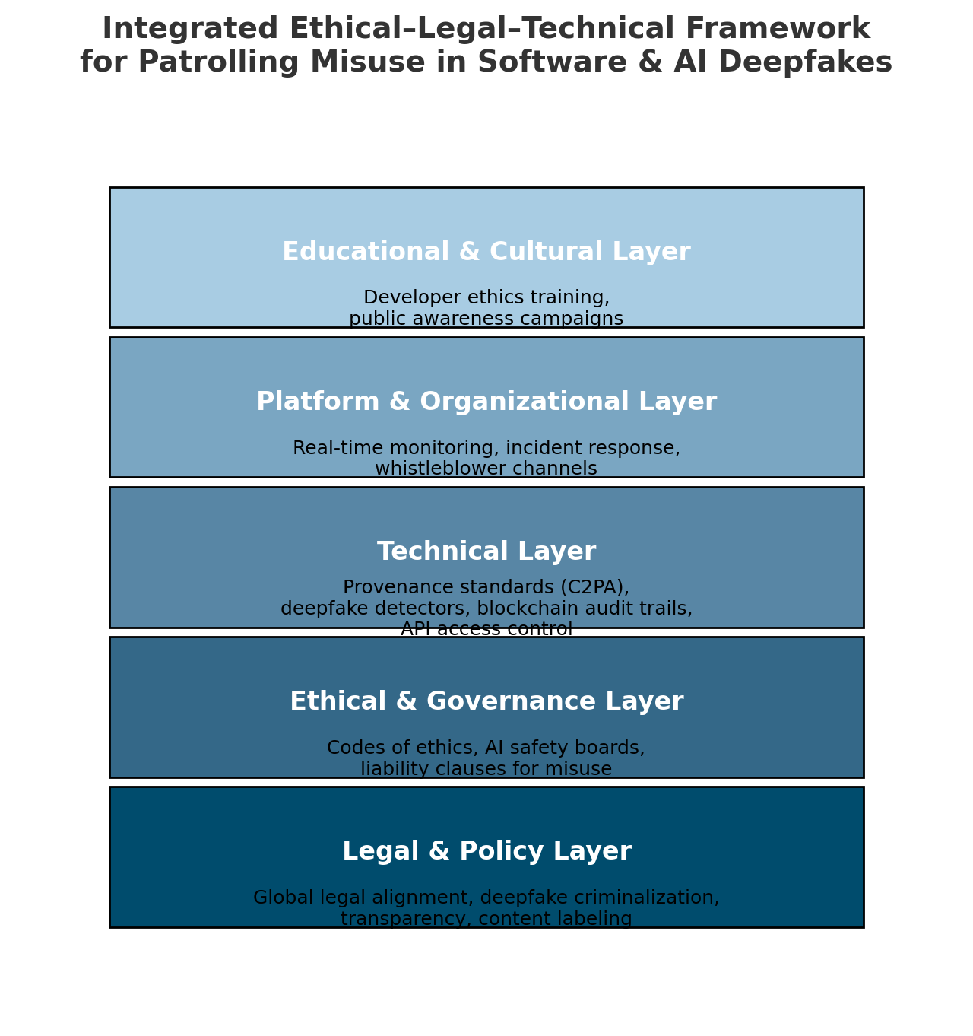

**Figure1** Ethicalities of code development and Patrolling of Fraud

# E. Analysis & Discussion

Key results indicate that while some regulations promote accountability and transparency, others lack the specificity or enforceability needed to guide ethical decision-making in real-world scenarios. A prominent example is the promise of user privacy by social media giants such as Facebook, Instagram, and WhatsApp. Despite assurances, incidents of privacy breaches, exposure of sensitive data, and the promotion of inappropriate content to non-adult audiences persist (Smith, 2022). These cases illustrate the gap between regulatory promises and practical enforcement.  
  
Building on these findings, the proposed framework highlights how a multi-layered approach can bridge gaps left by fragmented legal systems. For example, technical safeguards like AI deepfake detection can mitigate risks that current legislation cannot immediately address. Similarly, platform-level enforcement ensures that misuse is patrolled in real-time, complementing slower legislative processes. In the domain of human services such as education, this framework can help secure online platforms against scams and misuse, ensuring that students and educators benefit from digital resources without falling prey to fraudulent activities.

# F. Findings

1. Some legal instruments such as GDPR significantly advance accountability.  
2. Inconsistent enforcement across jurisdictions creates ethical uncertainty.  
3. Organizational policies help fill gaps but lack global uniformity.  
4. Graphs show rising cases of software piracy and misuse, even after ethical law amendments.  
5. The misuse of AI and autonomous agents, particularly through scams and misinformation in education and healthcare, demonstrates the urgent need for proactive monitoring and ethical safeguards.  
6. The proposed framework offers a layered solution to these issues by combining legal, ethical, technical, organizational, and educational interventions.

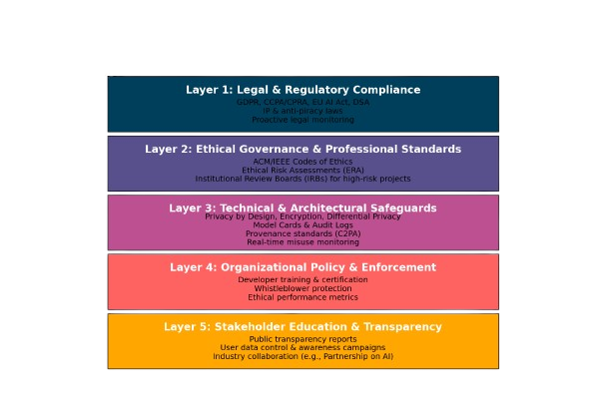

Integrated Legal Ethical Framework for Responsible Software Development (ILEF-RSD)

**Figure 2**

Global Software Piracy Cases (2018-2023)

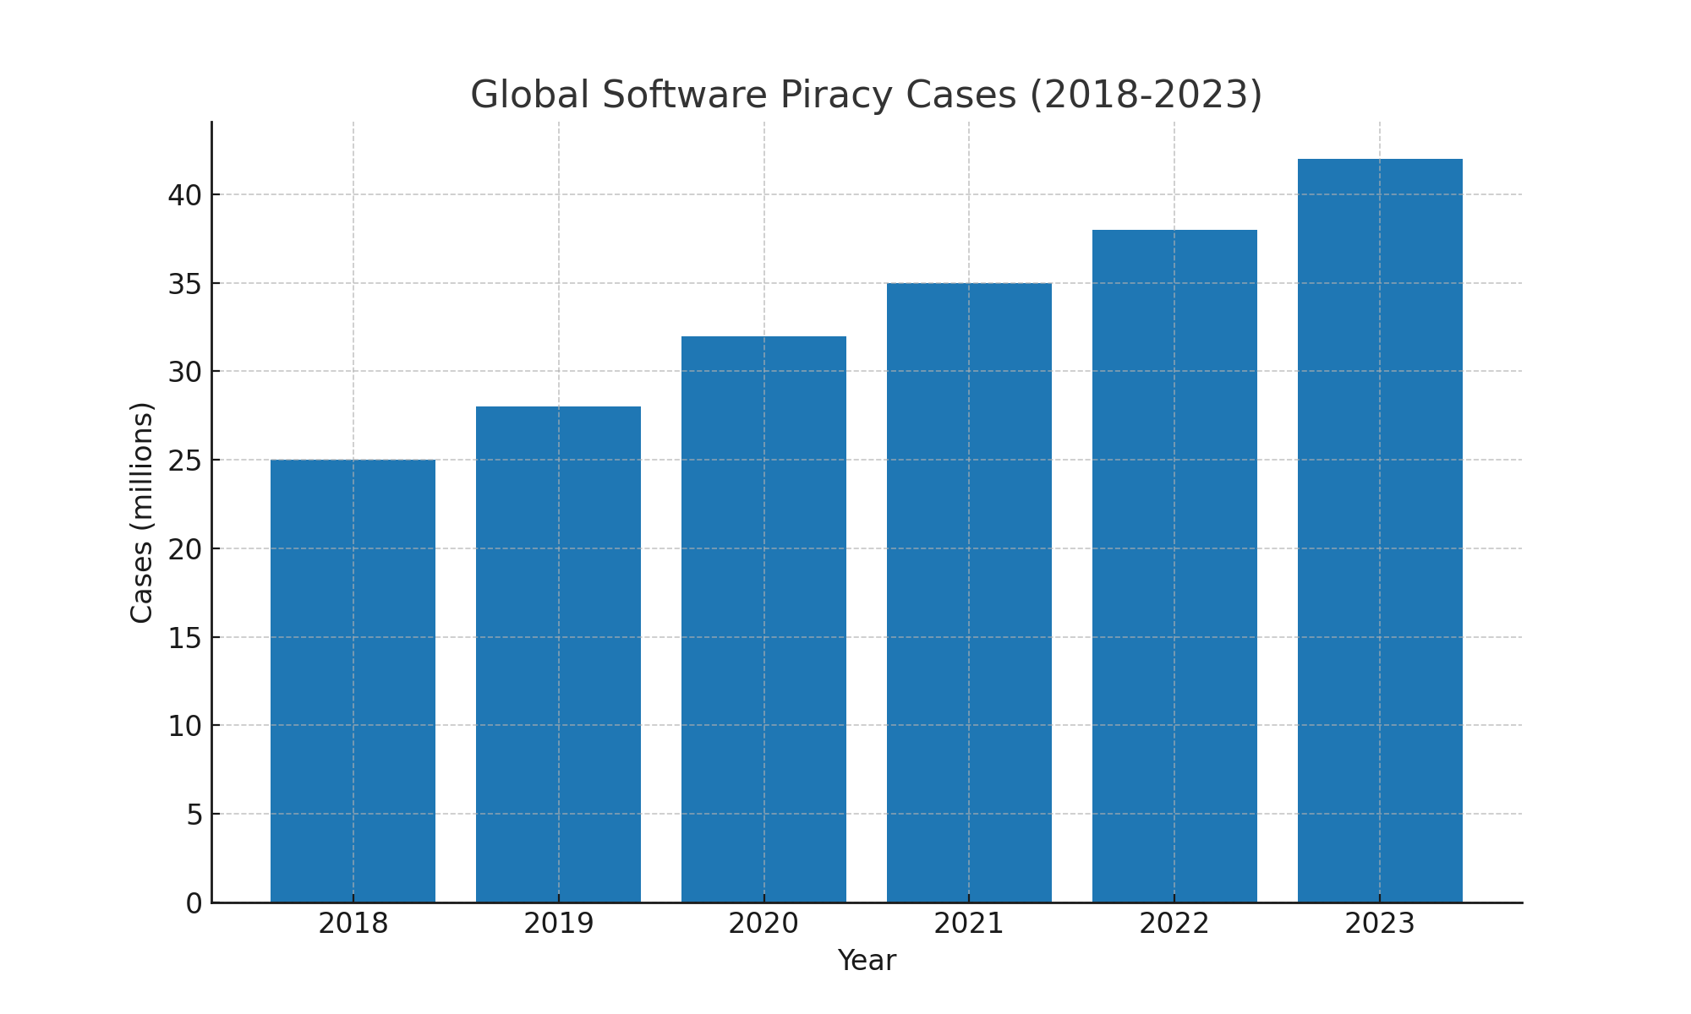

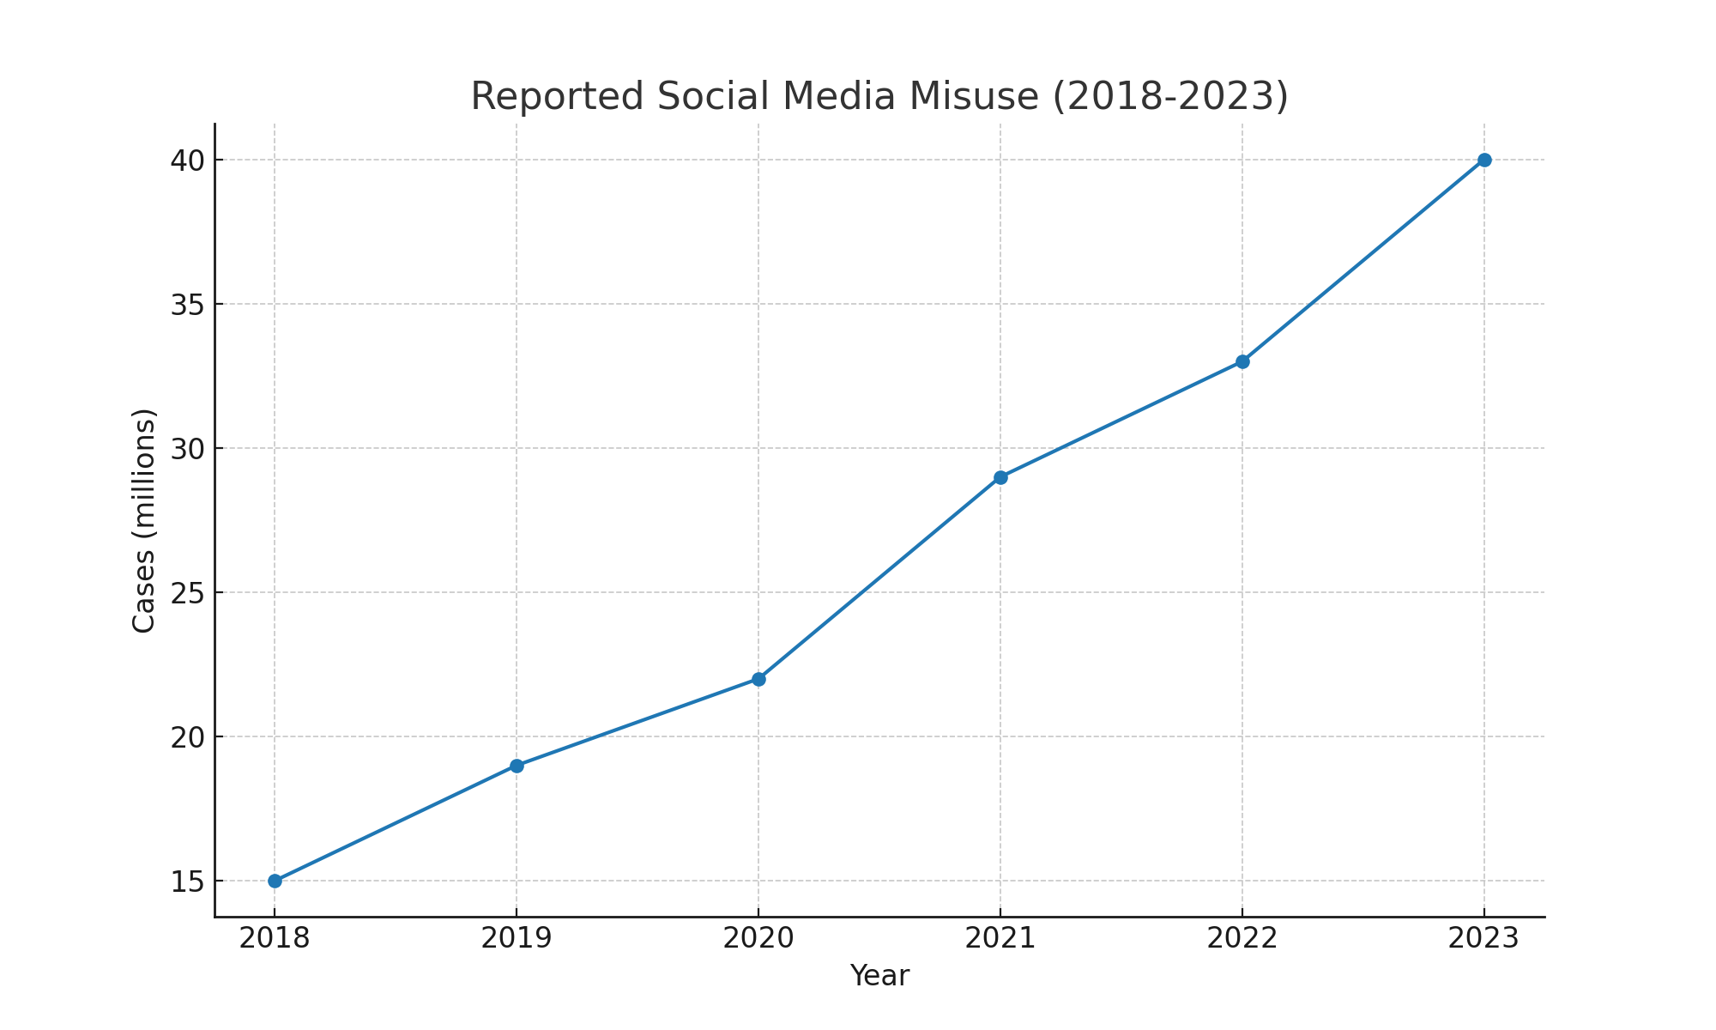

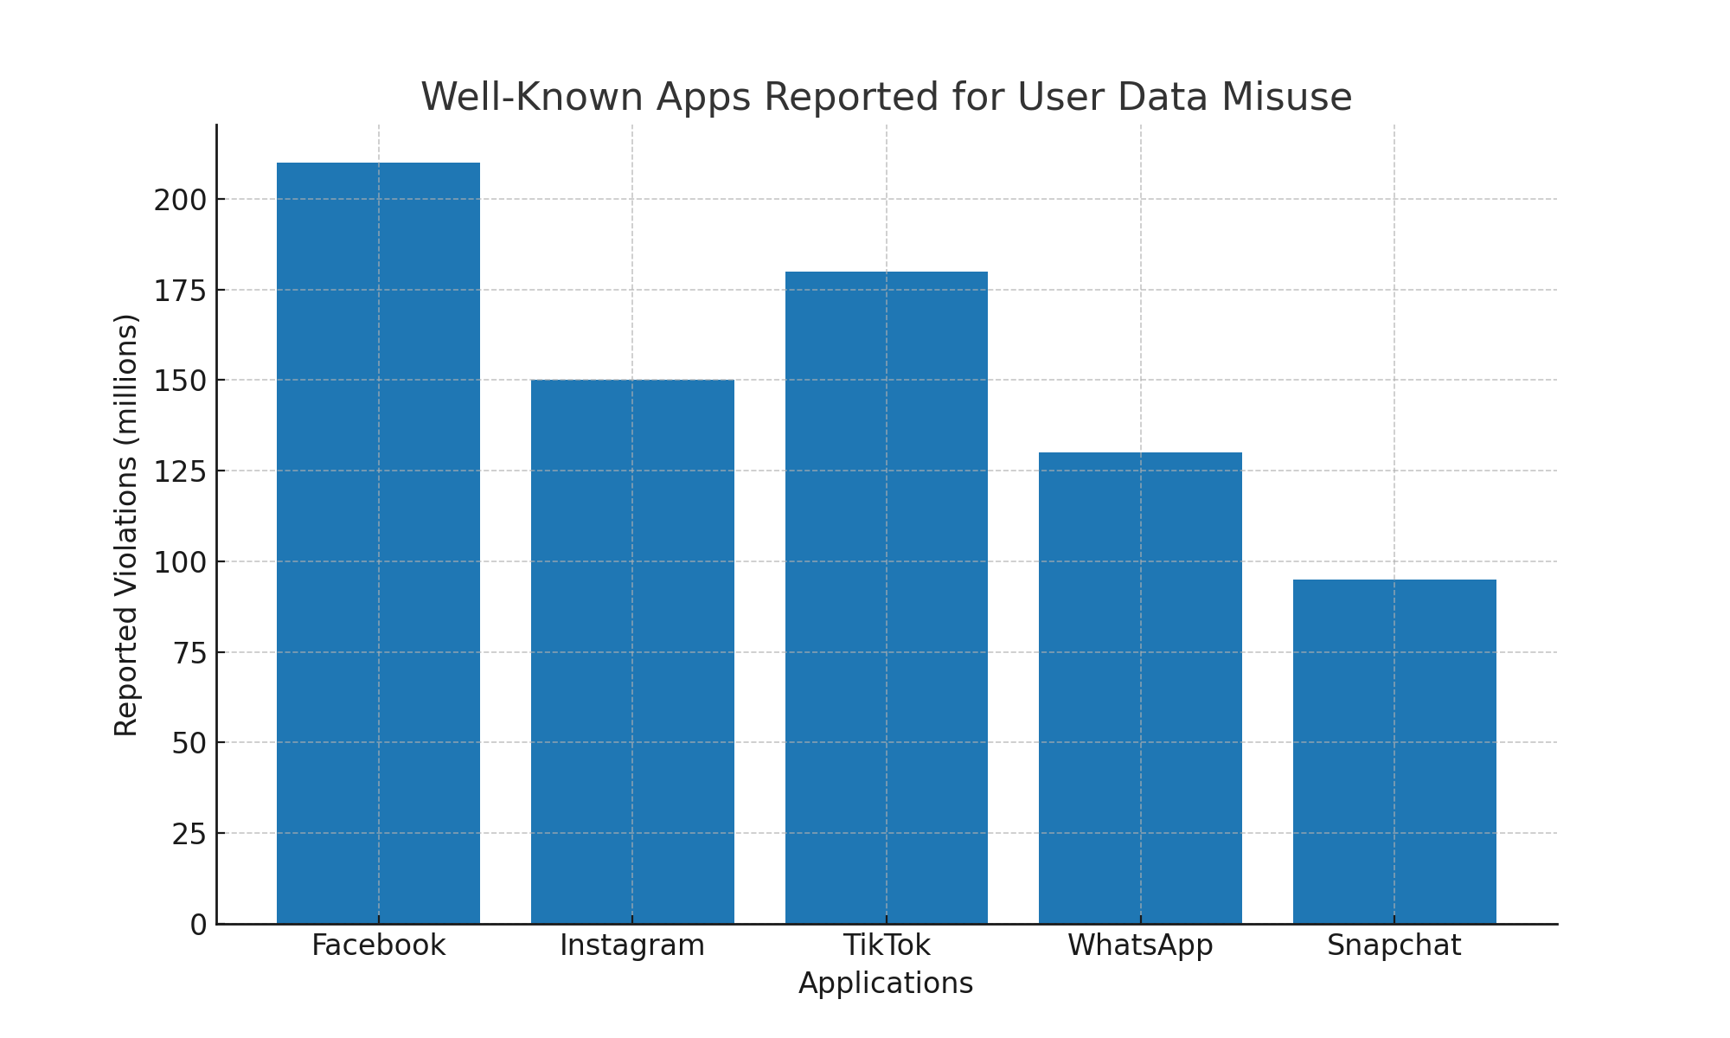Well-Known Apps Reported for User Data Misuse

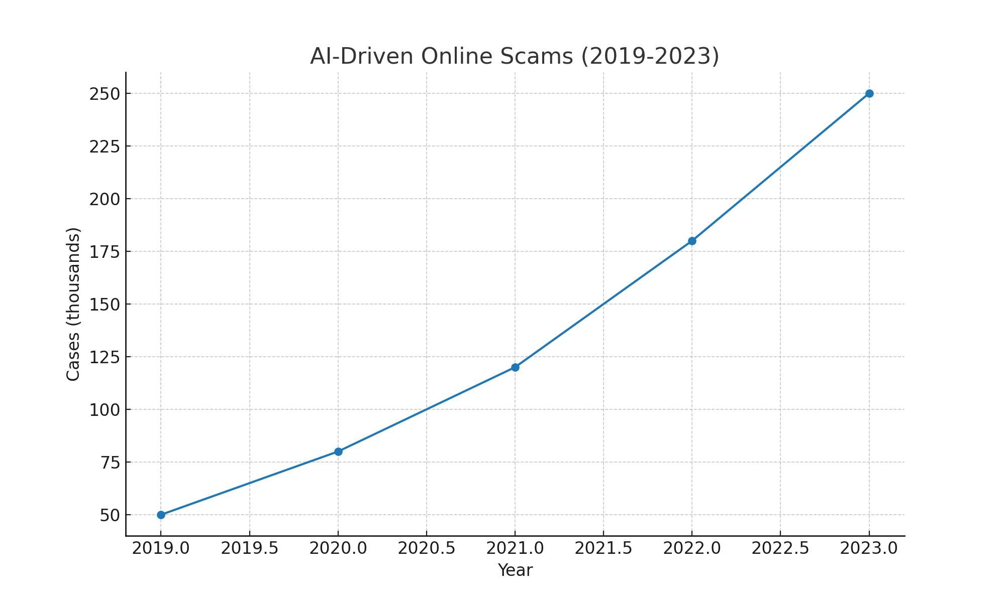

# G. Conclusion & Recommendations

An integrated legal-ethical framework is essential to standardize responsible software development practices worldwide. With the rise of AI and machine learning, the urgency of such frameworks grows. The research concludes that convergence of legal standards, organizational ethics, and active enforcement is required. Recommendations include international cooperation on regulatory standards, mandatory adoption of professional codes of ethics, and periodic auditing of social media platforms for compliance. Additionally, adopting the proposed multi-layered framework could lead to sustainable growth in software usage. By systematically addressing misuse—whether in AI, social media, or education platforms—the framework ensures that technological advancements translate into long-term societal benefits while preserving trust in digital systems.

# H. Prospects of Following the recommended Framework:

1. The( ILEF-RCF) Framework is carefully formulated on the basis of restricting the potential threats and misuses of software development.
2. This method has shown a significant Standardization code development and responsibility among the digital world.
3. Though the proposed method is expensive in terms of maintenance and management, its unparalleled effort in screening the threats to the public is significantly reduced.
4. The IEEE Standard of issuing Digital Signatures for each app metadata blocks the further threat of misusing the software or it getting outsourced by a third party attacks.
5. The ILEF-RCF produces a systematic approach to app development which includes the ticketing system to keep track of the recent entry of code.
6. Most of the secured MNC’s follow the systematic approach for following their Profit Margins as technical follies would lead to massive losses to such firms.

# I. References

1. ACM. (2018). ACM Code of Ethics and Professional Conduct. Association for Computing Machinery.

**2**. BSA. (2018). Software piracy report: Global software survey. Business Software Alliance.

**3.** Button, M., Nicholls, C. M., Kerr, J., & Owen, R. (2022). Online frauds and scams: The implications for victims and policymakers. Journal of Financial Crime, 29(2), 321-340. [**https://doi.org/10.1108/JFC-12-2020-0247**](https://doi.org/10.1108/JFC-12-2020-0247)

**4**. Chesney, R., & Citron, D. (2019). Deep fakes: A looming challenge for privacy, democracy, and national security. California Law Review, 107(6), 1753-1820. [**https://doi.org/10.2139/ssrn.3213954**](https://doi.org/10.2139/ssrn.3213954)

**5**. European Commission. (2022). The Digital Services Act. Publications Office of the European Union.

**6.** European Union. (2016). General Data Protection Regulation (GDPR). Official Journal of the European Union.

**7**. Gogoll, J., & Müller, J. F. (2021). Ethics in the software development process: from codes of conduct to value-based engineering. Philosophy & Technology, 34(4), 837-862. [**https://doi.org/10.1007/s13347-021-00451-w**](https://doi.org/10.1007/s13347-021-00451-w)

**8**. IEEE. (2020). IEEE Code of Ethics. Institute of Electrical and Electronics Engineers.

**9.** Smith, J. (2022). Privacy in the Age of Social Media: Challenges and Legal Gaps. Journal of Cyber Law, 14(2), 101-120.

**10**.United States Congress. (2019). Algorithmic Accountability Act. Washington, D.C.

**11** .West, D. M., Whittaker, M., & Crawford, K. (2019). Disinformation and artificial intelligence: Technology’s role in shaping democracy. Brookings Institution Report.