Mira — Architecture Writeup
AI-Powered Project Intelligence Assistant · Nexora Pvt. Ltd. · Q2 submission · Rosh

Problem
Nexora's few PM/TPMs run 3–5 concurrent client projects and build plans (3–4 hrs each), weekly status reports (1–2 hrs each) and risk assessments by hand, inconsistently, from each project's task board and files. Mira is an internal drafting assistant that generates these artefacts from a project's own description, timeline, risk register and task board, so a PM edits a grounded draft instead of starting from scratch. The governing risk is fabrication: an invented milestone, task status or risk is worse than no tool, so every agent is built to refuse rather than guess.

Architecture
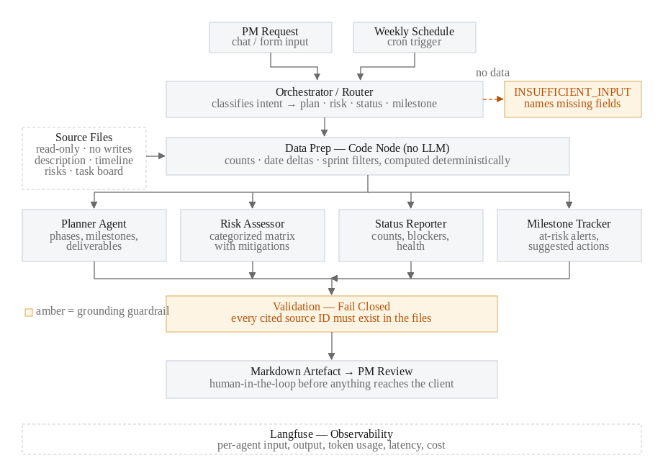

Tool Selection
Category | Choice | Why
Platform | n8n | Visual canvas meets the screenshot/JSON-export requirement; Code node runs counting and date logic outside the LLM.
LLM | gpt-4o-mini | Work is extraction, classification and templated generation over small inputs; cheap, fast, the playbook's default.
Ingestion | n8n file/CSV nodes | All inputs are local text/CSV; no OAuth removes the largest build risk.
Observability | Langfuse | Per-agent input/output visibility; free tier; all 5 LLM components traced.
Output | Markdown | Renders in the submission, diffs cleanly in Git.

Orchestration: Router / Dispatcher
The four request types (plan, risk, status, milestone) need different files, output schemas and guardrails, and no request needs several agents collaborating, so a Router fits better than a sequential pipeline (not every request touches every capability) or a hierarchy (nothing to decompose). The Router is a temperature-0 classifier that reads the request and a manifest of loaded files, returns a JSON intent, and refuses (INSUFFICIENT) when no valid intent or required file exists, so vague requests are stopped before any generating agent runs. Counting, sprint filters and date arithmetic run in a deterministic Data Prep Code node; the agents only narrate.

Agents
Agent | Input → Output | Key rules
Router | Request + file manifest → JSON intent, target, missing | Never guess an intent; valid question with no data is INSUFFICIENT.
Planner | Description + timeline → phase table with source per row | No phases, goals or dates beyond CONTEXT; refuse if scope is missing.
Risk Assessor | Description + risk register → risk matrix + coverage note | Every risk traces to a register row; no generic AI risks.
Status Reporter | Precomputed counts + tasks → weekly report, health rating | Repeat supplied figures exactly; stay in requested sprint scope.
Milestone Tracker | Timeline + precomputed windows → upcoming, at-risk, blocked | Never compute a date; state the anchor date used.

Cost Analysis
gpt-4o-mini at $0.15 / $0.60 per 1M input/output tokens; token counts from the baseline outputs and one logged run (Status Reporter: 2,577 in + 282 out), with other inputs derived from measured prompt lengths.
 | Router | Planner | Risk | Status | Milestone
Input / output tokens | ~640 / 34 | ~1,326 / 510 | ~1,575 / 618 | 2,577 / 282 | ~1,497 / 188
Cost per run | $0.000116 | $0.000505 | $0.000607 | $0.000556 | $0.000337
Typical request (Router + one specialist) ≈ $0.00062. At 20 requests per PM per day: about $0.0124 per PM per day, or $0.37 per PM per month. Langfuse is on its free tier.

Evaluation Strategy: 3 Production Metrics
- Plan groundedness: % of plan phases/milestones whose source citation resolves to the timeline or description. Target 100%.
- Risk relevance: % of risks that trace to the risk register rather than generic boilerplate. Target ≥90%.
- Status accuracy: % of reported counts matching the task board exactly. Target 100%, by construction (computed in code).

Testing Observations
All 12 baseline tests pass with 0 confirmed hallucinations (4/4 refusal cases correct). Five defects were found via traces and fixed: a sprint filter not reaching scoped data (T5); an override reader mistaking a task's sprint column for a filter (T10); a refusal that dropped its follow-up text because the rule sat too deep in the prompt (T4); series-instead-of-parallel CSV reads that produced 200 duplicate items and hid the blocked task (T11); and run-to-run variance in the Planner (T1), fixed by temperature 0.2. All were wiring or prompt-completeness gaps, not invented facts. Known gaps: the Milestone Tracker has no Overdue output slot, top-N risk ranking is positional (no severity field), and Langfuse cost/latency understate real values because the tracing payload carries placeholder input and identical timestamps.

