Mira — Architecture Writeup
AI-Powered Project Intelligence Assistant · Nexora Pvt. Ltd. · Capstone: Applied Agentic AI for PMs/TPMs
Q2 Build submission, Step 7.1 · Author: Rosh

Problem Summary
Nexora Pvt. Ltd., a London-based software and IT services firm, is delivering a 6-month, 8-phase AI Adoption Project for its client ABCDE Ltd., a logistics and supply-chain company — but the small team of PMs/TPMs running Nexora's concurrent client engagements produces plans, risk matrices, and status reports manually, spending 3–4 hours per project plan and 1–2 hours per weekly status report, with risk assessment left inconsistent across the portfolio. Mira is an internal drafting assistant that generates these artefacts directly from a project's own description, timeline, risk register, and task board files, so a PM edits a grounded first draft instead of building one from scratch. The governing risk is fabrication: a fast tool that invents a milestone, task status, or risk is worse than no tool at all, because it hands the PM an unearned reviewing burden while appearing authoritative — so every agent in Mira is designed to refuse rather than guess when its input is insufficient.

Architecture Diagram
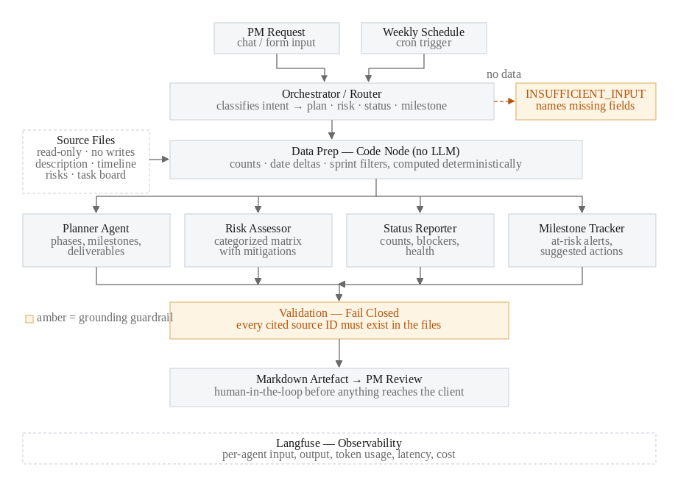
The Orchestrator/Router sits at the entry point exactly as designed here, classifying every request into plan / risk / status / milestone (or INSUFFICIENT_INPUT) before any specialist agent runs; the Data Prep code node performs all counting and date arithmetic deterministically, so the four specialist agents underneath narrate rather than calculate; and every generated artefact passes a fail-closed source-citation check before reaching the PM for review.

Tool Selection & Rationale
Category | Choice | Why
Workflow platform | n8n | Visual canvas satisfies the screenshot/JSON-export submission requirements natively. Its Code node lets counting and date logic run deterministically outside the LLM. Native scheduling and CSV nodes remove plumbing work.
LLM | gpt-4o-mini | Mira's work is extraction, classification, and templated generation over small inputs, not deep reasoning. Cheap and fast, and the playbook names it the best default.
Data ingestion | n8n file + CSV nodes, no auth | All inputs are local text/CSV files. Avoiding OAuth removes the largest source of build risk in a fixed timeline.
Observability | Langfuse | Per-agent input/output, token, latency, and cost visibility via the legacy ingestion API. Free tier sufficient; connected across all 5 workflow components (Router + 4 specialists).
Output format | Markdown | Renders directly in the submission, diffs cleanly in Git, needs no export integration.
Task board source | CSV upload only (no live Trello/Jira API) | Explicitly optional in the brief; deferred to keep the auth surface at zero for v1.

Orchestration Pattern: Router / Dispatcher
Mira routes every request through a classification step because the four request types — project plan, risk assessment, status report, and milestone/blocker digest — are genuinely different jobs: each needs a different subset of source files, produces a different output schema, and carries its own hallucination guardrails. A sequential pipeline doesn't fit because not every request touches every capability (a status question shouldn't trigger risk analysis), and a hierarchical pattern doesn't fit either, since no single user request in Mira's scope decomposes into multiple agents collaborating on one answer — the Router always resolves to exactly one specialist, or to a refusal.
The Router itself is a temperature-0 classification-only LLM call: it reads the request text and a manifest of which source files are currently loaded, and returns a JSON object naming the target agent, any extracted parameters (sprint, horizon, audience), and — critically — a list of missing requirements when the request is underspecified. When intent resolves to INSUFFICIENT, the Switch node's fallback path returns the missing-file explanation directly, without ever invoking a generating agent. This means the routing decision itself is a second, independent hallucination guardrail: a vague request is refused before it reaches an agent capable of inventing content, not just discouraged from inventing once inside one.

Agent Descriptions

Router / Orchestrator
Classifies the incoming request against a fixed manifest of loaded files. Input: request text + file manifest. Output: JSON with intent, target_agent, extracted parameters, and missing (populated whenever intent is INSUFFICIENT). Key rule: never guess an intent to keep the pipeline moving — a valid question with no backing data is still classified INSUFFICIENT.

Planner
Converts a project description and timeline CSV into a phased project plan. Input: project_description.txt + project_timeline.csv. Output: one Markdown table row per phase, each citing its source file and phase number. Key rules: never add a phase absent from CONTEXT even where standard methodology suggests one; never assign a date unless CONTEXT supplies it; if the description lacks a stated scope or objective, return the fixed INSUFFICIENT_INPUT block rather than a partial plan.

Risk Assessor
Produces a categorized risk matrix from the project's own risk register. Input: project_description.txt + project_risks.csv. Output: one row per risk (ID, category, risk, impact, mitigation, source), plus a coverage note. Key rules: every risk must trace to a register row or an explicit sentence in the description; no generic AI/software risk may be added beyond what the register supplies.

Status Reporter
Narrates precomputed task-board aggregates into a weekly status report; it performs no arithmetic itself. Input: Data-Prep output (counts, blocked items, overdue items, scope filter) plus the underlying task records for that scope. Output: counts, completed/in-progress/blocked/overdue sections, and a Green/Amber/Red health rating with the rule that produced it. Key rule: never include a task outside the requested sprint or date scope, and quote blocking reasons verbatim rather than speculating about cause.

Milestone Tracker
Reports which timeline milestones fall within a horizon window and which tasks are blocked, from precomputed window dates. Input: timeline records, the project start anchor, reference date, horizon in days, and precomputed blocked/overdue lists. Output: upcoming-milestones, at-risk, and blocked tables. Key rule: never calculate a date itself — all window dates and day counts are supplied precomputed, and the agent must state the anchor date it was given.

Cost Analysis
Estimated using gpt-4o-mini's published pricing ($0.15 / 1M input tokens, $0.60 / 1M output tokens) applied against real input/output text from the 12 baseline tests and one directly logged trace (Status Reporter, full-board run: 2,577 prompt + 282 completion tokens), rather than a blind guess. Input token counts for the other four agents were derived by measuring each system prompt's actual length and adding a per-row token cost inferred from that same logged trace (~77 tokens per task/timeline/risk row).
Agent | Input tokens | Output tokens | Cost / run
Router (classification) | ~640 | ~34 | $0.000116
Planner | ~1,326 | ~510 | $0.000505
Risk Assessor | ~1,575 | ~618 | $0.000607
Status Reporter | 2,577 (logged) | 282 (logged) | $0.000556
Milestone Tracker | ~1,497 | ~188 | $0.000337
A typical end-to-end request (Router classification + one specialist call) costs approximately $0.00062. At an assumed 20 requests per PM per day, that is roughly $0.0124 per PM per day, or about $0.37 per PM per month — negligible against the 3–4 hours per plan and 1–2 hours per weekly status report Mira is intended to reclaim. Observability (Langfuse) runs on its free tier for this volume.

Evaluation Strategy: Production Metrics
Three metrics, chosen because each is directly measurable from the source-citation discipline already built into every agent's output contract, rather than requiring separate instrumentation:
- Plan groundedness — the percentage of milestones/phases in a generated plan whose Source citation resolves to a real row in project_timeline.csv or a stated sentence in project_description.txt. Target: 100%; any breach is a defect, not a tolerance. Baseline evidence: T1 correctly limited output to the 8 supplied phases and declined to state an uncited duration.
- Risk relevance — the percentage of generated risks that trace to a row in project_risks.csv, as opposed to a generic AI/software risk with no register source. Target: ≥90%. Baseline evidence: T3 traced all 10 risks to their register rows with zero additions; T7 surfaced a known limitation — without a severity field in the register, a top-N ranking request can't be verified as reasoned rather than positional, which is worth tracking as a false-relevance risk even when nothing is technically fabricated.
- Status accuracy — the percentage of reported task counts that match a fresh pull of the task board CSV exactly. Target: 100%, and achievable by construction since counts are computed in the deterministic Data Prep Code node, not by the LLM. Baseline evidence: T10 matched ground truth exactly (5/3/16/1/25); T5 and T11 each failed on a first attempt due to wiring bugs in that same deterministic layer, not model hallucination, and passed after the wiring was fixed.

Testing Observations
All 12 baseline tests pass, with zero confirmed hallucinations across the set. Five defects were found and fixed during evaluation, and all five were either scoping/wiring bugs in the deterministic Data Prep layer or prompt-completeness gaps — none were the model inventing a fact from nothing:
- T5 (Sprint 3 status): the sprint filter wasn't propagated into the scoped data structures the agent was reading, so the header said “Sprint 3” while every list underneath was the full 25-task board. Fixed by computing counts, tasks_by_status, blocked, and overdue from a single sprint-aware scopedTasks list.
- T10 (whole-board counts): an early Data Prep bug read config overrides from the first input item, mistaking a task row's own sprint column for a filter. Fixed by ignoring override reads on items that carry task_id, phase, or risk_id.
- T4 (Risk Assessor refusal): the refusal returned only the bare word INSUFFICIENT_INPUT, dropping its required follow-up text, because the refusal rule sat after five ADDITIONAL RULES in the prompt. Fixed by moving it immediately after the global rules and adding an explicit line barring a single-word response.
- T11 (Milestone Tracker blocked-task detection): the task-board and timeline CSV reads were wired in series rather than parallel, so the timeline parse re-ran once per task row, producing 200 duplicated items and silently dropping every task field — the agent reported “no tasks are blocked” despite T024 genuinely being blocked. Fixed by rebuilding the ingestion as two parallel branches joined by a Merge node in Append mode.
- Reproducibility (Planner, T1): an identical prompt returned six goals on one run and three on another, both defensible readings of the same description. Not a hallucination, but a consistency concern; fixed by lowering temperature to 0.2 on the generative agents.
One design gap was flagged rather than “fixed”: the Milestone Tracker's output template has no Overdue section, so T006's overdue status — supplied correctly in its CONTEXT — is never surfaced by that agent. This is the agent correctly following its output contract, not an omission on its part; it is a prompt-design inconsistency (an input declared with no corresponding output slot) worth resolving in a v2 by either adding an Overdue section or explicitly assigning overdue reporting to the Status Reporter.

