Dynamic Table – Assignment 1

Aim: To simulate the working of a dynamic table in C and find optimum insertion and deletion factors.

Solution:
1. If the number of elements in a dynamic table array reaches the maximum, it will be increased in size by a mentioned factor.

2. In order to not use extra memory, if the number of elements reaches a paricular lower threshold, the size will be reduced to an appropriate value.

3. The code assumes equally likely operations of insertion and deletion (this can be changed in the code)

4. The initial structure which houses the dynamic table is defined as follows:

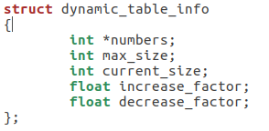

5. This structure is initialised as follows:

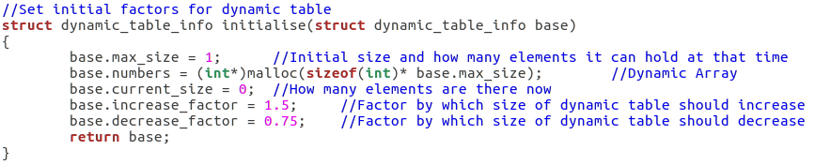
6. A sequence of operations is defined as an array of I’s and D’s which denote that in Insertion or deletion has to be performed. This array is read sequentially and appropriate operation is performed.

Conclusions and Results:

1.Time for Insertion, Deletion, Total, Average and Max were recorded as follows:

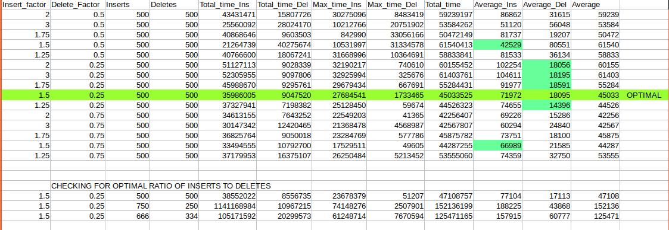
2. The minimum time was taken for insertion when the size of the dynamic table was increasing by 1.5 and decreasing by 0.25 times itself.

3. Also, we could conclude that on an average, insertions take moretime than deletions as in some cases all elements need to be copied and stored, this operation could take more time.

4. More number of insertions increases the total time taken as seen in 2nd table.

5. On resizing an array created through malloc, if required memory is available in the same location, reallocation occurs with the pointer pointing to the same address. But if there is no contiguous memory available, the allocation happens elsewhere and a new address is returned.

6. A 50-50 ratio of inserts to deletes maintains best timing as more number of inserts increases the time.

7. The overall cost for an insertion is more than that for a deletion irresplective of the current and max size of the dynamic table.

