HANGWORD – The Word Game.
Run instructions:
gcc -w code.c
./a.out

Introduction:
Hangword is a game in which a user has to guess a word one letter at a time, sequentially starting from the first letter going up to the final letter of the word. This word is chosen by the compiler at random and every word selected has to make sense.

This game idea is a creation by the group members and is implemented in the C language. This game aims to test the vocabulary of a user and give him a score based on how many guesses he takes to guess the right word.

The game consists of 3 levels:
1. Level One for four-lettered words.
2. Level Two for five- lettered words.
3. Level Three for six- lettered words.

A user can play the game as many times as he likes. The game is menu driven and the user can pick whichever of the three levels he wants to play. If he chooses to end the game, a summary of his game play along with the points he scored is displayed.

Methodology:
We have used trees, queues and linked list concepts to implement this project. The algorithm and flow of our project is as follows:
STEP 1 - Consider a tree hard coded into a system such that every word in the tree (read root to leaf) makes sense.

STEP 2- From the root, randomly, a child is selected for each level until the leaves. The letters are inserted in order into a queue, starting from root towards the leaves.

STEP 3- The user is then asked to guess the first letter of the above randomly generated word from 4 options given. If he fails to guess the letter, he loses a point. Eventually when the user guesses all the letters, the word he has guessed is stored into a linked list, along with the points he has scored.

STEP 4- He is asked if would like to play the game again, if yes, another random word is generated. If he does not want to play again, then the game ends and the words he guessed correctly are displayed along with the score for that word and the final score.
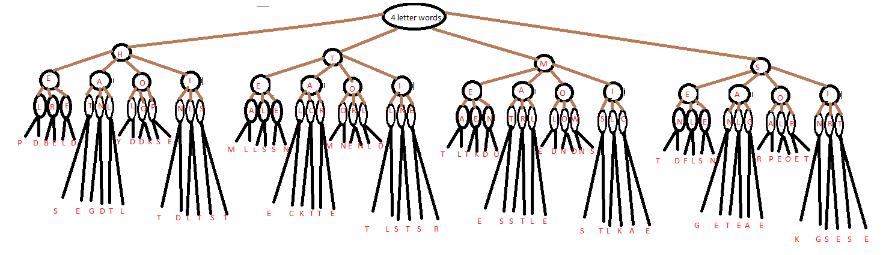
A sample tree which we have used to store 4 letter words

Implementation:
- Consider a tree like the one above. In this tree, starting from the root node, any child you select until you reach a leaf node, if you keep track of the letters passed, you get a meaningful word in all cases
- We have functions make_tree_4(), make_tree_5() and make_tree_6() which store this tree with its values in memory.
- There are function four(), five() and six() which randomly generate the word from the tree as follows: Consider the above tree shown in the figure. There is a pointer which first points to the root of the tree. This node has 4 children.
- A number between 0 and 3 (inclusive) is randomly generated using the rand() function. Suppose 0 was generated, the pointer then moves to the 0th child of the root( ie H)
- This letter H is stored in a queue. Subsequently at the next level, the compiler has to choose again between 4 child nodes and the procedure of random selection and traversal is performed again and the letters passed are sequentially stored in the queue.
- Eventually as a sample, we get a queue which looks like this:
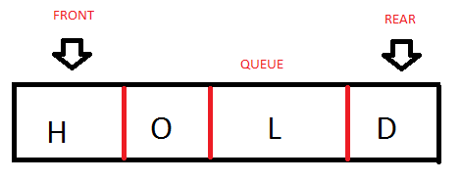

- In this case, the random numbers generated would have been 0,2,0,1. Hence, hold is stored in the queue.
- The next part of the code is where the user guesses the word one letter at a time.

GUESSING THE WORD:
- The user is given 4 options to guess the first letter of the word. One of these letters is the correct answer (taken from above mentioned queue). The rest of the letters are got by randomly generating 3 numbers between 0 and 25 and adding 65 to convert them to an ASCII value of an uppercase alphabet.
- Thus we now have 4 options the user can guess from. To make it harder for him, we arrange the letters alphabetically so that no patterns in option ordering can be detected. We have also handled the case of duplicate values being selected.
- The user on selecting a level is prompted with 4 options. If he enters aletter which is not one of the given options, he is asked to try again but points are not deducted. But if he enters a letter which is a part of the given options then his score for that particular word is deducted by one point and he is asked to guess again. Scoring scheme is mentioned in detail later.
- If he guesses the letter correctly, we move on to the next letter, options are generated and the user is made to guess the next letter. This continues until the whole word is guessed.
- Once the user has guessed all the letters of the word, the word is stored in a linked list along with the points he has scored for that word.
- Upon guessing all letters, the user is prompted with two options. He can either play the game again with a different word and is asked which level he wants to play or he can exit the game at which point he’s shown the words he guessed correctly and the score he got.
- He is also shown the total points he has scored.

SCORING METHODOLOGY:
- The scores are based on how many incorrect guesses the user has made until he gets the whole word correct.
- 4 letter words are scored on 12, 5 letter words on 15 and 6 letter words on 20.
- Every time the user guesses incorrectly, a point is reduced.

Future Enhancements:
- To increase the number of words that can be selected.
- To increase word length to accommodate more complex words.
- To not hard code the tree and develop an algorithm which directly ready the letters from a figurative tree stored in a .pdf/ .jpg file.
- Make the user terminal more interactive with the use of graphics and design.

Sample output:
Welcome to HANGWORD
_____________________________________________________________________________
This is a word guessing game, don't think it is easy, neither you nor me know what the word is. Its all the compiler's decision
On choosing a level, you will be given 4 choices of letters, only one of these
is the correct first letter of the word selected
This will continue until you guess all the letters of the word correctly and
you will be asked if you would like to play again
4 letter words are scored on 12 pointS, 5 letter words on 15 points and 6
letter words on 18 points. Wrong guesses cause a reduction in points.
ENJOY! and All the Best
Enter level:
1. for 4 letter words
2. for 5 letter words
3. for 6 letter words
1
CHOICES: E R S V
Enter your guess: R
TRY AGAIN. Wrong choice
Enter your guess: w
INCORRECT CHOICE ENTERED
Enter your guess: s
YOU GUESSED THAT LETTER RIGHT! S___
CHOICES: G I J T
Enter your guess: t
TRY AGAIN. Wrong choice
Enter your guess: i
YOU GUESSED THAT LETTER RIGHT! SI__
CHOICES: K N O W
Enter your guess: n
YOU GUESSED THAT LETTER RIGHT! SIN_
CHOICES: B D G K
Enter your guess: g
TRY AGAIN. Wrong choice
Enter your guess: k
YOU GUESSED THAT LETTER RIGHT! SINK
Do you want to continue?
Enter 1 to continue and zero to quit
1
Enter level:
1. for 4 letter words
2. for 5 letter words
3. for 6 letter words
2
CHOICES: H P S T
Enter your guess: p
TRY AGAIN. Wrong choice
Enter your guess: s
YOU GUESSED THAT LETTER RIGHT! S____
CHOICES: G O T Z
Enter your guess: o
YOU GUESSED THAT LETTER RIGHT! SO___
CHOICES: A H P S
Enter your guess: P
TRY AGAIN. Wrong choice
Enter your guess: A
YOU GUESSED THAT LETTER RIGHT! SOA__
CHOICES: D E H P
Enter your guess: P
YOU GUESSED THAT LETTER RIGHT! SOAP_
CHOICES: K S T Y
Enter your guess: Y
YOU GUESSED THAT LETTER RIGHT! SOAPY
Do you want to continue?
Enter 1 to continue and zero to quit
1
Enter level:
1. for 4 letter words
2. for 5 letter words
3. for 6 letter words
3
CHOICES: A C D V
Enter your guess: a
YOU GUESSED THAT LETTER RIGHT! A_____
CHOICES: F G P S
Enter your guess: p
TRY AGAIN. Wrong choice
Enter your guess: g
TRY AGAIN. Wrong choice
Enter your guess: s
YOU GUESSED THAT LETTER RIGHT! AS____
CHOICES: D H I J
Enter your guess: h
YOU GUESSED THAT LETTER RIGHT! ASH___
CHOICES: L M R S
Enter your guess: l
TRY AGAIN. Wrong choice
Enter your guess: m
YOU GUESSED THAT LETTER RIGHT! ASHM__
CHOICES: E F T X
Enter your guess: e
YOU GUESSED THAT LETTER RIGHT! ASHME_
CHOICES: A N O P
Enter your guess: n
YOU GUESSED THAT LETTER RIGHT! ASHMEN
Do you want to continue?
Enter 1 to continue and zero to quit
0
You have chosen to end the game thank you for playing
--RESULTS--
WORD:SINK
SCORE: 9
WORD:SOAPY
SCORE: 13
WORD:ASHMEN
SCORE: 15
Your total score is: 37

