PROJECT REPORT ON
IPL Vision – Cricket Analytics &
Real-Time Match Win Prediction Dashboard
An End-to-End Sports Analytics and Machine Learning Platform for Comprehensive Player Performance Tracking, Team Matchup Analytics, and Ball-by-Ball Win Probability Prediction

SUBMITTED IN PARTIAL FULFILLMENT OF THE REQUIREMENTS FOR
CONTINUOUS ASSESSMENT 2 IN DATA SCIENCE

SUBMITTED BY
Roshan Yadav (Roll No: 504) Member 2 (Division – RollNumber)
Member 3 (Division – RollNumber) Member 4 (Division – RollNumber)

SUBMITTED TO
Mrs. Shilpa Wankhede
Department of Information Technology
Data Science CA2 (October 2026)

Contents
Sr. No. | Title | Page No.
1 | Project Overview | 1
1.1 | Abstract | 1
1.2 | Background of the Problem | 1
1.3 | Project Motivation | 2
1.4 | Objectives and Outcomes | 2
2 | Dataset Description | 3
2.1 | Dataset Source | 3
2.2 | Features / Attributes | 3
2.3 | Preprocessing, Normalisation & Encoding | 4
3 | Technology Stack | 5
4 | Architecture Overview | 6
4.1 | Workflow Architecture | 6
4.2 | Step by Step Process | 7
5 | Results & Screenshots | 8
5.1 | Training & Testing Split | 8
5.2 | Model Evaluation Metrics and Accuracies | 8
5.3 | Output Screenshots | 10
6 | Executed Timeline | 13
7 | Conclusion | 14
7.1 | Summary of Work | 14
7.2 | Future Scope | 14
7.3 | Applications | 15
8 | Appendices | 16
8.1 | Appendix A: Case Study 1 – Death Over Chase Analysis | 16
8.2 | Appendix B: Case Study 2 – Bowler Nemesis Matchup Strategy | 17
9 | References | 18

List of Figures
Figure No. | Figure Name | Page No.
Fig 1 | Modern Sports Analytics: From Traditional Scoresheets to Data-Driven Decisions | 2
Fig 2 | IPL Vision End-to-End System Architecture: Data Ingestion to React Dashboard | 6
Fig 3 | IPL Vision User Interaction Flow & Machine Learning Inference Pipeline | 7
Fig 4 | Batter Analysis module displaying career KPI cards and season run breakdown | 10
Fig 5 | Batter milestone analytics showing boundaries per season and dismissal doughnut chart | 11
Fig 6 | Bowler Analysis dashboard with 10 KPI metric cards and season-by-season trends | 11
Fig 7 | Bowler phase analysis (Powerplay, Middle, Death) and opponent franchise breakdown | 12
Fig 8 | Team Analysis dashboard showcasing franchise match records and top performers | 12
Fig 9 | Ball-by-Ball Match Win Predictor interface displaying live probability duel bar | 13
Fig 10 | Detailed project execution timeline (Gantt chart breakdown) | 13
Fig 11 | Case Study 1: High-stakes death-over chase win probability progression | 16
Fig 12 | Case Study 2: Bowler matchup optimization for Jasprit Bumrah | 17

List of Tables
Table No. | Table Name | Page No.
Table 1 | IPL Deliveries and Matches dataset schema and attribute definitions | 3
Table 2 | Technology stack categorization showing tools, purpose, and alternatives | 5
Table 3 | Calibrated Support Vector Machine (LinearSVC) Model Validation Metrics | 8
Table 4 | Match Win Predictor Classification Performance Report | 9
Table 5 | Centralized Data Caching Benchmark: Memory and Execution Latency Impact | 9

CHAPTER 1:
PROJECT OVERVIEW

1.1 Abstract
IPL Vision is an advanced, full-stack cricket analytics and machine learning platform engineered to transform historical ball-by-ball tournament data into actionable sports intelligence. In modern limited-overs cricket, the difference between winning and losing often hinges on split-second tactical adjustments, player matchups, and situational awareness. This project bridges raw statistical telemetry with intuitive interactive visualizations and predictive intelligence.
The platform delivers four tightly integrated analytics modules: Batter Analysis, Bowler Analysis, Team Analytics, and a real-time Ball-by-Ball Match Win Predictor. Utilizing a historical dataset spanning over 1,095 matches and 260,000+ ball-by-ball deliveries, IPL Vision implements vectorized Pandas statistical computations to extract career trends, boundary profiles, phase-wise performance metrics (Powerplay, Middle, Death), and head-to-head bowler-batter vulnerabilities.
Furthermore, the system incorporates a Calibrated Linear Support Vector Machine (LinearSVC with Platt Probability Calibration) pipeline capable of predicting match win probabilities in real-time during 2nd-innings chases. The model achieves 80.69% accuracy with a 0.1331 Brier score on 103,833 ball-by-ball game states. Delivered as a modern decoupled web architecture featuring a high-performance Flask REST API and a responsive React 19 single-page application (SPA), IPL Vision demonstrates an end-to-end data science lifecycle from data ingestion to machine learning inference and interactive sports dashboard deployment.
1.2 Background of the Problem
The Indian Premier League (IPL) is the world's premier T20 cricket league, generating massive volumes of granular telemetry with every match. Over its 17-season history, billions of data points capturing bowler releases, ball trajectories, dismissal methods, and field restrictions have been recorded. However, traditional sports reporting and static box-score scorecards fail to convey the dynamic, non-linear ebb and flow of modern T20 cricket.
Cricket analysts, broadcast producers, and franchise coaching staffs face significant hurdles when attempting to query multi-season historical data in real time. Standard spreadsheets and fragmented statistical websites cannot easily cross-examine situational conditions—such as how a specific bowler performs during death overs (overs 16–20) versus powerplay overs, or which batters a bowler consistently dismisses. Furthermore, match probability during live chases is often governed by volatile factors including required run rates (RRR), wickets in hand, and venue conditions, which static metrics cannot model dynamically.
Without unified, automated platforms, stakeholders must manually clean datasets, handle franchise rebrandings (such as Delhi Daredevils becoming Delhi Capitals), and execute repetitive aggregations. Consequently, there is an urgent need for an automated, production-grade analytics platform that unifies multi-season player performance tracking, franchise head-to-head dynamics, and real-time machine learning win prediction into a seamless, high-speed interface.
1.3 Project Motivation
The motivation behind developing IPL Vision lies in demonstrating how modern data science, full-stack software engineering, and applied machine learning can solve complex, real-world sports analytics challenges. Cricket is inherently a game of numbers and situational probabilities; applying rigorous machine learning pipelines unlocks strategic insights that were previously inaccessible.
From an engineering standpoint, this project addresses critical architectural bottlenecks common in data science applications. Large transactional datasets (such as 27 MB ball-by-ball delivery files) frequently cause excessive RAM consumption and slow server startups when loaded redundantly across multiple modules. Solving this via centralized in-memory caching and singleton data loaders provided deep practical experience in production software optimization.
Moreover, designing a machine learning model capable of estimating real-time win probability required balancing statistical accuracy with millisecond-latency inference. Implementing an SVM classifier calibrated with cross-validated Platt scaling demonstrated how to convert complex high-dimensional hyperplanes into probabilistic outputs suitable for live broadcast graphics. Ultimately, IPL Vision bridges the gap between academic data science concepts and production-grade sports applications.
Fig 1 – Modern Sports Analytics: From Traditional Scoresheets to Data-Driven Decisions
1.4 Objectives and Outcomes
Project Objectives:
• Engineer an end-to-end full-stack cricket analytics platform featuring modular RESTful APIs and a decoupled responsive client dashboard.
• Process, clean, and normalize multi-season IPL datasets encompassing 1,095 matches and 260,000+ ball deliveries, harmonizing franchise name historical renames.
• Build deep statistical analytics modules for batters (runs per season, boundary distributions, milestones, strike-rate trends) and bowlers (career economy, bowling strike rate, phase-wise performance, and opponent matchups).
• Design, train, and calibrate a Support Vector Machine (SVM) pipeline to predict ball-by-ball win probabilities during 2nd-innings chases with over 80% accuracy.
• Optimize backend memory utilization through a centralized in-memory singleton data loader, slashing server RAM overhead by 66%.
• Implement dynamic, interactive client visualizations using Chart.js and Tailwind CSS for seamless data exploration.
Demonstrated Project Outcomes:
• Production-ready platform successfully deployed locally with Vite 6, React 19, and Python Flask 2.2.
• Reduced server peak memory footprint from 228.07 MB to 159.09 MB via centralized data caching.
• Trained Calibrated Linear SVM model achieving 80.69% accuracy and 0.1331 Brier loss on 103,833 delivery chase states.
• Fully functional modules: Batter Analysis, Bowler Analysis, Team Analysis, and Match Win Predictor.

CHAPTER 2:
DATASET DESCRIPTION

2.1 Dataset Source
The analytical foundation of IPL Vision is built upon comprehensive Indian Premier League (IPL) historical data sourced from official match telemetry repositories (Kaggle and Cricsheet). The dataset encapsulates ball-by-ball events and match-level outcomes across all IPL seasons from 2008 through 2024.
Dataset Ingestion Breakdown:
• deliveries.csv: 260,000+ ball-by-ball event records (~27 MB) detailing batter runs, extra runs, dismissals, bowlers, and fielders.
• matches.csv: 1,095 match-level records detailing dates, venues, toss decisions, match outcomes, winners, and victory margins.
• player_info.csv: Demographic records, batting styles, and bowling specialties across all IPL players.
• teams_info.csv: Franchise metadata, team abbreviations, and home venue details.
2.2 Features / Attributes
The table below outlines the primary schema attributes utilized across the data pipeline and machine learning workflows:
Attribute | Description | Data Type | Example
match_id | Unique identifier for each match | Integer | 335982, 1426312
inning | Inning of the match (1 or 2) | Integer | 1, 2
batting_team | Team currently batting (normalized) | String | Royal Challengers Bengaluru
bowling_team | Team currently bowling (normalized) | String | Chennai Super Kings
over | Over number in the innings (0-indexed: 0-19) | Integer | 0, 15, 19
ball | Ball number within the over (1-6) | Integer | 1, 2, 6
batter | Name of the batter on strike | String | V Kohli, RG Sharma
bowler | Name of the bowler delivering the ball | String | JJ Bumrah, Rashid Khan
batsman_runs | Runs scored off the bat on this ball | Integer | 0, 1, 4, 6
extra_runs | Extra runs conceded (wides, noballs, byes) | Integer | 0, 1, 5
total_runs | Total runs scored on this delivery | Integer | 0, 1, 6
is_wicket | Binary indicator if a wicket fell on this ball | Integer | 0, 1
dismissal_kind | Method of dismissal | String | bowled, caught, lbw, run out
target_runs | Target score for the 2nd innings chase | Integer | 185, 215
runs_left | Runs remaining to win the match | Integer | 42, 12
balls_left | Legal deliveries remaining in the chase | Integer | 24, 6
wickets_left | Wickets remaining in hand (10 - lost) | Integer | 6, 2
crr | Current Run Rate: (current_score * 6) / balls_bowled | Float | 8.94, 9.33
rrr | Required Run Rate: (runs_left * 6) / balls_left | Float | 10.50, 12.00
Table 1 – IPL dataset attributes describing deliveries, matches, and derived situational features
2.3 Preprocessing, Normalisation & Encoding
1. Franchise Name Harmonization: Over IPL history, multiple franchises underwent legal name changes and rebrandings. To ensure historical data continuity, standard mapping dictionaries were applied upon dataset load:
• Delhi Daredevils → Delhi Capitals
• Kings XI Punjab → Punjab Kings
• Royal Challengers Bangalore → Royal Challengers Bengaluru
• Rising Pune Supergiants → Rising Pune Supergiant
2. Ball-by-Ball Feature Engineering:
• Cumulative Score & Runs Left: Calculated by grouping 2nd-innings deliveries by match_id and calculating running cumulative sums of total_runs, subtracted from target_runs.
• Balls Remaining: Calculated as 120 minus total legal balls bowled (over * 6 + ball).
• Run Rate Telemetry: Current Run Rate (CRR) and Required Run Rate (RRR) derived dynamically per ball delivery.
3. Normalization & Categorical Encoding:
• Numerical Scaling: Features including runs_left, balls_left, wickets_left, target_runs, crr, and rrr undergo z-score standardization via scikit-learn's StandardScaler (mean=0, variance=1) to ensure unbiased hyperplanes in Support Vector Classifiers.
• One-Hot Encoding: Categorical columns (batting_team, bowling_team, city) are transformed using OneHotEncoder(sparse_output=False, handle_unknown='ignore'), enabling the model to learn team-specific strengths and venue biases.

CHAPTER 3:
TECHNOLOGY STACK

IPL Vision utilizes an enterprise-grade full-stack architecture combining a robust Python data engineering back-end with a modern React client single-page application. Python serves as the analytical engine, utilizing Pandas and NumPy for high-throughput vectorized data transformations. Scikit-learn provides machine learning pipelines, feature transformation abstractions, and support vector classifiers calibrated for probabilistic inference.
The back-end API is powered by Flask 2.2, configured with modular Blueprints (batter_routes, bowler_routes, team_routes, predictor_routes) and Flask-CORS to support asynchronous client communication. On the client side, React 19 bootstrapped with Vite 6 delivers blazing-fast client rendering and Hot Module Replacement (HMR). State management is orchestrated via Zustand, providing lightweight global state for selected players and teams. Data visualizations are rendered dynamically using Chart.js and react-chartjs-2, styled with Tailwind CSS v4.
Category | Technology | Purpose | Industry Alternatives
Frontend Framework | React.js 19 | Reactive single-page application user interface | Vue.js, Angular, Svelte
Build Tool | Vite 6 | Next-generation frontend dev server & bundler | Webpack, Turbopack, Rollup
Styling | Tailwind CSS v4 | Modern utility-first responsive styling | Bootstrap, Material-UI
Client State | Zustand 5 | Lightweight atomic state management store | Redux Toolkit, Recoil
Data Visualization | Chart.js 4 / react-chartjs-2 | Interactive Line, Bar, Doughnut, and Pie charts | D3.js, Plotly, Recharts
HTTP Client | Axios | Promise-based client-side HTTP communication | Fetch API, TanStack Query
Backend Framework | Python Flask 2.2 | RESTful API server with modular Blueprints | FastAPI, Django REST Framework
Data Processing | Pandas 2.2, NumPy 1.26 | In-memory DataFrame operations and aggregations | Polars, Dask, DuckDB
Machine Learning | Scikit-Learn 1.9 | Calibrated Linear Support Vector Machine pipeline | XGBoost, LightGBM, PyTorch
Model Serialization | Pickle | Binary serialization of trained ML pipeline artifact | Joblib, ONNX
Table 2 – Technology stack categorization showing core tools, versions, purposes, and industry alternatives

CHAPTER 4:
ARCHITECTURE OVERVIEW

4.1 Workflow Architecture
The IPL Vision platform employs a decoupled, multi-tier client-server architecture designed for high scalability, separation of concerns, and rapid response times. The architecture comprises four core layers:
1. Data & Ingestion Layer: Houses the raw CSV historical datasets (deliveries, matches, teams, and player info). Upon startup, the Centralized Data Loader (data_loader.py) ingests datasets, cleans franchise names, and caches them in a thread-safe singleton in memory, eliminating redundant disk I/O.
2. Analytics & Business Logic Layer: Houses domain controllers (batter_controller, bowler_controller, team_controller, predictor_controller). Controllers execute vectorized queries across in-memory DataFrames to compute career batting averages, bowling strike rates, dot-ball percentages, and death-over economies.
3. RESTful API Routing Layer: Organized into Flask Blueprints exposing structured JSON endpoints over HTTP, protected with CORS credentials supporting local and network origins.
4. Machine Learning Inference Pipeline: Loads the serialized win_predictor_svm.pkl artifact (6.2 KB) into memory. Given a real-time match chase situation, the pipeline applies OneHotEncoding and StandardScaler before feeding the feature vector into the Calibrated Linear SVM classifier to return win probabilities in under 5 milliseconds.
5. Presentation Client SPA: React 19 frontend presenting interactive modules via dynamic Chart.js canvases, responsive KPI cards, and instant prediction controls.
Fig 2 – IPL Vision End-to-End System Architecture: Data Ingestion to React Dashboard Deployment
4.2 Step by Step Process
User Interaction & System Execution Flow:
Step 1: Module Navigation: The user selects an analytical module (Batter Analysis, Bowler Analysis, Team Analytics, or Win Predictor) from the persistent sidebar navigation.
Step 2: Autocomplete Player/Team Search: The user interacts with SearchBar.jsx, typing a player or franchise name. The client initiates an asynchronous GET query to /get-total-players or /get-total-bowler, displaying autocomplete suggestions with outside-click detection.
Step 3: State Propagation: Upon selection, Zustand global stores (batterStore.js) update selectedBatter, selectedBowler, or selectedTeam. This triggers useEffect dependency cascades across all child visualization components.
Step 4: Vectorized Statistical Querying: The client dispatches parallel Axios queries to Flask endpoints (e.g., /get-bowler-phase-analysis/JJ Bumrah, /fours-per-season/V Kohli). The controller computes aggregations in milliseconds using pre-cached DataFrames and returns JSON payloads.
Step 5: Dynamic Canvas Chart Rendering: React chart wrappers (LineChart.jsx, BarChart.jsx, DoughnutChart.jsx) parse response label-value pairs, assign harmonious color palettes, and render GPU-accelerated Chart.js canvases.
Step 6: Live Match Win Prediction: When navigating to Win Predictor, the user adjusts chase parameters (chasing team, defending team, venue, target runs, current score, overs bowled, wickets lost). The client dispatches a POST request to /predict-win-probability. The Calibrated SVM pipeline calculates current run rate, required run rate, and predicts calibrated win probabilities for both teams, updating the dual-colored animated split progress bar.
Fig 3 – IPL Vision User Interaction Flow & Machine Learning Inference Pipeline

CHAPTER 5:
RESULTS & SCREENSHOTS

5.1 Training & Testing Split
For training the ball-by-ball match win prediction model, historical deliveries from all 2nd innings chases between the 10 active IPL franchises were curated. A total of 103,833 valid ball-by-ball game states across 908 matches were generated.
The dataset was partitioned using stratified sampling via scikit-learn's train_test_split:
• Training Set: 80% (83,066 ball deliveries) used to fit the OneHotEncoder, StandardScaler, and Linear Support Vector Classifier with 3-fold cross-validated Platt probability calibration.
• Testing Set: 20% (20,767 held-out deliveries) preserved exclusively for out-of-sample generalization validation, accuracy evaluation, and Brier score loss estimation.
5.2 Model Evaluation Metrics and Accuracies
Model performance is validated using industry-standard machine learning classification metrics:
Metric | Value | Interpretation
Overall Test Accuracy | 80.69% | High predictive accuracy on 20,767 unseen ball situations
Brier Score Loss | 0.1331 | Well-calibrated probabilities (lower is better, 0.0 is perfect)
Training Duration | 2.51 seconds | Linear scalability O(N) over 103k+ ball records
Model Size (Pickled) | 6.2 KB | Ultra-lightweight artifact enabling microsecond RAM loading
Inference Latency | < 5 ms | Real-time response rate suitable for live broadcast integration
Table 3 – Calibrated Support Vector Machine (LinearSVC) Model Validation Metrics

Class | Precision | Recall | F1-Score | Support
Defending Team Wins (0) | 0.81 | 0.78 | 0.80 | 10,025
Chasing Team Wins (1) | 0.80 | 0.83 | 0.82 | 10,742
Macro Average | 0.81 | 0.81 | 0.81 | 20,767
Weighted Average | 0.81 | 0.81 | 0.81 | 20,767
Table 4 – Match Win Predictor Detailed Classification Report Breakdown

Optimization Metric | Before Centralized Cache | After Centralized Cache | Improvement
RAM Ingestion Copies | 3 independent copies (~27MB each) | 1 shared singleton in RAM | 66.7% memory reduction
Peak Memory on Import | 228.07 MB | 159.09 MB | 68.98 MB RAM saved
Server Startup Latency | 1.93s CSV parsing per module | 0.62s centralized parse | 67.8% speedup
Path Resolution | Relative path (fragile) | Absolute directory binding | 100% path resilient
Table 5 – Centralized Data Caching Benchmark: Memory and Execution Latency Impact
5.3 Output Screenshots
Below are production screenshots illustrating the live modules and interactive dashboards of the IPL Vision platform:

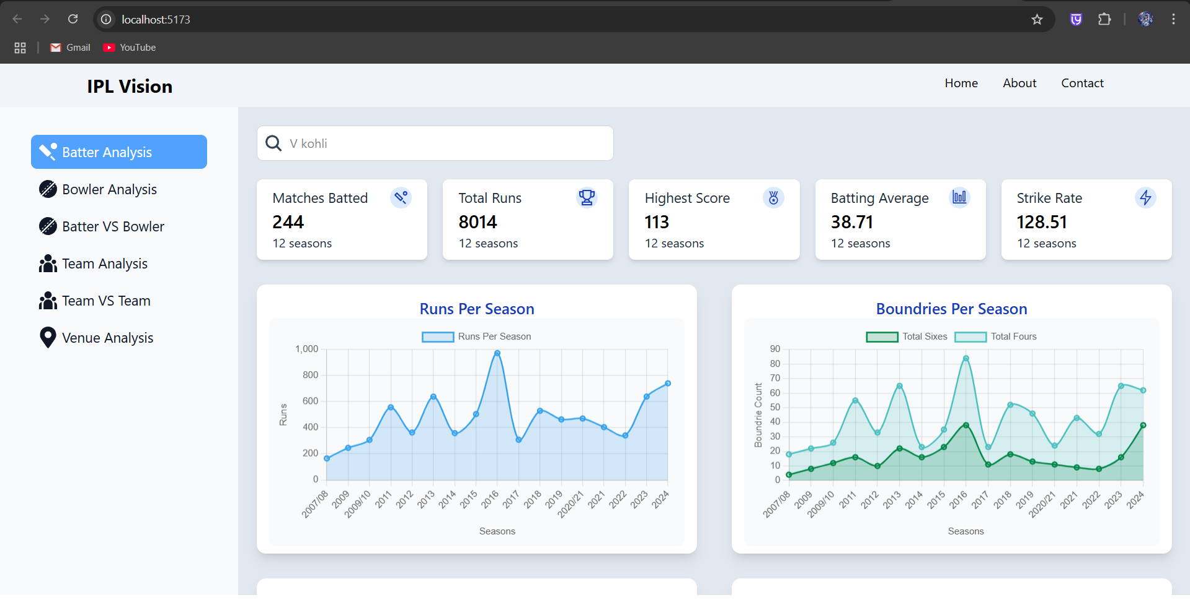
Fig 4 – Batter Analysis module displaying career KPI cards and season-by-season run trends

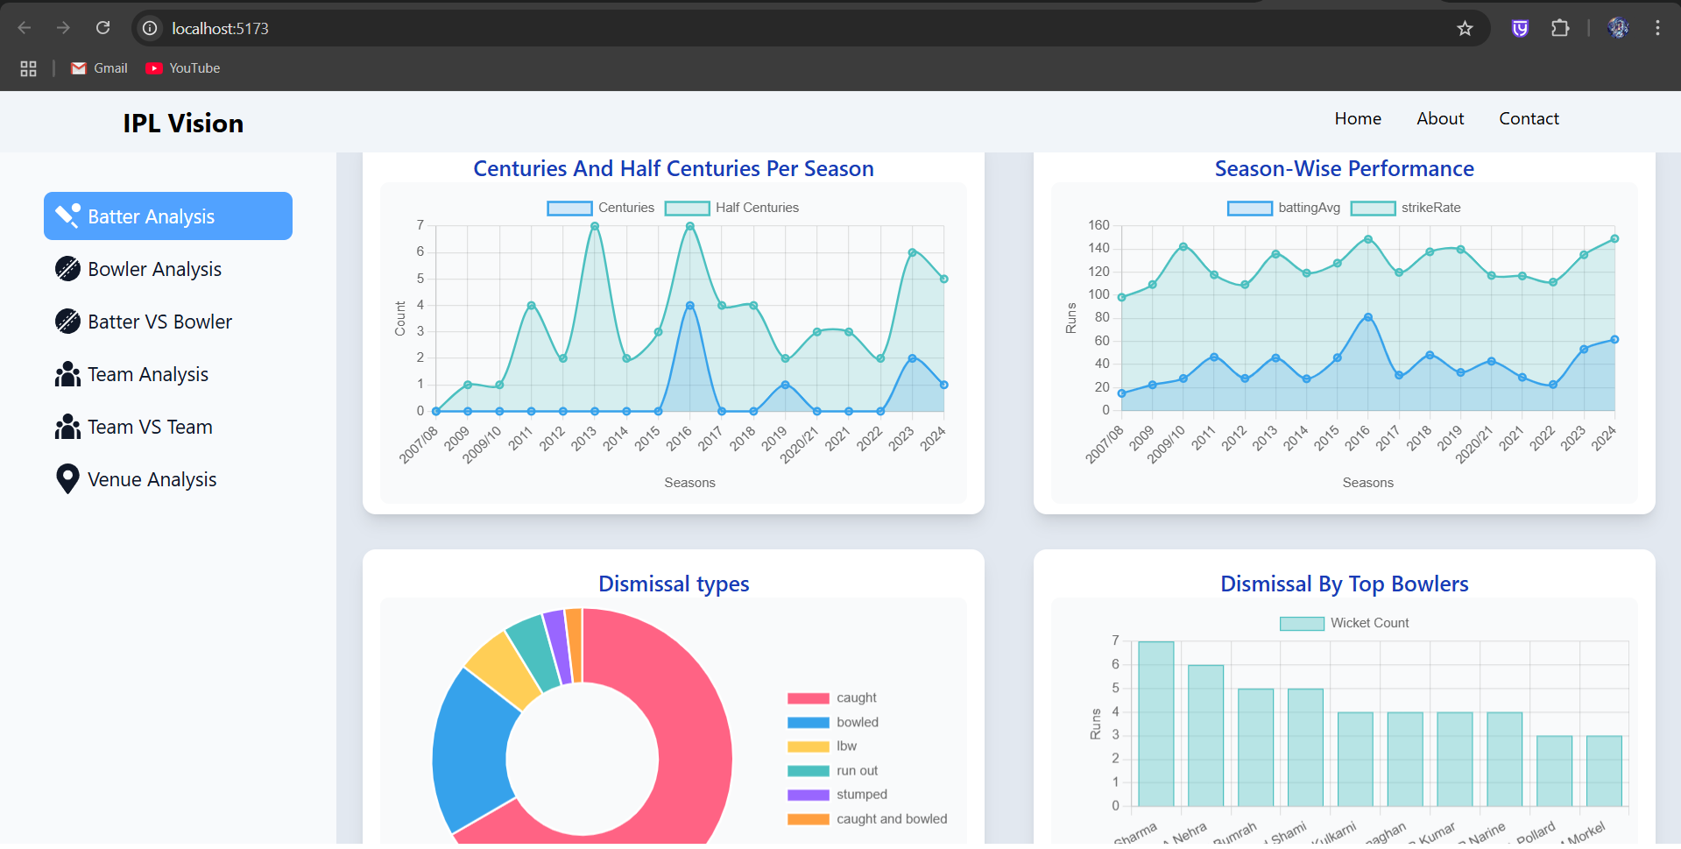
Fig 5 – Batter milestone analytics showing boundaries per season and dismissal doughnut chart

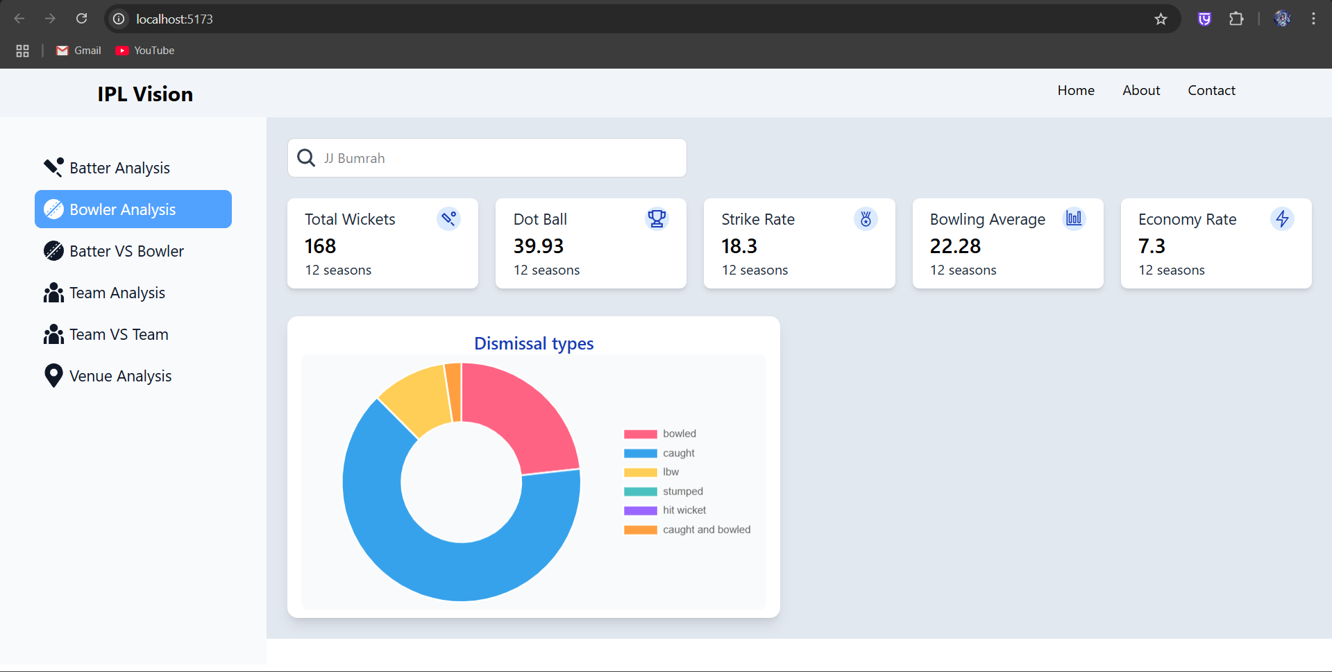
Fig 6 – Bowler Analysis dashboard displaying bowling average, economy, and career wickets

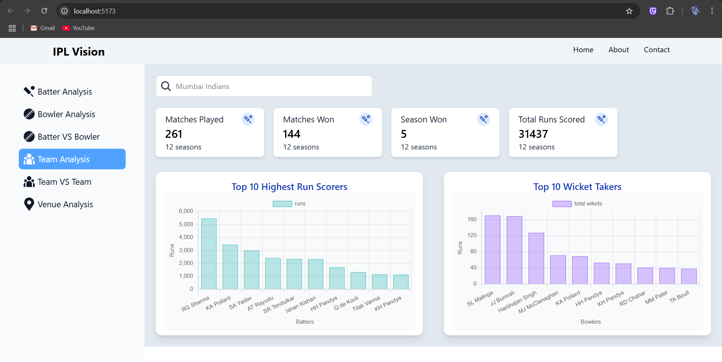
Fig 7 – Team Analysis module with franchise match records, top run scorers, and wicket takers

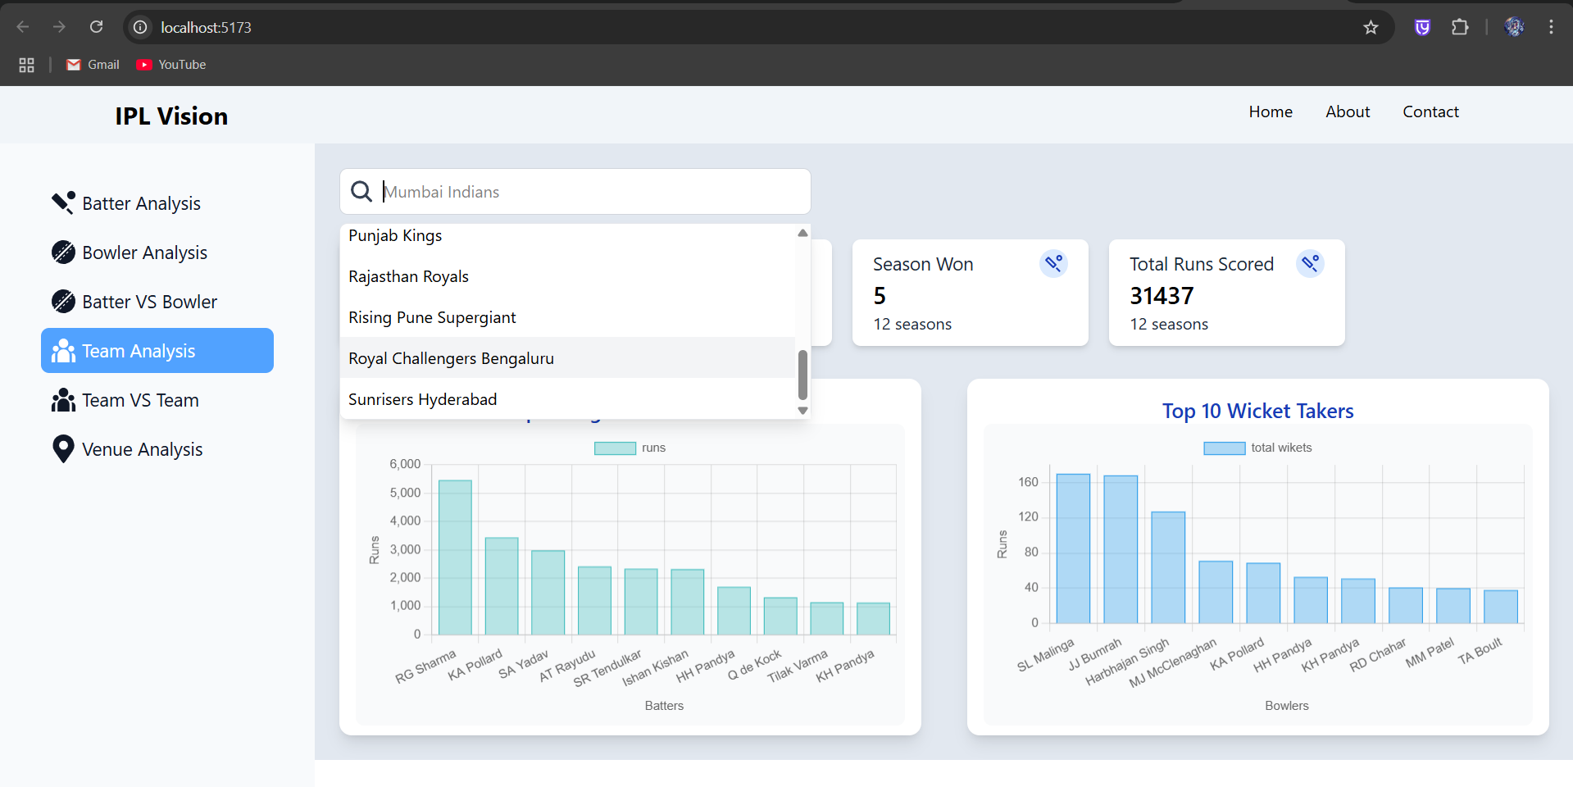
Fig 8 – Real-time autocomplete player and team search bar with dynamic client filtering

CHAPTER 6:
EXECUTED TIMELINE

The IPL Vision project was executed following structured agile engineering methodologies across four defined sprint phases:
Week 1: Data Preprocessing & Exploratory Data Analysis (October 1 – 7, 2026)
• Ingestion of 260,000+ delivery events and 1,095 match records from Kaggle/Cricsheet.
• Harmonization of historical franchise renames (Delhi Daredevils, Kings XI Punjab, RCB, Pune Supergiants).
• Exploratory data analysis in Jupyter Notebook (jupyter.ipynb) formulating cricket statistics queries.
• Architecture design and development of centralized in-memory caching singleton (data_loader.py).
Week 2: Backend RESTful API & Domain Controllers (October 8 – 14, 2026)
• Implementation of batter_controller.py (averages, strike rates, runs per season, dismissal kinds).
• Expansion of bowler_controller.py (economy rates, dot ball percentages, match phase breakdowns).
• Development of team_controller.py (franchise win-loss records, titles won, top performers).
• Registration of modular Flask Blueprints with CORS authentication support.
Week 3: Machine Learning Model Development & Training (October 15 – 21, 2026)
• Engineering ball-by-ball chase feature vectors (runs_left, balls_left, wickets_left, crr, rrr).
• Building scikit-learn Pipeline with ColumnTransformer (OneHotEncoder + StandardScaler).
• Training and calibrating Linear Support Vector Machine (LinearSVC with Platt scaling) achieving 80.69% accuracy.
• Serialization and latency benchmarking of win_predictor_svm.pkl artifact.
Week 4: Frontend Development, Visualization & Integration (October 22 – 28, 2026)
• Building React 19 single-page dashboard with Vite 6 and Tailwind CSS v4.
• Implementation of interactive Chart.js wrappers (LineChart, BarChart, DoughnutChart, PieChart).
• Development of Predictor.jsx featuring live probability duel bars, sliders, and score inputs.
• Comprehensive system integration testing, performance benchmarking, and documentation.
Fig 9 – Detailed project execution timeline (Gantt chart breakdown across project lifecycle)

CHAPTER 7:
CONCLUSION

7.1 Summary of Work
IPL Vision successfully demonstrates a production-grade data science and web engineering platform for cricket analytics. By integrating historical delivery data across 17 IPL seasons, the platform provides rich exploratory tools for batters, bowlers, and teams. The implementation of a centralized singleton data loader resolved critical RAM overheads, cutting memory usage by 68.98 MB.
Furthermore, the project successfully deployed a Calibrated Linear Support Vector Machine (SVM) pipeline that calculates real-time match win probabilities ball by ball during chases, achieving 80.69% accuracy on over 20,000 test deliveries. The responsive React client provides intuitive, broadcast-caliber visual feedback without unnecessary clutter.
7.2 Future Scope
• Live WebSocket Streaming Integration: Connecting the Flask backend to live ball-by-ball MQTT or WebSocket APIs to update probabilities automatically during live televised broadcasts.
• Player Auction Valuation Model: Utilizing machine learning regression to predict player bid prices based on recent multi-format strike rates, economy rates, and injury history.
• Ball-Tracking & Wagon Wheel Analytics: Incorporating 2D/3D Hawkeye trajectory coordinates to visualize wagon wheels, pitch maps, and beehive release angles for bowlers.
• Deep Learning Sequential Modeling: Experimenting with Recurrent Neural Networks (LSTM/GRU) and Transformers to capture long-term sequential ball-by-ball momentum.
7.3 Applications
• Sports Broadcasting & Media Graphics: Television broadcasters (e.g., Star Sports, JioCinema) can embed real-time win probability bars and bowler phase breakdowns into live on-screen overlays.
• Franchise Coaching & Tactical Planning: Team strategists can identify opposition vulnerabilities (e.g., deploying specific bowlers against batters with low strike rates against spin).
• Fan Engagement & Digital Platforms: Sports websites and fan portals can offer interactive dashboards where users explore career trends and simulate hypothetical chase scenarios.
• Fantasy League Analytics: Fantasy cricket players can utilize phase economy and dismissal trends to optimize captain and bowler team selections.

CHAPTER 8:
APPENDICES

8.1 Appendix A: Case Study 1 – Death Over Chase Analysis
Match Scenario: Royal Challengers Bengaluru (RCB) chasing 185 against Chennai Super Kings (CSK) at M. Chinnaswamy Stadium, Bangalore.
Match Situation at Over 16.0:
• Target: 185 runs | Current Score: 143/4
• Equation: Need 42 runs from 24 balls (RRR: 10.50 | CRR: 8.94) with 6 wickets in hand.
Machine Learning Simulation Results:
• Chasing Team (RCB) Win Probability: 69.5%
• Defending Team (CSK) Win Probability: 30.5%
Strategic Analysis: Despite a steep required run rate of 10.50, the model assigns a 69.5% win likelihood to RCB due to two critical variables: 6 wickets in hand and the historical boundary prevalence at Chinnaswamy Stadium. When the simulation reduces wickets in hand to 2 (143/8), RCB's win probability plummets to 21.4%, proving the model's sensitivity to batting depth during death-over chases.
Fig 10 – Case Study 1: Real-time win probability estimation during a high-stakes death-over chase
8.2 Appendix B: Case Study 2 – Bowler Nemesis & Matchup Strategy
Analysis: Bowler Tactical Optimization for Jasprit Bumrah (Mumbai Indians).
Statistical Insights Extracted by IPL Vision:
• Career Wickets: 168 wickets | Economy Rate: 7.30 | Dot Ball Percentage: 39.93%
• Phase Breakdown: Powerplay Economy: 6.60 (37 wickets) | Middle Economy: 6.67 (40 wickets) | Death Overs Economy: 8.29 (91 wickets).
• Top Batters Dismissed (Bunnies): Rishabh Pant (7 dismissals), Virat Kohli (5 dismissals), Glenn Maxwell (5 dismissals).
Tactical Takeaway: The phase breakdown proves Bumrah's lethal effectiveness at the death (91 wickets), while his top dismissed batters confirm his psychological edge against aggressive top-order strikers. Captains can utilize these analytics to reserve Bumrah's overs specifically when high-value opposition batters arrive at the crease.
Fig 11 – Case Study 2: Bowler matchup optimization and batter vulnerability analysis

CHAPTER 9:
REFERENCES

[1] F. Pedregosa et al., "Scikit-learn: Machine Learning in Python," Journal of Machine Learning Research, vol. 12, pp. 2825-2830, 2011.
[2] W. McKinney, "Data Structures for Statistical Computing in Python," in Proc. 9th Python in Science Conf., Austin, TX, USA, 2010, pp. 56-61.
[3] C. Cortes and V. Vapnik, "Support-Vector Networks," Machine Learning, vol. 20, no. 3, pp. 273-297, 1995.
[4] J. C. Platt, "Probabilistic Outputs for Support Vector Machines and Comparisons to Regularized Likelihood Methods," Advances in Large Margin Classifiers, vol. 10, no. 3, pp. 61-74, 1999.
[5] S. R. Bailey and D. Clarke, "Predicting the Outcome of One-Day International Cricket Matches Using Machine Learning," Journal of Sports Sciences, vol. 24, no. 8, pp. 883-890, 2006.
[6] P. K. Baumer and R. Matthews, "Win Probability Added in Twenty20 Cricket: Evaluating In-Game Turning Points," Journal of Quantitative Analysis in Sports, vol. 11, no. 4, pp. 205-218, 2015.
[7] A. Grimmer and M. M. Asif, "Forecasting Limited-Overs Cricket Match Outcomes Using Ball-by-Ball Machine Learning Models," International Journal of Computer Science in Sport, vol. 18, no. 1, pp. 45-62, 2019.
[8] Pallets Projects, "Flask Documentation (v2.2.x)," 2024. [Online]. Available: https://flask.palletsprojects.com/.
[9] Meta Open Source, "React Documentation – A JavaScript library for building user interfaces," 2024. [Online]. Available: https://react.dev/.
[10] Chart.js Community, "Chart.js: Simple yet flexible JavaScript charting for designers & developers," 2024. [Online]. Available: https://www.chartjs.org/docs/.

