**GUJARAT TECHNOLOGICAL UNIVERSITY**



CHANDKHEDA, AHMEDABAD



AFFILIATED

**L.D. College of Engineering**

A report on

**EasyBlood**

Submitted by

**Roshan Rawal 150280107097**

Page | 1

**Problem which is going to solve by this application :-**

Basically many times it happen that people don’t get blood when they

required in emergency so I am trying to solve this problem. At the same time

there are many people and organizations who are willing to help those guys in

emergency but this message is not reached to them. So through this application

anyone who need blood in emergency can send an emergency message so that

message will spread via email and SMS to all blood donors of our

city,organizations and blood banks. So they can help them at the

time of emergency. In short, through this application all community working in

this field get to know about if any emergency blood need occurs in our city so

they can help.

This will be an identity for any emergency blood requirement so whenever any

one needed blood in emergency they can use this application. And this

application is associated many organization and blood banks so it will spread

the same message to all blood donors as per requirement of blood.

Page | 2

**ABOUT PROJECT:**

EasyBlood is a web application to fill the requirement of blood in the emergency cases.

This is our HomePage

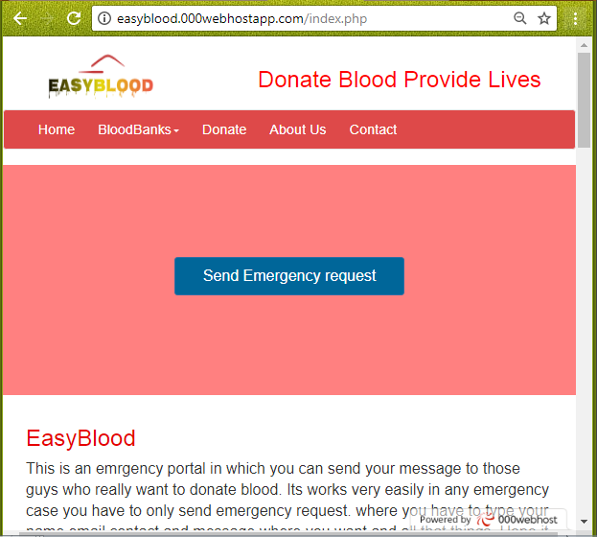

In this application user have to just click on a button

Named “Send emergency request”.

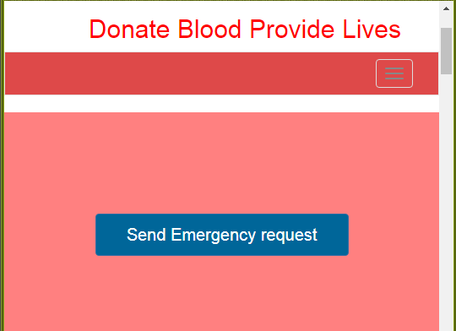

On clicking this button a form will open in which user have to fill their basic information like their names, contact, email, and final message in which they can mention their problem. Here problem means user can write message like which group of blood is needed and where, all that information in one message.

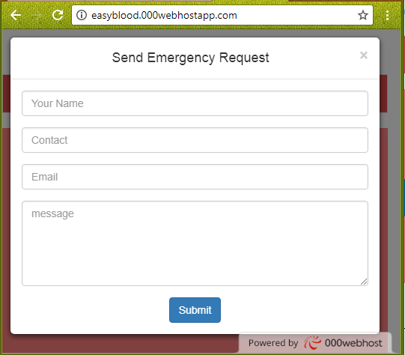

When user will click on this submit button then this message will send to our

blood donors through email and SMS. And then our blood donors can help

them easily.

In this home page here BloodBanks button will indicate bloodbanks

in the state according to sector and areawise.

As per below we can see the blood banks as per areas and sector

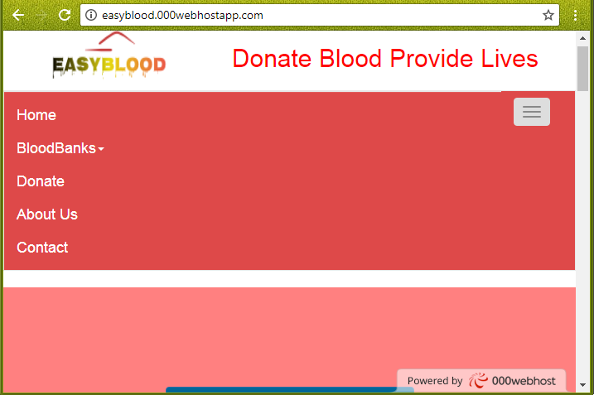

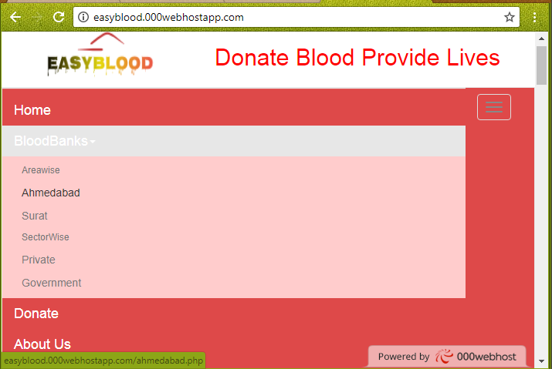

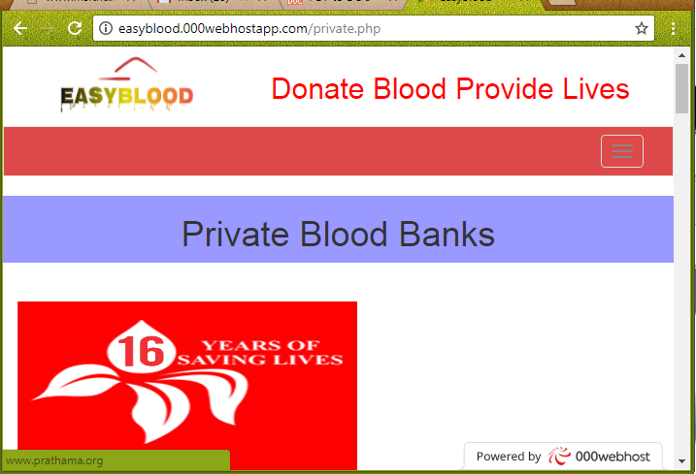

Then next feature of this application is Donate in this anyone can be donor. In this case you have to fill the form and you will be donor of EasyBlood. Then after whenever any emergency of blood required in the city then EasyBlood will let you know.

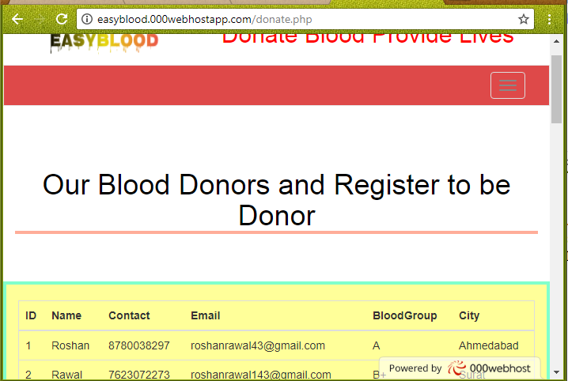

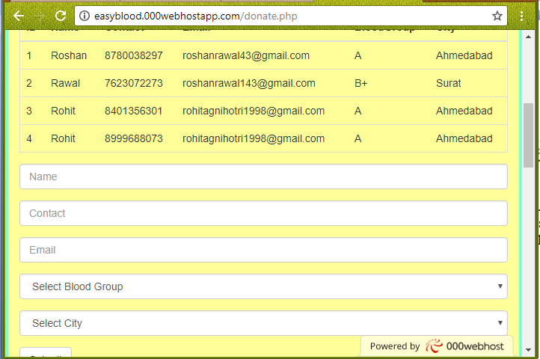

And at last there are two buttons AboutUs and Contact. It can be used as usual as in all web application for knowing about us and contact us.

**Conclusion :-**

EasyBlood can be use by anyone in any emergency requirement of blood. It will connect user requirement to the responsible Blood Banks, Blood Donors and organization and they will fulfill the requirement. Thus, Cycle of Blood Needer and Blood Donor will be completed and it will saves many valuable lives of our nation.

**Thank You**