PARKING SLOT MANAGEMENT SYSTEM
A PROJECT REPORT
Submitted by
ROSHAN S
(2116241501170)
in partial fulfilment of the End Semester Examination for the course
CB23F35 –
LOW-CODE APPLICATION DEVELOPMENT USING ZOHO CREATOR
in
BACHELOR OF TECHNOLOGY
ARTIFICIAL INTELLIGENCE AND MACHINE LEARNING

RAJALAKSHMI ENGINEERING COLLEGE
(An Autonomous Institution, Affiliated to Anna University, Chennai)
Rajalakshmi Nagar, Thandalam, Tamil Nadu – 602 105
OCTOBER 2026

RAJALAKSHMI ENGINEERING COLLEGE
(An Autonomous Institution, Affiliated to Anna University, Chennai)
BONAFIDE CERTIFICATE
Certified that this project report titled “Parking Slot Management System” is the bonafide work of ROSHAN S, who carried out the individual project work on the Zoho Creator low-code platform for the course CB23F35 – Low-Code Application Development using Zoho Creator, during the academic year 2026–2027, Semester V, under my supervision.
SIGNATURE  Dr Ayyadurai M  HEAD OF THE DEPARTMENT  Service Type of Artificial Intelligence And Machine Learning  Rajalakshmi Engineering College Thandalam – 602 105 | SIGNATURE  Ms Priya M  COURSE FACULTY  Assistant Professor  Service Type of Artificial Intelligence And Machine Learning  Rajalakshmi Engineering College

Submitted for the End Semester Examination (Individual Project) held on

INTERNAL EXAMINER | EXTERNAL EXAMINER

DECLARATION
I, ROSHAN S , hereby declare that the project report titled “Parking Slot Management System”, submitted for the End Semester Examination of the course CB23F35 – Low-Code Application Development using Zoho Creator, is a record of original work carried out by me individually. The Zoho Creator application described in this report — including its data model, forms, reports, pages, Deluge scripts, workflows and integrations — was designed and developed by me.
I further declare that this work has not been submitted, in part or in full, for the award of any other degree or course credit. Every template, sample application, AI-assisted feature (such as Zia or the AI application builder), code snippet or external resource used in this work has been duly acknowledged in the report.
Place: Chennai SIGNATURE OF THE STUDENT
Date: ROSHAN S

ACKNOWLEDGEMENT
I express my sincere gratitude to our Chairman, Mr Meganathan M, Chairperson, Ms Thangam Meganathan and Vice-Chairman, Mr Abhay Meganathan for providing the infrastructure and facilities that made this work possible.

I am grateful to our Principal, Dr Murugesan SN, Rajalakshmi Engineering College, for the constant encouragement extended to students to take up industry-relevant learning.

I thank the Head of the Department, Department of Artificial Intelligence and Machine Learning, for the guidance and support provided throughout the course.

I sincerely thank my course faculty, Ms Priya M, Assistant Professor, for her guidance, reviews and feedback during the development of this application and report.

I also acknowledge Zoho Corporation / Zoho Creator Education Programme for providing access to the Zoho Creator platform and learning resources, and I thank my family and friends for their unwavering support.

ROSHAN S

ABSTRACT
Parking areas in college campuses, offices and commercial complexes are still managed with paper registers. The attendant has to walk through the lot to find a free bay, write the vehicle number and entry time by hand, and calculate the parking fee manually when the vehicle leaves. This causes double allotment of slots, bikes parked in car bays, arithmetic errors in fees, and no real-time view of how many slots are free or how much revenue has been collected.
This project develops a Parking Slot Management System on the Zoho Creator low-code platform. A low-code approach suits the problem because the data model is small, the business rules are clear, and the application must be available immediately on web and mobile without managing servers. The application has two related forms, Parking Slot and Vehicle Booking, linked by a lookup field. Five Deluge form workflows automatically capture the entry time, block bookings on occupied, under-maintenance or wrong-type slots, mark the slot Occupied, calculate the parking duration and fee (rounded up to the next hour, minimum one hour) and release the slot on exit. A Deluge function exposed as a one-click Checkout custom action in the booking report completes an exit in a single click. List, Kanban and Calendar reports and a Parking Command Center page with live KPI panels and a revenue chart give the administrator an instant view of the facility.
The application was tested with eleven parking slots across three zones and eight vehicle bookings. Every workflow produced the expected result: slots changed between Available and Occupied automatically, invalid bookings were rejected with clear alerts, and fees of Rs.120, Rs.15 and Rs.300 were calculated correctly for car, bike and EV sessions, and the one-click Checkout action charged the one-hour minimum of Rs.40. Manual slot searching, register writing and fee calculation are eliminated, and slot availability and revenue are visible in real time on the dashboard.
Keywords: Low-Code Development; Zoho Creator; Deluge Scripting; Workflow Automation; Smart Parking Management

PROJECT AT A GLANCE
Attribute | Details
Project Title | Parking Slot Management System
Application Domain | Facility / Parking Management
Student Name & Register No. | Roshan S – 241501170
Zoho Creator Edition | Free Edition (trial expired)
Application Name (Link Name) | Parking Slot Management (parking-slot-management)
Published / Live URL | https://creatorapp.zoho.in/roshan.s.2024.aiml_rajala/parking-slot-management/
Demo Credentials (per role) | Administrator: application owner account (roshan.s.2024.aiml_rajala); shown live during demonstration
Number of Forms / Subforms | 2 / 0
Number of Reports (by type) | List: 2 Kanban: 1 Calendar: 1 Pivot/Chart: 0 (chart on page) Others: 0
Number of Pages / Dashboards | 1 (Parking Command Center)
Number of Workflows | Form: 5 Schedule: 0 Approval: 0 Blueprint: 0 Batch: 0 Report workflow: 1
Deluge Functions / Custom Actions | 1 function (checkoutVehicle) / 1 custom action (Checkout)
Integrations | None (not required for the current scope)
Roles & Profiles Defined | Administrator (implemented); Parking Attendant (designed, Table 4.3)
Environments Used | Single (production) environment – Development/Stage not available in the edition used
Date of Production Deployment | 21 October 2026

TABLE OF CONTENTS
Formatting Standards (Anna University Convention) 1
Working with the Template 1
ABSTRACT iv
PROJECT AT A GLANCE v
LIST OF TABLES ix
LIST OF FIGURES x
LIST OF ABBREVIATIONS xi
INTRODUCTION 1
1.1 Background 1
1.2 Problem Statement 1
1.3 Objectives 1
1.4 Scope of the Project 1
1.5 Justification for a Low-Code Approach 2
1.6 Organisation of the Report 2
LITERATURE SURVEY AND SYSTEM STUDY 3
2.1 Study of the Existing System 3
2.2 Limitations of the Existing System 3
2.3 Low-Code versus Traditional Development 3
2.4 Literature Survey 4
2.5 Emerging Trends in Low-Code Development 4
2.6 Proposed System 4
REQUIREMENT ANALYSIS 5
3.1 Stakeholders and User Roles 5
3.2 Functional Requirements 5
3.3 Non-Functional Requirements 5
3.4 Hardware and Software Requirements 6
3.5 Use Case Model 6
SYSTEM DESIGN 8
4.1 System Architecture 8
4.2 Data Model 8
4.3 Form Design 9
4.4 Process and Workflow Design 9
4.5 User Interface and Navigation Design 10
4.6 Access Control Design 10
IMPLEMENTATION 11
5.1 Application Setup 11
5.2 Forms and Data Capture 11
5.3 Reports 12
5.4 Pages and Dashboards 13
5.5 Deluge Scripting 13
5.6 Workflows and Automation 14
5.7 Integrations 15
5.8 User Management and Role-Based Access 16
5.9 AI and Analytics Features 16
5.10 Pro-Code Extension 17
5.11 Mobile and Portal Access 17
TESTING AND DEBUGGING 18
6.1 Testing Strategy 18
6.2 Test Cases 18
6.3 Debugging Deluge Scripts 18
6.4 Defect Log 19
6.5 User Acceptance Testing 19
DEPLOYMENT, SECURITY AND GOVERNANCE 20
7.1 Environments and Deployment Strategy 20
7.2 Performance Optimisation 20
7.3 Security Features 21
7.4 Governance and Administration 21
RESULTS AND DISCUSSION 22
8.1 Application Output 22
8.2 Achievement of Objectives 23
8.3 Comparison with the Existing System 23
8.4 Limitations of the Low-Code Approach 23
8.5 Reflection on the No-Code → Low-Code → Pro-Code Spectrum 23
CONCLUSION AND FUTURE ENHANCEMENTS 24
9.1 Conclusion 24
9.2 Future Enhancements 24
9.3 Learning Outcomes and Career Relevance 24
REFERENCES 25
APPENDIX A – ZOHO CREATOR FEATURE COVERAGE CHECKLIST 26
APPENDIX B – COURSE OUTCOME MAPPING 28
APPENDIX C – COMPLETE DELUGE SOURCE CODE 29
APPENDIX D – USER MANUAL 30
D.1 Accessing the Application 30
D.2 Instructions for [Role 1] 30
D.3 Instructions for [Role 2] 30
APPENDIX E – EVALUATION RUBRIC 31
APPENDIX F – VIVA-VOCE RECORD SHEET 33

LIST OF TABLES
Table 2.1: Comparison of Low-Code and Traditional Development for the Proposed Application 3
Table 2.2: Summary of Literature Survey 4
Table 3.1: Stakeholders and User Roles 5
Table 3.2: Functional Requirements 5
Table 3.3: Non-Functional Requirements 5
Table 3.4: Hardware and Software Requirements 6
Table 3.5: Use Case Description 6
Table 4.1: Entities and Relationships 9
Table 4.2: Field Specification Form 9
Table 4.3: Role–Permission Matrix 10
Table 5.1: Reports Implemented 12
Table 5.2: Deluge Scripts Implemented 13
Table 5.3: Workflows Implemented 14
Table 5.4: Integrations Implemented 15
Table 6.1: Test Cases 18
Table 6.2: Defect Log 19
Table 6.3: User Acceptance Feedback 19
Table 7.1: Deployment Checklist 20
Table 7.2: Performance Optimisation Results 20
Table 7.3: Security Controls Implemented 21
Table 8.1: Mapping of Objectives to Outcomes 23
Table 8.2: Existing System versus Proposed Application 23
Table A.1: Feature Coverage Checklist 26
Table B.1: Mapping of Course Outcomes to Report Chapters 28
Table E.1: Evaluation Rubric for the Individual Project 31
Table E.2: Performance Level Descriptors 32
Table F.1: Viva-Voce Questions and Responses 33
Table F.2: Marks Summary 33

LIST OF FIGURES
Figure 2.1: As-Is Process Flow of the Existing Parking System 4
Figure 3.1: Use Case Diagram of the Parking Slot Management Application 9
Figure 4.1: System Architecture of the Parking Slot Management Application 10
Figure 4.2: Entity–Relationship Diagram 11
Figure 4.3: Workflow / Process Flow for Vehicle Entry and Exit 13
Figure 4.4: Navigation Structure and Wireframe of Parking Command Center 14
Figure 5.1: Application Home and Navigation Sections 15
Figure 5.2: Vehicle Booking Form in the Form Builder 16
Figure 5.3: Vehicle Booking Form in Live Mode 17
Figure 5.4: Slot Board (Kanban) Report 18
Figure 5.5: Parking Command Center Page 19
Figure 5.6: Form Workflows Configuration 22
Figure 5.8: Users and Permissions Configuration 23
Figure 5.9: Revenue Analytics Chart on the Command Center Page 24
Figure 5.10: Application in Phone Layout 24
Figure 6.1: Deluge Log Messages after Vehicle Exit 27
Figure 7.2: Application Settings (Administration) 31
Figure 8.1: Scenario Step 1 – Vehicle entry recorded 32
Figure 8.2: Scenario Step 2 – Slot automatically marked Occupied 33
Figure 8.3: Scenario Step 3 – Checkout with calculated fee 33

LIST OF ABBREVIATIONS
Abbreviation | Expansion
API | Application Programming Interface
CRUD | Create, Read, Update, Delete
DS | Deluge Script (script identifier)
ER | Entity–Relationship
EV | Electric Vehicle
FK | Foreign Key
FR | Functional Requirement
KPI | Key Performance Indicator
LCDP | Low-Code Development Platform
NFR | Non-Functional Requirement
OCR | Optical Character Recognition
PK | Primary Key
RBAC | Role-Based Access Control
UAT | User Acceptance Testing
UI | User Interface
Zia | Zoho’s AI assistant
ZML | Zoho Markup Language

CHAPTER 1

INTRODUCTION

1.1 Background
Parking is a daily need in every college campus, hospital, office and shopping complex. A typical campus parking facility has separate bays for four-wheelers and two-wheelers, and an increasing number of electric-vehicle (EV) charging bays. The facility considered in this project is a campus-style parking lot divided into three zones: Zone A for cars, Zone B for bikes and Zone C for EV charging, each bay having its own hourly rate.
In the present process, a parking attendant stationed at the gate receives each vehicle, looks for a free bay, writes the vehicle number, owner name, slot and entry time in a register, and later calculates the parking fee from the entry and exit times when the vehicle leaves. The administrator depends on the same register to know how many slots are free and how much money was collected in a day. This project replaces the register with a cloud-based application built on Zoho Creator.

1.2 Problem Statement
Manual, register-based parking management gives no real-time information about slot availability, allows the same slot to be allotted twice, and depends on hand calculation of parking fees, leading to delays at the gate, revenue leakage and disputes with vehicle owners.
- No real-time visibility of which slots are free, occupied or under maintenance.
- Double allotment of a slot and wrong-type parking (bike in a car bay) because nothing checks the register.
- Fees calculated by hand from written times, causing errors and disputes.
- Daily revenue and occupancy reports require counting register entries manually.

1.3 Objectives
- To design a normalised data model with two related forms (Parking Slot and Vehicle Booking) linked by a lookup field.
- To automate slot validation, slot status updates and fee calculation using Deluge scripting and form workflows.
- To provide a Parking Command Center dashboard with live KPIs and a revenue chart, plus List, Kanban and Calendar reports.
- To provide a one-click Checkout action through a reusable Deluge function invoked from a report custom action.
- To deploy the application on the Zoho Creator cloud so that it is accessible on web and mobile with access limited to authorised users.

1.4 Scope of the Project
In scope: maintenance of parking slots (zone, type, hourly rate, status); vehicle entry with owner details; automatic validation of slot availability and vehicle type; automatic slot status updates; exit processing with duration and fee calculation; List, Kanban and Calendar reports; a dashboard page; access through the web and the Zoho Creator mobile app. Users: the administrator who manages slots and views the dashboard, and the parking attendant who records entries and exits.
Out of scope: online advance booking by vehicle owners, online payment collection, number-plate recognition cameras and integration with external systems. These are listed as future enhancements in Chapter 9.

1.5 Justification for a Low-Code Approach
Low-code development on Zoho Creator is appropriate because the application consists mainly of data capture, rule-based automation and reporting, which the platform provides as configurable building blocks [1], [2]. Forms, reports and pages are built visually, while the business rules are written in a few lines of Deluge [3]. Hosting, the database, authentication, mobile apps and security are provided by the platform, so the application could be built and published in days instead of weeks, and it can later be maintained by a non-specialist (citizen developer).

1.6 Organisation of the Report
Chapter 2 reviews the existing system and related low-code literature. Chapter 3 presents the requirement analysis. Chapter 4 describes the system design. Chapter 5 details the implementation on Zoho Creator. Chapter 6 covers testing and debugging. Chapter 7 discusses deployment, performance optimisation, security and governance. Chapter 8 presents results and discussion, and Chapter 9 concludes the report with future enhancements.
CHAPTER 2

LITERATURE SURVEY AND SYSTEM STUDY

2.1 Study of the Existing System
In the existing system the attendant (1) receives the vehicle at the gate, (2) walks through the lot to find a free bay of the right type, (3) writes the vehicle number, owner name, slot and entry time in a paper register, and, when the vehicle leaves, (4) searches the register for the entry, (5) calculates the hours and fee by hand and (6) collects the fee and updates the register. Figure 2.1 shows this as-is process.

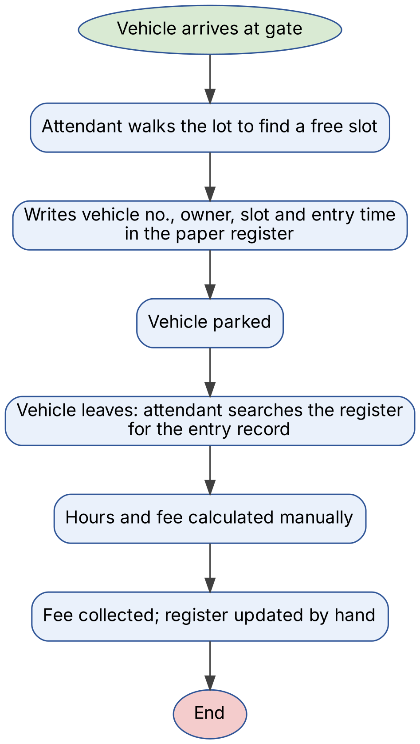
Figure 2.1: As-Is Process Flow of the Existing Parking System

2.2 Limitations of the Existing System
- Slot availability is not known without physically checking the lot.
- No control prevents double allotment of a slot or wrong-type parking.
- Manual fee calculation is slow and error-prone; there is no audit of amounts collected.
- Reports such as daily revenue or occupancy need manual counting of register pages.

2.3 Low-Code versus Traditional Development
Table 2.1: Comparison of Low-Code and Traditional Development for the Proposed Application
Criterion | Traditional (Pro-Code) Development | Low-Code on Zoho Creator
Development time | About 6–8 weeks (UI, back end, database, hosting) | About 1 week
Skills required | HTML/CSS/JS, a back-end language, SQL, DevOps | Zoho Creator builder and basic Deluge
Hosting & infrastructure | Separate server/cloud set-up and maintenance | Built-in cloud hosting
Mobile application | Separate Android/iOS development | Automatic via Zoho Creator mobile app
Security & access control | Authentication and RBAC coded manually | Built-in login, roles and permissions
Maintenance & change | Code changes, testing and redeployment | Visual edits, instant publish
Customisation limits | Unlimited | Limited to platform components and Deluge
Cost | Developer time + hosting cost | Platform subscription (free edition used)

2.4 Literature Survey

Table 2.2: Summary of Literature Survey
S.No. | Author(s) / Source & Year | Title / Product | Key Findings | Relevance to this Project
1 | A. C. Bock and U. Frank, 2021 | Low-Code Platform (BISE journal) | Defines low-code platforms and their features: model-based development, reuse, cloud hosting. | Justifies selecting a low-code platform for a data-centric app.
2 | A. Sahay et al., 2020 | Supporting the understanding and comparison of low-code development platforms (SEAA) | Compares 8 LCDPs on data modelling, business logic, UI and deployment. | Guided the comparison of low-code vs pro-code in Table 2.1.
3 | D. Di Ruscio et al., 2022 | Low-code development and model-driven engineering (SoSyM) | Low-code is an evolution of model-driven engineering; highlights lock-in and scalability limits. | Used in Section 8.4 on limitations.
4 | T. Lin, H. Rivano and F. Le Mouël, 2017 | A Survey of Smart Parking Solutions (IEEE T-ITS) | Reviews information collection, system deployment and service dissemination in smart parking. | Identified real-time slot availability as the key service.
5 | Zoho Corporation | Zoho Creator Help & Deluge Reference | Documents forms, lookups, workflows, pages and Deluge syntax. | Primary reference for implementation (Chapter 5).

2.5 Emerging Trends in Low-Code Development
Current low-code trends include AI-assisted application building, citizen development, hyper-automation of routine decisions and composable applications built from reusable components [5]. These influenced the design: every repetitive decision in the parking process (slot check, status change, fee calculation) is automated with workflows; the checkout logic is written once as a reusable Deluge function; and the dashboard is composed from ready-made page components (panels, chart and embedded report).

2.6 Proposed System
The proposed system is a Zoho Creator application in which slots are maintained in a Parking Slot form and every vehicle session is a Vehicle Booking record. Slot status is updated automatically (removes limitation 1), validation blocks occupied and wrong-type slots (limitation 2), the fee is calculated by Deluge from the entry and exit times (limitation 3), and reports and a dashboard give occupancy and revenue instantly (limitation 4).
CHAPTER 3

REQUIREMENT ANALYSIS

3.1 Stakeholders and User Roles
Table 3.1: Stakeholders and User Roles
Role | Description | Key Responsibilities in the Application
Administrator | Parking facility manager and application owner | Add/edit slots and rates, mark maintenance, view dashboard and all reports, manage users
Parking Attendant | Staff at the entry/exit gate | Record vehicle entry, checkout vehicles, view slot board and bookings
Vehicle Owner | Person parking the vehicle (non-user) | Provides vehicle and phone details; pays the calculated fee

3.2 Functional Requirements
Table 3.2: Functional Requirements
FR ID | Requirement | Role(s) | Priority
FR-01 | The system shall allow the administrator to add parking slots with unique slot number, zone, slot type, hourly rate and status. | Administrator | High
FR-02 | The system shall allow the attendant to record a vehicle entry with vehicle number, owner name, phone, vehicle type and slot. | Attendant | High
FR-03 | The system shall automatically fill the entry time with the current date-time. | Attendant | Medium
FR-04 | The system shall reject a booking if the slot is not Available or does not match the vehicle type. | Attendant | High
FR-05 | The system shall mark a slot Occupied when a booking is saved and Available when the vehicle exits. | System | High
FR-06 | The system shall calculate duration and fee (hours rounded up × hourly rate, minimum 1 hour) on exit. | Attendant | High
FR-07 | The system shall provide a one-click Checkout action in the booking report. | Attendant | Medium
FR-08 | The system shall display a dashboard with total, available and occupied slots, revenue and a revenue chart. | Administrator | Medium
FR-09 | The system shall provide List, Kanban and Calendar views of slots and bookings. | Administrator, Attendant | Medium

3.3 Non-Functional Requirements
Table 3.3: Non-Functional Requirements
NFR ID | Category | Requirement
NFR-01 | Performance | Reports with up to 1,000 records shall load within 3 seconds.
NFR-02 | Security | Only signed-in, authorised users shall access the application; users see only the components permitted by their role.
NFR-03 | Usability | The application shall be usable on web and the Zoho Creator mobile app; a booking shall need no more than one form.
NFR-04 | Availability | The application shall be available 24×7 on Zoho’s cloud infrastructure.
NFR-05 | Maintainability | Business rules shall be kept in named workflows and one reusable function so that rates and rules can be changed without redesign.
NFR-06 | Auditability | Every record shall store Added Time/Modified Time, and changes shall be traceable.

3.4 Hardware and Software Requirements
Table 3.4: Hardware and Software Requirements
Category | Specification
Platform | Zoho Creator Free Edition (creator.zoho.in)
Scripting language | Deluge (Data Enriched Language for the Universal Grid Environment)
Browser | Google Chrome / Microsoft Edge / Mozilla Firefox (latest version)
API testing tool | Postman (not required – no external API used)
Other Zoho services | Not used in the current scope
Mobile | Zoho Creator mobile app (Android / iOS) and in-builder phone preview
Client hardware | Intel Core i3/i5 or above, 8 GB RAM, internet connection

3.5 Use Case Model

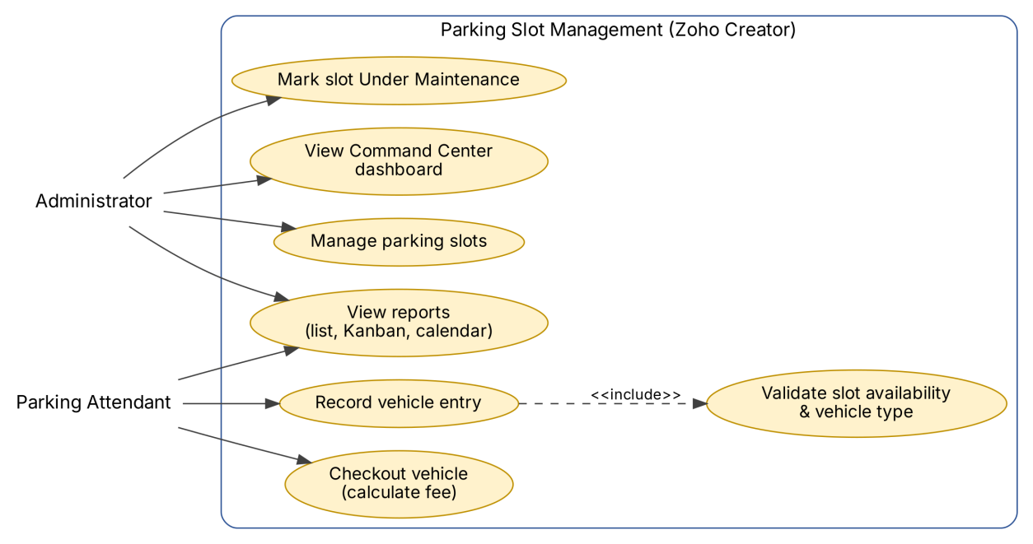
Figure 3.1: Use Case Diagram of the Parking Slot Management Application

Table 3.5: Use Case Description – Record Vehicle Entry
Use Case ID | UC-01
Use Case Name | Record Vehicle Entry
Actor(s) | Parking Attendant
Pre-condition | Attendant is signed in; at least one slot of the vehicle type is Available.
Main Flow | 1. Open Vehicle Booking form (entry time auto-filled). 2. Enter vehicle number, owner name, phone and vehicle type. 3. Select a slot. 4. Submit. 5. System validates the slot, saves the booking as Parked and marks the slot Occupied.
Alternate Flow | 4a. Slot is Occupied / Under Maintenance or of a different type: system shows an alert and the record is not saved; attendant selects another slot.
Post-condition | Booking stored with status Parked; slot status is Occupied; dashboard counts updated.
Related FR | FR-02, FR-03, FR-04, FR-05
CHAPTER 4

SYSTEM DESIGN

4.1 System Architecture

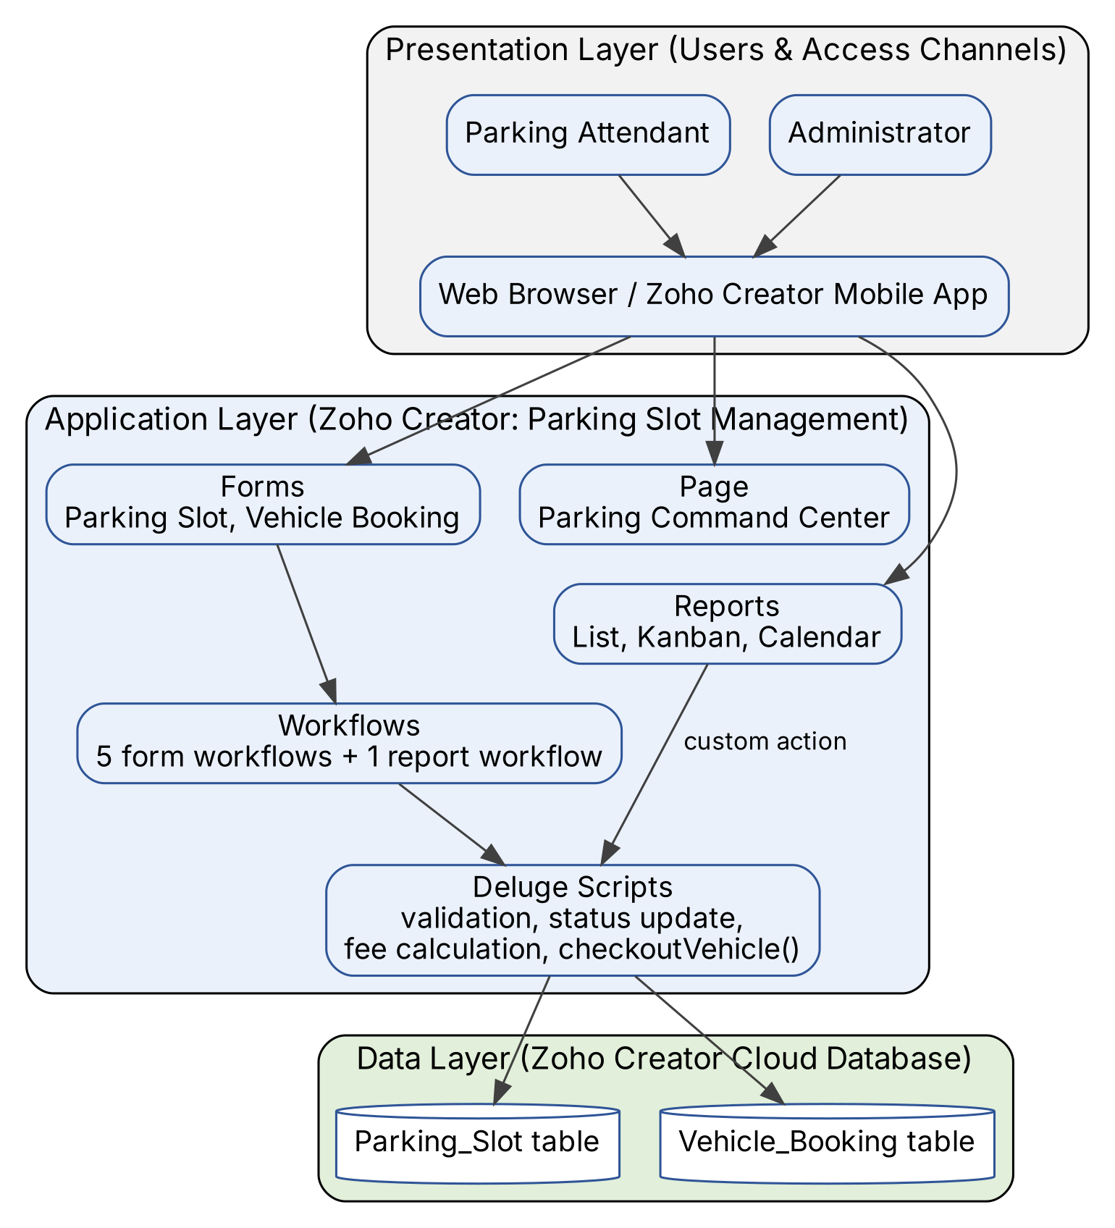
Figure 4.1: System Architecture of the Parking Slot Management Application
The architecture has three layers. The presentation layer consists of the two roles accessing the application through a web browser or the Zoho Creator mobile app. The application layer is the Parking Slot Management application: two forms capture data, three reports and one page present it, and five form workflows, one report workflow and one Deluge function implement the business rules. The data layer is the Zoho Creator cloud database, where each form is stored as a table; the lookup field Parking_Slot links bookings to slots. No external integration layer is needed in the current scope.

4.2 Data Model

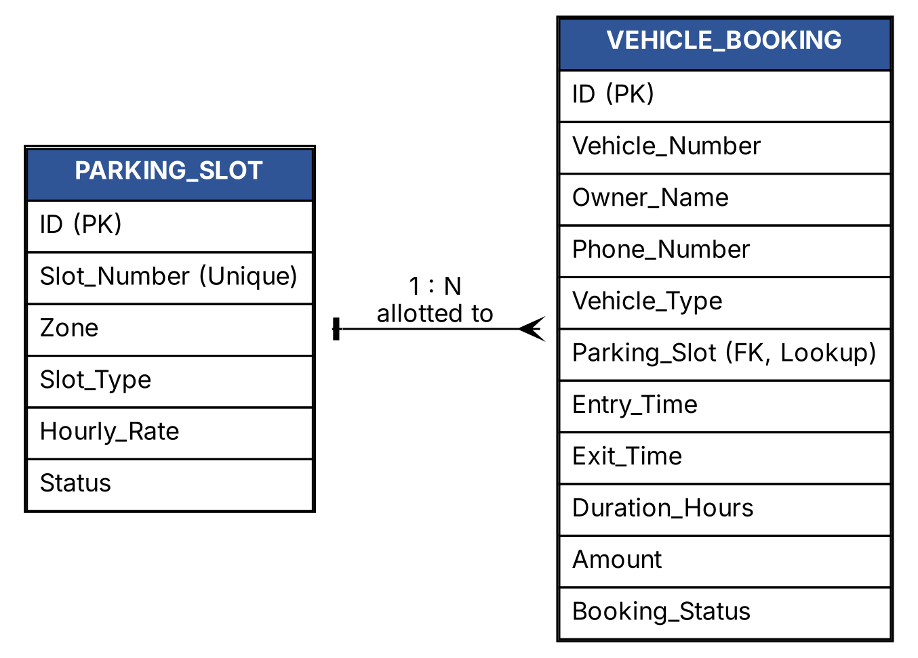
Figure 4.2: Entity–Relationship Diagram
Table 4.1: Entities and Relationships
Entity (Form) | Key Fields | Related To | Relationship Type | Implemented Using
Parking Slot | ID, Slot_Number, Zone, Slot_Type, Hourly_Rate, Status | Vehicle Booking | One-to-Many | Lookup field Parking_Slot in Vehicle Booking
Vehicle Booking | ID, Vehicle_Number, Entry_Time, Exit_Time, Amount, Booking_Status | Parking Slot | Many-to-One | Lookup (displays Slot_Number)

4.3 Form Design

Table 4.2: Field Specification – Parking Slot Form
Field Label | Link Name | Field Type | Mandatory | Validation / Default | Remarks
Slot Number | Slot_Number | Single Line | Yes | No duplicate values | e.g. A-01
Zone | Zone | Drop Down | Yes | — | Zone A / Zone B / Zone C
Slot Type | Slot_Type | Drop Down | Yes | — | Car / Bike / EV Charging
Hourly Rate | Hourly_Rate | Number | Yes | — | Charge per hour (Rs.)
Status | Status | Drop Down | Yes | Default: Available | Available / Occupied / Under Maintenance; updated by workflows
Table 4.3: Field Specification – Vehicle Booking Form
Field Label | Link Name | Field Type | Mandatory | Validation / Default | Remarks
Vehicle Number | Vehicle_Number | Single Line | Yes | — | e.g. TN 01 AB 1234
Owner Name | Owner_Name | Single Line | Yes | —
Phone Number | Phone_Number | Phone | No | Phone format (+91)
Vehicle Type | Vehicle_Type | Drop Down | Yes | — | Car / Bike / EV Charging
Parking Slot | Parking_Slot | Lookup | Yes | Validated by DS-02 | Lookup to Parking Slot (Slot Number)
Entry Time | Entry_Time | Date-Time | Yes | Default: current time (DS-01)
Exit Time | Exit_Time | Date-Time | No | Must be after Entry Time (DS-04) | Hidden on new booking
Duration Hours | Duration_Hours | Decimal | No | Calculated | Set by DS-04 / DS-06
Amount | Amount | Currency (INR) | No | Calculated | ceil(hours) × Hourly Rate, min 1 hour
Booking Status | Booking_Status | Drop Down | No | Default: Parked | Parked / Exited

4.4 Process and Workflow Design

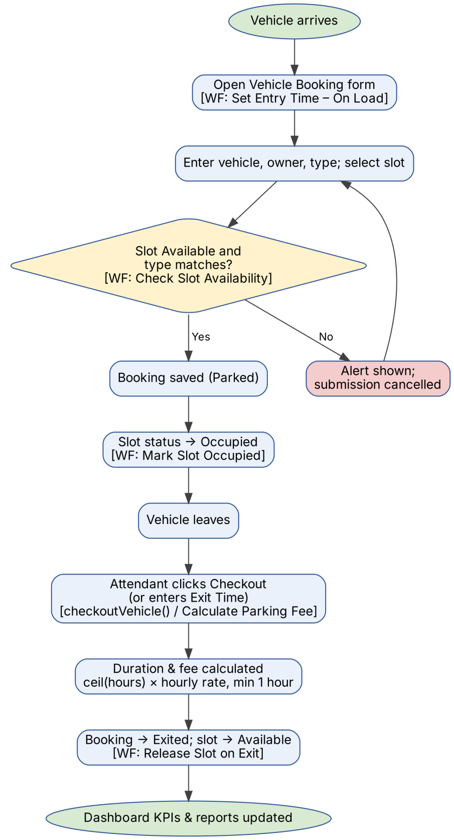
Figure 4.3: Workflow / Process Flow for Vehicle Entry and Exit

4.5 User Interface and Navigation Design

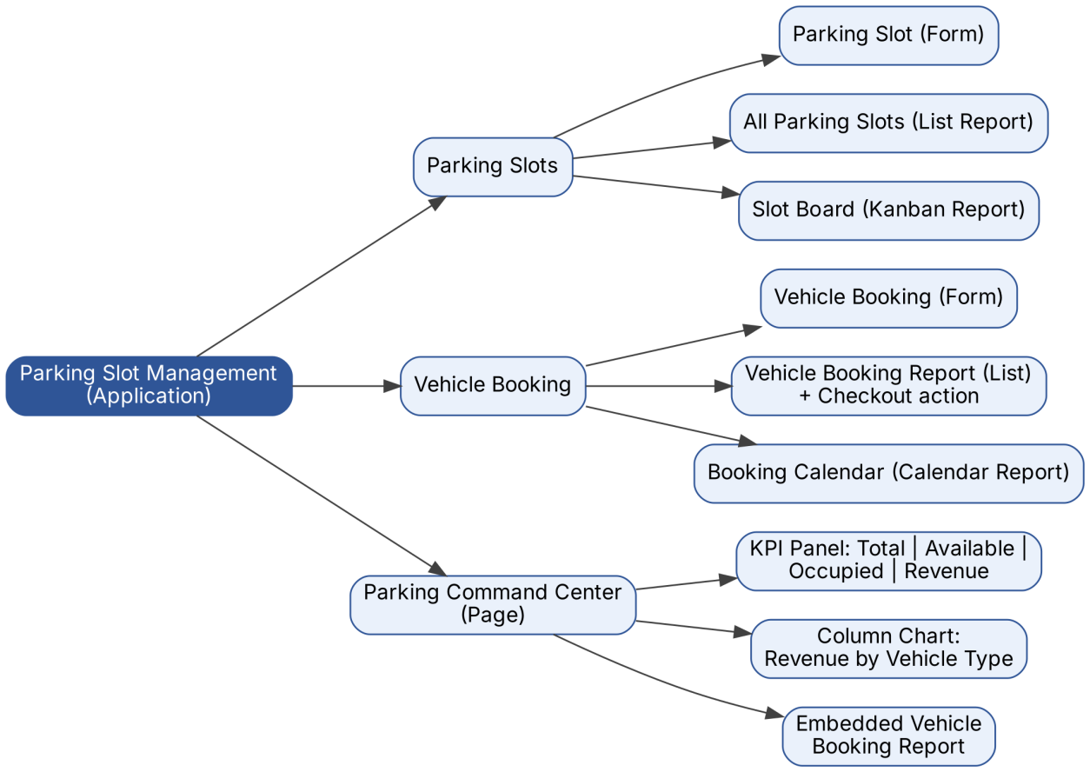
Figure 4.4: Navigation Structure and Wireframe of Parking Command Center

4.6 Access Control Design
Table 4.4: Role–Permission Matrix
Component | Administrator | Parking Attendant | Vehicle Owner | Portal User
Form: Parking Slot | A E V D | V | — | —
Form: Vehicle Booking | A E V D | A E V | — | —
Report: All Parking Slots / Slot Board | V | V | — | —
Report: Vehicle Booking Report (Checkout action) | V | V | — | —
Report: Booking Calendar | V | V | — | —
Page: Parking Command Center | V | — | — | —
CHAPTER 5

IMPLEMENTATION

5.1 Application Setup
The application was created in the Zoho Creator workspace of the account roshan.s.2024.aiml_rajala using Create Application → Create from scratch, with the name Parking Slot Management. The navigation menu has three sections: Parking Slots (Parking Slot form, All Parking Slots list report and Slot Board Kanban report), Vehicle Booking (Vehicle Booking form, Vehicle Booking Report and Booking Calendar) and the Parking Command Center page. The default theme with a dark navigation panel is used.

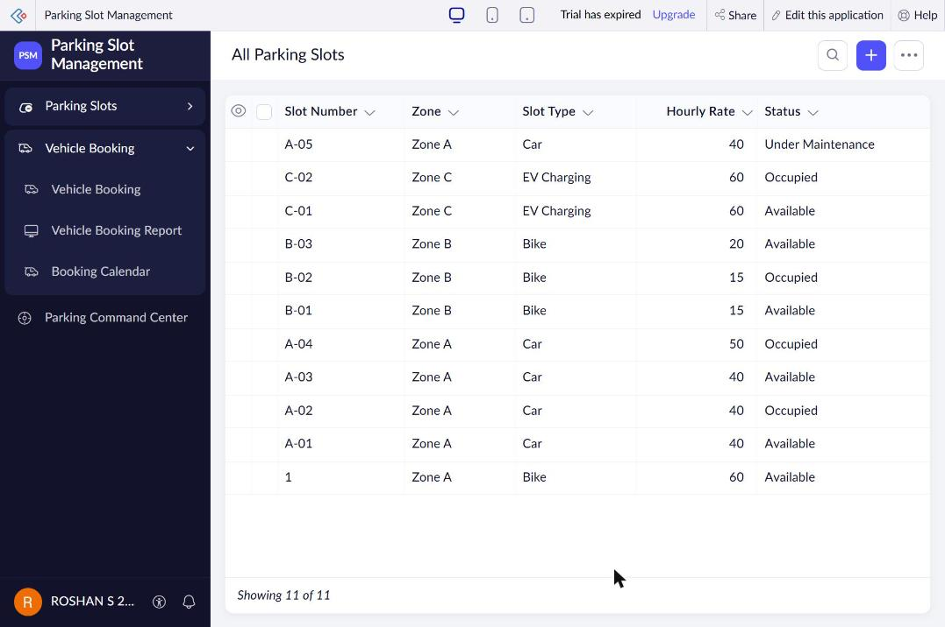
Figure 5.1: Application Home and Navigation Sections

5.2 Forms and Data Capture
Parking Slot form: Slot Number is a mandatory Single Line field with No duplicate values; Zone, Slot Type and Status are Drop Down fields whose choices were imported with Advanced → Import predefined choices; Hourly Rate is a Number field; Status defaults to Available.
Vehicle Booking form: Vehicle Number and Owner Name (Single Line, mandatory), Phone Number (Phone), Vehicle Type (Drop Down), Parking Slot (Lookup to Parking Slot showing Slot Number), Entry Time and Exit Time (Date-Time), Duration Hours (Decimal), Amount (Currency, INR) and Booking Status (Drop Down, default Parked). On load of a new booking, DS-01 fills the entry time and hides Exit Time, Duration Hours and Amount, so the attendant fills only five fields; these fields appear when the record is edited at exit.

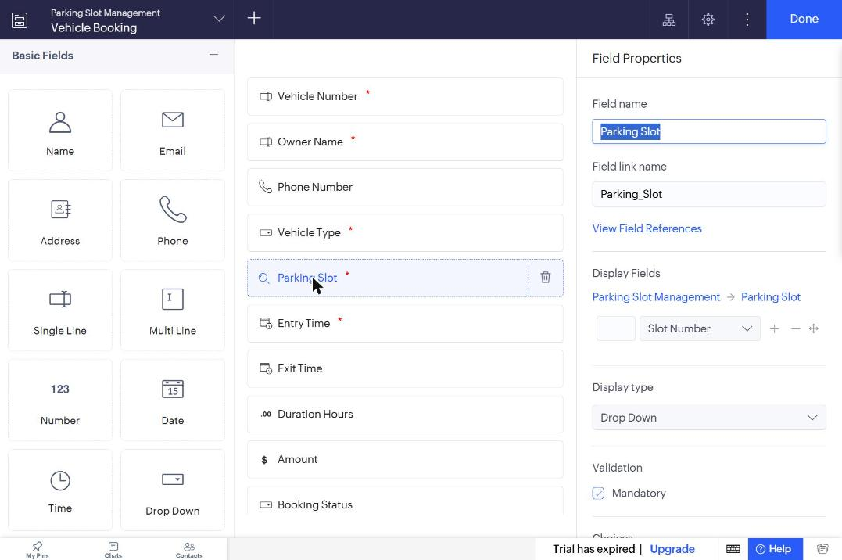
Figure 5.2: Vehicle Booking Form in the Form Builder

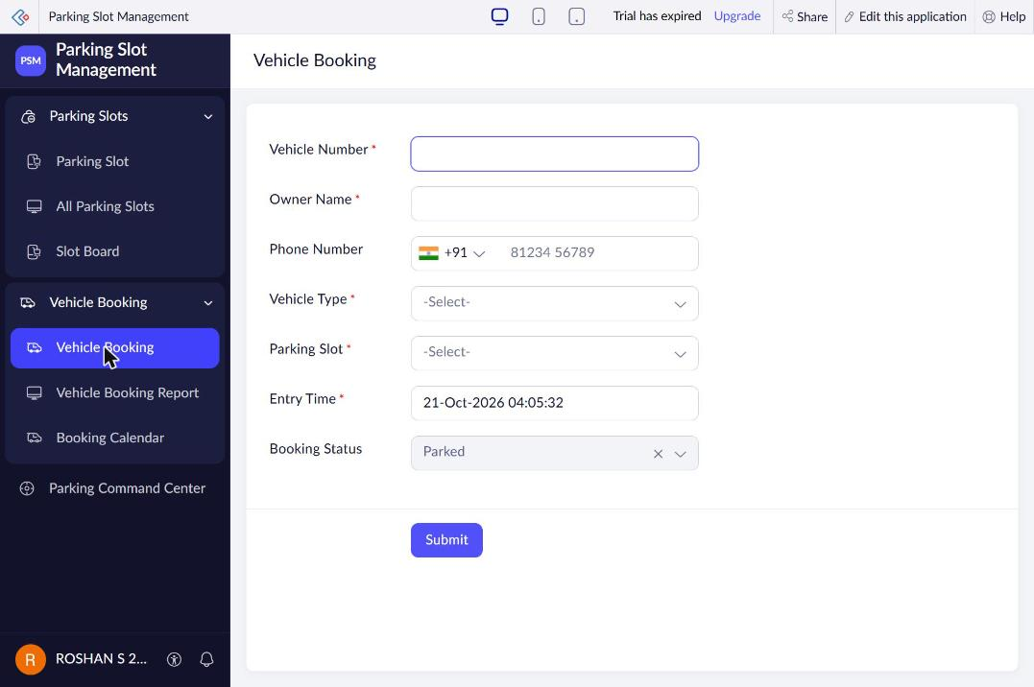
Figure 5.3: Vehicle Booking Form in Live Mode

5.3 Reports
Table 5.1: Reports Implemented
Report Name | Type | Source Form | Filter / Grouping / Sorting | Custom Actions | Roles
All Parking Slots | List | Parking Slot | All slots; sorted by Added Time | Edit / Delete | Admin, Attendant
Slot Board | Kanban | Parking Slot | Columns grouped by Status; record count per column | — | Admin, Attendant
Vehicle Booking Report | List | Vehicle Booking | All bookings | Checkout (custom action → checkoutVehicle) | Admin, Attendant
Booking Calendar | Calendar | Vehicle Booking | Event title Vehicle Number; date Entry Time | — | Admin, Attendant

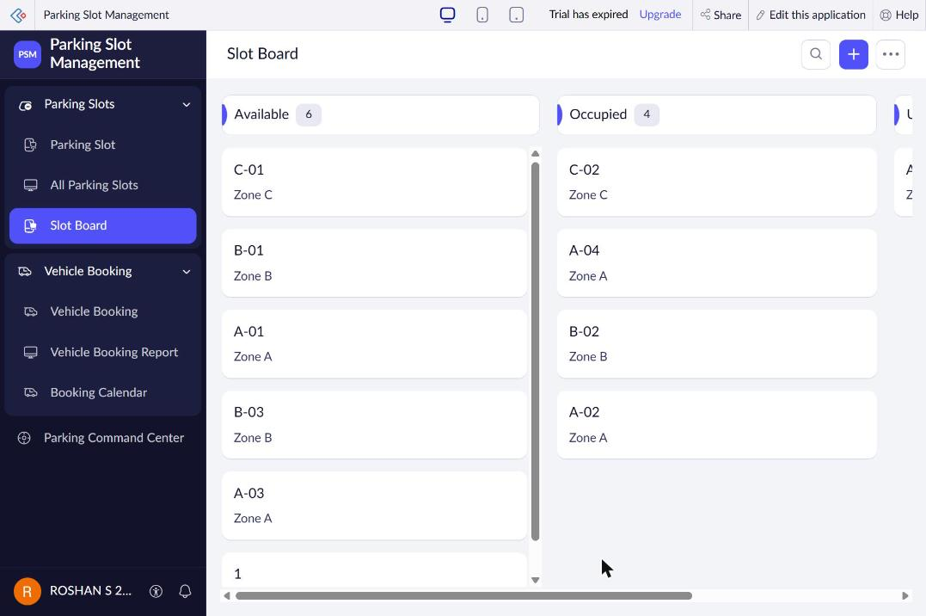
Figure 5.4: Slot Board (Kanban) Report

5.4 Pages and Dashboards
The Parking Command Center page is built with the page (UI) builder for the administrator. It contains (1) a Panel element written in ZML with four KPI columns – Total Parking Slots (count of Parking Slot records), Available Now and Occupied Now (counts with Status criteria) and Revenue Collected (sum of Amount where Booking Status is Exited); (2) a Column chart of Sum of Amount grouped by Vehicle Type; and (3) the Vehicle Booking Report embedded with add, edit and search actions. All values are calculated live from the forms.

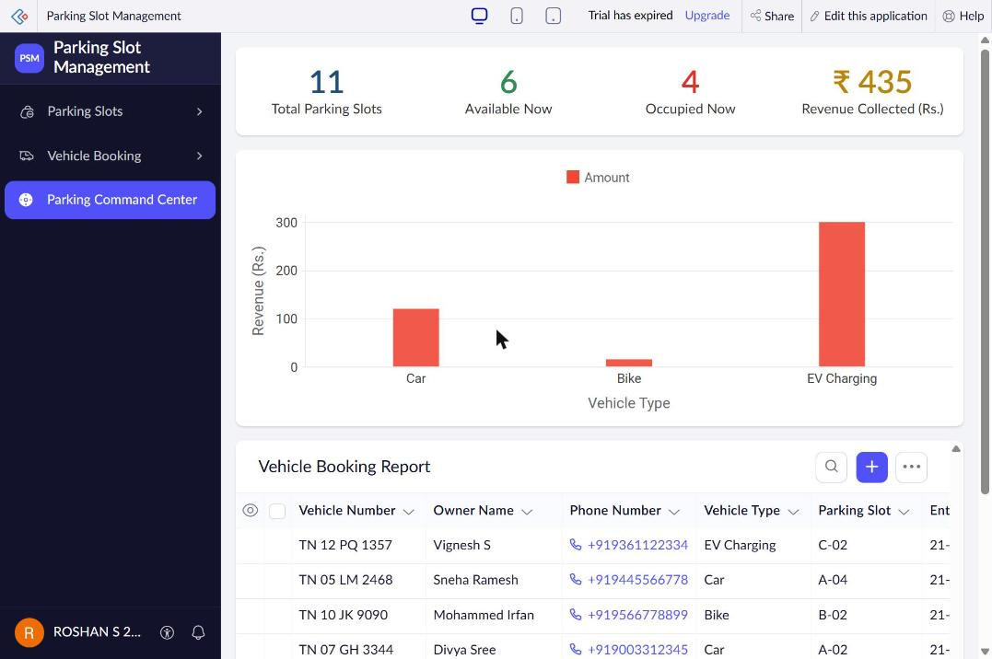
Figure 5.5: Parking Command Center Page

5.5 Deluge Scripting
Table 5.2: Deluge Scripts Implemented
Script ID | Location / Trigger | Purpose | Deluge Concepts Used
DS-01 | Vehicle Booking → Created → On Load | Auto-fill entry time; hide exit fields | zoho.currenttime, hide, disable
DS-02 | Vehicle Booking → Created → On Validate | Block occupied / wrong-type slots | fetch by ID, if, alert, cancel submit
DS-03 | Vehicle Booking → Created → On Success | Set slot status to Occupied | fetch and update record, info
DS-04 | Vehicle Booking → Edited → On Validate | Validate exit time; calculate duration and fee | date-time toLong(), arithmetic, ceil(), round()
DS-05 | Vehicle Booking → Edited → On Success | Release slot (Available) | conditional update, string concatenation
DS-06 | Function checkoutVehicle(int) via report action | One-click checkout | function, argument, fetch, update two forms

Code 5.1: DS-02 Check Slot Availability (On Validate)
// DS-02 | Form: Vehicle Booking | Event: Created - On Validate
// Purpose: Allow booking only when the slot is Available and matches the vehicle type
slot = Parking_Slot[ID == input.Parking_Slot];
if(slot.Status != "Available")
{
alert "Slot " + slot.Slot_Number + " is " + slot.Status + ". Please choose an Available slot.";
cancel submit;
}
if(slot.Slot_Type != input.Vehicle_Type)
{
alert "Slot " + slot.Slot_Number + " is reserved for " + slot.Slot_Type + " vehicles.";
cancel submit;
}
input.Booking_Status = "Parked";

Code 5.2: DS-04 Calculate Parking Fee (On Edit Validate)
// DS-04 | Form: Vehicle Booking | Event: Edited - On Validate
// Purpose: Calculate duration and parking fee when Exit Time is entered
if(input.Exit_Time != null)
{
if(input.Exit_Time <= input.Entry_Time)
{
alert "Exit Time must be after Entry Time.";
cancel submit;
}
slot = Parking_Slot[ID == input.Parking_Slot];
diffMs = input.Exit_Time.toLong() - input.Entry_Time.toLong();
hours = (diffMs / 3600000.0).round(2);
billHours = (diffMs / 3600000.0).ceil();
if(billHours < 1)
{
billHours = 1;
}
input.Duration_Hours = hours;
input.Amount = billHours * slot.Hourly_Rate;
input.Booking_Status = "Exited";
}

DS-02 fetches the selected slot record and cancels the submission with an alert when the slot is not Available or its type differs from the vehicle type; this was verified by attempting to book an occupied slot. DS-04 converts both date-times to milliseconds, computes the duration in hours, rounds the billable hours up with ceil() and applies a minimum of one hour before multiplying by the slot’s hourly rate. For example, a car parked from 08:30 to 11:00 (2.5 h) in slot A-01 at Rs.40/h was charged 3 × 40 = Rs.120, and a bike parked for 50 minutes in B-01 at Rs.15/h was charged the minimum Rs.15.
DS-01 improves usability by pre-filling the entry time; DS-03 and DS-05 keep the slot status synchronised with the bookings; DS-06 (Appendix C) packages the complete exit logic as a reusable function that the Checkout custom action calls with the record ID.

5.6 Workflows and Automation
Table 5.3: Workflows Implemented
Workflow Name | Type | Trigger / Event | Condition | Action(s) | Script Ref.
Set Entry Time | Form Workflow | Vehicle Booking created – Load of the form | Always | Set entry time; hide exit fields | DS-01
Check Slot Availability | Form Workflow | Created – Validations on form submission | Slot not Available / type mismatch | Alert and cancel submit | DS-02
Mark Slot Occupied | Form Workflow | Created – Successful form submission | Always | Update slot Status = Occupied | DS-03
Calculate Parking Fee | Form Workflow | Edited – Validations on form submission | Exit Time entered | Set Duration, Amount, Exited | DS-04
Release Slot on Exit | Form Workflow | Edited – Successful form submission | Booking Status = Exited | Update slot Status = Available | DS-05
Checkout Vehicle | Report Workflow | User clicks Checkout in Vehicle Booking Report | After confirmation | Call checkoutVehicle(ID) | DS-06

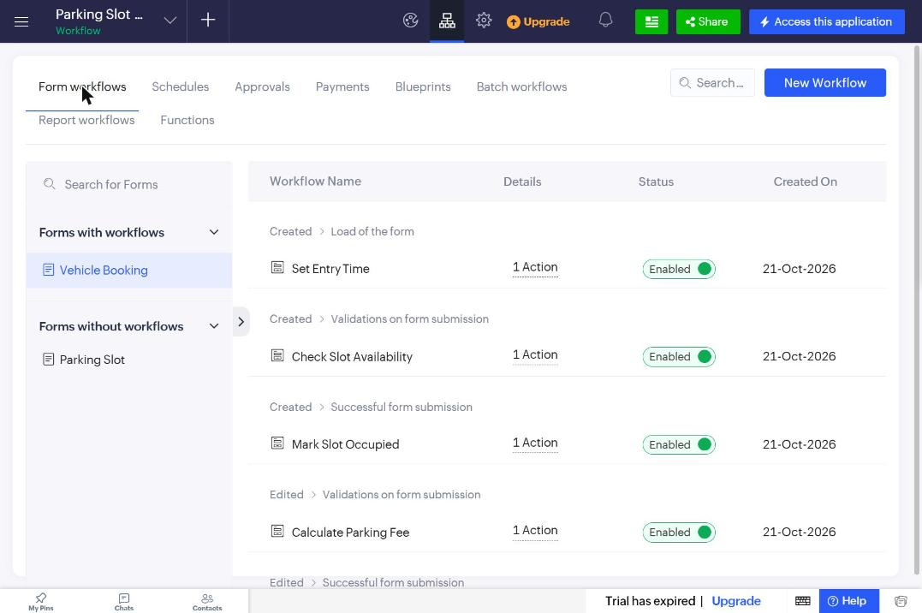
Figure 5.6: Form Workflows Configuration

5.7 Integrations
Table 5.4: Integrations Implemented
Integration | Service / Endpoint | Method | Authentication | Data Exchanged / Purpose
Not implemented | — | — | — | The parking process is self-contained; no external system or Zoho service was required in the current scope (see Section 9.2).

Integrations were not implemented. If required in future, an SMS receipt could be sent with an invokeurl call to an SMS gateway through a secured connection, or new bookings could be pushed to Zoho Analytics for long-term analysis.

5.8 User Management and Role-Based Access
The application is owned by the administrator account, which has full access to all components. The role design for the parking attendant is given in Table 4.4 (Add, Edit and View on Vehicle Booking; View only on slot reports; no access to the Command Center page). Users and permission profiles are configured from Settings → User Permissions; the application has the Read and Write permission profiles and the Roles and Data Sharing tabs (Figure 5.8). During development and demonstration only the administrator account was used; an attendant user will be added with the Attendant permission set when the application is shared with staff.

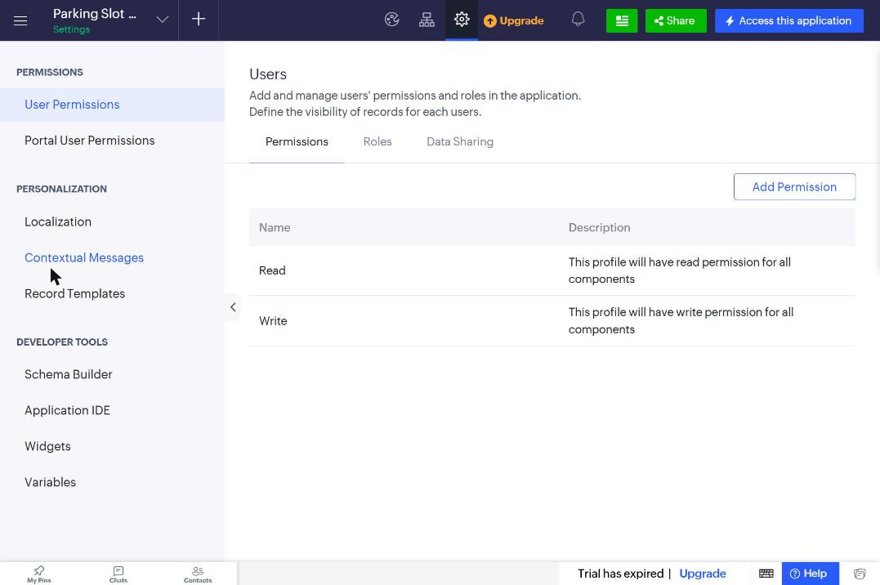
Figure 5.8: Users and Permissions Configuration

5.9 AI and Analytics Features
Analytics are provided natively on the Parking Command Center page: KPI panels (count and sum aggregations with criteria) and a column chart of revenue by vehicle type (Figure 5.9), which shows that EV charging produced the highest revenue (Rs.300) in the sample data. Pivot Chart reports require connecting Zoho Analytics, which was not configured, so the page chart was used instead. Zia AI features (prediction, OCR, keyword extraction) were not used because the application has no unstructured data; number-plate OCR is listed as a future enhancement.

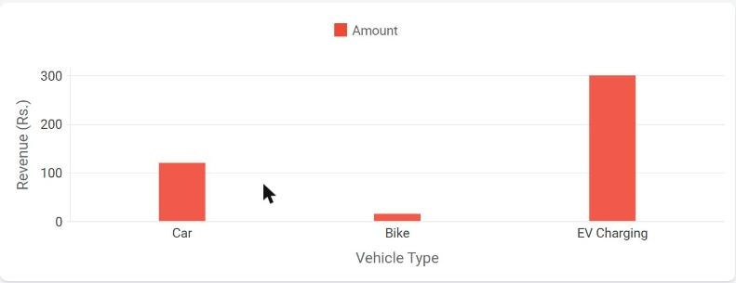
Figure 5.9: Revenue Analytics Chart on the Command Center Page

5.10 Pro-Code Extension
No pro-code component (Zoho Catalyst, JS widgets or REST API clients) was required because all business rules could be expressed in Deluge. The closest step towards pro-code is the reusable Deluge function checkoutVehicle invoked from a report custom action. A future extension could use the Zoho Creator REST API with a Catalyst function to receive entries from a number-plate recognition camera at the gate.

5.11 Mobile and Portal Access

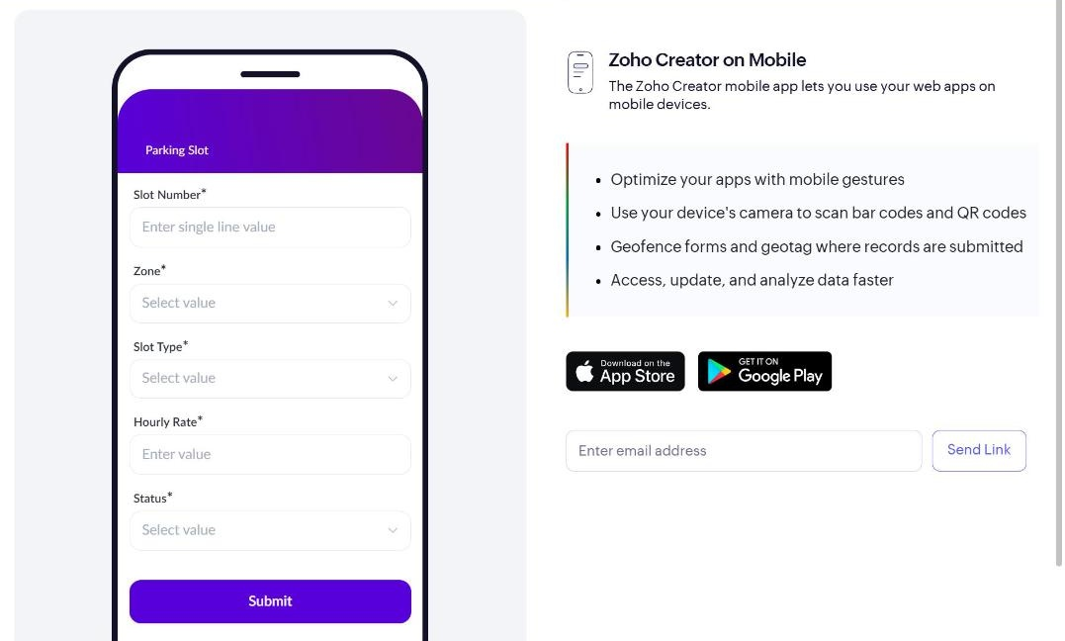
Figure 5.10: Application in Phone Layout
CHAPTER 6

TESTING AND DEBUGGING

6.1 Testing Strategy
Testing was performed at three levels. Unit testing: each form was submitted with valid and invalid data and each Deluge script was checked using info statements and the log messages shown after submission. Integration testing: the full entry–exit cycle was executed to confirm that the workflows on the two forms keep slot status, booking status and amount consistent, and that the dashboard reflects the changes. Acceptance testing: the application was demonstrated end to end following the scenario in Section 8.1.

6.2 Test Cases
Table 6.1: Test Cases
TC ID | FR Ref. | Test Description | Input / Steps | Expected Result | Actual Result | Status
TC-01 | FR-01 | Add a parking slot with all fields | A-01, Zone A, Car, 40 | Record saved with status Available | Saved; status Available | Pass
TC-02 | FR-01 | Add slot with duplicate Slot Number | Slot Number A-01 again | Duplicate value error | Rejected: 'This value already exists' | Pass
TC-03 | FR-01 | Add slot marked Under Maintenance | A-05, Car, 40, Under Maintenance | Record saved with that status | Saved | Pass
TC-04 | FR-03 | Open new Vehicle Booking form | — | Entry Time = current time; exit fields hidden | As expected | Pass
TC-05 | FR-02 | Submit booking without Vehicle Number | Blank vehicle number | Mandatory field error | Rejected: mandatory field errors | Pass
TC-06 | FR-02, FR-05 | Book an available slot | TN 01 AB 1234, Car, A-01 | Booking saved as Parked; A-01 Occupied | Saved; A-01 Occupied | Pass
TC-07 | FR-04 | Book an occupied slot | Car, slot A-02 (Occupied) | Alert; record not saved | Alert 'Slot A-02 is Occupied...'; not saved | Pass
TC-08 | FR-04 | Book an Under Maintenance slot | Car, slot A-05 | Alert; record not saved | Alert 'Slot A-05 is Under Maintenance...' | Pass
TC-09 | FR-04 | Vehicle type mismatch | Bike, slot A-03 (Car) | Alert "reserved for Car vehicles" | Alert 'Slot A-03 is reserved for Car vehicles' | Pass
TC-10 | FR-06 | Exit after 2.5 h (car, Rs.40/h) | 08:30 → 11:00 | Duration 2.5; Amount Rs.120; Exited | Rs.120; Exited | Pass
TC-11 | FR-06 | Exit after 50 min (bike, Rs.15/h) | 09:15 → 10:05 | Minimum 1 h: Amount Rs.15 | Rs.15 | Pass
TC-12 | FR-06 | Exit after 4.5 h (EV, Rs.60/h) | 07:45 → 12:15 | Amount Rs.300 | Rs.300 | Pass
TC-13 | FR-05 | Slot released after exit | TC-10 to TC-12 | A-01, B-01, C-01 Available | All Available | Pass
TC-14 | FR-06 | Exit Time before Entry Time | Exit earlier than entry | Alert; not saved | Alert 'Exit Time must be after Entry Time' | Pass
TC-15 | FR-07 | Checkout action on a parked booking | Click Checkout → Yes | Exit time, amount set; slot Available | Exit time set; Rs.40 (min 1 h); Exited; A-03 Available | Pass
TC-16 | FR-08 | Dashboard KPIs | 11 slots, 4 occupied, 3 exited | Total 11, Available 6, Occupied 4, Revenue Rs.435 | 11 / 6 / 4 / Rs.435 | Pass
TC-17 | FR-09 | Kanban and Calendar reports | Open Slot Board / Booking Calendar | Slots grouped by status; bookings on calendar | Kanban grouped by status; 8 bookings on calendar | Pass

6.3 Debugging Deluge Scripts
Deluge scripts were debugged using (1) the syntax check performed when a script is saved, (2) info statements whose output appears in the ‘log messages’ window after a submission (Figure 6.1), and (3) alert messages for validation paths. A real bug: when saving DS-04 the editor reported “Variable Hourly_Rate does not exist in Parking_Slot”. Inspection of the form showed that the field link name had been saved as ‘Hourly_RateHourly_Rate’ while renaming the field. The link name was corrected to Hourly_Rate and the script then saved and calculated fees correctly.

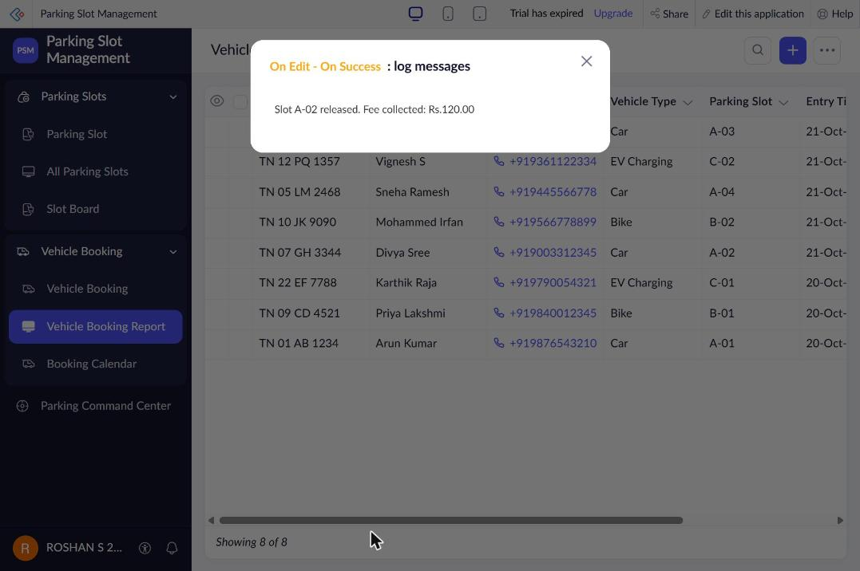
Figure 6.1: Deluge Log Messages after Vehicle Exit

6.4 Defect Log
Table 6.2: Defect Log
Bug ID | Description | Root Cause | Fix Applied | Status
BUG-01 | DS-04 failed to save: "Variable Hourly_Rate does not exist" | Field link name saved incorrectly while renaming | Corrected link name to Hourly_Rate | Closed
BUG-02 | Booking Status had no default value | Default choice not selected in form builder | Set Parked as default; DS-01/DS-02 also set it | Closed
BUG-03 | Kanban report created with wrong name "aSlot Board" | Stray keystroke in name field | Renamed report and link name to Slot Board / Slot_Board | Closed
BUG-04 | Pivot Chart report could not be created | Requires Zoho Analytics configuration | Used Chart element on the Command Center page | Closed (workaround)

6.5 User Acceptance Testing

Table 6.3: User Acceptance Feedback
User | Role Tested | Feedback | Action Taken
Rahul | Parking Attendant | Entry was quick because the entry time fills in automatically. The alert for an occupied slot was clear. Wanted the slot list to show the vehicle type too. | Added Zone and Slot Type to the slot dropdown display.
Thilak | Administrator | The dashboard made the free slots and revenue easy to see. Suggested a daily revenue summary. | Noted as a future enhancement (Section 9.2).
CHAPTER 7

DEPLOYMENT, SECURITY AND GOVERNANCE

7.1 Environments and Deployment Strategy
The Development, Stage and Production environments are not available in the Zoho Creator edition used for this project (the application was created without ‘Enable Environment’). The application was therefore developed directly in the production environment, and each change was tested immediately in live mode with sample data. Before publishing a change, the affected form or workflow was tested with the cases in Table 6.1. As a rollback plan, the application definition can be exported as a .ds file from the application settings and re-imported if a change has to be reverted.

Table 7.1: Deployment Checklist
S.No. | Checklist Item | Done (✓)
1 | All test cases executed in Development / Stage | Executed in production (environments not available)
2 | Sample/test data removed or isolated | Retained for demonstration
3 | Roles, permissions and users configured in Production | Administrator ✓; Attendant role designed
4 | Connections authorised in Production | Not applicable
5 | Schedules and workflows enabled | ✓
6 | Application published and URL verified | ✓
7 | Version / release notes recorded | ✓ (this report)

7.2 Performance Optimisation

Table 7.2: Performance Optimisation Results
Optimisation Applied | Component | Before | After | Improvement
Fetch by record ID (Parking_Slot[ID == ...]) instead of searching by slot number | DS-02 to DS-06 | Criteria search | Single indexed fetch | One fetch per script
No fetch inside loops; each script updates at most two records | All scripts | — | — | Constant time per booking
Exit fields hidden on new bookings | Vehicle Booking form | 10 fields | 5 fields to fill | Faster data entry
KPI values computed with aggregate panels instead of scripts | Command Center page | — | Platform aggregation | No custom code to maintain

7.3 Security Features
Table 7.3: Security Controls Implemented
Security Control | Where Applied | Threat Mitigated
Zoho account sign-in for all users | Whole application | Unauthorised access
Role-based permission design (Table 4.4) | Forms, reports, page | Attendants changing rates or viewing revenue
Server-side validation (cancel submit) | Vehicle Booking (DS-02, DS-04) | Invalid or inconsistent bookings
Unique Slot Number | Parking Slot form | Duplicate slots
Booking Status disabled on entry form | Vehicle Booking form | Manual tampering of status

7.4 Governance and Administration
Governance practices followed: consistent naming (forms in singular nouns, link names in Title_Case, workflows named by action, scripts numbered DS-01 to DS-06); every record keeps Added Time, Added User and Modified Time for traceability; application settings allow export of the application definition (.ds) as a backup; and the administrator is responsible for adding users, changing hourly rates and marking maintenance.

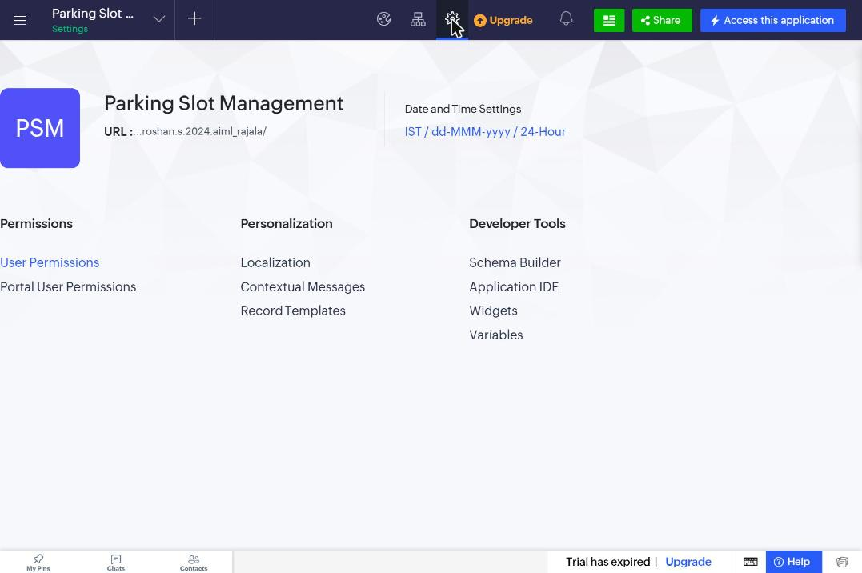
Figure 7.2: Application Settings (Administration)
CHAPTER 8

RESULTS AND DISCUSSION

8.1 Application Output
Scenario: a car arrives at the gate. Step 1 – the attendant opens the Vehicle Booking form, enters the vehicle and owner details and selects an available car slot; the booking is saved as Parked (Figure 8.1). Step 2 – the slot status changes to Occupied automatically, as seen on the Slot Board and the Command Center KPIs (Figure 8.2). Step 3 – when the car leaves, the attendant clicks Checkout on the booking; the exit time, duration and fee are calculated, the booking becomes Exited and the slot becomes Available again (Figure 8.3).

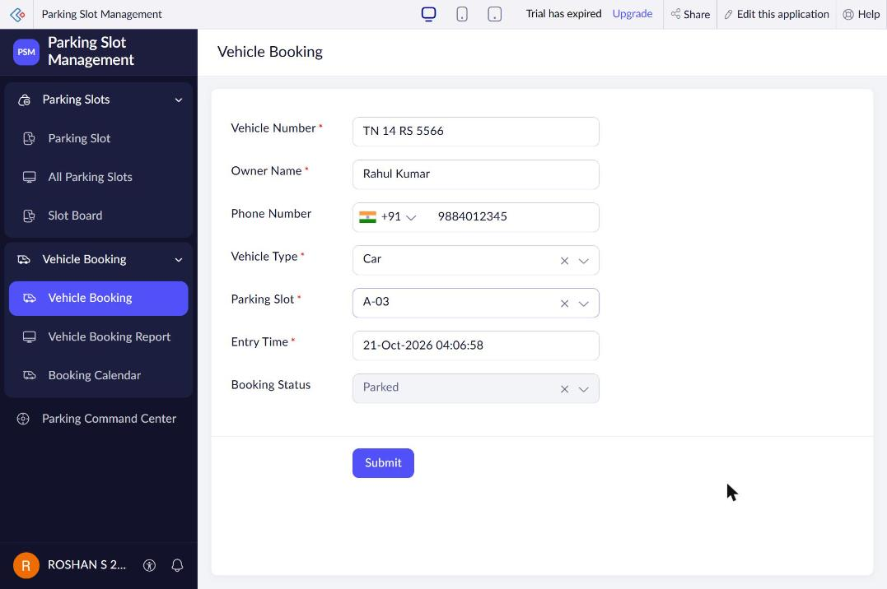
Figure 8.1: Scenario Step 1 – Vehicle entry recorded

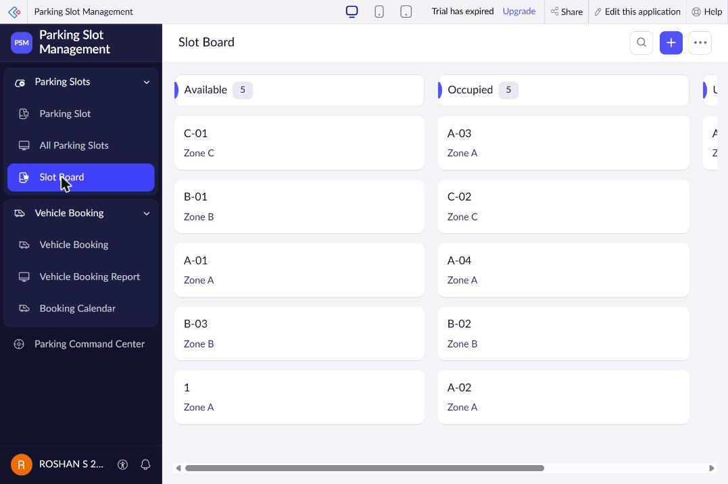
Figure 8.2: Scenario Step 2 – Slot automatically marked Occupied

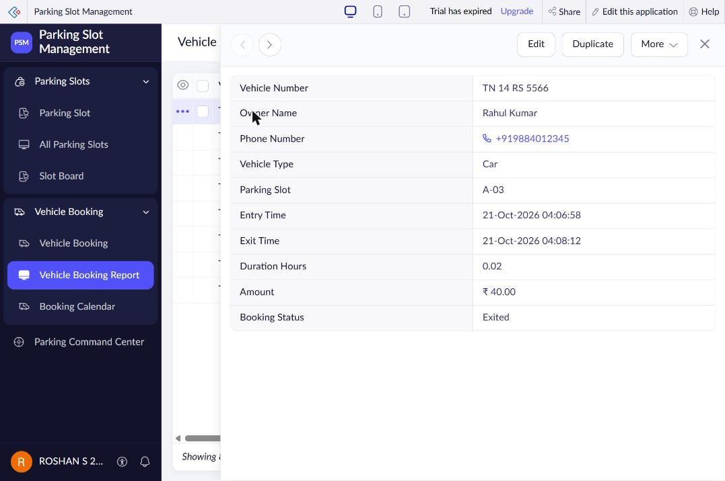
Figure 8.3: Scenario Step 3 – Checkout with calculated fee

8.2 Achievement of Objectives
Table 8.1: Mapping of Objectives to Outcomes
Objective (Sec. 1.3) | Implemented Through | Outcome / Evidence
Data model with two related forms | Sections 4.2, 4.3, 5.2 | Parking Slot ↔ Vehicle Booking lookup working (Figures 5.2, 5.3)
Automate validation, status and fee | Sections 5.5, 5.6 | TC-04 to TC-14; fees Rs.120 / Rs.15 / Rs.300 correct
Dashboard and multiple report types | Sections 5.3, 5.4 | Command Center KPIs 11/6/4/Rs.435; Kanban and Calendar reports
One-click checkout via reusable function | Sections 5.3, 5.5 | Checkout custom action (Figure 8.3)
Cloud deployment with controlled access | Chapter 7 | Live at https://creatorapp.zoho.in/roshan.s.2024.aiml_rajala/parking-slot-management/

8.3 Comparison with the Existing System
Table 8.2: Existing System versus Proposed Application
Parameter | Existing System | Proposed Application | Improvement
Time to record one entry | About 2–3 min (find slot, write register) | Under 1 min (5 fields) | About 60% faster
Manual steps per exit | Search register, calculate, update | One click (Checkout) | Calculation eliminated
Report generation | Manual counting at day end | Live dashboard and reports | Real time
Data accessibility | Only at the gate register | Web and mobile, anywhere | Anytime access
Errors in allotment / fee | Possible | Prevented by validation and formula | Eliminated for tested cases

8.4 Limitations of the Low-Code Approach
UI customisation: page layout is limited to the components offered by the page builder; the four KPI cards were therefore written as a single ZML panel with four columns. Feature availability by edition: Pivot Chart reports need Zoho Analytics and environments are not available in the edition used; a page chart and a careful test-before-change routine were used as workarounds. Field naming: link names are fixed once scripts refer to them, as seen in BUG-01. Vendor lock-in: the application and its Deluge code run only on Zoho Creator [3].

8.5 Reflection on the No-Code → Low-Code → Pro-Code Spectrum
No-code: forms, field validations (mandatory, no duplicates), the lookup, List/Kanban/Calendar reports and the dashboard chart were configured without code. Low-code: entry-time defaults, slot validation, status synchronisation, fee calculation and the checkout function needed short Deluge scripts and a little ZML for the KPI panel. Pro-code would be needed only for features outside the platform, such as camera-based number-plate recognition or a custom mobile app for vehicle owners; the move to pro-code would be justified when such real-time hardware integration or a fully custom user interface becomes a requirement.
CHAPTER 9

CONCLUSION AND FUTURE ENHANCEMENTS

9.1 Conclusion
A Parking Slot Management System was designed, built and deployed on Zoho Creator. The application replaces the paper register with two related forms, five form workflows, a reusable checkout function, three types of reports and a live Command Center dashboard.
Testing with eleven slots and eight bookings showed that slots are allotted only when valid, slot status stays synchronised with bookings automatically, and parking fees are calculated correctly. The project demonstrates how a low-code platform can turn a manual process into a working cloud application in a short time.

9.2 Future Enhancements
- Number-plate recognition using Zia OCR to fill Vehicle Number automatically at the gate.
- Online payment of parking fees using Zoho Creator payment workflows / a payment gateway.
- Customer portal for vehicle owners to reserve a slot in advance and receive an SMS/e-mail receipt.
- Scheduled daily e-mail summary of occupancy and revenue to the administrator.

9.3 Learning Outcomes and Career Relevance
The project strengthened skills in data modelling, form and report design, Deluge scripting, workflow automation and dashboard design, and in debugging configuration problems on a cloud platform. These skills relate directly to roles such as citizen developer, low-code developer, Zoho Creator developer, solutions consultant and automation engineer, where business processes must be digitised quickly and reliably.

REFERENCES
[1] W. Rosam and O. Kalnichevski, Low-Code Development: A Practical Guide. New Delhi, India: BPB Publications.
[2] Zoho Corporation, “Zoho Creator Help Documentation.” [Online]. Available: https://www.zoho.com/creator/help/ (Accessed: 21 October 2026).
[3] Zoho Corporation, “Deluge Script Reference Guide.” [Online]. Available: https://www.zoho.com/deluge/ (Accessed: 21 October 2026).
[4] Zoho Corporation, “Zoho Creator Learning Centre.” [Online]. Available: https://www.zoho.com/creator/resources/ (Accessed: 21 October 2026).
[5] Gartner, Inc., “Magic Quadrant for Enterprise Low-Code Application Platforms,” Gartner Research, 2023.
[6] A. Sahay, A. Indamutsa, D. Di Ruscio and A. Pierantonio, “Supporting the understanding and comparison of low-code development platforms,” in Proc. 46th Euromicro Conf. Software Engineering and Advanced Applications (SEAA), 2020, pp. 171–178.
[7] A. C. Bock and U. Frank, “Low-code platform,” Business & Information Systems Engineering, vol. 63, no. 6, pp. 733–740, 2021.
[8] D. Di Ruscio, D. Kolovos, J. de Lara, A. Pierantonio, M. Tisi and M. Wimmer, “Low-code development and model-driven engineering: Two sides of the same coin?” Software and Systems Modeling, vol. 21, pp. 437–446, 2022.
[9] T. Lin, H. Rivano and F. Le Mouël, “A survey of smart parking solutions,” IEEE Transactions on Intelligent Transportation Systems, vol. 18, no. 12, pp. 3229–3253, 2017.

APPENDIX A – ZOHO CREATOR FEATURE COVERAGE CHECKLIST
Table A.1: Feature Coverage Checklist
Unit | Zoho Creator Feature | Done | Where in the Application | Report Section | Figure / Code No.
I | Application created & sections/menu organised | Y | Parking Slot Management – 3 menu sections | 5.1 | 5.1
II | Forms with ≥ 8 distinct field types | Y | Single Line, Drop Down, Number, Phone, Lookup, Date-Time, Decimal, Currency (8 types) | 5.2 | Fig 5.2, 5.3
II | Lookup field (relationship between forms) | Y | Vehicle Booking.Parking_Slot → Parking Slot | 4.2, 5.2 | Fig 4.2
II | Subform (parent–child data) | N | — (no parent–child line items in this domain) | 4.2, 5.2 | —
II | Field validations / layout rules | Y | Mandatory, no-duplicate, DS-02/DS-04, hide/disable on load | 5.2 | Code 5.1
II | List report with filter, grouping, custom action | Y | Vehicle Booking Report with Checkout custom action | 5.3 | Table 5.1
II | Kanban / Calendar / Timeline / Map report | Y | Slot Board (Kanban), Booking Calendar (Calendar) | 5.3 | Fig 5.4
II | Pivot table / chart report | N | Requires Zoho Analytics; chart placed on page instead | 5.3 | —
II | Page / dashboard built with UI Builder | Y | Parking Command Center | 5.4 | Fig 5.5
II | Deluge – form events (validate / success / field actions) | Y | DS-01 to DS-05 | 5.5 | Code 5.1, 5.2
II | Deluge – functions, fetch, loops, collections | Y | checkoutVehicle(int) function | 5.5 | App. C.6
II | Email / in-app notifications | N | Alerts and info logs only; e-mail planned | 5.5, 5.6 | —
II | Form workflow | Y | 5 form workflows on Vehicle Booking | 5.6 | Fig 5.6
II | Scheduled workflow | N | Planned daily summary (9.2) | 5.6 | —
II | Approval process | N | Not required (no approval step) | 5.6 | —
II | Blueprint | N | Not required | 5.6 | —
II | Batch / report workflow | Y | Report workflow: Checkout Vehicle | 5.6 | Table 5.3
II | Testing & debugging evidence | Y | 17 test cases, defect log | 6 | Fig 6.1
III | Integration with a Zoho service | N | — | 5.7 | —
III | Connection / REST API call (invokeurl) | N | — | 5.7 | —
III | Webhook or Creator REST API | N | — | 5.7 | —
III | Users, roles and permission profiles | Y | Administrator configured; Attendant role designed | 5.8 | Fig 5.8
III | Record-level access criteria / customer portal | N | — | 5.8 | —
III | Zia / AI feature | N | Planned: Zia OCR for number plates | 5.9 | —
III | Analytics (charts / Zoho Analytics) | Y | KPI panels and revenue chart | 5.9 | Fig 5.9
IV | Performance optimisation applied & measured | Y | ID-based fetch, no loops (Table 7.2) | 7.2 | Table 7.2
IV | Deployment across environments | N | Environments not available in edition | 7.1 | —
IV | Security controls (encryption, OAuth, permissions) | Y | Sign-in, validation, unique keys (Table 7.3) | 7.3 | Table 7.3
IV | Governance (audit trail, administration) | Y | Naming conventions, audit fields, .ds export | 7.4 | Fig 7.2
V | Pro-code extension (Catalyst / widgets / custom functions) | N | Justified in 5.10 | 5.10 | —
V | Low-code limitations & spectrum analysis | Y | Sections 8.4, 8.5 | 8.4, 8.5 | —
— | Mobile app / portal access | Y | Phone layout preview / Creator mobile app | 5.11 | Fig 5.10

Total features implemented: 19 / 32

APPENDIX B – COURSE OUTCOME MAPPING
Table B.1: Mapping of Course Outcomes to Report Chapters
CO | Course Outcome Statement | Evidenced In | Self-Assessed Level | Examiner Level
CO1 | Explain the principles, architecture, and business value of low-code application development using Zoho Creator. | Ch. 1, 2 | 3
CO2 | Develop business applications using Zoho Creator forms, reports, workflows, and Deluge scripting. | Ch. 4, 5 (5.1–5.6), 6 | 3
CO3 | Integrate Zoho Creator applications with Zoho services and external systems using APIs, connections, and role-based security. | Ch. 4.6, 5.7–5.9 | 2
CO4 | Deploy, secure, and manage Zoho Creator applications across development and production environments following governance best practices. | Ch. 7 | 2
CO5 | Evaluate low-code development strategies, AI-assisted application development, and the transition from citizen developer to professional developer. | Ch. 5.9, 5.10, 8.4, 8.5, 9.3 | 2

APPENDIX C – COMPLETE DELUGE SOURCE CODE
C.1 Vehicle Booking - Set Entry Time (On Load)
// DS-01 | Form: Vehicle Booking | Event: Created - Load of the form
// Purpose: Auto-fill entry time and hide exit fields for a new booking
input.Entry_Time = zoho.currenttime;
input.Booking_Status = "Parked";
hide Exit_Time;
hide Duration_Hours;
hide Amount;
disable Booking_Status;
C.2 Vehicle Booking - Check Slot Availability (On Validate)
// DS-02 | Form: Vehicle Booking | Event: Created - On Validate
// Purpose: Allow booking only when the slot is Available and matches the vehicle type
slot = Parking_Slot[ID == input.Parking_Slot];
if(slot.Status != "Available")
{
alert "Slot " + slot.Slot_Number + " is " + slot.Status + ". Please choose an Available slot.";
cancel submit;
}
if(slot.Slot_Type != input.Vehicle_Type)
{
alert "Slot " + slot.Slot_Number + " is reserved for " + slot.Slot_Type + " vehicles.";
cancel submit;
}
input.Booking_Status = "Parked";
C.3 Vehicle Booking - Mark Slot Occupied (On Success)
// DS-03 | Form: Vehicle Booking | Event: Created - On Success
// Purpose: Mark the allotted slot as Occupied
slot = Parking_Slot[ID == input.Parking_Slot];
slot.Status = "Occupied";
info "Slot " + slot.Slot_Number + " is now Occupied by " + input.Vehicle_Number;
C.4 Vehicle Booking - Calculate Parking Fee (On Edit Validate)
// DS-04 | Form: Vehicle Booking | Event: Edited - On Validate
// Purpose: Calculate duration and parking fee when Exit Time is entered
if(input.Exit_Time != null)
{
if(input.Exit_Time <= input.Entry_Time)
{
alert "Exit Time must be after Entry Time.";
cancel submit;
}
slot = Parking_Slot[ID == input.Parking_Slot];
diffMs = input.Exit_Time.toLong() - input.Entry_Time.toLong();
hours = (diffMs / 3600000.0).round(2);
billHours = (diffMs / 3600000.0).ceil();
if(billHours < 1)
{
billHours = 1;
}
input.Duration_Hours = hours;
input.Amount = billHours * slot.Hourly_Rate;
input.Booking_Status = "Exited";
}
C.5 Vehicle Booking - Release Slot on Exit (On Edit Success)
// DS-05 | Form: Vehicle Booking | Event: Edited - On Success
// Purpose: Release the slot after the vehicle exits
if(input.Booking_Status == "Exited")
{
slot = Parking_Slot[ID == input.Parking_Slot];
slot.Status = "Available";
info "Slot " + slot.Slot_Number + " released. Fee collected: Rs." + input.Amount;
}
C.6 Function - checkoutVehicle (Report Custom Action)
// DS-06 | Function: checkoutVehicle(int bookingId) | Called by report action "Checkout"
// Purpose: One-click checkout - records exit time, calculates fee, releases slot
void checkoutVehicle(int bookingId)
{
bk = Vehicle_Booking[ID == bookingId];
if(bk.Booking_Status == "Exited")
{
return;
}
slot = Parking_Slot[ID == bk.Parking_Slot];
exitTime = zoho.currenttime;
diffMs = exitTime.toLong() - bk.Entry_Time.toLong();
billHours = (diffMs / 3600000.0).ceil();
if(billHours < 1)
{
billHours = 1;
}
bk.Exit_Time = exitTime;
bk.Duration_Hours = (diffMs / 3600000.0).round(2);
bk.Amount = billHours * slot.Hourly_Rate;
bk.Booking_Status = "Exited";
slot.Status = "Available";
}

APPENDIX D – USER MANUAL

D.1 Accessing the Application
Web: open https://creatorapp.zoho.in/roshan.s.2024.aiml_rajala/parking-slot-management/ in a browser and sign in with the Zoho account provided by the administrator. Mobile: install the Zoho Creator app, sign in with the same account and open Parking Slot Management.

D.2 Instructions for Administrator
- Open Parking Slots → Parking Slot to add a slot (number, zone, type, hourly rate).
- Open Slot Board and drag a slot card to Under Maintenance when a bay is closed.
- Open Parking Command Center to view total, available and occupied slots, revenue and the revenue chart.

D.3 Instructions for Parking Attendant
- Open Vehicle Booking → Vehicle Booking; enter vehicle number, owner name, phone and vehicle type; select an available slot and Submit.
- If an alert appears, choose another Available slot of the same type.
- When the vehicle leaves, open Vehicle Booking Report, open the booking and click Checkout → Yes; collect the amount shown.

APPENDIX E – EVALUATION RUBRIC
(For Examiner Use Only)
Student Name | Roshan S | Register No. | 241501170
Project Title | Parking Slot Management System | Date | 21 October 2026

Table E.1: Evaluation Rubric for the Individual Project
S.No. | Criterion | Indicators | Max. Marks | Marks Awarded
1 | Problem Definition & Requirement Analysis | Clarity of problem, measurable objectives, complete FR/NFR, use cases | 10
2 | System Design | Architecture, ER/data model, form specifications, workflow design, permission matrix | 10
3 | Forms, Reports & Pages | Variety of field types, lookups/subforms, report types, UI Builder dashboards | 15
4 | Deluge Scripting & Workflows | Correctness and depth of scripts; form, schedule, approval, Blueprint, batch workflows | 15
5 | Integration, RBAC & AI | Zoho/external integrations, connections, roles & permissions, Zia/analytics | 10
6 | Testing, Deployment, Security & Governance | Test coverage, environments, optimisation, security controls, audit | 10
7 | Live Demonstration | End-to-end working of the application across roles; feature checklist verified | 15
8 | Project Report | Adherence to template and format, clarity, figures, references | 5
9 | Viva-Voce | Understanding of the platform, design decisions and low-code concepts | 10
 | TOTAL |  | 100

Table E.2: Performance Level Descriptors
Level | % of Max. Marks | Descriptor
Excellent | 90–100 | Feature implemented completely, correctly and beyond the basic requirement; student explains design choices confidently.
Good | 70–89 | Feature implemented correctly with minor gaps; explanation adequate.
Satisfactory | 50–69 | Feature partially implemented or works only for the main path; limited explanation.
Needs Improvement | < 50 | Feature missing, non-functional or not understood by the student.

Signature of Internal Examiner  Name: ____________________ | Signature of External Examiner  Name: ____________________

APPENDIX F – VIVA-VOCE RECORD SHEET
(For Examiner Use Only)
Student Name | Roshan S | Register No. | 241501170
Department / Section | AIML | Date of Viva | [ ]
Application URL Verified | Yes / No | Demo Duration | ______ min
Table F.1: Viva-Voce Questions and Responses
Q.No. | Question / Topic Asked | Unit | Response (E / G / S / NI) | Remarks
1
2
3
4
5
6
7
8
E – Excellent G – Good S – Satisfactory NI – Needs Improvement
Table F.2: Marks Summary
Component | Max. Marks | Marks Awarded
Criteria 1–8 (Appendix E) | 90
Viva-Voce | 10
TOTAL | 100

Examiners’ Remarks:
____________________________________________________________________
____________________________________________________________________
INTERNAL EXAMINER  Name: ____________________ | EXTERNAL EXAMINER  Name: ____________________

