**Lab No: 3 Date:**

**Title: Prepare a lab report on demonstrate the function of macros using both keyboard**

**Macros**

In Microsoft Word, a macro serves as a tool for automating repetitive tasks by recording a series of user actions and then replaying them upon command. These recorded sequences of commands can range from simple text formatting to complex data manipulations. Macros can be recorded, edited, and executed through Word's interface, allowing users to streamline their workflow and save time. However, due to potential security risks, macros are disabled by default, and users must adjust their settings to enable them, either for all documents or selectively for trusted sources. Additionally, macros can be written manually using Visual Basic for Applications (VBA), providing advanced users with greater flexibility and control over their automation solutions. While macros can significantly enhance productivity, users should exercise caution when running macros from unknown or untrusted sources to mitigate potential security vulnerabilities. Overall, macros in Word offer a powerful means of automating tasks and customizing the user experience to suit individual needs.

In word, we can automate frequently used tasks by creating and running macros. A macro is a series of commands and instructions that you group together as a single command to accomplish a task automatically. To save time on tasks you do often, bundle the steps into a macro. First, you record the macro.

Macros are used to make a sequence of computing instructions available to the programmer as a single [program statement](https://en.wikipedia.org/wiki/Program_statement), making the programming task less tedious and less error-prone. Thus, they are called "macros" because a "big" [block of code](https://en.wikipedia.org/wiki/Block_(programming)) can be expanded from a "small" sequence of characters. Macros often allow positional or keyword parameters that dictate what the [conditional assembler](https://en.wikipedia.org/wiki/Conditional_assembly_language) program generates and have been used to create entire [programs](https://en.wikipedia.org/wiki/Computer_program) or program suites according to such variables as [operating system](https://en.wikipedia.org/wiki/Operating_system), [platform](https://en.wikipedia.org/wiki/Computing_platform) or other factors.

* **Steps to Create macro (Type: Keyboard)**
* Making a macro(Ctrl +shift +t) which can change the selected word Theme font in Times New Roman, with font size 12.

Step 1: Click View > Macros

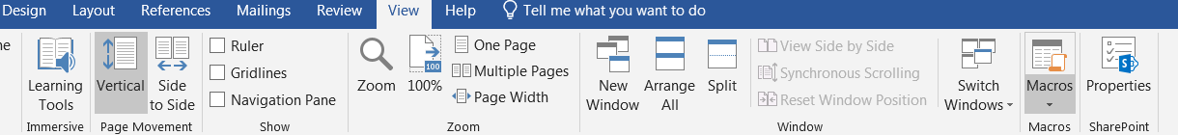

Step 2: Record micro > keyboard icon

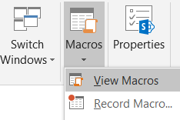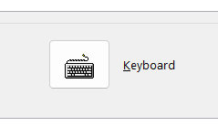

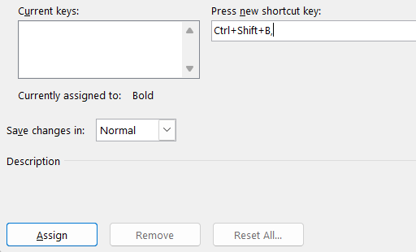Step 3: Give shortcut key > Assign > Close

Step 4: Give the Task > Stop Recording

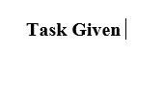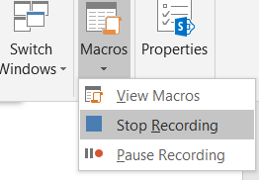

**Results:** *Before: After macro used:*

* **Steps to Create macro (Type: Button)**
* To create a macro which can set the first page for IIT lab report.

Step 1: Go to View > click on Macros

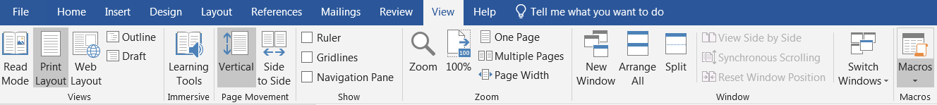

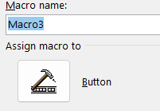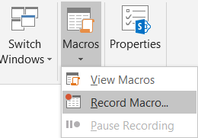Step 2: Record micro > Click on Button icon

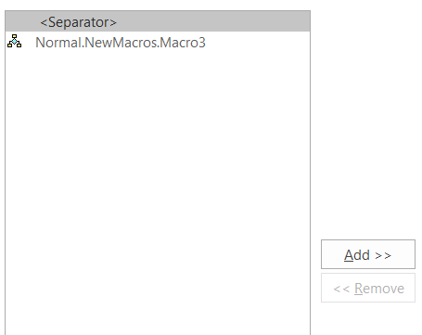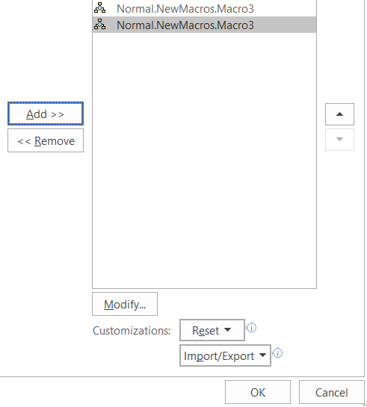Step 3: Select macros > Add > Ok

Step 4: Modify > Choose any symbol > Ok > again Ok

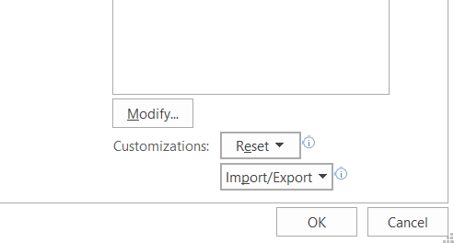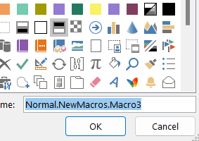

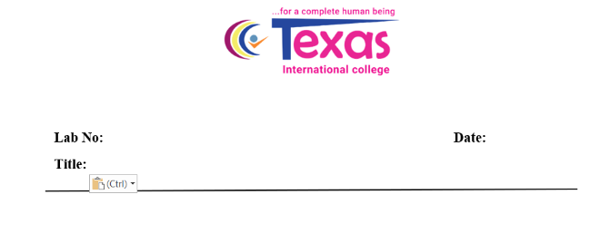Step 5: Give task > Stop Recording

