**Lab No: 4 Date:**

**Title: Prepare a lab report to demonstrate creation of table of content step by step**

**Table of content**

A table of contents, usually headed simply Contents and abbreviated informally as TOC, is a [list](https://en.wikipedia.org/wiki/List_(information)), usually found on a page before the start of a written work, of its chapter or section titles or brief descriptions with their commencing page numbers.

A table of contents usually includes the titles or descriptions of first-level headings (chapters in longer works), and often includes second-level headings (sections or A-heads) within the chapters as well, and occasionally even includes third-level headings (subsections or B-heads) within the sections as well. The depth of detail in tables of contents depends on the length of the work, with longer works having less. Formal reports (ten or more pages and being too long to put into a [memo](https://en.wikipedia.org/wiki/Memorandum) or letter) also have a table of contents. Within an English-language book, the table of contents usually appears after the title page, [copyright notices](https://en.wikipedia.org/wiki/Copyright_notice), and, in technical journals, the [abstract](https://en.wikipedia.org/wiki/Abstract_(summary)); and before any lists of tables or [figures](https://en.wikipedia.org/wiki/Figure_(publishing)), the [foreword](https://en.wikipedia.org/wiki/Foreword), and the [preface](https://en.wikipedia.org/wiki/Preface).

Printed tables of contents indicate page numbers where each part starts, while digital ones offer [links](https://en.wikipedia.org/wiki/Hyperlink) to go to each part. The format and location of the page numbers is a matter of style for the publisher. If the page numbers appear after the heading text, they might be preceded by characters called [leaders](https://en.wikipedia.org/wiki/Leader_(typography)), usually dots or [periods](https://en.wikipedia.org/wiki/Full_stop), that run from the chapter or section titles on the opposite side of the page, or the page numbers might remain closer to the titles. In some cases, the page number appears before the text.

If a book or document contains chapters, articles, or stories by different authors, their names usually appear in the table of contents.

Matter preceding the table of contents is generally not listed there. However, all pages except the outside cover are counted, and the table of contents is often numbered with a lowercase Roman numeral page number. Many popular [word processors](https://en.wikipedia.org/wiki/Word_processor), such as [Microsoft Word](https://en.wikipedia.org/wiki/Microsoft_Word), [WordPerfect](https://en.wikipedia.org/wiki/WordPerfect), and [Star Writer](https://en.wikipedia.org/wiki/StarOffice_Writer) are capable of automatically generating a table of contents if the author of the text uses specific styles for chapters, sections, subsections, etc.

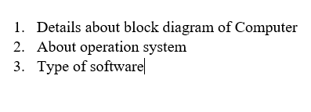Step 1**:** Type the content > Select heading 1 or heading 2

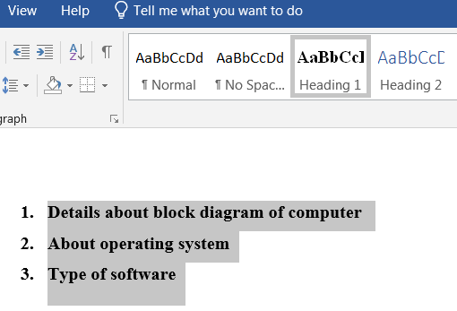

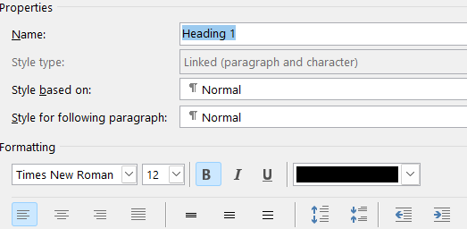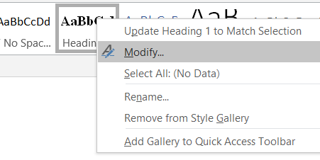Step 2: Modify heading as required > Ok

Step 3: Reference > Table of Contents

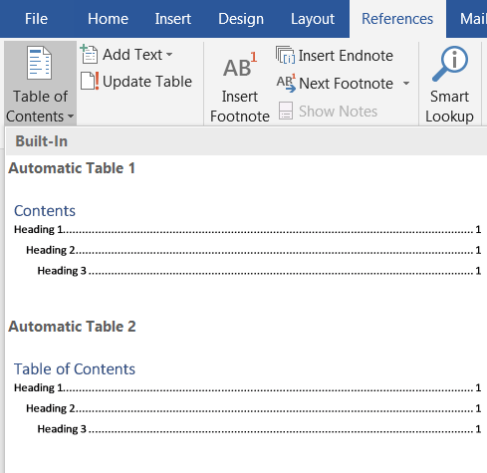

Step 4: Automatic table 2

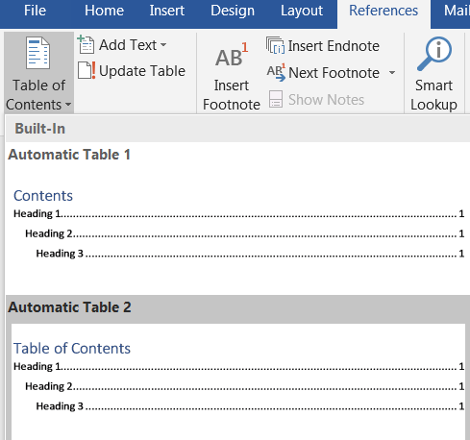

**Result:**

