**Lab No: 1 Date:**

**Title**: Write down the command to create the tree structure as given.

# **Introduction of command prompt**

A command prompt is the input field in a text-based [user interface](https://www.techtarget.com/searchapparchitecture/definition/user-interface-UI) screen for an operating system (OS) or program. The prompt is designed to elicit an action. The command prompt consists of a brief text string followed by a blinking [cursor](https://www.techtarget.com/whatis/definition/cursor), which is where the user types command prompt commands.

Command-line interfaces ([CLI](https://www.techtarget.com/searchwindowsserver/definition/command-line-interface-CLI)) and prompts were the standard interface for computers from the early days of computing into the 1980s. Microsoft [MS-DOS](https://www.techtarget.com/searchenterprisedesktop/definition/MS-DOS) systems and other early consumer-based computers used CLIs. Current [Windows](https://www.techtarget.com/searchwindowsserver/definition/Windows) systems offer the CLI for administrative tasks. The CLI is still an essential part of the [Linux](https://www.techtarget.com/searchdatacenter/definition/Linux-operating-system) OS.

**Types of command prompt:**

* Internal Commands

Internal Commands are built into the operating system as the part of a file called COMMAND.COM .When you type an Internal Command MS-DOS will perform it immediately. All of the internal commands are part of the shell which could be command.com or cmd.exe (depending on your version of MS-DOS or Windows) and are not separate files on the hard drive. Example Of Ms-dos Internal Command Are: CLS, BREAK, REN, CHDIR, EXIT, DEL, DATE, TIME, DIR, SET, MKDIR/MD.

* External Commands

These external commands are for performing advanced tasks and they do need some external file support as they are not stored in COMMAND.COM. There are also Batch commands or Batch files which are text files that contain a list of internal and/or external commands which are executed in sequence when the batch file is executed. AUTOEXEC.BAT gets executed automatically on booting. Examples of External Commands are:- TREE, PRINT, FIND, XCOPY, DISK COMP, FORMAT.

**Root**

D

E

C

Destination

Source

File1.txt

File2.txt

File2.txt

File1.txt

Temporary

1. Write down the command to create the tree structure as given.

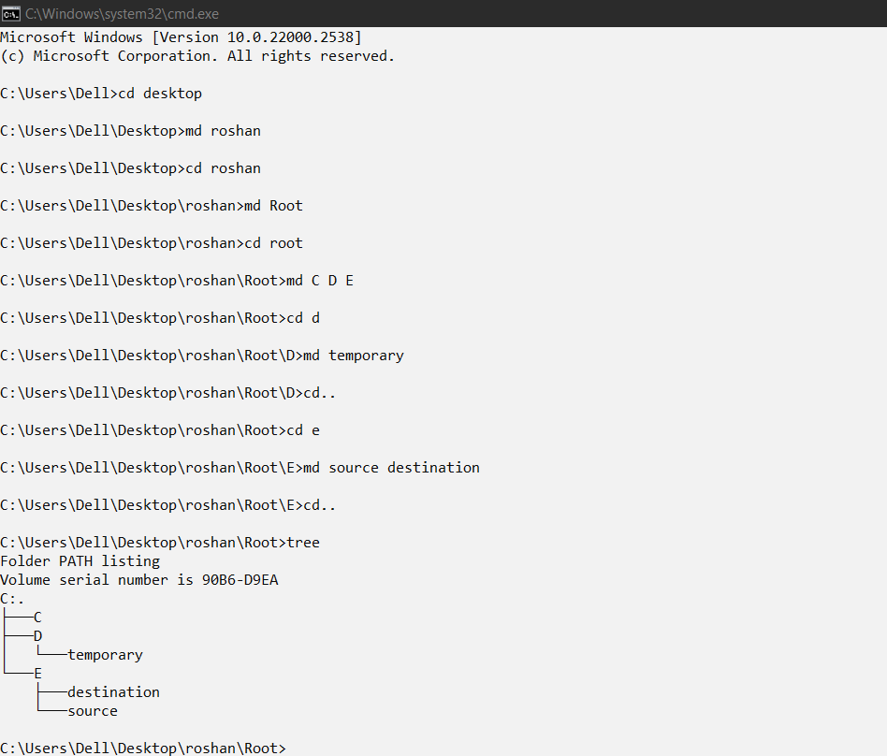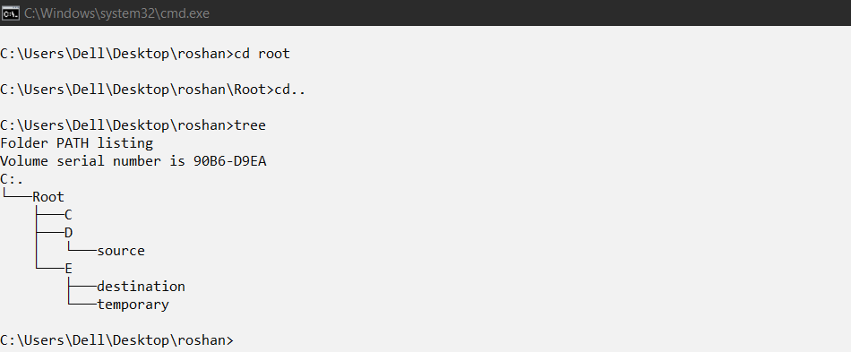

1. Create two files file1.txt and file2.txt inside directory C.

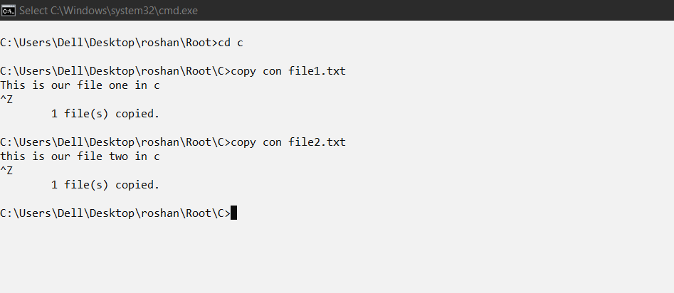

1. Create two files file1.txt and file2.txt in directory destination

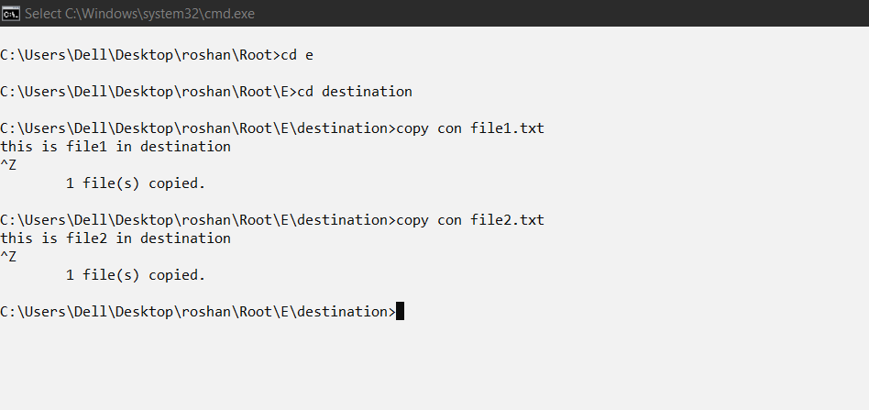

1. Rename the directory source into temporary and temporary into source.

